AI- Assignment-9.3
Name:G.Harika
Ht.No:2303A51612
Batch:05
Prompt: #You are developing a utility function that processes numerical lists and must be properly
#documented for future maintenance.
#Write a Python function to return the sum of even numbers and sum of odd numbers in a
#given list
#• Manually add a Google Style docstring to the function
#• Use an AI-assisted tool (Copilot / Cursor AI) to generate a function-level docstring
#• Compare the AI-generated docstring with the manually written docstring
#• Analyze clarity, correctness, and completeness
Code: def sum_even_odd(numbers):
"""Calculate the sum of even and odd numbers in a list.

This function takes a list of integers and returns a tuple containing
the sum of even numbers and the sum of odd numbers.

Args:
numbers (list of int): A list of integers to be processed.
Returns:
tuple: A tuple containing two integers: (sum_of_evens, sum_of_odds)
"""
sum_of_evens = sum(num for num in numbers if num % 2 == 0)
sum_of_odds = sum(num for num in numbers if num % 2 != 0)
return sum_of_evens, sum_of_odds

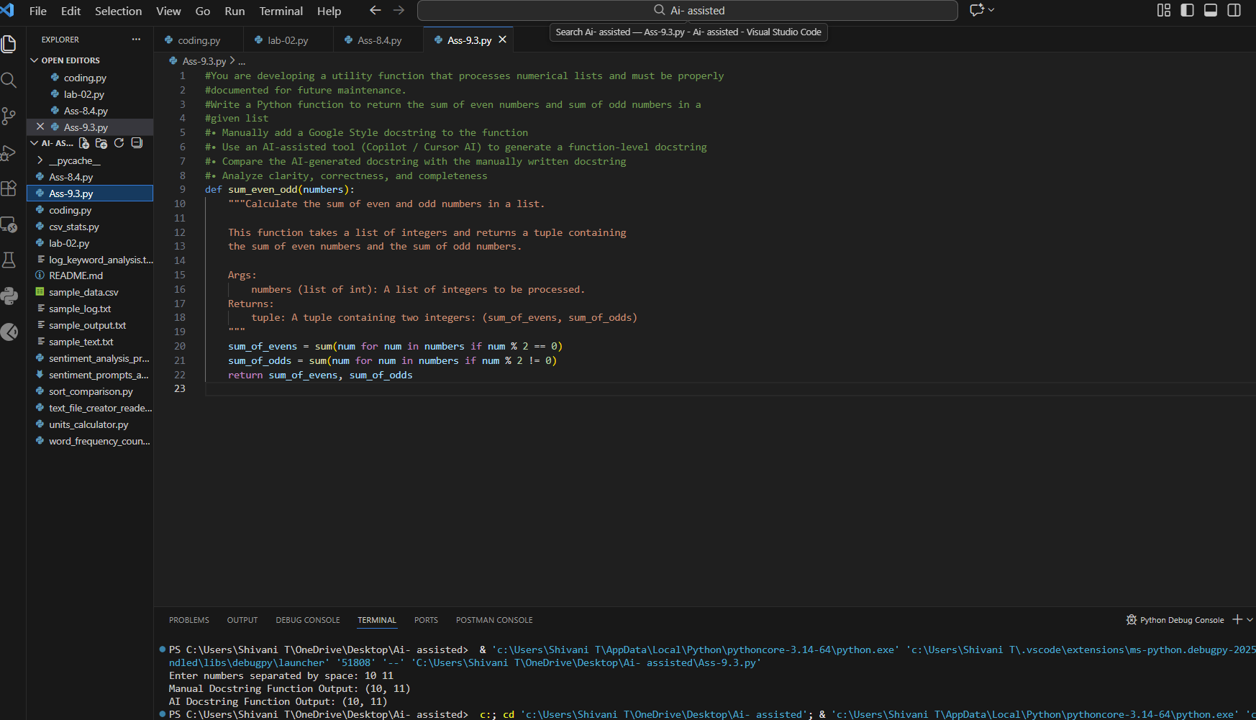
Prompt: Task 2: Automatic Inline Comments
#You are developing a student management module that must be easy to understand for new
developers.
#Write a Python program for an sru_student class with the following:
#Attributes: name, roll_no, hostel_status
# Methods: fee_update() and display_details()
# Manually write inline comments for each line or logical block
# Use an AI-assisted tool to automatically add inline comments
#Compare manual comments with AI-generated comments
# Identify missing, redundant, or incorrect AI comments
Expected Output
• Python class with manually written inline comments
• AI-generated inline comments added to the same code
• Comparative analysis of manual vs AI comments
• Critical discussion on strengths and limitations of AI-generated comments
Code: class sru_student:
# Constructor to initialize student attributes
def __init__(self, name, roll_no, hostel_status):
self.name = name # Store student name
self.roll_no = roll_no # Store student roll number
self.hostel_status = hostel_status # Store hostel status (True/False)

# Method to update fee based on hostel status
def fee_update(self):
if self.hostel_status: # If student stays in hostel
fee = 50000 # Hostel students pay higher fee
else:
fee = 30000 # Non-hostel students pay lower fee
return fee # Return calculated fee

# Method to display student details
def display_details(self):
print("Name:", self.name) # Print student name
print("Roll No:", self.roll_no) # Print student roll number
print("Hostel Status:", "Yes" if self.hostel_status else "No") # Print hostel status
print("Fee:", self.fee_update()) # Print fee based on hostel status

# Example usage
student1 = sru_student("Shivani", "SRU123", True)
student1.display_details()

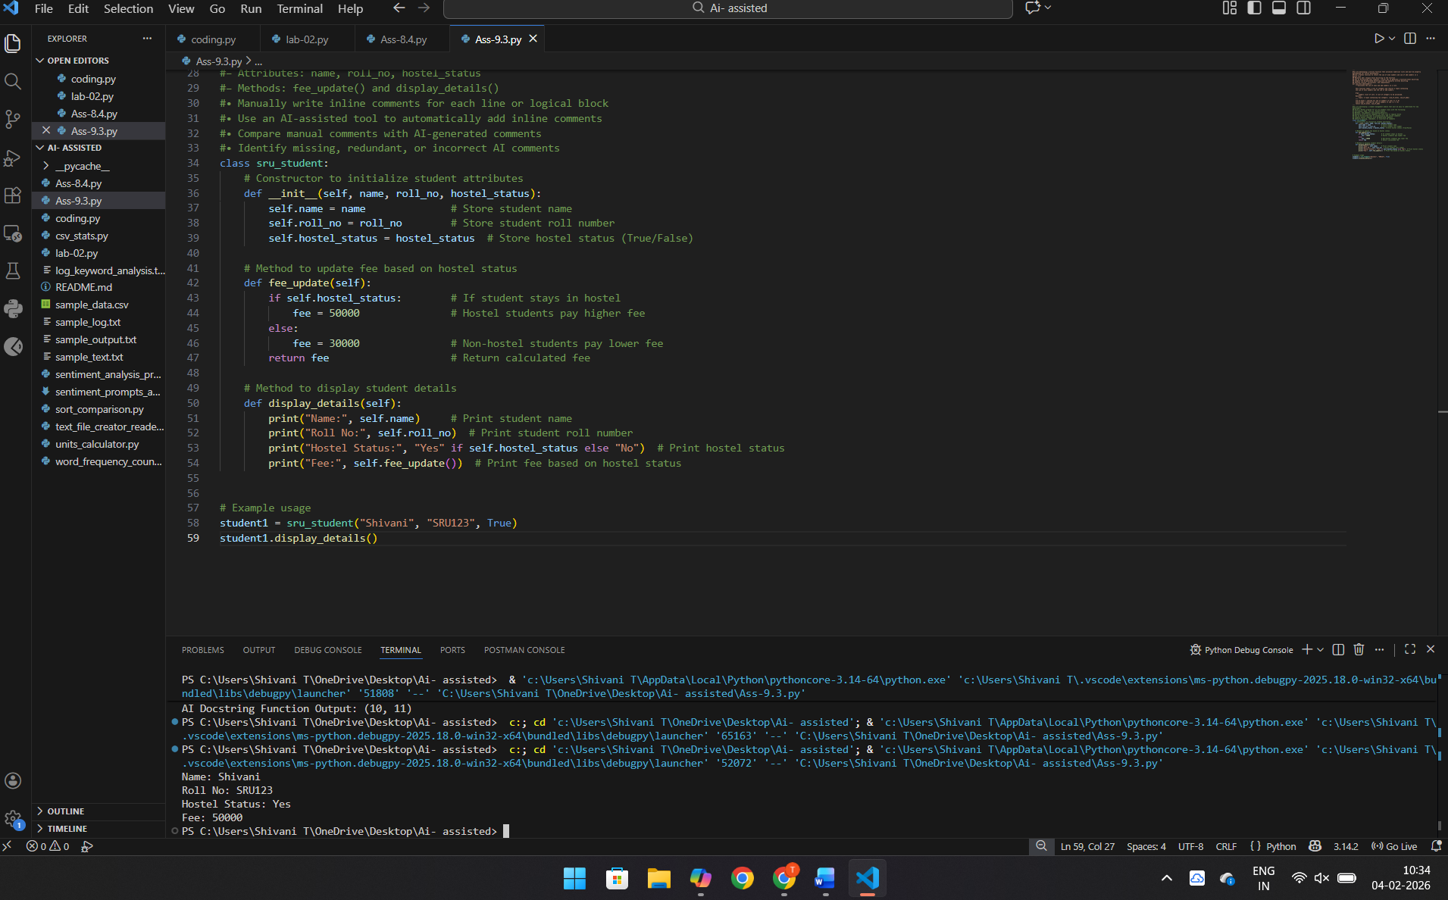

Prompt: Task 3: Module-Level and Function-Level Documentation
#You are building a small calculator module that will be shared across multiple projects and
requires structured documentation.
# Write a Python script containing 3–4 functions (e.g., add, subtract, multiply, divide)
#Manually write NumPy Style docstrings for each function
#Use AI assistance to generate:
#A module-level docstring
#Individual function-level docstrings
# Compare AI-generated docstrings with manually written ones
# Evaluate documentation structure, accuracy, and readability
Code: """
calculator.py
=============

A simple calculator module providing basic arithmetic operations.
This module can be reused across multiple projects where basic
mathematical functions are required.
"""

def add(a, b):
"""
Add two numbers.

Parameters
----------
a : float or int
First number.
b : float or int
Second number.

Returns
-------
float or int
The sum of `a` and `b`.

Examples
--------
>>> add(2, 3)
5
"""
return a + b

def subtract(a, b):
"""
Subtract one number from another.

Parameters
----------
a : float or int
First number.
b : float or int
Second number to subtract from `a`.

Returns
-------
float or int
The result of `a - b`.

Examples
--------
>>> subtract(5, 2)
3
"""
return a - b

def multiply(a, b):
"""
Multiply two numbers.

Parameters
----------
a : float or int
First number.
b : float or int
Second number.

Returns
-------
float or int
The product of `a` and `b`.

Examples
--------
>>> multiply(4, 3)
12
"""
return a * b

def divide(a, b):
"""
Divide one number by another.

Parameters
----------
a : float or int
Numerator.
b : float or int
Denominator.

Returns
-------
float
The result of `a / b`.

Raises
------
ZeroDivisionError
If `b` is zero.

Examples
--------
>>> divide(10, 2)
5.0
"""
if b == 0:
raise ZeroDivisionError("Division by zero is not allowed.")
return a / b

