AI Assistant Coding
Assignment-10.4
Name: Gaje Harika
Hall Ticket No.: 2303A51612
Batch No.:05

Task 1: AI-Assisted Syntax and Code Quality Review
Scenario
You join a development team and are asked to review a junior
developer’s Python script that fails to run correctly due to basic coding
mistakes. Before deployment, the code must be corrected and
standardized.
Task Description
You are given a Python script containing:
• Syntax errors
• Indentation issues
• Incorrect variable names
• Faulty function calls
Use an AI tool (GitHub Copilot / Cursor AI) to:
• Identify all syntactic and structural errors
• Correct them systematically
• Generate an explanation of each fix made
Python Script with errors:
def CalculateTotal(price, tax
total = price + price * tax
return total

items = [100, 200, 300]

for i in items
print(CalculateTotal(i, 0.05))
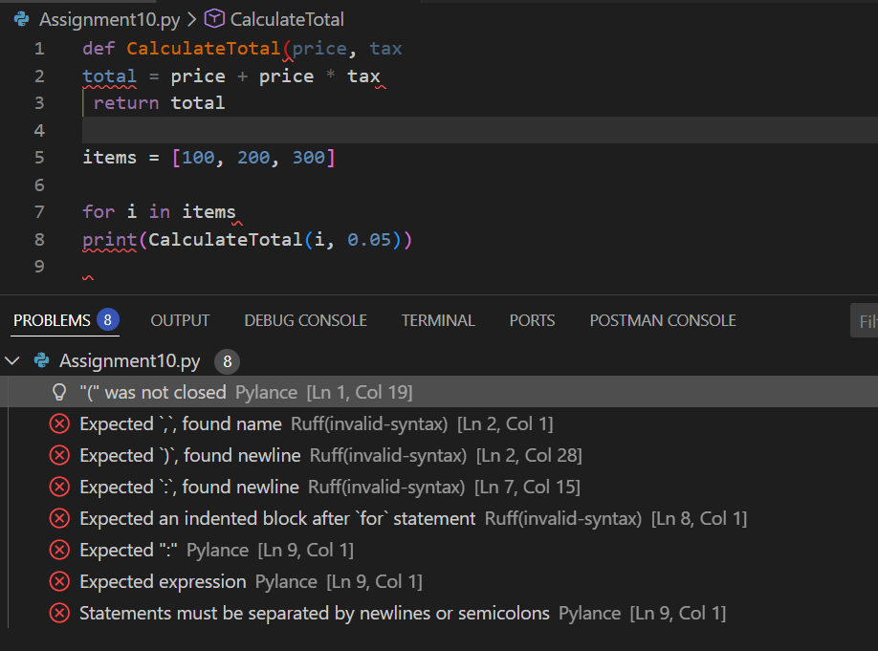

Output:
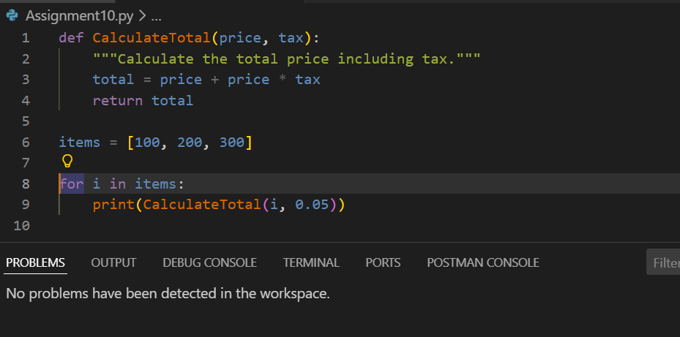

AI Explanation of Fixes
Syntax Fixes
- Added missing ) in function definition.
- Corrected indentation inside the function.
- Added : after the for loop.
- Fixed indentation for the print() statement.

Naming Corrections
- Renamed CalculateTotal → calculate_total
✔ Follows PEP 8 snake_case convention.
- Renamed loop variable i → item for clarity.
Structural Improvements
- Added a docstring explaining the function.
- Improved spacing for readability.

Task 2: Performance-Oriented Code Review
Scenario
A data processing function works correctly but is inefficient and slows
down the system when large datasets are used.
Task Description
You are provided with a function that identifies duplicate values in a list
using inefficient nested loops.
Using AI-assisted code review:
• Analyze the logic for performance bottlenecks
• Refactor the code for better time complexity
• Preserve the correctness of the output
Ask the AI to explain:
• Why the original approach was inefficient
• How the optimized version improves performance
Inefficient Duplicate Finder
def find_duplicates(lst):
duplicates = []
for i in range(len(lst)):
for j in range(i + 1, len(lst)):
if lst[i] == lst[j]:
duplicates.append(lst[i])
return duplicates
Optimised Code:
def find_duplicates(lst):
"""
Find duplicates in a list.
This function takes a list as input and returns a list of duplicate values found in the input list.
It uses a set to track seen items, which allows for O(1) average time complexity for membership checks.
This makes the function more efficient than a naive approach that would involve nested loops,
resulting in O(n^2) time complexity. By using sets, the function efficiently identifies duplicates
in a single pass through the list.
Parameters:
lst (list): The input list from which to find duplicates.
Returns:
list: A list of duplicate values found in the input list.
"""
seen = set()
duplicates = set()

for item in lst:
if item in seen:
duplicates.add(item)
else:
seen.add(item)

return list(duplicates)
Problem Analysis
Why It Is Inefficient
- Uses nested loops.
- Time Complexity = O(n²).
- Extremely slow for large datasets.

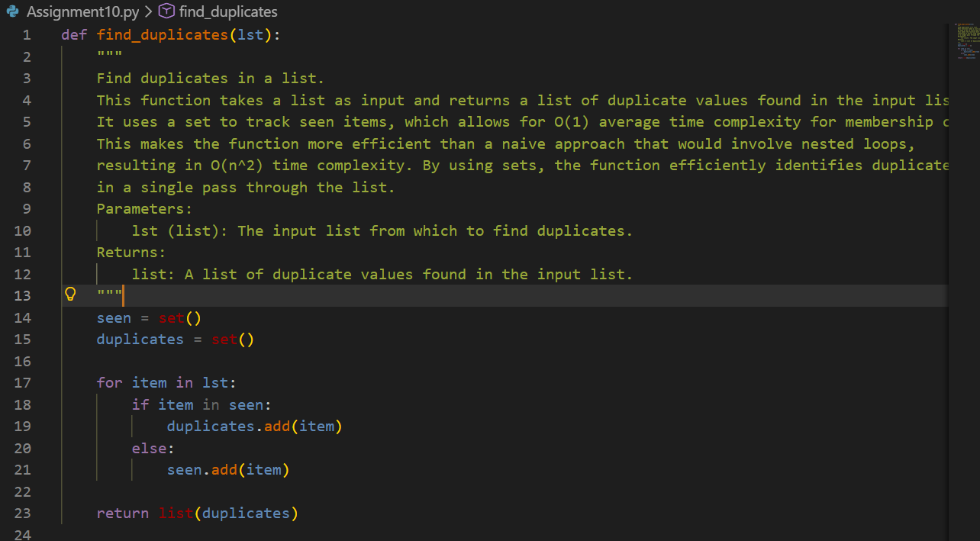
Performance Improvement Explanation
Approach | Time Complexity
Nested loops | O(n²)
Hash set | O(n)
Why Faster?
- Set lookups are O(1).
- Only one loop is required.
Task 3: Readability and Maintainability Refactoring
Scenario
A working script exists in a project, but it is difficult to understand due to
poor naming, formatting, and structure. The team wants it rewritten for
long-term maintainability.
Task Description
You are given a poorly structured Python function with:
• Cryptic function names
• Poor indentation
• Unclear variable naming
• No documentation
Use AI-assisted review to:
• Refactor the code for clarity
• Apply PEP 8 formatting standards
• Improve naming conventions
• Add meaningful documentation
Poorly Written Function
def f(x,y):
z=[]
for i in x:
if i>y:
z.append(i)
return z

Refactored Version

def filter_greater_than(numbers, threshold):
"""
Filter numbers greater than a given threshold.

Args:
numbers (list): List of numeric values.
threshold (int or float): Minimum value.

Returns:
list: Numbers greater than the threshold.
"""
filtered_numbers = []

for number in numbers:
if number > threshold:
filtered_numbers.append(number)

return filtered_numbers
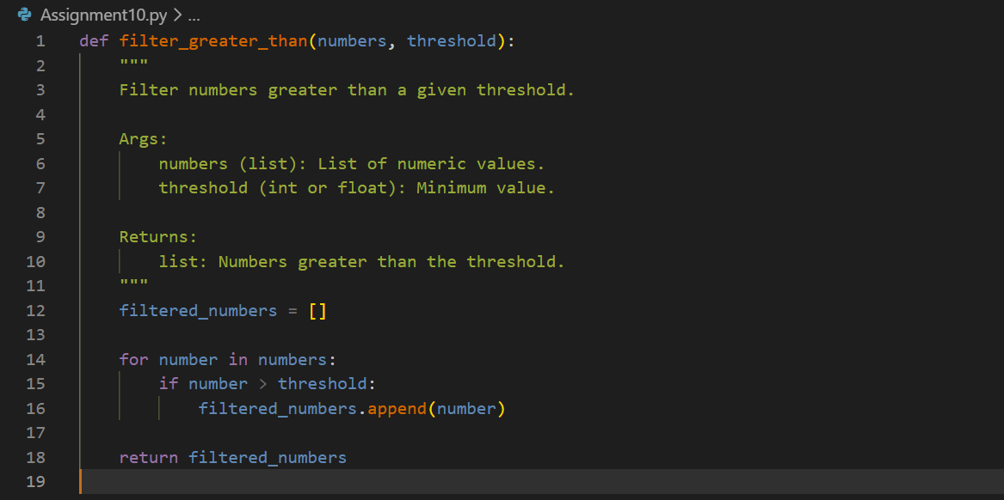
Readability Improvements
Naming
- f → filter_greater_than
- x → numbers
- y → threshold
- z → filtered_numbers
Format
- Proper indentation.
- Logical spacing.
Documentation
- Added professional docstring.

- Maintainable, team-friendly code.

Task 4: Secure Coding and Reliability Review
Scenario
A backend function retrieves user data from a database but has security
vulnerabilities and poor error handling, making it unsafe for production
deployment.
Task Description
You are given a Python script that:
• Uses unsafe SQL query construction
• Has no input validation
• Lacks exception handling
Use AI tools to:
• Identify security vulnerabilities
• Refactor the code using safe coding practices
• Add proper exception handling
• Improve robustness and reliability
Unsafe Script
import sqlite3
def get_user(username):
conn = sqlite3.connect("users.db")
cursor = conn.cursor()
query = "SELECT * FROM users WHERE username = '" + username + "'"
cursor.execute(query)
return cursor.fetchall()
Security Issues Identified
- SQL Injection vulnerability.
- No input validation.
- No exception handling.
- Connection not closed.
Production-Ready Secure Version
import sqlite3

def get_user(username):
"""
Retrieve user details safely from the database.
"""
if not isinstance(username, str) or not username.strip():
raise ValueError("Invalid username provided.")

try:
with sqlite3.connect("users.db") as conn:
cursor = conn.cursor()

cursor.execute(
"SELECT * FROM users WHERE username = ?",
(username,)
)

return cursor.fetchall()

except sqlite3.Error as error:
print(f"Database error occurred: {error}")
return None
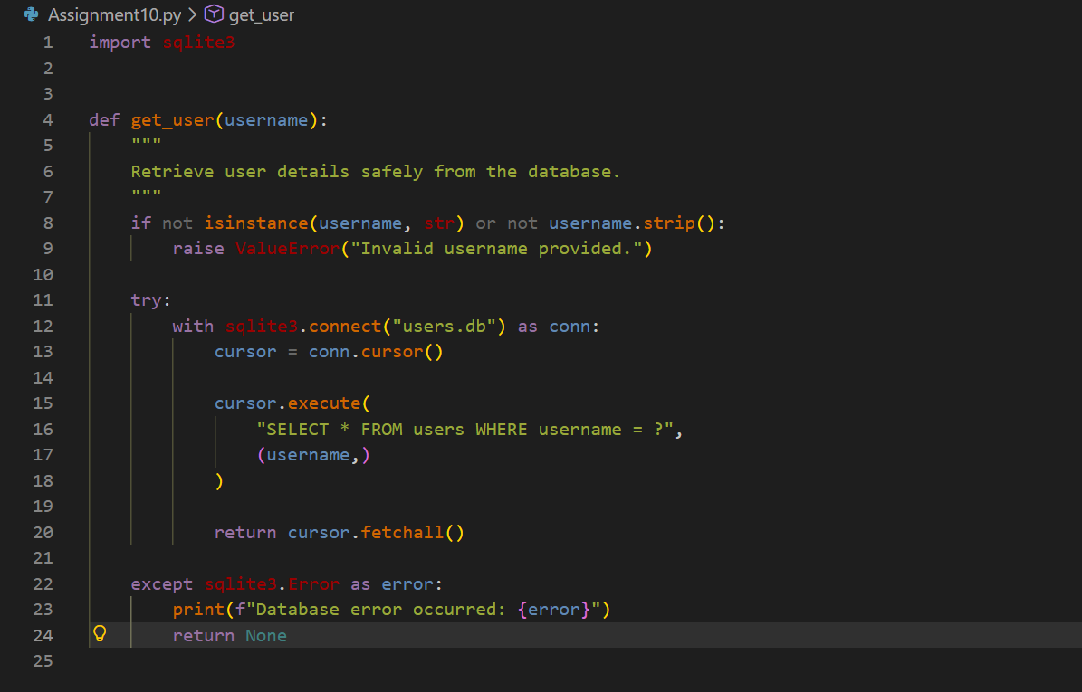
Security Improvements Explained
Parameterized Queries
Prevents SQL injection.
Input Validation
Stops malicious or empty input.
Exception Handling
Avoids runtime crashes.
Context Manager
Auto-closes database connection.

Task 5: AI-Based Automated Code Review Report
Scenario
Your team uses AI tools to perform automated preliminary code reviews
before human review, to improve code quality and consistency across
projects.
Task Description
You are provided with a poorly written Python script.
Using AI-assisted review:
• Generate a structured code review report that evaluates:
o Code readability
o Naming conventions
o Formatting and style consistency
o Error handling
o Documentation quality
o Maintainability
The task is not just to fix the code, but to analyze and report on quality
issues.
Poor Script for Review
def d(a,b):return a/b

x=10
y=0
print(d(x,y))
AI Code Review Report
Readability
Issue: Cryptic function name d.
Risk: Hard for teams to understand.
Naming Conventions
Not following PEP 8.
Examples:
- a, b
- d
Use descriptive names.
Formatting & Style
- One-line function reduces readability.
- No spacing.

Error Handling
- Critical Risk
- Division by zero causes crash.

Documentation Quality
- None present.

Maintainability
- Low — unclear intent and unsafe execution.

- def divide_numbers(dividend, divisor):
- '''Parameters:
- dividend (float): The number to be divided.
- divisor (float): The number by which to divide.
- Returns:
- float: The result of the division.
- ValueError: If divisor is zero, indicating that division by zero is not allowed.'''
- if divisor == 0:
- raise ValueError("Division by zero is not allowed.")
- return dividend / divisor
- # Example usage:
- try:
- result = divide_numbers(10, 0)
- print(result)
- except ValueError as error:
- print(error)

Code Smells Detected
- Magic values
- Poor naming
- Missing error handling
- Lack of documentation

Demonstration of AI as Code Reviewer
This review showcased how AI can:
Detect syntax errors, Improve performance, Refactor for readability, Harden security
& Generate structured review reports.

