ICP3 - Report

Harika Gurram

Class Id : 17

1. Create a class Employee and then do the following

•Create a data member to count the number of Employees

•Create a constructor to initialize name, family, salary, department

•Create a function to average salary

•Create a Fulltime Employeeclass and it should inherit the properties of Employee class

•Create the instances of Fulltime Employeeclass and Employee class and call their member functions.

Code:

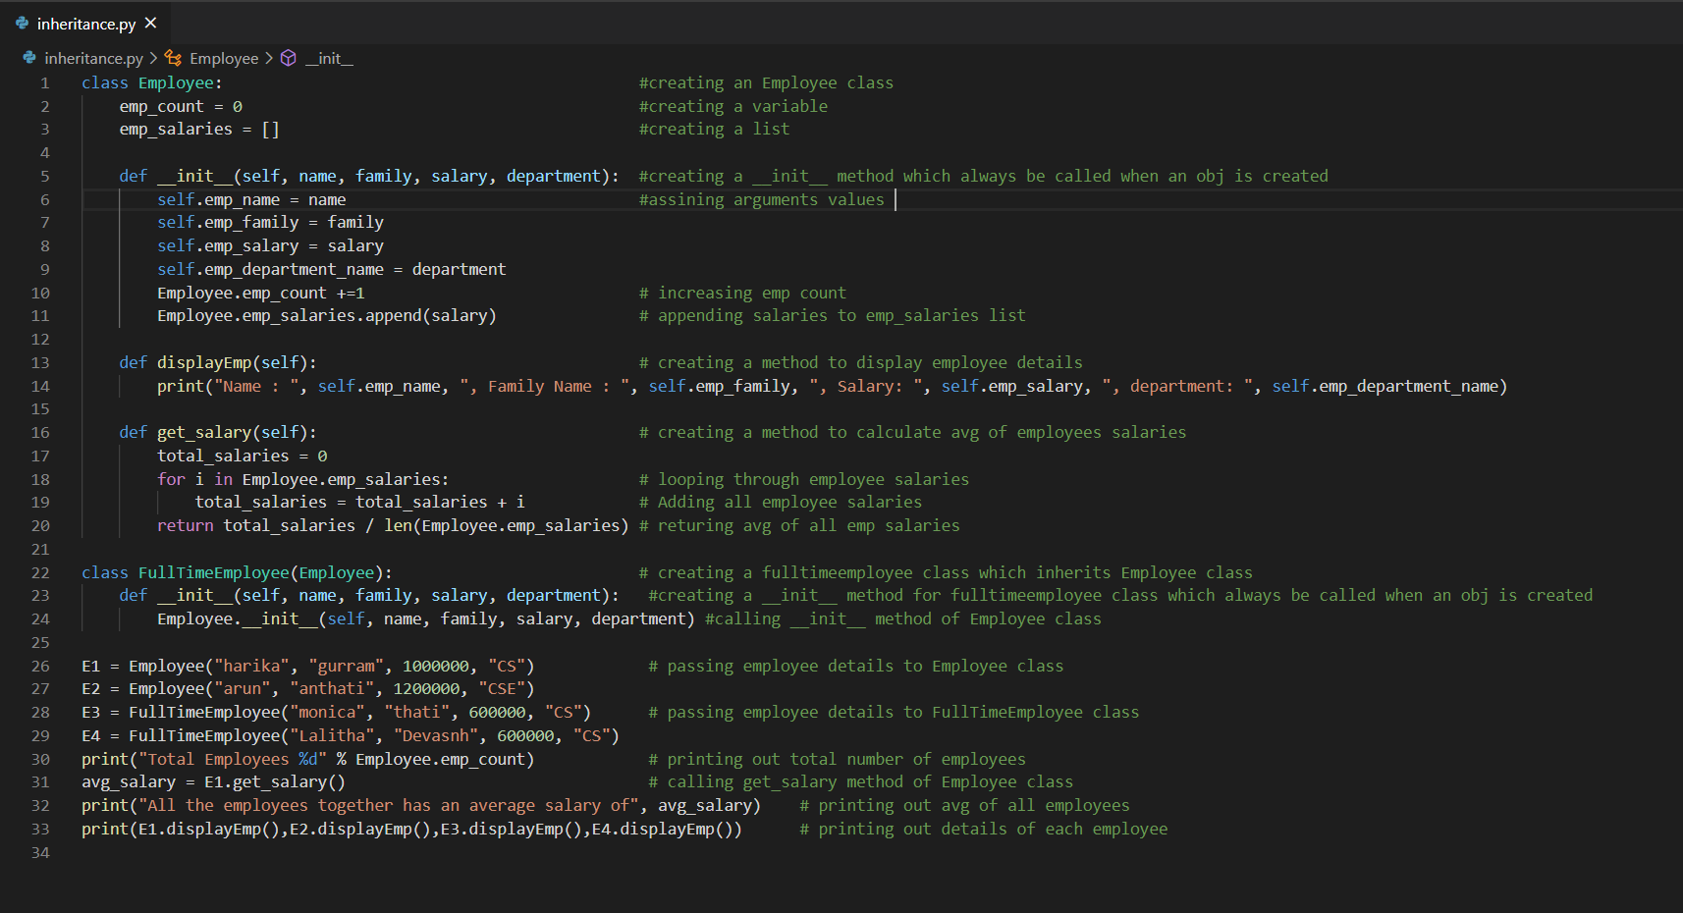

Output :

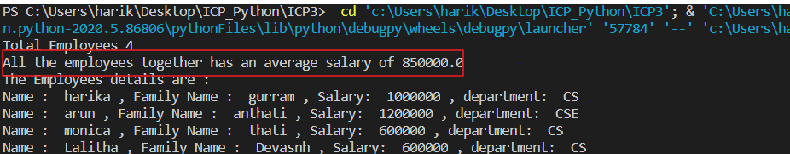

1. Web scrapingWrite a simple program that parse a Wiki page mentioned below and follow the instructions:https://en.wikipedia.org/wiki/Deep_learning

•Print out the title of the page

•Find all the links in the page (‘a’ tag)

•Iterate over each tag(above) then return the link using attribute "href" using get

•Save all the links in the file

Code:

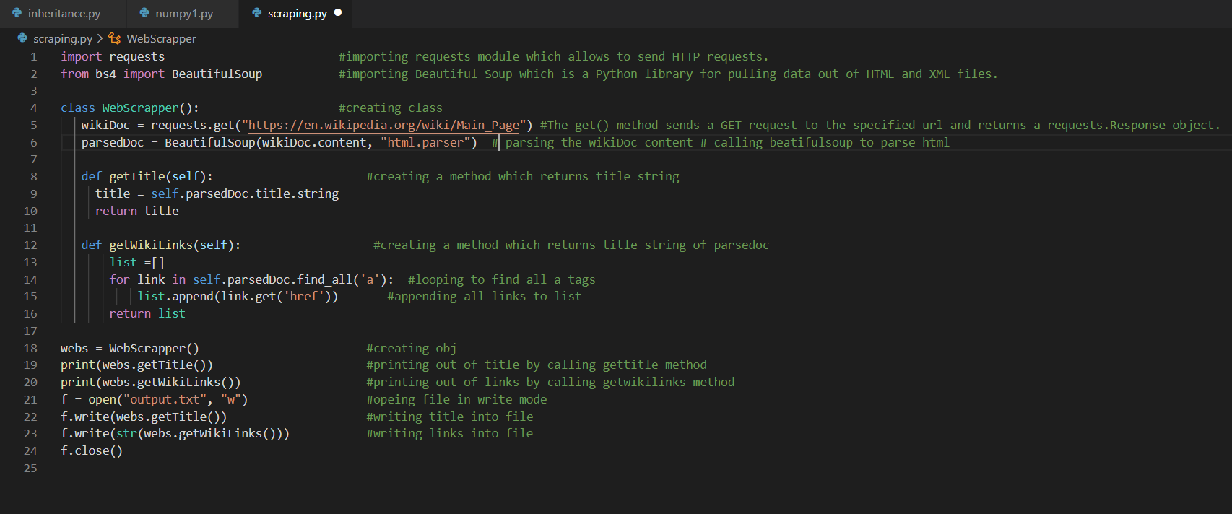

Output:

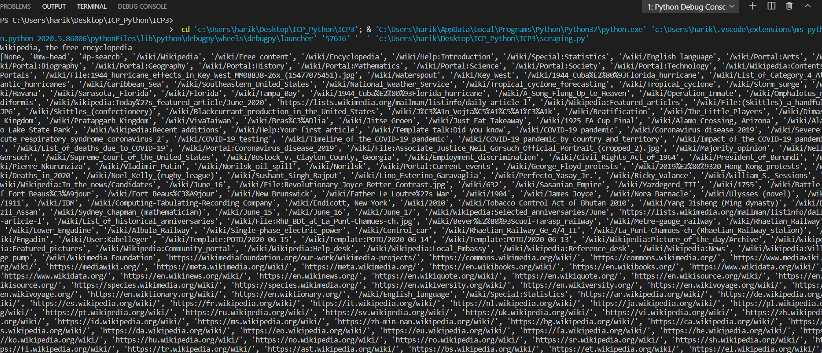

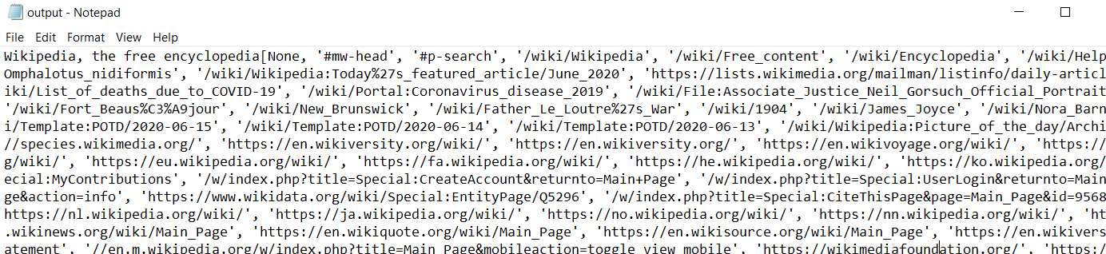

1. NumpyUsing NumPy create random vector of size 20having only floatin the range 1-20. Then reshape the array to 4by 5Then replace the max in each row by 0(axis=1)(you can NOT implement it via for loop)

Code:

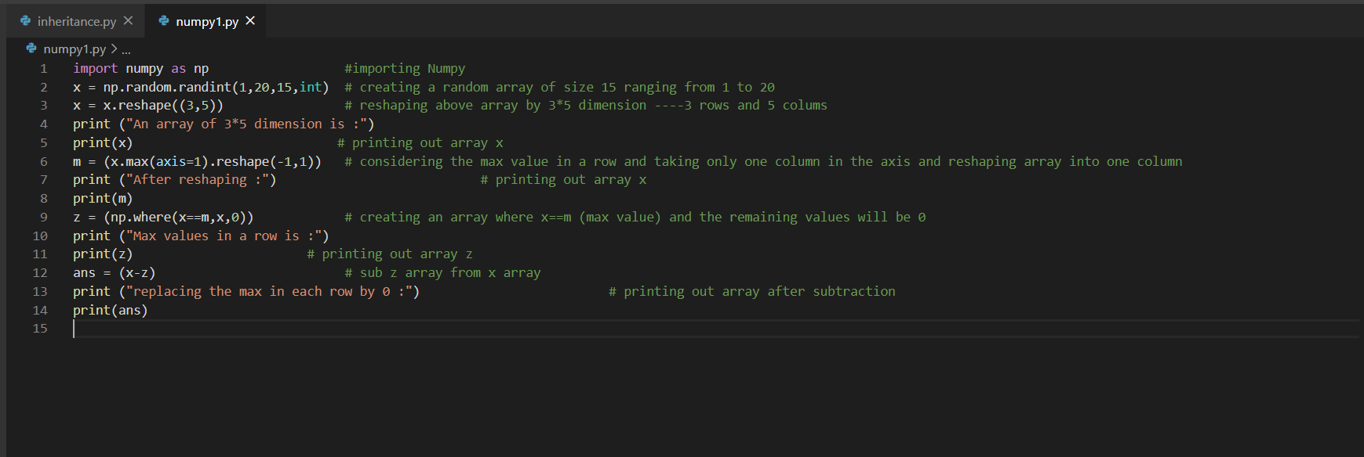

Output :

