STUDENT PERFORMANCE ANALYTICS SYSTEM
Submitted by: Harika Sumana
Course: Python with AI
Organization: EWB Courses
1. Project Objective
The objective of this project is to develop a Python-based Student Performance Analytics System that analyzes student marks and attendance. It calculates total and average marks, assigns grades, identifies pass/fail students, analyzes subject-wise performance, and identifies top-performing students.
2. Technologies Used
- Python
- NumPy
- Pandas
- CSV dataset
3. Dataset Description
The project uses a CSV dataset containing 20 fictional student records. Each record includes Student ID, Name, Department, Python marks, Mathematics marks, AI marks, and Attendance.
4. Implementation
- Created a CSV dataset containing 20 student records.
- Loaded the dataset using Pandas.
- Checked required columns and validated marks and attendance.
- Used NumPy to calculate average marks.
- Created reusable functions for calculating totals, averages, grades, and results.
- Applied conditions and loops to determine pass/fail status.
- Calculated class performance statistics and subject-wise averages.
- Identified the top five students using average marks.
- Exported the analyzed data to student_analysis_results.csv.
5. Key Features
- Student dataset loading and validation.
- Total and average marks calculation.
- Automatic grade assignment.
- Pass/fail classification.
- Highest, lowest, and overall class average calculations.
- Subject-wise performance analysis.
- Top five student identification.
- CSV export of analysis results.
6. Grading and Pass/Fail Rules
Grades are assigned according to the student's average marks:
- A+: 90–100
- A: 80–89.99
- B: 70–79.99
- C: 60–69.99
- D: 50–59.99
- F: Below 50
A student passes only if they score at least 40 marks in every subject.
7. Output and Screenshots
The program displays the student dataset, individual student results, class summary, subject-wise averages, and top five performers.
Screenshots to insert:
- Screenshot 1: Complete student dataset displayed in the terminal.
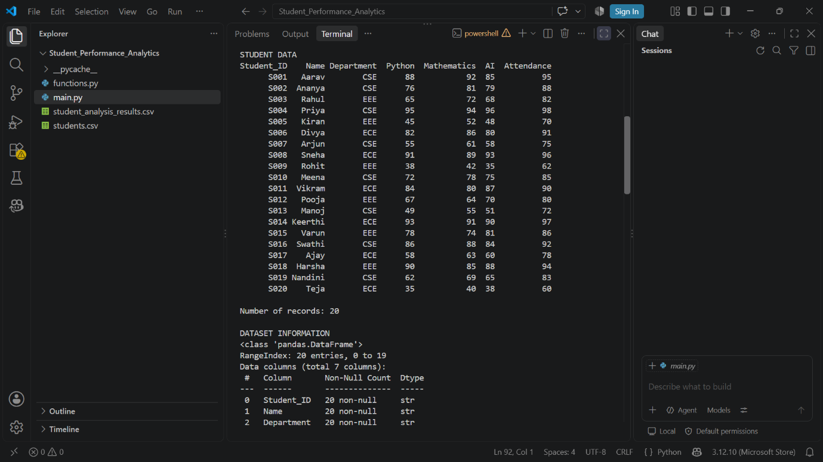
- Screenshot 2: Student results showing total marks, averages, grades, and pass/fail status.

- Screenshot 3: Class summary and subject-wise analysis.
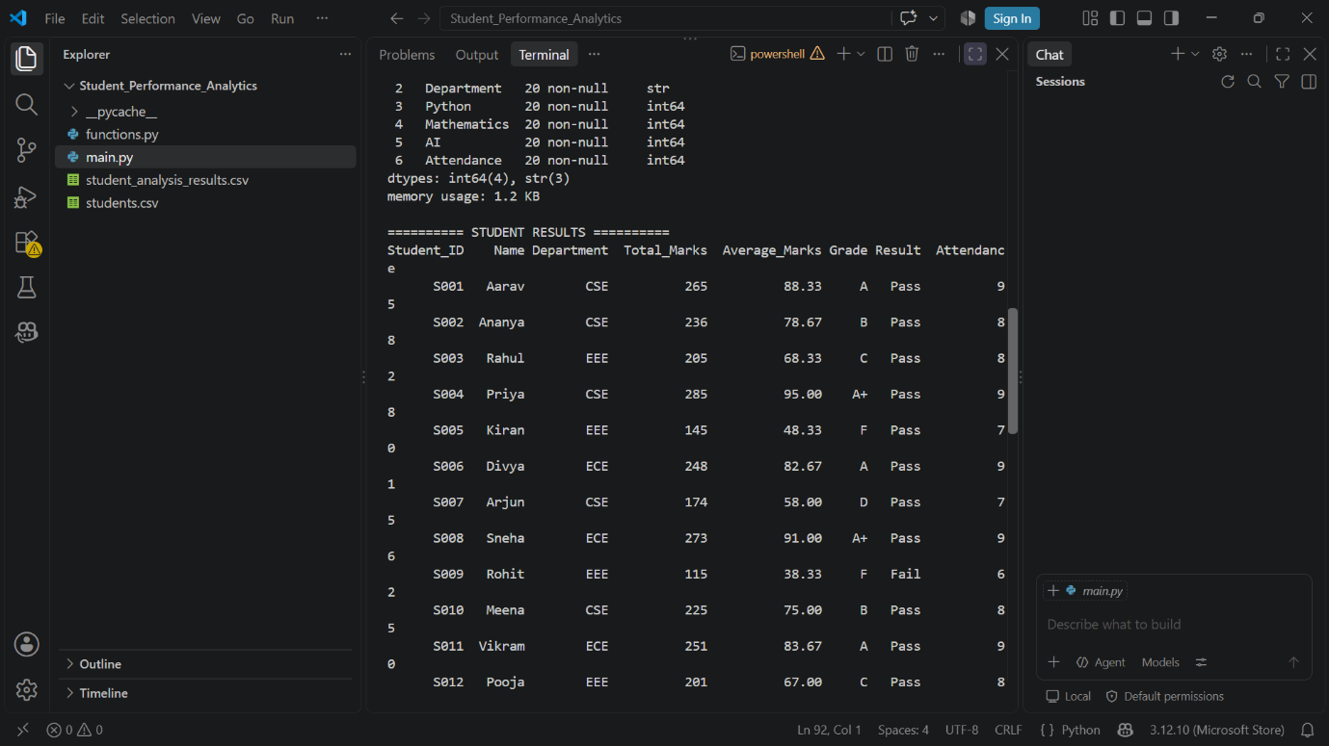

- Screenshot 4: Top five performers and successful CSV export.
8. Final Outcome
The project successfully demonstrates how Python, NumPy, and Pandas can be used to process student data and generate useful academic performance insights. It produces an analyzed CSV file and helps identify overall and subject-wise performance.
9. Challenges and Learning Outcomes
This project helped me understand CSV file handling, Pandas DataFrames, NumPy numerical calculations, functions, loops, conditional statements, data validation, and exporting analysis results. I also learned how to organize a Python project into multiple files.
10. GitHub Repository
Repository URL: https://github.com/HarikaKalangi23/student-performance-analytics

