A Real-Time (or) Field-based Research Project Report on

AUTOMATED CONTROL SYSTEM FOR AIR POLLUTION DETECTION IN VEHICLES

submitted in partial fulfilment of the requirements for the award of THE degree

of

Bachelor of Technology in

COMPUTER SCIENCE AND ENGINEERING

By M.SRUJANA [227R1A05G0] T.ANITHA [227R1A05K0]

V. HARIKANTH GOUD [227R1A05K1]

Under the guidance of

P. Rashmitha

(Assistant Professor)



DEPARTMENT OF COMPUTER SCIENCE AND ENGINEERING CMR TECHNICAL CAMPUS

UGC AUTONOMOUS

Accredited by NBA & NAAC with ‘A’ Grade Approved by AICTE, New Delhi and JNTUH Hyderabad

Kandlakoya (V), Medchal Road, Hyderabad – 501401 2022-2026

# DEPARTMENT OF COMPUTER SCIENCE AND ENGINEERING CERTIFICATE

This is to certify that the Real-Time (or) Field-based Research Project Report entitled “**AUTOMATED CONTROL SYSTEM FOR AIR POLLUTION DETECTION IN VEHICLES** ” being submitted by **M.SRUJANA (227R1A05G0) T.ANITHA (227R1A05K0) V.HARIKANTH GOUD**

**(227R1A05K1)** in partial fulfilment of the requirements for the award of the degree of Bachelor of Technology in **COMPUTER SCIENCE AND ENGINEERING** to the **Jawaharlal Nehru Technological University, Hyderabad** is a record of Bonafede work carried out by them under my guidance and supervision during the Academic Year 2023 – 24.

The results embodied in this thesis have not been submitted to any other University or Institute for the award of any other degree or diploma.

P.Rashmitha Dr. K. Srujan Raju

#### Assistant Professor Head of the Department

Dr. A. Raji Reddy

**Director**

# ABSTRACT

Vehicles have become an integral part of everyone's life. As we know that a coin has two sides that have their own effects, one of the main side effects is air pollution. Every vehicle is having emission but the problem occurs when it is beyond the standardized level. This emission from vehicles cannot be completely avoided but, it definitely controlled. Now a day accident is a common feature of deaths. The common feature of accidents will be rash driving, drunk and driving, due to minor drivers etc. Rash driving is a nature of driver which causes panic in the traffic and finally leads to accidents. These are critical things to control so we aim to develop a system that reduce rash driving. As a solution to the above problems we aim to build an automated control system for air pollution detection and rash driving prevention in vehicles. This emission of hazards gases can be control by the evolvement of semi- conductor sensor system. Sensors in the system detect the level of pollution gases along with level of ethanol in driver’s breath & indicate it on the display. If the pollution level goes beyond the threshold level the microcontroller alerts the buzzer and displays pollution level on LCD. At the same time, microcontroller activates the timer that indicates vehicle will be stopped after predefined time if appropriate action is not taken by driver. When timer run-out, the vehicle will be get stop due to the fuel supply to engine get stop. For that a relay circuit is used. The GSM sends the alert SMS at registered mobile number with vehicle current location using GPS in the latitude & longitude values.

# TABLE OF CONTENTS

CHAPTER 1: Introduction

* 1. Introduction to Embedded systems
  2. Classification
  3. Other common parts found on many Embedded system
  4. Design process

CHAPTER 2: Literature survey CHAPTER 3: THEORY

* 1. Structure of Arduino
  2. Features
  3. AVR CPU core
  4. Arduino characteristics

CHAPTER 4: Analysis and Design

* 1. Hardware Components
     1. LCD
     2. Regulated power supply
     3. LED
  2. Block diagram
  3. Working
  4. Software description
     1. Arduino software
     2. launch and blink!

CHAPTER 5: Implementation

CHAPTER 6: Testing and debugging/result CHAPTER 7: CONCLUSION

CHAPTER 8: REFERENCE/BIBLIOGRAPHY

CHAPTER 9: APPENDICES

# CHAPTER 1. INTRODUCTION

## 1.1. Introduction EMBEDDED SYSTEMS

### INTRODUCTION TO EMBEDDED SYSTEMS

Many embedded systems have substantially different design constraints than desktop computing applications. No single characterization applies to the diverse spectrum of embedded systems. However, some combination of cost pressure, long life-cycle, real -time requirements, reliability requirements, and design culture dysfunction can make it difficult to be successful applying traditional computer design methodologies and tools to embedded applications. Embedded systems in many cases must be optimized for life-cycle and business-driven factors rather than for maximum computing throughput. There is currently little tool support for expanding embedded computer design to the scope of holistic embedded system design. However, knowing the strengths and weaknesses of current approaches can set expectations appropriately, identify risk areas to tool adopters, and suggest ways in which tool builders can meet industrial needs. If we look around us, today we see numerous appliances which we use daily, be it our refrigerator, the microwave oven, cars, PDAs etc. Most appliances today are powered by something beneath the sheath that makes them do what they do. These are tiny microprocessors, which respond to various keystrokes or inputs. These tiny microprocessors, working on basic assembly languages, are the heart of the appliances. We call them embedded systems. Of all the semiconductor industries, the embedded systems market place is the most conservative, and engineering decisions here usually lean towards established, low risk solutions. Welcome to the world of embedded systems, of computers that will not look like computers and won’t function like anything we are familiar with.

### CLASSIFICATION

Embedded systems are divided into autonomous, real-time, networked & mobile categories.

#### Autonomous systems

They function in standalone mode. Many embedded systems used for process control in manufacturing units& automobiles fall under this category.

#### Real-time embedded systems

These are required to carry out specific tasks in a specified amount of time. These systems are extensively used to carry out time critical tasks in process control.

#### Networked embedded systems

They monitor plant parameters such as temperature, pressure and humidity and send the data over the network to a centralized system for on line monitoring.

#### Mobile gadgets

Mobile gadgets need to store databases locally in their memory. These gadgets imbibe powerful computing & communication capabilities to perform real-time as well as nonrealtime tasks and handle multimedia applications. The embedded system is a combination of computer hardware, software, firmware and perhaps additional mechanical parts, designed to perform a specific function. A good example is an automatic washing machine or a microwave oven. Such a system is in direct contrast to a personal computer, which is not designed to do only a specific task. But an embedded system is designed to do a specific task with in a given timeframe, repeatedly, endlessly, with or without human interaction.

#### Hardware

Good software design in embedded systems stems from a good understanding of the hardware behind it. All embedded systems need a microprocessor, and the kinds of microprocessors used in them are quite varied. A list of some of the common microprocessor’s families are: ARM family, The Zilog Z8 family, Intel 8051/X86 family, Motorola 68K family and the power PC family. For processing of information and execution of programs, embedded system incorporates microprocessor or micro- controller. In an embedded system the microprocessor is a part of final product and is not available for reprogramming to the end user. An embedded system also needs memory for two purposes, to store its program and to store its data. Unlike normal desktops in which data and programs are stored at the same place, embedded systems store data and programs in different memories. This is simply because the embedded system does not have a hard drive and the program must be stored in memory even when the power is turned off. This type of memory is called ROM. Embedded applications commonly employ a special type of ROM that can be programmed or reprogrammed with the help of special devices.

### OTHER COMMON PARTS FOUND ON MANY EMBEDDED SYSTEMS

* + - UART& RS232
    - PLD
    - ASIC’s& FPGA’s
    - Watch dog timer etc.

### DESIGN PROCESS

Embedded system design is a quantitative job. The pillars of the system design methodology are the separation between function and architecture, is an essential step from conception to implementation. In recent past, the search and industrial community has paid significant attention to the topic of hardware-software (HW/SW) codesign and has tackled the problem of coordinating the design of the parts to be implemented as software and the parts to be implemented as hardware avoiding the HW/SW integration problem marred the electronics system industry so long. In any large-scale embedded systems design methodology, concurrency must be considered as a first-class citizen at all levels of

abstraction and in both hardware and software. Formal models & transformations in system design are used so that verification and synthesis can be applied to advantage in the design methodology. Simulation tools are used for exploring the design space for validating the functional and timing behaviours of embedded systems. Hardware can be simulated at different levels such as electrical circuits, logic gates, RTL etc. using VHDL description. In some environments software development tools can be coupled with hardware simulators, while in others the software is executed on the simulated hardware. The later approach is feasible only for small parts of embedded systems. Design of an embedded system using Intel’s 80C188EB chip is shown in the figure. In order to reduce complexity, the design process is divided in four major steps: specification, system synthesis, implementation synthesis and performance evaluation of the prototype.

### SPECIFICATION

During this part of the design process, the informal requirements of the analysis are transformed to formal specification using SDL.

### SYSTEM-SYNTHESIS

For performing an automatic HW/SW partitioning, the system synthesis step translates the SDL specification to an internal system model switch contains problem graph& architecture graph. After system synthesis, the resulting system model is translated back to SDL.

### IMPLEMENTATION-SYNTHESIS

SDL specification is then translated into conventional implementation languages such as VHDL for hardware modules and C for software parts of the system.

### PROTOTYPING

On a prototyping platform, the implementation of the system under development is executed with the software parts running on multiprocessor unit and the hardware part running on a FPGA board known as phoenix, prototype hardware for Embedded Network Interconnect Accelerators.

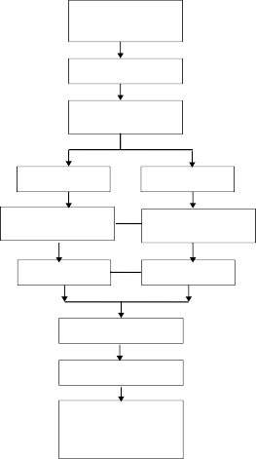

Requirement analysis

Specification

System

H/w design

S/w design

H/w

implementation

S/w

implementation

H/w testing

S/w testing

System integration

System validation

Operation Maintenance Evolution

**Fig: Embedded Development Life Cycle**

### APPLICATIONS

Embedded systems are finding their way into robotic toys and electronic pets, intelligent cars and remote controllable home appliances. All the major toy makers across the world have been coming out with advanced interactive toys that can become our friends for life. ‘Furby’ and ‘AIBO’ are good examples at this kind. Furies have a distinct life cycle just like human beings, starting from being a baby and growing to an adult one. In AIBO first two letters stand for Artificial Intelligence. Next two letters represent robot. The AIBO is robotic dog. Embedded systems in cars also known as Telematic Systems are used to provide navigational security communication & entertainment services using GPS, satellite. Home appliances are going the embedded way. LG electronics digital DIOS refrigerator can be used for surfing the net, checking e-mail, making video phone calls and watching TV.IBM is developing an air conditioner that we can control over the net. Embedded systems cover such a broad range of products that generalization is difficult. Here are some broad categories.

* + - **Aerospace and defiance electronics:** Fire control, radar, robotics/sensors, sonar.
    - **Automotive:** Autobody electronics, auto power train, auto safety, car information systems.
    - **Broadcast & entertainment:** Analog and digital sound products, camaras, DVDs, Set top boxes, virtual reality systems, graphic products.
    - **Consumer/internet appliances:** Business handheld computers, business network computers/terminals, electronic books, internet smart handheld devices, PDAs.
    - **Data communications:** Analog modems, ATM switches, cable modems, XDSL modems, Ethernet switches, concentrators.
    - **Digital imaging:** Copiers, digital still cameras, Fax machines, printers, scanners.
    - **Industrial measurement and control:** Hydro electric utility research & management traffic management systems, train marine vessel management systems.
    - **Medical electronics:** Diagnostic devices, real time medical imaging systems, surgical devices, critical care systems.
    - **Server I/O**: Embedded servers, enterprise PC servers, PCI LAN/NIC controllers, RAID devices, SCSI devices.
    - **Telecommunications:** ATM communication products, base stations, networking switches, SONET/SDH cross connect, multiplexer.
    - **Mobile data infrastructures:** Mobile data terminals, pagers, VSATs, Wireless LANs, Wireless phones.

# CHAPTER 2: LITERATURE SURVEY

The integration of MEMS technology with gesture recognition represents a significant advancement in communication aids for the hearing impaired. MEMS-based systems offer a compact and efficient solution, leveraging advantages such as small form factor, low power consumption, and high accuracy. Recent advancements in MEMS technology, particularly in inertial sensors like accelerometers and gyroscopes, have enabled precise capture of hand movements and orientations, forming the foundation for gesture recognition algorithms.

State-of-the-art techniques, including deep learning algorithms such as CNNs and RNNs, have shown promising results in accurately interpreting hand gestures. Despite these advancements, challenges such as variability in gestures, environmental noise, and user adaptation persist. However, these challenges present opportunities for further research and development in optimizing sensor configurations, enhancing algorithm robustness, and integrating feedback mechanisms for improved user interaction.

# CHAPTER 3: THEORY

### 3.2 ARUDINO

The Arduino is a family of microcontroller boards to simplify electronic design, prototyping and experimenting for artists, hackers, hobbyists, but also many professionals. People use it as brains for their robots, to build new digital music instruments, or to build a system that lets your house plants tweet you when they’re dry. Arduinos (we use the standard Arduino Uno) are built around an AT mega microcontroller — essentially a complete computer with CPU, RAM, Flash memory, and input/output pins, all on a single chip. Unlike, say, a Raspberry Pi, it’s designed to attach all kinds of sensors, LEDs, small motors and speakers, servos, etc. directly to these pins, which can read in or output digital or analog voltages between 0 and 5 volts. The Arduino connects to your computer via USB, where you program it in a simple language (C/C++, similar to Java) from inside the free Arduino IDE by uploading your compiled code to the board. Once programmed, the Arduino can run with the USB link back to your computer, or stand-alone without it — no keyboard or screen needed, just power.

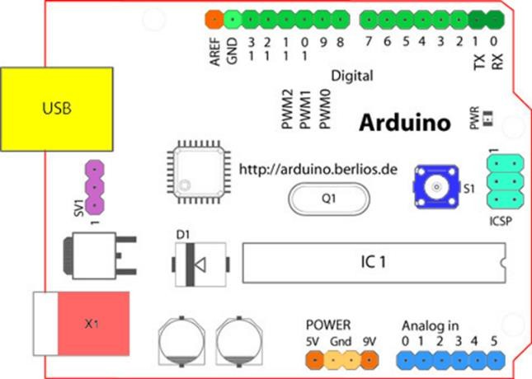

#### Fig: Structure of Arduino Board

Looking at the board from the top down, this is an outline of what you will see (parts of the board you might interact with in the course of normal use are highlighted)

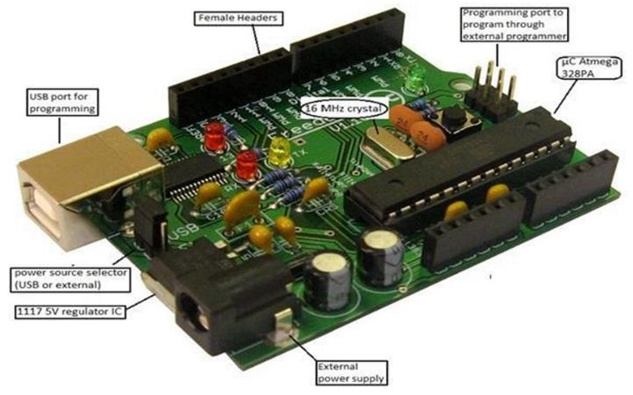

#### Fig: Arduino Board

Starting clockwise from the top centre:

* Analog Reference pin (orange)
* Digital Ground (light green)
* Digital Pins 2-13 (green)
* Digital Pins 0-1/Serial In/Out - TX/RX (dark green) - These pins cannot be used for digital I/O (Digital Read and Digital Write) if you are also using serial communication (e.g. Serial. Begin).
* Reset Button - S1 (dark blue)
* In-circuit Serial Programmer (blue-green)
* Analog In Pins 0-5 (light blue)

### DIGITAL PINS

* Power and Ground Pins (power: orange, grounds: light orange)
* External Power Supply In (9-12VDC) - X1 (pink)
* Toggles External Power and USB Power (place jumper on two pins closest to desired supply) - SV1 (purple)
* USB (used for uploading sketches to the board and for serial communication between the board and the computer; can be used to power the board) (yellow)

In addition to the specific functions listed below, the digital pins on an Arduino board can be used for general purpose input and output via the pin Mode (), Digital Read (), and Digital Write () commands. Each pin has an internal pull-up resistor which can be turned on and off using digital Write () (w/ a value of HIGH or LOW, respectively) when the pin is configured as an input. The maximum current per pin is 40mA.

* + **Serial: 0 (RX) and 1 (TX).** Used to receive (RX) and transmit (TX) TTL serial data. On the Arduino Diecimila, these pins are connected to the corresponding pins of the FTDI USB-to-TTL Serial chip. On the Arduino BT, they are connected to the corresponding pins of the WT11 Bluetooth module. On the Arduino Mini and Lilypad Arduino, they are intended for use with an external TTL serial module (e.g. the Mini-USB Adapter).
  + **External Interrupts: 2 and 3**. These pins can be configured to trigger an interrupt on a low value, a rising or falling edge, or a change in value. See the attach Interrupt () function for details.
  + **PWM**: 3, 5, 6, 9, 10, and 11 Provide 8-bit PWM output with the analog Write () function. On boards with an ATmega8, PWM output is available only on pins 9, 10, and 11.
  + **BT Reset: 7**. (Arduino BT-only) Connected to the reset line of the Bluetooth module.
  + **SPI: 10 (SS), 11 (MOSI), 12 (MISO), 13 (SCK).** These pins support SPI

communication, which, although provided by the underlying hardware, is not currently included in the Arduino language.

* + **LED: 13.** On the Diecimila and Lilypad, there is a built-in LED connected to digital pin 13. When the pin is HIGH value, the LED is on, when the pin is LOW, it's off.

### ANALOG PINS

In addition to the specific functions listed below, the analog input pins support 10-bit analog-to-digital conversion (ADC) using the analog Read () function. Most of the analog inputs can also be used as digital pins: analog input 0 as digital pin 14 through analog input 5 as digital pin 19. Analog inputs 6 and 7 (present on the Mini and BT) cannot be used as digital pins.

* I2C: 4 (SDA) and 5 (SCL). Support I2C (TWI) communication using the Wire library (documentation on the Wiring website).

### POWER PINS

* **VIN (sometimes labelled "9V"):** The input voltage to the Arduino board when it's using an external power source (as opposed to 5 volts from the USB connection or other regulated power source). You can supply voltage through this pin, or, if supplying voltage via the power jack, access it through this pin. Also note that the Lily Pad has no VIN pin and accepts only a regulated input.
* **5V:** The regulated power supply used to power the microcontroller and other components on the board. This can come either from VIN via an on-board regulator, or be supplied by USB or another regulated 5V supply.
* **3V3 (Diecimila-only):** A 3.3-volt supply generated by the on-board FTDI chip.
* **GND:** Ground pins.

### OTHER PINS

* **AREF:** Reference voltage for the analog inputs. Used with analog Reference ().
* **Reset:** (Diecimila-only) Bring this line LOW to reset the microcontroller. Typically used to add a reset button to shields which block the one on the board.

### ATMEGA328

Pin diagram

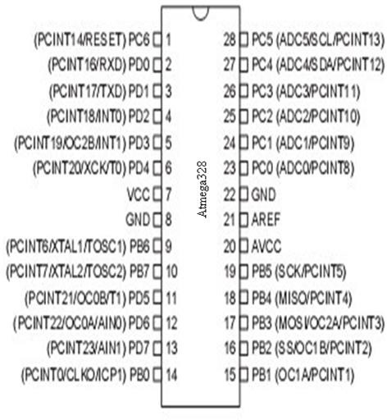

#### Fig: Pin Configuration of Atmega328

**Pin Description**

**VCC:** Digital supply voltage.

**GND:** Ground.

#### Port A (PA7-PA0):

Port A serves as the analog inputs to the A/D Converter. Port A also serves as an 8-bit bi-directional I/O port, if the A/D Converter is not used. Port pins can provide internal pull-up resistors (selected for each bit). The Port A output buffers have symmetrical drive characteristics with both high sink and source capability. When pins PA0 to PA7 are used as inputs and are externally pulled low, they will source current if the internal pull-up resistors are activated. The Port A pins are tri-stated when a reset condition becomes active, even if the clock is not running.

#### Port B (PB7-PB0):

Port B is an 8-bit bi-directional I/O port with internal pull-up resistors (selected for each bit). The Port B output buffers have symmetrical drive characteristics with both high sink and source capability. As inputs, Port B pins that are externally pulled low will source current if the pull-up resistors are activated. The Port B pins are tri-stated when a reset condition becomes active, even if the clock is not running. Port B also serves the functions of various special features of the ATmega32.

#### Port C (PC7-PC0):

Port C is an 8-bit bi-directional I/O port with internal pull-up resistors (selected for each bit). The Port C output buffers have symmetrical drive characteristics with both high sink and source capability. As inputs, Port C pins that are externally pulled low will source current if the pull-up resistors are activated. The Port C pins are tri-stated when a reset condition becomes active, even if the clock is not running. If the JTAG interface is enabled, the pull-up resistors on pins PC5(TDI), PC3(TMS) and PC2(TCK) will be activated even if a reset occurs. The TD0 pin is tri-stated unless TAP states that shift out data are entered. Port C also serves the functions of the JTAG interface.

#### Port D (PD7-PD0):

Port D is an 8-bit bi-directional I/O port with internal pull-up resistors (selected for each bit). The Port D output buffers have symmetrical drive characteristics with both high sink and source capability. As inputs, Port D pins that are externally pulled low will source current if the pull-up resistors are activated. The Port D pins are tri-stated when a reset condition becomes active, even if the clock is not running. Port D also serves the functions of various special features of the ATmega32.

#### Reset (Reset Input):

A low level on this pin for longer than the minimum pulse length will generate a reset, even if the clock is not running. Shorter pulses are not guaranteed to generate a reset.

### XTAL1:

Input to the inverting Oscillator amplifier and input to the internal clock operating circuit.

### XTAL2:

Output from the inverting Oscillator amplifier.

### AVCC:

AVCC is the supply voltage pin for Port A and the A/D Converter. It should be externally connected to VCC, even if the ADC is not used. If the ADC is used, it should be connected to VCC through a low- pass filter.

### FEATURES

* 1.8-5.5V operating range
* Up to 20MHz
* Part: ATMEGA328P-AU
* 32kB Flash program memory
* 1kB EEPROM
* 2kB Internal SRAM
* 2 8-bit Timer/Counters
* 16-bit Timer/Counter
* RTC with separate oscillator
* 6 PWM Channels
* 8 Channel 10-bit ADC
* Serial USART
* Master/Slave SPI interface
* 2-wire (I2C) interface
* Watchdog timer
* Analog comparator
* 23 IO lines
* Data retention: 20 years at 85C/ 100 years at 25C
* Digital I/O Pins are 14 (out of which 6 provide PWM output)
* Analog Input Pins are 6.
* DC Current per I/O is 40 mA
* DC Current for 3.3V Pin is 50mA

### AVR CPU CORE

The AVR core combines a rich instruction set with 32 general purpose working registers. All the 32 registers are directly connected to the Arithmetic Logic Unit (ALU), allowing two independent registers to be accessed in one single instruction executed in one clock cycle. The resulting architecture is more code efficient while achieving throughputs up to ten times faster than conventional CISC microcontrollers.

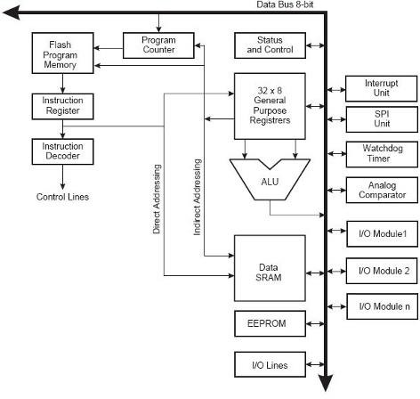

**Fig: Block Diagram**

### OVERVIEW

This section discusses the AVR core architecture in general. The main function of the CPU core is to ensure correct program execution. The CPU must therefore be able to access memories, perform calculations, control peripherals, and handle interrupts.

#### Fig: AVR core architecture

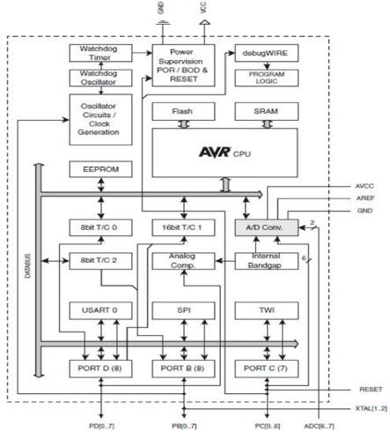

In order to maximize performance and parallelism, the AVR uses a Harvard architecture – with separate memories and buses for program and data. Instructions in the program memory are executed with a single level pipelining. While one instruction is being executed, the next instruction is pre-fetched from the program memory. This concept enables instructions to be executed in every clock cycle. The program memory is In-System Reprogrammable Flash memory. The fast-access Register File contains 32 x 8-bit general purpose working registers with a single clock cycle access time. This allows single- cycle Arithmetic Logic Unit (ALU) operation. In a typical ALU operation, two operands are output from the Register File, the operation is executed, and the result is stored back in the Register File– in one clock cycle.

Six of the 32 registers can be used as three 16-bit indirect address register pointers for Data Space addressing – enabling efficient address calculations. One of these address pointers can also be used as an address pointer for look up tables in Flash program memory. These added function

registers are the 16-bit X-, Y-, and Z-register, described later in this section. The ALU supports arithmetic and logic operations between registers or between a constant and a register. Single register operations can also be executed in the ALU. After an arithmetic operation, the Status Register is updated to reflect information about the result of the operation. Program flow is provided by conditional and unconditional jump and call instructions, able to directly address the whole address space. Most AVR instructions have a single 16-bit word format. Every program memory address contains a 16- or 32-bit instruction. Program Flash memory space is divided in two sections, the Boot Program section and the Application Program section. Both sections have dedicated Lock bits for write and read/write protection. The SPM instruction that writes into the Application Flash memory section must reside in the Boot Program section. During interrupts and subroutine calls, the return address Program Counter (PC) is stored on the Stack. The Stack is effectively allocated in the general data SRAM, and consequently the Stack size is only limited by the total SRAM size and the usage of the SRAM. All user programs must initialize the SP in the Reset routine (before subroutines or interrupts are executed). The Stack Pointer (SP) is read/write accessible in the I/O space. The data SRAM can easily be accessed through the five different addressing modes supported in the AVR architecture.

The memory spaces in the AVR architecture are all linear and regular memory maps. A flexible interrupt module has its control registers in the I/O space with an additional Global Interrupt Enable bit in the Status Register. All interrupts have a separate Interrupt Vector in the Interrupt Vector table. The interrupts have priority in accordance with their Interrupt Vector position. The lower the Interrupt Vector address, the higher the priority.

### ALU – ARITHMETIC LOGIC UNIT

The high-performance AVR ALU operates in direct connection with all the 32 general purpose working registers. Within a single clock cycle, arithmetic operations between general purpose registers or between a register and an immediate are executed. The ALU operations are divided into three main categories – arithmetic, logical, and bit functions. Some implementations of the architecture also provide a powerful multiplier supporting both signed/unsigned multiplication and fractional format. See the “Instruction Set” section for a detailed description.

### STATUS REGISTER

The Status Register contains information about the result of the most recently executed arithmetic instruction. This information can be used for altering program flow in order to perform conditional operations. Note that the Status Register is updated after all ALU operations, as specified in the Instruction Set Reference. This will in many cases remove the need for using the dedicated compare instructions, resulting in faster and more compact code. The Status Register is not automatically stored when entering an interrupt routine and restored when returning from an interrupt. This must be handled by software.

The AVR Status Register – SREG is defined as:

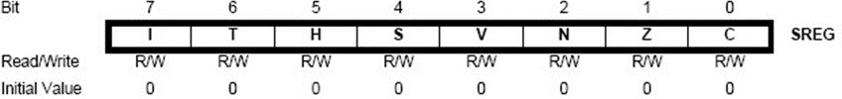

#### Fig: AVR status register

**Bit 7 – I: Global Interrupt Enable**

The Global Interrupt Enable bit must be set for the interrupts to be enabled. The individual interrupt enable control The Global Interrupt Enable bit must be set for the interrupts to be enabled. The individual interrupt enable control is then performed in separate control registers. If the Global Interrupt Enable Register is cleared, none of the interrupts are enabled independent of the individual interrupt enable settings. The I-bit is cleared by hardware after an interrupt has occurred, and is set by the RETI instruction to enable subsequent interrupts. The I-bit can also be set and cleared by the application with the SEI and CLI instructions, as described in the instruction set reference.

#### Bit 6 – T: Bit Copy Storage

The Bit Copy instructions BLD (Bit Load) and BST (Bit Store) use the T-bit as source or destination for the operated bit. A bit from a register in the Register File can be copied into T by the BST instruction, and a bit in T can be copied into a bit in a register in the Register File by the BLD instruction.

#### Bit 5 – H: Half Carry Flag

The Half Carry Flag H indicates a Half Carry in some arithmetic operations The Half Carry Flag H indicates a Half Carry in some arithmetic operations. Half Carry Is useful in BCD arithmetic. See the “Instruction Set Description” for detailed information.

#### Bit 4 – S: Sign Bit, S = N V

The S-bit is always an exclusive or between the Negative Flag N and the Two’s Complement Overflow Flag V. See the “Instruction Set Description” for detailed information.

**Bit 3 – V:** Two’s Complement Overflow Flag

The Two’s Complement Overflow Flag V supports two’s complement arithmetic.

**Bit 2 – N:** Negative Flag

The Negative Flag N indicates a negative result in an arithmetic or logic operation.

**Bit 1 – Z:** Zero Flag

The Zero Flag Z indicates a zero result in an arithmetic or logic operation.

**Bit 0 – C:** Carry Flag

The Carry Flag C indicates a carry in an arithmetic or logic operation.

### STACK POINTER

The Stack is mainly used for storing temporary data, for storing local variables and for storing return addresses after interrupts and subroutine calls. Note that the Stack is implemented as growing from higher to lower memory locations. The Stack Pointer Register always points to the top of the Stack. The Stack Pointer points to the data SRAM Stack area where the Subroutine and Interrupt Stacks are located. A Stack PUSH command will decrease the Stack Pointer.

The Stack in the data SRAM must be defined by the program before any subroutine calls are executed or interrupts are enabled. Initial Stack Pointer value equals the last address of the internal SRAM and the Stack Pointer must be set to point above start of the SRAM

#### Table 2.1 Stack Pointer instructions

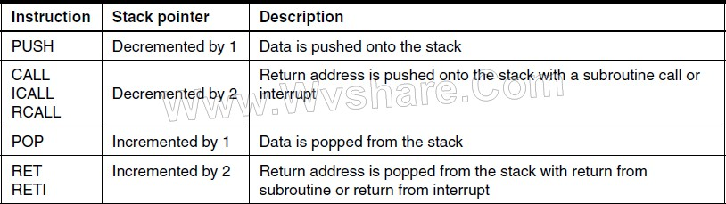

The AVR ATmega128A Stack Pointer is implemented as two 8-bit registers in the I/O space. The number of bits actually used is implementation dependent. Note that the data space in some

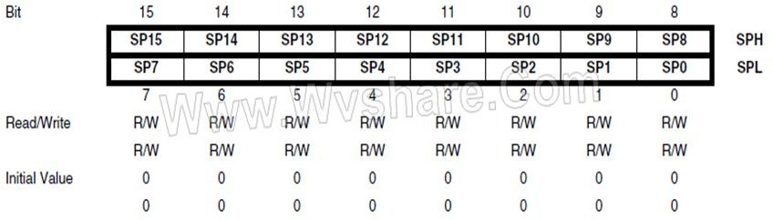

Fig: SPH and SPL - Stack Pointer High and Low Register

implementations of the AVR architecture is so small that only SPL is needed. In this case, the SPH Register will not be presents and SPL - Stack Pointer High and Low Register.

### INTERRUPT RESPONSE TIME

The interrupt execution response for all the enabled AVR interrupts is four clock cycles minimum. After four clock cycles the program vector address for the actual interrupt handling routine is executed. During this four-clock cycle period, the Program Counter is pushed onto the Stack. The vector is normally a jump to the interrupt routine, and this jump takes three clock cycles. If an interrupt occurs during execution of a multi-cycle instruction, this instruction is completed before the interrupt is served. If an interrupt occurs when the MCU is in sleep mode, the interrupt execution response time is

#### Arduino with ATmega328

The Arduino Uno is a microcontroller board based on the ATmega328 (datasheet). It has 14 digital input/output pins (of which 6 can be used as PWM outputs), 6 analog inputs, a 16 MHz ceramic resonator, a USB connection, a power jack, an ICSP header, and a reset button. It contains everything needed to support the microcontroller; simply connect it to a computer with a USB cable or power it with a AC-to-DC adapter or battery to get started.

The Uno differs from all preceding boards in that it does not use the FTDI USB-to-serial driver chip. Instead, it features the Atmega16U2 (Atmega8U2 up to versionR2) programmed as a USB- to-serial converter**.**

* **Pin out**: Added SDA and SCL pins that are near to the AREF pin and two other new pins placed near to the RESET pin, the IOREF that allow the shields to adapt to the voltage provided from the board. In future, shields will be compatible with both the board that uses the AVR, which operates with 5V and with the Arduino. Due that operates with 3.3V. The second one is a not connected pin that is reserved for future purposes.

#### Stronger RESET circuit.

* **At mega 16U2 replace the 8U2.**

"Uno" means one in Italian and is named to mark the upcoming release of Arduino 1.0. The Uno and version 1.0 will be the reference versions of Arduino, moving forward. The Uno is the latest in a series of USB Arduino boards, and the reference model for the Arduino platform; for a comparison with previous versions, see the index of Arduino boards.

#### Arduino Characteristics Power

The Arduino Uno can be powered via the USB connection or with an external power supply. The power source is selected automatically. External (non-USB) power can come either from an AC- to-DC adapter (wall-wart) or battery. The adapter can be connected by plugging a 2.1mm centre- positive plug into the board's power jack. Leads from a battery can be inserted in the GND and Vin pin headers of the POWER connector. The board can operate on an external supply of 6 to 20 volts. If supplied with less than 7V, however, the 5V pin may supply less than five volts and the board may be unstable. If using more than 12V, the voltage regulator may overheat and damage the board. The recommended range is 7 to 12 volts.

#### The power pins are as follows:

* **VIN:** The input voltage to the Arduino board when it's using an external power source (as opposed to 5 volts from the USB connection or other regulated power source). You can supply voltage through this pin, or, if supplying voltage via the power jack, access it through this pin.
* **5V:** This pin outputs a regulated 5V from the regulator on the board. The board can be supplied with power either from the DC power jack (7 - 12V), the USB connector (5V), or

the VIN pin of the board (7-12V). Supplying voltage via the 5V or 3.3V pins bypasses the regulator, and can damage your board. We don't advise it.

* **3V3.** A 3.3-volt supply generated by the on-board regulator. Maximum current draw is 50 mA.
* **GND**. Ground pins.
* **IOREF**. This pin on the Arduino board provides the voltage reference with which the microcontroller operates. A properly configured shield can read the IOREF pin voltage and select the appropriate power source or enable voltage translators on the outputs for working with the 5V or 3.3V.

#### Memory:

The ATmega328 has 32 KB (with 0.5 KB used for the boot loader). It also has 2 KB of SRAM and 1 KB of EEPROM (which can be read and written with the EEPROM library).

#### Serial Communication:

The Arduino Uno has a number of facilities for communicating with a computer, another Arduino, or other microcontrollers. The ATmega328 provides UART TTL (5V) serial communication, which is available on digital pins 0 (RX) and 1 (TX). An ATmega16U2 on the board channels this serial communication over USB and appears as a virtual com port to software on the computer. The '16U2 firmware uses the standard USB COM drivers, and no external driver is needed. However, on Windows, a .inf file is required. The Arduino software includes a serial monitor which allows simple textual data to be sent to and from the Arduino board. The RX and TX LEDs on the board will flash when data is being transmitted via the USB-to-serial chip and USB connection to the computer (but not for serial communication on pins 0 and 1).

A Software Serial library allows for serial communication on any of the Uno's digital pins. The ATmega328 also supports I2C (TWI) and SPI communication. The Arduino software includes a Wire library to simplify use of the I2C bus. For SPI communication, use the SPI library.

# CHAPTER 4: ANALYSIS AND DESIGN

## HARDWARE COMPONENTS

#### LCD (Liquid Cristal Display) Introduction:

A liquid crystal display (LCD) is a thin, flat display device made up of any number of color or monochrome pixels arrayed in front of a light source or reflector. Each pixel consists of a column of liquid crystal molecules suspended between two transparent electrodes, and two polarizing filters, the axes of polarity of which are perpendicular to each other. Without the liquid crystals between them, light passing through one would be blocked by the other. The liquid crystal twists the polarization of light entering one filter to allow it to pass through the other.

A program must interact with the outside world using input and output devices that communicate directly with a human being. One of the most common devices attached to a controller is an LCD display. Some of the most common LCDs connected to the controllers are 16X1, 16x2 and 20x2 displays. This means 16 characters per line by 1 line 16 characters per line by 2 lines and 20 characters per line by 2 lines, respectively.

#### Shapes and S

**available. Line lengths of 8, 16, 20, 24, 32 and 40 characters are all standard, in one, two**

Many microcontroller devices use 'smart LCD' displays to output visual information. LCD displays designed around LCD NT-C1611 module, are inexpensive, easy to use, and it is even possible to produce a readout using the 5X7 dots plus cursor of the display. They have a standard ASCII set of characters and mathematical symbols. For an 8-bit data bus, the display requires a +5V supply plus 10 I/O lines (RS RW D7 D6 D5 D4 D3 D2 D1 D0). For a 4-bit data bus it only requires the supply lines plus 6 extra lines (RS RW D7 D6 D5 D4). When the LCD display is not enabled, data lines are tri-state and they do not interfere with the operation of the microcontroller.

#### Features:

* + - 1. Interface with either 4-bit or 8-bit microprocessor.
      2. Display data RAM
      3. 80x8 bits (80 characters).
      4. Character generator ROM.
      5. 160 different 5 x7 dot-matrix character patterns.
      6. Character generator RAM.
      7. 8 different users programmed 5 x7 dot-matrix patterns.
      8. Display data RAM and character generator RAM may be accessed by the microprocessor.
      9. Numerous instructions.
      10. Clear Display, Cursor Home, Display ON/OFF, Cursor ON/OFF, blink Character, Cursor Shift, Display Shift.
      11. Built-in reset circuit is triggered at power ON.
      12. Built-in oscillator.

**Power supply for lcd driving:**

### PIN DESCRIPTION:

Most LCDs with 1 controller have 14 Pins and LCDs with 2 controllers has 16 Pins (two pins are extra in both for back-light LED connections).

**Fig: pin diagram of 1x16 lines lcd**

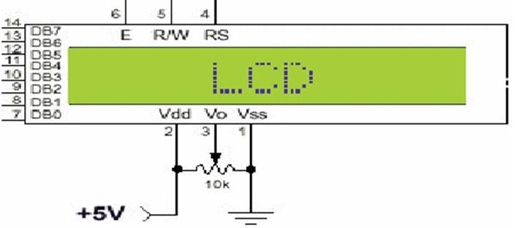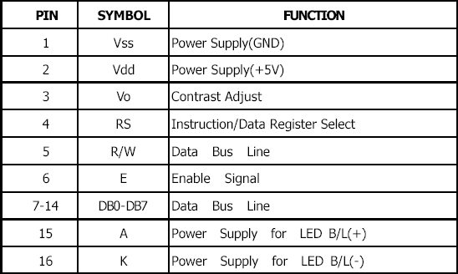

### CONTROL LINES:

**EN:**

Line is called "Enable." This control line is used to tell the LCD that you are sending it data. To send data to the LCD, your program should make sure this line is low (0) and then set the other two control

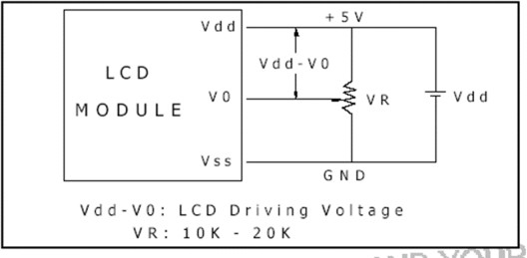

lines and/or put data on the data bus. When the other lines are completely ready, bring EN high (1) and wait for the minimum amount of time required by the LCD datasheet (this varies from LCD to LCD), and end by bringing it low (0) again.

### RS:

Line is the "Register Select" line. When RS is low (0), the data is to be treated as a command or special instruction (such as clear screen, position cursor, etc.). When RS is high (1), the data being sent is text data which should be displayed on the screen. For example, to display the letter "T" on the screen you would set RS high.

### RW:

Line is the "Read/Write" control line. When RW is low (0), the information on the data bus is being written to the LCD. When RW is high (1), the program is effectively querying (or reading) the LCD. Only one instruction ("Get LCD status") is a read command. All others are writing commands, so RW will almost always be low.

Finally, the data bus consists of 4 or 8 lines (depending on the mode of operation selected by the user). In the case of an 8-bit data bus, the lines are referred to as DB0, DB1, DB2, DB3, DB4, DB5, DB6, and DB7.

#### Logic status on control lines:

* E - 0 Access to LCD disabled
* 1 Access to LCD enabled
* R/W - 0 Writing data to LCD
* 1 Reading data from LCD
* RS - 0 Instructions

-1 Character

#### Writing data to the LCD:

1. Set R/W bit to low
2. Set RS bit to logic 0 or 1 (instruction or character)
3. Set data to data lines (if it is writing)
4. Set E line to high
5. Set E line to low

#### Read data from data lines (if it is reading) on LCD:

1. Set R/W bit to high
2. Set RS bit to logic 0 or 1 (instruction or character)
3. Set data to data lines (if it is writing)
4. Set E line to high
5. Set E line to low

#### Entering Text:

First, a little tip: it is manually a lot easier to enter characters and commands in hexadecimal rather than binary (although, of course, you will need to translate commands from binary couple of sub- miniature hexadecimal rotary switches is a simple matter, although a little bit into hex so that you know which bits you are setting). Replacing the D.I.L. switch pack with a of re-wiring is necessary.

The switches must be the type where On = 0, so that when they are turned to the zero position, all four outputs are shorted to the common pin, and in position “F”, all four outputs are open circuit.

All the available characters that are built into the module are shown in Table 3. Studying the table, you will see that codes associated with the characters are quoted in binary and hexadecimal, most significant bits (“left-hand” four bits) across the top, and least significant bits (“right-hand” four bits) down the left.

Most of the characters conform to the ASCII standard, although the Japanese and Greek characters (and a few other things) are obvious exceptions. Since these intelligent modules were designed in the “Land of the Rising Sun,” it seems only fair that their Katakana phonetic symbols should also be incorporated. The more extensive Kanji character set, which the Japanese share with the Chinese, consisting of several thousand different characters, is not included!

Using the switches, of whatever type, and referring to Table 3, enter a few characters onto the display, both letters and numbers. The RS switch (S10) must be “up” (logic 1) when sending the characters, and switch E (S9) must be pressed for each of them. Thus, the operational order is: set RS high, enter character, trigger E, leave RS high, enter another character, trigger E, and so on.

The first 16 codes in Table 3, 00000000 to 00001111, ($00 to $0F) refer to the CGRAM. This is the Character Generator RAM (random access memory), which can be used to hold user-defined graphics characters.

#### Transformers:

A transformer is a device that transfers electrical energy from one circuit to another through inductively coupled conductors without changing its frequency. A varying current in the first or primary winding creates a varying magnetic flux in the transformer's core, and thus a varying magnetic field through the secondary winding. This varying magnetic field induces a varying electromotive force (EMF) or "voltage" in the secondary winding. This effect is called mutual induction.

If a load is connected to the secondary, an electric current will flow in the secondary winding and electrical energy will be transferred from the primary circuit through the transformer to the load. This field is made up from lines of force and has the same shape as a bar magnet.

If the current is increased, the lines of force move outwards from the coil. If the current is reduced, the lines of force move inwards.

If another coil is placed adjacent to the first coil, then, as the field moves out or in, the moving lines of force will "cut" the turns of the second coil. As it does this, a voltage is induced in the second coil. With the 50 Hz AC mains supply, this will happen 50 times a second. This is called MUTUAL INDUCTION and forms the basis of the transformer.

The input coil is called the PRIMARY WINDING; the output coil is the SECONDARY WINDING. Fig: 3.3.4 shows step-down transformer.

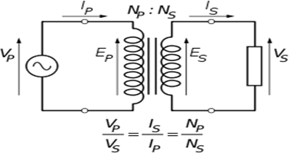

#### Fig: Step-Down Transformer

The voltage induced in the secondary is determined by the TURNS RATIO**.**



For example, if the secondary has half the primary turns; the secondary will have half the primary voltage.

Another example is if the primary has 5000 turns and the secondary has 500 turns, then the turn’s ratio is 10:1.

If the primary voltage is 240 volts, then the secondary voltage will be x 10 smaller = 24 volts. Assuming a perfect transformer, the power provided by the primary must equal the power taken by a load on the secondary. If a 24-watt lamp is connected across a 24-volt secondary, then the primary must supply 24 watts.

To aid magnetic coupling between primary and secondary, the coils are wound on a metal CORE. Since the primary would induce power, called EDDY CURRENTS, into this core, the core is LAMINATED. This means that it is made up from metal sheets insulated from each other. Transformers to work at higher frequencies have an iron dust core or no core at all.

Note that the transformer only works on AC, which has a constantly changing current and moving field. DC has a steady current and therefore a steady field and there would be no induction.

Some transformers have an electrostatic screen between primary and secondary. This is to prevent some types of interference being fed from the equipment down into the mains supply, or in the other direction. Transformers are sometimes used for IMPEDANCE MATCHING.

We can use the transformers as step up or step down.

#### Step Up transformer:

In case of step-up transformer, primary windings are every less compared to secondary winding.

Because of having more turns secondary winding accepts more energy, and it releases more voltage at the output side.

#### Step down transformer:

In case of step-down transformer, Primary winding induces more flux than the secondary winding, and secondary winding is having a smaller number of turns because of that it accepts a smaller number of fluxes, and releases less amount of voltage.

#### Battery power supply:

A battery is a type of linear power supply that offers benefits that traditional line-operated power supplies lack: mobility, portability and reliability. A battery consists of multiple electrochemical cells connected to provide the voltage desired.

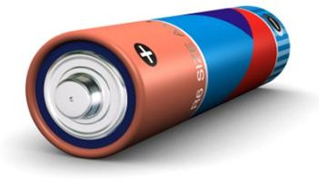

#### Fig: Hi-Watt 9V Battery

The most commonly used dry-cell battery is the carbon-zinc dry cell battery. Dry-cell batteries are made by stacking a carbon plate, a layer of electrolyte paste, and a zinc plate alternately until the desired total voltage is achieved. The most common dry-cell batteries have one of the following voltages: 1.5, 3, 6, 9, 22.5, 45, and 90. During the discharge of a carbon-zinc battery, the zinc metal is converted to a zinc salt in the electrolyte, and magnesium dioxide is reduced at the carbon electrode. These actions establish a voltage of approximately 1.5 V.

The lead-acid storage battery may be used. This battery is rechargeable; it consists of lead and lead/dioxide electrodes which are immersed in sulfuric acid. When fully charged, this type of battery has a 2.06-2.14 V potential (A 12-volt car battery uses 6 cells in series). During discharge, the lead is converted to lead sulphate and the sulfuric acid is converted to water. When the battery is charging, the lead sulphate is converted back to lead and lead dioxide A nickel-cadmium battery has become more popular in recent years. This battery cell is completely sealed and rechargeable. The electrolyte is not involved in the electrode reaction, making the voltage constant over the span of the batteries long service life. During the charging process, nickel oxide is oxidized to its higher oxidation state and cadmium oxide is reduced. The nickel-cadmium batteries have many benefits. They can be stored both charged and uncharged. They have a long service life, high current availabilities, constant voltage, and the ability to be recharged.

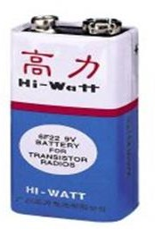

#### Fig: Pencil Battery of 1.5V

**Step 2: Rectification**

The process of converting an alternating current to a pulsating direct current is called as rectification. For rectification purpose we use rectifiers.

#### Rectifiers:

A rectifier is an electrical device that converts alternating current (AC) to direct current (DC), a process known as rectification. Rectifiers have many uses including as components of power supplies and as detectors of radio signals. Rectifiers may be made of solid-state diodes, vacuum tube diodes, mercury arc valves, and other components.

A device that it can perform the opposite function (converting DC to AC) is known as an inverter.

When only one diode is used to rectify AC (by blocking the negative or positive portion of the waveform), the difference between the term diode and the term rectifier is merely one of usage, i.e., the term rectifier describes a diode that is being used to convert AC to DC. Almost all rectifiers comprise a number of diodes in a specific arrangement for more efficiently converting AC to DC than is possible with only one diode. Before the development of silicon semiconductor rectifiers, vacuum tube diodes and copper (I) oxide or selenium rectifier stacks were used.

#### Bridge full wave rectifier:

The Bridge rectifier circuit is shown in figure, which converts an ac voltage to dc voltage using both half cycles of the input ac voltage. The Bridge rectifier circuit is shown in the figure. The circuit has four diodes connected to form a bridge. The ac input voltage is applied to the diagonally opposite ends of the bridge. The load resistance is connected between the other two ends of the bridge.

For the positive half cycle of the input ac voltage, diodes D1 and D3 conduct, whereas diodes D2 and D4 remain in the OFF state. The conducting diodes will be in series with the load resistance RL and hence the load current flows through RL.

For the negative half cycle of the input ac voltage, diodes D2 and D4 conduct whereas, D1 and D3 remain OFF. The conducting diodes D2 and D4 will be in series with the load resistance RL and hence the current flows through RL in the same direction as in the previous half cycle. Thus, a bi-directional wave is converted into a unidirectional wave.

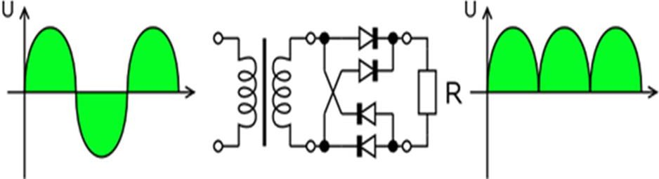

**Fig: Bridge rectifier: a full-wave rectifier using 4 diodes**

### DB107:

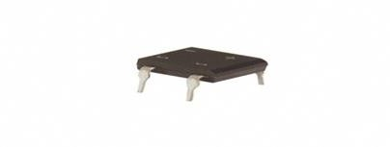

#### Fig: DB107

Now -a -days Bridge rectifier is available in IC with a number of DB107. In our project we are using an IC in place of bridge rectifier.

#### Features:

* Good for automation insertion
* Surge overload rating - 30 amperes peak
* Ideal for printed circuit board
* Reliable low-cost construction utilizing moulded
* Glass passivated device
* Polarity symbols moulded on body
* Mounting position: Any
* Weight: 1.0 gram

#### Step 3: Filtration:

The process of converting a pulsating direct current to a pure direct current using filters is called as filtration.

#### Filters:

Electronic filters are electronic circuits, which perform signal-processing functions, specifically to remove unwanted frequency components from the signal, to enhance wanted ones.

#### Introduction to Capacitors:

The Capacitor or sometimes referred to as a Condenser is a passive device, and one which stores energy in the form of an electrostatic field which produces a potential (static voltage) across its plates. In its basic form a capacitor consists of two parallel conductive plates that are not connected but are electrically separated either by air or by an insulating material called the Dielectric. When a voltage is applied to these plates, a current flows charging up the plates with electrons giving one plate a positive charge and the other plate an equal and opposite negative charge. This flow of electrons to the plates is known as the Charging Current and continues to flow until the voltage across the plates (and hence the capacitor) is equal to the applied voltage VCC. At this point the capacitor is said to be fully charged and this is illustrated below**.**

#### Units of Capacitance:

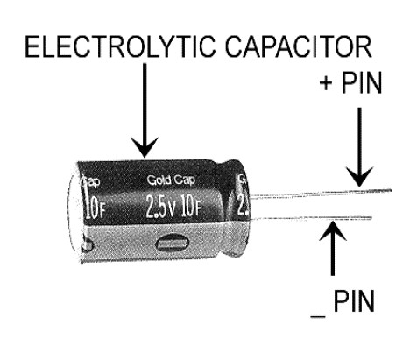Microfarad (μF) 1μF = 1/1,000,000 = 0.000001 = 10-6 F

Nano-farad (nF) 1nF = 1/1,000,000,000 = 0.000000001 = 10-9 F

Pico farad (pF) 1pF = 1/1,000,000,000,000 = 0.000000000001 = 10-12 F

#### Operation of Capacitor:

Think of water flowing through a pipe. If we imagine a capacitor as being a storage tank with an inlet and an outlet pipe, it is possible to show approximately how an electronic capacitor works.

First, let's consider the case of a "coupling capacitor" where the capacitor is used to connect a signal from one part of a circuit to another but without allowing any direct current to flow.

If the current flow is alternating between zero and a maximum, our "storage tank" capacitor will allow the current waves to pass through.

Resistors are elements of electrical networks and electronic circuits and are ubiquitous in most electronic equipment. Practical resistors can be made of various compounds and films, as well as resistance wire (wire made of a high-resistivity alloy, such as nickel/chrome).

The primary characteristics of a resistor are the resistance, the tolerance, maximum working voltage and the power rating. Other characteristics include temperature coefficient, noise, and inductance. Less well-known is critical resistance, the value below which power dissipation limits the maximum permitted current flow, and above which the limit is applied voltage. Critical resistance is determined by the design, materials and dimensions of the resistor.

Resistors can be made to control the flow of current, to work as Voltage dividers, to dissipate power and it can shape electrical waves when used in combination of other components. Basic unit is ohms.

#### Theory of operation:

**Ohm's law:**

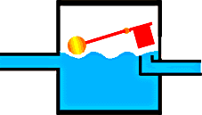The behaviour of an ideal resistor is dictated by the relationship specified in Ohm's law:

### V = IR

Ohm's law states that the voltage (V) across a resistor is proportional to the current (I) through it where the constant of proportionality is the resistance (R).

#### Power dissipation:

visible, ultraviolet and infrared wavelengths, with very high brightness. The internal structure and parts of a led are shown below.

#### Working:

The structure of the LED light is completely different than that of the light bulb. Amazingly, the LED has a simple and strong structure. The light-emitting semiconductor material is what determines the LED's colour. The LED is based on the semiconductor diode.

When a diode is forward biased (switched on), electrons are able to recombine with holes within the device, releasing energy in the form of photons. This effect is called electroluminescence and the colour of the light (corresponding to the energy of the photon) is determined by the energy gap of the semiconductor. An LED is usually small in area (less than 1 mm2), and integrated optical components are used to shape its radiation pattern and assist in reflection. LEDs present many advantages over incandescent light sources including lower energy consumption, longer lifetime, improved robustness, smaller size, faster switching, and greater durability and reliability. However, they are relatively expensive and require more precise current and heat management than traditional light sources. Current LED products for general lighting are more expensive to buy than fluorescent lamp sources of comparable output. They also enjoy use in applications as diverse as replacements for traditional light sources in automotive lighting (particularly indicators) and in traffic signals. The compact size of LEDs has allowed new text and video displays and sensors to be developed, while their high switching rates are useful in advanced communications technology. The electrical symbol and polarities of led are shown in fig:

LED lights have a variety of advantages over other light sources:

* High-levels of brightness and intensity
* High-efficiency
* Low-voltage and current requirements
* Low radiated heat
* High reliability (resistant to shock and vibration)
* No UV Rays
* Long source life
* Can be easily controlled and programmed Applications of LED fall into three major categories:
* Visual signal application where the light goes more or less directly from the LED to the human eye, to convey a message or meaning.
* Illumination where LED light is reflected from object to give visual response of these objects.
* Generate light for measuring and interacting with processes that do not involve the human visual system.

### SOFTWARE DESCRIPTION ARDUINO SOFTWARE:

The Arduino is a family of microcontroller boards to simplify electronic design, prototyping and experimenting for artists, hackers, hobbyists, but also many professionals. People use it as brains for their robots, to build new digital music instruments, or to build a system that lets your house plants tweet you when they’re dry. Arduinos (we use the standard Arduino Uno) are built around an AT mega microcontroller — essentially a complete computer with CPU, RAM, Flash memory, and input/output

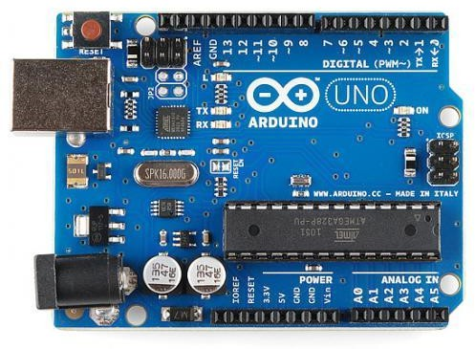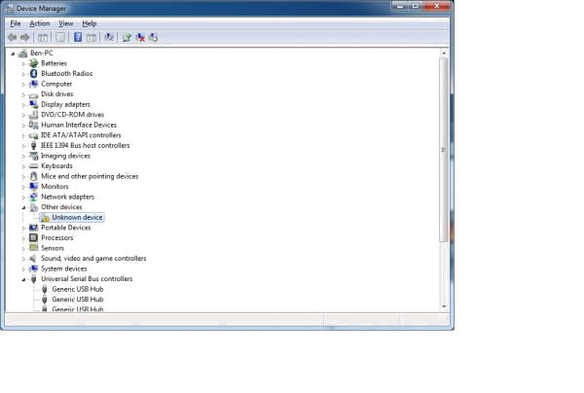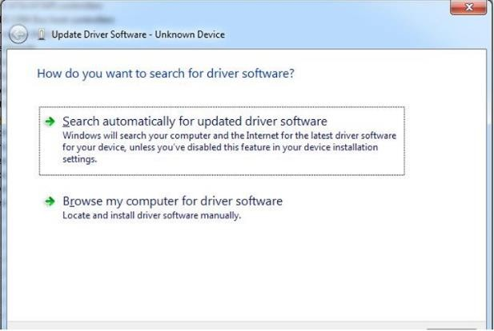

#### What you will need:

* + A computer (Windows, Mac, or Linux)
  + An Arduino-compatible microcontroller (anything from this guide should work).
  + A USB A-to-B cable, or another appropriate way to connect your Arduino-compatible microcontroller to your computer (check out this USB buying guide if you’re not sure which cable to get).
  + An Arduino Uno
  + Windows 7, Vista, and XP
  + Installing the Drivers for the Arduino Uno (from Arduino.cc)
  + Plug in your board and wait for Windows to begin its driver installation process After a few moments, the process will fail, despite its best efforts.
  + Click on the Start Menu, and open up the Control Panel.
  + While in the Control Panel, navigate to System and Security. Next, click on System Once the System window is up, open the Device Manager.
  + Look under Ports (COM & LPT). You should see an open port named “Arduino UNO (COMxx)”.
  + If there is no COM & LPT section, look under ‘Other Devices’ for ‘Unknown Device’.
  + Right click on the “Arduino UNO (COMxx)” or “Unknown Device” port and choose the “Update Driver Software” Opti Next, choose the “Browse my computer for Driver software” option.
  + Finally, navigate to and select the Uno’s driver file, named “ArduinoUNO.inf”, located in the “Drivers” folder of the Arduino Software download (not the “FTDI USB Drivers” sub- directory). If you cannot see the .inf file, it is probably just hidden. You can select the ‘drivers’ folder with the ‘search sub-folders’ option selected instead. Windows will finish up the driver installation

### LAUNCH AND BLINK!

After following the appropriate steps for your software install, we are now ready to test your first program with your Arduino board!

* + Launch the Arduino application.
  + If you disconnected your board, plug it back in.
  + Open the Blink example sketch by going to: File > Examples > 1. Basics > Blink.
  + Select the type of Arduino board you’re using: Tools > Board > your board type.
  + Select the serial/COM port that your Arduino is attached to: Tools > Port > COMxx

If you’re not sure which serial device is your Arduino, take a look at the available ports, then unplug your Arduino and look again. The one that disappeared is your Arduino.

With your Arduino board connected, and the Blink sketch open, press the ‘Upload’ button

After a second, you should see some LEDs flashing on your Arduino, followed by the message ‘Done Uploading’ in the status bar of the Blink sketch.

If everything worked, the onboard LED on your Arduino should now be blinking! You just programmed your first Arduino!

# CHAPTER 5: IMPLEMENTATION

#include <LiquidCrystal.h> #include <stdio.h>

LiquidCrystal lcd(6, 7, 5, 4, 3, 2); int co = 10;

int ign = 8; int motor = 9; int buzzer = 13; int tempc=0;

int hbtc=0,hbtc1=0,rtrl=0,rtr2=0;

int temps=0,hums=0,alcs=0,eyes=0,buttons=0; unsigned char rcv,count,gchr='x',gchr1='x',robos='s';

char rcvmsg[10],pastnumber[11]; char gpsval[50];

// char dataread[100] = "";

// char lt[15],ln[15]; int i=0,k=0,lop=0; int gps_status=0; float latitude=0; float logitude=0; String Speed=""; String gpsString="";

char *test="$GPRMC";

//int hbtc=0,hbtc1=0,rtrl=0;

unsigned char gv=0,msg1[10],msg2[11]; float lati=0,longi=0;

unsigned int lati1=0,longi1=0; unsigned char flat[5],flong[5]; unsigned char finallat[8],finallong[9]; int ii=0,rchkr=0;

String inputString = ""; // a string to hold incoming data boolean stringComplete = false; // whether the string is complete void okcheck(){

unsigned char rcr; do{

rcr = Serial.read();

}while(rcr == 'K');

}

void sound(){ digitalWrite(buzzer,LOW);delay(1500);digitalWrite(buzzer,HIGH);

}

void setup() {

Serial.begin(9600);//serialEvent();

digitalWrite(motor, LOW);digitalWrite(buzzer, HIGH); lcd.begin(16, 2);lcd.cursor();

lcd.print("Automated Control"); lcd.setCursor(0,1);

lcd.print(" Air Pollution"); delay(1500);

lcd.clear(); lcd.setCursor(0,0); lcd.print("CO:"); //3,0

}void loop() { if(digitalRead(co) == LOW) {

lcd.setCursor(3,0);lcd.print("ON "); digitalWrite(buzzer, LOW); }

if(digitalRead(co) == HIGH){ lcd.setCursor(3,0);lcd.print("OFF ");

digitalWrite(buzzer, HIGH); } if(digitalRead(ign) == LOW){

lcd.setCursor(0,1);lcd.print("Ign ON ");

}

if(digitalRead(ign) == HIGH){ lcd.setCursor(0,1);lcd.print("Ign OFF ");}

if(digitalRead(ign) == LOW && digitalRead(co) == HIGH){ digitalWrite(motor, HIGH); }

else{

digitalWrite(motor, LOW);} delay(100);

}

# CHAPTER 6: RESULT

According to this project we can implement system which intimates the CO exhausted from vehicle. By using this project, we can design a system to provide alert system for pollution of vehicle.

# CHAPTER 7: CONCLUSION

The structure of the LED light is completely different than that of the light bulb. Amazingly, the LED has a simple and strong structure. The light-emitting semiconductor material is what determines the LED's color. The LED is based on the semiconductor diode.

When a diode is forward biased (switched on), electrons are able to recombine with holes within the device, releasing energy in the form of photons. This effect is called electroluminescence and the color of the light (corresponding to the energy of the photon) is determined by the energy gap of the semiconductor. An LED is usually small in area (less than 1 mm2), and integrated optical components are used to shape its radiation pattern and assist in reflection. LEDs present many advantages over incandescent light sources including lower energy consumption, longer lifetime, improved robustness, smaller size, faster switching, and greater durability and reliability. However, they are relatively expensive and require more precise current and heat management than traditional light sources. Current LED products for general lighting are more expensive to buy than fluorescent lamp sources of comparable output. They also enjoy use in applications as diverse as replacements for traditional light sources in automotive lighting (particularly indicators) and in traffic signals. The compact size of LEDs has allowed new text and video displays and sensors to be developed, while their high switching rates are useful in advanced communications technology.

# CHAPTER 8: REFERENCES

[1] K. Galatsis, W. Wlodarsla, K. Kalantar-Zadeh and A. Trinchi, "Investigation of Gas Sensors for Vehicle Cabin Air Quality Monitoring”, vol 42, pp. 167-175, 2002. [2]. George F. Fine, Leon M. Cavanagh, Ayo Afonja and Russell Binions “Metal Oxide SemiConductor Gas Sensors in Environmental Monitoring", Sensors vol 10, issue 6, pp. 5469- 5502, June 2010. DOI: 10.3390/s100605469. [ 3]. Siva Shankar Chandrasekaran, Sudharshan Muthukumar and Sabeshkumar Rajendran, “Automated Control System for Air Pollution Detection in Vehicles,” 2013 4th International Conference on Intelligent Systems, Modelling and Simulation, IEEE 2166-0662, 2013. DOI: 10.1109/ISMS.2013.94. [4]. Anita Kulkarni, Ravi Teja, “Automated System for Air Pollution Detection and Control in Vehicles”, IJAREEIE, vol 3, issue 9, pp. 12196- 12200 September 2014. [5]. R. Al-Ali, Member, IEEE, Imran Zualkernan, and Fadi Aloul, “A Mobile GPRS-Sensors Array for Air Pollution Monitoring”, IEEE Sensors Journal, vol 10, issue 10, pp. 1666-1671, October 2010. [ 6]. Diego Mendez, Alfredo J. Perez, Miguel

A. Labrador, Juan Jose Marron, ―P-Sense: A Participatory Sensing System for Air Pollution Monitoring and Control‖, IEEE International Conference on PERCOM Workshops, pp. 344-347, March 2011. [ 7]. Amarakanth,

N. V. Uma Reddy, “Engine SelfTest With Air Pollution Detection and Remote. Information System”, IJRET, vol 3, special issue 3 May-2014. [8]. Drunken driving protection system International Journal of Scientific & Engineering Research vol 2, issue 12, December-2011. ISSN 2229- 5518.

# CHAPTER 9: APPENDICES

* **Technical Specifications**: Detailed specifications of the automated control system components, including sensors, actuators, controllers, and communication interfaces.
* **System Architecture Diagrams**: Diagrams illustrating the overall architecture of the control system, showing how different components interact and communicate.
* **Control Algorithms**: Detailed descriptions or pseudocode of the algorithms used for controlling emissions in different operating conditions (e.g., urban driving, highway driving).
* **Data Sheets**: Data sheets for key components used in the system, providing technical details such as performance characteristics, power requirements, and operational limits.
* **Testing and Validation Results**: Detailed results from testing and validation procedures conducted to ensure the effectiveness and reliability of the control system in reducing vehicle emissions.
* **User Interface Designs**: Mockups or screenshots of the user interface used for interacting with the control system, if applicable.
* **Cost Analysis**: Breakdown of costs associated with developing and implementing the automated control system, including hardware, software, and installation costs.
* **Regulatory Compliance Documentation**: Copies of relevant regulatory standards or certifications that the control system complies with, such as emissions standards or vehicle safety regulations.
* **Maintenance and Troubleshooting Guides**: Guides or documentation outlining recommended maintenance procedures and troubleshooting steps for the control system.
* **References**: A comprehensive list of all sources cited throughout the main document, including technical papers, standards, and manufacturer documentation.