IMDB_Hypertuning

Harika

2/4/2020

#Loading IMDB dataset from keras.

library(keras)

## Warning: package 'keras' was built under R version 3.6.2

imdb <- dataset_imdb(num_words = 10000)  
c(c(train_data, train_labels), c(test_data, test_labels)) %<-% imdb  
  
vectorize_sequences <- function(sequences, dimension = 10000) {  
 # Create an all-zero matrix of shape (len(sequences), dimension)  
 results <- matrix(0, nrow = length(sequences), ncol = dimension)  
 for (i in 1:length(sequences))  
 # Sets specific indices of results[i] to 1s  
 results[i, sequences[[i]]] <- 1  
 results  
}  
  
# Our vectorized training data  
train <- vectorize_sequences(train_data)  
# Our vectorized test data  
test <- vectorize_sequences(test_data)  
  
# Our vectorized labels  
train_label <- as.numeric(train_labels)  
test_label <- as.numeric(test_labels)

#Divide training set into train and validation set for validating purposes.

set.seed(123)  
val_indices <- 1:10000  
  
x_val <- train[val_indices,]  
x_train <-train[-val_indices,]  
  
y_val <- train_label[val_indices]  
y_train <- train_label[-val_indices]

#Model building (neural network) with initial model setting/parameters as layers=3,hidden units=16,activation functions as “relu”,Loss function “binary cross entropy” and optimizer as rmsprop.

initial_model <- keras_model_sequential() %>%   
 layer_dense(units = 16, activation = "relu", input_shape = c(10000)) %>%   
 layer_dense(units = 16, activation = "relu") %>%   
 layer_dense(units = 1, activation = "sigmoid")  
  
initial_model %>% compile(  
 optimizer = "rmsprop",  
 loss = "binary_crossentropy",  
 metrics = c("accuracy")  
)  
  
history <- initial_model %>% fit(  
 x_train, y_train,  
 epochs = 20,  
 batch_size = 512,  
 validation_data = list(x_val, y_val)  
)  
plot(history)

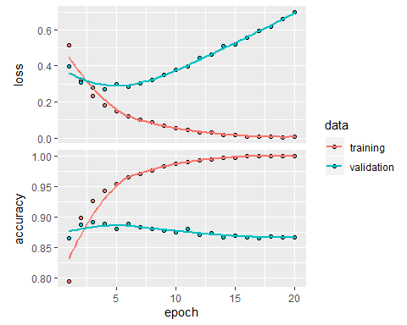

val <-initial_model %>% evaluate(x_val,y_val)  
val

## $loss  
## [1] 0.6973878  
##   
## $accuracy  
## [1] 0.8656

# Retrain the network  
  
initial_model <- keras_model_sequential() %>%   
 layer_dense(units = 16, activation = "relu", input_shape = c(10000)) %>%   
 layer_dense(units = 16, activation = "relu") %>%   
 layer_dense(units = 1, activation = "sigmoid")  
  
initial_model %>% compile(  
 optimizer = "rmsprop",  
 loss = "binary_crossentropy",  
 metrics = c("accuracy")  
)  
  
initial_model%>% fit(train, train_label, epochs = 4, batch_size = 512)  
results_initial <- initial_model %>% evaluate(test,test_label)  
results_initial

## $loss  
## [1] 0.2864298  
##   
## $accuracy  
## [1] 0.88564

#Different hidden units like 4,64,128

#Now lets start with hidden units as 4 and all other parameters are same as initial model

units4_model <- keras_model_sequential() %>%   
 layer_dense(units = 4, activation = "relu", input_shape = c(10000)) %>%   
 layer_dense(units = 4, activation = "relu") %>%   
 layer_dense(units = 1, activation = "sigmoid")  
  
units4_model %>% compile(  
 optimizer = "rmsprop",  
 loss = "binary_crossentropy",  
 metrics = c("accuracy")  
)  
history_4units <- units4_model %>% fit(  
 x_train, y_train,  
 epochs = 20,  
 batch_size = 512,  
 validation_data = list(x_val, y_val)  
)  
  
plot(history_4units)

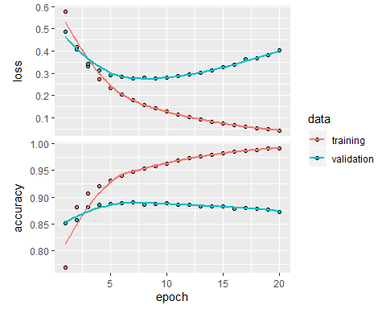

val <-units4_model %>% evaluate(x_val,y_val)  
val

## $loss  
## [1] 0.4024967  
##   
## $accuracy  
## [1] 0.8731

#Retrain the model  
  
units4_model <- keras_model_sequential() %>%   
 layer_dense(units = 4, activation = "relu", input_shape = c(10000)) %>%   
 layer_dense(units = 4, activation = "relu") %>%   
 layer_dense(units = 1, activation = "sigmoid")  
  
units4_model %>% compile(  
 optimizer = "rmsprop",  
 loss = "binary_crossentropy",  
 metrics = c("accuracy")  
)  
units4_model%>% fit(train, train_label, epochs = 2, batch_size = 512)  
results_units4 <- units4_model %>% evaluate(test,test_label)  
results_units4

## $loss  
## [1] 0.3954482  
##   
## $accuracy  
## [1] 0.87696

#Hidden units as 64 and remaining parameters same as initial model

units64_model <- keras_model_sequential() %>%   
 layer_dense(units = 64, activation = "relu", input_shape = c(10000)) %>%   
 layer_dense(units = 64, activation = "relu") %>%   
 layer_dense(units = 1, activation = "sigmoid")  
  
units64_model %>% compile(  
 optimizer = "rmsprop",  
 loss = "binary_crossentropy",  
 metrics = c("accuracy")  
)  
history_64units <- units64_model %>% fit(  
 x_train, y_train,  
 epochs = 20,  
 batch_size = 512,  
 validation_data = list(x_val, y_val)  
)  
  
plot(history_64units)

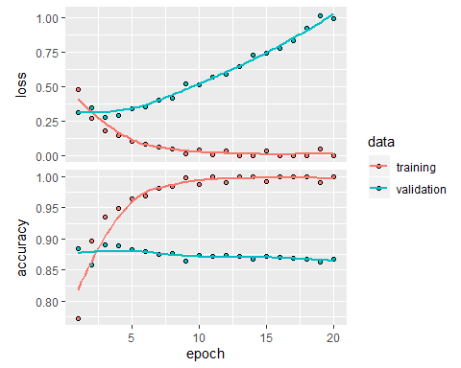

val <-units64_model %>% evaluate(x_val,y_val)  
val

## $loss  
## [1] 0.9896655  
##   
## $accuracy  
## [1] 0.8667

#Retrain the network  
  
units64_model <- keras_model_sequential() %>%   
 layer_dense(units = 64, activation = "relu", input_shape = c(10000)) %>%   
 layer_dense(units = 64, activation = "relu") %>%   
 layer_dense(units = 1, activation = "sigmoid")  
  
units64_model %>% compile(  
 optimizer = "rmsprop",  
 loss = "binary_crossentropy",  
 metrics = c("accuracy")  
)  
units64_model%>% fit(train, train_label, epochs = 4, batch_size = 512)  
results_units64 <- units64_model %>% evaluate(test,test_label)  
results_units64

## $loss  
## [1] 0.3193173  
##   
## $accuracy  
## [1] 0.87828

#Increase more hidden units like to 128.

units128_model <- keras_model_sequential() %>%   
 layer_dense(units = 128, activation = "relu", input_shape = c(10000)) %>%   
 layer_dense(units = 128, activation = "relu") %>%   
 layer_dense(units = 1, activation = "sigmoid")  
  
units128_model %>% compile(  
 optimizer = "rmsprop",  
 loss = "binary_crossentropy",  
 metrics = c("accuracy")  
)  
history_128units <- units128_model %>% fit(  
 x_train, y_train,  
 epochs = 20,  
 batch_size = 512,  
 validation_data = list(x_val, y_val)  
)  
  
plot(history_128units)

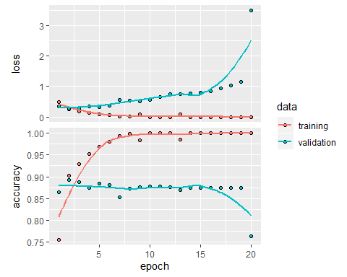

val <-units64_model %>% evaluate(x_val,y_val)  
val

## $loss  
## [1] 0.09586284  
##   
## $accuracy  
## [1] 0.9717

#Retrain the network  
  
units128_model <- keras_model_sequential() %>%   
 layer_dense(units = 128, activation = "relu", input_shape = c(10000)) %>%   
 layer_dense(units = 128, activation = "relu") %>%   
 layer_dense(units = 1, activation = "sigmoid")  
  
units128_model %>% compile(  
 optimizer = "rmsprop",  
 loss = "binary_crossentropy",  
 metrics = c("accuracy")  
)  
  
units128_model%>% fit(train, train_label, epochs = 4, batch_size = 512)  
results_units128 <- units128_model %>% evaluate(test,test_label)  
results_units128

## $loss  
## [1] 0.4395602  
##   
## $accuracy  
## [1] 0.84904

#Plotting different hidden units losses

library(ggplot2)  
library(tidyr)  
plot_val_losses <- function(losses) {  
 loss_names <- names(losses)  
 losses <- as.data.frame(losses)  
 losses$epoch <- seq_len(nrow(losses))  
 losses %>%   
 gather(model, loss, loss_names[[1]], loss_names[[2]],loss_names[[3]],loss_names[[4]]) %>%   
 ggplot(aes(x = epoch, y = loss)) +  
 geom_point(aes(colour = model))  
}  
plot_val_losses(losses = list(  
 initial_model = history$metrics$val_loss,  
 units4_model = history_4units$metrics$val_loss,  
 units64_model = history_64units$metrics$val_loss,  
 units128_model = history_128units$metrics$val_loss))

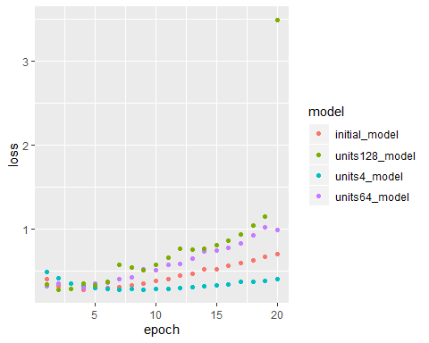 # smaller hidden units of 4 model starts slightly overfitting much later than initial model and when hidden units are increased to 64 or 128 the models overfits early like with 128 units loss is increased in third epoch itself.

#mse loss function

#Now changing loss function from binary cross entropy to “mse” and all other parameters as same.

mse_model <- keras_model_sequential() %>%   
 layer_dense(units = 16, activation = "relu", input_shape = c(10000)) %>%   
 layer_dense(units = 16, activation = "relu") %>%   
 layer_dense(units = 1, activation = "sigmoid")  
  
mse_model %>% compile(  
 optimizer = "rmsprop",  
 loss = "mse",  
 metrics = c("accuracy")  
)  
  
history_mse <- mse_model %>% fit(  
 x_train, y_train,  
 epochs = 20,  
 batch_size = 512,  
 validation_data = list(x_val, y_val)  
)  
  
plot(history_mse)

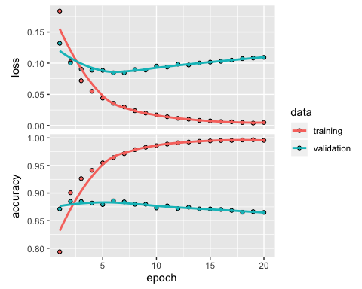

val <-mse_model %>% evaluate(x_val,y_val)  
val

## $loss  
## [1] 0.1092886  
##   
## $accuracy  
## [1] 0.8649

#Retrain the network  
mse_model <- keras_model_sequential() %>%   
 layer_dense(units = 16, activation = "relu", input_shape = c(10000)) %>%   
 layer_dense(units = 16, activation = "relu") %>%   
 layer_dense(units = 1, activation = "sigmoid")  
  
mse_model %>% compile(  
 optimizer = "rmsprop",  
 loss = "mse",  
 metrics = c("accuracy")  
)  
mse_model%>% fit(train, train_label, epochs = 4, batch_size = 512)  
results_mse <- mse_model %>% evaluate(test,test_label)  
results_mse

## $loss  
## [1] 0.08682205  
##   
## $accuracy  
## [1] 0.8818

#Using “mse” as loss function for IMDB dataset, loss value is low when compared to binary cross entropy. MSE is also good measure for data of form normal distribution. Let’s examine with an example If actual and predicted labels are same, then both loss functions give error as “0”. Actual label: 1 Predicted label: 1 MSE: (1 - 1) ² = 0 Cross-entropy: -(1 * log (1) + 0 * log (0)) = 0

Consider different scenario like Actual label: 1 Predicted label: 0 MSE: (1 - 1) ² = 1 Cross-entropy: -(1 * log (0) + 0 * log (1)) = tends to infinity Here “mse” loss function error is less compared to cross entropy loss function. Cross entropy strongly penalizes the misclassifications.

#Plots for loss and accuracy for initial model and mse model.

library(ggplot2)  
library(tidyr)  
  
plot_val_losses <- function(losses) {  
 loss_names <- names(losses)  
 losses <- as.data.frame(losses)  
 losses$epoch <- seq_len(nrow(losses))  
 losses %>%   
 gather(model, loss, loss_names[[1]], loss_names[[2]]) %>%   
 ggplot(aes(x = epoch, y = loss))+  
 geom_point(aes(colour = model))  
   
}  
plot_val_losses(losses = list(  
 initial_model = history$metrics$val_loss,  
 mse_model = history_mse$metrics$val_loss  
 ))

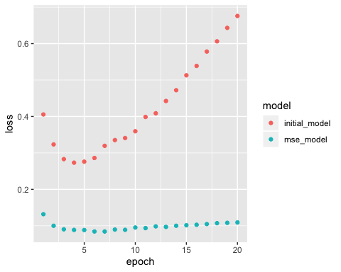

plot_val_accuracy <- function(accuracy) {  
 accuracy_names <- names(accuracy)  
 accuracy <- as.data.frame(accuracy)  
 accuracy$epoch <- seq_len(nrow(accuracy))  
 accuracy %>%   
 gather(model, accuracy, accuracy_names[[1]], accuracy_names[[2]]) %>%   
 ggplot(aes(x = epoch, y = accuracy))+  
 geom_point(aes(colour = model))  
}  
plot_val_accuracy(accuracy = list(  
 initial_model = history$metrics$val_accuracy,  
 mse_model = history_mse$metrics$val_accuracy  
 ))

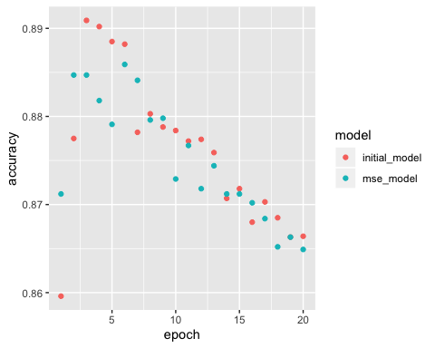

#In above graphs we can clearly notice that loss is less and accuracy is also same for mse as loss function model.

#tanh activation function

#Using tanh instead of ReLu activation function

tanh_model <- keras_model_sequential() %>%   
 layer_dense(units = 16, activation = "tanh", input_shape = c(10000)) %>%   
 layer_dense(units = 16, activation = "tanh") %>%   
 layer_dense(units = 1, activation = "sigmoid")  
  
tanh_model %>% compile(  
 optimizer = "rmsprop",  
 loss = "binary_crossentropy",  
 metrics = c("accuracy")  
)  
  
history_tanh <- tanh_model %>% fit(  
 x_train, y_train,  
 epochs = 20,  
 batch_size = 512,  
 validation_data = list(x_val, y_val)  
)  
  
plot(history_tanh)

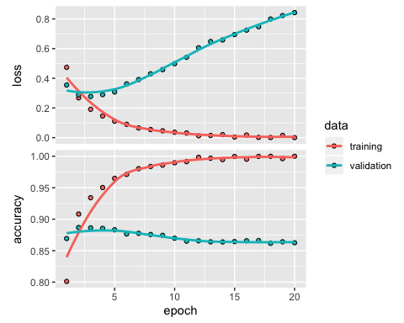

val <-tanh_model %>% evaluate(x_val,y_val)  
val

## $loss  
## [1] 0.8425935  
##   
## $accuracy  
## [1] 0.8626

#Retrain the network  
  
tanh_model <- keras_model_sequential() %>%   
 layer_dense(units = 16, activation = "tanh", input_shape = c(10000)) %>%   
 layer_dense(units = 16, activation = "tanh") %>%   
 layer_dense(units = 1, activation = "sigmoid")  
  
tanh_model %>% compile(  
 optimizer = "rmsprop",  
 loss = "binary_crossentropy",  
 metrics = c("accuracy")  
)  
tanh_model%>% fit(train, train_label, epochs = 4, batch_size = 512)  
results_tanh <- tanh_model %>% evaluate(test,test_label)  
results_tanh

## $loss  
## [1] 0.341305  
##   
## $accuracy  
## [1] 0.87036

#PLotting loss and accuracy

plot_val_losses(losses = list(  
 initial_model = history$metrics$val_loss,  
 tanh_model = history_tanh$metrics$val_loss  
 ))

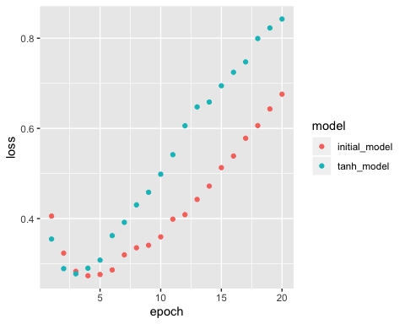

plot_val_accuracy(accuracy = list(  
 initial_model = history$metrics$val_accuracy,  
 tanh_model = history_tanh$metrics$val_accuracy  
 ))

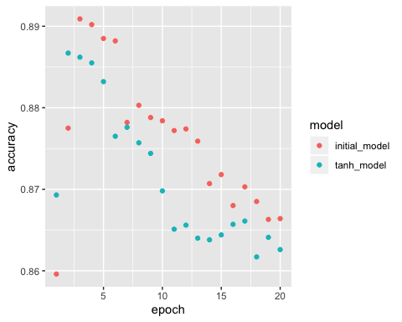

#The accuracy of tanh activation function for the model is low and also degrades performance due to vanishing gradient problem.

#L-1 regularization #L-1 norm regularization is cost added is proportional to the absolute values of weight coefficients.

L1_model <- keras_model_sequential() %>%   
 layer_dense(units = 16,kernel_regularizer = regularizer_l1(0.001), activation = "relu", input_shape = c(10000)) %>%   
 layer_dense(units = 16,kernel_regularizer = regularizer_l1(0.001), activation = "relu") %>%   
 layer_dense(units = 1, activation = "sigmoid")  
  
L1_model %>% compile(  
 optimizer = "rmsprop",  
 loss = "binary_crossentropy",  
 metrics = c("accuracy")  
)  
  
history_L1 <- L1_model %>% fit(  
 x_train, y_train,  
 epochs = 20,  
 batch_size = 512,  
 validation_data = list(x_val, y_val)  
)  
  
plot(history_L1)

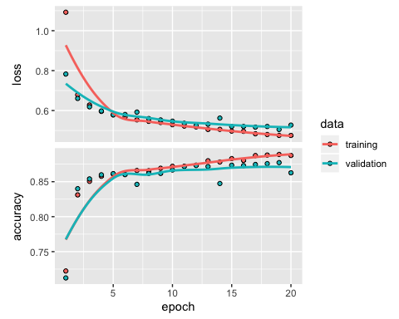

val <-initial_model %>% evaluate(x_val,y_val)  
val

## $loss  
## [1] 0.1436349  
##   
## $accuracy  
## [1] 0.9527

#  
L1_model <- keras_model_sequential() %>%   
 layer_dense(units = 16,kernel_regularizer = regularizer_l1(0.001), activation = "relu", input_shape = c(10000)) %>%   
 layer_dense(units = 16,kernel_regularizer = regularizer_l1(0.001), activation = "relu") %>%   
 layer_dense(units = 1, activation = "sigmoid")  
  
L1_model %>% compile(  
 optimizer = "rmsprop",  
 loss = "binary_crossentropy",  
 metrics = c("accuracy")  
)  
L1_model%>% fit(train, train_label, epochs = 4, batch_size = 512)  
results_L1 <- L1_model %>% evaluate(test,test_label)  
results_L1

## $loss  
## [1] 0.5730344  
##   
## $accuracy  
## [1] 0.84968

#Plotting loss and accuracy for validation dataset

library(ggplot2)  
library(tidyr)  
  
plot_val_losses <- function(losses) {  
 loss_names <- names(losses)  
 losses <- as.data.frame(losses)  
 losses$epoch <- seq_len(nrow(losses))  
 losses %>%   
 gather(model, loss, loss_names[[1]], loss_names[[2]]) %>%   
 ggplot(aes(x = epoch, y = loss))+  
 geom_point(aes(colour = model))  
   
}  
plot_val_accuracy <- function(accuracy) {  
 accuracy_names <- names(accuracy)  
 accuracy <- as.data.frame(accuracy)  
 accuracy$epoch <- seq_len(nrow(accuracy))  
 accuracy %>%   
 gather(model, accuracy, accuracy_names[[1]], accuracy_names[[2]]) %>%   
 ggplot(aes(x = epoch, y = accuracy))+  
 geom_point(aes(colour = model))  
}  
plot_val_losses(losses = list(  
 initial_model = history$metrics$val_loss,  
 L1_model = history_L1$metrics$val_loss  
))

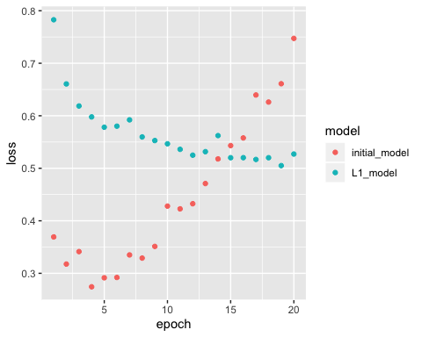

plot_val_accuracy(accuracy = list(  
 initial_model = history$metrics$val_accuracy,  
 L1_model = history_L1$metrics$val_accuracy  
))

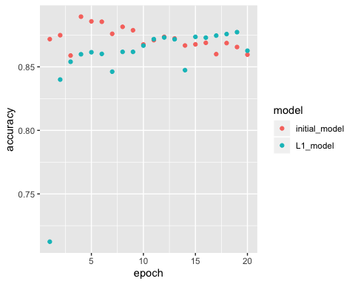

#L-1 model is resistant to overfitting than initial model.Accuracy is almost the same with small differnces in each epoch.

#L-2 regularization #L-2 norm regularization-cost added is proportional to square of the value of weight coefficients.

L2_model <- keras_model_sequential() %>%   
 layer_dense(units = 16,kernel_regularizer = regularizer_l2(0.001), activation = "relu", input_shape = c(10000)) %>%   
 layer_dense(units = 16,kernel_regularizer = regularizer_l2(0.001), activation = "relu") %>%   
 layer_dense(units = 1, activation = "sigmoid")  
  
L2_model %>% compile(  
 optimizer = "rmsprop",  
 loss = "binary_crossentropy",  
 metrics = c("accuracy")  
)  
  
history_L2 <- L2_model %>% fit(  
 x_train, y_train,  
 epochs = 20,  
 batch_size = 512,  
 validation_data = list(x_val, y_val)  
)  
  
plot(history_L2)

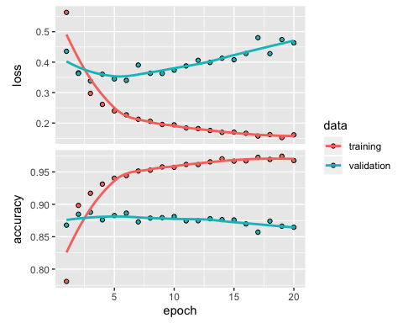

val <-L2_model %>% evaluate(x_val,y_val)  
val

## $loss  
## [1] 0.4633024  
##   
## $accuracy  
## [1] 0.8646

L2_model <- keras_model_sequential() %>%   
 layer_dense(units = 16,kernel_regularizer = regularizer_l2(0.001), activation = "relu", input_shape = c(10000)) %>%   
 layer_dense(units = 16,kernel_regularizer = regularizer_l2(0.001), activation = "relu") %>%   
 layer_dense(units = 1, activation = "sigmoid")  
  
L2_model %>% compile(  
 optimizer = "rmsprop",  
 loss = "binary_crossentropy",  
 metrics = c("accuracy")  
)  
L2_model%>% fit(train, train_label, epochs = 4, batch_size = 512)  
results_L2 <- L2_model %>% evaluate(test,test_label)  
results_L2

## $loss  
## [1] 0.3366686  
##   
## $accuracy  
## [1] 0.88788

#plot for loss and accuracy

plot_val_losses(losses = list(  
 initial_model = history$metrics$val_loss,  
 L2_model = history_L2$metrics$val_loss  
))

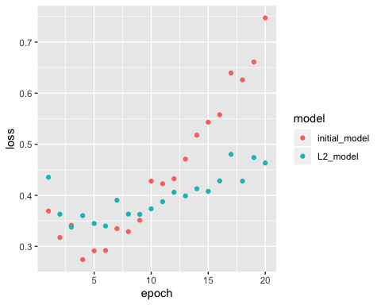

plot_val_accuracy(accuracy = list(  
 initial_model = history$metrics$val_accuracy,  
 L2_model = history_L2$metrics$val_accuracy  
))

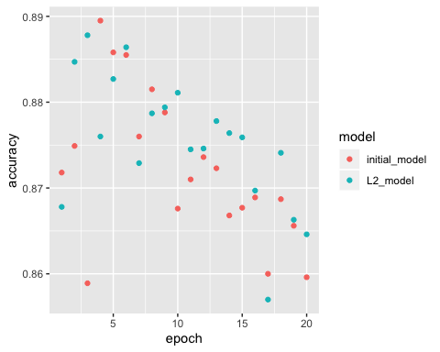 #The graph for L-2 model shows loss is significantly low and also less overfitting compared to initial model. Coming to the accuracy the L-2 model showing slightly better accuracy.

#Differnt number ofHidden Layers # 3 hidden layers

layers3_model <- keras_model_sequential() %>%   
 layer_dense(units = 16, activation = "relu", input_shape = c(10000)) %>%   
 layer_dense(units = 16, activation = "relu") %>%   
 layer_dense(units = 16, activation = "relu") %>%   
 layer_dense(units = 1, activation = "sigmoid")  
  
layers3_model %>% compile(  
 optimizer = "rmsprop",  
 loss = "binary_crossentropy",  
 metrics = c("accuracy")  
)  
  
history_layers3 <- layers3_model %>% fit(  
 x_train, y_train,  
 epochs = 20,  
 batch_size = 512,  
 validation_data = list(x_val, y_val)  
)  
  
plot(history_layers3)

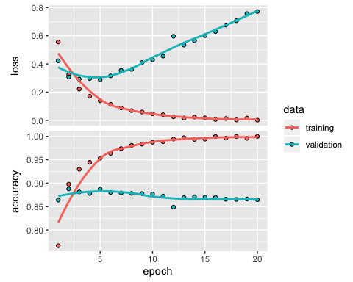

val <-layers3_model %>% evaluate(x_val,y_val)  
val

## $loss  
## [1] 0.771575  
##   
## $accuracy  
## [1] 0.8646

#re train  
layers3_model <- keras_model_sequential() %>%   
 layer_dense(units = 16, activation = "relu", input_shape = c(10000)) %>%   
 layer_dense(units = 16, activation = "relu") %>%   
 layer_dense(units = 16, activation = "relu") %>%   
 layer_dense(units = 1, activation = "sigmoid")  
  
layers3_model %>% compile(  
 optimizer = "rmsprop",  
 loss = "binary_crossentropy",  
 metrics = c("accuracy")  
)  
layers3_model%>% fit(train, train_label, epochs = 4, batch_size = 512)  
results_layers3 <- layers3_model %>% evaluate(test,test_label)  
results_layers3

## $loss  
## [1] 0.3085506  
##   
## $accuracy  
## [1] 0.8814

#Plots for loss and accuracy for initial model and different layers.

library(ggplot2)  
library(tidyr)  
  
plot_val_losses <- function(losses) {  
 loss_names <- names(losses)  
 losses <- as.data.frame(losses)  
 losses$epoch <- seq_len(nrow(losses))  
 losses %>%   
 gather(model, loss, loss_names[[1]], loss_names[[2]]) %>%   
 ggplot(aes(x = epoch, y = loss))+  
 geom_point(aes(colour = model))  
   
}  
  
  
plot_val_accuracy <- function(accuracy) {  
 accuracy_names <- names(accuracy)  
 accuracy <- as.data.frame(accuracy)  
 accuracy$epoch <- seq_len(nrow(accuracy))  
 accuracy %>%   
 gather(model, accuracy, accuracy_names[[1]], accuracy_names[[2]]) %>%   
 ggplot(aes(x = epoch, y = accuracy))+  
 geom_point(aes(colour = model))  
}

#Plot

plot_val_losses(losses = list(  
 initial_model = history$metrics$val_loss,  
 layers3_model = history_layers3$metrics$val_loss  
))

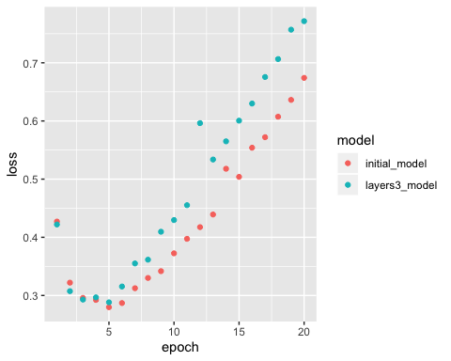

plot_val_accuracy(accuracy = list(  
 initial_model = history$metrics$val_accuracy,  
 layers3_model = history_layers3$metrics$val_accuracy  
))

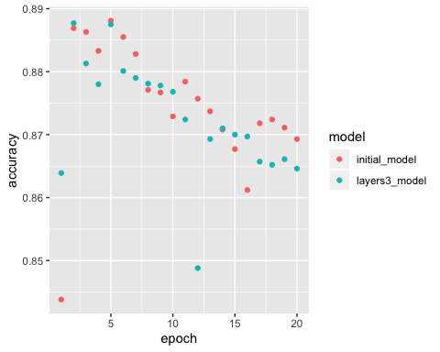

#one hidden layer

layers1_model <- keras_model_sequential() %>%   
 layer_dense(units = 16, activation = "relu", input_shape = c(10000)) %>%   
 layer_dense(units = 1, activation = "sigmoid")  
  
layers1_model %>% compile(  
 optimizer = "rmsprop",  
 loss = "binary_crossentropy",  
 metrics = c("accuracy")  
)  
  
history_layers1 <- layers1_model %>% fit(  
 x_train, y_train,  
 epochs = 20,  
 batch_size = 512,  
 validation_data = list(x_val, y_val)  
)  
  
plot(history_layers1)

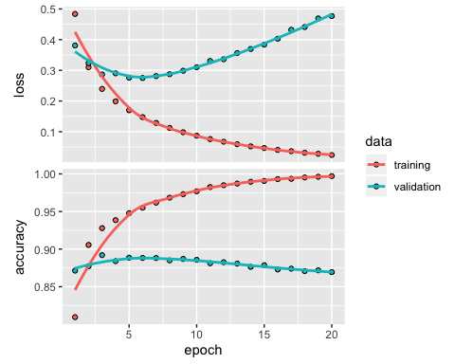

val <-layers1_model %>% evaluate(x_val,y_val)  
val

## $loss  
## [1] 0.476826  
##   
## $accuracy  
## [1] 0.8694

#re-train  
layers1_model <- keras_model_sequential() %>%   
 layer_dense(units = 16, activation = "relu", input_shape = c(10000)) %>%   
 layer_dense(units = 1, activation = "sigmoid")  
  
layers1_model %>% compile(  
 optimizer = "rmsprop",  
 loss = "binary_crossentropy",  
 metrics = c("accuracy")  
)  
  
layers1_model%>% fit(train, train_label, epochs = 4, batch_size = 512)  
results_layers1 <- layers1_model %>% evaluate(test,test_label)  
results_layers1

## $loss  
## [1] 0.2795235  
##   
## $accuracy  
## [1] 0.88868

# Plot for loss and accuarcy

plot_val_losses(losses = list(  
 initial_model = history$metrics$val_loss,  
 layers1_model = history_layers1$metrics$val_loss  
))

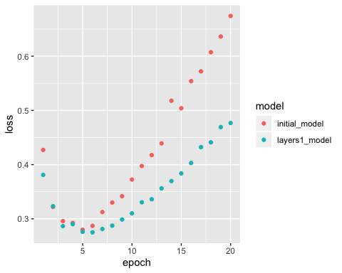

plot_val_accuracy(accuracy = list(  
 initial_model = history$metrics$val_accuracy,  
 layers1_model = history_layers1$metrics$val_accuracy  
))

