ASSIGNMENT – CREATING DBVIEW AND USING IN SE38.

1. Create a database view. file name: ZP_DBVIEW.

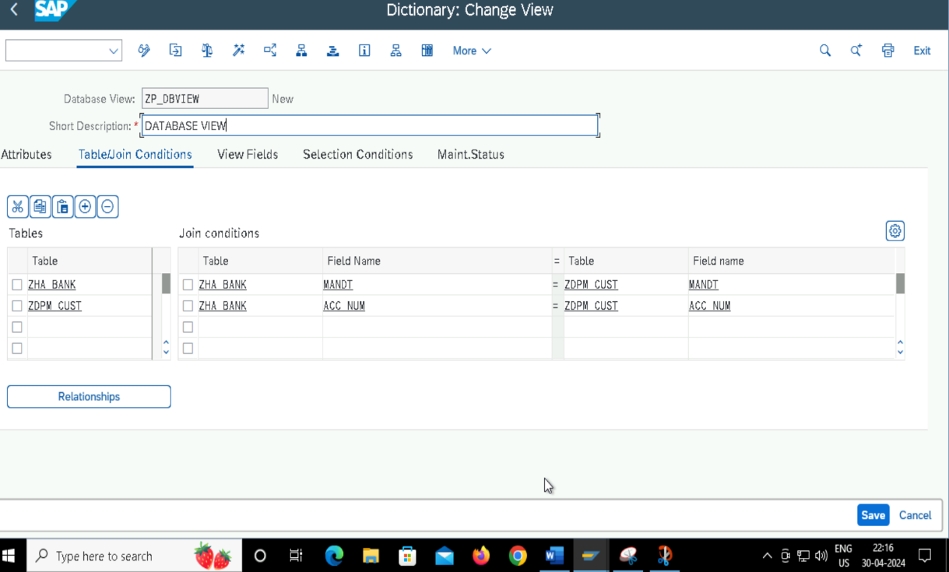

1. Using Database view in se38 progs.

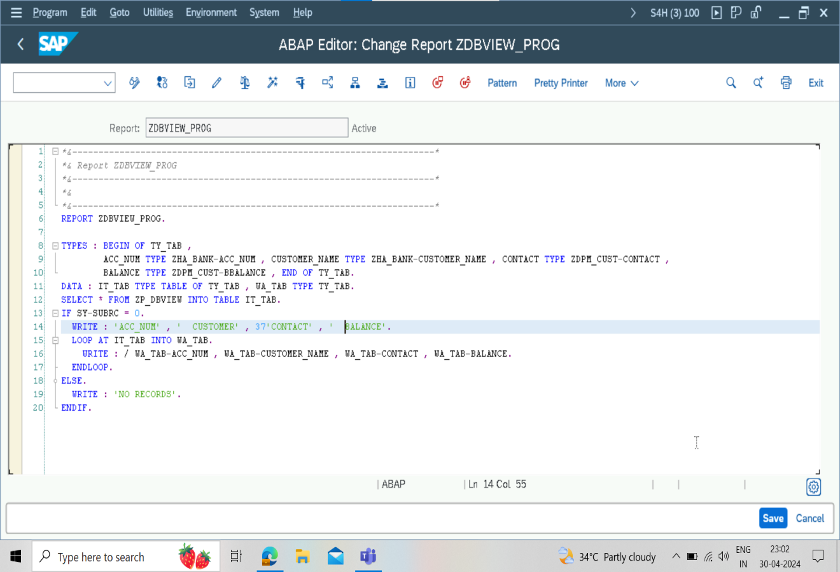

1. Output.

