ASSIGNMENT: MM01 CREATION AND INNERJOINS.

1. Created 3 entries into mara table using mm01 T-code.

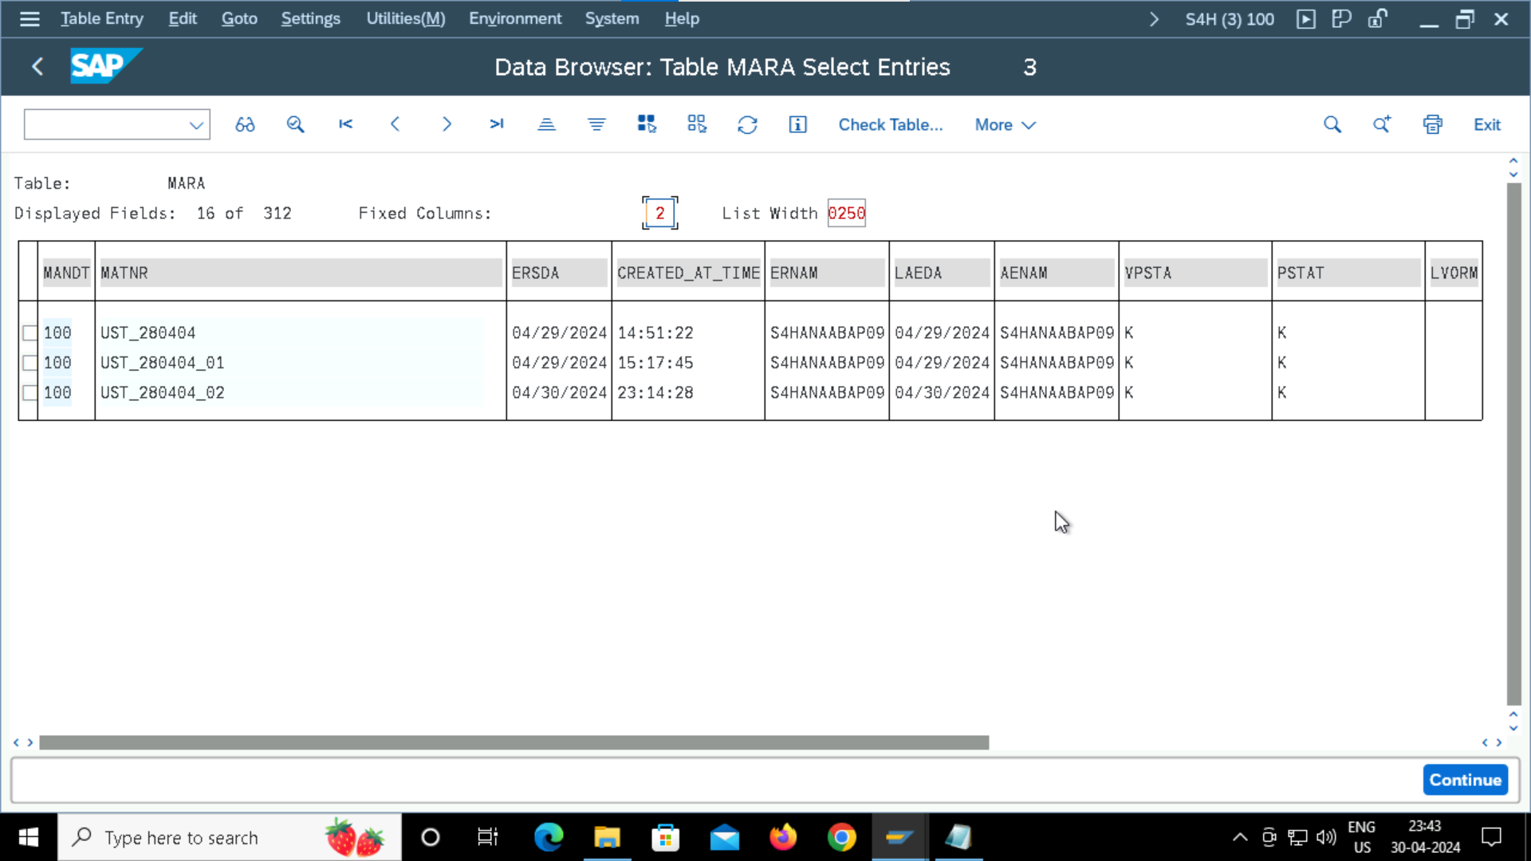

1. Writing a program using inner joins to view the data .

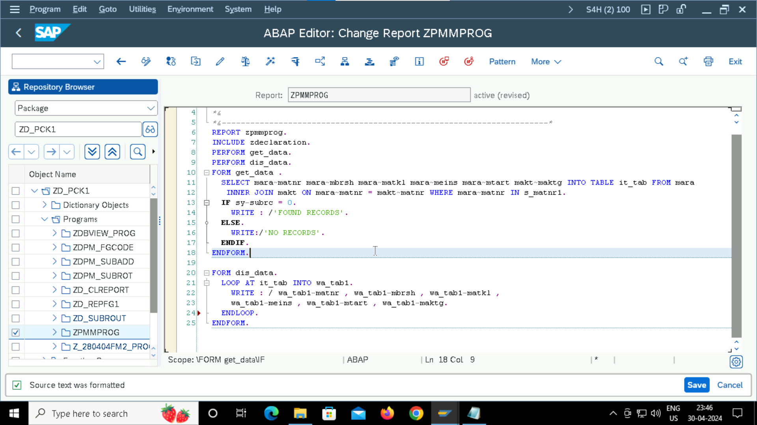

1. Output.

