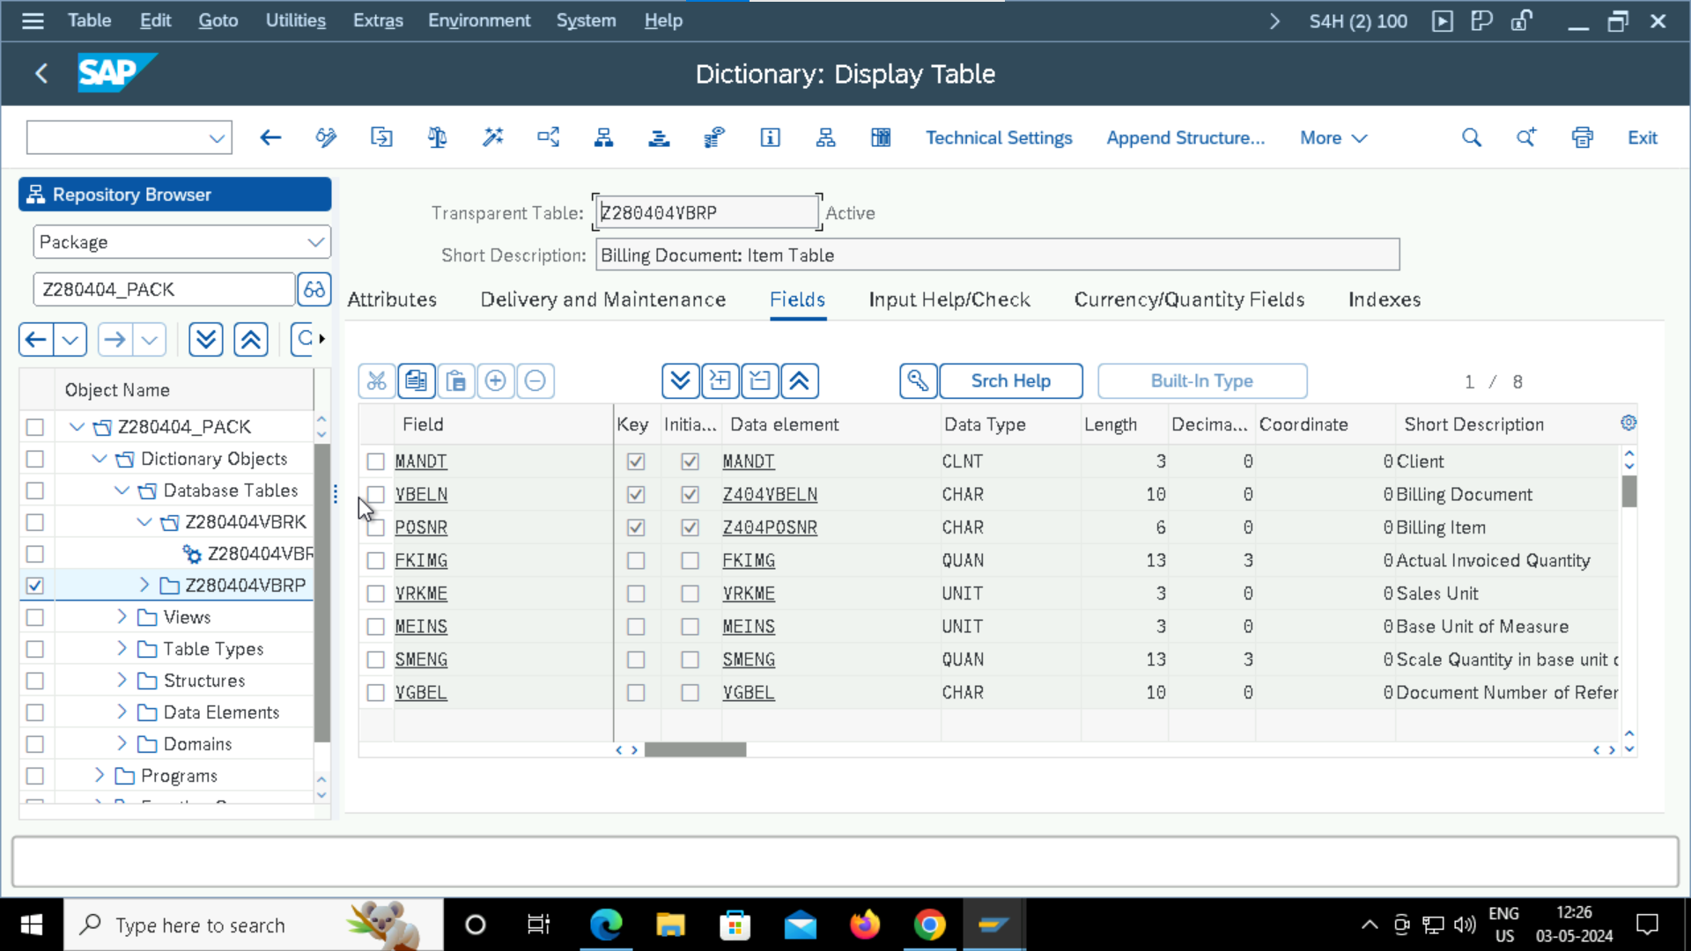

FOREIGN KEY

