30th August Task

MySql Database Connection

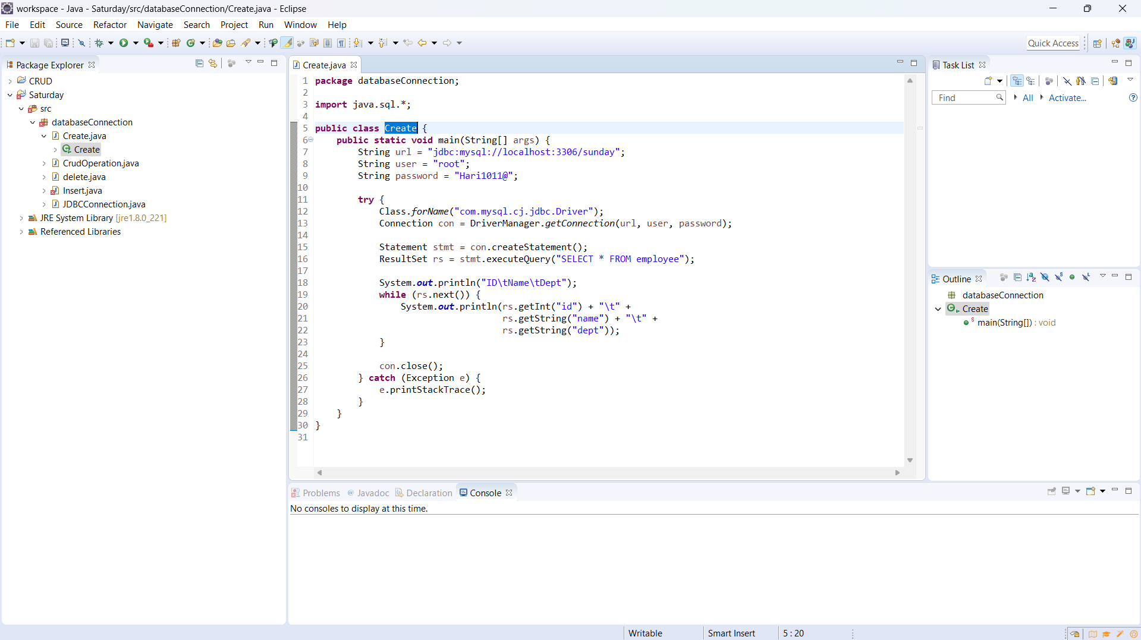

Task 2: Performing Crud operation using java with my sql

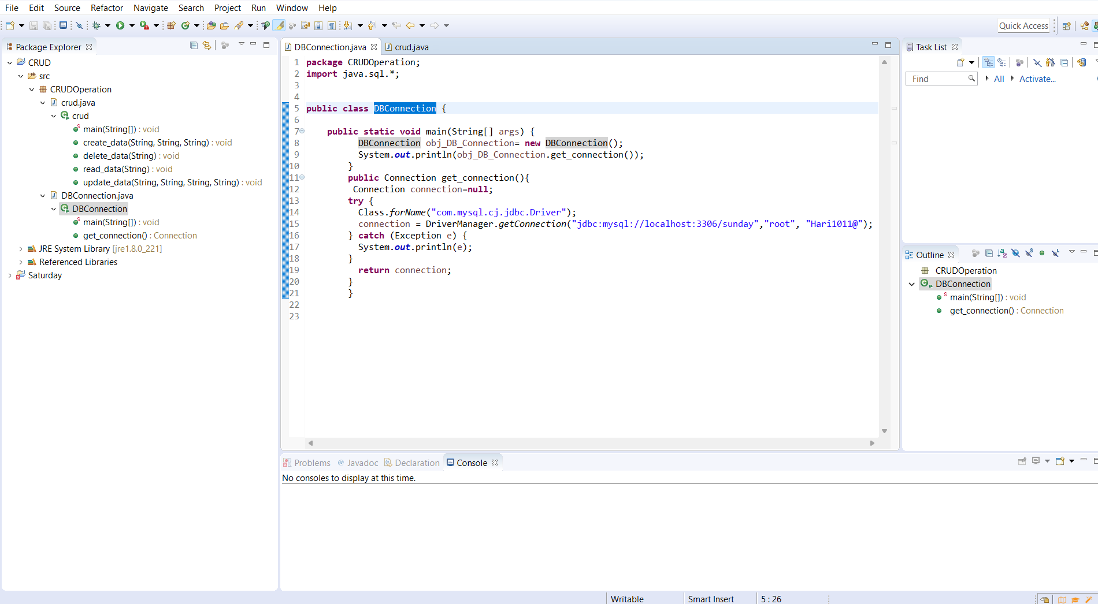

A single page that has the connection with the database

The page that will perform the create , read, update and the delete operation

