**Steps to run the Tests**

1. **Create a Maven Project in Eclipse:**

* Open Eclipse IDE.
* Go to File > New > Other.
* Select Maven Project and click Next.
* Check Create a simple project (skip archetype selection) and click Next.
* Enter Group Id and Artifact Id for your project, then click Finish.

1. **Add Dependencies to pom.xml:**

* Open the pom.xml file located in the root of your Maven project.
* Add the given dependencies (from .xml file) inside the <dependencies> tag.
* Save the pom.xml file.

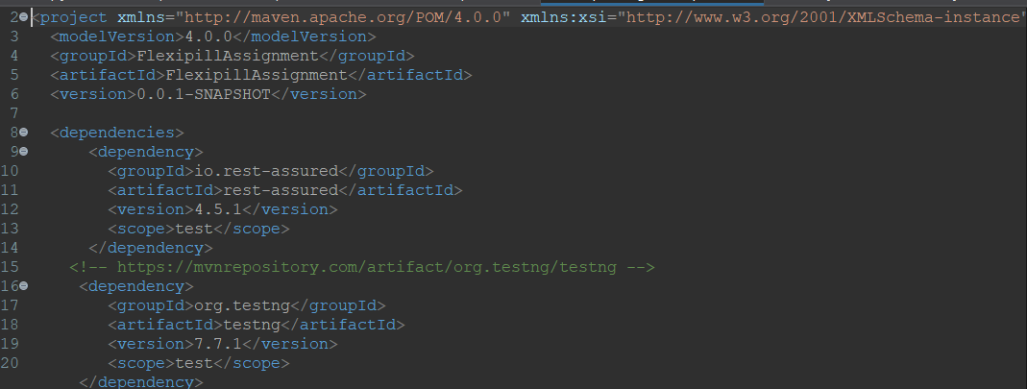

1. **Update the Maven Project:**

* Right-click on your project in the Project Explorer.
* Select Maven > Update Project.
* Check Force Update of Snapshots/Releases and click OK.

1. **Create a Package:**

* In the src/test/java directory, right-click and select New > Package.
* Name the package loginCartOrder and click Finish.

1. **Create a New Java Class:**

* Right-click on the loginCartOrder package and select New > Class.
* Name the class FlexLCO and click Finish.

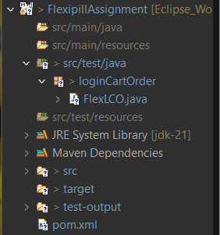

1. **Add Code to the FlexLCO.java File:**

* Open the newly created FlexLCO.java file.
* Add the given code (from .java file) to the file.
* Save the FlexLCO.java file.

1. **Run the Test:**

* Right-click on the FlexLCO.java file.
* Select Run As > TestNG Test.

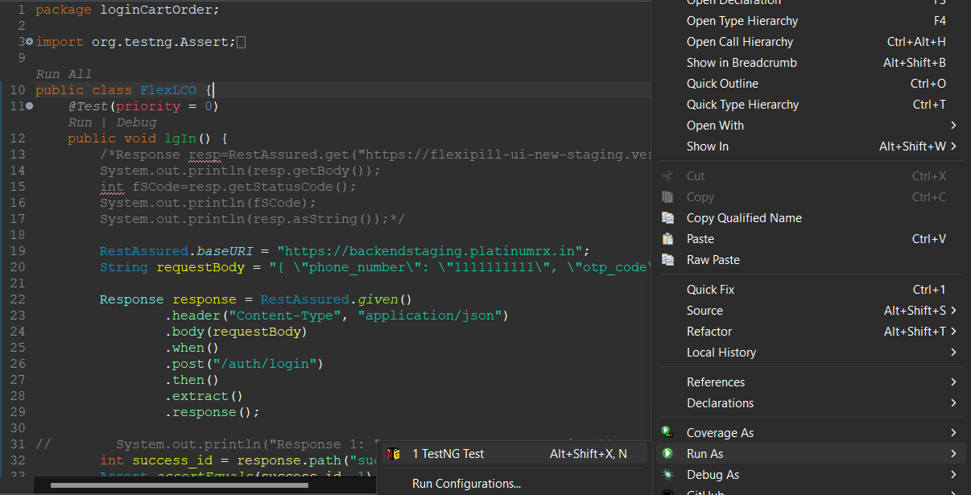

1. **Check the Output in the Console:**

* Open the Console view in Eclipse to see the output of your test.
* Ensure that the test runs successfully and the correct status code is returned.

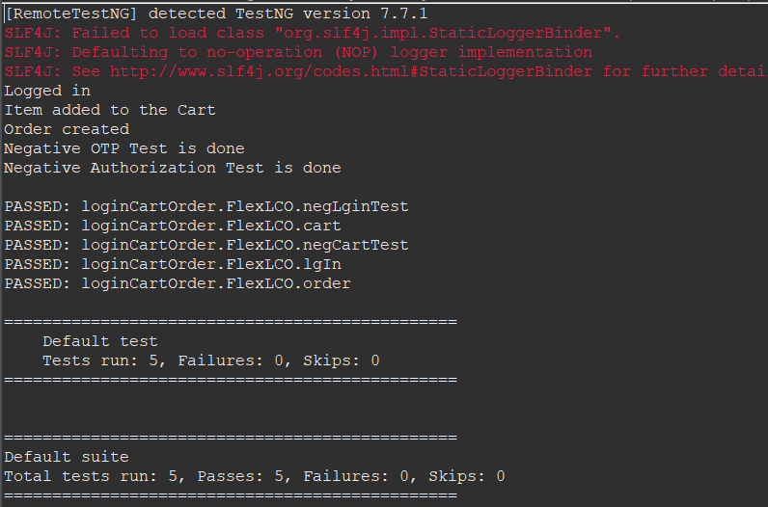

1. **Check the Emailable Report:**

* After running the test, go to your project directory in Eclipse.
* Navigate to the test-output folder.
* Locate the emailable-report.html file.
* Open the emailable-report.html file in a web browser to view the detailed TestNG report.

