📘 Project Documentation

1. Project Overview
Project Title:EMPLOYEE MANAGEMENT SYSYTEM
Description: This project is used to handle employee data efficiently for a company.
There are two users –
- ADMIN –ADMINISTRATOR. ADMIN has more functions like employee access control , Employee CRUD Operations, Department CRUD Operations,
Salary Operations, Leave Handling.
- EMPLOYEE – Employee can view data and can request for leave and access gain.

Objectives of Employee Management System (Python Mini Project)

1. Primary Objective
- To develop a Python-based Employee Management System that efficiently manages employee records such as personal details, department information, salary and leave data.

2. Functional Objectives
- To add, view, update, and delete employee records.
- To store employee information such as employee ID, name, department, salary, and contact details.
- To implement search functionality for quick retrieval of employee data.
- To ensure data validation and avoid duplicate or incorrect entries.

3. Technical Objectives
- To apply Python programming concepts such as:
  - Functions and modules
  - Database connectivity (e.g., SQLite)
  - Validate inputs to avoid SQL Injection and Errors
- To design a menu-driven COMMAND LINE INTERFACE

4. Security and Reliability Objectives
- To maintain data integrity and consistency.
- To implement basic authentication (admin login) if required.
- To handle errors and exceptions gracefully.

5. Learning Objectives
- To gain hands-on experience in real-world application development using Python.
- To understand CRUD operations (Create, Read, Update, Delete).
- To improve problem-solving and logical thinking skills.

6. Performance and Usability Objectives
- To create a user-friendly interface for easy interaction.
- To ensure quick response time for data operations.
- To design a system that is scalable for future enhancements
Target Users:
- Example: ADMIN
- Example: EMPLOYEES

2. Functional Requirements
Describe what the system must do.

User Requirements
- EMPLOYEE can register and log in
- EMPLOYEE can view personal info, department info, salary info, leave info, request for leave , request for login access from ADMIN
- Users can log out securely

Admin Requirements
- ADMIN can login securely
- ADMIN can control users login access , CRUD operation on employee details, department details
- ADMIN can view system reports of employee details , department details ,salary details, leave details
- ADMIN can approve or reject leave requests

3. Non-Functional Requirements
- Performance: Response time < 2 seconds
- Security: Authentication and authorization
- Usability: Simple and intuitive UI
- Scalability: Supports multiple users
- Compatibility: Works on major browsers/devices

4. Database Schema
Tables Description
Table: employee

FIELD NAME DATATYPE DESCRIPTION

Employee _Id INTEGER PRIMARY KEY

Employee_Name VARCHAR(75) EMPLOYEE NAME

Gender CHAR(1) GENDER

Date_Of_Joining DATE(10)

Employee_Address VARCHAR(200)

Phone_Number VARCHAR(20)

Email_Id VARCHAR(50)

Table: user

FIELD NAME DATATYPE DESCRIPTION

id INTEGER PRIMARY KEY

username VARCHAR(15)

password TEXT

Emp_Id INTEGER FOREIGN KEY REF employee(Employee _Id)

role TEXT

access_control TEXT DEFAULT ‘ACCESS GRANTED’

status_access_control TEXT

logged_status TEXT DEFAULT ‘LOGGEDOUT’

Table: salary

FIELD NAME DATATYPE DESCRIPTION

Salary _Id INTEGER PRIMARY KEY

Employee_Id INTEGER FOREIGN KEY REF employee(Employee _Id)

Basic_Pay DOUBLE(20)

DA DOUBLE(20)

HRA DOUBLE(20)

Medical_Allowance DOUBLE(20)

Table: department

FIELD NAME DATATYPE DESCRIPTION

Department_Id INTEGER

Department_Name VARCHAR(100)

Location VARCHAR(100

Employee_Id INTEGER FOREIGN KEY REF employee(Employee _Id)

Table: leave_requests

FIELD NAME DATATYPE DESCRIPTION

leave_id INTEGER PRIMARY KEY

employee_id INTEGER FOREIGN KEY REF employee(Employee _Id)

leave_type VARCHAR(50)

start_date DATE

end_date DATE

reason TEXT

status TEXT DAFAULT ‘Pending’
applied_date TIMESTAMP DEFAULT CURRENT_TIMESTAMP

5. Technologies Used
- Programming Language: PYTHON
- Database: MYSQL

6. Usage Guide

User Flow
- Open the application. User see this on the command prompt
WELCOME TO EMPLOYEE MANAGEMENT SYSTEM
1.USER REGISTERATION
2.USER LOGIN
3.USER LOGOUT
4.EXIT
ENTER YOUR CHOICE :
- User first go for registeration using the company provided Employee Id, Username and Password.
- After successful login, User see this
EMPLOYEE MANAGEMENT SYSTEM - EMPLOYEE OPERAIONS
1.VIEW PROFILE
2.VIEW DEPARTMENT
3.VIEW SALARY
4.VIEW LEAVES -STATUS OF LEAVES APPLIED
5.REQUEST FOR NEW LEAVE
6.EXIT
ENTER YOUR CHOICE :
- Log out

Screenshots
THE EMPLOYEE DASHBOARD
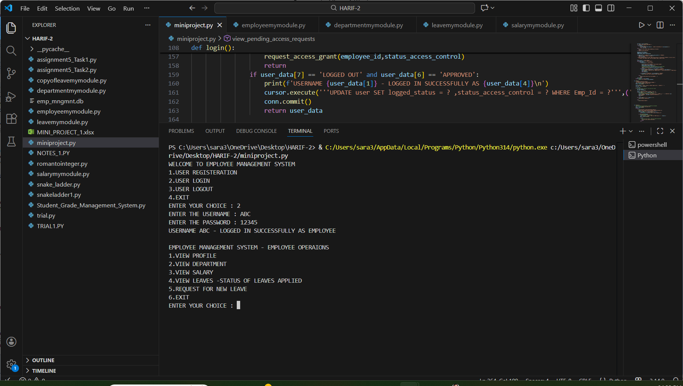
📸 VIEW PROFILE OF EMPLOYEE
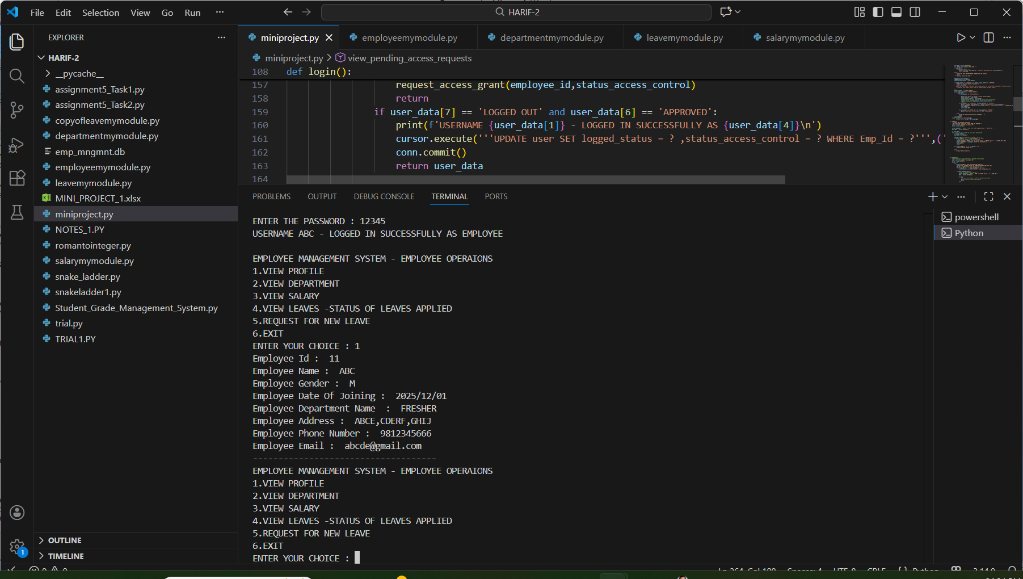

📸 VIEW DEPARTMENT DETAILS OF EMPLOYEE
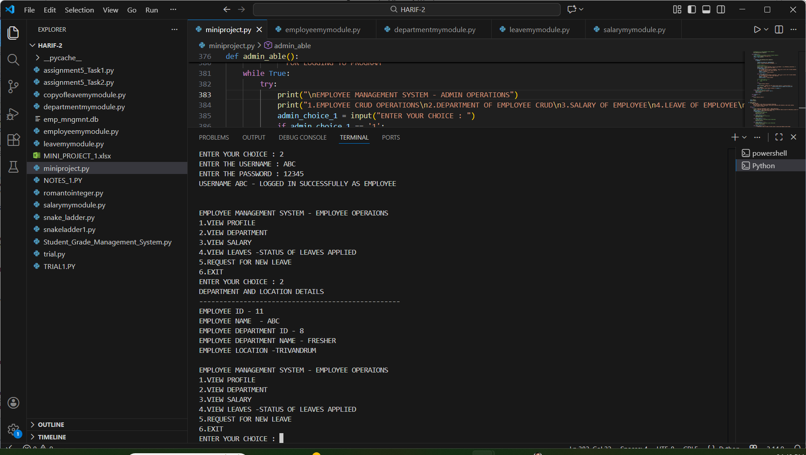

📸 VIEW SALARY DETAILS OF EMPLOYEE
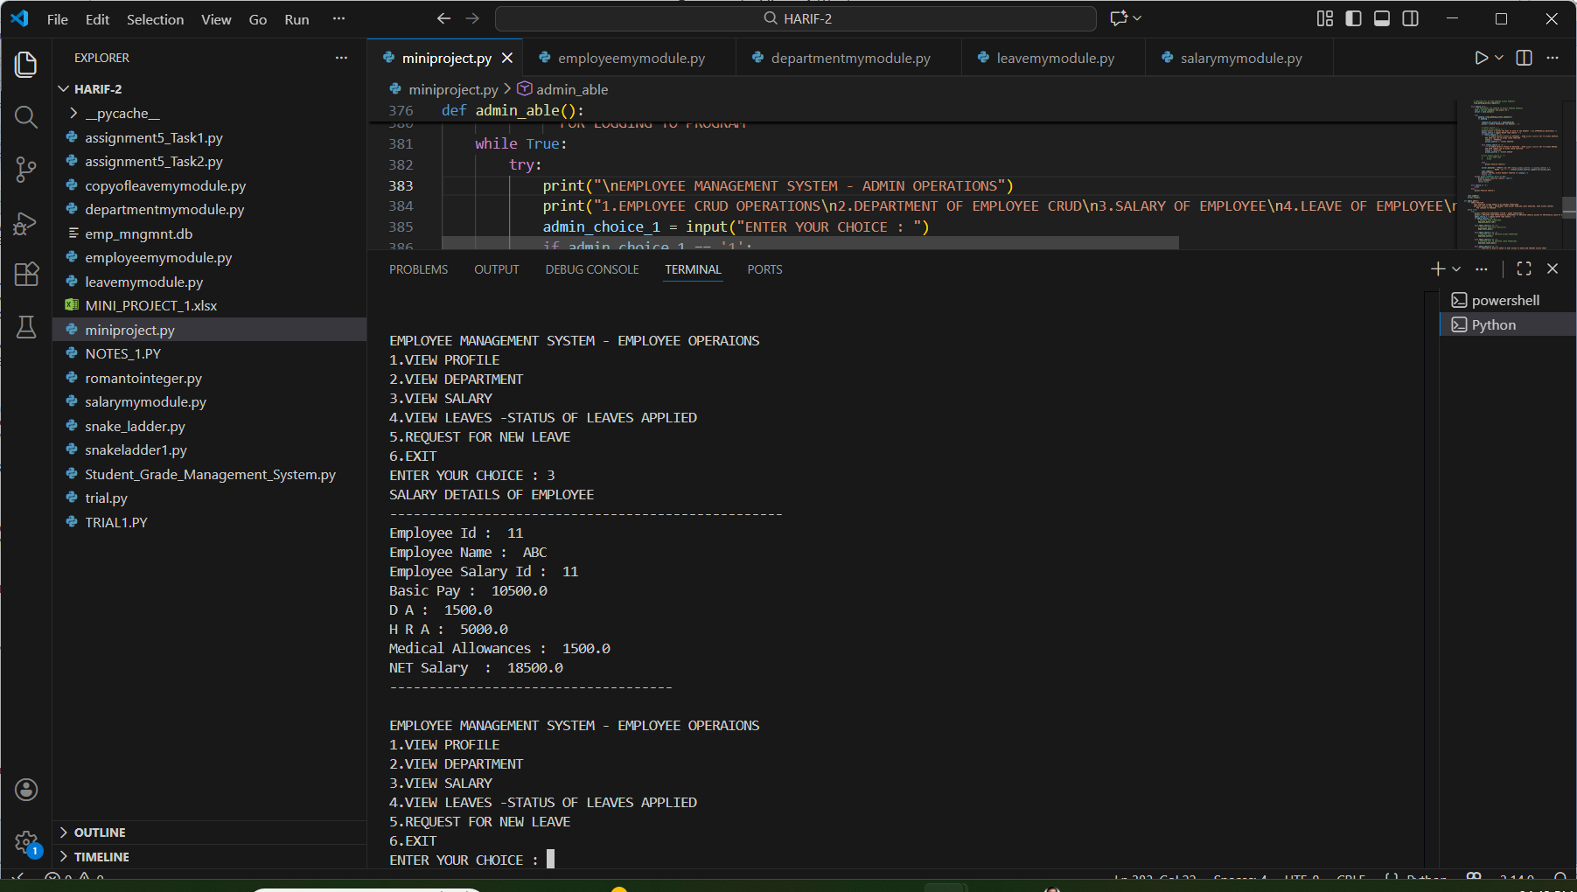

📸 VIEW LEAVE REQUEST SENT BY EMPLOYEE TO ADMIN

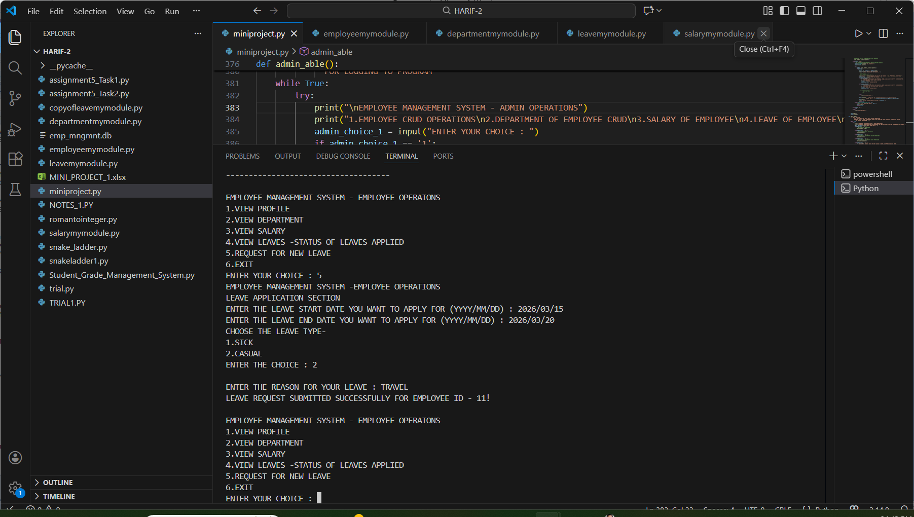

ADMIN DASHBOARD

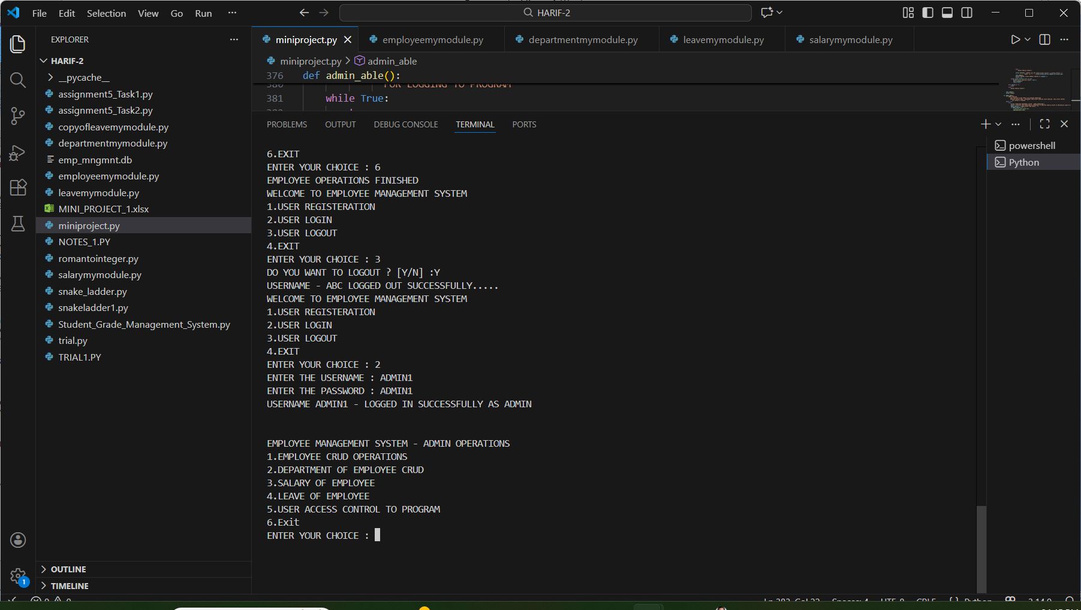

VIEW ALL EMPLOYEES DETAILS

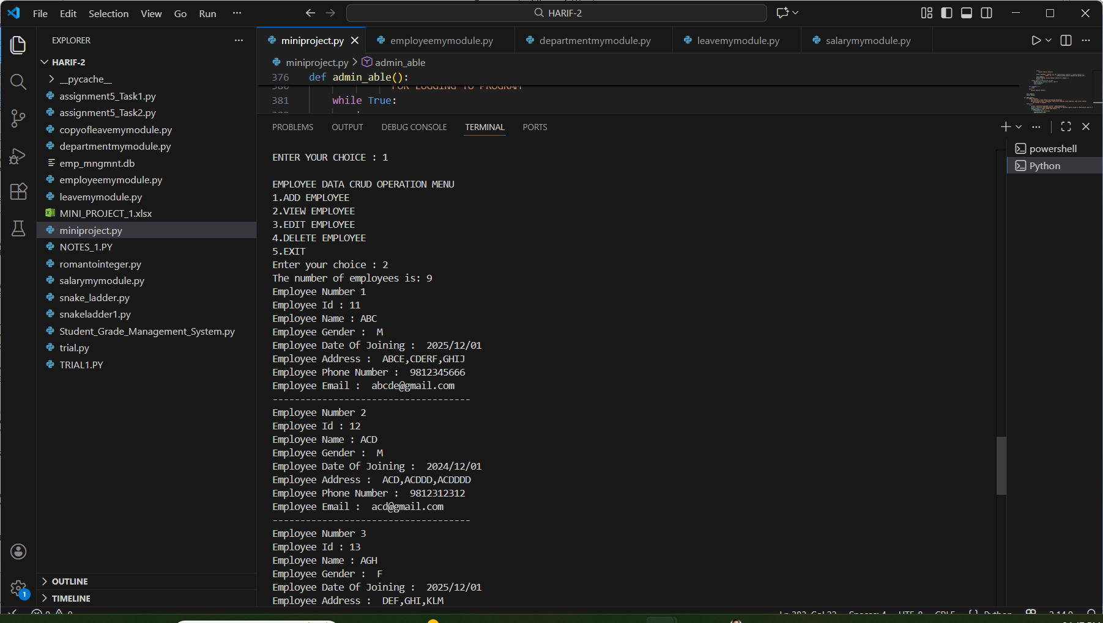

VIEW PENDING LEAVE REQUESTS

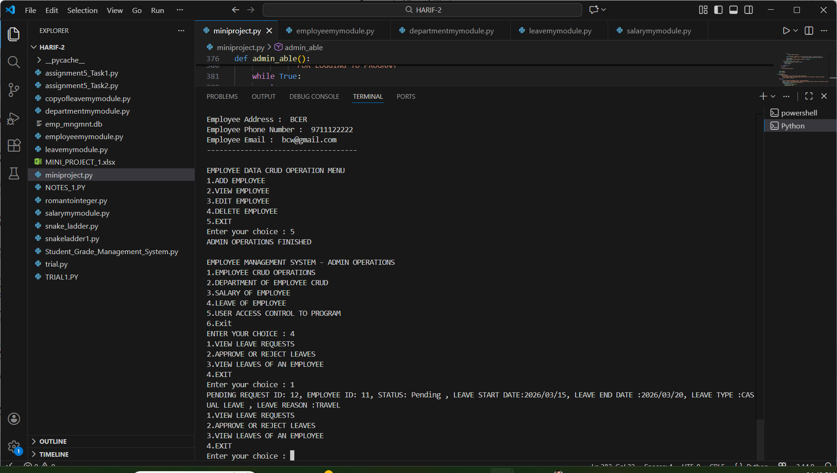

7. Source Code Submission
- GitHub Repository Link:
- Include:
  - Source code
  - README file
  - Database scripts (if any)

📄 README.md

Project Name: EMPLOYEE MANAGEMENT SYSTEM
ADMIN first login using username and password. Employee details are added initially. Then, Department details are entered. Then, Salary details are entered . After this , Employee obtains the Employee ID. With this ID, Employee can do registeration by providing username and password. After this, Employee can login to Employee Dashboard. Employee can view Personal Profile, Department Details, Salary Details, Leave Details, Request for new leave.

How to Run
- Clone the repository
- Install dependencies
- Configure database
- Run the application

Author
HARIKIRAN DILIP |

✅ Submission Checklist
✔ Project Documentation
✔ Database Schema
✔ Screenshots
✔ Source Code
✔ README.md

