**OUTPUT**

1. **RESPONSE HAS BEEN SUBMITTED SUCESSFULLY**

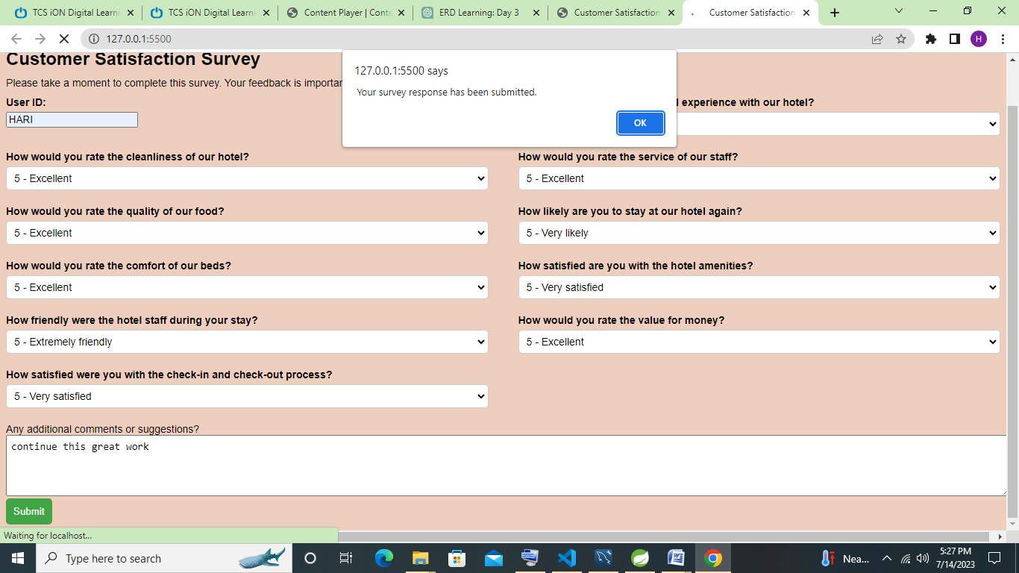

1. **AND THE RESPONSE HAS BEEN STORED IN THE DATABASE**

