SALESFORCE CRM PROJECT DOCUMENTATION
WhatNext Vision Motors
A Salesforce CRM Implementation for Vehicle Dealership Management
Submitted by
Name: Hari Kowshik Kota
Department: CSE(AI&DS)
Registration No.: 238W1A5431
Salesforce Developer Edition Org | September 2026

1. Project Overview
WhatNext Vision Motors is a Salesforce CRM application built to digitize and streamline the core operations of a vehicle dealership. The system brings vehicle inventory, customer records, dealer information, sales orders, test-drive scheduling, and after-sales service requests into a single connected platform. It replaces fragmented, manual tracking of stock and customer interactions with a structured, automated Salesforce data model, supported by record-triggered automation (Flows and Apex) that keeps vehicle stock accurate and dealer assignment consistent as orders are placed.
The application is organised around six custom objects — Vehicle, Vehicle Customer, Vehicle Dealer, Vehicle Order, Vehicle Service Request and Vehicle Test Drive — connected through lookup relationships, and is accessed through a dedicated Lightning App named “WhatNext Vision Motors”.

2. Objectives
The primary goal of this project is to build a functional, extensible CRM foundation for a vehicle dealership using native Salesforce capabilities. The specific objectives are:
- Centralise vehicle inventory, dealer, and customer data in a structured, relational data model instead of spreadsheets.
- Automate routine sales operations — such as assigning a dealer to a new order and updating stock counts — using Record-Triggered Flows.
- Enforce basic business rules at the data layer (e.g. blocking an order when a vehicle is out of stock) using Apex triggers.
- Provide a scalable batch process to reconcile pending orders against current stock on a scheduled basis.
- Package the objects, automation and Apex logic into a single Lightning App (“WhatNext Vision Motors”) for day-to-day use.
These objectives translate directly into business value: fewer overselling errors, faster dealer allocation, a single source of truth for customer and order data, and a foundation that can later be extended with reporting, approvals and a full security model.

3. Phase 1 — Requirement Analysis & Planning

3.1 Understanding Business Requirements
A vehicle dealership needs to track which vehicles are in stock, who the dealer/showroom holding each vehicle is, which customers have placed orders or booked test drives, and which vehicles have open service requests. The recurring problems being solved are: (a) vehicles being oversold when stock is not checked in real time, (b) no automatic linking of a new order to the right customer and dealer, and (c) no scheduled safety-net to reconcile orders that are still pending against current stock.

3.2 Defining Project Scope and Objectives
- In scope: custom object model for Vehicle, Vehicle Customer, Vehicle Dealer, Vehicle Order, Vehicle Service Request and Vehicle Test Drive; field-level design for each object; record-triggered Flow automation for orders and test drives; Apex trigger-handler pattern for stock validation and stock decrement; a scheduled Apex batch job for pending-order reconciliation; and a Lightning App to expose all of the above.
- Out of scope for this iteration (documented under Future Enhancements): page layout customisation, a formal security/sharing model, reports & dashboards, Lightning Web Components, and Apex test classes.

3.3 Data Model and Object Relationships
Six custom objects were created (see Object Manager below). Each is suffixed __c and stores its own record data, with lookup relationships connecting orders, customers, dealers and vehicles together.
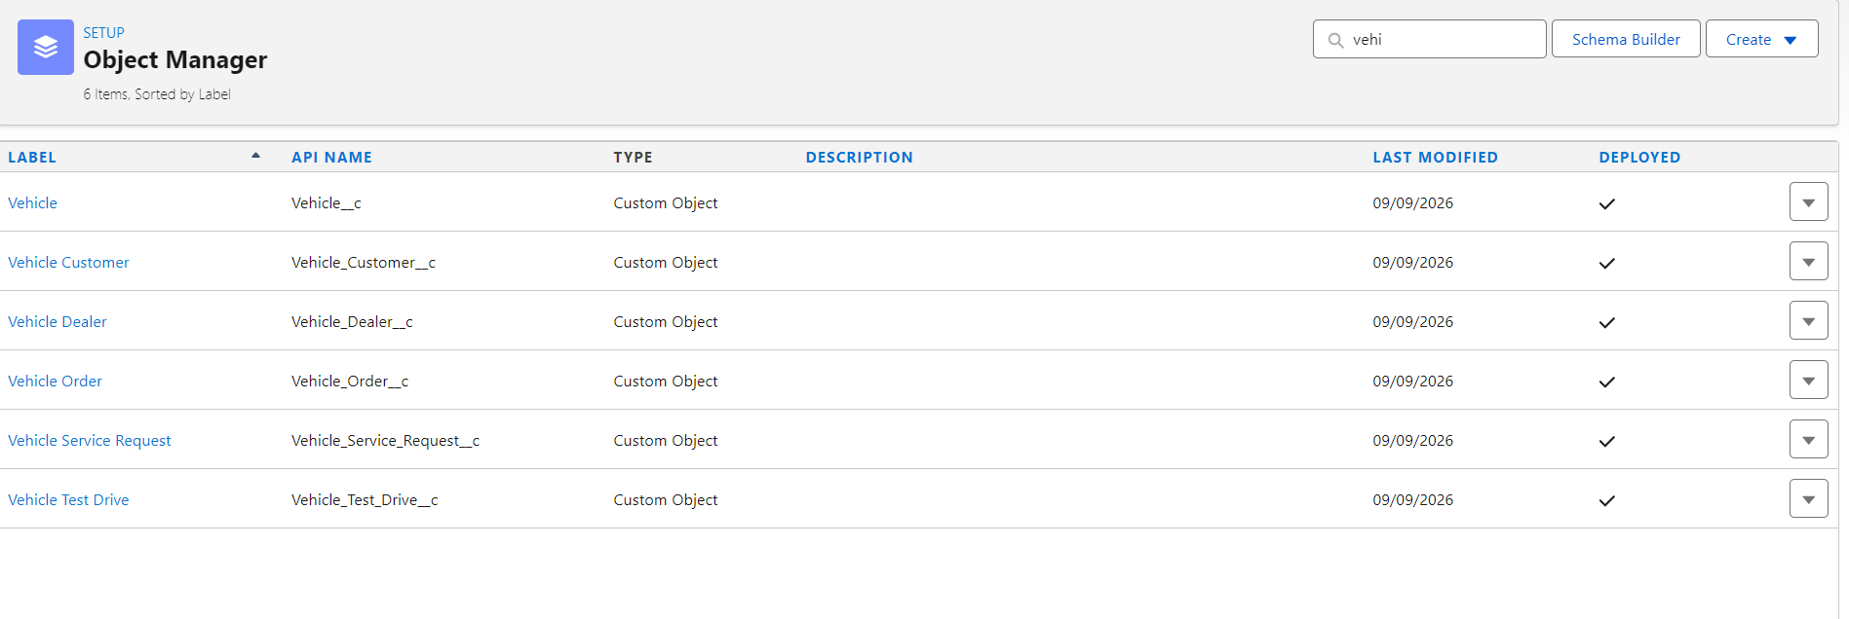
Figure 3.1 — Object Manager: the six custom objects that make up the data model.
The relationships between the objects are summarised below:
Object | Key Relationships
Vehicle__c | Lookup to Vehicle Dealer; Lookup to Vehicle Order
Vehicle Customer__c | Lookup to Vehicle Order; Lookup to Vehicle Test Drive
Vehicle Dealer__c | Lookup to Vehicle Order
Vehicle Order__c | Lookup to Vehicle; Lookup to Vehicle Customer
Vehicle Service Request__c | Lookup to Vehicle; Lookup to Vehicle Customer
Vehicle Test Drive__c | Lookup to Vehicle; Lookup to Vehicle Customer

4. Phase 2 — Salesforce Development: Backend & Configuration

4.1 Environment
Development was carried out directly in a Salesforce Developer Edition org (trailblaze.my.salesforce.com) using the Setup UI (Object Manager, Flow Builder, Apex) rather than a formal CI/CD or sandbox-based DevOps pipeline. All custom objects, fields, Flows and Apex classes are deployed and active in this org, as shown by the “Deployed” column in Object Manager (Figure 3.1).

4.2 Custom Objects & Fields
Fields were defined per object to capture the data needed for dealership operations. No custom validation rules were configured in this iteration; data integrity for the stock/order relationship is instead enforced in Apex (Section 4.4).

4.2.1 Vehicle__c
Stores each vehicle's model, price, stock quantity and status, and links to its dealer and order.
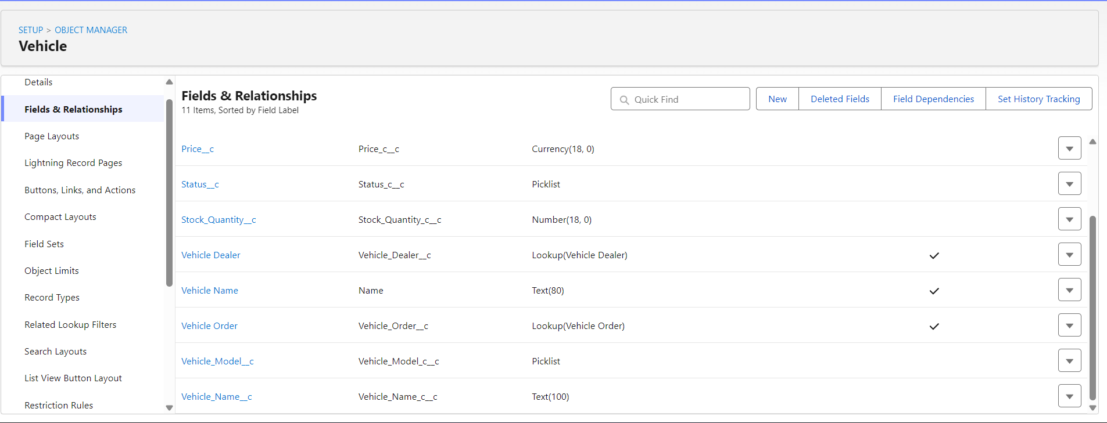
Figure 4.1 — Vehicle__c fields: Price, Status, Stock Quantity, Vehicle Dealer (lookup), Vehicle Order (lookup), Vehicle Model, Vehicle Name.

4.2.2 Vehicle_Customer__c
Stores customer contact details and preferences, and links to their order and test drive.
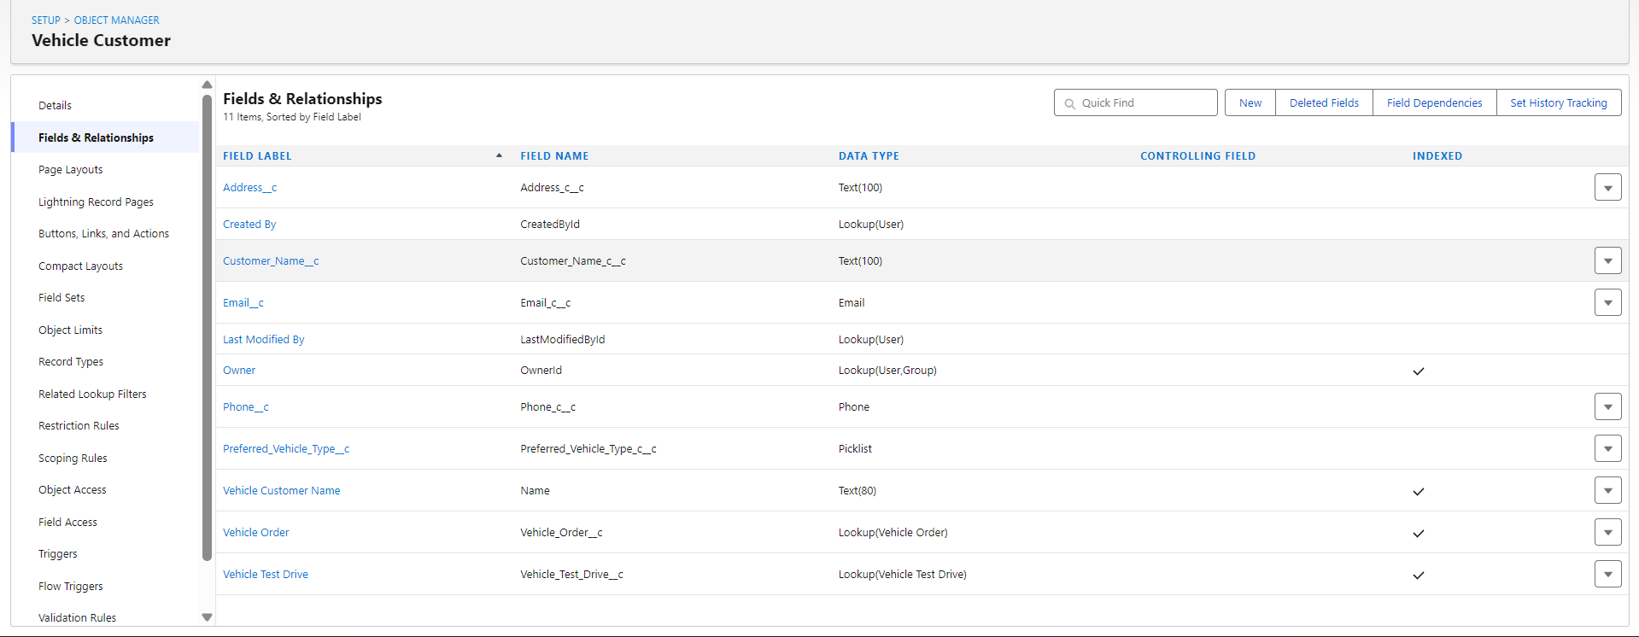
Figure 4.2 — Vehicle Customer fields: Address, Customer Name, Email, Phone, Preferred Vehicle Type, Vehicle Order (lookup), Vehicle Test Drive (lookup).

4.2.3 Vehicle_Dealer__c
Stores dealer/showroom details, including an auto-numbered dealer code, and links to associated orders.
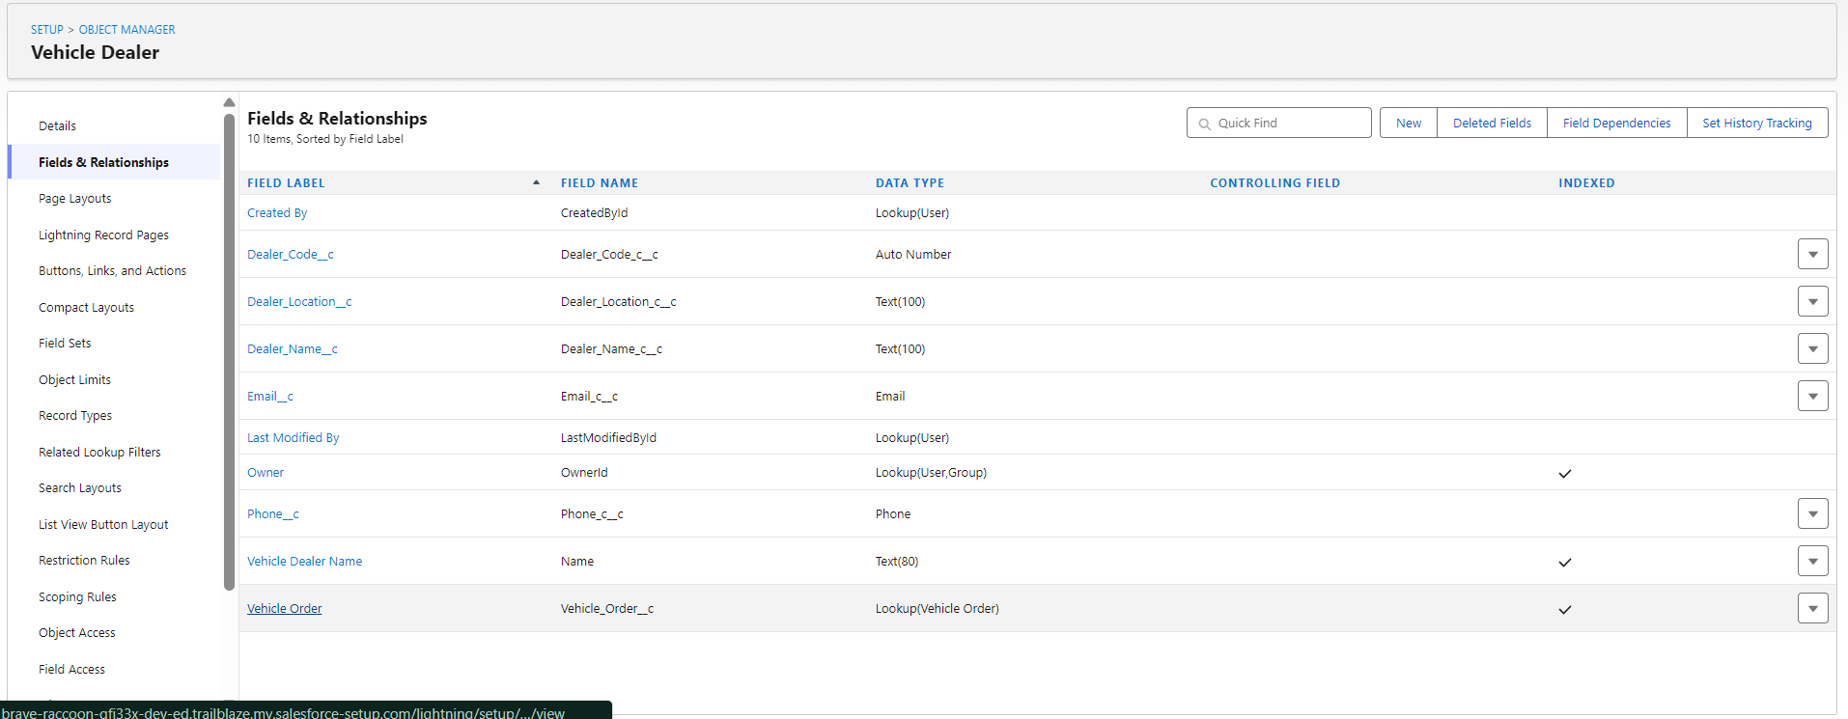
Figure 4.3 — Vehicle Dealer fields: Dealer Code (auto number), Dealer Location, Dealer Name, Email, Phone, Vehicle Order (lookup).

4.2.4 Vehicle_Order__c
The central transactional object: captures order date, status, and links to the Vehicle, Vehicle Customer and (post-automation) the assigned Vehicle Dealer.
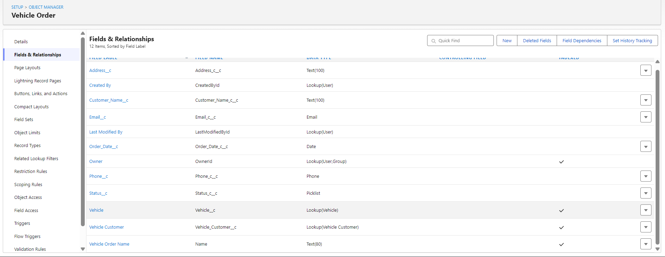
Figure 4.4 — Vehicle Order fields: Address, Customer Name, Email, Order Date, Phone, Status, Vehicle (lookup), Vehicle Customer (lookup).

4.2.5 Vehicle_Service_Request__c
Captures after-sales service requests raised against a vehicle by a customer, with an issue description, service date and status.
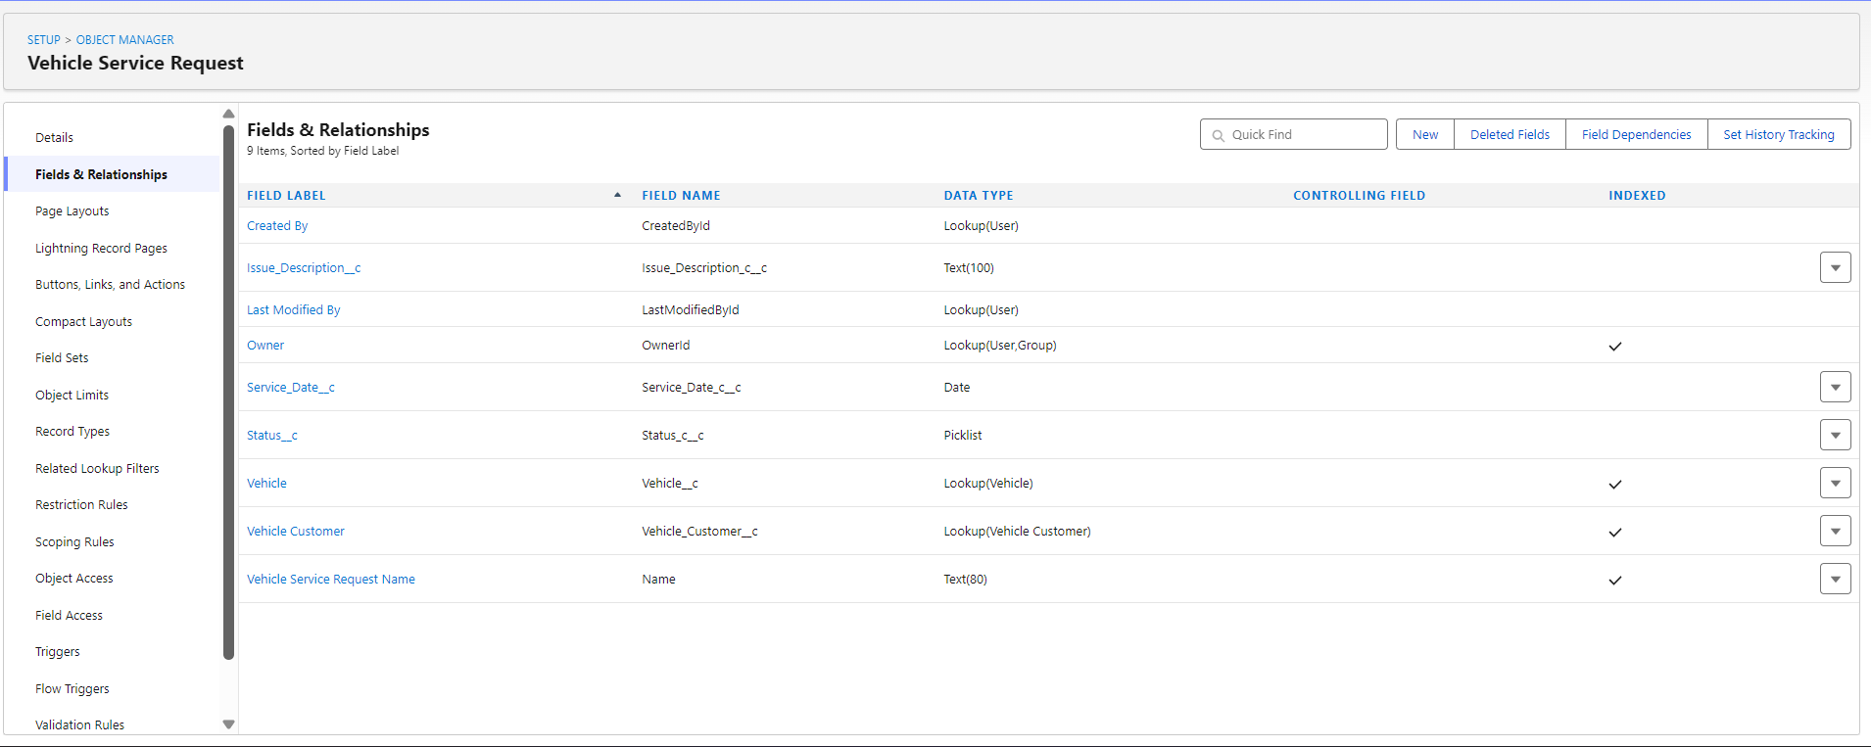
Figure 4.5 — Vehicle Service Request fields: Issue Description, Service Date, Status, Vehicle (lookup), Vehicle Customer (lookup).

4.2.6 Vehicle_Test_Drive__c
Captures test-drive bookings, linking a customer to a vehicle with a scheduled date and status.
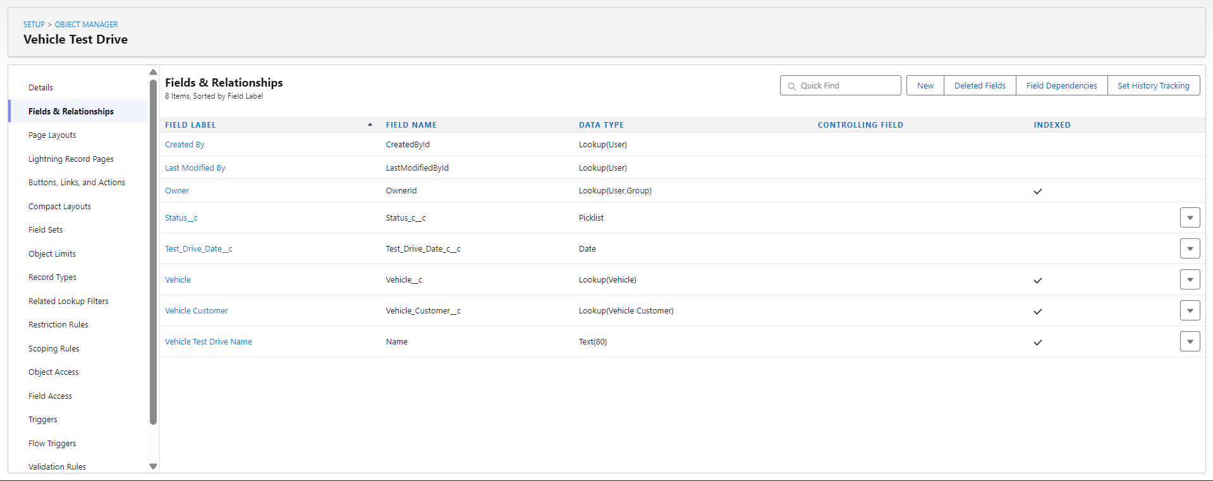
Figure 4.6 — Vehicle Test Drive fields: Status, Test Drive Date, Vehicle (lookup), Vehicle Customer (lookup).

4.3 Automation — Record-Triggered Flows
Two Record-Triggered Flows were built to automate the order and test-drive lifecycle.

4.3.1 Vehicle Order — Dealer Assignment Flow
Object: Vehicle_Order__c | Trigger: A record is created | Runs immediately.
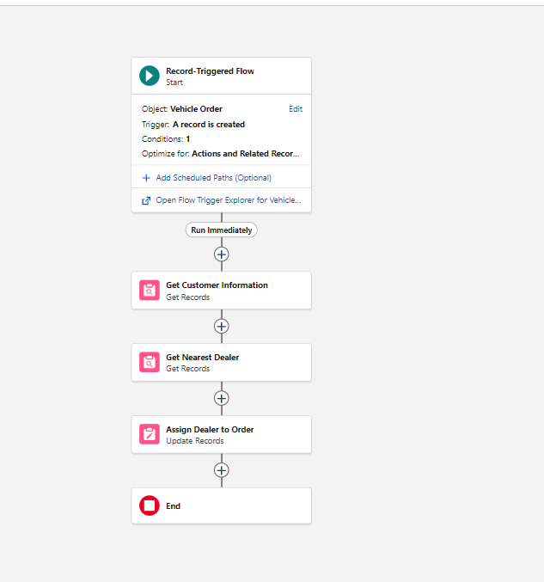
Figure 4.7 — Vehicle Order flow: Get Customer Information → Get Nearest Dealer → Assign Dealer to Order.
- Get Customer Information — retrieves the related Vehicle Customer record for the new order.
- Get Nearest Dealer — retrieves a matching Vehicle Dealer record.
- Assign Dealer to Order — updates the newly created order with the resolved dealer.

4.3.2 Vehicle Test Drive — Reminder Flow
Object: Vehicle_Test_Drive__c | Trigger: A record is created | 2 scheduled paths.
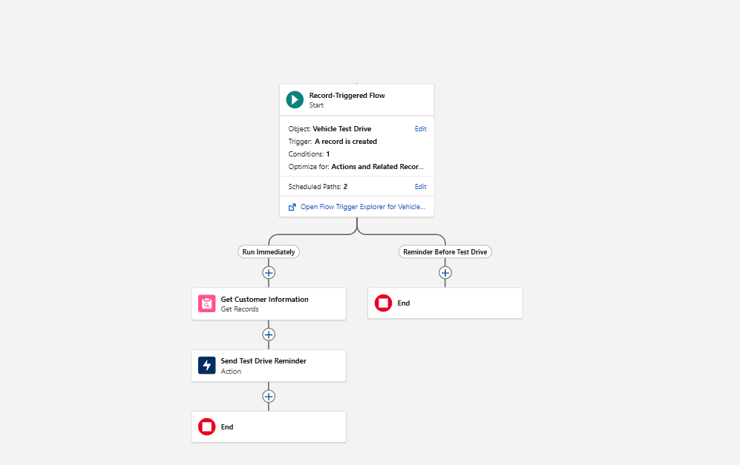
Figure 4.8 — Vehicle Test Drive flow: an immediate path that sends a confirmation action, and a scheduled “Reminder Before Test Drive” path.
- Run Immediately path — Get Customer Information, then Send Test Drive Reminder (action).
- Reminder Before Test Drive path (scheduled) — fires ahead of the booked test-drive date as a follow-up reminder.

4.4 Apex Classes & Triggers
Order-level stock control is implemented in Apex rather than Flow, using the trigger-handler pattern: a single lean trigger delegates all logic to a handler class, keeping one trigger per object and making the logic unit-testable.

4.4.1 VehicleOrderTrigger
A single trigger on Vehicle_Order__c covering before/after insert and update, delegating to the handler class.
trigger VehicleOrderTrigger on Vehicle_Order__c (before insert, before update, after insert, after update) {
VehicleOrderTriggerHandler.handleTrigger(Trigger.new, Trigger.oldMap, Trigger.isBefore,
Trigger.isAfter, Trigger.isInsert, Trigger.isUpdate);
}

4.4.2 VehicleOrderTriggerHandler
Contains two pieces of business logic:
- preventOrderIfOutOfStock (before insert/update) — bulk-queries the related Vehicle records and adds an error to any order whose vehicle has Stock_Quantity__c ≤ 0, blocking the save.
- updateStockOnOrderPlacement (after insert/update) — for orders whose Status__c is ‘Confirmed’, decrements the related vehicle’s Stock_Quantity__c by 1 and bulk-updates the affected Vehicle records.
public class VehicleOrderTriggerHandler {
public static void handleTrigger(List<Vehicle_Order__c> newOrders, Map<Id, Vehicle_Order__c> oldOrders,
Boolean isBefore, Boolean isAfter, Boolean isInsert, Boolean isUpdate) {
if (isBefore) {
if (isInsert || isUpdate) {
preventOrderIfOutOfStock(newOrders);
}
}
if (isAfter) {
if (isInsert || isUpdate) {
updateStockOnOrderPlacement(newOrders);
}
}
}
// Prevents orders when the vehicle is out of stock
private static void preventOrderIfOutOfStock(List<Vehicle_Order__c> orders) {
Set<Id> vehicleIds = new Set<Id>();
for (Vehicle_Order__c order : orders) {
if (order.Vehicle__c != null) {
vehicleIds.add(order.Vehicle__c);
}
}
if (!vehicleIds.isEmpty()) {
Map<Id, Vehicle__c> vehicleStockMap = new Map<Id, Vehicle__c>();
for (Vehicle__c vehicle : [SELECT Id, Stock_Quantity__c FROM Vehicle__c WHERE Id IN :vehicleIds]) {
vehicleStockMap.put(vehicle.Id, vehicle);
}
for (Vehicle_Order__c order : orders) {
if (vehicleStockMap.containsKey(order.Vehicle__c)) {
Vehicle__c vehicle = vehicleStockMap.get(order.Vehicle__c);
if (vehicle.Stock_Quantity__c <= 0) {
order.addError('This vehicle is out of stock. Order cannot be placed.');
}
}
}
}
}
// Decrements vehicle stock when an order is confirmed
private static void updateStockOnOrderPlacement(List<Vehicle_Order__c> orders) {
Set<Id> vehicleIds = new Set<Id>();
for (Vehicle_Order__c order : orders) {
if (order.Vehicle__c != null && order.Status__c == 'Confirmed') {
vehicleIds.add(order.Vehicle__c);
}
}
if (!vehicleIds.isEmpty()) {
Map<Id, Vehicle__c> vehicleStockMap = new Map<Id, Vehicle__c>();
for (Vehicle__c vehicle : [SELECT Id, Stock_Quantity__c FROM Vehicle__c WHERE Id IN :vehicleIds]) {
vehicleStockMap.put(vehicle.Id, vehicle);
}
List<Vehicle__c> vehiclesToUpdate = new List<Vehicle__c>();
for (Vehicle_Order__c order : orders) {
if (vehicleStockMap.containsKey(order.Vehicle__c)) {
Vehicle__c vehicle = vehicleStockMap.get(order.Vehicle__c);
if (vehicle.Stock_Quantity__c > 0) {
vehicle.Stock_Quantity__c -= 1;
vehiclesToUpdate.add(vehicle);
}
}
}
if (!vehiclesToUpdate.isEmpty()) {
update vehiclesToUpdate;
}
}
}
}

4.5 Asynchronous Apex — Batch & Scheduler
A Batchable class reconciles any orders left in ‘Pending’ status: for each pending order it checks the related vehicle’s stock, and if stock is available it confirms the order and decrements stock, updating both records in bulk. A Schedulable wrapper runs this batch on a daily cron schedule (12:00 PM), acting as a safety net alongside the real-time trigger logic in Section 4.4.
global class VehicleOrderBatch implements Database.Batchable<sObject> {
global Database.QueryLocator start(Database.BatchableContext bc) {
return Database.getQueryLocator([
SELECT Id, Status__c, Vehicle__c
FROM Vehicle_Order__c
WHERE Status__c = 'Pending'
]);
}
global void execute(Database.BatchableContext bc, List<Vehicle_Order__c> orderList) {
Set<Id> vehicleIds = new Set<Id>();
for (Vehicle_Order__c order : orderList) {
if (order.Vehicle__c != null) {
vehicleIds.add(order.Vehicle__c);
}
}
if (!vehicleIds.isEmpty()) {
Map<Id, Vehicle__c> vehicleStockMap = new Map<Id, Vehicle__c>();
for (Vehicle__c vehicle : [SELECT Id, Stock_Quantity__c FROM Vehicle__c WHERE Id IN :vehicleIds]) {
vehicleStockMap.put(vehicle.Id, vehicle);
}
List<Vehicle_Order__c> ordersToUpdate = new List<Vehicle_Order__c>();
List<Vehicle__c> vehiclesToUpdate = new List<Vehicle__c>();
for (Vehicle_Order__c order : orderList) {
if (vehicleStockMap.containsKey(order.Vehicle__c)) {
Vehicle__c vehicle = vehicleStockMap.get(order.Vehicle__c);
if (vehicle.Stock_Quantity__c > 0) {
order.Status__c = 'Confirmed';
vehicle.Stock_Quantity__c -= 1;
ordersToUpdate.add(order);
vehiclesToUpdate.add(vehicle);
}
}
}
if (!ordersToUpdate.isEmpty()) {
update ordersToUpdate;
}
if (!vehiclesToUpdate.isEmpty()) {
update vehiclesToUpdate;
}
}
}
global void finish(Database.BatchableContext bc) {
System.debug('Vehicle order batch job completed.');
}
}
global class VehicleOrderBatchScheduler implements Schedulable {
global void execute(SchedulableContext sc) {
VehicleOrderBatch batchJob = new VehicleOrderBatch();
Database.executeBatch(batchJob, 50); // batch size = 50
}
}
// Scheduled to run daily at 12:00 PM
String cronExp = '0 0 12 * * ?';
System.schedule('Daily Vehicle Order Processing', cronExp, new VehicleOrderBatchScheduler());

5. Phase 3 — UI/UX Development & Customization

5.1 Lightning App Setup
A Lightning App was created through App Manager to bring the six objects together into a single, brand-named workspace for end users:
Setting | Value
App Name | WhatNext Vision Motors
Developer Name | Auto-populated by Salesforce from the App Name
Description | Descriptive summary of the app's purpose (dealership CRM workspace)
App Image | Optional — not set (default Salesforce app icon used)
Primary Colour | Default Salesforce theme colour (not customised)
This app acts as the entry point through which sales and dealership staff would access Vehicle, Vehicle Customer, Vehicle Dealer, Vehicle Order, Vehicle Service Request and Vehicle Test Drive records.

5.2 Scope Not Yet Implemented
Page layout customisation, Dynamic Forms, dedicated user management, Reports & Dashboards, Lightning Web Components, and custom Lightning record pages were not built in this iteration. These are carried forward under Future Enhancements (Section 8).

6. Phase 4 — Data Migration, Testing & Security
This phase was not implemented in the current iteration of the project. No data was migrated via the Data Import Wizard or Data Loader (records were created directly for development/testing), and the following were not configured: Field History Tracking, Duplicate/Matching Rules, a Profiles/Roles/Role Hierarchy or Permission Set model, Sharing Rules, and Apex test classes. Because no formal test classes exist yet, the two Apex classes and one trigger described in Section 4 are not currently deployable to a Production org (Salesforce requires ≥75% Apex code coverage via test classes for Production deployments) and have only been validated manually in the Developer org. This is flagged explicitly here rather than left implicit, and is the top priority under Future Enhancements.

7. Phase 5 — Deployment, Documentation & Maintenance

7.1 Deployment Strategy
All components (objects, fields, Flows, Apex classes and the trigger) were built and are currently active directly inside a single Salesforce Developer Edition org, rather than being promoted between environments via Change Sets, a Scratch-Org/SFDX pipeline, or a second-generation package. For a production rollout, the recommended path would be to move development into a Scratch Org or sandbox, add Apex test coverage (Section 6), and promote via Change Sets or an SFDX-based CI/CD pipeline.

7.2 Maintenance & Monitoring
- Flow and Apex execution can be monitored via Setup → Flows (run history) and Setup → Apex Jobs / Scheduled Jobs (for the daily batch).
- Debug Logs can be enabled on the automation user to trace trigger and batch execution when investigating an issue.
- The daily scheduled batch (Section 4.5) acts as an ongoing reconciliation safety-net for orders that were left Pending.

7.3 Troubleshooting Approach
- Order not confirming automatically → check the Vehicle's Stock_Quantity__c and the order's Status__c value.
- Order blocked unexpectedly → check the addError() message raised by preventOrderIfOutOfStock; it fires whenever stock is ≤ 0.
- Dealer not assigned to a new order → check the Vehicle Order Flow's run history for the failed Get/Update element.
- Test-drive reminder not received → check the Vehicle Test Drive Flow's scheduled-path run history for that record.

8. Conclusion & Future Enhancements
WhatNext Vision Motors demonstrates a working Salesforce data model and automation layer for a vehicle dealership: six connected custom objects, two Record-Triggered Flows handling dealer assignment and test-drive reminders, and an Apex trigger-handler pair backed by a scheduled batch job that keeps vehicle stock and order status accurate. Together these show the core CRM pattern of combining declarative automation (Flow) with programmatic automation (Apex) around a shared data model, packaged into a single Lightning App for end users.
The following items are recommended as next steps to take the project to a production-ready state:
- Apex test classes for VehicleOrderTriggerHandler and VehicleOrderBatch, to reach the 75% code coverage required for Production deployment.
- A security model: Profiles, Permission Sets, Role Hierarchy and Sharing Rules appropriate to sales reps, dealers and administrators.
- Page Layouts / Dynamic Forms tailored to each object, plus Lightning Record Pages for a cleaner user experience.
- Reports & Dashboards for stock levels, order pipeline, and test-drive conversion.
- Field History Tracking and Duplicate/Matching Rules on customer and order data.
- A Lightning Web Component for a richer vehicle-browsing / order-placement experience.
- AI-driven vehicle recommendations and a chatbot for customer-facing test-drive/service booking.

