**index.html**

<!DOCTYPE html>

<html lang="en">

<head>

    <meta charset="UTF-8">

    <meta http-equiv="X-UA-Compatible" content="IE=edge">

    <meta name="viewport" content="width=device-width, initial-scale=1.0">

    <title>Document</title>

    <link rel="stylesheet" href="index.css">

    <link rel="shortcut icon" href="https://www.rose-hulman.edu/class/csse/csse290-WebProgramming/images/pie-icon.png" type="image/x-icon">

</head>

<body>

    <h1>Recipe Page</h1>

    <div class="card">

        <img src="https://www.rose-hulman.edu/class/csse/csse290-WebProgramming/images/pie.jpg" alt="" class="card-image">

        <h1 class="card-heading">Grandma's Lemon Meringue Pie</h1>

        <p class="card-description">This adaptation of Alice Waters's lemon meringue pie came to the Times in a 1987 article in the Sunday magazine. It takes a little time, but your efforts will be rewarded with a spectacular centerpiece dessert to be proud of: a cloud of toasted meringue atop a pool of buttery and bright lemon curd in a light and flaky crust. If you can't find Meyer lemons, regular supermarket lemons will make a worthy substitute.</p>

        <div class="card-link-box">

            <a href="favourite_recipe.html">Click here</a>

        </div>

    </div>

</body>

</html>

**Index.css**

@import url("https://fonts.googleapis.com/css2?family=Cormorant+Garamond&display=swap");

* {

  padding: 0;

  margin: 0;

  box-sizing: border-box;

  font-family: "Cormorant Garamond", serif;

}

body {

  display: flex;

  justify-content: center;

  flex-direction: column;

  align-items: center;

  background-color: beige;

}

.card {

  height: 1005;

  width: 19rem;

  border-radius: 0.25rem;

  margin: 3rem;

  border: 1px solid gray;

  background-color: #ffff;

}

.card-image {

  width: 100%;

  height: 15rem;

}

.card-heading {

  text-align: center;

  color: gray;

}

.card-description {

  padding: 1rem;

}

.card-link-box {

  margin: 1rem;

}

**favourite_recipe.html**

<!DOCTYPE html>

<html lang="en">

<head>

    <meta charset="UTF-8">

    <meta http-equiv="X-UA-Compatible" content="IE=edge">

    <meta name="viewport" content="width=device-width, initial-scale=1.0">

    <title>Favourite Recipe</title>

    <link rel="stylesheet" href="favourite_recipe.css">

    <link rel="shortcut icon" href="https://www.rose-hulman.edu/class/csse/csse290-WebProgramming/images/pie-icon.png"

        type="image/x-icon">

</head>

<body>

    <div class="top-heading">

        <h1 class="heading">

            Grandma's Lemon Meringue Pie</h1>

    </div>

    <div class="recipe-2">

        <img class="recipe-image" src="https://www.rose-hulman.edu/class/csse/csse290-WebProgramming/images/pie.jpg"

            alt="Lemon-meringue">

        <p class="recipe-name-1"><span class="recipe-name-2">One</span><span class="recipe-name-3"> 9 Iced</span><span

                class="recipe-name-4"> die</span></p>

        <p class="recipe-name-1">

            <span class="recipe-name-5" >Preparation Time</span>

            <span class="recipe-name-4"> 40min Total</span></p>

        <hr >

        <p class="ingredients">

            INGREDIENTS</p>

        <ul class="ingredients-list">

            <li>1 and 1/2 cups water</li>

            <li>4 egg yolks, beatean</li>

            <li>4 egg white</li>

            <li><abbr title="tablespoon">tbsp</abbr> unsalted butter, cut in 3 pieces</li>

            <li><abbr title="tablespoon">tbsp</abbr> salted butter, cut in 3 pieces</li>

            <li><abbr title="tablespoon">tbsp</abbr> sugar</li>

        </ul>

        <hr>

        <h1 class="direction-heading">

            DIRECTION</h1>

        <ol class="direction-list">

            <li class="direction-lists"><strong>Prepare the shell.</strong>Roll the pastry into a 12-inch circle,

                1/8-inch thick,

                and fit gently into the pan. Tri the edge a half-inch beyond the rim, fold under and crimp or pinch to

                make a decorative edge. Prick the bottom with a fork. Freeze the shell for 20 to 30 minutes.</li>

            <li class="direction-lists"><strong>Prepare the filling</strong>. Grate the zest from the lemons into a

                small,

                noncorrodable bowl. Strain in the lemon juice, then press through as much lemon pulp as possible.</li>

            <li class="direction-lists">In a heavy, noncorrodable saucepan, beat the eggs, yolks and sugar until

                just mixed. Stir in the lemon juice and pulp, then the six <abbr title="tablespoon"

                    style="font-weight: bold; text-decoration: none;">tbsp</abbr> of butter.</li>

            <li class="direction-lists">Cook, stirring constantly, over low to medium heat, until the mixture comes

                together and thickens enough to coat a spoon. Remove from heat, allow to stand five minutes, then whisk

                briefly to smooth. Set aside.</li>

            <li class="direction-lists"><strong>Preheat the oven</strong> to 375 degrees. Line the frozen shell

                with aluminum foil,

                weight with beans or pie weights and bake for 20 minutes, or until set and dry looking. Remove the

                weights and foil, turn the heat down to 350 and continue baking until shell is golden brown, about 12 to

                15 minutes. Set aside and allow to cool slightly, but leave the oven on.</li>

            <li class="direction-lists">Spread the prepared filling in the shell and bake for 10 to 15 minutes or

                until the filling is just set. Remove pie and turn oven to 375.

            </li>

            <li class="direction-lists"><strong>Make the meringue</strong>. Beat the egg whites until frothy, add

                the cream of

                tartar and continue beating until rounded peaks form. Beat in sugar and vanilla.

            </li>

            <li class="direction-lists">Spread the meringue over the filling, making sure it meets the edges of the

                crust to make a seal. Swirl in a design with a knife or spatula and bake for about 10 minutes, or until

                the meringue is lightly browned.

            </li>

            <li class="direction-lists">Allow to cool completely, from one to two hours, but do not refrigerate.

            </li>

        </ol>

        <hr>

        <div>

            <h1 class="user-comments-heading">

                USER COMMENTS</h1>

            <pre class="comments">

            <span class="comments-1">The site can really engage my interest. Follow the recipe above and make it so! This pie is number one</span>

                        -Jean Lue Piecard

            </pre>

        </div>

        <hr>

        <h1 class="link-heading">

            LINKS</h1>

        <div class="link-div">

            <a class="link-1" href="index.html">Home</a>

            <a class="link-1" href="https://www.google.com/search?q=lemon%2Bmeringue%2Bpie%2Brecipe&start=10">Search for

                other

                lemon</a>

            <a class="link-2" href="http://validator.w3.org/check/referer" target="_blank">

                <img src="http://www.rose-hulman.edu/class/csse/csse290-WebProgramming/images/w3c-html.png"

                    alt="Validate" />

            </a>

            <a class="link-2" href="http://validator.w3.org/check/referer" target="_blank">

                <img src="http://www.rose-hulman.edu/class/csse/csse290-WebProgramming/images/w3c-css.png"

                    alt="Validate" />

            </a>

        </div>

        <footer class="footer-heading">

            A Granny's Pleas Production

            <br>

            All Right Reserved

        </footer>

    </div>

</body>

</html>

**favourite_recipe.css**

@import url("https://fonts.googleapis.com/css2?family=Cormorant+Garamond&display=swap");

* {

  padding: 0;

  margin: 0;

  box-sizing: border-box;

}

body {

  background: url("https://rose-hulman.edu/class/csse/csse290-WebProgramming/images/silverware.jpg");

}

h1 {

  letter-spacing: 0.25em;

}

.top-heading {

  display: flex;

  justify-content: center;

  align-items: center;

}

.heading {

  color: #a4a400;

  background-color: #f0f0f0;

  font-family: "Lucida Sans Unicode", "Helvetica", Arial, sans-serif;

  text-align: center;

  font-size: 30px;

  text-decoration: underline;

}

.recipe-2 {

  margin-top: 1.5rem;

  margin: 2rem;

}

.recipe-image {

  display: block;

  margin: auto;

}

.recipe-name-1 {

  font-size: 1.5rem;

  margin: 1.5rem;

}

.recipe-name-2 {

  color: rgb(142, 142, 251);

}

.recipe-name-5{

    color: rgb(142, 142, 251);

    display: block; margin-bottom: 1rem;

}

.recipe-name-3 {

  color: #6a6a6a;

}

.recipe-name-4 {

  color: #a4a400;

}

.ingredients {

  margin: 2rem;

  color: #a4a400;

  text-decoration: underline;

  font-size: 2.5rem;

  letter-spacing: 0.23em;

}

.ingredients-list {

  margin: 2rem;

  font-family: "Cormorant Garamond", serif;

}

.direction-heading {

  font-size: 2.5rem;

  font-weight: bold;

  color: #a4a400;

  text-decoration: underline;

  margin: 1.5rem;

  font-family: "Cormorant Garamond", serif;

}

.direction-list {

  margin: 2rem;

  font-family: "Cormorant Garamond", serif;

  list-style-image: url("https://www.rose-hulman.edu/class/csse/csse290-WebProgramming/images/pie_bullet.png");

}

.direction-lists {

  margin-bottom: 1rem;

}

.user-comments-heading {

  font-size: 2.5rem;

  color: #a4a400;

  text-decoration: underline;

  margin: 1.5rem;

  font-family: "Cormorant Garamond", serif;

}

.comments {

  font-family: "Cormorant Garamond";

  font-style: italic;

}

.comments-1 {

  background-color: #ffffa8;

}

.link-heading {

  font-size: 2.5rem;

  color: #a4a400;

  text-decoration: underline;

  margin: 1.5rem;

  font-family: "Cormorant Garamond", serif;

}

.link-div {

  color: #a4a400;

  display: flex;

  align-items: center;

  margin: 2rem;

}

.link-1 {

  margin-right: 1.5rem;

  color: #a4a400;

}

.link-2 {

  margin-right: 1.5rem;

}

.footer-heading {

  text-align: right;

  font-family: "Cormorant Garamond", serif;

  margin-bottom: 1rem;

  margin-right: 1rem;

}

hr {

  width: 80%;

  display: block;

  margin: auto;

}

abbr {

  font-weight: bold;

  text-decoration: none;

}

**index.html**

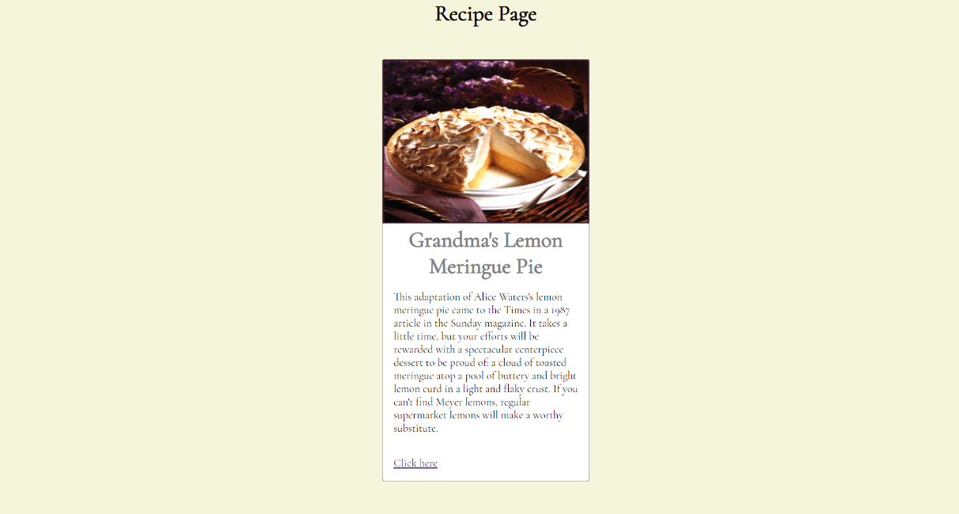

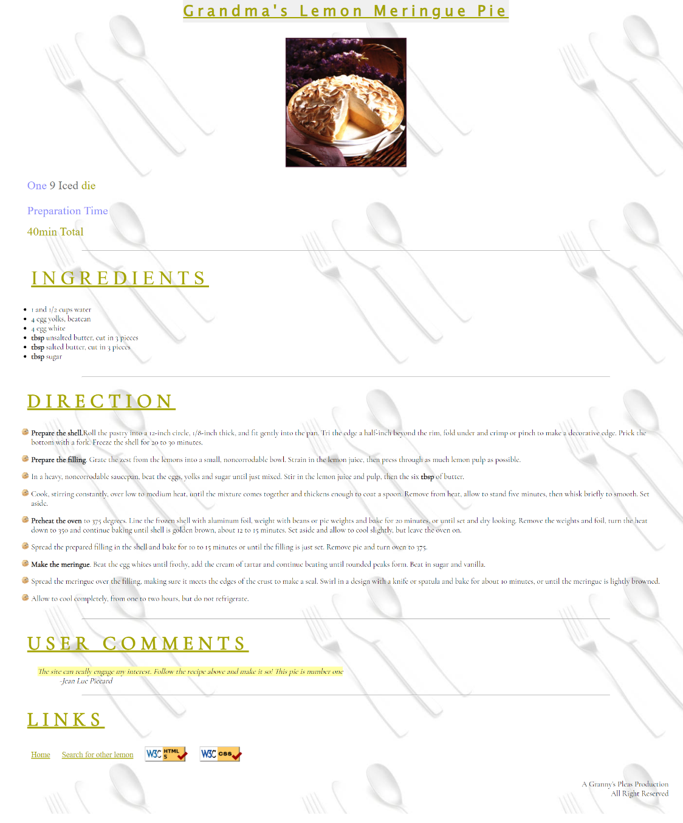**favourite_recipe.html**

