HARIKRISHNA.K

# EDUCATION

|  |  |  |
| --- | --- | --- |
| Degree/Grade | Institution | Score |
| B.E CSE | Sathyabama Institute of science and technology, Chennai | 8.47 CGPA (up to 6th semester) |
| Senior Secondary | Infant Jesus matriculation  higher secondary school, Tirupur | 71.33% |
| Secondary | Infant Jesus matriculation  higher secondary school, Tirupur | 93.6% |

**PROJECTS**

|  |  |
| --- | --- |
| **Project name** | **Project Action** |
| Covid Tracker (using Angular Framework) | Details of the patients verify how many cases are present in that district |
| Student infotainment system (using Django Framework) | One-point access to entire information related to any student in the university/college |

# INTERNSHIP

|  |  |
| --- | --- |
| **Internship Name** | **Action** |
| **TUFIDCO (Government Project)** | Created a website for (TUFIDCO)  My contribution to this project is the  The front-end part of this web application |

**CERTIFICATION:**

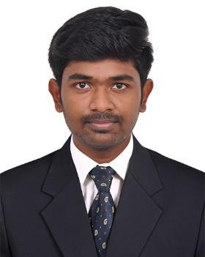



# CONTACT

PHONE:

+91-7358882652

EMAIL:

[k.harikris69@gmail.com](mailto:k.harikris69@gmail.com)



* Smart knower - Internship in Web Development
* TCS Ion career Edge – Young Professional
* IEEE - Web Development using React JS
* KPMG - Data Analytics Consulting Virtual Internship
* Accenture - Discovery Program
* JP Morgan Chase & Co - Software Engineering Virtual Experience
* Credo Systemz - python Django framework
* Credo Systemz - Angular framework
* TUFIDCO - Government Internship
* Teachnook-Amazon Web Services

# TECHNICAL SKILLS

* C
* C++
* Python
* SQL
* JavaScript
* Data structure
* HTML & CSS
* Django & Angular Framework
* Amazon Web Services