Researcher: Harikrishna Pillai
1) Personal and project-specific data
Project title: Learning Without Forgetting: Testing Short-Term Memory in Dendritic Neural Networks
Organizational unit: Chair of Scalable Software Architectures for Data Analytics, ScaDS.AI Dresden/Leipzig, TU Dresden
Funding line: STUDENTRESEARCH@TUD
Project period: 4 months (September 2026 – December 2026)

2) Abstract of your project
Artificial intelligence systems often struggle to learn new tasks without losing what they learned before. This project explores whether ideas from the brain can help them retain earlier knowledge.
Brain cells have branching extensions called dendrites, which help process information [1]. Earlier studies show that including such branches in AI networks can improve learning [2,3]. This project investigates two forms of memory: lasting connections that store learned knowledge, and temporary memory within individual branches that tracks recent learning feedback, with older feedback gradually losing influence.
The branches will compete, allowing different tasks to use different combinations of branches. The aim is for this separation to develop without telling the network which task it is performing, so that learning something new interferes less with earlier knowledge.
The network will learn a sequence of tasks and be compared with ordinary networks of similar size. Further tests will examine whether any improvement comes from the branches, their temporary memory, or their competition.
The main expected outcome is to establish whether this design helps different tasks use different branches and preserves earlier skills. The findings could guide the development of AI systems that keep learning without repeatedly relearning old knowledge.

3) Further links
How dendrites process information (Poirazi and Papoutsi, 2020).
Using dendrites in AI networks (Chavlis and Poirazi, 2025).
Dendritic networks for continual learning (Huang and colleagues, 2024).
4) Project-specific images, graphics and logos

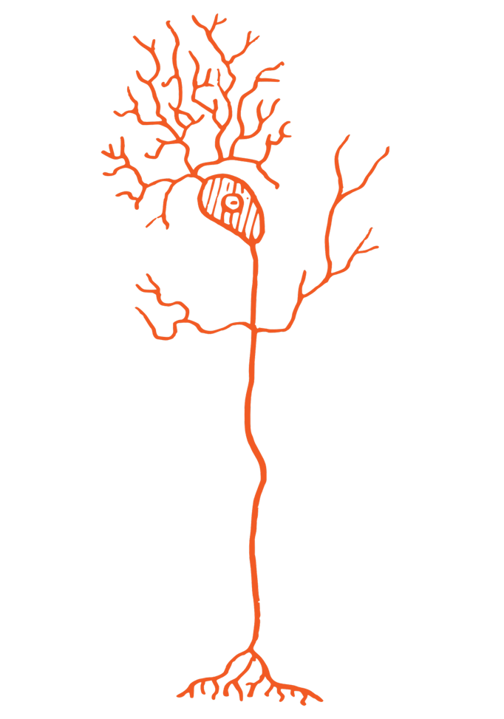
Figure 1. A biological neuron with branching dendrites that receive incoming signals. These structures inspire the artificial branches investigated in this project.
Image adapted from Pearson Scott Foresman; SVG version by Marekich. Source: Wikimedia Commons. Public domain (CC0 1.0).
Appendix Bibliography
[1] Poirazi, P., & Papoutsi, A. (2020). Illuminating dendritic function with computational models. Nature Reviews Neuroscience, 21, 303-321. Full paper
[2] Chavlis, S., & Poirazi, P. (2025). Dendrites endow artificial neural networks with accurate, robust and parameter-efficient learning. Nature Communications, 16, 943. Full paper
[3] Huang, Y., Fang, W., Ma, Z., Li, G., & Tian, Y. (2024). Flexible and Scalable Deep Dendritic Spiking Neural Networks with Multiple Nonlinear Branching. arXiv:2412.06355v1. Full paper

