|  |  |
| --- | --- |
| EXP.NO: 9 | **Case Study on**  **CPU Performance** |
| DATE:21.10.24 |

**Aim:**  
 To analyse the performance of cpu produced by intel and amd and identify who has best performance for price .

**Procedure :**

1.Import required modules

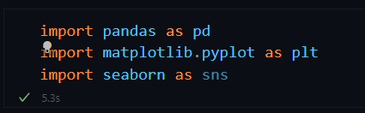

2. Load the Dataset and view it

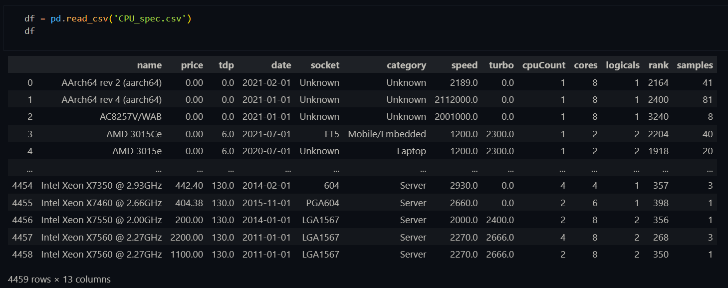

3. Perform EDA on the datatset

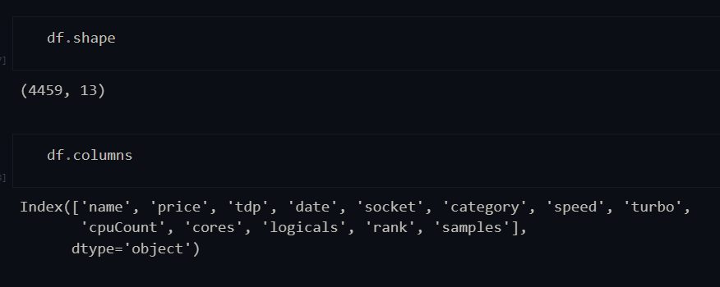

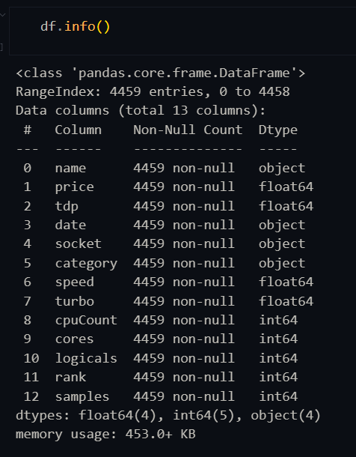

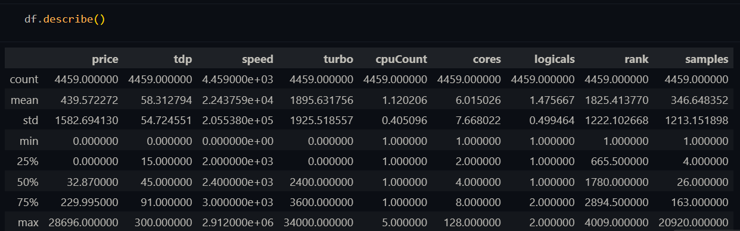

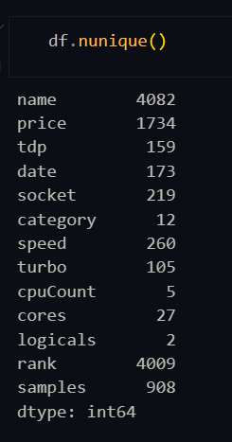

4. Removing Price marked as 0

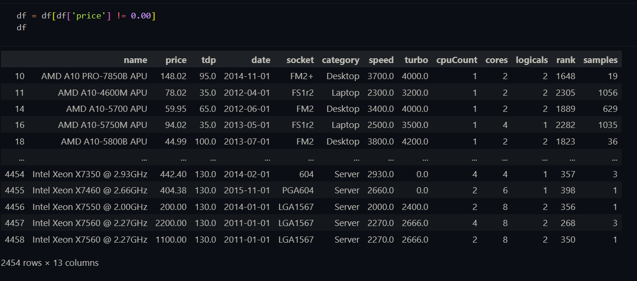

**Inference 1 : Plot The Difference in The Rank vs Price in The CPU's With Turbo Booster and Without Turbo Booster**

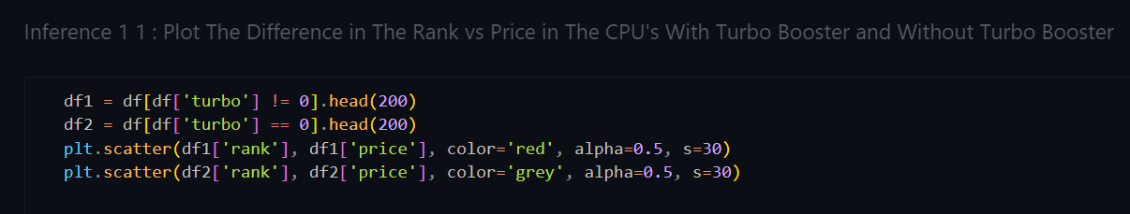

**Graph :**

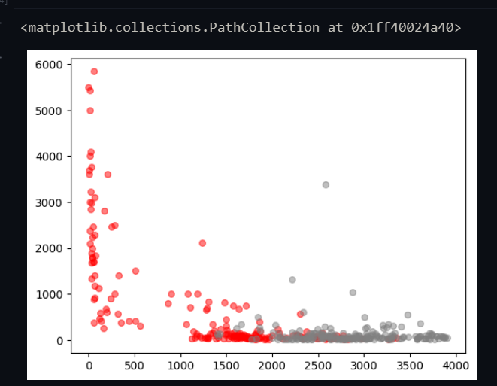

**Inferance 2 : Plot The Distribution of The Thermal Design Power (Maximum Power) in AMD and Intel Processors**

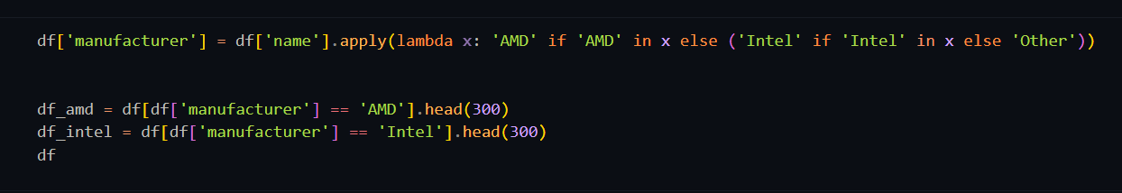

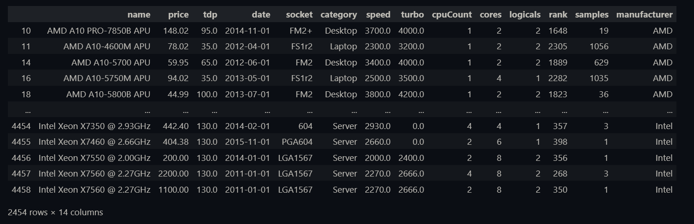

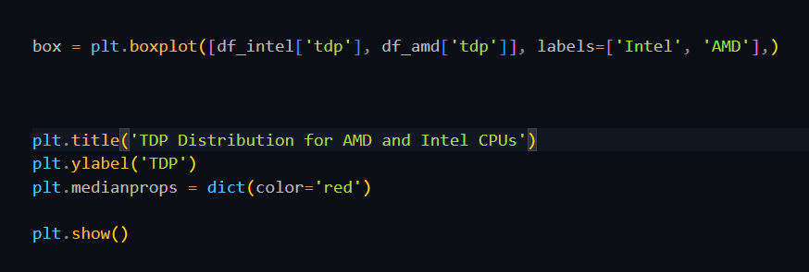

**Graph:**

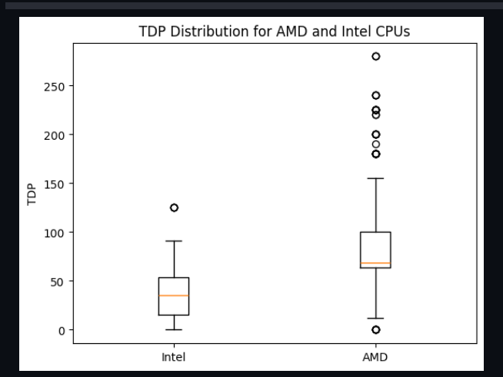

**Result:**

Thus analysis was made on dataset and inference such as Rank vs Price on Turbo Boosted CPU’s and TDP on Intel and AMD CPUs.