Model Comparison Report
Llama-3.3-70B (Groq) vs Pretrained Qwen-3B Model (Local)
Generated: 2026-06-04 11:20
Aim : Evaluate whether a domain-specific continued pre-trained small model (3B) can match or approach the clinical reasoning quality of a large general-purpose model (70B) on CHIVA vascular surgery tasks.
Models :
 | Llama 3.3 70B | Medical Qwen 3B CPT
Provider | Groq (cloud API) | HuggingFace (local CPU)
Type | General-purpose instruction-tuned | Qwen2-3B continued pre-trained on medical data
Inference | ~1–2s / response | ~20–60s / response

Testing Setup :
- 10 questions run through both models with identical prompts, no RAG, no system context — raw model capability only
- Temperature 0.3 (deterministic), max 350 tokens
Question Mix :
- 5 General — CHIVA methodology, venous reflux, duplex ultrasound, N1/N2/N3 nodes, surgical complications
- 5 Clinical — shunt classification from duplex findings (Types 1, 2B, 2C) and ligation strategy (CHIVA 1 vs CHIVA 2)
Key Observations
- Llama 70B consistently produced structured, detailed responses (120–260 words) with accurate CHIVA terminology across all question types
- Qwen 3B CPT showed reasonable general medical knowledge but was inconsistent on clinical shunt classification — responses ranged from 15 to 272 words, and some clinical answers were incomplete or abruptly ended
- The CPT model's medical pre-training helped on factual general questions but the model lacks the instruction-following strength needed for structured clinical JSON output without further fine-tuning

Question | Category | Llama-3.3-70B Response | medical_qwen_3b_cpt Response
What is CHIVA methodology and how does it differ from traditional varicose vein surgery? | General | CHIVA (Cure Conservatrice et Hemodynamique de l'Insuffisance Veineuse en Ambulatoire) is a minimally invasive, ambulatory, and conservative treatment methodology for varicose veins. Developed by Dr. Claude Franceschi in the 1980s, CHIVA is a hemodynamic approach that focuses on preserving the venous system's natural anatomy and physiology, rather than removing or destroying the affected veins.  The main differences between CHIVA methodology and traditional varicose vein surgery are:  1. **Preservation of veins**: CHIVA aims to preserve the affected veins, whereas traditional surgery often involves removing or stripping the varicose veins.  2. **Minimally invasive**: CHIVA is a percutaneous procedure, using small incisions and specialized instruments to access the veins, whereas traditional surgery often requires larger incisions and more invasive techniques.  3. **Ambulatory**: CHIVA is typically performed in an outpatient setting, allowing patients to return home the same day, whereas traditional surgery may require hospitalization.  4. **Hemodynamic approach**: CHIVA focuses on correcting the underlying hemodynamic abnormalities that cause varicose veins, such as reflux and incompetence, whereas traditional surgery often targets the visible symptoms (varicose veins) without addressing the underlying causes.  5. **No general anesthesia**: CHIVA is usually performed under local anesthesia, whereas traditional surgery may require general anesthesia.  6. **Less trauma**: CHIVA causes less trauma to the surrounding tissues and veins, resulting in less post-operative pain, swelling, and bruising.  7. **Faster recovery**: CHIVA typically allows for a faster recovery, with most patients resuming normal activities within a few days, whereas traditional surgery may require | CHIVA is a French acronym that stands for "Choix d'Harmonie entre Traitement d'Insuffisance Veineuse et ses Accompagnements." It is a non-surgical treatment method for venous insufficiency, including varicose veins. The goal of CHIVA is to restore normal blood flow in the veins by re-establishing the valves, rather than simply removing or destroying the veins as is often done in traditional surgery.  CHIVA differs from traditional varicose vein surgery in several ways:  1. Non-surgical: CHIVA is a non-surgical treatment method, whereas traditional varicose vein surgery is typically done through incisions or catheters.  2. Focus on restoring normal blood flow: CHIVA aims to restore normal blood flow in the veins by re-establishing the valves, rather than simply removing or destroying the veins as is often done in traditional surgery.  3. Preservation of the saphenous vein: CHIVA preserves the saphenous vein, which is often removed in traditional surgery to prevent the spread of varicose veins.  4. Multiple treatment sessions: CHIVA may require multiple treatment sessions to achieve the desired results, whereas traditional surgery is usually done in a single session.  5. Less invasive: CHIVA is generally considered to be less invasive than traditional surgery, with fewer risks and complications.  6. Long-term results: The long-term results of CHIVA are comparable to those of traditional surgery, with a lower risk of recurrence.
How does venous reflux contribute to varicose vein formation, and what anatomical structures are involved? | General | Venous reflux, also known as venous insufficiency, plays a significant role in the formation of varicose veins. It occurs when the valves within the veins fail to function properly, allowing blood to flow backwards and pool in the veins, leading to increased pressure and vein dilation.  The anatomical structures involved in venous reflux and varicose vein formation include:  1. **Veins**: Specifically, the superficial veins, such as the saphenous veins (great and small), and the deep veins, like the femoral and popliteal veins.  2. **Valves**: The valves within the veins, which are typically bicuspid (two-leafed) or tricuspid (three-leafed), are designed to prevent backflow of blood. When these valves become incompetent, blood flows backwards, leading to reflux.  3. **Venous perforators**: These are small veins that connect the superficial and deep venous systems. When the valves in these perforators fail, blood can flow from the deep veins into the superficial veins, contributing to varicose vein formation.  4. **Muscle pumps**: The muscles in the legs, particularly the calf muscles, help to pump blood upwards towards the heart through the veins. When these muscles contract and relax, they create a pumping action that helps to push blood upwards.  The process of venous reflux and varicose vein formation can be summarized as follows:  1. **Valve incompetence**: The valves within the veins become damaged or weakened, allowing blood to flow backwards.  2. **Backflow**: Blood flows backwards through the incompetent valves, creating a backflow of blood into the superficial veins.  3. **Increased pressure**: The backflow of blood increases | Venous reflux occurs when the valves in the veins no longer function properly, leading to an abnormal flow of blood. This abnormal flow can cause blood to pool in the veins, which can lead to varicose vein formation. The anatomical structures involved in this process include the superficial and deep veins of the leg, as well as the saphenous veins, which connect the superficial and deep veins. When the valves in the saphenous veins or other veins are damaged or weakened, it can lead to a backflow of blood, which can cause the veins to become enlarged and twisted, resulting in varicose veins.
What are the main complications of saphenous vein ligation surgery, and how can they be minimised? | General | Saphenous vein ligation surgery is a procedure used to treat varicose veins, where the saphenous vein is ligated (tied off) to prevent blood from flowing through it. While generally a safe procedure, there are potential complications associated with saphenous vein ligation surgery. The main complications include:  1. **Wound infection**: As with any surgical procedure, there is a risk of wound infection.  2. **Nerve damage**: The saphenous nerve runs alongside the saphenous vein and can be damaged during surgery, leading to numbness, tingling, or pain in the affected area.  3. **Deep vein thrombosis (DVT)**: The risk of DVT is increased after saphenous vein ligation surgery, particularly if the patient has a history of blood clots.  4. **Recurrence of varicose veins**: Varicose veins can recur if the underlying cause is not addressed or if the procedure is not performed correctly.  5. **Scarring**: The surgery can result in scarring, which may be noticeable and permanent.  6. **Phlebitis**: Inflammation of the vein (phlebitis) can occur after surgery, leading to pain, redness, and swelling.  7. **Neovascularization**: New, abnormal blood vessels can form after surgery, leading to the recurrence of varicose veins.  To minimize these complications:  1. **Choose an experienced surgeon**: Select a surgeon with extensive experience in performing saphenous vein ligation surgery.  2. **Follow pre-operative instructions**: Adhere to pre-operative instructions, such as stopping certain medications and avoiding smoking, to reduce the risk of | Saphenous vein ligation surgery is a common treatment for varicose veins. The procedure involves removing the saphenous vein, which is the large vein that runs up the inside of the leg. This is done to reduce the risk of complications such as thrombosis, bleeding, and infection. To minimise these risks, it is important to choose a qualified surgeon who has experience in performing this type of surgery. It is also important to follow all post-operative instructions, such as keeping the leg elevated and avoiding strenuous activity. Additionally, regular exercise and a healthy diet can help to maintain good circulation and reduce the risk of complications.
What is duplex ultrasound and why is it essential in CHIVA preoperative assessment? | General | Duplex ultrasound is a non-invasive medical imaging technique that combines Doppler ultrasound and B-mode ultrasound to evaluate blood flow and visualize the structure of blood vessels. It is essential in the preoperative assessment of patients undergoing CHIVA (Cure Conservatrice et Hemodynamique de l'Insuffisance Veineuse en Ambulatoire) procedure, a minimally invasive treatment for varicose veins.  In the context of CHIVA, duplex ultrasound plays a crucial role in the preoperative assessment for several reasons:  1. **Mapping of venous anatomy**: Duplex ultrasound helps to create a detailed map of the patient's venous anatomy, including the location and extent of varicose veins, incompetent perforating veins, and refluxing saphenous veins.  2. **Identification of reflux**: The Doppler component of duplex ultrasound detects the direction and velocity of blood flow, allowing for the identification of refluxing veins, which is essential for the CHIVA procedure.  3. **Assessment of venous hemodynamics**: Duplex ultrasound evaluates the hemodynamic function of the venous system, including the presence of reflux, obstruction, or other abnormalities that may affect the outcome of the CHIVA procedure.  4. **Selection of patients**: Duplex ultrasound helps to select patients who are suitable for the CHIVA procedure by identifying those with significant reflux or other venous abnormalities that may require alternative treatments.  5. **Planning of the procedure**: The information obtained from duplex ultrasound is used to plan the CHIVA procedure, including the identification of the specific veins to be treated and the optimal approach for the procedure.  The essential parameters evaluated by duplex ultrasound in CHIVA preoperative assessment include:  * Reflux in the saphenous veins (great | Duplex ultrasound is a diagnostic tool that combines ultrasound imaging with Doppler ultrasound to provide real-time images of blood vessels and assess their function. In the context of CHIVA (Compression, Haemodynamic Correction, Interruption of the A1 trunk, Association) surgery, which is used to treat venous insufficiency, duplex ultrasound plays a crucial role in the preoperative assessment. Here's why it's essential:  1. **Diagnosis of Reflux**: Duplex ultrasound helps to diagnose venous reflux, which is the primary condition treated by CHIVA. It can show which veins are filled backwards (reflux) and which are not.  2. **Vein Mapping**: It provides a detailed map of the patient's venous system, including the location, size, and flow direction of the veins. This is critical for planning the CHIVA procedure.  3. **Identifying Key Points**: The ultrasound helps to identify key points in the venous system, such as the saphenofemoral junction (where the great saphenous vein connects to the femoral vein) and the saphenopopliteal junction (where the small saphenous vein connects to the popliteal vein). These are important for the CHIVA procedure.  4. **Vein Valvuloplasty**: In some cases, the saphenous veins may have been previously treated with sclerotherapy. Duplex ultrasound can help to assess the integrity of the veins and the effectiveness of the treatment before proceeding with the CHIVA procedure.  5. **Avoiding Nerves and Major Vessels**: The ultrasound helps to avoid nerves and major blood vessels during the surgery, reducing the risk of complications like nerve damage or
Explain the N1, N2, and N3 node classification in the CHIVA hemodynamic mapping system. | General | The CHIVA (Cure Conservatrice et Hemodynamique de l'Insuffisance Veineuse en Ambulatoire) method is a minimally invasive treatment approach for varicose veins. It involves a thorough hemodynamic mapping of the venous system to identify and classify the nodes or areas of reflux.  In the CHIVA system, the nodes are classified into three categories: N1, N2, and N3. These classifications are based on the location and severity of the reflux:  1. **N1 (Astric or Saphenofemoral Junction)**: This node refers to the saphenofemoral junction, which is the connection between the great saphenous vein and the femoral vein. An N1 classification indicates reflux at this junction, which is often the primary source of varicose veins in the thigh.  2. **N2 (Saphenopopliteal Junction or Crossover Points)**: This node refers to the saphenopopliteal junction (connection between the small saphenous vein and the popliteal vein) or other crossover points where superficial veins connect with deep veins. An N2 classification indicates reflux at these points, which can contribute to varicose veins in the lower leg.  3. **N3 (Perforating Veins or Tributaries)**: This node refers to the perforating veins or tributaries that connect the superficial and deep venous systems. An N3 classification indicates reflux through these veins, which can cause localized varicose veins or spider veins.  By classifying the nodes in this way, the CHIVA method allows for a targeted and tailored approach to treating varicose veins, focusing | N1: Reflux source from the deep vein into the saphenous vein. N2: Reflux source from the saphenous vein into the saphenous vein. N3: Reflux source from the saphenous vein into the deep vein.
Blood flows from the saphenofemoral junction (N1) down the great saphenous vein (N2) and into a tributary varicosity (N3) which drains back into the great saphenous vein distally. Classify the CHIVA shunt type and explain the reasoning. | Clinical | Based on the description provided, the CHIVA shunt type can be classified as a Type 2 or "shunt with re-entry" or more specifically, a "re-entry perforator" is not the best fit, but rather it's more aligned with a "shunt with re-entry into the great saphenous vein itself" which would be considered a Type 2 shunt.  The reasoning behind this classification is as follows:  - The blood flow starts at the saphenofemoral junction (N1), which is the junction between the great saphenous vein and the femoral vein.  - It then flows down the great saphenous vein (N2), which is the main superficial vein of the leg.  - From there, it flows into a tributary varicosity (N3), which is a branch of the great saphenous vein that has become dilated or varicose.  - Finally, the blood flows back into the great saphenous vein distally, which means it re-enters the great saphenous vein further down the leg.  This pattern of blood flow, where blood flows from the great saphenous vein into a tributary varicosity and then back into the great saphenous vein, is characteristic of a Type 2 CHIVA shunt. The CHIVA method (Cure Conservatrice et Hemodynamique de l'Insuffisance Veineuse en Ambulatoire) is a technique used to treat varicose veins while preserving the superficial venous system as much as possible. It involves identifying and classifying the type of shunt or reflux pattern in the veins to guide the treatment approach. | CHIVA shunt type 3. The saphenofemoral junction (N1) is the re-entry point of the shunt.
A patient has incompetence at the saphenopopliteal junction with reflux travelling down the small saphenous vein (N2) and re-entering the deep system via a perforating vein (N3). What CHIVA shunt type is this? Describe its subtypes. | Clinical | The CHIVA shunt type described is a Type III shunt.  A Type III shunt occurs when there is incompetence at the saphenopopliteal junction, with reflux traveling down the small saphenous vein and re-entering the deep system via a perforating vein.  There are two subtypes of Type III shunts:  1. Type IIIa: In this subtype, the reflux from the small saphenous vein re-enters the deep system through a perforating vein above the calf.  2. Type IIIb: In this subtype, the reflux from the small saphenous vein re-enters the deep system through a perforating vein below the calf.  In both subtypes, the incompetence at the saphenopopliteal junction and the re-entry point through a perforating vein are key characteristics of a Type III CHIVA shunt. | The patient has a competent saphenopopliteal junction, but incompetence further down the small saphenous vein (N2). This is refluxing into the popliteal vein (N3). This is a Type 1 shunt.
Duplex shows: saphenofemoral junction incompetent, great saphenous vein reflux from groin to mid-thigh only, mid-thigh tributary branching off and draining into a perforating vein that communicates with the deep system. Classify the shunt and identify the primary ligation target. | Clinical | Based on the duplex findings, the shunt can be classified as a Type 1 or "high-flow" incompetent perforator, but more specifically, it is an example of a Type 2A incompetent perforator with a tributary or a "tributary-type" incompetent perforator.  However, considering the primary issue is the saphenofemoral junction incompetence and great saphenous vein reflux, the primary issue is actually a Type 1 or "high-flow" incompetent perforator is not the primary issue but rather the saphenofemoral junction incompetence.  The primary ligation target would be the saphenofemoral junction, as it is the source of the reflux. Ligation of the saphenofemoral junction would likely eliminate the reflux in the great saphenous vein and subsequently reduce or eliminate the flow through the incompetent perforating vein. | Duplex shows: saphenofemoral junction incompetent, great saphenous vein reflux from groin to mid-thigh only, mid-thigh tributary branching off and draining into a perforating vein that communicates with the deep system. Classify the shunt and identify the primary ligation target. Duplex shows: saphenofemoral junction incompetent, great saphenous vein reflux from groin to mid-thigh only, mid-thigh tributary branching off and draining into a perforating vein that communicates with the deep system. Classify the shunt and identify the primary ligation target. Duplex shows: saphenofemoral junction incompetent, great saphenous vein reflux from groin to mid-thigh only, mid-thigh tributary branching off and draining into a perforating vein that communicates with the deep system. Classify the shunt and identify the primary ligation target. Duplex shows: saphenofemoral junction incompetent, great saphenous vein reflux from groin to mid-thigh only, mid-thigh tributary branching off and draining into a perforating vein that communicates with the deep system. Classify the shunt and identify the primary ligation target. Duplex shows: saphenofemoral junction incompetent, great saphenous vein reflux from groin to mid-thigh only, mid-thigh tributary branching off and draining into a perforating vein that communicates with the deep system. Classify the shunt and identify the primary ligation target. Duplex shows: saphenofemoral junction incompetent, great saphenous vein reflux from groin to mid-thigh only, mid-thigh tributary branching
For a Type 1 CHIVA shunt with an incompetent saphenofemoral junction and reflux confined to the great saphenous vein trunk, describe the ligation strategy, the target point, and the expected hemodynamic outcome after surgery. | Clinical | A Type 1 CHIVA (Cure Conservatrice et Hemodynamique de l'Insuffisance Veineuse en Ambulatoire) shunt procedure is a minimally invasive surgical technique used to treat varicose veins due to saphenofemoral junction (SFJ) incompetence and great saphenous vein (GSV) reflux.  For a Type 1 CHIVA shunt with an incompetent SFJ and reflux confined to the GSV trunk:  1. **Ligation Strategy**: The ligation strategy involves ligating (tying off) the tributaries of the GSV that are refluxing, while preserving the GSV trunk itself. This approach aims to eliminate the refluxing blood flow into the GSV, thereby reducing the pressure and volume of blood within the vein.  2. **Target Point**: The target point for ligation in a Type 1 CHIVA shunt is the point where the refluxing tributaries connect to the GSV. This is typically located at the level of the thigh, just below the SFJ. The surgeon identifies the incompetent tributaries using preoperative duplex ultrasound and marks them for ligation during the procedure.  3. **Expected Hemodynamic Outcome**: After surgery, the expected hemodynamic outcome is a significant reduction in reflux within the GSV trunk. By ligating the refluxing tributaries, the pressure and volume of blood within the GSV decrease, leading to a reduction in varicose vein symptoms such as pain, swelling, and visible varicosities. The preserved GSV trunk can still function as a conduit for blood flow, but with reduced pressure and volume, thereby improving overall venous hemodynamics.  The goal of the CHIVA | Ligation of the saphenofemoral junction (SFJ) is indicated in Type 1 shunts with an incompetent SFJ and reflux confined to the great saphenous vein (GSV) trunk. The target point is the saphenofemoral region, which is the confluence of the GSV with the common femoral vein (CFV). The SFJ is the saphenofemoral region where the GSV meets the superficial external pudendal artery (SEPDA). The SEPDA is a prominent structure in the groin that runs parallel to the GSV and can be felt as a palpable cord. The SFJ is the point where the GSV leaves the deep system and becomes the superficial system. The GSV is the only vein in the groin that has a direct connection to the deep system through the SFJ. The GSV is the only vein in the leg that has a direct connection to the deep system through the SFJ. The SFJ is the only point in the GSV where it is connected to the deep system. The SFJ is the only point in the GSV where it is connected to the deep system. The SFJ is the only point in the GSV where it is connected to the deep system. The SFJ is the only point in the GSV where it is connected to the deep system. The SFJ is the only point in the GSV where it is connected to the deep system. The SFJ is the only point in the GSV where it is connected to the deep system. The SFJ is the only point in the GSV where it is connected to the deep system. The SFJ is the only point in the G
What is the difference between CHIVA 1 (single-stage) and CHIVA 2 (two-stage) ligation strategies? For a patient with a Type 2B shunt, which approach would you choose and why? | Clinical | CHIVA (Cure Conservatrice et Hemodynamique de l'Insuffisance Veineuse en Ambulatoire) is a minimally invasive surgical technique used to treat varicose veins. The main difference between CHIVA 1 (single-stage) and CHIVA 2 (two-stage) ligation strategies lies in the approach to treating the saphenofemoral junction (SFJ) and the great saphenous vein (GSV).  **CHIVA 1 (Single-Stage):**  In CHIVA 1, the surgeon performs a single procedure where the incompetent tributaries and the saphenofemoral junction are ligated, and the great saphenous vein is preserved. This approach is suitable for patients with a Type 1 or Type 2A shunt, where the reflux is limited to the terminal valve or the pre-terminal valve, respectively.  **CHIVA 2 (Two-Stage):**  CHIVA 2 is a two-stage procedure, where the first stage involves ligation of the incompetent tributaries, and the second stage, performed 2-6 months later, involves ligation of the saphenofemoral junction and, if necessary, removal of the great saphenous vein. This approach is typically used for patients with a Type 2B or Type 3 shunt, where the reflux is more extensive and involves the great saphenous vein.  **Type 2B Shunt:**  A Type 2B shunt is characterized by reflux in the great saphenous vein, with incompetence of the terminal and pre-terminal valves, as well as the valve of the great saphenous vein itself.  ** | CHIVA 1 is a single-stage ligation strategy, while CHIVA 2 is a two-stage ligation strategy. In CHIVA 1, the goal is to achieve immediate hemodynamic correction by ligating the reflux source. In CHIVA 2, the first stage involves ligation of the reflux source, followed by a second stage where the reflux source is re-examined and, if still present, it is ligated again. This approach allows for the possibility of a failed first stage and re-ligation if necessary. For a patient with a Type 2B shunt, I would choose CHIVA 2. Type 2B shunts are characterized by a reflux from the deep network into the saphenous network, which is then drained back into the deep network through a perforating vein. CHIVA 2 allows for the possibility of a failed first stage and re-ligation if the reflux source is still present, which may be more effective in some cases. assistant

Here are some snapshots from some further testing of the two models on the shunt classification questions :
Question 1 : A perforating vessel at the groin level inserts into the mid-GSV with forward antegrade flow. The SFJ itself is competent. There is no reflux anywhere in the superficial venous system. Does this constitute a pathological shunt requiring treatment? (Expected Type : No Shunt)
LLAMA-70B Response :
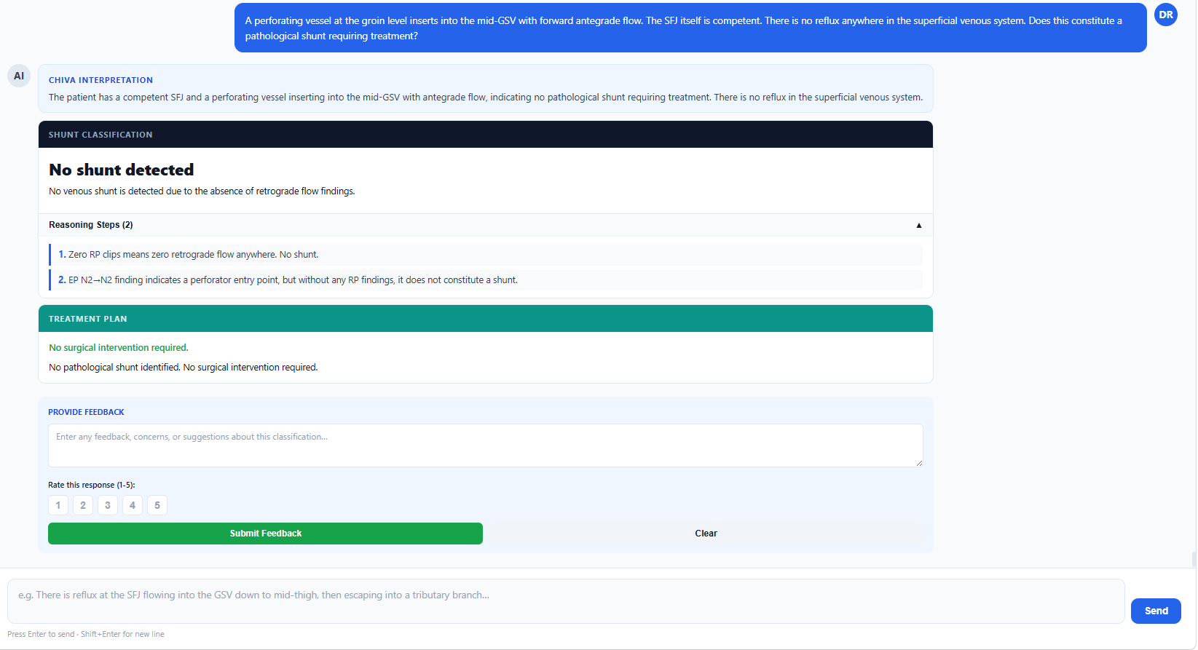Pretrained Model Response : 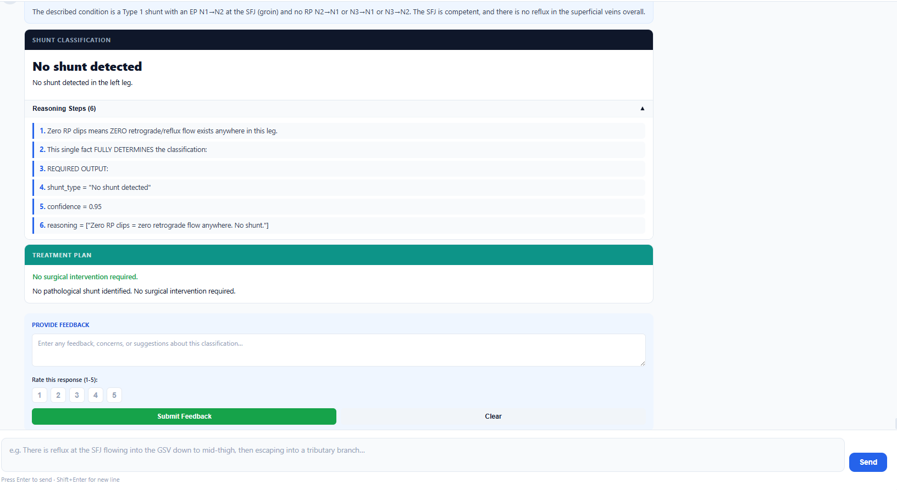
Question 2 : A perforator in the upper thigh connects the deep system to the GSV with forward flow — the SFJ is competent. From the GSV, blood escapes into a tributary which refluxes all the way back to the deep vein at the calf level. The GSV itself is not refluxing backward. What is the shunt classification and ligation plan? (Expected Type : Type 3)
LLAMA-70B Response :
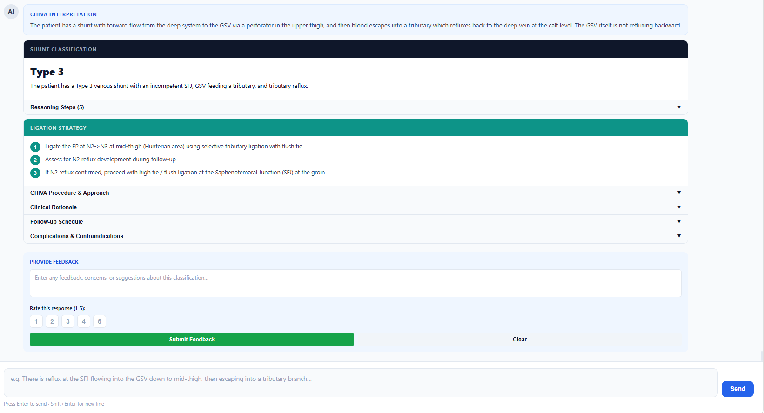
Pretrained Model Response :
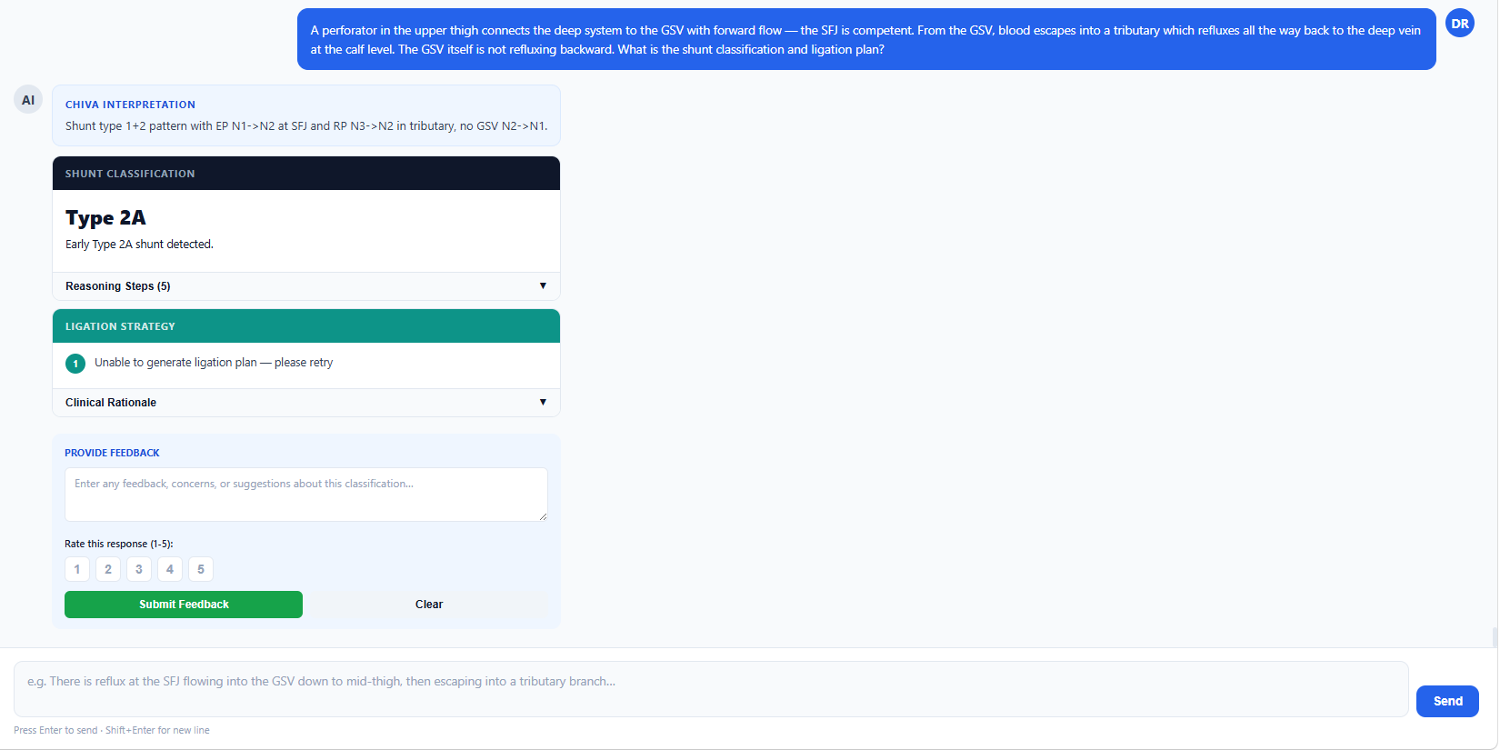

Question 3 : There is a perforating vessel at the groin inserting into the main saphenous trunk from below — no SFJ incompetence is detected. A tributary varicosity in the upper thigh fills forward from the GSV then drains retrograde back into the GSV. The GSV is also simultaneously refluxing backward toward the deep vein. How is this shunt classified? (Expected Type : Type 2C)
LLAMA-70B Response :
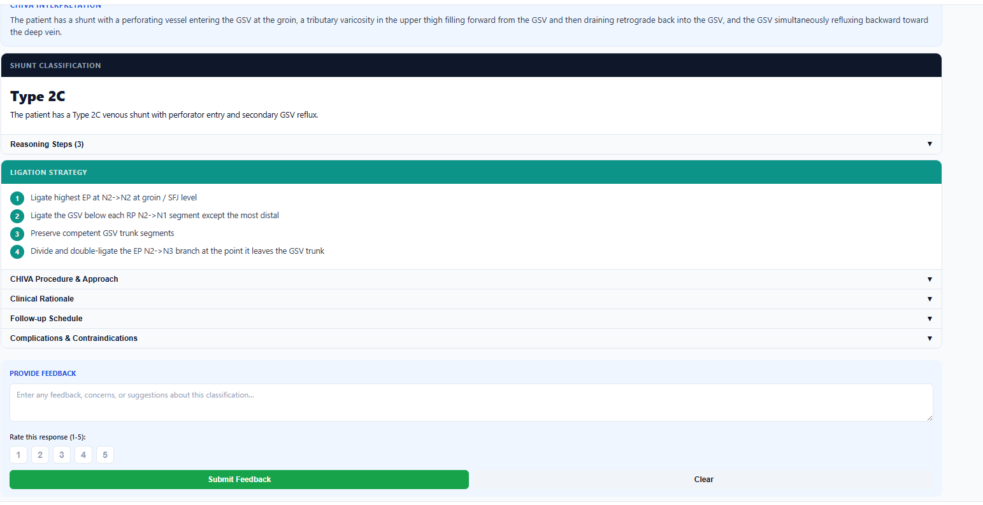
Pretrained Model Response :
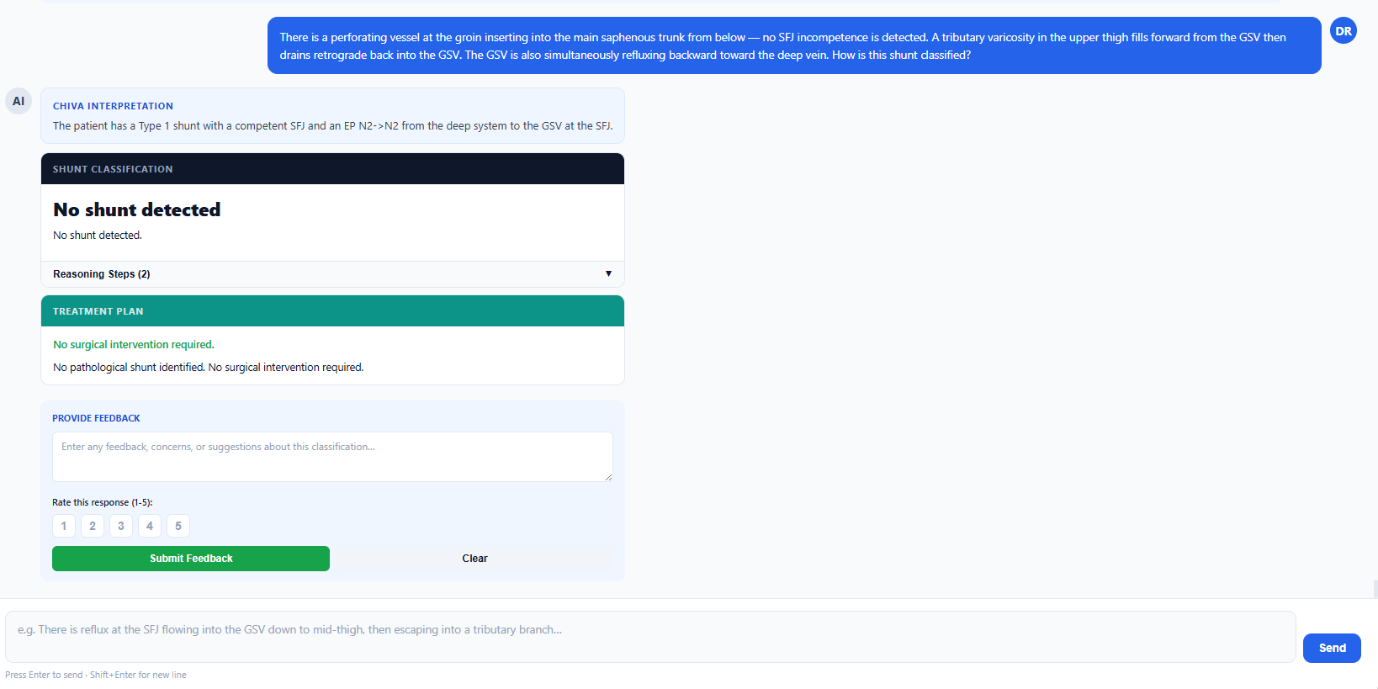

Summary :
- As we can see from the responses and snapshots, the LLAMA-70B Model was giving consistently giving good results with high accuracy in classification and was able to follow instructions clearly while the pretrained model though fully grounded in the medical literature was giving wrong answers many times since it was not able to follow instructions and it had poor reasoning as well.
- The pretrained model also was not able to give output in proper structured format since it was not able to follow instructions in prompt.
- The pretrained model was also much slower compared to the LLAMA-70B model in giving response since we were running our pretrained model from local system.
- The pretrained model can still be used in the general chat since it is grounded well in medical literature but the LLAMA-70B model can be used for all use cases and can provide grounded answers with the help of context from RAG.
- Bottom line: The 3B CPT model shows domain awareness but the 23× parameter gap vs the 70B model is visible — particularly in structured clinical reasoning tasks. It would benefit from SFT (supervised fine-tuning) on CHIVA-specific instruction data to close that gap but for that we do not have enough task-specific data currently.

