Manual Testing of Short Scenarios to determine if Shunt System is working well:

Type 1 — SFJ entry + GSV trunk reflux
Important: drag the probe past SPJ zone (posY ≈ 0.50) at some point before marking RP N2→N1 — the system checks that the popliteal region was visited before declaring complete.

Step Clip posY Notes
1 EP N1→N2 0.06 Groin/SFJ
2 — 0.50 Just move probe here (no mark)
3 RP N2→N1 0.25 Mid-thigh
→ Expected: action = complete
→ Result: Scenario Passed and Shunt Identified Correctly
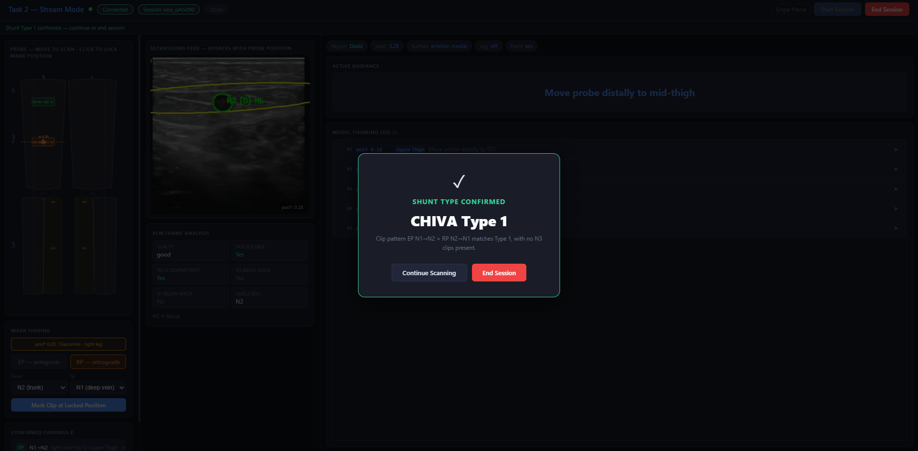
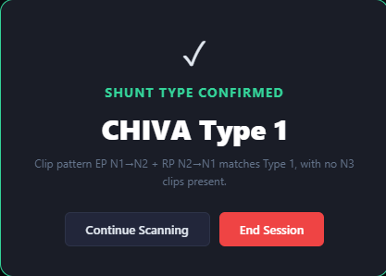

Type 2A — Trunk escape, SFJ competent, no re-entry back to trunk
Step Clip posY
1 EP N2→N3 0.30
2 RP N3→N1 0.65
Do NOT mark EP N1→N2 or RP N2→N1.
→ Expected: action = complete
→ Result: Scenario Passed and Shunt Identified Correctly
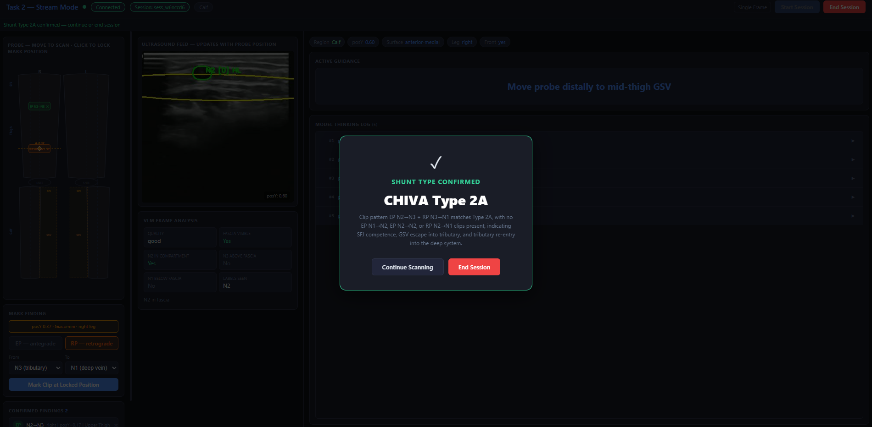
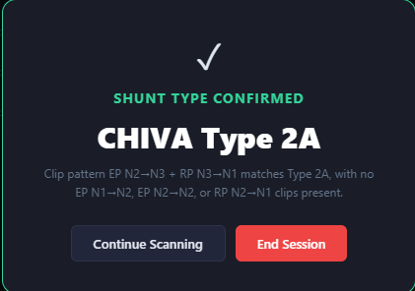

Type 2B — Perforator feeds GSV, drains via tributary only
Step Clip posY
1 EP N2→N2 0.40
2 RP N3→N1 0.65
Do NOT mark EP N1→N2 or RP N2→N1.
→ Expected: action = complete
→ Result: Scenario Passed and Shunt Identified Correctly
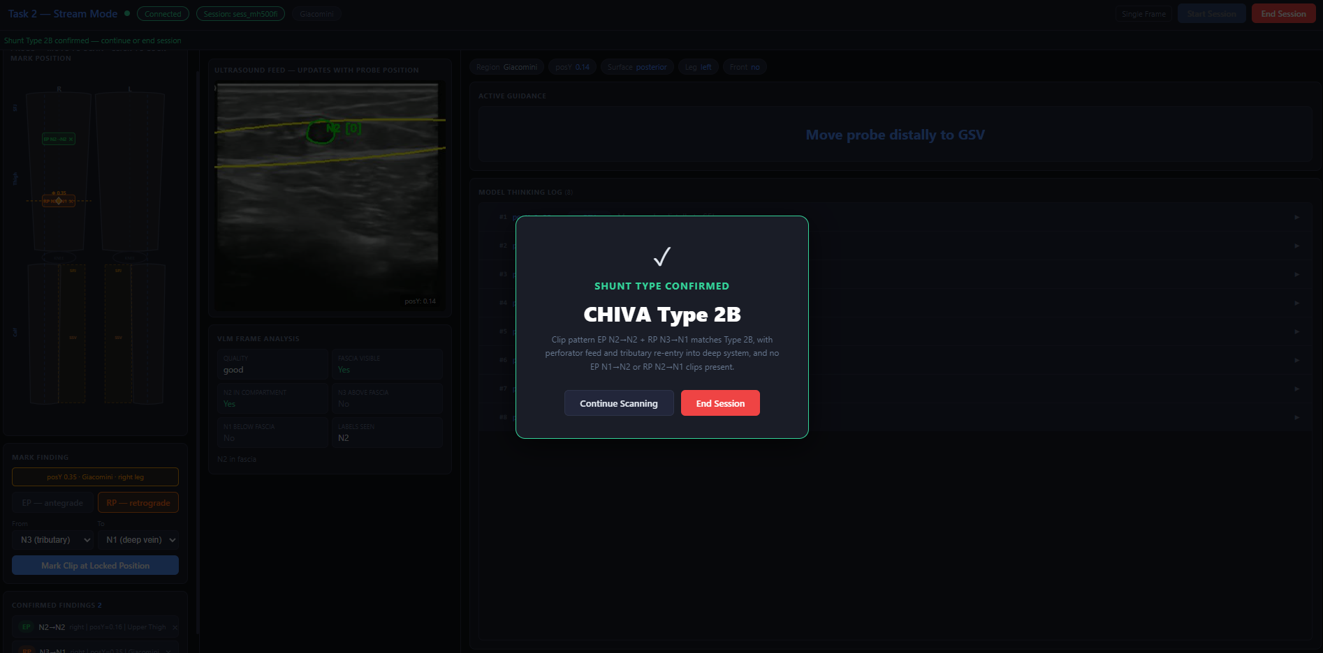
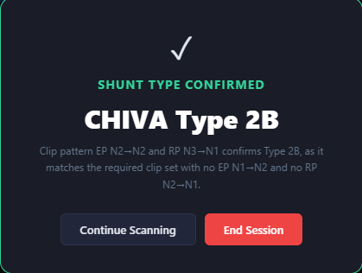

Type 2C — Perforator entry + secondary trunk reflux
Step Clip posY
1 EP N2→N2 0.40
2 RP N3→N1 0.65
3 RP N2→N1 0.25
Do NOT mark EP N1→N2.
→ Expected: action = complete
→ Result: Scenario Passed and Shunt Identified Correctly
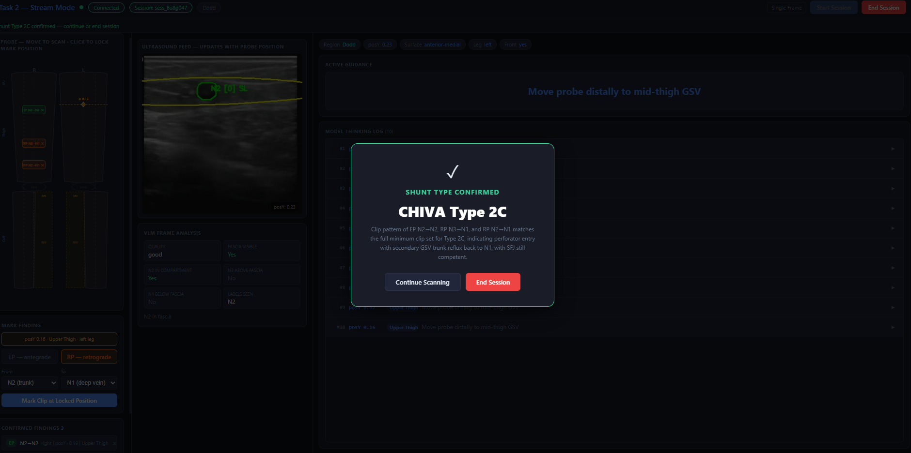
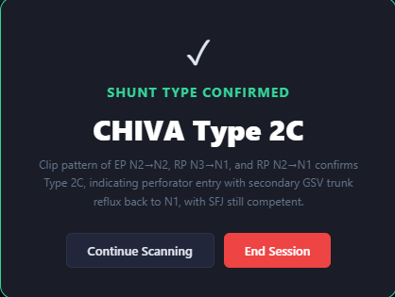
Type 3 — SFJ entry, GSV conduit to escape (no trunk reflux)
Step Clip posY
1 EP N1→N2 0.06
2 EP N2→N3 0.25
3 RP N3→N1 0.65
Do NOT mark RP N2→N1.
→ Expected: action = complete
→ Result: Scenario Passed and Shunt Identified Correctly
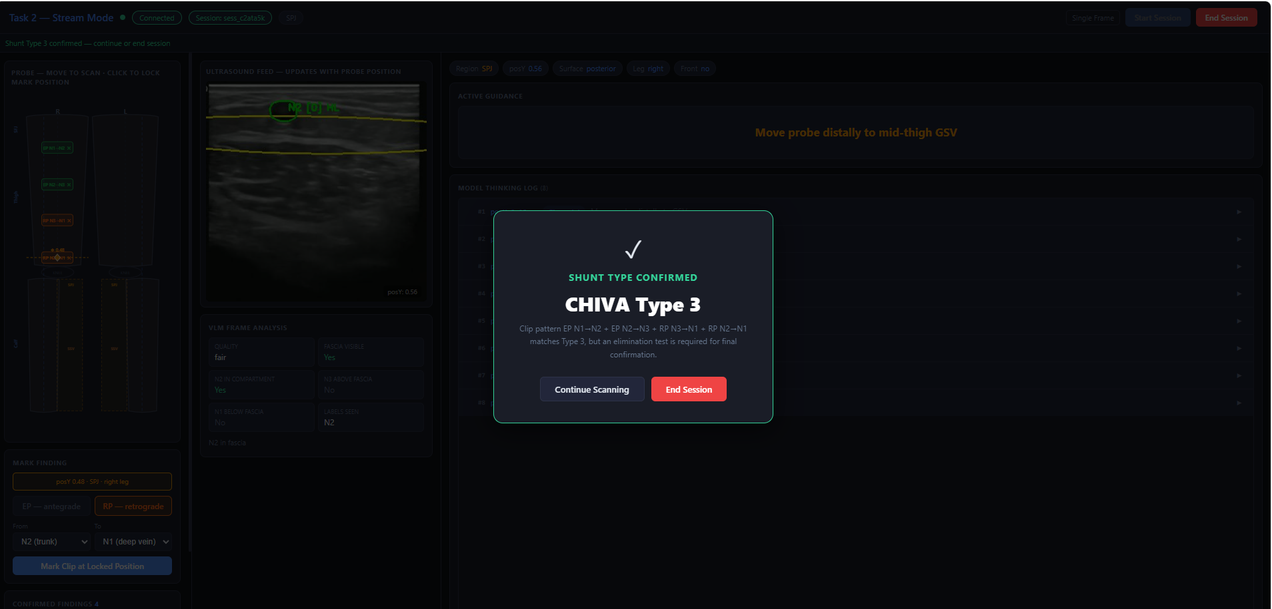
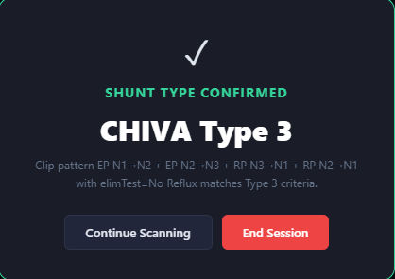

In elimination test (more clinically rigorous): mark all four clips including RP N2→N1 → system returns action = maneuver → click "No Reflux" in the elimination test banner → action = complete.
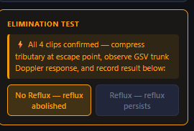
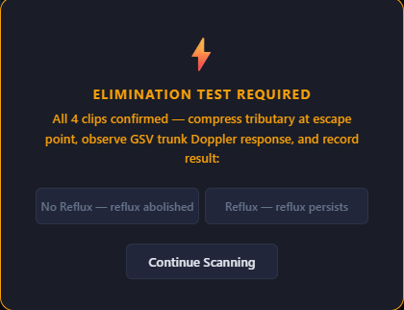

Type 1+2 — Same as Type 3 but elimination test shows reflux persists
Step Clip posY
1 EP N1→N2 0.06
2 EP N2→N3 0.25
3 RP N3→N1 0.65
4 RP N2→N1 0.40
→ System returns action = maneuver → click "Reflux" in the elimination test banner → action = complete
→ Result: Scenario Passed and Shunt Identified Correctly
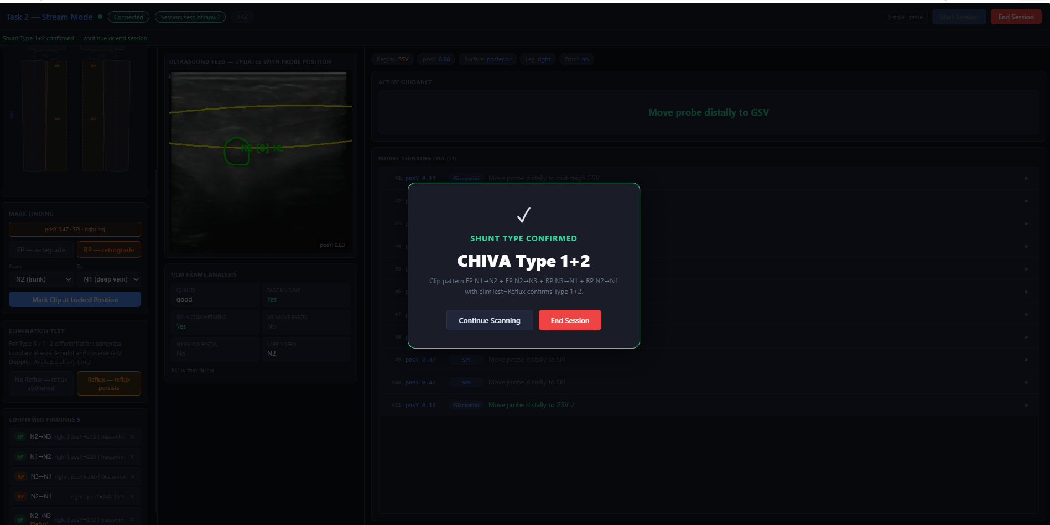
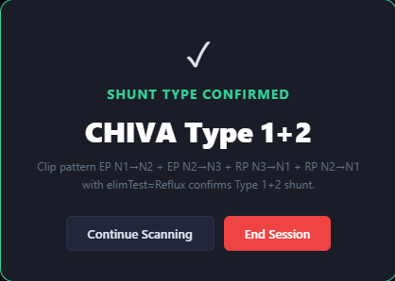

Type 4 — Deep blood directly into tributary, trunk refluxes back
Step Clip posY
1 EP N1→N3 0.35
2 RP N2→N1 0.25
→ Expected: action = complete (fires immediately — this is the explicit Type 4 complete rule)
→ Result: Scenario Passed and Shunt Identified Correctly
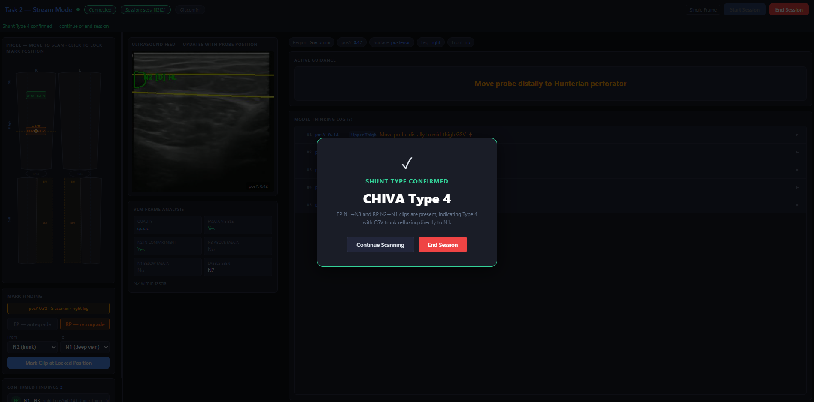
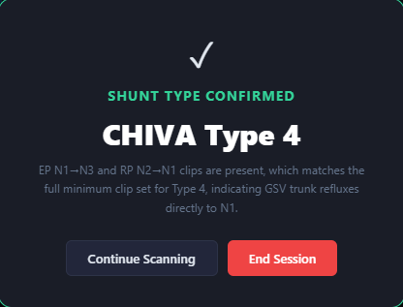

Type 5 — Complex loop: deep→tributary→trunk→tributary→deep
Step Clip posY
1 EP N1→N3 0.30
2 RP N3→N2 0.45
3 EP N2→N3 0.55
4 RP N3→N1 0.70
Do NOT mark RP N2→N1.
→ Expected: action = complete
→ Result: Scenario Passed and Shunt Identified Correctly
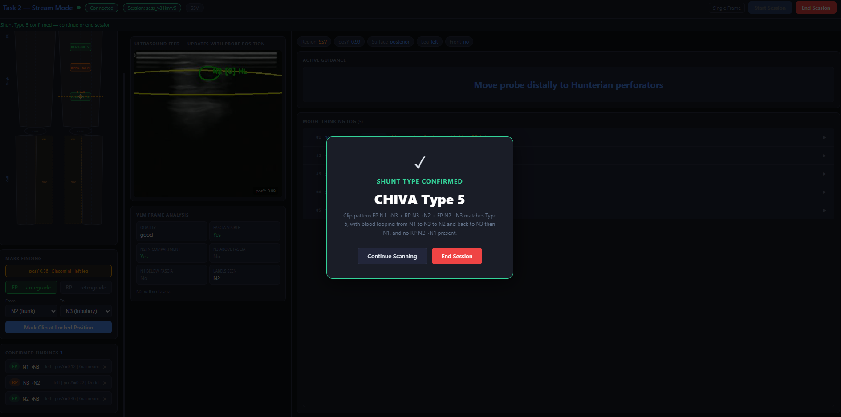
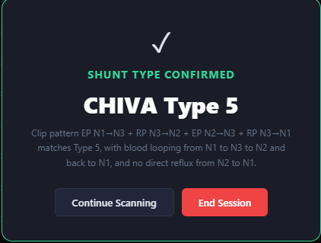

Type 6 — Pure perforator circuit, trunk completely bypassed
Step Clip posY
1 EP N1→N3 0.35
2 RP N3→N1 0.65
Mark absolutely no N2 clips (no EP N1→N2, no EP N2→N3, no RP N2→N1, no RP N3→N2).
→ Expected: action = complete
→ Result: Scenario Passed and Shunt Identified Correctly
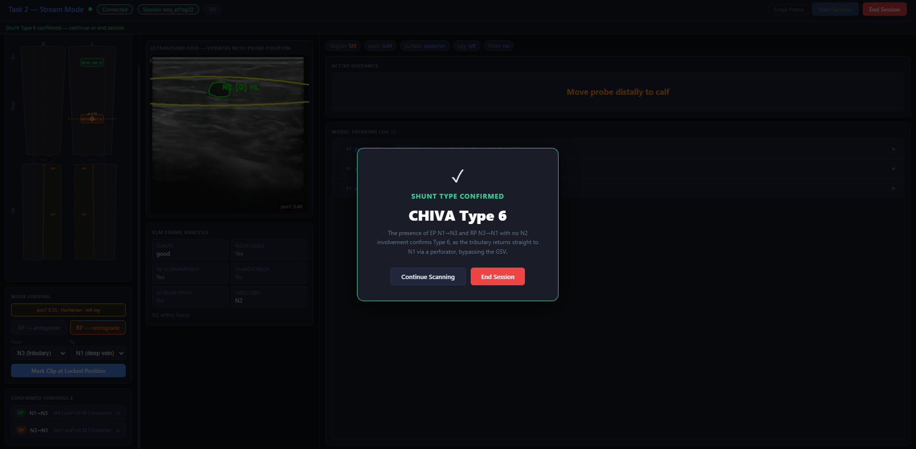
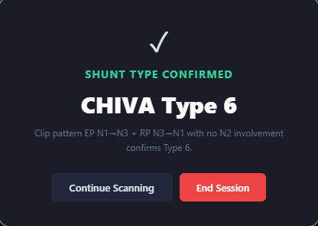

Quick reference — few manual mistakes that can happen and how the system would respond to the testing :

Type | Most common mistake
2A/2B | Accidentally adding RP N2→N1 — that changes it to 2C
3 | Adding RP N2→N1 without elimination test — system will demand maneuver
1+2 vs 3 | Same 4 clips; elimination test result is the only differentiator
4 | Adding any RP N3→N1 alongside RP N2→N1 changes it to Type 5
6 | Any N2 clip (RP N3→N2 or RP N2→N1) would reclassify toward Type 4/5

Interface :
