Task 1 — Developer Guide
CHIVA Clinical Assistant — Shunt Classification & Ligation Planning and General QnA

1. High-Level Architecture
Task 1 is a Flask backend (backend/app.py) serving a single-page frontend (frontend/index.html) plus two secondary pages (general.html for open medical Q&A, admin.html for user/session management). Clinical input is either free-text or raw clip JSON and is classified into a CHIVA shunt type and a suitable ligation plan is also generated using an LLM (Groq) grounded by a RAG pipeline over a ligation knowledge base (Qdrant + BM25 + cross-encoder reranking). CrewAI wraps the LLM calls as agents but the underlying prompts and business logic are unchanged from the original direct-call implementation.

2. System Diagram
Note : The clinical chat functions (parse_nl_to_clips,build_conversational_response, classify_and_plan_ligation_with_llm, run_pipeline) are only ever called from ‘routes/clinical.py’ and general chat functions (generate_general_response()) is only ever called from routes/general.py. Neither path calls the other.
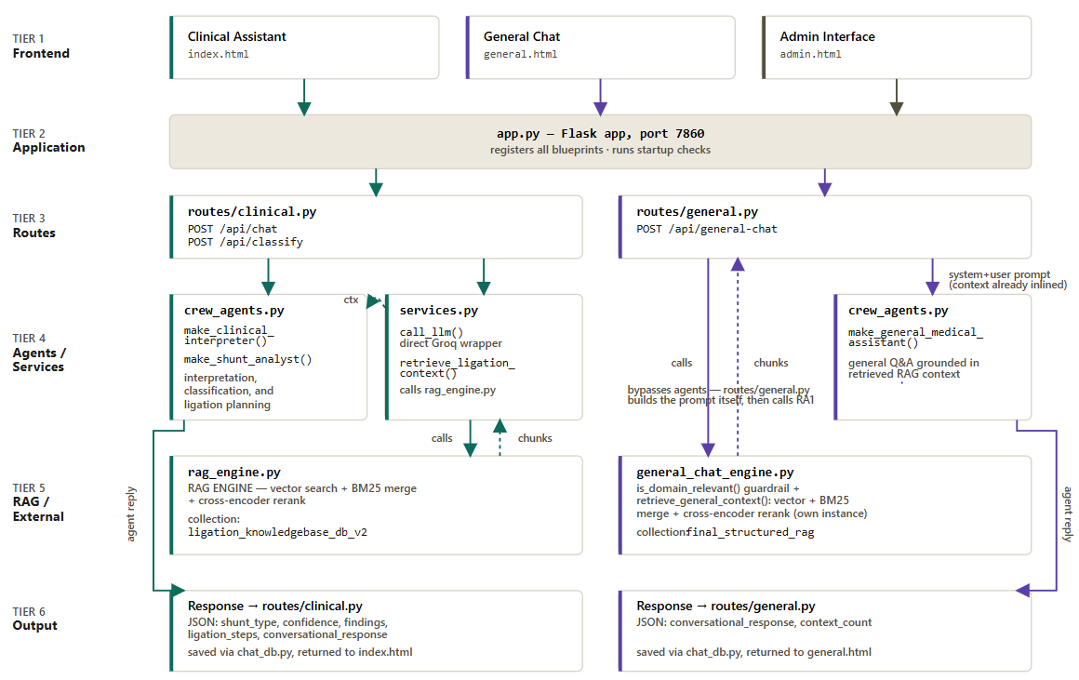

3. Module Map (backend/)
What every file owns and why it exists.
app.py — Flask application entry point. Bootstraps sys.path, loads config, sets up logging, initializes Groq/Qdrant clients via services.init_services(), registers all blueprints, and runs startup checks (DB init, Qdrant collection existence, BM25 index load) before serving on port 7860.
config.py — All configuration constants in one place: Qdrant path/collection, Ollama embedding settings, Groq model name, RAG tuning (VECTOR_TOP_K=50, RERANK_TOP_N=15, cross-encoder model), server host/port, SQLite DB path, CORS origins, and auth secrets. Reads sensitive values from environment variables with safe blank/dev defaults.
services.py — Initializes and holds the Groq client and Qdrant/BM25 state. Exposes call_llm() (raw Groq chat completion), retrieve_ligation_context() (the RAG entry point used by the ligation prompt builder), and format_analysis_for_context() (turns a classification result into a text blob for follow-up conversational turns).
chat_db.py — SQLite persistence for sessions, messages, and feedback. Provides save_message, get_messages, update_session_title, and the session-hide/list functions used by routes/sessions.py.
rag_engine.py — Implements the retrieval pipeline: Qdrant vector search (cosine similarity, top-50), BM25 keyword search merged with the vector results, and cross-encoder reranking down to the top-15 passages that get inserted into the ligation prompt. Also exposes collection_exists() and get_collection_size() used by startup checks and the /api/status endpoint.
general_chat_engine.py — RAG engine for the separate General Medical Chat tab (/api/general-chat), mirroring rag_engine.py's vector+BM25+cross-encoder pattern but against its own collection which is “final_structured_rag” , which is entirely separate from the clinical ligation_knowledgebase_db_v2 collection. Also owns is_domain_relevant() — a guardrail check run before retrieval that rejects questions outside venous disease/CHIVA scope. Exposes retrieve_general_context() and collection_exists() functions, both used by routes/general.py.
nl_interpreter.py — Owns every prompt used to turn a clinician's free-text description into CHIVA clip notation: the sufficiency-check prompt (is there enough info to classify?), the NL-to-clips prompt (EP/RP, N1/N2/N3, posYRatio mapping rules), and the conversational follow-up prompt. crew_pipeline.py imports these prompts directly rather than duplicating them.
shunt_classification_and_ligation_llm.py — The core clinical logic, independent of whether input came from NL parsing or raw JSON: builds the shunt-classification prompt from a list of clips, builds the ligation-planning prompt (given a shunt type + RAG context) and computes ligation hints (ligation hints are used to find the point of ligationlike for example : ligate at SFJ).
classify_and_plan_ligation_with_llm() here is the original direct-Groq-call implementation, crew_pipeline.py re-implements the same function using CrewAI agents but imports all prompt builders from this module.
crew_pipeline.py — CrewAI-backed orchestration layer with the same public function names as the original modules, so route code is agent-framework-agnostic. Contains parse_nl_to_clips, build_conversational_response, classify_and_plan_ligation_with_llm, generate_general_response, and the new run_pipeline() mode router added for this handover.
crew_agents.py — Factory functions that construct the three CrewAI agents used across the app: make_clinical_interpreter() (NL parsing + conversational replies), make_shunt_analyst() (classification + ligation planning), make_general_medical_assistant() (open medical Q&A tab).
auth.py — Session-cookie authentication: login_required decorator used on every protected route, plus password hashing/verification helpers backing routes/auth.py and routes/admin.py.
sheets_logger.py — Optional Google Sheets export — mirrors feedback/session data to a spreadsheet when GOOGLE_SHEETS_CREDENTIALS_FILE and GOOGLE_SHEETS_ID are set in config; silently disabled otherwise.
wsgi.py / gunicorn.conf.py — Production WSGI entry point and Gunicorn worker configuration, used when running behind nginx (see deploy/) instead of Flask's built-in dev server.
routes/__init__.py — Aggregates and re-exports every blueprint (views_bp, status_bp, sessions_bp, clinical_bp, general_bp, feedback_bp, auth_bp, admin_bp) so app.py can import them all from one place.
routes/views.py — Serves every HTML page (login, clinical, general, admin) and the static shunt-diagram images. Owns _require_login() and _require_admin() — the page-level (not API-level) auth gates that redirect to /login instead of returning a JSON 401.
routes/status.py — Health-check endpoint (/api/status) reporting RAG readiness, collection size, and whether the parent classification module loaded. set_parent_module_flag() lets app.py record that state at startup for this endpoint to read.
routes/sessions.py — CRUD for chat sessions: list sessions, create a new one, fetch its messages, rename it, and hide/archive it. Thin wrappers around the corresponding chat_db.py functions.
routes/clinical.py — The main clinical conversation endpoint (/api/chat) plus the new stateless /api/classify endpoint (§1.3). Owns the follow-up-question guards (_already_asked, _times_asked, _sufficiency_gate_already_answered) that stop the assistant re-asking a question the clinician already answered.
routes/general.py — The General Medical Chat endpoint (/api/general-chat). Cleans and deduplicates RAG chunks before they reach the prompt (_clean_text, _strip_bibliography_lines) so bibliography noise from the knowledge base isn't echoed back to the user.
routes/feedback.py — Read and write the feedback log — the audit trail of past clinical inputs and their classifications, shown in the Feedback Log UI.
routes/auth.py — Login/logout and the current-user endpoint (/api/login, /api/logout, /api/me) — the API-level counterpart to routes/views.py's page-level auth gates.
routes/admin.py — Admin-only user management and full-database export (/api/admin/users, /api/admin/export-db) — gated by the admin_required decorator from auth.py.

4. Data Flow — Both Input Modes
Task 1 supports two input modes behind a single mode switch, matching the two ways clinical data reaches the system: a clinician typing a description in English (NLP), or another system/integration sending pre-structured clip data captured directly from the ultrasound assessment tool (RAW). Both modes converge on the same classification and ligation-planning core, so results are identical in shape regardless of entry point.
NLP MODE - /api/chat and /api/classify with mode=NLP :
- User types free text
- parse_nl_to_clips() runs (crew_pipeline.py / nl_interpreter.py)
  - Stage 1: Sufficiency check - is there enough info to classify?
  - Stage 2: NL to CHIVA clip notation - EP/RP, N1/N2/N3, posYRatio
- Output: clips (a list of dicts)
RAW MODE - /api/classify with mode=RAW :
- User sends clips directly as JSON
- The assessment tool produces json containing : flow, fromType, toType, posYRatio, legSide, calibre, eliminationTest
- No parsing step - clips used as-is
BOTH MODES CONVERGE HERE :
- classify_and_plan_ligation_with_llm(clips) runs (crew_pipeline.py)
- Clips are grouped by legSide
- For each leg, two steps run in sequence namely Step-A and Step-B.
STEP A - Classification, no RAG
- build_shunt_classification_prompt() builds the prompt
- LLM returns shunt_type, confidence, reasoning
STEP B - Ligation Planning, with RAG
- retrieve_rag_context_for_ligation() runs (rag_engine.py via services.py)
- Retrieval: vector top-50, then BM25 merge, then cross-encoder rerank to top-15
- build_ligation_prompt(shunt_type, clips, rag_context) builds the prompt
- LLM returns ligation_steps, clinical_rationale, complications, followup_schedule
The Merged findings dict is then returned as the final JSON response
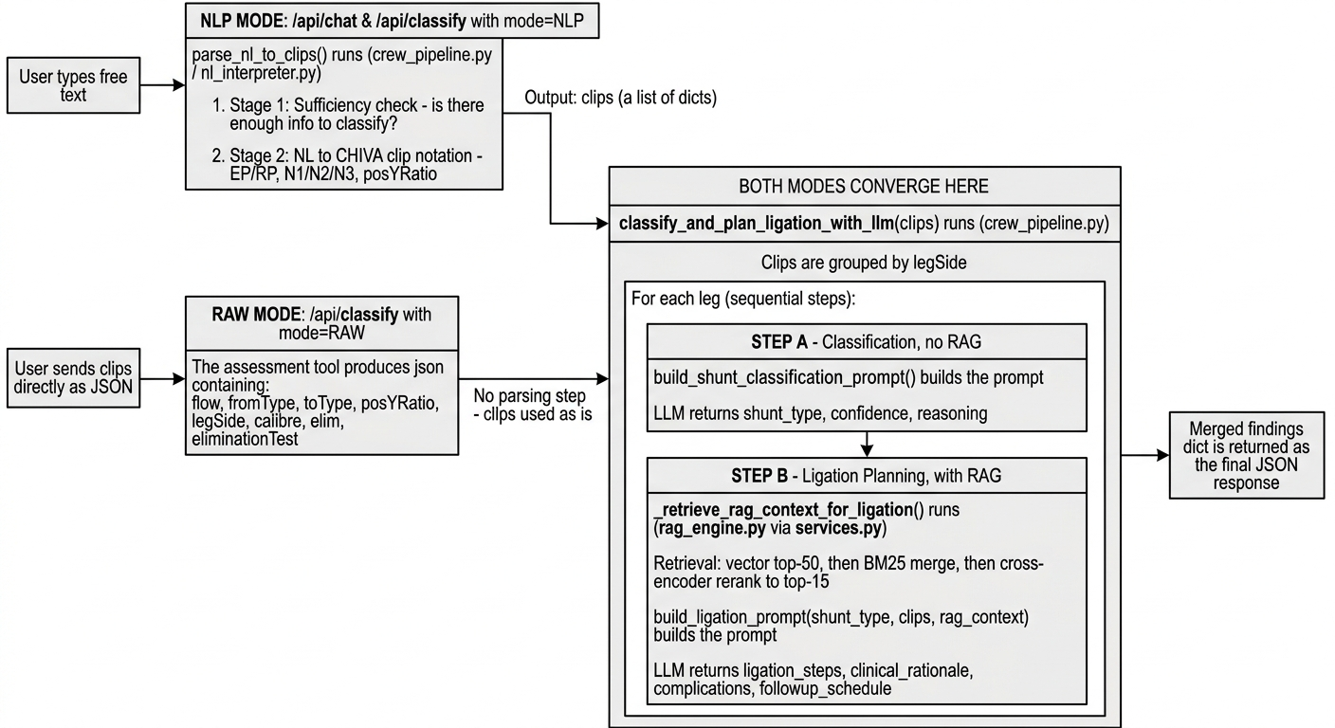

5. The NLP / RAW Mode Switch
The "mode" field lets users choose whether the natural-language interpretation or raw clip interpretation step runs. This exists because Task 1 was originally built around structured clip JSON captured from the assessment app, then a natural-language mode was created for surgeon-facing use. Some integrations (and any future automated pipeline) can still have the original JSON input, so both modes must be supported without duplicating the classification logic.
- mode = "NLP" (default) — payload is {"message": "<free text>"}. Runs parse_nl_to_clips() first, then classifies.
- mode = "RAW" — payload is {"clips": [...]}. Skips NL interpretation entirely and classifies the clips as given.

Implementation:
- The function run_pipeline(mode, payload, history, retrieve_ligation_context_fn) in backend/crew_pipeline.py dispatches on mode.
- New stateless route POST /api/classify in backend/routes/clinical.py accepts {"mode": ..., "message"|"clips": ...} and returns the same findings/shunt_type/ligation_steps shape either way.
- The existing POST /api/chat route (session-based, NL-only, with follow-up questions for missing info / elimination test / calibre) is untouched, it remains the conversational endpoint the web UI uses.

Example — NLP mode request
POST /api/classify
{
"mode": "NLP",
"message": "Reflux at the SFJ, flows down GSV to mid-thigh, escapes into a tributary."
}

Example — RAW mode request
POST /api/classify
{
"mode": "RAW",
"clips": [
{"flow": "EP", "fromType": "N1", "toType": "N2", "posYRatio": 0.05, "legSide": "right"},
{"flow": "RP", "fromType": "N2", "toType": "N1", "posYRatio": 0.13, "legSide": "right"}
]
}

Response shape (both modes)
{
"findings": [ { "leg": "Right", "shunt_type": "Type 1", "confidence": 0.9,
"reasoning": [...], "ligation_steps": [...], ... } ],
"shunt_type": "Type 1",
"confidence": 0.9,
"ligation": [...],
"summary": "...",
"num_clips": 2,
"num_findings": 1,
"token_usage": {...}
}

6. Routes Reference (backend/routes/)
Method | Path | Blueprint | Auth | Purpose
GET | /login | views | No | Serves login.html
GET | / | views | Yes | Serves index.html — the main Clinical Assistant chat UI
GET | /clinical | views | Yes | Alias/redirect to the clinical chat page
GET | /general | views | Yes | Serves general.html — open medical knowledge chat
GET | /admin | views | Admin | Serves admin.html — user & session management
GET | /shunt-diagram/<file> | views | Yes | Serves static CHIVA shunt-type reference diagrams
GET | /api/status | status | No | Health check — RAG readiness, collection size, module load status
GET | /api/sessions | sessions | Yes | List chat sessions for the logged-in user
POST | /api/session | sessions | Yes | Create a new chat session
GET | /api/session/<id>/messages | sessions | Yes | Fetch message history for a session
PATCH | /api/session/<id>/title | sessions | Yes | Rename a session
PATCH | /api/session/<id>/hide | sessions | Yes | Hide/archive a session from the sidebar
POST | /api/chat | clinical | Yes | Conversational NL clinical turn — sufficiency gate, classification, follow-up questions (elimination test, calibre, Type 4 subtype)
POST | /api/classify | clinical | Yes | NEW — stateless classification, mode="NLP"|"RAW"
POST | /api/general-chat | general | Yes | Open medical Q&A, not tied to the CHIVA classification flow
GET | /api/feedback | feedback | Yes | List logged feedback entries (session audit trail)
POST | /api/feedback | feedback | Yes | Submit feedback on a classification/ligation result
POST | /api/login | auth | No | Authenticate and set session cookie
POST | /api/logout | auth | Yes | Clear session cookie
GET | /api/me | auth | Yes | Return current logged-in user info
GET | /api/admin/users | admin | Admin | List all user accounts
POST | /api/admin/users | admin | Admin | Create a new user account
DELETE | /api/admin/users/<id> | admin | Admin | Delete a user account
GET | /api/admin/export-db | admin | Admin | Export the full SQLite DB (sessions/messages/feedback) as a file

7. RAG Pipeline Detail
Configured entirely in config.py; the numbers below are the current tuning values.
Stage | Mechanism | Config
1. Vector search | Qdrant cosine similarity over Ollama embeddings (nomic-embed-text, 768-dim) | VECTOR_TOP_K = 50
2. Keyword search | BM25 over the same chunk corpus, merged and deduplicated with vector hits | rank-bm25 library
3. Reranking | Cross-encoder scores every merged candidate against the query | cross-encoder/ms-marco-MiniLM-L-6-v2
4. Final context | Top reranked passages inserted into the ligation prompt | RERANK_TOP_N = 15

This pipeline description covers the Clinical Assistant's RAG (rag_engine.py, collection ligation_knowledgebase_db_v2). The General Medical Chat tab runs the same vector→BM25→rerank pattern independently through general_chat_engine.py against a separate collection, final_structured_rag — the two tabs never share a knowledge base or retrieval index.
CROSS_ENCODER_ENABLED can be set to False (config.py) to skip step 3 on machines where installing torch/sentence-transformers is undesirable — retrieval then falls back to the merged vector+BM25 ranking only.

8. Extending the Codebase
- New API route → add a handler to the relevant backend/routes/<name>.py blueprint (or create a new blueprint file) and register it in app.py's register_blueprint calls.
- New prompt or clinical rule → nl_interpreter.py for NL-parsing rules, shunt_classification_and_ligation_llm.py for classification/ligation prompt content — never duplicate prompt text in crew_pipeline.py, always import it.
- New CrewAI agent or role → crew_agents.py; wire it into crew_pipeline.py the same way make_shunt_analyst() / make_clinical_interpreter() are used.
- New config value → config.py, sourced from os.getenv with a safe default; never hardcode secrets.
- New input mode (beyond NLP/RAW) → add a branch to run_pipeline() in crew_pipeline.py and document the payload shape in this guide's section 1.3.

9. Deployment (backend/deploy/ and .github/workflows/)
These files are infrastructure, not Python modules — they define how the app gets onto and stays running on the production server (a systemd service behind nginx). This is a different concern from Docker (see the Docker guide): deploy/ assumes a specific, already-provisioned Alibaba Cloud VM and deploys by SSH + git pull + systemd restart, whereas Docker packages the app to run anywhere with zero manual server setup.
deploy/setup.sh — One-time server bootstrap, run manually the first time a new server is provisioned. Installs system packages (python3-venv, nginx, git), installs and starts Ollama, pulls the nomic-embed-text embedding model, creates the Python virtual environment and installs requirements.txt, copies .env.example to .env (prompting for GROQ_API_KEY), installs shunt.service into systemd, installs nginx.conf, and starts both services.
deploy/shunt.service — The systemd unit definition for the app itself. Runs gunicorn (using backend/gunicorn.conf.py) against wsgi:app as a persistent service owned by root, restarting automatically on failure (RestartSec=5). Its ExecStartPre step also runs git pull and reinstalls requirements on every service start/restart, so a systemctl restart shunt always redeploys the latest main branch, not just the last-built code.
deploy/nginx.conf — Reverse-proxy config: listens on port 80 and forwards all traffic to gunicorn over a Unix socket (/var/www/shunt_classification_and_ligation/shunt.sock), setting the standard forwarded-for/proto headers and a 120s read timeout (long enough for slow LLM calls to complete without nginx cutting the connection).
deploy/update.sh — The actual redeploy script — this is what runs on every push to main (triggered by .github/workflows/deploy.yml over SSH). Backs up chat_history.db before git pull (in case git would otherwise touch/delete it), pulls latest main, and — if the pulled database has zero sessions — restores a known-good backup of the db from a specific git commit (8d8fb2ea) rather than starting empty. Reinstalls requirements, then systemctl restart shunt to pick up the new code.
.github/workflows/deploy.yml — The GitHub Actions workflow that triggers deploy/update.sh. On every push to main, it SSHes into the production server (using the SSH_PRIVATE_KEY and SERVER_IP repo secrets) and runs deploy/update.sh remotely — this is the actual CI/CD trigger; update.sh itself is what does the real work.

10. Deploy Flow
git push to main
|
v
.github/workflows/deploy.yml (GitHub Actions)
| SSH into the server using SERVER_IP + SSH_PRIVATE_KEY secrets
v
deploy/update.sh (runs ON the server)
|
1. Back up chat_history.db to /tmp
2. git pull origin main
3. If chat_history.db has 0 sessions, restore it from a known git commit
4. pip install -r requirements.txt
5. systemctl restart shunt
|
v
shunt.service (systemd, installed once by deploy/setup.sh)
| ExecStartPre also does its own git pull + pip install
v
gunicorn -c backend/gunicorn.conf.py wsgi:app
| listens on a Unix socket
v
nginx (deploy/nginx.conf)
| reverse-proxies port 80 -> the gunicorn socket
v
Public app URL

11. QuickStart to locally start the app without Docker
The Prerequisites are :
- Python 3.10+ installed and in PATH.
- Ollama installed on local device (https://ollama.com).
- Internet access (for Groq API).
Step 1 (Pulling embedding model) :
  - bash ollama pull llama3.2:1b
Step 2 (Install dependencies) :
  - cd Task_1_Handover/Code
  - pip install -r backend/requirements.txt
Step 3 (Set API key):
  - cd backend
  - go to .env file and add the GROQ_API_KEY
Step 4 (Ingest knowledge base (first time only)) :
  - python ingest.py
Step 5 (Start the app) :
  - python backend/app.py (do from Task_1_Handover/Code/)

Step 6 (Open browser) :
  - http://127.0.0.1:7860
To stop the app: Press Ctrl+C in terminal.

