Task 2 — Developer Guide
Probe Localisation & Active Guidance — real-time CHIVA duplex-scan guidance from a 5-agent CrewAI crew
Read this first: Every LLM and vision call goes to the Groq cloud API. The app needs a GROQ_API_KEY in Code\.env and an internet connection; nothing runs locally except Flask. Groq retired the Llama models the app was developed with, so the model IDs were updated — see Section 8 before comparing new results with the bundled test reports.

1. High-Level Architecture
Task 2 guides a surgeon through a CHIVA duplex ultrasound examination of the leg. It does two things:
- Probe localisation — turns a scanner reading (segment_id, segment_dist, is_front) into a named anatomical region (SFJ, GSV-THI, GSV-CAL, SPJ, SSV). Pure Python, no model.
- Active guidance — after every probe move or marked finding, tells the surgeon where to move the probe next, when to perform the elimination test, and when a CHIVA shunt type (1, 2A, 2B, 2C, 3, 1+2, 4, 5, 6) is confirmed.
It is a Flask + Flask-SocketIO backend (backend/app.py, port 7861) serving three static HTML pages. The main page, /stream, talks to the server over Socket.IO; each probe_move or clip_mark event is handled in its own daemon thread. There is no database and no queue: session state lives in memory (streaming_session.StreamSession) and is lost on restart.
Guidance is produced by one CrewAI crew of five agents that run in sequence. Before the crew runs, four plain-Python context builders assemble everything the agents need into a single state message. The crew never sees raw sensor data, only that message.

2. System Diagrams
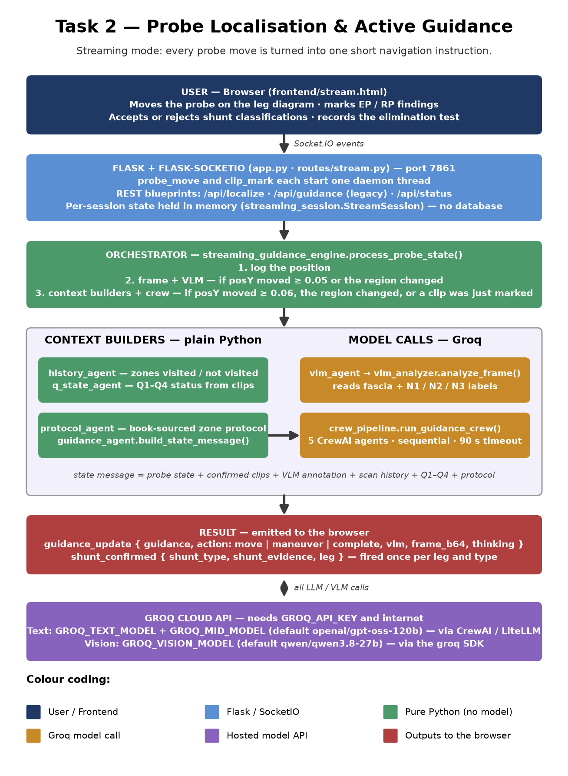
Figure 1: End-to-end architecture. Amber = calls to Groq.

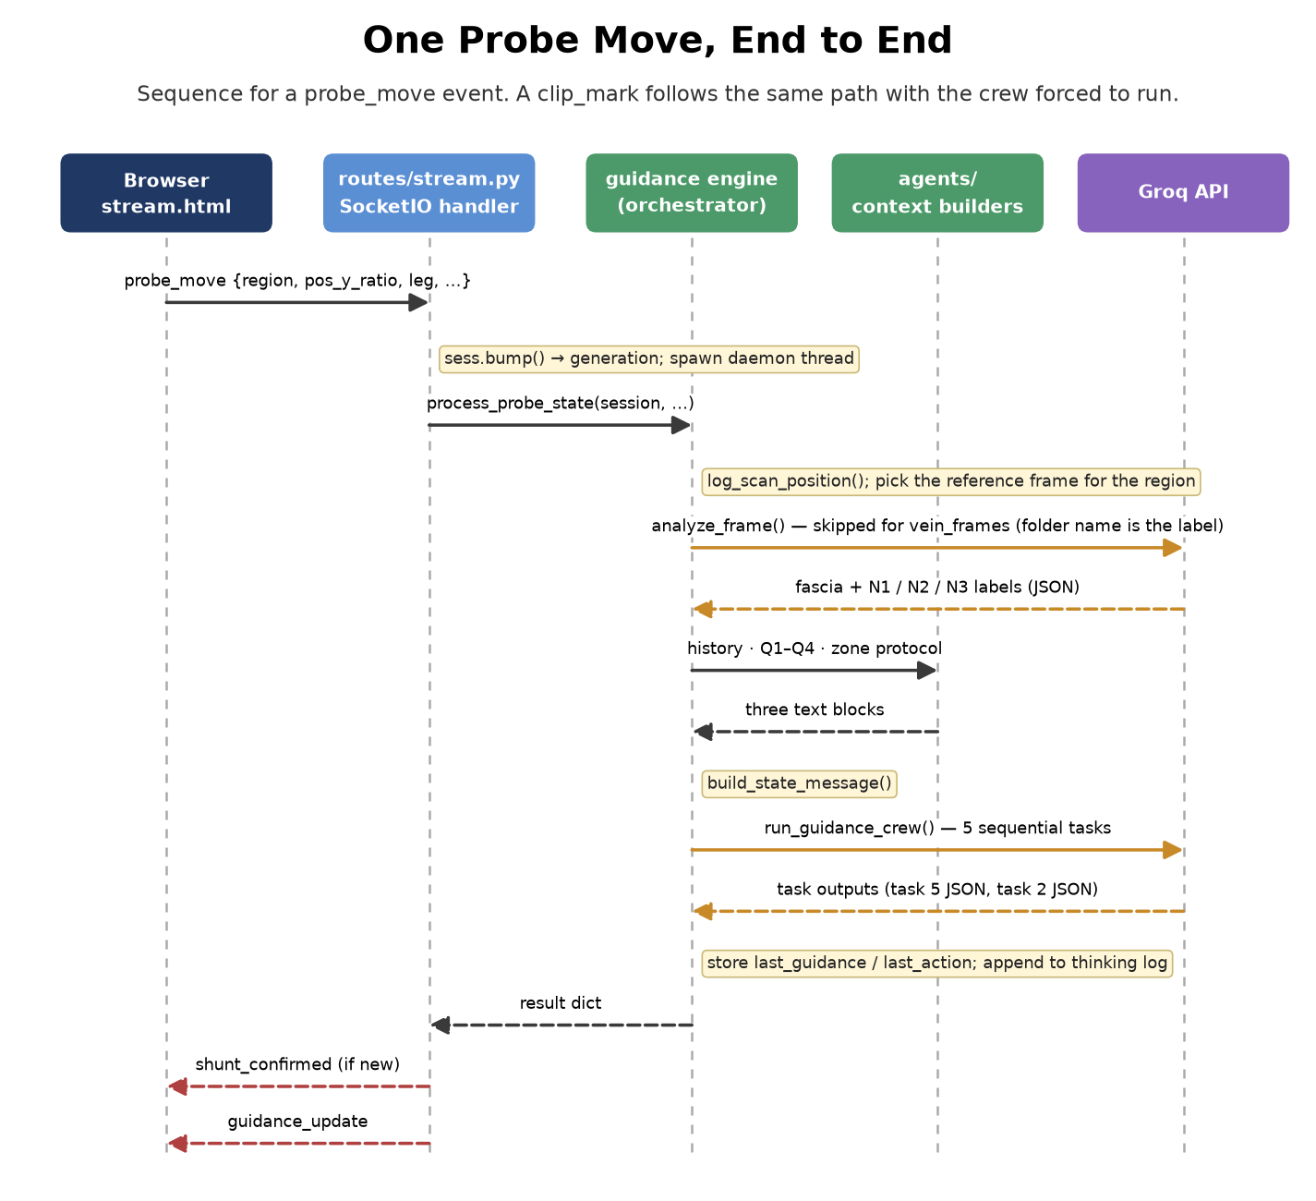
Figure 2: What happens for one probe_move event.

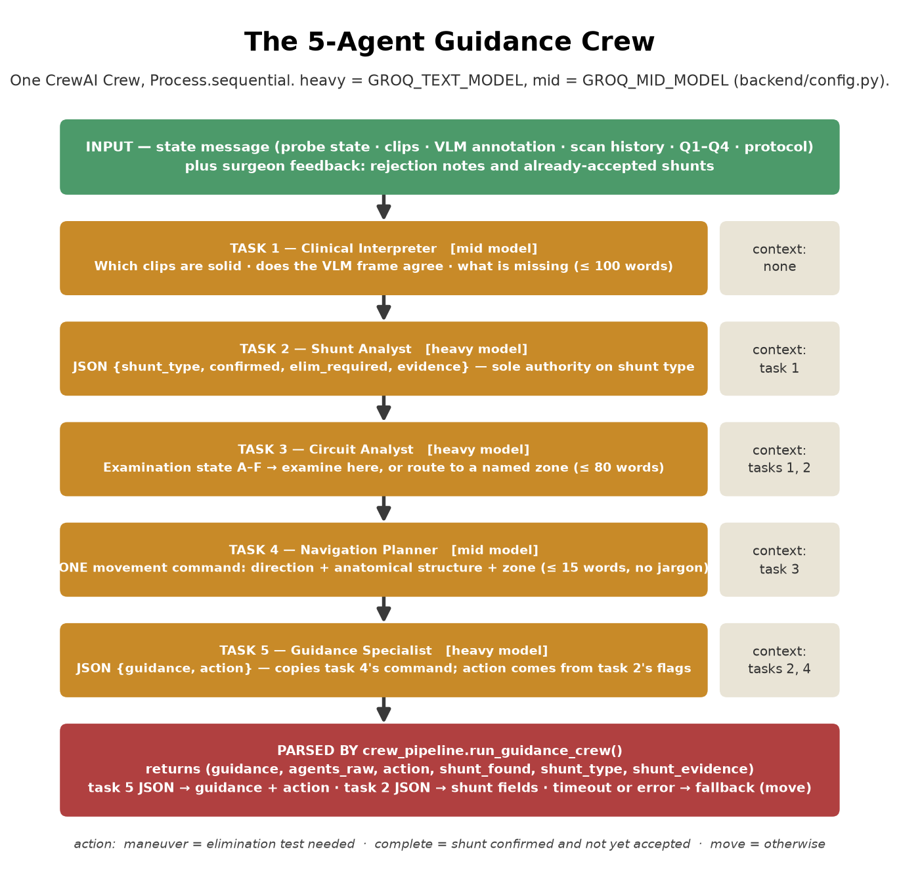
Figure 3: The five crew tasks and which earlier outputs each one reads.

3. Module Map (Code/backend/)
What every file owns. Everything listed is on the import path from app.py.
File | Responsibility
app.py | Flask app factory and entry point. Registers the REST blueprints and the SocketIO events, serves the three pages and /api/vein-frame (the reference frame shown in the UI). Opens the browser at /stream.
config.py | All settings: port, Groq key and model IDs (env-overridable), localisation thresholds, VLM / LLM re-run thresholds, stream video path.
streaming_guidance_engine.py | Orchestrator. process_probe_state() decides whether to run the VLM and the crew, picks the reference frame for the region, calls the context builders, and returns the result dict that is emitted to the browser.
streaming_session.py | StreamSession dataclass + in-memory registry: clips, guidance history, thinking log, scan log, confirmed / accepted / rejected shunts, generation counter.
routes/stream.py | SocketIO event handlers (Section 6.2). Spawns one thread per probe_move / clip_mark.
routes/localization.py | REST: /api/localize, /api/localize/batch, /api/localize/reset.
routes/guidance.py | REST, legacy single-LLM path: /api/guidance and /api/wrong-region. Used by the / and /test pages, not by /stream.
routes/status.py | REST: /api/status — reports whether the Groq key is loaded.
probe_localizer.py | classify_single() maps a reading (segment_id, segment_dist, is_front) to a region string. ProbeLocalizer smooths over a 10-reading majority-vote window. Used ONLY by the REST /api/localize endpoint — the streaming path never calls it; the browser JavaScript (mapReg() in stream.html) computes the region independently and sends it in the probe_move payload.
vlm_analyzer.py | analyze_frame(): sends one ultrasound frame to the Groq vision model and returns an UltrasoundAssessment (fascia visible, N1 / N2 / N3 labels, vein types).
active_guidance_engine.py | Legacy single-LLM guidance (generate_guidance) behind /api/guidance. Holds its own CHIVA system prompt. Not used by the streaming path.
agents/crew_pipeline.py | run_guidance_crew(): builds the five tasks, runs the crew with a 90 s timeout, parses task 5 (guidance, action) and task 2 (shunt) JSON.
agents/crew_agents.py | Five agent factories (role, goal, backstory, model tier). Also strips the cache_breakpoint field CrewAI adds, which Groq rejects.
agents/history_agent.py | build_summary(): which of the 7 posY zones were visited / not visited, plus the clip list.
agents/q_state_agent.py | analyze(): derives Q1–Q4 status from the clips in plain Python (no model).
agents/protocol_agent.py | get_protocol(): literature-sourced examination protocol text for the current zone.
agents/vlm_agent.py | Thin wrapper around vlm_analyzer.analyze_frame() returning (dict, summary text).
agents/guidance_agent.py | build_state_message(): composes the state message the crew receives.

Other folders under Code/:
Folder | Contents
frontend/ | stream.html (main streaming UI), index.html (single-reading localisation + legacy guidance), test.html (single-state image test).
assets/guidance/ | Reference ultrasound frames per region (sfj, gsv_thigh, gsv_calf, spj, ssv) with yellow fascia lines and N-labels. These are sent to the vision model.
assets/vein_frames/ | Reference frames per named vein. The folder name is the label, so no vision call is made for these.
sample_data/ | One annotated ultrasound recording, used only when a region has no reference frames.
tests/ | Crew smoke test, three scenario suites and their shared harness (Section 10).
Notes/ | Protocol source references and clinical verification notes behind the prompts.

4. Data Flow — One Probe Move
- The browser converts the mouse position on the leg diagram to posY (0 = groin, 1 = ankle), leg, surface and a region name, and emits probe_move (debounced 200 ms).
- routes/stream.py bumps the session generation counter and starts a thread that calls process_probe_state().
- The position is appended to the scan log (last 300 kept).
- If posY moved ≥ 0.05 or the region changed, a reference frame is picked for the region. Frames from assets/guidance go to the vision model; frames from assets/vein_frames are labelled from their folder name.
- If posY moved ≥ 0.06, the region changed, or the event was a clip_mark, the context builders run and the crew is kicked off. Otherwise the last guidance is echoed back so the UI always gets an answer.
- Only clips from the leg under the probe are passed to the crew.
- The result is emitted as guidance_update. If a shunt type was newly confirmed for that leg, shunt_confirmed is emitted first (once per leg and type per session).
- A result is discarded only if more than 6 newer requests have arrived since it started.
- Session state lives in streaming_session._sessions — an in-memory Python dict. Sessions are never deleted (session_end sets sess.active=False but does not remove the entry). All state is lost on app restart.

4.1 Vocabulary
Term | Meaning
posY | Normalised position down the leg: 0.00 groin → 1.00 ankle. Knee is at 0.5497.
Zones | SFJ/groin ≤ 0.07 · upper thigh ≤ 0.20 · Hunterian ≤ 0.33 · Dodd ≤ 0.47 · popliteal/SPJ ≤ 0.57 · calf ≤ 0.88 · ankle ≤ 1.00. The same bands are used in crew_pipeline, q_state_agent, history_agent and protocol_agent — change them together.
N1 / N2 / N3 | Deep vein / saphenous trunk inside the fascia / tributary above the fascia.
Clip | A finding the surgeon marks: flow (EP or RP), from_type → to_type, posY, leg, optional elimination_test.
Q1–Q4 | Q1 entry point · Q2 trunk reflux · Q3 escape to a tributary · Q4 re-entry to the deep system.
action | move (navigate) · maneuver (perform the elimination test) · complete (shunt type confirmed).

5. The Agent Layer

5.1 Context builders (pure Python, no model)
Before the crew runs, four plain-Python functions assemble the state message. None of them call a model. All four are called by streaming_guidance_engine.process_probe_state() and their outputs are passed to guidance_agent.build_state_message() which concatenates them into the single string the crew receives.
Function | File | Inputs | Output
build_summary(session) | history_agent.py | session.scan_log (last 300 entries), session.clips | SCAN HISTORY SUMMARY block: which of the 7 posY bands were visited (with posX range) and which were not; confirmed clip list. Band definitions (_BANDS) are a local constant: SFJ/groin ≤0.07 · upper thigh ≤0.20 · Hunterian ≤0.33 · Dodd ≤0.47 · popliteal/SPJ ≤0.57 · calf ≤0.88 · ankle ≤1.00.
analyze(clips) | q_state_agent.py | session.clips (snake_case keys: flow, from_type, to_type, pos_y_ratio, elimination_test) | Q1-Q4 STATUS block: one line per Q (CONFIRMED / OPEN / N/A) with posY level. Includes Type 3 conduit check (EP N1→N2 + EP N2→N3, no RP N2→N1) and elimination-test status alert (PENDING / DONE) when all four clips are present. Zone band definitions (_level()) are duplicated here with the same boundary values as history_agent._BANDS.
get_protocol(region, pos_y) | protocol_agent.py | region string (e.g. 'SFJ'), pos_y float | EXAMINATION PROTOCOL block: a static literature-sourced numbered protocol for the zone. Named junctions (SFJ, SPJ, SSV) take precedence over posY. For all other regions, posY selects from the same 7-band sequence. Seven protocol texts are stored in _PROTOCOLS dict. Sources: Adler 2022, Gianesini 2014, Delfrate 2023, AVF 2023, Mendoza 2014.
analyze(frame_b64, region, leg) | agents/vlm_agent.py → vlm_analyzer.py | Base64 JPEG, region, leg | Returns (vlm_dict, summary_text). summary_text is the VLM FRAME ANNOTATION block. Calls vlm_analyzer.analyze_frame() which sends the frame to qwen/qwen3.8-27b via Groq. For assets/vein_frames images, streaming_guidance_engine bypasses this and constructs UltrasoundAssessment directly from _VEIN_FOLDER_TO_META — no Groq call.

guidance_agent.build_state_message() then joins all four outputs plus the current probe position into one string with six labelled sections: PROBE STATE / CONFIRMED FINDINGS / VLM FRAME ANNOTATION / SCAN HISTORY SUMMARY / Q1-Q4 STATUS / EXAMINATION PROTOCOL. This string is the sole input to task 1.
Clip key naming: The streaming path (routes/stream.py → session.clips) stores clips with snake_case keys (flow, from_type, to_type, pos_y_ratio). The context builders and the crew all expect snake_case. The legacy REST path (active_guidance_engine.py) uses camelCase (fromType, toType, posYRatio) — that is an inconsistency inherited from the original development and limited to the /api/guidance endpoint.

5.2 The crew
# | Agent | Model tier | Reads | Produces
1 | Clinical Interpreter | mid | state message | ≤ 100 words: which clips are sound, VLM agreement, what is absent
2 | Shunt Analyst | heavy | task 1 + raw clips | JSON {shunt_type, confirmed, elim_required, evidence}
3 | Circuit Analyst | heavy | tasks 1, 2 + Q-state + history | Examination state A–F and where the probe should be
4 | Navigation Planner | mid | task 3 | One movement command, ≤ 15 words
5 | Guidance Specialist | heavy | tasks 2, 4 | JSON {guidance, action}

Important: Task 5 (Guidance Specialist) reads context from tasks 2 and 4 only — task 3 (Circuit Analyst) is deliberately excluded. The Navigation Planner distils task 3's zone routing into a single movement command; the Guidance Specialist then packages that command without needing to see the Circuit Analyst's prose directly.
Things that are computed in Python and injected into the prompts, so the model cannot get them wrong: the zone name for the current posY, whether the probe is inside the Q1 corridor (posY 0.04–0.57), and which zones were suggested twice already (anti-repetition, only while Q1 is open).
Surgeon feedback reaches the crew through two lists on the session: rejection_notes (prepended to task 1) and accepted_shunts (prepended to task 2 and used by task 5 so an accepted type is not re-announced).
If the crew times out (90 s) or raises, run_guidance_crew() returns the fallback guidance "Continue scanning distally to locate anatomical junction" with action = move, and the error text is placed in the thinking log under guidance as [crew-timeout] or [crew-error].

5.3 Legacy guidance engine — active_guidance_engine.py
active_guidance_engine.py is the backend for the REST /api/guidance endpoint (used by the / and /test pages). It is a completely separate guidance path from the 5-agent crew and has no shared state with streaming_guidance_engine.py. Key differences:
Aspect | Streaming path (crew) | Legacy REST path (active_guidance_engine)
Entry point | SocketIO probe_move event → streaming_guidance_engine.process_probe_state() | POST /api/guidance → routes/guidance.generate_guidance()
Model calls | 1 vision call (qwen) + 5 sequential text calls (gpt-oss-120b) | 1 text call (GROQ_MID_MODEL = gpt-oss-120b), max_tokens=1024, temperature=0.0
Output length | guidance: free-form sentence; agents produce internal prose | JSON {"guidance": "<≤16 words>"} — format enforced by system prompt
Session history | Session state in StreamSession (clips, scan_log, etc.) | Separate conversation history: last 6 (user, assistant) pairs in _history_store dict. Window constant: _ACTIVE_HISTORY_WINDOW = 6. Stored per session_id. Never deleted (same as StreamSession).
Clip key format | snake_case: from_type, to_type, pos_y_ratio | camelCase: fromType, toType, posYRatio
CHIVA logic | Distributed across 5 agent prompts + q_state_agent.analyze() | Monolithic _CHIVA_SYSTEM_PROMPT (~200 lines) embedded in the file. Separate _chiva_component_status() function does pure-Python Q1-Q4 analysis with the same logic as q_state_agent.analyze() but for camelCase clip dicts.

Internal call chain for one /api/guidance request:
- routes/guidance.guidance() — validates POST body, optionally calls vlm_analyzer.analyze_frame() for an attached ultrasound image, then calls generate_guidance().
- generate_guidance(probe, expected_region, ep_rp_findings, vlm_assessment, session_id) — builds the user message via _build_prompt() and the session history via _get_history(), calls _call_groq(), parses the JSON response, pushes to history via _push_history(), returns ActiveGuidanceResponse dataclass.
- _build_prompt(probe, wrong, expected_region, clips, vlm_summary) — assembles a structured user message with sections: Current probe position / Confirmed EP/RP clips / CHIVA Q1-Q4 status / VLM frame / Task instruction.
- _chiva_component_status(clips) — pure-Python Q1-Q4 analysis on camelCase clip dicts. Produces a detailed text block including junction location, conduit check, and Type 4/5 pattern hints. Injected into _build_prompt() output.
- _call_groq(system, prompt, api_key, model, history) — direct Groq SDK call (not via litellm or CrewAI). Sends system prompt + history + user message. Strips markdown code fences before JSON parsing.
- ActiveGuidanceResponse — dataclass returned to the caller. Fields: location (ProbeLocation.to_dict()), guidance (str), ultrasound_assessment (dict|None), expected_region (str|None), error (str|None), llm_system, llm_prompt, llm_raw (debug strings).
Important: The litellm cache_breakpoint patch in agents/crew_agents.py does NOT apply to active_guidance_engine.py. The legacy engine calls the Groq SDK directly, bypassing litellm entirely, so no patch is needed.

6. Interface Reference

6.1 HTTP routes
Route | Method | Purpose
/stream | GET | Main streaming UI.
/ | GET | Single-reading localisation + legacy guidance page.
/test | GET | Single-state image test page.
/api/status | GET | {ok, groq_configured}.
/api/vein-frame?region=&pos_y= | GET | JPEG reference frame for the region; X-Vein-Label header names it. Uses the same picker as the VLM step, so the UI shows the analysed frame.
/api/localize | POST | One scanner reading → smoothed ProbeLocation + wrong-region check.
/api/localize/batch | POST | List of readings → final stable location.
/api/localize/reset | POST | Clear the smoothing window for a session.
/api/wrong-region | POST | {current_region, expected_region} → is_wrong, reason, suggestion.
/api/guidance | POST | Legacy: one reading (+ optional frame and Task-1 clips) → one guidance line from a single LLM call.

6.2 Socket.IO events
Event | Direction | Payload / effect
stream_start | client → server | {session_id}. Creates or resets the session. Replies session_ready.
probe_move | client → server | {session_id, region, pos_y_ratio, pos_x_ratio?, surface, leg, is_front?}.
clip_mark | client → server | {session_id, flow, from_type, to_type, pos_y_ratio, leg, region, elimination_test?, surface, is_front?}. Always forces a crew run.
clips_replace | client → server | {session_id, clips}. Sent when the surgeon deletes a finding.
shunt_accept | client → server | {session_id, shunt_type, leg}. Type is not announced again.
shunt_reject | client → server | {session_id, shunt_type, leg}. Adds a rejection note; the type may re-confirm on stronger evidence.
session_end | client → server | {session_id}. Replies session_ended with the clip list.
session_ready | server → client | {session_id}.
guidance_update | server → client | {guidance, action, vlm, vlm_summary, frame_b64, region, pos_y, shunt_confirmed, shunt_type, shunt_evidence, thinking}.
shunt_confirmed | server → client | {shunt_type, shunt_evidence, leg}.
clips_updated | server → client | {clips}.
session_ended | server → client | {session_id, clips, log_count}.

7. Configuration Reference

7.1 Environment variables (Code/.env)
Variable | Default | Purpose
GROQ_API_KEY | — (required) | Groq key for every model call.
PORT | 7861 | Port the app listens on.
GROQ_TEXT_MODEL | openai/gpt-oss-120b  (same default as GROQ_MID_MODEL) | Heavy tier: Shunt Analyst, Circuit Analyst, Guidance Specialist.
GROQ_MID_MODEL | openai/gpt-oss-120b  (same default as GROQ_TEXT_MODEL; both are the same model unless env vars differ) | Mid tier: Clinical Interpreter, Navigation Planner, legacy /api/guidance.
GROQ_VISION_MODEL | qwen/qwen3.8-27b | Frame reading.
STREAM_VIDEO_PATH | sample_data\…Moving.mp4 | Fallback frame source when a region has no reference frames.
CORS_ORIGINS | * | Allowed origins for the REST routes.

7.2 Tunables in config.py
Name | Value | Effect
STREAM_VLM_THRESHOLD | 0.05 | Minimum posY change before a new frame is analysed.
STREAM_LLM_THRESHOLD | 0.06 | Minimum posY change before the crew runs again. Lower = more Groq calls.
STREAM_HISTORY_WINDOW | 8 | Guidance exchanges kept per session (feeds the anti-repetition list).
SLIDING_WINDOW_SIZE / STABILITY_THRESHOLD | 10 / 0.6 | Localiser majority-vote window and the share needed to call it stable.
SFJ_THIGH_MAX_DIST | 0.13 | Front of thigh at or above this fraction = SFJ.
SPJ_THIGH_MIN_DIST / SPJ_CALF_MAX_DIST | 0.80 / 0.10 | Back of thigh below / back of calf above these = SPJ.

8. Changes From Original Development
The following issues were identified and fixed after the original development phase. Behaviour of the streaming path is unchanged except where noted.

8.1 Model IDs (behaviour change)
Groq retired llama-3.3-70b-versatile and meta-llama/llama-4-scout-17b-16e-instruct. With those IDs every request fell back to the canned guidance. Current defaults:
Role | Was | Now
Mid-tier text (2 agents + legacy path) | llama-3.3-70b-versatile | openai/gpt-oss-120b
Vision | meta-llama/llama-4-scout-17b-16e-instruct | qwen/qwen3.8-27b

- The bundled test reports (Test_Reports/) and the Methodology Report were produced with the old models. The full scenario suites have not been re-run on the new model IDs; only the checks in Section 10.1 were.
- The legacy /api/guidance call had max_tokens = 80, which a reasoning model exhausts before answering. It is now 1024 (temperature = 0.0, no other parameters changed).
- The Navigation Planner backstory told the agent to call a get_zone_protocol tool that was never attached. The old model ignored this; gpt-oss tries to call it and Groq rejects the request. The sentence was removed.

8.2 Secrets and paths
- The hardcoded Groq key fallback in config.py was removed; the key is read only from .env.
- The stream video path pointed at a folder on the author's machine; it now resolves to Code/sample_data/.

8.3 Unused code removed
Everything below had no caller in the backend, the three pages or the tests and was removed.
Removed | Why it was unreachable
agents/crew_tools.py; tools= arguments on two agents | Both tool lists were empty, so the two tool functions were never offered to a model.
Vein-scan mode: set_scan_vein event, session.scan_vein, the Mendoza vein-objective texts in protocol_agent | No page emits set_scan_vein.
mock_data_generator.py, video_processor.py, /api/scenario, /api/scenarios | No page or test requests the mock scenarios.
/video/stream-main, /video/frame, /assets/<path>, the catch-all static route | No page requests them. The raw-video branch of extract_frame_at() went with /video/frame.
guidance_config.py, /api/guidance-regions, /api/guidance-clips, /api/localize/single | No page or test requests them.
extract_guidance_frames.py, extract_vein_frames.py, rebuild_vein_frames.py, remove_doppler_frames.py | One-off scripts that built assets/ from source videos that are not part of the handover.
Unused parameters of run_guidance_crew() (region, surface, leg, vlm_summary, protocol_text, pos_x, is_front) | Never read inside the function; the same information is already in state_message.
Assorted: is_current(), remove(), get_leg(), EXAM_ORDER, DB_PATH, GROQ_FAST_MODEL, three *_ack emits, unused imports | Defined but never referenced.
stream.html: shunt and elimination modals with their CSS and handlers | Nothing opens them; inline notifications replaced them.
index.html / stream.html: unused CSS rules and variables | No matching markup.
Tests: three copies of the scenario runner and report writer | Merged into tests/scenario_harness.py; the scenario steps are byte-identical.
Tests: test_shunt_type1_2_scenario.py, test_shunt_type1_2_llm_eval.py | One-off report generators with hard-coded findings; the second needs an Anthropic key.
Data: *_concat.mp4, four unreferenced vein_frames folders, four extra sample videos | Only the removed code read them.
deploy/, gunicorn.conf.py, wsgi.py | Linux server deployment; this handover runs from .bat files.

9. Extending the Codebase
To change… | Edit
What an agent is told to do | The task description in agents/crew_pipeline.py (per-turn instructions) or the backstory in agents/crew_agents.py (standing knowledge).
Shunt-type rules | Task 2 description in crew_pipeline.py and the Shunt Analyst backstory — keep the two lists identical.
Zone boundaries | _zone_name() in crew_pipeline.py, _level() in q_state_agent.py, _BANDS in history_agent.py, get_protocol() in protocol_agent.py, and mapReg() in stream.html.
Zone boundary values | Update _BANDS in agents/history_agent.py, _zone_name() in agents/crew_pipeline.py, and _level() in agents/q_state_agent.py — all three must match.
Protocol text for a zone | _PROTOCOLS in agents/protocol_agent.py. Cite the source in the text.
Which frames a region shows | _REGION_TO_GUIDANCE_DIRS / _REGION_TO_VEIN_DIRS in streaming_guidance_engine.py, then add the folder under assets/.
A model | Set the GROQ_*_MODEL variable in .env. No code change.
A new socket event | Add the handler in routes/stream.py and the emit / listener in stream.html.

10. Running and Testing (Windows)
File | What it does
setup.bat | Finds Python 3.10–3.13, creates Code\.venv, installs requirements.txt (about 1 GB), creates .env from .env.example.
run.bat | Runs setup.bat if .venv is missing, checks the key is set, starts backend\app.py. The browser opens /stream.
run_tests.bat | No argument: crew smoke test. scenarios / scenarios_v2 / scenarios_june: the scenario suites (the app must already be running).

Python 3.14 is not supported by CrewAI; setup.bat will not pick it.

10.1 What was verified on this copy
- setup.bat built a fresh .venv on Python 3.12.10 and run.bat started the app from it.
- All REST routes in Section 6.1 return 200 with valid bodies; the removed routes return 404.
- A Socket.IO session (probe_move at SFJ, EP N1→N2, RP N2→N1) produced three distinct guidance lines, action = complete and a shunt_confirmed event for Type 1, with all five agents producing output.
- The crew smoke test (run_tests.bat) returned move, move, complete (Type 1) and maneuver for its four cases.
- The scenario suites were not run end to end. Their step lists were confirmed identical before and after the harness merge, and each suite's Word report was generated from dummy results.

10.2 Known limitations
- A crew run takes roughly 5–15 s; guidance lags the probe by that much.
- Sessions are in memory only; restarting the app loses them.
- stream.html loads the Socket.IO client from a CDN, so the page itself needs internet.
- The ultrasound frame shown is a reference frame chosen by region and posY, not a live feed.
- The "Rule 6" gate the scenario comments refer to (probe must reach the SPJ zone before Type 1 completes) is not enforced in code; it is left to the agents.
- Zone boundaries (posY bands) are defined independently in three modules — _BANDS in history_agent.py, _zone_name() in crew_pipeline.py, and _level() in q_state_agent.py. They are consistent in the current code but there is no shared constant; changing one requires changing all three.

