Task 2 — Probe Localisation & Active Guidance
Methodology Report — Real-Time CHIVA Duplex-Scan Guidance System

1. Overview
Task 2 is a real-time surgical guidance system for CHIVA duplex ultrasound examination. During an examination, the surgeon moves a duplex probe over the patient leg. The system tracks the probe normalised position (posY, 0.0 = groin, 1.0 = ankle), receives flow findings (EP/RP clips) as the surgeon marks them, and returns one short movement instruction after each probe position change or finding. When the confirmed clip pattern matches a CHIVA shunt type, the system classifies it and requests surgeon confirmation.

2. System Architecture
Figure 1 shows the end-to-end architecture. The system is a Flask + Flask-SocketIO application (backend/app.py, port 7861). All guidance is delivered over WebSocket. The main page (/stream) maintains a persistent Socket.IO connection. Each probe_move or clip_mark event spawns one daemon thread; the response is emitted asynchronously when ready.

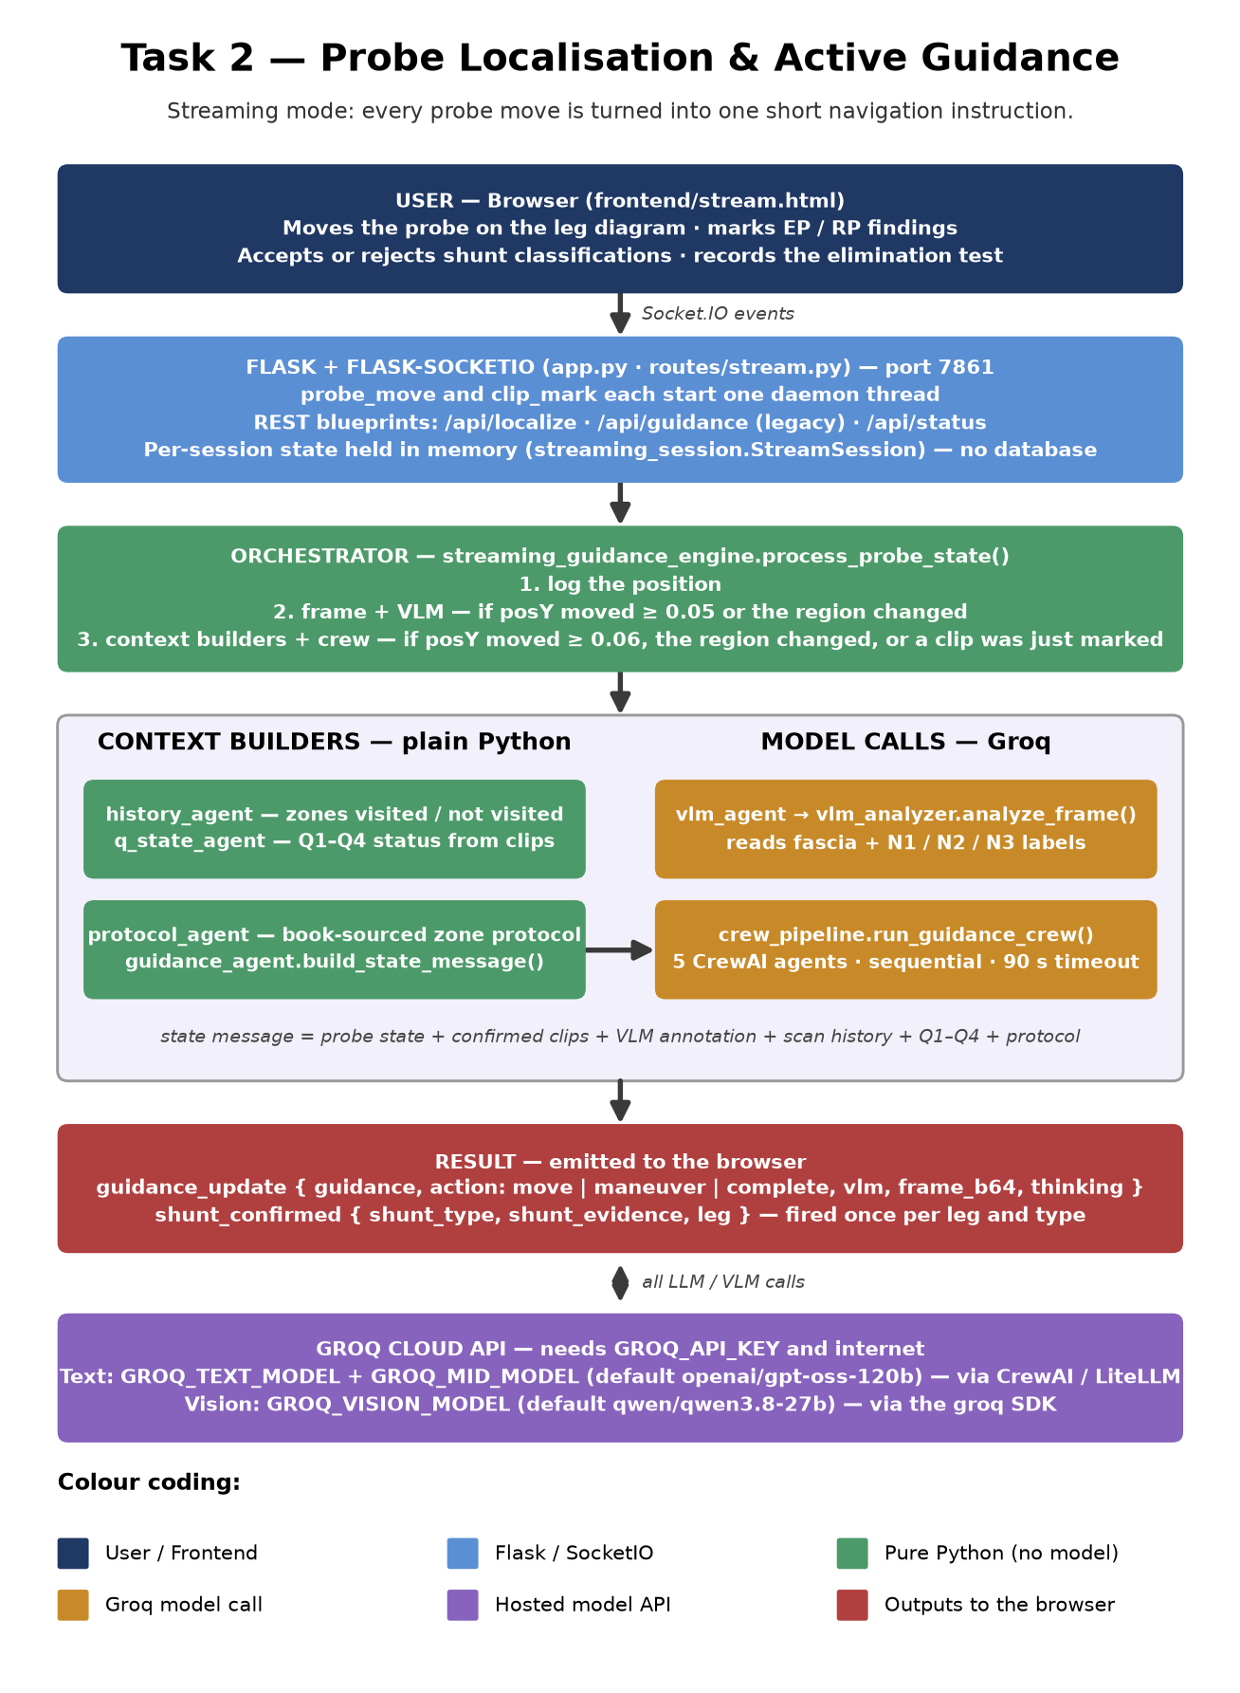
Figure 1 — End-to-end system architecture. Amber boxes indicate Groq API calls.

3. Clinical Context
CHIVA maps superficial venous reflux through four circuit components: Q1 (entry point, SFJ or SPJ), Q2 (trunk reflux in GSV or SSV), Q3 (escape point to a tributary), Q4 (re-entry to the deep system). Shunt classification determines which perforators to ligate. Task 2 tracks these four components as the surgeon scans and classifies the developing shunt type in real time.
Type | Clip Pattern Required | Special Condition
Type 1 | EP N1->N2 at SFJ + RP N2->N1 anywhere below | Valsalva AND Parana must both be positive at EP
Type 2A | EP N1->N2 at SFJ + EP N2->N3 below + RP N3->N1 (no trunk RP)
Type 2B | EP N1->N2 at SFJ + EP N2->N3 + RP N2->N1 + RP N3->N1 | Elimination test required to distinguish from Type 3
Type 2C | EP N1->N2 at SFJ + EP N2->N3 + RP N3->N1 below Dodd
Type 3 | EP N1->N2 + EP N2->N3 + RP N3->N1 + RP N2->N1 | Elimination test: reflux abolished = Type 3
Type 1+2 | Same four-clip pattern as Type 3 | Elimination test: reflux persists = Type 1+2
Type 4 | EP N1->N3 direct (Giacomini route)
Type 5 | EP N1->N2 at SPJ + RP in SSV
Type 6 | Direct tributary re-entry, no trunk involvement

4. Guidance Generation Pipeline

4.1 Thresholds and gating
Not every probe movement triggers a model call. Two thresholds gate the two processing stages:
Condition | Threshold | Effect
|pos_y - last_vlm_pos_y| >= 0.05 OR region changed | STREAM_VLM_THRESHOLD = 0.05 | New VLM frame analysis from Groq
|pos_y - last_llm_pos_y| >= 0.06 OR region changed OR clip_mark event | STREAM_LLM_THRESHOLD = 0.06 | Full 5-agent crew run
Neither threshold met | — | Last cached guidance echoed; no Groq call
sess.generation > req_gen + 6 | Stale threshold = 6 (hardcoded) | Result discarded silently

4.2 Probe-move data flow
Figure 2 traces the complete execution path for one probe_move event — from the WebSocket event handler through frame selection, VLM analysis, context building, crew invocation, stale check, and final emission to the browser.

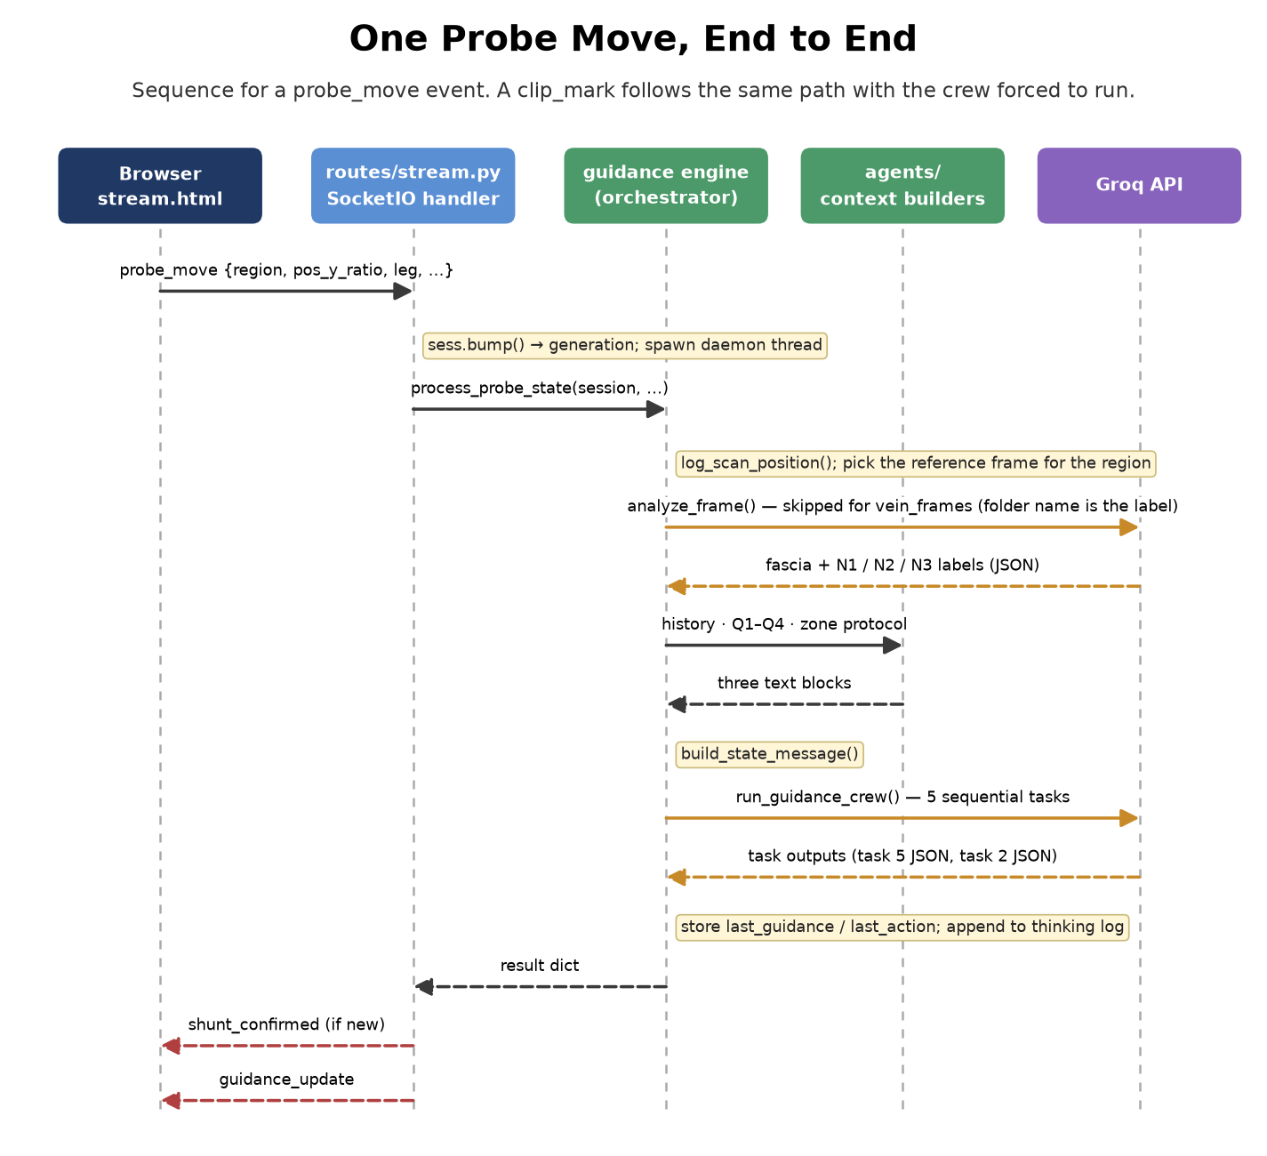
Figure 2 — Probe-move event flow. Green = pure Python; amber = Groq API call; red = output emitted to browser.

4.3 Frame selection
When the VLM threshold is met, _get_frame_for_region() selects one JPEG using a deterministic formula: bucket = int(round(pos_y x 20)), source = sources[bucket % n_sources], frame = jpgs[(bucket // n_sources) % len(jpgs)]. Guidance-folder frames are annotated reference images sent to the Groq vision model (qwen/qwen3.8-27b, max_tokens=512, timeout=15 s). Vein-frames-folder files are labelled by folder name — for these no Groq API call is made; an UltrasoundAssessment is constructed directly from the hardcoded _VEIN_FOLDER_TO_META dictionary in streaming_guidance_engine.py.

4.4 Context builders (pure Python, no model)
Before the crew runs, four plain-Python functions assemble the state message:
- history_agent.build_summary(session) — scans session.scan_log and session.clips to report which of the seven posY zones have been visited and what clips were found there.
- q_state_agent.analyze(leg_clips) — maps each clip posY to a zone band and returns Q1/Q2/Q3/Q4 status using pure Python conditionals. No model call.
- protocol_agent.get_protocol(region, pos_y) — returns a static literature-sourced text block from the _PROTOCOLS dict for the current zone. No model call.
- guidance_agent.build_state_message(...) — concatenates all of the above into a single multi-section string (PROBE STATE / CONFIRMED FINDINGS / VLM FRAME ANNOTATION / SCAN HISTORY SUMMARY / Q1-Q4 STATUS / EXAMINATION PROTOCOL) that forms the sole input to the crew.

4.5 The 5-agent crew
Figure 3 shows the sequential task graph. All five agents are instantiated fresh on every crew call. The crew runs inside a daemon thread with a hard 90-second timeout (_done.wait(timeout=90)).
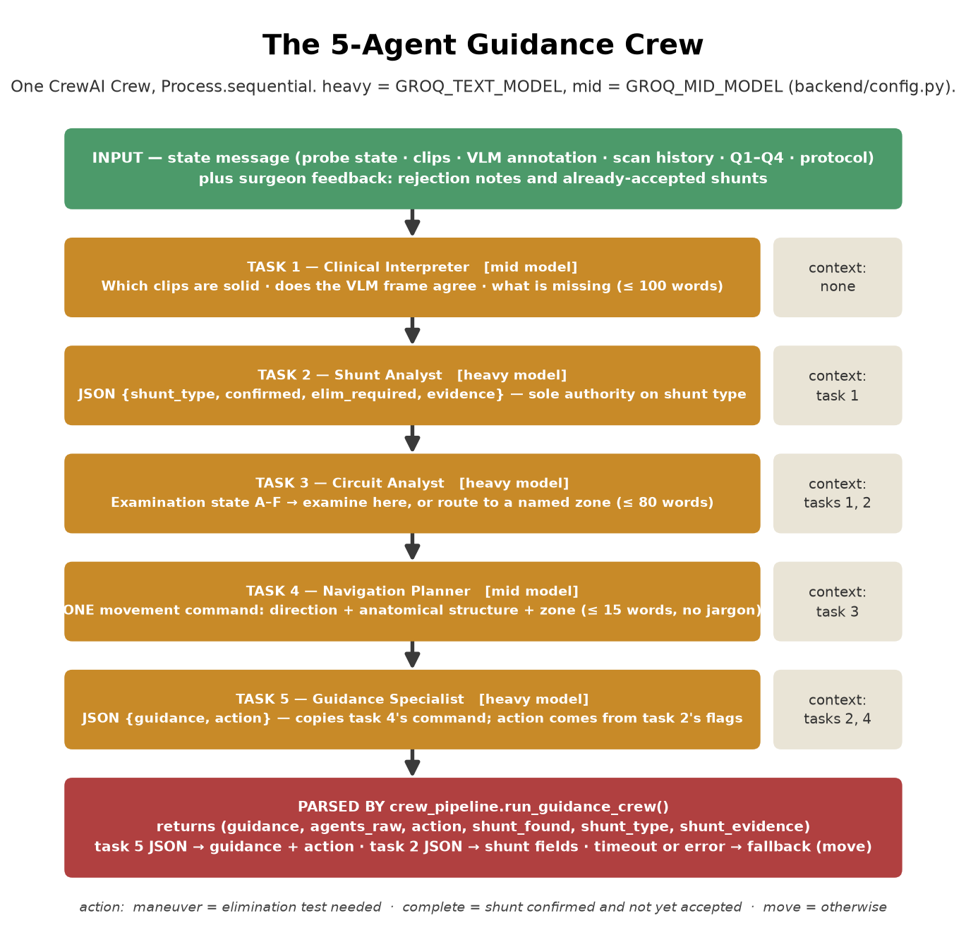
Figure 3 — The five sequential crew tasks and their context wiring.

Task | Agent | Model tier | Context inputs | Output
1 | Clinical Interpreter | Mid (openai/gpt-oss-120b) | state_message only | <=100 words: clip soundness, VLM agreement, absent clips
2 | Shunt Analyst | Heavy (openai/gpt-oss-120b) | task 1 | JSON {shunt_type, confirmed, elim_required, evidence}
3 | Circuit Analyst | Heavy | tasks 1, 2 | Examination state A-F and next target zone <=80 words
4 | Navigation Planner | Mid | task 3 | ONE movement command <=15 words, starts with Move
5 | Guidance Specialist | Heavy | tasks 2, 4 ONLY (task 3 excluded) | JSON {guidance, action: move|maneuver|complete}

Note: GROQ_TEXT_MODEL and GROQ_MID_MODEL both default to openai/gpt-oss-120b — the same model unless overridden via environment variables. Task 5 context excludes task 3 deliberately: the Navigation Planner already distils the Circuit Analyst output into a single movement command.

4.6 Fallback behaviour
- Crew timeout (90 s): returns fallback string 'Continue scanning distally to locate anatomical junction', action='move'. The daemon thread keeps running but its result is ignored.
- Crew exception: same fallback. The outer try/except in process_probe_state() also catches this.
- VLM failure: returns UltrasoundAssessment(error=...) with all boolean fields False. The crew still runs with 'Frame analysis unavailable' as the VLM section.
- JSON parse failure (task 5): fallback guidance kept, action defaults to 'move'.
- JSON parse failure (task 2): shunt_found=False, shunt_type='undetermined'. No shunt_confirmed event emitted.

5. Surgeon Feedback Loop
The system maintains two feedback lists on the session: rejection_notes and accepted_shunts. When the surgeon rejects a classification (shunt_reject event), a note is appended to rejection_notes and the type is removed from confirmed_shunts. On the next crew run, rejection_notes are prepended to task 1 description so the agents re-evaluate with that context. When a shunt is accepted (shunt_accept event), the type is added to accepted_shunts and task 5 description tells the Guidance Specialist not to re-announce it.

6. Probe Localisation
probe_localizer.py provides the REST-based localisation endpoint (/api/localize). It accepts a scanner reading (segment_id: 0-3, segment_dist: 0-1, is_front: bool) and maps it to a region string using classify_single(). A majority-vote smoothing window (ProbeLocalizer, window=10, stability_threshold=0.6) stabilises the region over successive readings.
Important: The streaming path (/stream page) does NOT use probe_localizer.py. The browser JavaScript mapReg() in stream.html computes the region from mouse posY and sends it directly in the probe_move payload. The two implementations are independent with no shared source of truth.

7. Known Limitations
- Sessions accumulate in _sessions dict and are never removed; restarting the app is the only way to clear them.
- Concurrent probe_move threads share session state without per-field locking. Only get_or_create() and bump() are explicitly locked.
- Zone boundaries (posY bands) are duplicated in three files: _BANDS in history_agent.py, _zone_name() in crew_pipeline.py, _level() in q_state_agent.py. A boundary change must be applied in all three.
- The reference frame sent to the VLM is selected by a deterministic formula, not by spatial alignment with the actual probe position.
- Shunt classification logic is entirely in LLM prompts — no Python code validates clip patterns against shunt type rules.
- The 90-second crew timeout does not cancel background Groq API calls; the daemon thread runs to completion even after the fallback is returned.
- Groq retired llama-3.3-70b-versatile and llama-4-scout-17b-16e-instruct. Current defaults (openai/gpt-oss-120b for text, qwen/qwen3.8-27b for vision) are set in config.py and all three model IDs are env-overridable.

