Vein Naming System — Developer Guide
Vein name annotation from ultrasound + webcam video · local Qwen 27B (4-bit) as the reasoning / vision engine

1. High-Level Architecture
The Vein Naming System takes two recordings of the same leg-ultrasound exam — the ultrasound screen capture and a webcam video of the clinician scanning — and produces two annotated videos: an intermediate video where every vein is labelled by fascial depth (N1 deep / N2 saphenous trunk / N3 superficial), and a final video where each vein carries its real name (CFV, FV, PV, GSV, SSV, AASV, PASV, Giacomini, Tributary, Perforator, …).
It is a Flask backend (backend/app.py) serving a single-page frontend (frontend/index.html). Work happens in a background thread per job. There is no database and no queue: job state is held in memory and lost on restart, by design (single-shot batch tool).
Two kinds of model are involved:
- BioMedParse (two finetuned checkpoints) — segments veins and the two fascia lines in the ultrasound video. GPU, in-process (PyTorch).
- Local Qwen 27B, 4-bit GGUF — the ONE model behind every reasoning / vision call: ROI cropping agent, Stage 2 (N-class), Stage 3a (probe location), Stage 3b (vein naming). Served by llama.cpp's llama-server as a separate process over an OpenAI-compatible HTTP API.
What is different in this edition: The original system called a hosted API (Groq, qwen3.6-27b) for every VLM/LLM call. That has been replaced by a locally-run Qwen. No API keys, no network dependency at inference time, no per-token cost. Prompts, stage logic, vocabulary gating, retry logic and rendering are unchanged. Section 5 documents exactly what changed and what was removed (the token-rate limiter, 429 back-off, cost tracker).

2. System Diagram
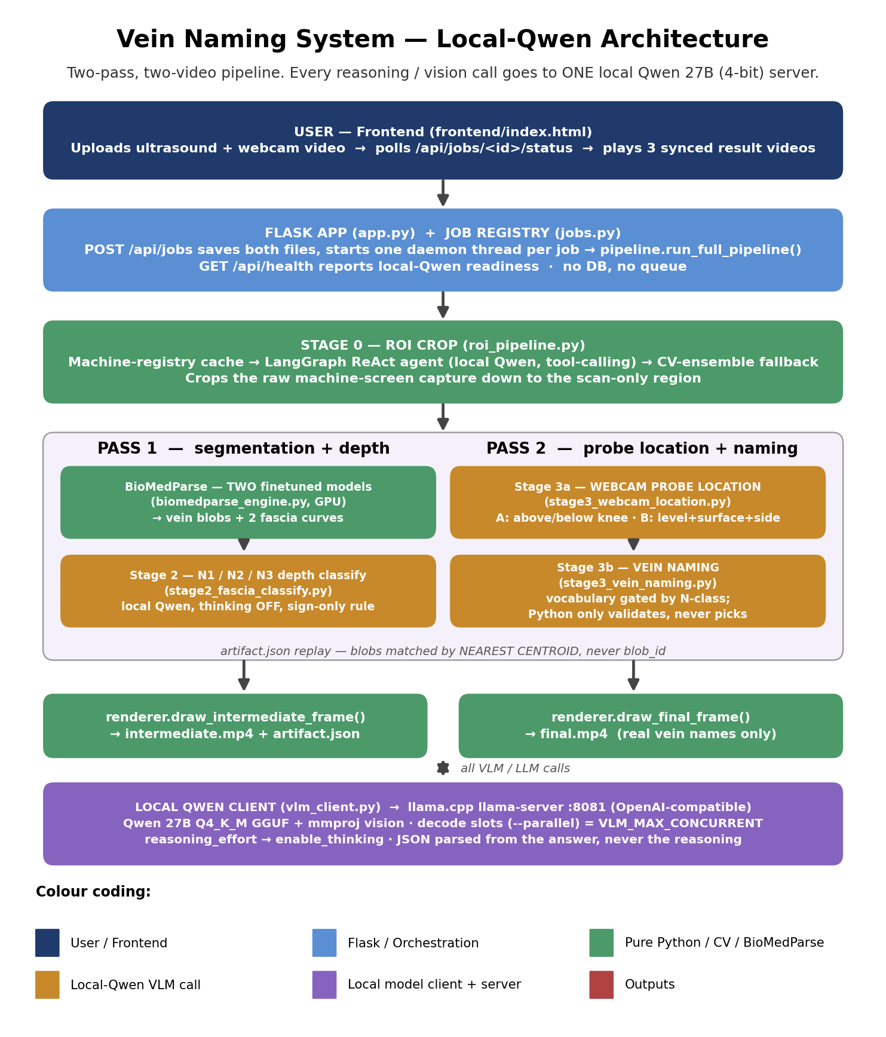
Figure 1: End-to-end architecture. Amber = calls to the local Qwen server.
Note: Stage 2 (Pass 1) needs only the segmented ultrasound frame. Stage 3a/3b (Pass 2) replay the geometry saved by Pass 1 (artifact.json) alongside the webcam video, so BioMedParse never runs twice.
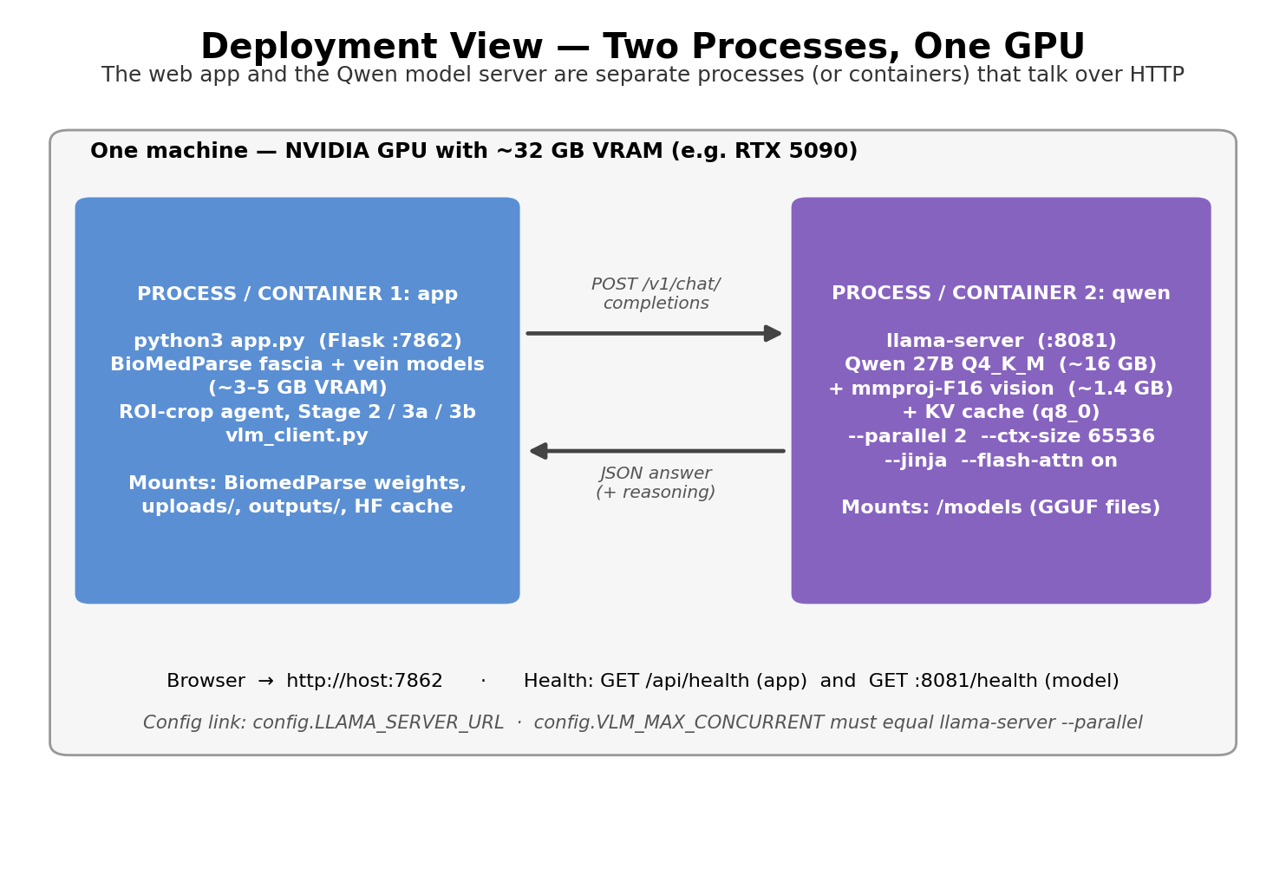
Figure 2: Deployment view — two processes/containers sharing one GPU.

3. Module Map (backend/)
What every file owns and why it exists. Everything except the smoke-test and utility scripts at the bottom is on the import path from app.py.
File | Responsibility
app.py | Flask entry point. Serves frontend/, POST /api/jobs (upload), job status, result videos, and GET /api/health (app + local-Qwen readiness). Host/port from CMED_HOST / CMED_PORT.
config.py | Single source of configuration: paths (env-overridable), BioMedParse thresholds, local-Qwen settings (LLAMA_SERVER_URL, VLM_MAX_CONCURRENT, token caps), sampling cadence, worker counts, motion-trigger thresholds.
jobs.py | In-memory job registry. create_job() starts one daemon thread running pipeline.run_full_pipeline(); tracks status/stage/progress/error and output paths.
pipeline.py | Two-pass orchestration: run_roi_crop, run_pass1 (segment → classify → render intermediate), run_pass2 (probe location → naming → render final), run_full_pipeline. Owns the plan-first / fire-concurrently / replay-sequentially pattern and nearest-centroid label holding.
vlm_client.py | NEW. The single gateway to the local Qwen server: call_vlm_json(), call_vlm_text(), wait_until_ready(), server_status(), usage_tracker. Maps reasoning_effort → enable_thinking, bounds concurrency to the server's decode slots, retries transient errors.
biomedparse_engine.py | Loads the two finetuned BioMedParse checkpoints (thread-safe singleton), runs per-frame inference under a lock, returns VeinBlob list + FasciaBoundary (two smoothed curves).
stage2_fascia_classify.py | Stage 2. Builds the annotated-frame prompt with a precomputed signed pixel distance to each fascia line; asks the VLM for N1/N2/N3 per blob (and whether a blob is a false positive such as a watermark); truncation and missing-answer retries.
stage3_webcam_location.py | Stage 3a. Stage A: above/below knee with CV knee-line assist. Stage B: leg level (vocabulary narrowed by Stage A), surface, leg side. Two-agent reflux path (Agent LN + Agent S) when two hands are in frame.
stage3_vein_naming.py | Stage 3b. Names each blob from its N-class vocabulary + resolved location + anatomy text; validates vocabulary and one-name-per-trunk uniqueness, retrying (never substituting) on violation.
anatomy_knowledge.py | Book-derived anatomy reference prose (fed to the VLM as context), LEG_LEVELS, per-N-class vein vocabularies, and the set of names unique per frame. No branching logic lives here.
knee_cv.py | Classical-CV (no ML) knee-height detector, foot crop, occlusion score — turns the repeatedly failing 'find the knee' reasoning task into a perception task.
renderer.py | Pure drawing: numbered contours, fascia lines, N-class colours, final vein-name labels, position-debug overlay. Enforces 'only real names are drawn'.
video_io.py | Timestamped frame sampling and an H.264 writer built on imageio-ffmpeg (OpenCV's own writer is not browser-safe on Windows).
roi_pipeline.py | Stage 0 orchestrator: machine-registry lookup → LangGraph agent → CV ensemble → texture-based edge trim → crop.
roi_agent.py | LangGraph ReAct agent. Uses langchain-openai's ChatOpenAI pointed at the local llama-server (needs --jinja for tool calling). Thinking disabled so tool calls are emitted directly.
vlm_agent.py | Optional VLM verify/classify helper for ROI detection and probe orientation (TRANSVERSE / LONGITUDINAL); goes through vlm_client.call_vlm_text().
agent_tools.py | LangChain tools the ROI agent calls: get_video_metadata, run_cv_detection, analyze_region, get_spatial_profile, scan_boundary.
cv_ensemble.py | Four-signal deterministic ROI detector (grayscale, non-dark, texture, contour) — the agent's starting point and its fallback.
machine_registry.py / machine_registry.json | Perceptual fingerprint cache of confirmed ROIs per ultrasound machine layout. Delete the JSON to reset.
video_cropper.py / frame_sampler.py | Frame-by-frame crop with ffmpeg remux; sharp-frame sampler + video metadata.
smoketest_step1 … step9, test_roi_batch.py | Layered smoke tests (dev tooling, not imported by the app). See section 10.
make_segmented_video.py, make_test_fragments.py | Dev utilities: pure-segmentation video without any VLM; cut aligned short fragments from a long recording pair.

4. Data Flow — One Job
A job is one (ultrasound, webcam) pair. The webcam is never ROI-cropped (it is a room view, not a machine screen).
STAGE 0 — ROI CROP :
- Machine-registry hash lookup (skip everything if this machine layout was seen before and re-verifies).
- LangGraph agent (local Qwen, thinking off) makes ≤5 tool calls over CV statistics and emits FINAL_ROI.
- CV ensemble runs alongside as check + fallback; edges trimmed to where speckle texture starts.
- Best effort: if ROI detection fails outright, the uncropped video is used.
PASS 1 — segment + depth (run_pass1) :
- Step 1 (GPU, no VLM): sample the video every SEG_SAMPLE_INTERVAL_SEC (0.5 s), segment each tick, decide which ticks need a Stage 2 call (blob count changed / unmatched blob / VLM_SAMPLE_INTERVAL_SEC = 4 s elapsed).
- Step 2: dispatch all scheduled Stage 2 calls concurrently (ThreadPoolExecutor; real concurrency bounded by vlm_client).
- Step 3 (sequential): replay ticks; between VLM calls hold the last N-class per blob by NEAREST CENTROID; render intermediate.mp4; write artifact.json.
PASS 2 — probe location + naming (run_pass2) :
- Step 1: schedule Stage 3a calls from CPU-only signals — a 64×48 frame-diff motion check triggers a call when the webcam changes (min 1.5 s, forced every 5 s).
- Step 2: run Stage 3a concurrently. Stage A → above/below knee; Stage B → leg_level (narrowed), surface, leg_side.
- Step 3 (VLM-free replay): resolve which location applies to each tick.
- Step 4: run Stage 3b naming concurrently per tick (blobs + N-class + location + anatomy text).
- Step 5: render final.mp4, position_debug.mp4, probe_location_log/ (every Stage 3a reading + the exact frame it saw).
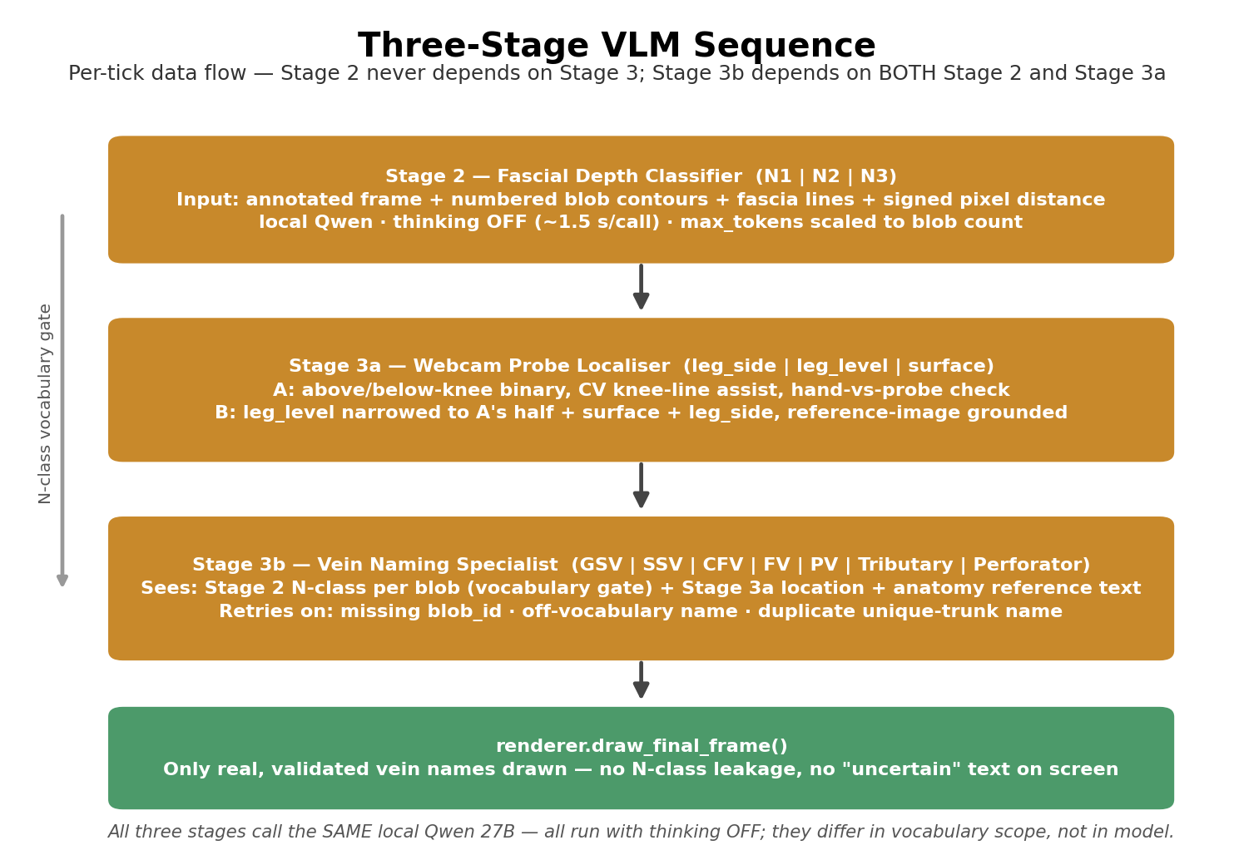
Figure 3: The three VLM stages and their dependencies.
A failed VLM call never kills the job: every concurrent dispatch is wrapped, and the affected tick's blobs simply stay unclassified / unnamed.

4.1 Vocabularies (anatomy_knowledge.py)
Item | Values
Leg levels | groin_sfj, upper_thigh, proximal_thigh_hunterian, distal_thigh_dodd, knee_popliteal, calf, ankle, uncertain
Above knee (Stage A = 0) | groin_sfj, upper_thigh, proximal_thigh_hunterian, distal_thigh_dodd
At/below knee (Stage A = 1) | knee_popliteal, calf, ankle
N1 names (deep) | CFV, FV, PV, Posterior Tibial Vein, Peroneal Vein, Perforator
N2 names (saphenous compartment) | GSV, SSV, AASV, PASV, Giacomini, Perforator
N3 names (superficial) | Tributary, AASV, PASV, Perforator
Unique per frame | GSV, SSV, CFV, PV, FV (at most one blob each; Tributary may repeat)

5. The Local Qwen Layer

5.1 What runs where
llama.cpp's llama-server hosts the model: Qwen 27B, Q4_K_M 4-bit GGUF (≈16 GB) plus the mmproj-F16 vision projector (≈1.4 GB) that makes it accept images. The app talks to it at config.LLAMA_SERVER_URL (default http://127.0.0.1:8081) via POST /v1/chat/completions. GGUF is used because its int4 kernels keep weights compressed in VRAM during compute; an AWQ/compressed-tensors build was tried first and decompressed to bf16 in VRAM, running out of memory on a 32 GB card (see Qwen_Local_VLM_Tester/README.md in the source repo).

5.2 vlm_client.py — the only place the model is called
Function | Purpose
call_vlm_json(system, user, image_b64, extra_images, max_tokens, reasoning_effort, label, …) | Same signature the stage modules always used. Builds an OpenAI-style multi-part message (primary image + reference images + text), returns (parsed_json, raw_answer). {} means no valid JSON — callers treat it as 'this tick failed'.
call_vlm_text(...) | Plain-text variant used by vlm_agent.py.
wait_until_ready() | Polls /health; raises an actionable RuntimeError if the server is not up. run_full_pipeline calls it first, so a forgotten server fails in seconds, not after cropping + segmentation.
server_status() | ready | loading | not_started | error — surfaced on GET /api/health.
usage_tracker | Per-job call count, prompt/completion tokens, cumulative call seconds (no cost).

5.3 Behaviour mapping from the hosted API
Was (hosted API) | Now (local Qwen)
reasoning_effort = "none" | chat_template_kwargs.enable_thinking = false
Per-call reasoning_effort = "default" in Stage 2 / 3a-B / reflux agents | OVERRIDDEN to thinking OFF for every call by config.VLM_FORCE_NO_THINKING = True (local evaluation: 25/25 correct at ~1.5–2.5 s vs 18/25 at ~15 s with thinking).
reasoning_effort = "default" (sentinel: omit param) | enable_thinking = true (only reachable if VLM_FORCE_NO_THINKING is set False). llama-server returns the trace in message.reasoning_content and only the answer in message.content; JSON is parsed from content only.
Groq SDK + per-minute OTPM/TPM token limiter + 429 back-off | Removed. Replaced by a semaphore of VLM_MAX_CONCURRENT slots (must equal llama-server --parallel) and 2 retries with back-off for connection resets / 503 / timeouts.
Cost tracker ($ estimate) | Removed. Tracker still reports calls, tokens and cumulative seconds.
Hard 16384 output ceiling (API limit) | VLM_MAX_TOKENS_CAP = 16384, enforced in vlm_client, sized to fit the per-slot context.
3-images-per-call limit (API limit) | Prompt design still uses ≤3 images (bounds prompt size / KV use); no server-side cap.
langchain-groq ChatGroq (ROI agent) | langchain-openai ChatOpenAI → llama-server /v1 (needs --jinja for tool calls).
GROQ_API_KEY in config / two other files | Gone. llama-server has no authentication in this setup; it binds to 127.0.0.1 (or the private compose network).

5.4 Server launch flags and sizing
llama-server --model Qwen3.8-27B-UD-Q4_K_M.gguf --mmproj mmproj-F16.gguf
--jinja --n-gpu-layers 999 --parallel 2 --ctx-size 65536
--cache-type-k q8_0 --cache-type-v q8_0 --flash-attn on
--host 127.0.0.1 --port 8081

Flag | Why
--mmproj | Required for image input; without it every call with an image fails.
--jinja | Chat template must render tool calls — the ROI LangGraph agent is tool-driven.
--parallel 2 | Two decode slots. Keep equal to VLM_MAX_CONCURRENT (config / env var).
--ctx-size 65536 | TOTAL context, divided across slots → 32768 tokens per call. A call = up to 3 images + prompt (≈10k) + up to 16384 output.
--cache-type-k/v q8_0 + --flash-attn on | 8-bit KV cache: about half the KV VRAM of fp16; a quantised V cache requires flash attention.
--n-gpu-layers 999 | All layers on the GPU.

Sizing note: Weights ≈17.4 GB + q8_0 KV cache for 64k tokens + BioMedParse (≈3–5 GB) is intended for a 32 GB card. These exact ctx/parallel/KV values were chosen by calculation and have NOT been load-tested on the GPU. If the server fails to start with an out-of-memory error, lower --ctx-size to 49152 (and keep --parallel 2), or drop to --parallel 1 with VLM_MAX_CONCURRENT=1.

6. Routes Reference (backend/app.py)
Method | Path | Purpose
GET | / | Serves frontend/index.html.
GET | /api/health | {app:'ok', vlm:{state, detail}, llama_server_url}. state = ready | loading | not_started | error.
POST | /api/jobs | Multipart: ultrasound_video + webcam_video (.mp4 .mov .avi .mkv .webm). Saves under uploads/<random>/, starts the job, returns {job_id}.
GET | /api/jobs/<id>/status | {job_id, status: queued|running|done|error, stage: starting|cropping|segmenting|naming, progress_pct, error, probe_log_path, position_debug_ready}.
GET | /api/jobs/<id>/result/<which> | which = intermediate | final | position_debug | webcam. 409 until ready (webcam is available immediately). Returns video/mp4.

6.1 Per-job output folder (outputs/<job_id>/)
Path | Content
intermediate.mp4 | N1/N2/N3-labelled video (red = N1, green = N2, blue-orange = N3) with both fascia lines.
final.mp4 | Same video with real vein names only.
position_debug.mp4 | Webcam video with Stage A's 0 / 1 / uncertain judgment burned in.
artifact.json | Pass 1 geometry per tick (blobs, fascia, N-classes) replayed by Pass 2.
roi_cropped/ | The cropped ultrasound video actually processed.
probe_location_log/ | probe_location_log.jsonl + the exact webcam frame behind every Stage 3a reading, for manual cross-checking.

7. Configuration Reference

7.1 Environment variables
Variable | Default | Meaning
LLAMA_SERVER_URL | http://127.0.0.1:8081 | Where the local Qwen server listens.
VLM_MAX_CONCURRENT | 2 | In-flight VLM calls. Must equal llama-server --parallel.
VLM_MODEL_NAME | qwen-local | Informational model id sent by the ROI agent.
CMED_HOST / CMED_PORT | 0.0.0.0 / 7862 | Flask bind address / port.
CMED_TASK4_DIR | BiomedParse_Assets/ | Root containing BiomedParse/ (source) and stubs/.
CMED_BIOMEDPARSE_DIR, CMED_STUBS_DIR | under the above | Override individually.
CMED_FASCIA_CKPT_DIR / CMED_VEIN_CKPT_DIR | BiomedParse_Assets/checkpoints/{fascia,vein} | Directories searched for the newest model_state_dict.pt.
CMED_UPLOADS_DIR / CMED_OUTPUTS_DIR | backend/uploads, backend/outputs | Where files are written.
HF_HOME | user default | Hugging Face cache (BiomedBERT text encoder is downloaded here once).

7.2 Tunables in config.py
Setting | Value | Effect
SEG_SAMPLE_INTERVAL_SEC | 0.5 | Segmentation tick spacing.
VLM_SAMPLE_INTERVAL_SEC | 4.0 | Max age of a Stage 2 classification before a refresh.
VLM_MIN_INTERVAL_SEC | 0.0 | Disabled early-refresh floor (historical).
WEBCAM_LOCATION_MIN/MAX_INTERVAL_SEC | 1.5 / 5.0 | Bounds on Stage 3a re-calls (motion-triggered).
WEBCAM_MOTION_DIFF_THRESHOLD | 20.0 | Mean abs grayscale diff (64×48) that counts as motion; calibrated on 6 real frame pairs — re-tune on new footage.
STAGE2_MAX_WORKERS / STAGE3A / STAGE3B | 4 / 2 / 3 | Submission-side thread pools (real limit: VLM_MAX_CONCURRENT).
VLM_MAX_TOKENS_CAP | 16384 | Clamp on any call's max_tokens; keep below (ctx-size / parallel) minus prompt.
VLM_TIMEOUT_SEC / VLM_TRANSIENT_RETRIES | 600 / 2 | Per-request timeout and retry count.
VEIN_PROB_THRESHOLD, VEIN_MIN/MAX_AREA_FRAC, … | 0.25, 0.002 / 0.025 | BioMedParse vein blob filtering. VEIN_MIN_AREA_FRAC was 0.0002 in the original; raised 10x to drop speckle blobs (~1290 px minimum).
VEIN_SMALL_MIN_AREA_FRAC / MAX_ANECHOIC_MEAN / MIN_CIRCULARITY / MAX_ASPECT_RATIO | 0.0006, 45.0, 0.55, 2.2 | Stricter second-chance gate for blobs below VEIN_MIN_AREA_FRAC -- recovers real small veins the floor raise above would otherwise drop.
GEOMETRY_DRIFT_PX | 20.0 | Forces a fresh Stage 2 call for a held label whose fascia-relative position has drifted this far, or crossed a line, since it was last classified.
FASCIA_PROB_THRESHOLD, FASCIA_POLY_DEGREE | 0.15, 3 | Fascia extraction and smoothing.
OUTPUT_FPS, WEBCAM_TIME_OFFSET_SEC | 10, 0.0 | Output frame rate; webcam-to-ultrasound sync offset.

8. Model Assets
Every model asset below is bundled in the package as shipped -- nothing to download, nothing to copy in, no environment variables to set. Verified end-to-end with every CMED_* and HF_HOME override unset: config.py resolves all paths to the bundled locations, biomedparse_engine loads both checkpoints and finds a real vein, and start_llama_server.bat finds both GGUF files.
Asset | Size | Where it is
BioMedParse source (modeling, utilities, configs) + detectron2/fvcore/mpi4py stubs | ≈1.2 MB | Code/BiomedParse_Assets/
Fascia checkpoint model_state_dict.pt | 1.7 GB | Code/BiomedParse_Assets/checkpoints/fascia/
Vein checkpoint model_state_dict.pt (phase 3) | 1.7 GB | Code/BiomedParse_Assets/checkpoints/vein/
Qwen 27B Q4_K_M GGUF | 16 GB | Code/QwenModel/
Qwen mmproj-F16 GGUF | 885 MB | Code/QwenModel/
BiomedBERT text encoder (microsoft/BiomedNLP-BiomedBERT-base-uncased-abstract-fulltext) | 841 MB | Code/hf_cache/hub/models--microsoft--BiomedNLP-.../

Package size as a result: ≈21 GB, almost all of it these five files. If you ever need to rebuild the package without them (e.g. to email just the code), delete BiomedParse_Assets/checkpoints/*/model_state_dict.pt, QwenModel/*.gguf, and hf_cache/hub/ -- everything falls back to raising a clear "not found, here's the exact path" error rather than silently running a different, non-finetuned model or hitting a gated Hugging Face repo (that silent-fallback behaviour existed early in this project and was deliberately removed).
Two separate BioMedParse checkpoints exist (not one combined model) because a combined model dropped fascia IoU from 0.679 to 0.20 -- see section 11 for the full training history, including exactly how each checkpoint was produced and how to fine-tune a new one.
Windows note: real detectron2 / fvcore / mpi4py are NOT installed anywhere; the stubs in BiomedParse_Assets/stubs/ are put on sys.path by biomedparse_engine.py. MultiScaleDeformableAttention prints a harmless ‘CUDA op not found, falling back to PyTorch’ warning.

9. Extending the Codebase
Task | Where
Swap the model (bigger quant, different Qwen build) | Change the GGUF/mmproj paths in start_llama_server.bat or .env. Nothing in Python changes. If the new model has a different chat-template switch than enable_thinking, edit only vlm_client._chat().
Point at a remote / shared model server | Set LLAMA_SERVER_URL. Any OpenAI-compatible vision server that honours chat_template_kwargs works; tool calling is needed only for the ROI agent.
Add or rename a vein / level | Edit anatomy_knowledge.py (LEG_LEVELS, N*_VEIN_NAMES, UNIQUE_PER_FRAME_VEIN_NAMES, reference text). Keep the vocabularies and the anatomy prose in sync. Prompts pick the change up automatically; renderer needs no change.
Change segmentation sensitivity | config.py: VEIN_* and FASCIA_* thresholds. Re-run smoketest_step1 and eyeball outputs/smoketest_step1_annotated.png.
Speed up jobs | Thinking is already off. Raise --parallel / VLM_MAX_CONCURRENT only if VRAM allows; raise VLM_SAMPLE_INTERVAL_SEC; lower max_tokens for Stage 2's first attempt; use a smaller quant. Concurrency beyond the slot count does not help a single GPU. Note the drift check (GEOMETRY_DRIFT_PX) adds real Stage 2 calls -- on a real 2-minute clip it raised the count from a would-be ~97 to 164 (67 drift-triggered); raising GEOMETRY_DRIFT_PX trades some of that correctness back for fewer calls.
Add a new VLM stage | Write a module with a pure build_prompt() and a function calling vlm_client.call_vlm_json(); pass label= for log timing; never branch in Python on the model's answer — validate and re-ask (project rule: no hardcoded region→vein tables).

Design rules to keep: (1) Python supplies measurements, the VLM decides. (2) Python may validate an answer and ask again — never substitute its own. (3) Match blobs across ticks by nearest centroid, never by blob_id. (4) Only real, validated vein names are drawn. (5) One failed call must never kill the job.

10. Quick Start (Windows)
- Install Python 3.12+ and an NVIDIA driver with CUDA 12.8 support. Install GPU PyTorch first (see the top of requirements.txt), then: pip install -r requirements.txt
- Double-click start_llama_server.bat. Leave it open. Wait until http://127.0.0.1:8081/health returns {"status":"ok"} (loading 17 GB takes a few minutes). All model files are already bundled (section 8) -- nothing to download or configure first.
- In another terminal: cd Code/backend && python3 app.py (or double-click run.bat). On this dev machine python3 is the interpreter with the full stack installed.
- Open http://localhost:7862 and upload a pair (Code/sample_data/ has a 5-second pair to start with).

11. Model Training & Fine-Tuning Reference (Training_Reference/)
The two BioMedParse checkpoints (section 8) were not trained from scratch -- they are the public BiomedParse foundation model, fine-tuned on a custom-labelled peripheral vascular ultrasound dataset. The notebooks, scripts and the full technical report behind that fine-tuning are bundled at the package root in Training_Reference/, separate from Code/ since none of it runs at inference time -- it exists so a new checkpoint can be trained if the model needs to improve or adapt to new footage. Everything in this section is drawn directly from that material, not reconstructed from memory.

11.1 What's in Training_Reference/
Path | Content
results/Fascia_Vein_Detection_Report.docx | The full technical report: architecture, dataset, methodology, results, discussion, limitations. Read this first -- it is the authoritative source; the JSON files below are earlier/interim snapshots, not the final numbers.
notebooks/finetune_biomedparse_v1.ipynb | Phase 1 (fascia-only) training notebook -- the one that actually produced the production fascia checkpoint. Includes the post-mortem on why an earlier attempt (“v5”) failed (IoU=0).
notebooks/finetune_biomedparse_v2.ipynb, finetune_biomedparse_vein.ipynb | Phase 2 (combined fascia+vein, then vein-focused) training notebooks.
notebooks/finetune_vein_phase3.ipynb | Phase 3 -- continues from the Phase 2 vein checkpoint with ~40k additional vein examples. This is the notebook that actually produced the vein checkpoint bundled in this package (D:\vein_phase3 on the original dev machine).
notebooks/finetune_biomedparse.ipynb | A later/consolidated version of the fine-tuning notebook (largest file, includes more exploratory cells).
scripts/prepare_finetune_data.py | Converts labelled frames + COCO-style metadata CSVs into BiomedParse's expected train/train_mask/test/test_mask PNG layout. This is the real starting point for training on NEW data.
scripts/eval_baseline.py, eval_finetuned.py | Compute mean IoU/Dice for the pretrained vs. fine-tuned checkpoints against a held-out test set, using the same _grounding_prob inference path as the deployed app.
scripts/build_report.py, generate_report_images.py | Generate the technical report and its side-by-side baseline-vs-finetuned comparison panels.
results/phase1_iou_curve.png, phase2_iou_curve.png, training_iou_curve.png | IoU-vs-epoch curves referenced by the report.
results/eval_baseline_results.json, eval_finetuned_results.json | Raw eval numbers from one run during development. CONFIRMED stale/interim -- do not quote these; use the report's numbers (11.3) instead.

11.2 How the checkpoints were actually trained
Base model: biomedparse_v1.pt, Microsoft's public pretrained checkpoint (trained on radiology, pathology, endoscopy, ophthalmology imagery -- never on vascular ultrasound). Only the mask predictor (transformer decoder, ≈18% of parameters) is trained; the Focal Transformer backbone, FPN pixel decoder, and the frozen BiomedBERT text encoder are never updated, in every phase below.
Phase | Starts from | Data | Key settings | Produces
1 — fascia-only | biomedparse_v1.pt | 2,364 fascia frames (vein annotations removed) | BASE_LR 1e-4, 10 epochs, pixel_decoder frozen, FP16, batch 4, 512×512 | fascia_finetuning_v2_production -- the bundled fascia checkpoint
2 — combined fascia+vein | Phase 1 checkpoint | 4,095 frames (2,364 fascia + 1,731 vein) | LR 5e-5, batch 16, FP16, up to 10 epochs (early stop) | fascia_vein_finetuning (superseded for vein by Phase 3; never used for fascia -- see 11.4)
3 — vein continuation | Phase 2 checkpoint | Phase 2 set + ~40k new vein examples from veins_vlm_finetuning/ | Same LR/batch/FP16 as Phase 2, 1 epoch | the bundled vein checkpoint (D:\vein_phase3 on the dev machine)

Phase 1's key fix over an earlier failed attempt (documented in the v1 notebook): that attempt trained on fascia+vein together at LR=1e-6 with the pixel decoder unfrozen, so the model learned the easier vein task and never moved far enough on fascia (IoU=0). Phase 1 isolates fascia, raises LR 100× to 1e-4, doubles epochs, and freezes the pixel decoder.
Training/grounding text prompts used at train time: fascia = "fascia layer in PeripheralVascular Ultrasound" (matches config.FASCIA_PROMPT exactly); vein = "vein in PeripheralVascular Ultrasound" in the training notebooks -- note this is SHORTER than config.VEIN_PROMPT ("small oval anechoic dark void vein lumen in cross-section peripheral vascular ultrasound below fascia") used at inference time in this package. BiomedParse grounds on free text via BiomedBERT rather than a fixed label set, so a more descriptive inference-time prompt than the training caption is expected to still work, but this difference is worth knowing if inference and training predictions ever disagree.

11.3 Results (from Fascia_Vein_Detection_Report.docx)
Target | Baseline (pretrained) IoU | Fine-tuned IoU
Fascia | 0.045 (essentially no detection) | 0.679 standard eval; 0.829 with the production top-bias query selection (18× improvement)
Vein | 0.568 (BiomedParse already saw generic vessel segmentation in pretraining) | 0.728

Evaluated on a 720-image held-out test set (415 fascia, 305 vein), same _grounding_prob pipeline the deployed app uses: 512×512 bicubic resize, grounding_eval task, threshold 0.5. A single combined checkpoint for both tasks was tried and abandoned: it dropped fascia IoU from 0.679 to 0.20, which is why fascia and vein ship as two separate checkpoints. The report's own noted limitations: all training data comes from one ultrasound machine (fine-tuned model can hallucinate detections on other machines/gain settings, mitigated in the deployed app by a CLAHE contrast-normalisation toggle and by Stage 2's own VLM-based false-positive check, section 2/5.2 -- the report's own “VLM Evaluator” mitigation is exactly what stage2_fascia_classify.py's is_valid_vein check now does, running on the local Qwen server instead of the report's original Groq-based one); vein annotation coverage (1,731 base samples) is smaller than fascia's.

11.4 How to fine-tune a new checkpoint (e.g. on new footage, or a different machine)
- Label new frames in the same format prepare_finetune_data.py expects: paired PNG frame + PNG mask (pixel value 1 = structure) per fascia/vein target, referenced by a metadata CSV (has_fascia/has_vein, valid_mask, video, frame_idx columns -- see that script's load_fascia_rows/load_vein_rows).
- Run prepare_finetune_data.py (edit its TASK3_BASE/BIOMEDPARSE paths at the top first) to produce the train/train_mask/test/test_mask layout BiomedParse expects, at 1024x1024 (resized to 512x512 at train time by the ResizeScale/FixedSizeCrop transforms in the report's section 3.5).
- Register the new dataset the way finetune_vein_phase3.ipynb does (section '5 - Register dataset' in that notebook) -- build a COCO-style JSON with the same category IDs (17=fascia, 18=vein) and caption strings as the existing dataset, since those IDs are remapped into BiomedParse's fixed 16-slot output head at load time.
- Copy finetune_biomedparse_v1.ipynb (fascia) or finetune_vein_phase3.ipynb (vein, if continuing from the current production checkpoint) as a starting point rather than writing the training call from scratch -- the entry.py invocation, PYTHONPATH/DATASET env vars, and config overrides in those notebooks are the ones actually confirmed to load and train correctly against this project's vendored BiomedParse/ source and stubs/.
- Train (RTX 5090, ~2h for 10 epochs at the Phase 1 settings). Evaluate with eval_finetuned.py before deploying -- compare IoU against the numbers in 11.3, on the SAME held-out test set if possible, not a new one, so the comparison is meaningful.
- Drop the new model_state_dict.pt into BiomedParse_Assets/checkpoints/fascia/ or .../vein/ in this package (or point CMED_FASCIA_CKPT_DIR / CMED_VEIN_CKPT_DIR at it) -- biomedparse_engine auto-picks the newest model_state_dict.pt under that directory, no code change needed.
If fine-tuning both fascia and vein together: the report's own experiment (section 6.1) found this measurably WORSE for fascia (IoU 0.679 → 0.20) than two separate checkpoints. Fine-tune and deploy them separately unless you have specific evidence that has changed for your new data.

