TECHNICAL REPORT

Fascia & Vein Detection in
Peripheral Vascular Ultrasound

1. Project Overview
This report documents the development of an automated fascia and vein detection system for vascular ultrasound. The goal is to identify two anatomical structures in every ultrasound frame:
- Fascia — the thin, curvilinear echogenic band separating subcutaneous fat from underlying muscle. Serves as the primary anatomical landmark for vein type classification.
- Vein lumen — the anechoic (dark) cross-section of veins (saphenous, perforators, and deep veins etc.) visible at or below or above the fascia line.
The approach uses BiomedParse, a foundation model for biomedical image segmentation, fine-tuned on a custom-labelled peripheral vascular ultrasound dataset collected from clinical examination videos.
Key Result: Fine-tuning increased fascia detection from a mean IOU of 0.045(pretrained — essentially no detection) to 0.678 on the standard evaluation. Vein detection with the pretrained model already achieved IOU 0.568 due to prior vessel training and further finetuning increased the IOU to 0.728.

2. Model Architecture

2.1 BiomedParse (GeneralizedSEEM)
BiomedParse is built on top of SEEM (Segment Everything Everywhere all at once), a universal segmentation model extended for biomedical imaging. It accepts multimodal prompts like free-text, visual references, spatial points and produces pixel-level segmentation masks.

2.2 Inference Pipeline
Each image passes through four sequential components:
Component | Description
Input Image | 512×512 RGB tensor, normalised with BioMed pixel mean/std
Focal Transformer (Backbone) | Hierarchical vision transformer. Outputs feature maps and is frozen during fine-tuning.
Pixel Decoder (FPN) | Deformable transformer encoder fusing multi-scale features into a dense representation. Frozen during fine-tuning.
Mask Predictor (SEEM Decoder) | Text-Image correlation learned via cross-attention. Only this component is trained.

2.3 Text Encoder — BiomedBERT
Microsoft's BiomedBERT (base, uncased, abstract-fulltext variant) tokenises and encodes the text prompt into a grounding embedding that is injected into the mask predictor's cross-attention layers. BiomedBERT weights are frozen throughout fine-tuning.

2.4 Query Selection at Inference
The mask predictor outputs 101 candidate mask proposals. The best is selected by:
probs = sigmoid(all_gmasks) # shape: [101, H, W]
weighted = probs.reshape(101,-1).max(dim=1).values
best_q = weighted.argmax() # index of chosen proposal
For fascia, a vertical spatial bias is additionally applied — query selection is weighted 2× at the top of the image, decreasing linearly to 0.2× at the bottom — because fascia consistently appears in the upper portion of peripheral vascular ultrasound frames.

2.5 Model Architecture and Finetuning Setup
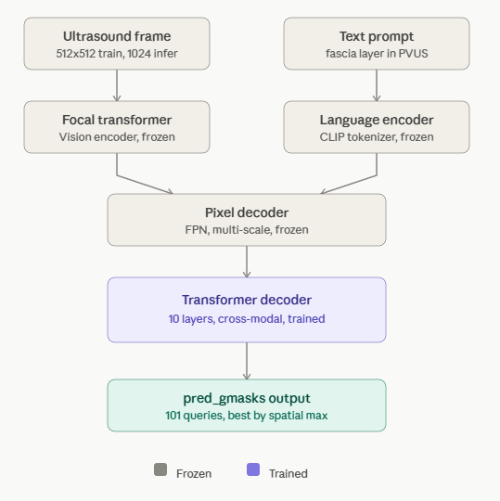

2.6 Dual-Model Deployment
The production system runs two separate inference passes per image:
- Fascia model (fascia_finetuning_v2_production) — Phase 1 checkpoint.
- Vein model (fascia_vein_finetuning) — Phase 2 checkpoint.
Design Note: A single combined checkpoint (Phase 2) was tested first for both tasks. It was abandoned because the combined model produced lower absolute sigmoid probabilities for fascia (fascia IOU fell from 0.679 to 0.20) and eliminated all fascia detections. Two separate checkpoints restored fascia quality without any trade-off.

3. Dataset

3.1 Source Material
Ultrasound frames were extracted from clinical examination videos captured during varicose vein assessments. All images are greyscale vascular ultrasound images stored as 1024×1024 PNG files.

3.2 Dataset Statistics
Split | Total Samples | Fascia (cat 17) | Vein (cat 18)
Training | 4,095 | 2,364 | 1,731
Test | 720 | 415 | 305
Total | 4,815 | 2,779 | 2,036

3.3 Annotation Format
The dataset follows COCO-style JSON format. Each annotation entry contains:
- image_id / category_id
- image_file — path to a raw input ultrasound image.
- mask_file — path to a separate PNG mask (pixel value 1 = structure, 0 = background)
- sentences — list of text grounding queries, e.g. "fascia layer in Peripheral Vascular Ultrasound"

3.4 Category Remapping
BiomedParse's output head has 16 built-in class slots (IDs 0–15). Custom category IDs 17 and 18 exceed this range and are remapped during training so the model reuses existing vocabulary slots rather than learning new output dimensions from scratch:
Our Category | ID | Mapped To | Mapped ID
Fascia layer | 17 | Histology structure | 14
Vein lumen | 18 | Vessel | 7

3.5 Training Pre-processing
The BioMedDatasetMapper applies these transforms to every training sample:
- ResizeScale —Scales so the shorter side falls between 0.9× and 1.1× of 512 px (scale jitter).
- FixedSizeCrop — Crops to exactly 512×512. This is the resolution the model trains at.
- RandomRotate — 50% probability of rotation by 90°, 180°, or 270°.
- Normalisation — BioMed pixel mean [64.3, 59.3, 60.0], std [62.5, 60.9, 59.8] — distinct from ImageNet values.

4. Fine-Tuning Methodology

4.1 Starting Point
Fine-tuning starts from biomedparse_v1.pt — Microsoft's publicly released pretrained checkpoint, trained on a large corpus of biomedical imaging data (radiology CT/MRI, pathology slides, endoscopy, ophthalmology, etc.). This checkpoint has never seen vascular ultrasound data during pretraining.

4.2 What Is Trained vs. Frozen
Only the mask predictor (transformer decoder) is updated. The Focal Transformer backbone, FPN pixel decoder, and BiomedBERT text encoder are all frozen throughout both fine-tuning phases. This preserves the general visual and language representations while adapting only the task-specific decoding head to vascular ultrasound anatomy.

4.3 Phase 1 — Fascia-Only Fine-Tuning
Training exclusively on 2,364 fascia samples using the following configuration:
Hyperparameter | Value | Rationale
Base learning rate | 1 × 10⁻⁵ | Conservative — avoids catastrophic forgetting
Backbone LR multiplier | 0.1× | Effectively frozen
Optimiser | AdamW | Weight decay 0.05
Batch size | 2 per GPU | Memory constraint
Input resolution | 512 × 512 | Matches training crop size
Epochs | 10 | Early stopping (patience = 2 epochs)
Mixed precision | FP16 | Faster training, lower VRAM usage
Gradient clip | 5.0 (L2 norm) | Prevents gradient explosion

The best checkpoint (epoch 10, step 1470) is selected by highest validation IOU and saved as fascia_finetuning_v2_production. This is the production fascia model.

4.4 Phase 2 — Combined Fascia + Vein Fine-Tuning
Phase 2 continues from the Phase 1 fascia checkpoint with the training set expanded to include both fascia (2,364) and vein (1,731) samples — 4,095 samples total.
Hyperparameter | Phase 1 Value | Phase 2 Value | Change
Starting checkpoint | biomedparse_v1.pt | fascia_finetuning_v2_production/step1470 | Continued training
Learning rate | 1 × 10⁻⁵ | 5 × 10⁻⁵ | 5× higher — new class to learn
Training data | Fascia only (2,364) | Fascia + Vein (4,095) | Vein samples added
Epochs | 10 | 10 | Unchanged
All other params | See Phase 1 | — | Unchanged

The best Phase 2 checkpoint is saved as fascia_vein_finetuning and is used exclusively for vein prediction in the deployed system.

5. Experiments

5.1 Experimental Setup
Three model configurations are evaluated on the same 720-image held-out test set:
- Baseline — Original biomedparse_v1.pt with no fine-tuning. Same grounding inference pipeline and text prompts as fine-tuned models.
- Phase 1 Fine-Tuned — fascia_finetuning_v2_production checkpoint. Evaluated on fascia test subset (415 images).
- Phase 2 Fine-Tuned — fascia_vein_finetuning checkpoint. Evaluated on vein test subset (305 images).

5.2 Evaluation Protocol
Each image is processed through the same _grounding_prob pipeline used in the deployed application: 512×512 bicubic resize, grounding_eval task, binary threshold at 0.5. Metrics computed against ground-truth binary masks (pixel > 0).
IOU = |pred ∩ gt| / |pred ∪ gt|
Dice = 2 × |pred ∩ gt| / (|pred| + |gt|)
Results are mean values across all test samples in each category subset.

6. Results

6.1 Fascia Detection
Model | Mean IOU | Mean Dice | N Samples | ΔIOU vs Baseline
Baseline (pretrained) | 0.045 | 2.85 | 415 | —
Phase 1 Fine-Tuned | 0.679 | 0.7873 | 415 | +0.634 (+1410%)
Note on fascia numbers: The standard evaluation uses the same flat max-probability query selection as the baseline. The production app additionally applies a top-bias (2× weight at top of image) which bumps the IOU to 0.829.
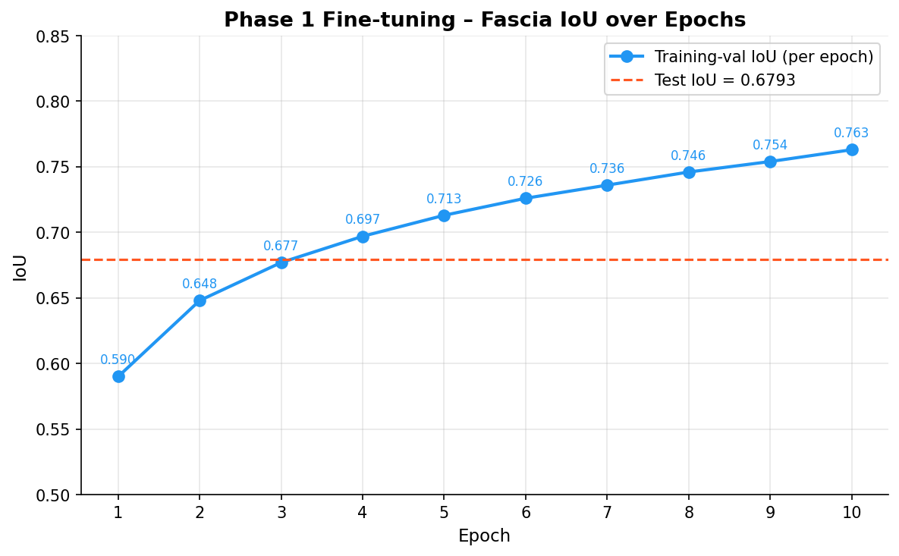
Figure : Fascia Detection IOU change during Finetuning Epochs.

6.2 Vein Detection
Model | Mean IOU | Mean Dice | N Samples | ΔIOU vs Baseline
Baseline (pretrained) | 0.568 | 0.819 | 305 | —
Phase 2 Fine-Tuned | 0.728 | 0.645 | 305 | +0.160 (+28.17%)
Note on vein numbers: The pretrained model scores decently on vein detection because BiomedParse was pretrained on vessel segmentation tasks from radiology and histology — the text prompt "vein in PeripheralVascular Ultrasound" maps to existing vessel knowledge. The fine-tuned model adapts this to the specific appearance of ultrasound veins.
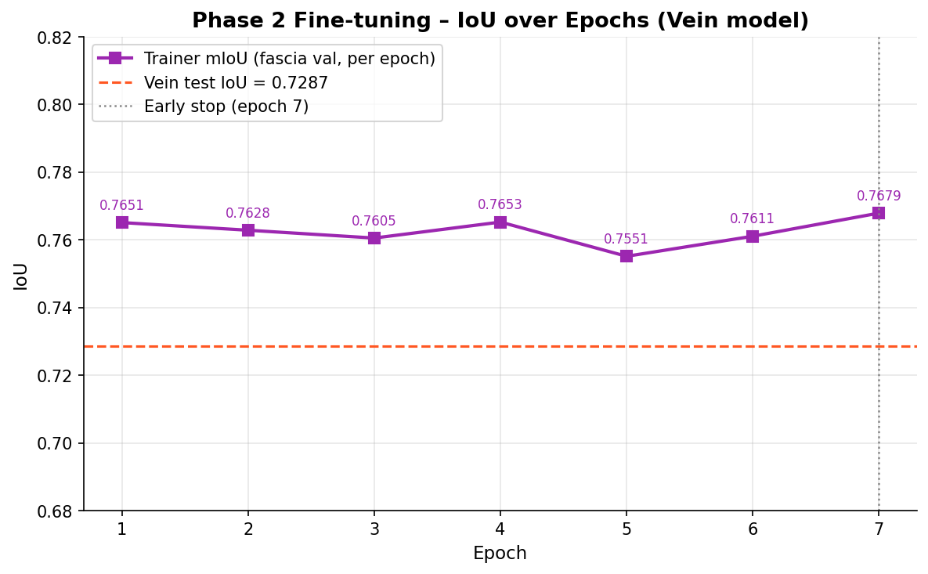
Figure : Fascia Detection IOU change during Finetuning Epochs.

7. Discussion

7.1 Why Fascia Required Fine-Tuning
Fascia as a distinct anatomical target does not appear in BiomedParse's pretraining corpus. The model has no concept of a thin curvilinear echogenic band in ultrasound, so pretraining covered organs, tumours, and histological structures. The baseline IOU of 0.045 confirms the model produces essentially random detections when asked for fascia.
After Phase 1 fine-tuning, the mask predictor learns to associate "fascia layer in PeripheralVascular Ultrasound" with the characteristic thin bright band near the top of the image. The improvement is entirely in the mask predictor decoder; the frozen backbone already extracts correct visual features (bright thin horizontal structures), the decoder simply could not prevIOUsly select the right proposal from the 101 candidates.

7.2 Domain Shift on Unseen Images With Different Image Quality
When tested on ultrasound images from other machines or with different gain/brightness settings, the fine-tuned model sometimes produces many false positive detections. This is expected — all 4,095 training samples come from a single machine and acquisition protocol. Two practical mitigations are implemented in the deployed application:
- CLAHE toggle — Contrast-limited adaptive histogram equalisation normalises the input image histogram before inference, reducing the distribution gap between unseen images and training data.
- VLM Evaluator toggle — Each predicted vein blob is passed to the Qwen3 vision model (via Groq API) with the full ultrasound frame as context. The model judges whether the highlighted structure is anatomically consistent with a real vein.

7.3 Limitations and Future Work
- Training data comes from a single ultrasound machine , adding images from multiple devices with different image quality and features and gain settings would substantially improve generalisation.
- Vein annotation coverage (1,731 samples) is smaller than fascia (2,364). More diverse vein labels, especially for deep veins (femoral, popliteal), would improve detection of non-saphenous structures.
- The VLM evaluator (Qwen3) depends on the Groq API and adds network latency per inference. A lightweight local binary classifier trained on confirmed/rejected blob crops would be faster and more reliable.
- Brightness/contrast augmentation (random gamma, gain jitter) during training would reduce domain shift without requiring additional labelled data.

8. Conclusions
- Fine-tuning BiomedParse on 2,364 labelled fascia frames increased fascia IOU from 0.045 to 0.679 (standard eval) and up to 0.829 oracle IOU with production top-bias query selection — an 18× improvement.
- The pretrained model already achieves IOU 0.568 for vein detection due to prior vessel segmentation training. Domain-specific fine-tuning adapts this to the specific visual characteristics of peripheral vascular ultrasound veins and the IOU improves little to 0.728.
- Only the mask predictor decoder (≈18% of parameters) is trained in both phases. Backbone, pixel decoder, and text encoder remain frozen, preventing catastrophic forgetting of general biomedical knowledge.
- A two-model deployment (one checkpoint per structure) eliminates the cross-task interference observed when a single combined checkpoint is used for both fascia and vein.
- Domain shift on non-training-distribution images is the primary remaining limitation. Adding training diversity through brightness/contrast augmentation or multi-machine labelled data would address this in future iterations.

9. Visual Results — Baseline vs. Fine-Tuned
Each panel shows five views of the same ultrasound frame: Input (letterboxed to 1024×1024 to match training format), Baseline mask overlay, Baseline boundary outline annotation, Fine-tuned mask overlay, and Fine-tuned boundary outline annotation. Cyan = fascia; Green = vein.

9.1 Seen Frames (in-distribution)
These frames come from the same ultrasound machine and acquisition protocol used for training. The fine-tuned model is expected to perform well; the baseline may miss fascia entirely.
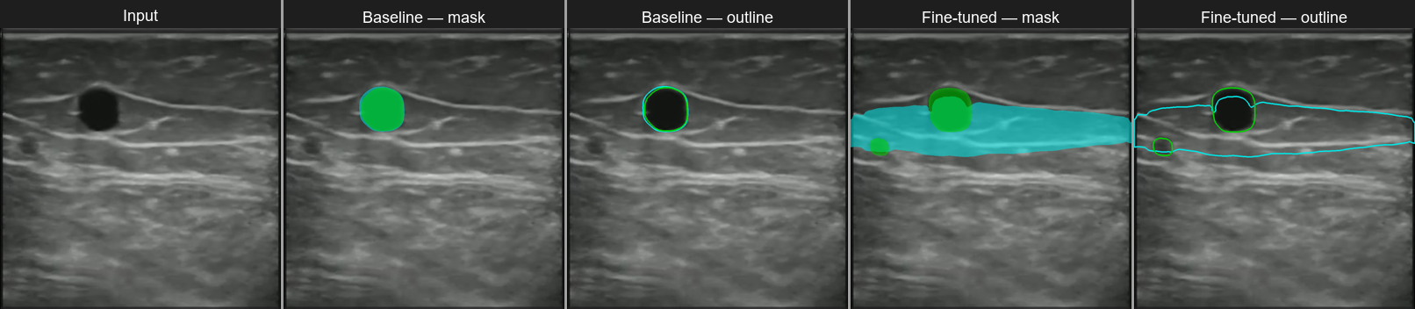
■ Fascia ■ Vein
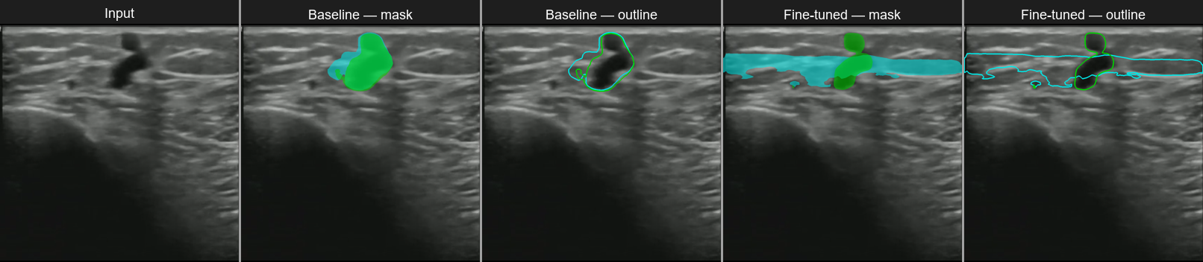
■ Fascia ■ Vein
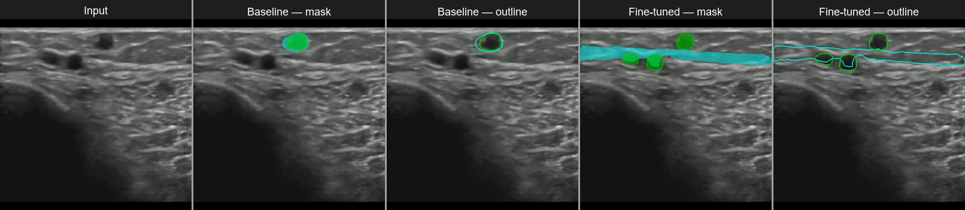
■ Fascia ■ Vein
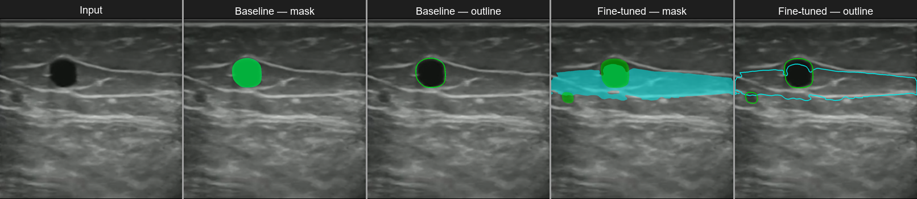
■ Fascia ■ Vein
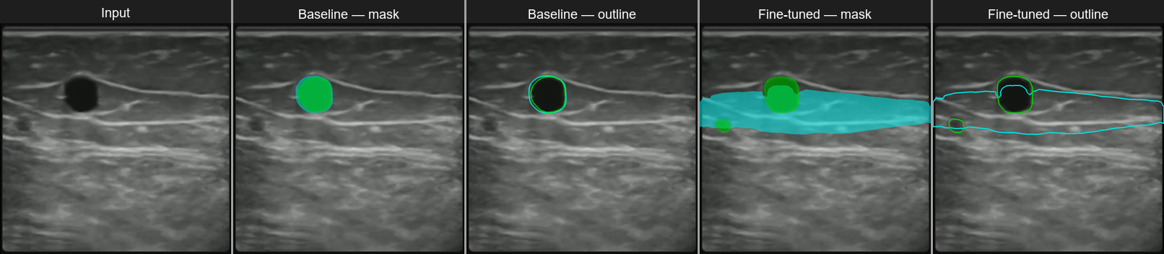■ Fascia ■ Vein
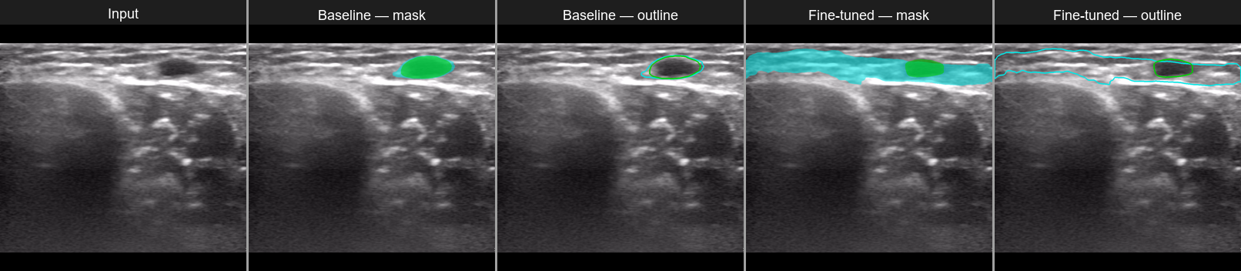
■ Fascia ■ Vein
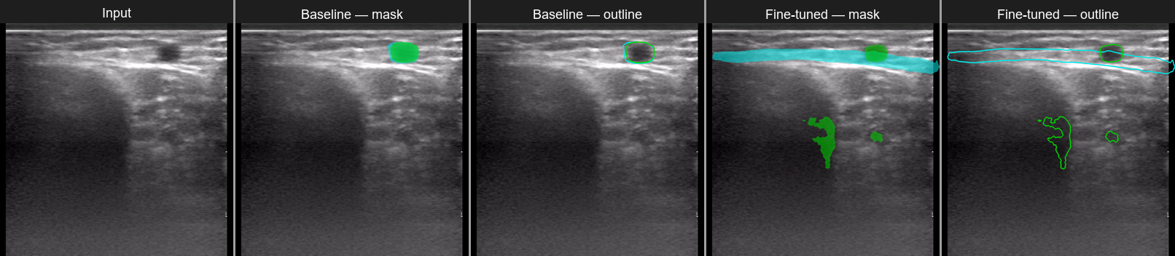
■ Fascia ■ Vein
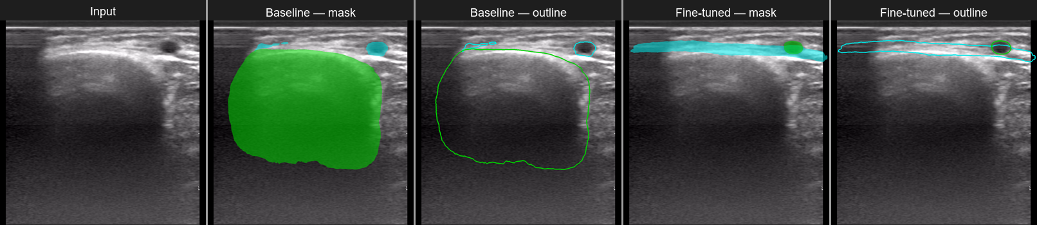
■ Fascia ■ Vein

9.2 Unseen Frames (out-of-distribution)
These frames come from different sources (different machine, brightness, or gain settings). They reveal the domain shift limitation: the fine-tuned model can hallucinate detections on images outside the training distribution, while the baseline is consistently poor on fascia.
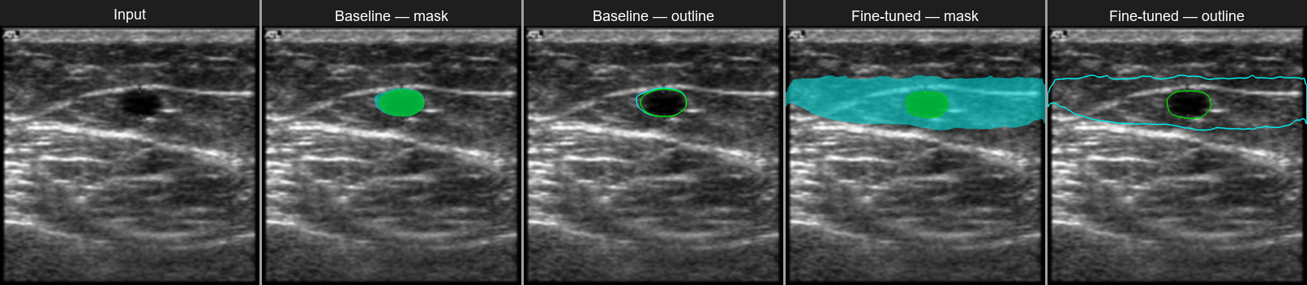
■ Fascia ■ Vein
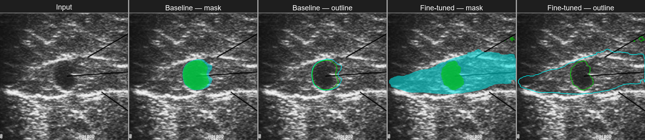
■ Fascia ■ Vein
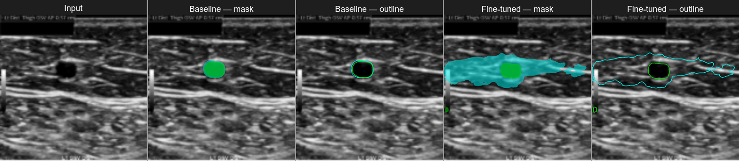
■ Fascia ■ Vein
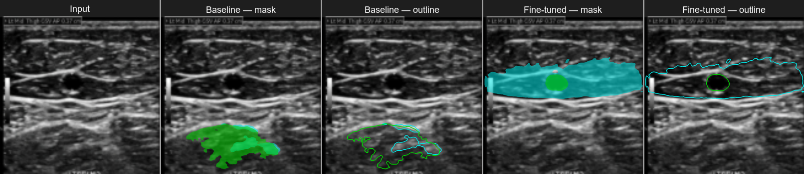
■ Fascia ■ Vein
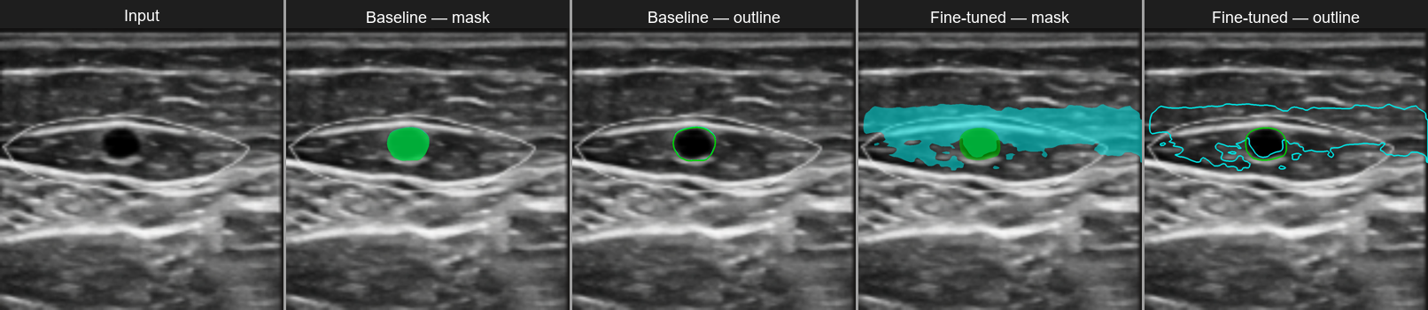
■ Fascia ■ Vein
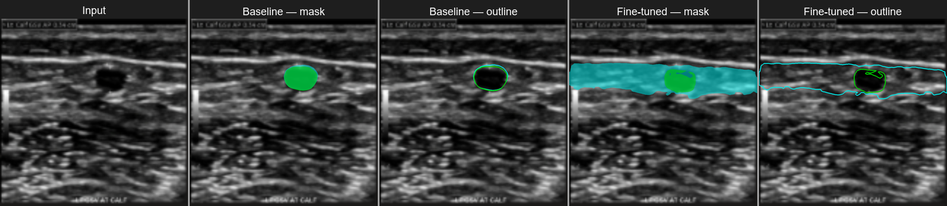
■ Fascia ■ Vein
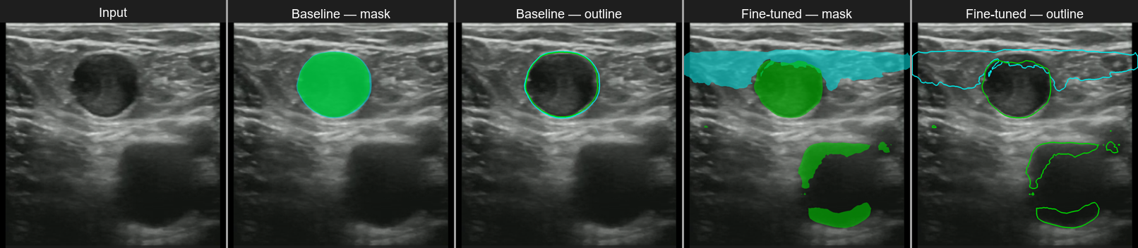
■ Fascia ■ Vein
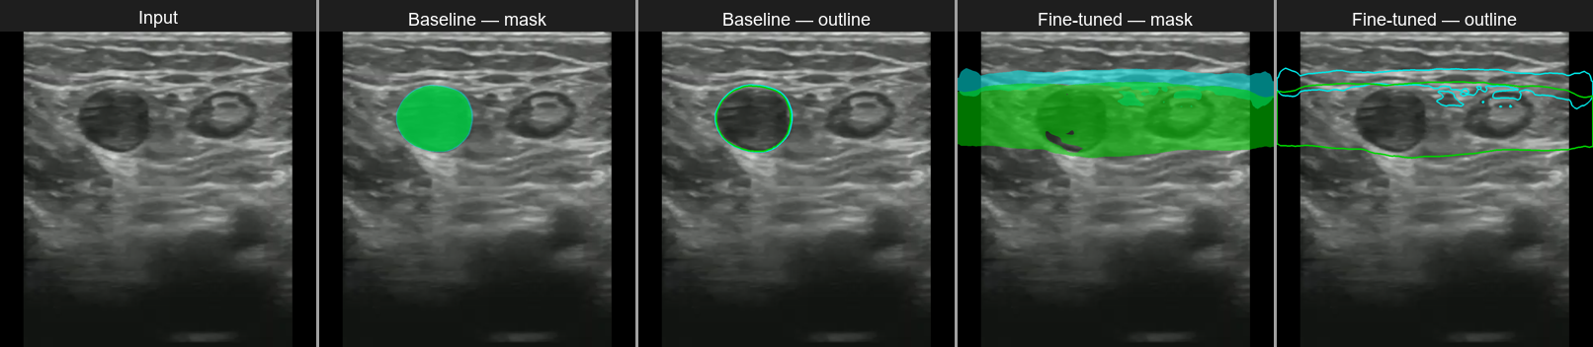
■ Fascia ■ Vein
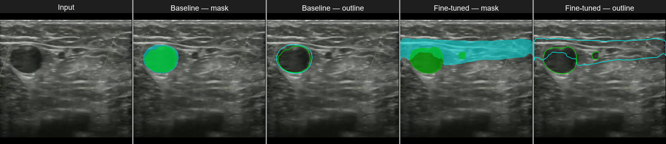
■ Fascia ■ Vein
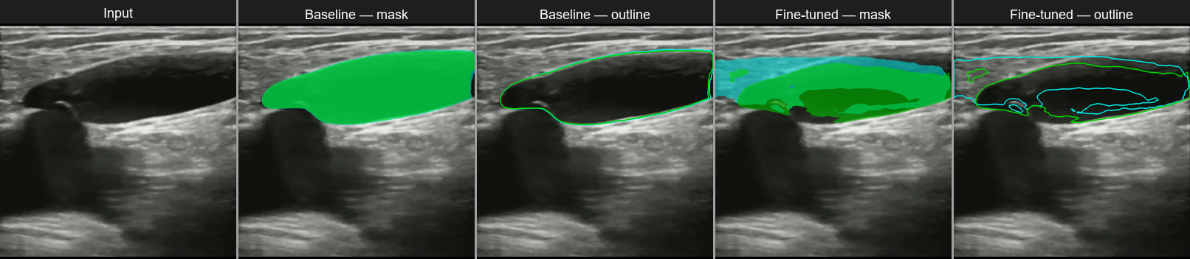
■ Fascia ■ Vein
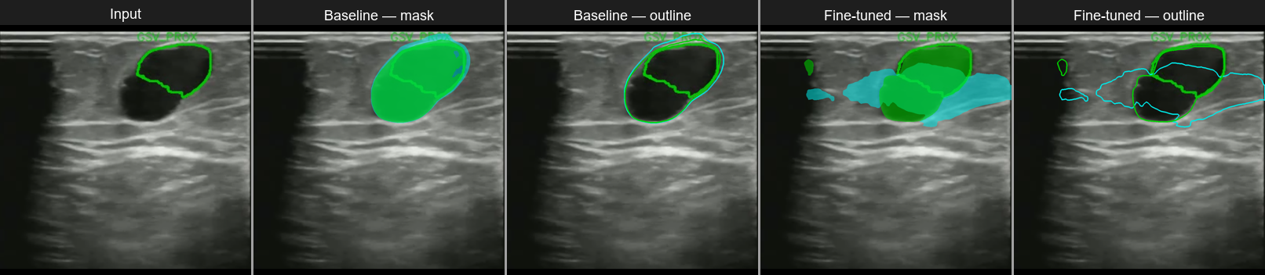
■ Fascia ■ Vein
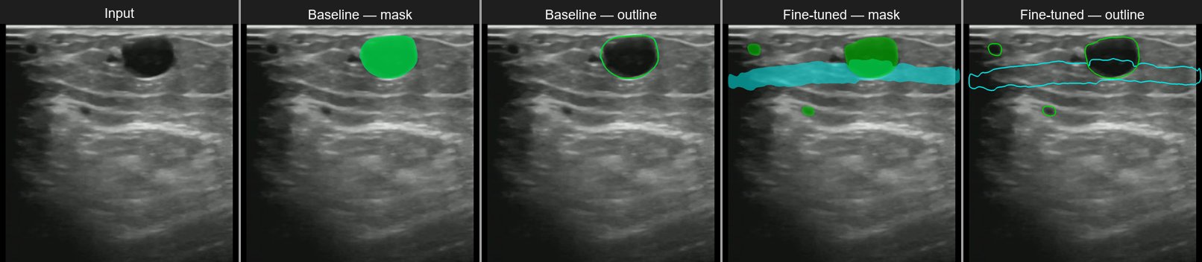
■ Fascia ■ Vein
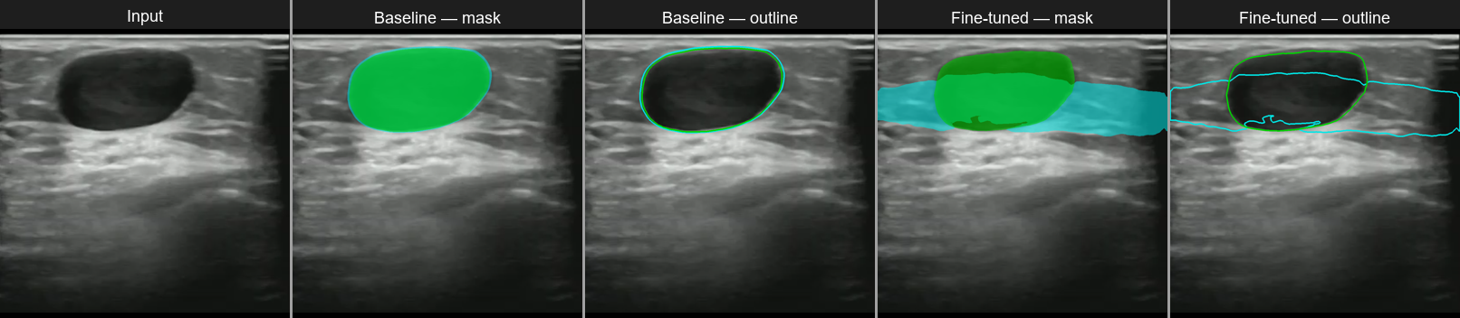
■ Fascia ■ Vein
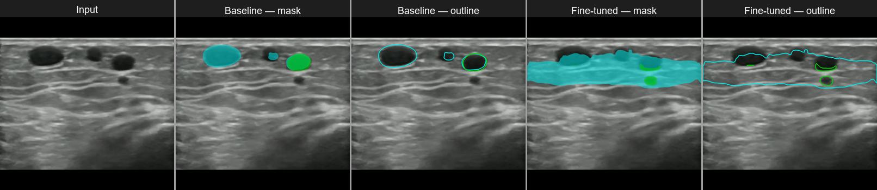
■ Fascia ■ Vein
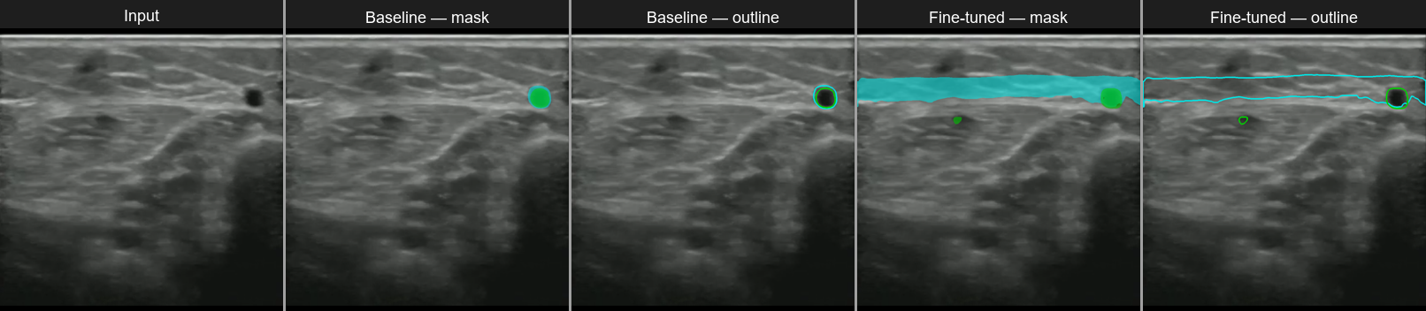
■ Fascia ■ Vein
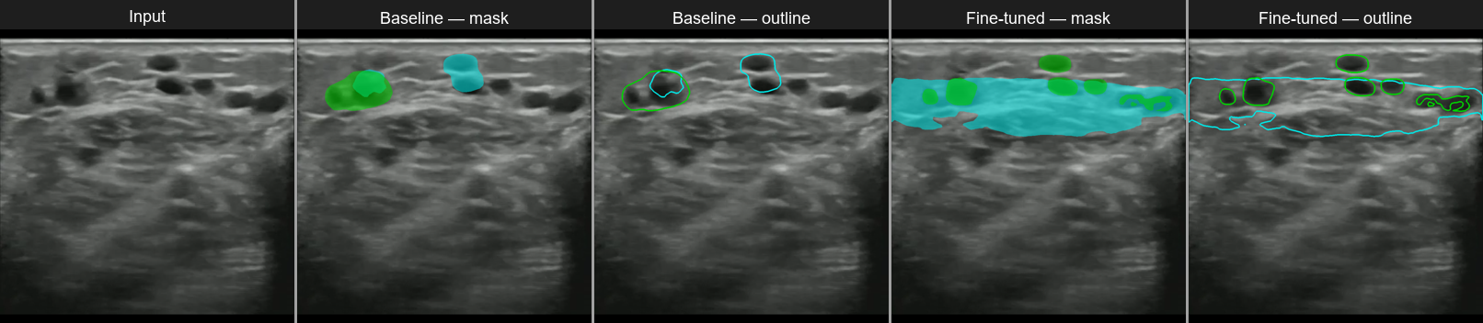
■ Fascia ■ Vein
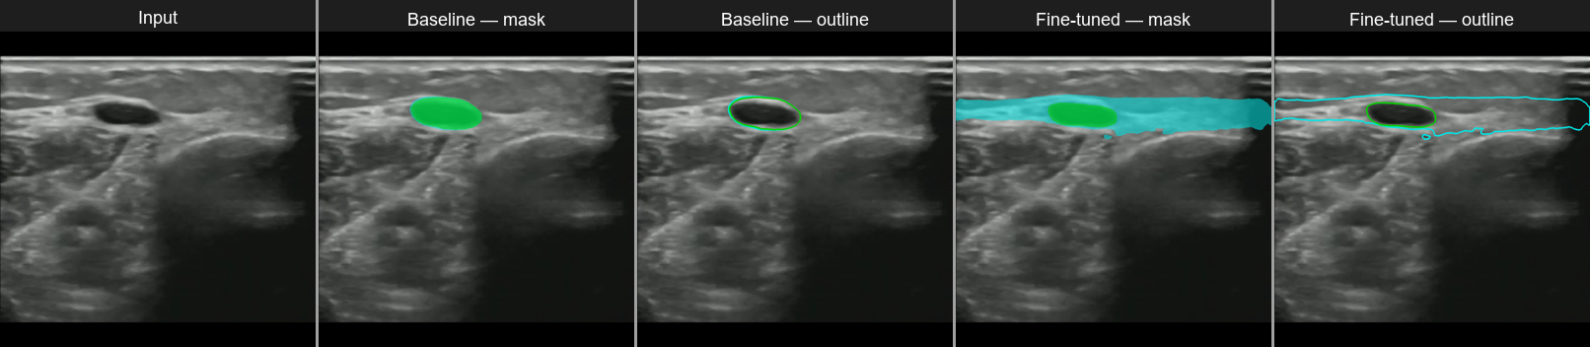
■ Fascia ■ Vein
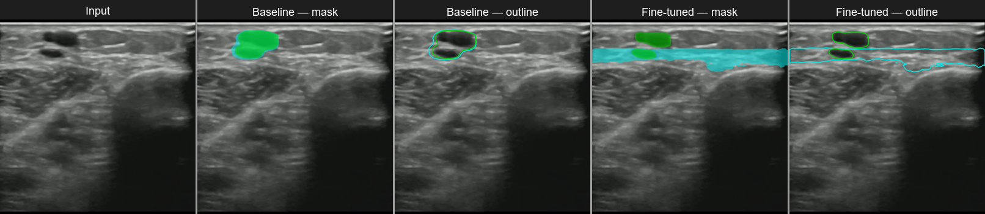
■ Fascia ■ Vein
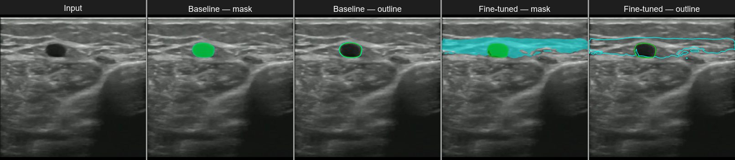
■ Fascia ■ Vein
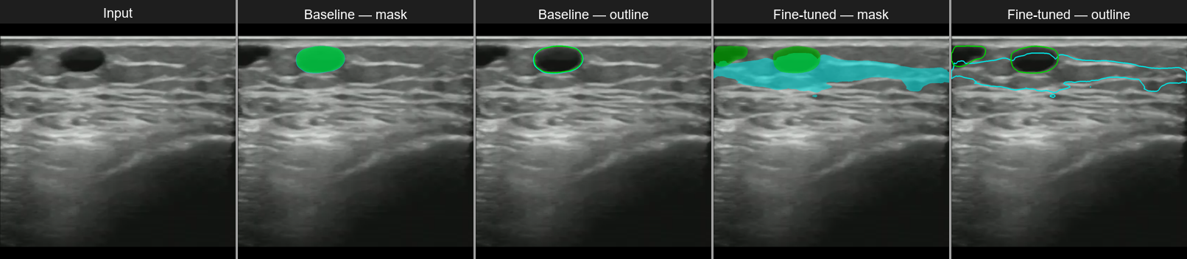
■ Fascia ■ Vein
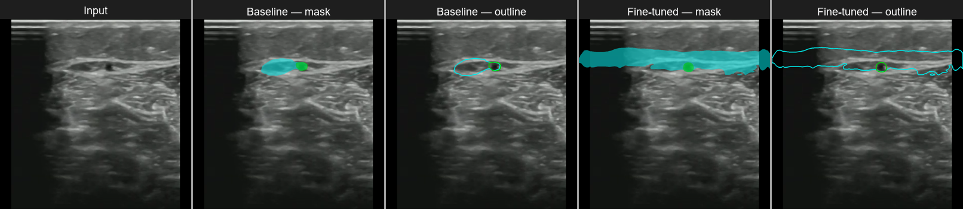
■ Fascia ■ Vein
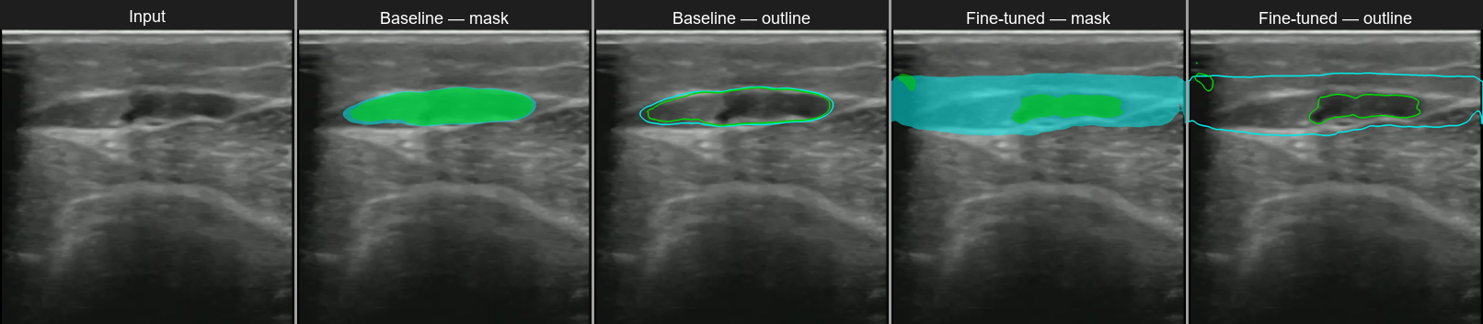
■ Fascia ■ Vein
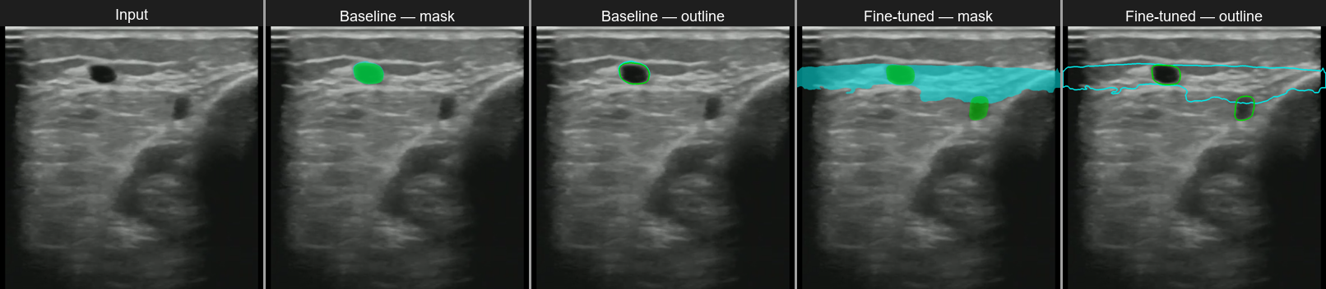
■ Fascia ■ Vein
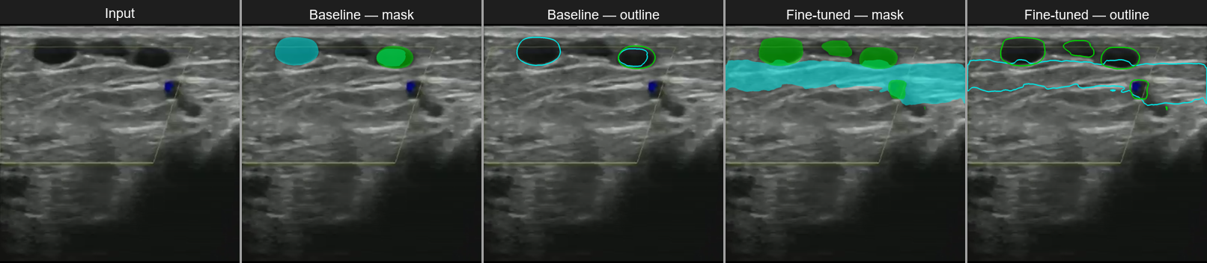
■ Fascia ■ Vein
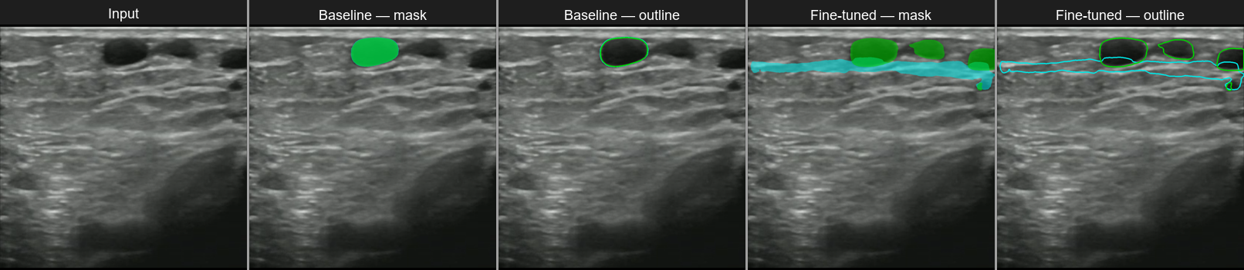
■ Fascia ■ Vein
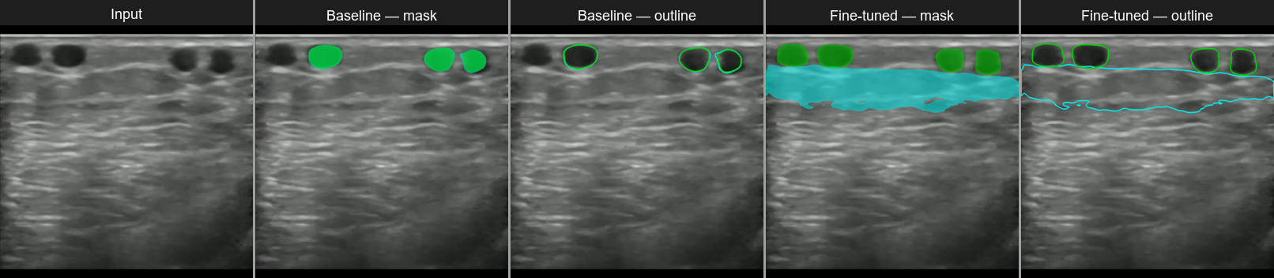
■ Fascia ■ Vein
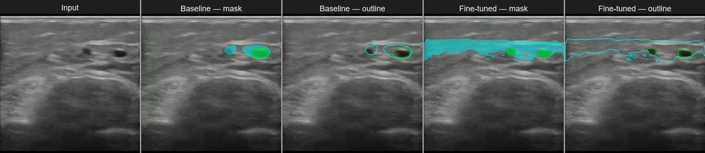
■ Fascia ■ Vein
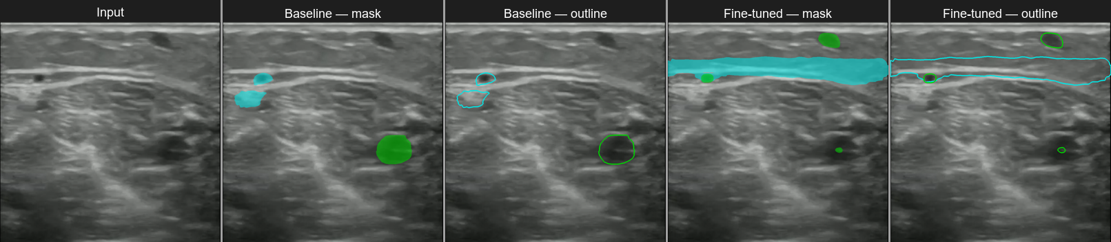
■ Fascia ■ Vein
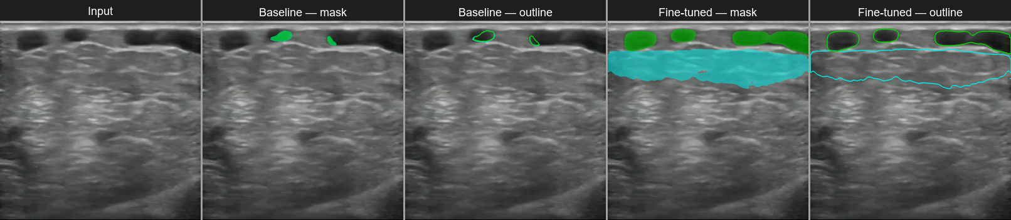
■ Fascia ■ Vein
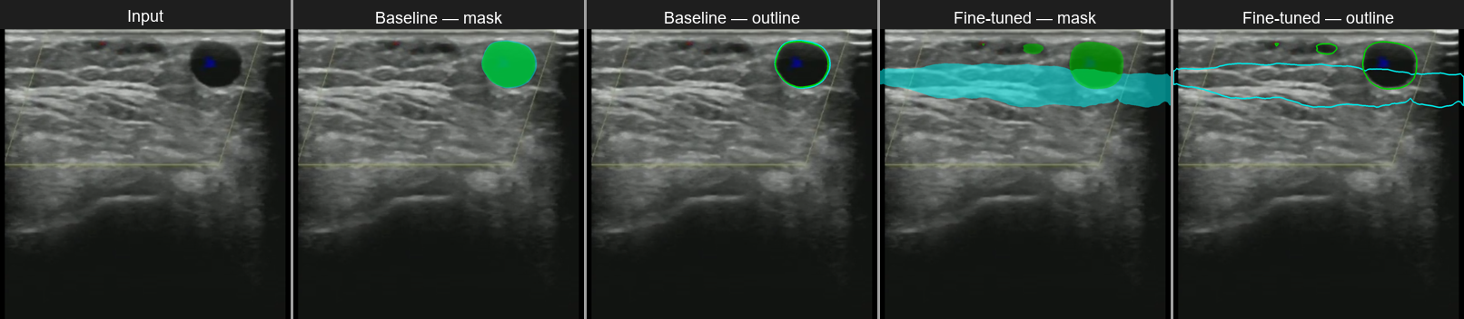
■ Fascia ■ Vein
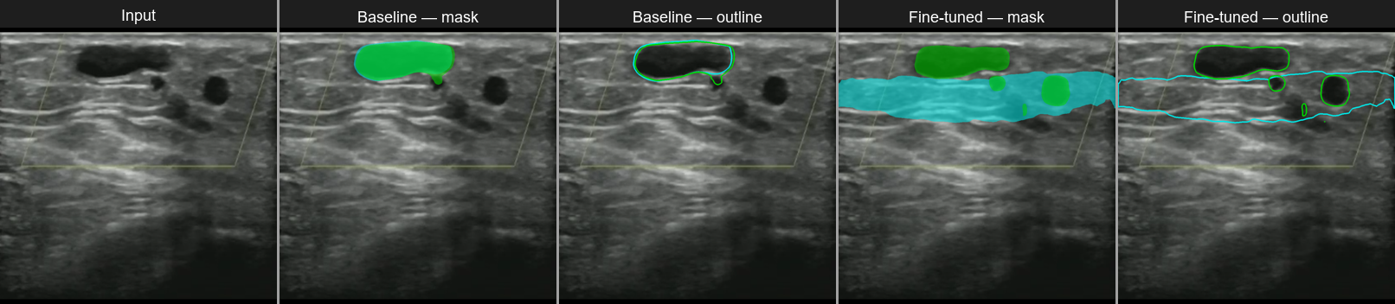
■ Fascia ■ Vein

