Vein Naming System — Docker Guide
Run the web app and the local Qwen model server as two containers

1. What Gets Containerized
Two containers share one NVIDIA GPU (see Figure 1):
- qwen — the official llama.cpp server image (ghcr.io/ggml-org/llama.cpp:server-cuda) running the Qwen 27B 4-bit GGUF + vision projector. It replaces the hosted API of the previous version.
- app — the Flask web app + BioMedParse segmentation (built from Docker/Dockerfile: CUDA 12.8 runtime, Python 3, PyTorch cu128).
Model files are NOT baked into either image (they are 20+ GB). They are mounted from folders on the host. The Hugging Face cache, uploads and outputs are Docker volumes.
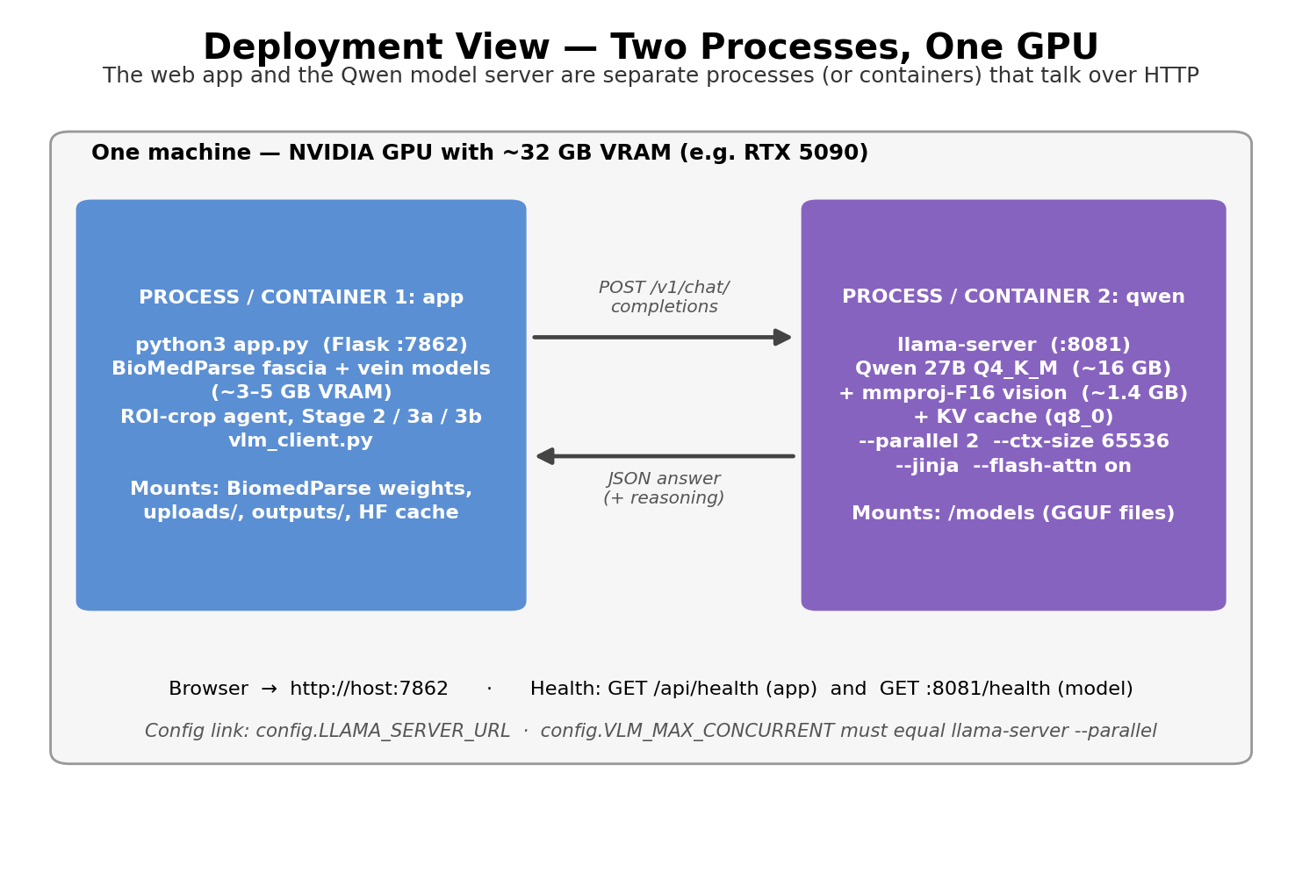
Figure 1: Two containers on one GPU.
Status of this Docker setup: docker compose config validates and the files follow the documented llama.cpp / NVIDIA-toolkit conventions, but the images were NOT built or started during handover preparation (no GPU-container run was possible). Treat the first build as a test and report issues.

2. Prerequisites
- An NVIDIA GPU with ~32 GB VRAM (Qwen ≈17.4 GB + KV cache + BioMedParse ≈3–5 GB).
- Docker Desktop (Windows: WSL2 backend with GPU support enabled) or Docker Engine + NVIDIA Container Toolkit (Linux). Check: docker run --rm --gpus all nvidia/cuda:12.8.1-base-ubuntu24.04 nvidia-smi
- On the host: the Qwen GGUF + mmproj files, and a folder with the two BioMedParse checkpoints laid out as fascia/model_state_dict.pt and vein/model_state_dict.pt.
- Internet on the first run only (Docker images, PyTorch wheels, Hugging Face BiomedBERT ~440 MB).

3. Quick Start (docker compose)
- Open a terminal in the Docker/ folder.
- Copy .env.example to .env and set QWEN_MODEL_DIR, QWEN_GGUF_FILE, QWEN_MMPROJ_FILE and BIOMEDPARSE_WEIGHTS_DIR (host paths; on Windows forward slashes such as D:/models/Qwen3.8-27B-GGUF work).
- Run: docker compose up --build
- Wait. The qwen container reports healthy after it has loaded the model (a few minutes); only then does the app container start.
- Open http://localhost:7862 (change with APP_PORT).
cd Vein_Naming_System_Handover/Docker
copy .env.example .env (then edit .env)
docker compose up --build

4. Checking That It Is Actually Running
docker compose ps # both services 'running', qwen 'healthy'
curl http://localhost:7862/api/health # {"app":"ok","vlm":{"state":"ready",...}}
docker compose logs -f qwen # model loading / per-request lines
docker compose logs -f app # [vlm] ... took Ns lines while a job runs
nvidia-smi # ~20-30 GB in use once loaded

5. Stopping, Restarting, Cleaning Up
docker compose stop # stop, keep volumes
docker compose down # remove containers, keep volumes (uploads, outputs, HF cache)
docker compose down -v # ALSO delete volumes (patient videos + cached text encoder)

6. Environment Variables (Docker/.env)
Variable | Meaning
QWEN_MODEL_DIR | Host folder containing the two GGUF files (mounted read-only at /models).
QWEN_GGUF_FILE / QWEN_MMPROJ_FILE | File names inside that folder. The mmproj file is required for images.
BIOMEDPARSE_WEIGHTS_DIR | Host folder holding fascia/model_state_dict.pt and vein/model_state_dict.pt (mounted at /weights).
VLM_MAX_CONCURRENT | Decode slots. Sets both qwen's --parallel and the app's in-flight call limit (default 2).
QWEN_CTX_SIZE | Total context split across slots (default 65536 → 32768 per call). Lower it if the model container runs out of VRAM.
APP_PORT | Host port for the web UI (default 7862).

Set inside the compose file for the app container: LLAMA_SERVER_URL=http://qwen:8081 (the compose network name), CMED_FASCIA_CKPT_DIR=/weights/fascia, CMED_VEIN_CKPT_DIR=/weights/vein.

7. Docker vs. running directly on Windows
 | Docker (this guide) | Direct (Developer Guide §10)
Setup | Install Docker + GPU support; edit one .env | Install Python stack, PyTorch cu128, download llama.cpp, edit .bat paths
Reproducibility | Pinned OS / CUDA / Python / torch | Depends on the machine's Python
Speed | Same GPU speed; small I/O overhead on Windows bind mounts | Native
Best for | Servers, handing to a teammate, clean installs | Development and debugging

8. Notes and Troubleshooting
- qwen container exits with an out-of-memory error: set QWEN_CTX_SIZE=49152 (or 32768 with VLM_MAX_CONCURRENT=1) in .env and recreate.
- app starts but jobs fail with ‘Local Qwen server is not ready’: check docker compose logs qwen; the app waits 30 s for the server at the start of a job.
- ‘Checkpoint not found’ / model loads from the wrong place: the weights folder must contain fascia/ and vein/ sub-folders; the app searches them recursively for model_state_dict.pt.
- First job is slow to start: BiomedBERT (~440 MB) downloads into the hf_cache volume once; later runs reuse it.
- GPU not visible in the container: confirm the nvidia-smi test in section 2 works; on Windows enable GPU support in Docker Desktop settings (WSL2).
- Data persistence: uploads and outputs live in named volumes app_uploads / app_outputs. Job records are in memory and are lost when the app container restarts, but the video files remain.
- Security: llama-server has no authentication; in this compose file it is reachable only on the private compose network (no ports: entry). Do not publish 8081.
- If PowerShell says ‘docker is not recognized’: start Docker Desktop and reopen the terminal, or add C:\Program Files\Docker\Docker\resources\bin to PATH.

