Shunt Analysis

Shunt Type 1:
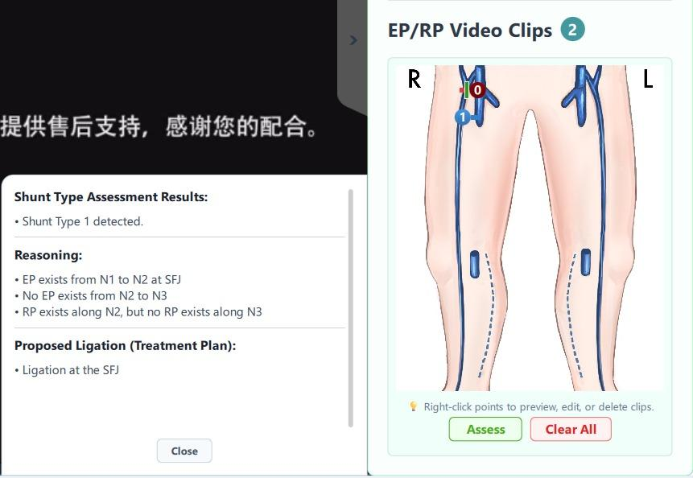

Shunt type 3 variant 1:
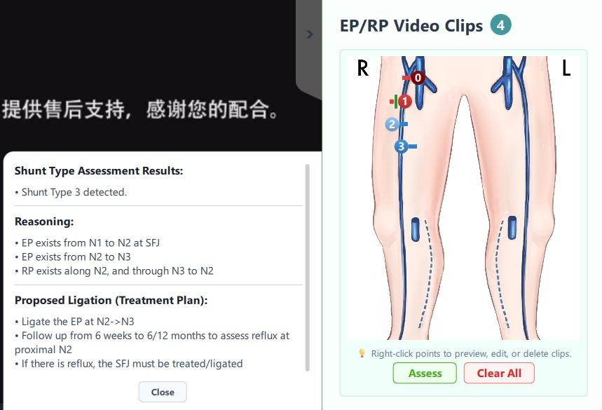

Shunt type 1+2 with small diameter :
note: shunt type 1+2 has the same markers as shunt type 3, only difference is the RP N3->N1 marker has elimination test result as "Reflux" instead of "No Reflux".
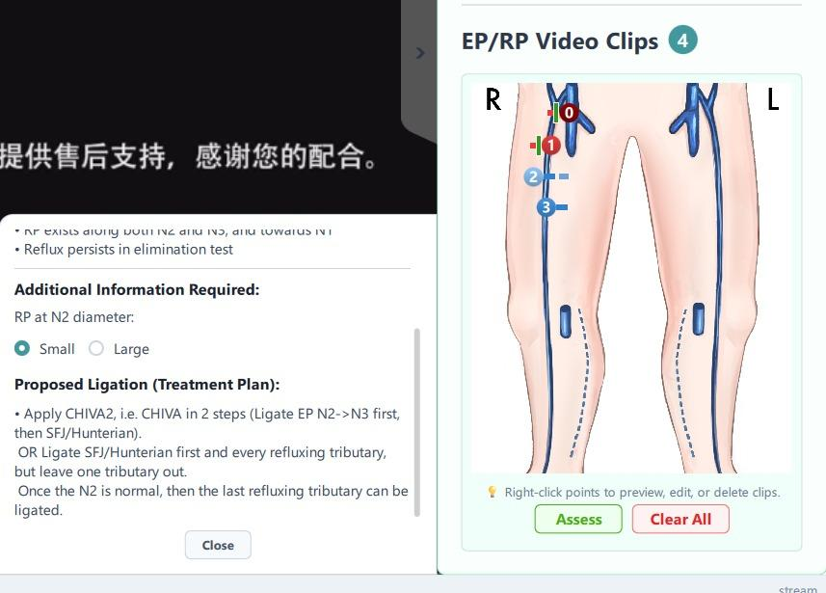

Shunt type 2 - equal calibre, unequal distance :
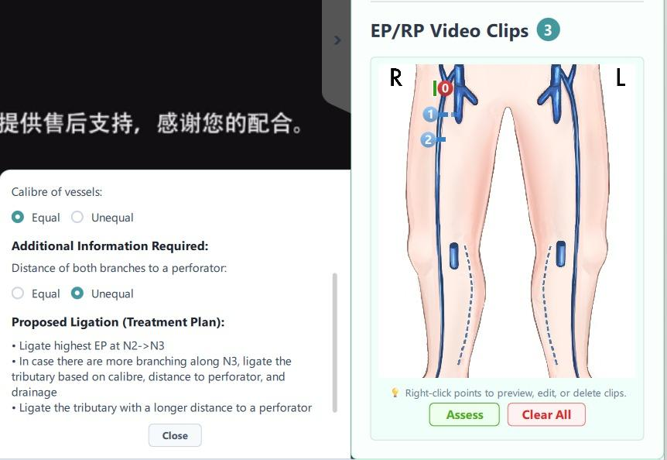
Shunt type 2 - equal calibre, yes to drainage :
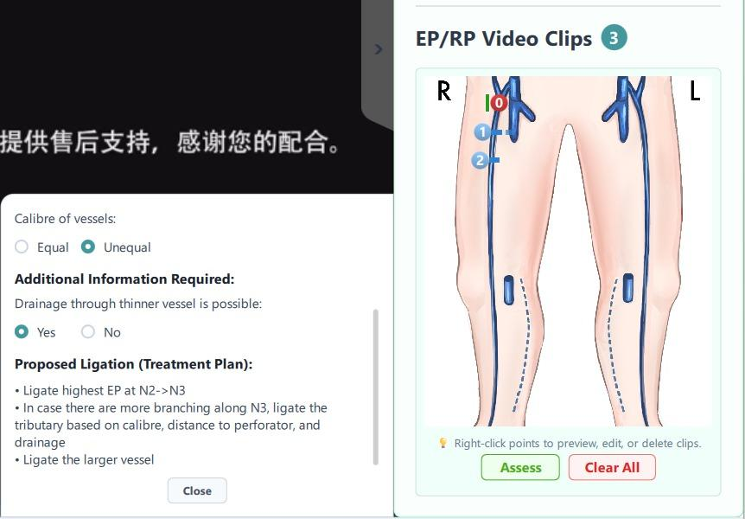

Shunt type 2 - unequal calibre, no drainage :
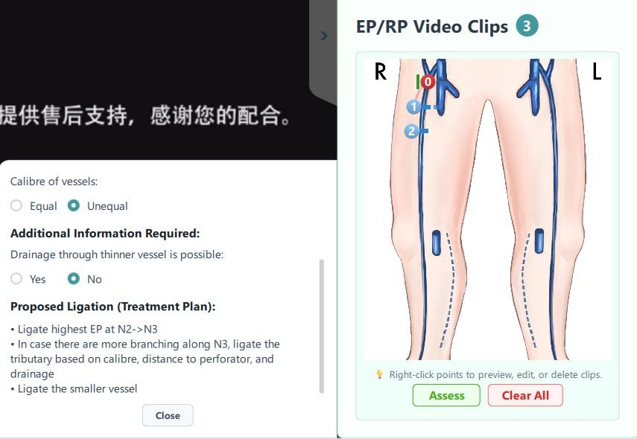

Current Rule Based Code being used for Shunt Classification (Task-1) :
import logging
from typing import Any

class ShuntManager:
"""
Manages ...
"""
def __init__(self) -> None:
self.logger = logging.getLogger(__name__)

def classify_shunt(self, clip_list: list[dict[str, Any]]) -> dict:
"""Takes clipList from QML and returns:
{
"st1": bool,
"st3": bool,
"st12": bool,
"needs_elim_test": bool,
...
}
"""
st1 = False
st3 = False
st12 = False
st2a = False
st2b = False
st2c = False
st_detected = True
ask_diameter = False
ask_aplastic = False
ask_reflux_perforator = False
ask_branching = False

ep12 = False
ep23 = False
ep22 = False
rp32 = False
rp31 = False
rp21 = False
rp3 = False
many_rp3 = False # more than 1 RP at tributary
many_rp21 = False

ep12_at_sfj = False
ep12_at_hunterian = False

elim_test_done = False
needs_elim_test = False
reflux_persists = False

sfj_min_x = 0.118
sfj_max_x = 0.473
sfj_min_y = 0.0
sfj_max_y = 0.098

hunterian_min_x = 0.118
hunterian_max_x = 0.473
hunterian_min_y = 0.098
hunterian_max_y = 0.353

reasoning = []
ligation = []

# list of ep12 to ligate
ep12_indexes = []
# list of rp21 to ligate, compare y position
rp21_indexes = []
# list of ep23 to ligate
ep23_indexes = []
# list of ep23 and ep22 to ligate for shunt type 2, compare y position
ep23_y_indexes = []

# Reset all ligation rectangles first in QML list
for clip in clip_list:
if "ep_ligation_rect" in clip:
del clip["ep_ligation_rect"]
if "ep_ligation_rect2" in clip:
del clip["ep_ligation_rect2"]

if "rp_ligation_rect" in clip:
del clip["rp_ligation_rect"]

# ==========================================================
# === 1. PRE-SHUNT TYPE ASSESSMENT CLIPLIST CRITERIAS CHECK ===
# ==========================================================

for idx, clip in enumerate(clip_list):
x = clip.get("posXRatio")
y = clip.get("posYRatio")
flow = clip.get("flow")
from_type = clip.get("fromType")
to_type = clip.get("toType")
elim_test_result = clip.get("eliminationTest")

# Check for EP at N1->N2
if flow == "EP" and from_type == "N1" and to_type == "N2":
ep12 = True
ep12_indexes.append(idx)
# Check if there is EP N1->N2 at SFJ or Hunterian Perforator
if (
x is not None
and y is not None
and hunterian_min_x <= x <= hunterian_max_x
and hunterian_min_y <= y <= hunterian_max_y
):
ep12_at_hunterian = True
ep12_at_sfj = False
elif (
x is not None
and y is not None
and sfj_min_x <= x <= sfj_max_x
and sfj_min_y <= y <= sfj_max_y
):
ep12_at_sfj = True
ep12_at_hunterian = False

# Check for EP at N2->N3
if flow == "EP" and from_type == "N2" and to_type == "N3":
ep23 = True
ep23_indexes.append(idx)
ep23_y_indexes.append((idx, y))
# Check if elim test has been done
if elim_test_result != "":
elim_test_done = True
if elim_test_result == "Reflux":
reflux_persists = True
elif elim_test_result == "No Reflux":
reflux_persists = False

# Check for EP at N2->N2
if flow == "EP" and from_type == "N2" and to_type == "N2":
ep22 = True
ep23_y_indexes.append((idx, y))

# Check for RP at N3->N2
if flow == "RP" and from_type == "N3" and to_type == "N2":
rp32 = True
# Check for RP at N3->N1
if flow == "RP" and from_type == "N3" and to_type == "N1":
rp31 = True

# Check for more than one RP at tributary
if flow == "RP" and from_type == "N3":
if rp3:
many_rp3 = True
else:
rp3 = True

# Check for RP at N2->N1
if flow == "RP" and from_type == "N2" and to_type == "N1":
rp21_indexes.append(
(idx, y)
) # include y-axis position to ensure most distal RP does not get ligated
if rp21:
many_rp21 = True
else:
rp21 = True

# Check elim test result at EP N2->N3
if ep23 and elim_test_done:
if elim_test_result == "Reflux":
reflux_persists = True
elif elim_test_result == "No Reflux":
reflux_persists = False

# ==========================================================
# 2. SHUNT TYPE DECISION TREE
# ==========================================================
""" Determine shunt types based on collected data above """
if ep12_at_sfj or ep12_at_hunterian:
if ep12_at_sfj:
reasoning.append("• EP exists from N1 to N2 at SFJ \n")
if ep12_at_hunterian:
reasoning.append("• EP exists from N1 to N2 at Hunterian perforator \n")

# --- SHUNT TYPE 1 ---
if not ep23:
reasoning.append("• No EP exists from N2 to N3 \n")
if rp21 and not (rp31 or rp32):
st1 = True
reasoning.append(
"• RP exists along N2, but no RP exists along N3 \n"
)
else:
st_detected = False
reasoning = []

# EP at N2->N3, and RP exists at N3 only, or RP exists at N2 only through N3->N2
elif ep23:
reasoning.append("• EP exists from N2 to N3 \n")

# --- SHUNT TYPE 3 ---
if (rp32 or rp31) and (not rp21):
st3 = True
reasoning.append(
"• RP exists along N3, but no RP exists along N2 \n"
)

elif rp32 and rp21:
st3 = True
reasoning.append("• RP exists along N2, and through N3 to N2 \n")

# --- Elimination Test needed to tell between Type 3 and 1+2 ---
# Requires thinking of how to add order between second type of Type 3 (2 RPs)
elif rp31 and rp21:
reasoning.append(
"• RP exists along both N2 and N3, and towards N1 \n"
)

if not elim_test_done:
needs_elim_test = True
reasoning.append("• Elimination test missing. \n")
ligation.append("• Elimination test missing. \n")

# --- SHUNT TYPE 1+2 ---
elif reflux_persists:
st12 = True
reasoning.append("• Reflux persists in elimination test \n")

if not many_rp21 and many_rp3:
reasoning.append(
"• There is one RP at N2 and more than one RP at tributary\n"
)

elif many_rp21 and many_rp3:
reasoning.append(
"• There is more than one RP at N2 and more than one RP at tributary\n"
)

# --- SHUNT TYPE 3 ---
elif not reflux_persists:
st3 = True
reasoning.append(
"• Reflux does not persist in elimination test \n"
)
else: # failsafe branch for unhandled logic
st_detected = False # type: ignore[unreachable]
reasoning = []

# fallback incase no shunt type detected but entered this branch
else:
st_detected = False
reasoning = []

# --- SHUNT TYPE 2A ---
elif ep23 and not ep12:
st2a = True
reasoning.append(
"• EP exists from N2 to N3, but no EP exists from N1 to N2 \n"
)

elif ep22 and not ep12:
reasoning.append("• EP starts at mid GSV from N2 to N2 \n")
# --- SHUNT TYPE 2B ---
if (rp32 or rp31) and (not rp21):
st2b = True
reasoning.append("• RP exists along N3, but no RP exists along N2 \n")
# --- SHUNT TYPE 2C ---
elif (rp32 or rp31) and rp21:
st2c = True
reasoning.append("• RP exists along both N2 (GSV) and N3 \n")
else:
st_detected = False
reasoning.append(
"• But neither Shunt Type 2B nor 2C because RP does not exist along N3 only or along both N2 and N3 \n"
)

# If none of the shunt types are detected, clear reasoning
else:
st_detected = False
reasoning = []

# ==========================================================
# === 3. LIGATION DECISION TREE ===
# ==========================================================
""" Append ligation text and assign rectangle markers to EP/RP that should be ligated """
# Ligation for shunt type 1
if st1:
if ep12_at_sfj:
ligation.append("• Ligation at the SFJ \n")

elif ep12_at_hunterian:
ligation.append(
"• Ligation at the Hunterian Perforator closer to N2 \n"
)
if many_rp21:
ligation.append(
"• When appropriate, ligate below each RP along N2, except the most distal RP \n"
)

# Sort list of RP from N2 according to y-axis position, then remove the last one (most distal)
self._ligate_all_rp21_except_distal(clip_list, rp21_indexes)

# Update clips with field for rectangle markings (EP12)
for idx in ep12_indexes:
self._mark_ligation_rect(clip_list, idx, "ep_ligation_rect")

# Ligation for shunt type 1+2
if st12:
ligation = []
ligation.append(
"• Shunt Type 1+2 detected, requires more data to classify ligation"
)

if not many_rp21 and rp3:
ask_diameter = True

elif many_rp21 and rp3:
ligation = []
ligation.append(
"• Ligate SFJ or Hunterian perforator, and every refluxing tributary\n "
"• When appropriate, ligate below each RP along N2, except the most distal RP\n "
"• If one of the RP at refluxing tributary is close to the N2, and that special RP is dilated, ligate that special RP."
)
# Add rectangles to ligate all RP21 except most distal
self._ligate_all_rp21_except_distal(clip_list, rp21_indexes)

# Update clips with field for rectangle markings (EP23)
for idx in ep23_indexes:
self._mark_ligation_rect(clip_list, idx, "ep_ligation_rect2")

# Update clips with field for rectangle markings (EP12)
for idx in ep12_indexes:
self._mark_ligation_rect(clip_list, idx, "ep_ligation_rect")

# Not yet implemented: Special case where one of the RP32 is close to N2 (Fig 6.28d)

# Ligation for shunt type 3
if st3:
ligation = []
ask_aplastic = True # Not yet implemented: Aplastic segment

if not many_rp3:
ligation.append("• Ligate the EP at N2->N3\n")
elif many_rp3:
ligation.append(
"• Ligate every refluxing tributary where it joins the N2 (first step of CHIVA 2)\n"
)

if ep12_at_sfj:
ligation.append(
"• Follow up from 6 weeks to 6/12 months to assess reflux at proximal N2"
"\n• If there is reflux, the SFJ must be treated/ligated\n"
)
if ep12_at_hunterian:
ask_reflux_perforator = True

# Update clips with field for rectangle markings (EP23)
for idx in ep23_indexes:
self._mark_ligation_rect(clip_list, idx, "ep_ligation_rect2")

# Not yet implemented: Special case combined with Shunt Type 1 for now (Fig. 6.33)

# Ligation for shunt type 2
if st2a or st2b or st2c:
ligation.append("• Ligate highest EP at N2->N3\n")

if many_rp3:
ligation.append(
"• In case there are more branching along N3, ligate the tributary based on calibre, distance to perforator, and drainage\n"
)
ask_branching = True

# Mark highest EP23 with rectangle
self._ligate_highest_ep23(clip_list, ep23_y_indexes)

# Ligation for no shunt types detected
if not st_detected:
ligation = []

return {
"ST1": st1,
"ST3": st3,
"ST12": st12,
"ST2A": st2a,
"ST2B": st2b,
"ST2C": st2c,
"shuntDetected": st_detected,
"elimTestDone": elim_test_done,
"needsElimTest": needs_elim_test,
"refluxPersists": reflux_persists,
"EP12AtSFJ": ep12_at_sfj,
"EP1AtHunterian": ep12_at_hunterian,
"EP23": ep23,
"RP32": rp32,
"RP31": rp31,
"RP21": rp21,
"reasoning": reasoning,
"ligation": ligation,
"updatedClipList": clip_list,
"askDiameter": ask_diameter,
"askAplastic": ask_aplastic,
"askRefluxPerforator": ask_reflux_perforator,
"askBranching": ask_branching,
}

def _ligate_all_rp21_except_distal(self, clip_list: list[dict[str, Any]], rp21_indexes: list) -> None:
# Add rectangles to ligate all RP21 except most distal
rp21_sorted = sorted(rp21_indexes, key=lambda t: t[1])
rp21_to_ligate = rp21_sorted[:-1] # all except last RP

for idx, _ in rp21_to_ligate:
self._mark_ligation_rect(clip_list, idx, "rp_ligation_rect")

def _ligate_highest_ep23(self, clip_list: list[dict[str, Any]], ep23_y_indexes: list) -> None:
# For shunt type 2, add rectangle to ligate an EP23 or EP22 based on highest y position
ep23_sorted = sorted(ep23_y_indexes, key=lambda t: t[1])
highest_ep_idx = ep23_sorted[0][0] # all except last RP

self._mark_ligation_rect(clip_list, highest_ep_idx, "ep_ligation_rect2")

def _mark_ligation_rect(self, clip_list: list[dict[str, Any]], index: int, field_name: str) -> None:
# Update clips with field for rectangle markings (e.g. EP23)
original = clip_list[index]
updated = original.copy()

updated[field_name] = True
clip_list[index] = updated

