# 

# CMPE – 202, Fall 2017

## PENTAGON (TEAM -5)

### PROJECT PRESENTATION

## PROJECT MEMBERS:

Hari Krishna Pariveda

Manvitha Challagundla

Radhika Srinivasan

Sanjay Raghavendra Karnati

Vinod Katta

UML Class Diagram:

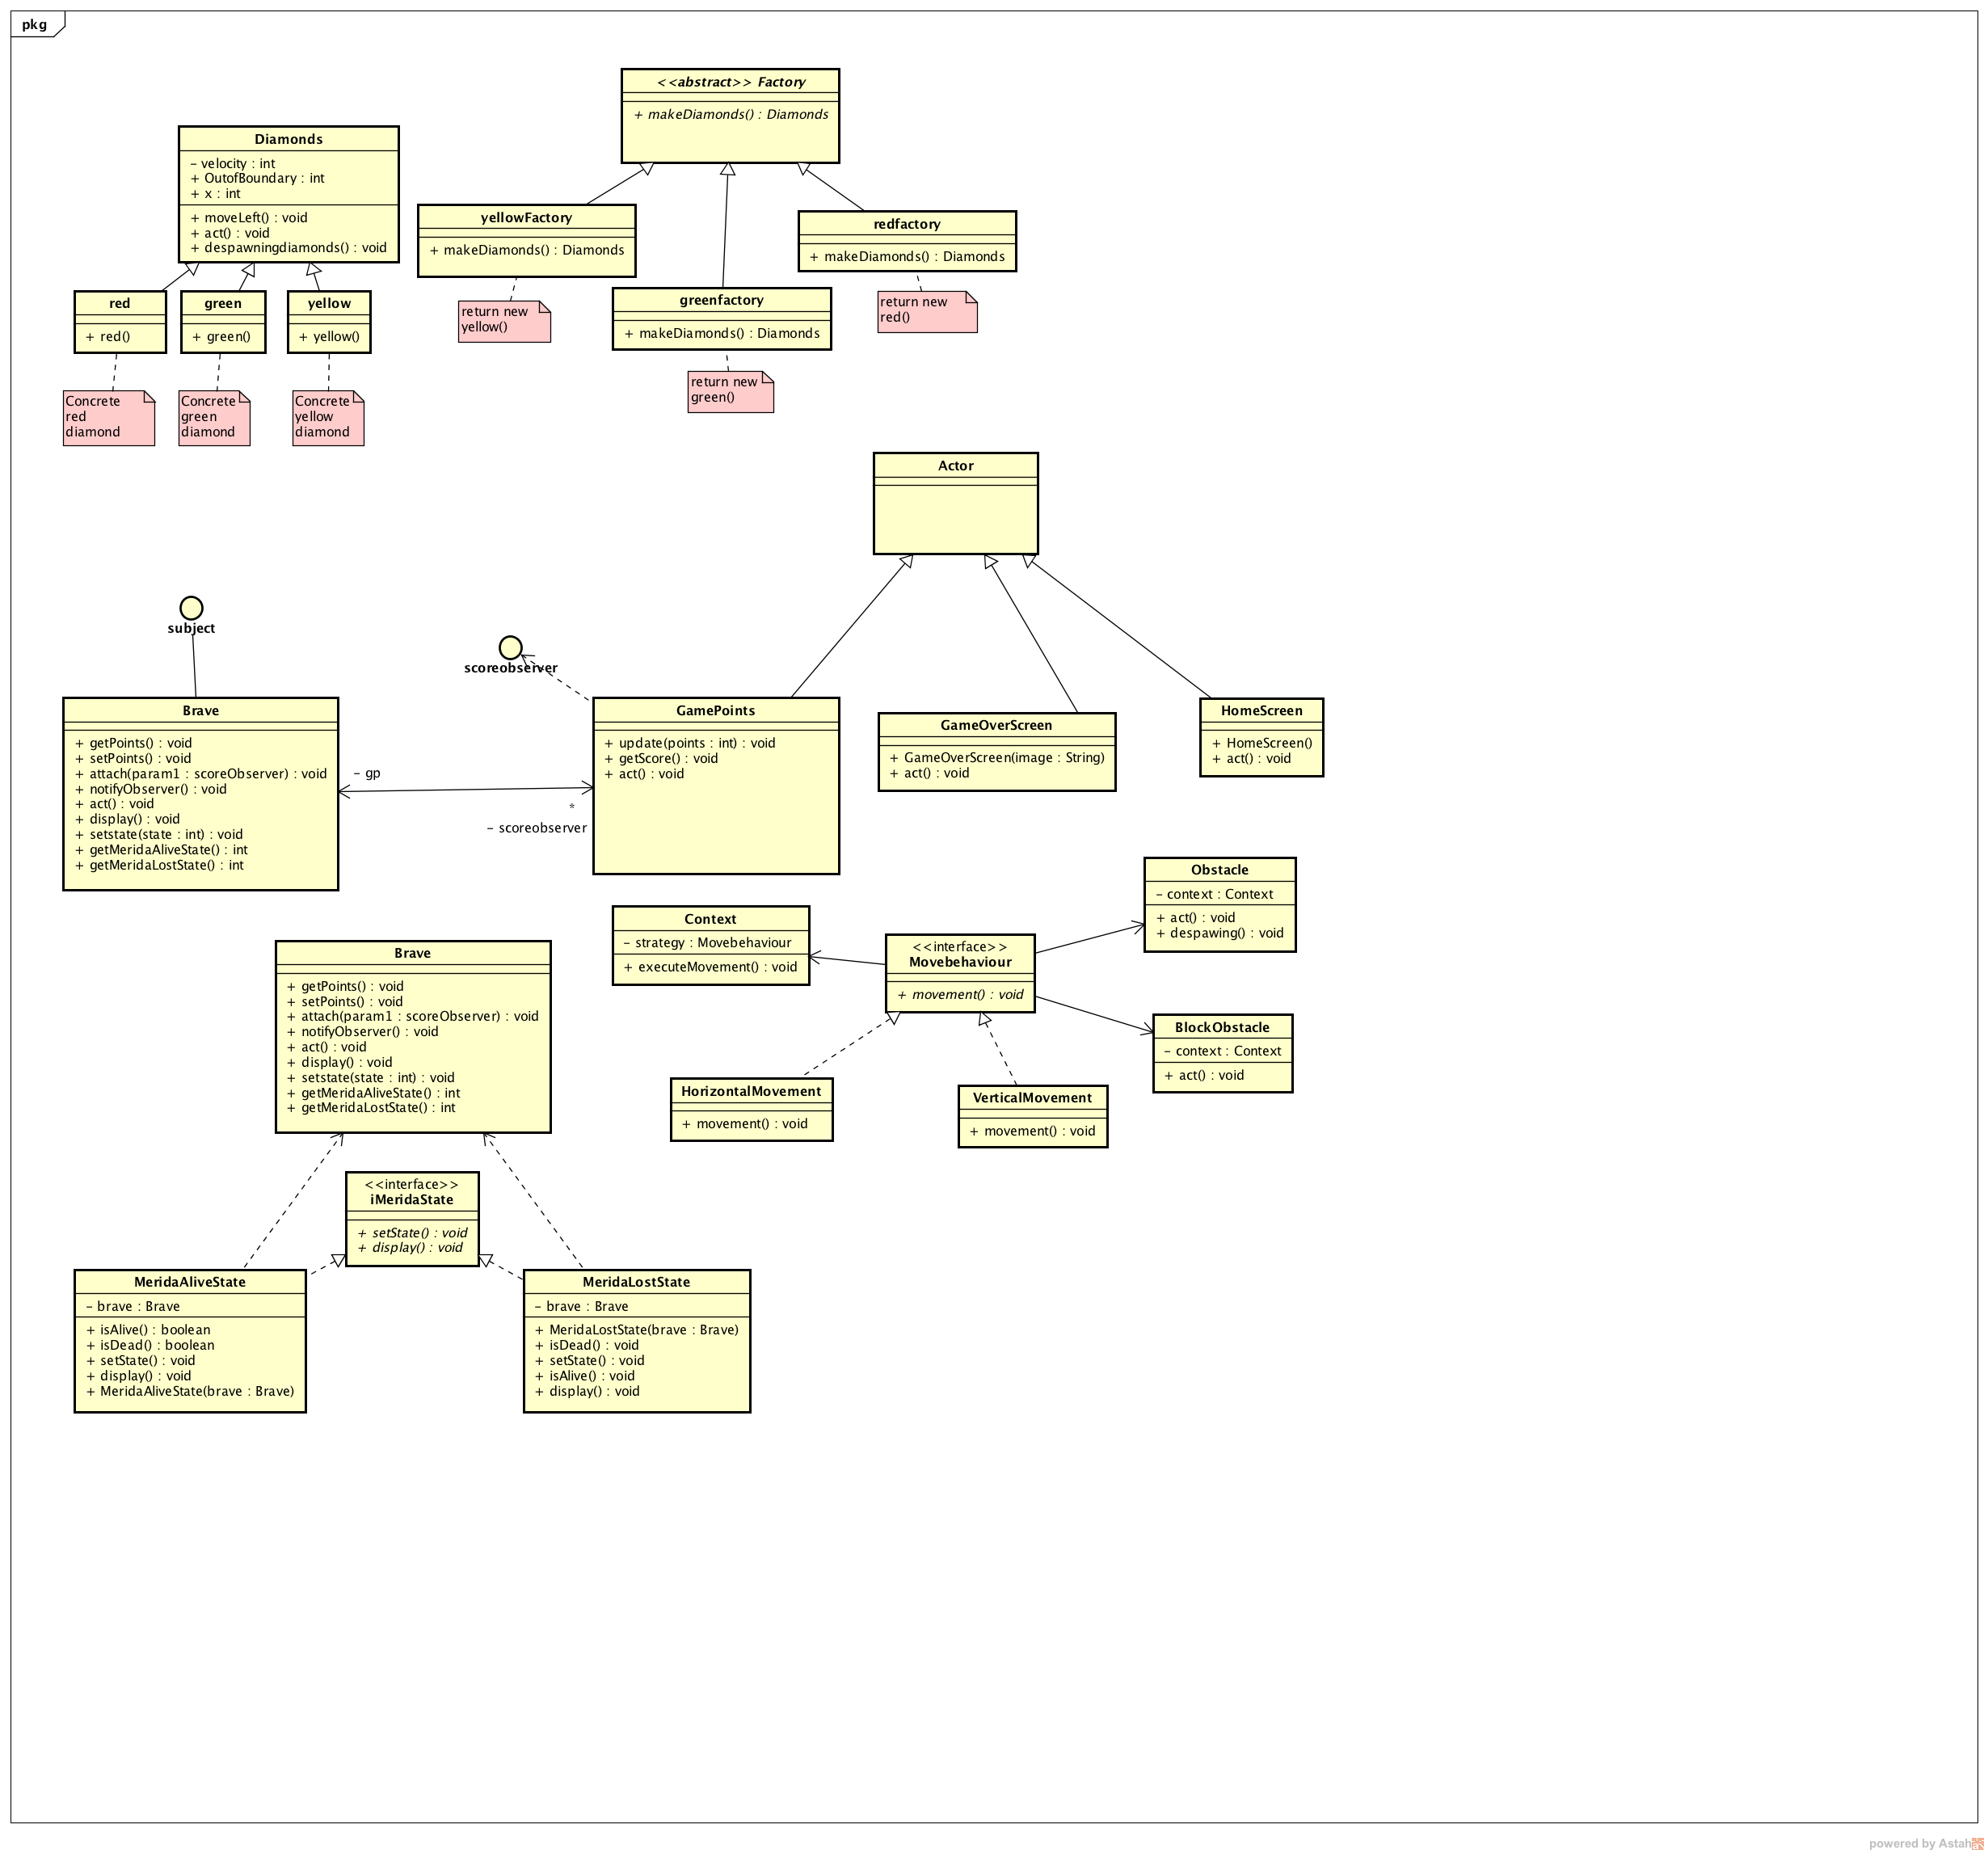

## UML Use case Diagram:

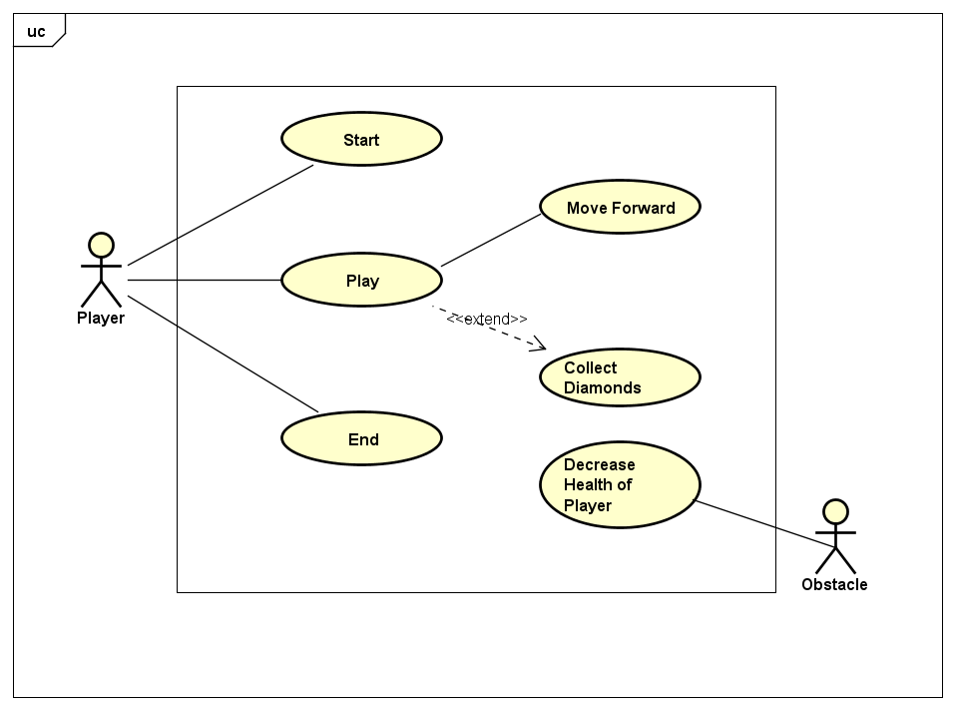

## Use Case Specification:

**Use case name** Play

**Related Requirements** Once the user starts the game, the user should be able to move forward, change lanes by pressing up and down arrows, collect diamonds along the way and the game should end when hit by an obstacle more than 3 times.

**Goal in context** User should be able to start and complete the game.

**Preconditions** The user machine should have a browser & must have Greenfoot installed or active Internet connectivity to play the game.

**Successful end condition** User should be able to complete the game under timed conditions.

**Failed end condition** The game does not start even when the user clicks “play” button.

**Primary actor** Player

**Trigger** The player clicks on “Play” button.

**Main flow Step Action**

1. The player starts the game.
2. The player selects “Play” option.
3. The player plays the game.
4. The player ends the game.

**Extensions Step Branching Action**

**3.1** The player moves forward.

**3.2** The player collects diamonds.

**3.3** The player Jumps when faced with obstacle

## UML Wireframe Diagram

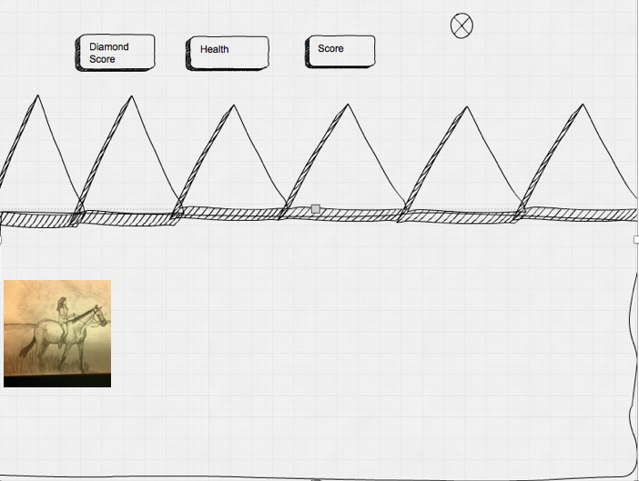

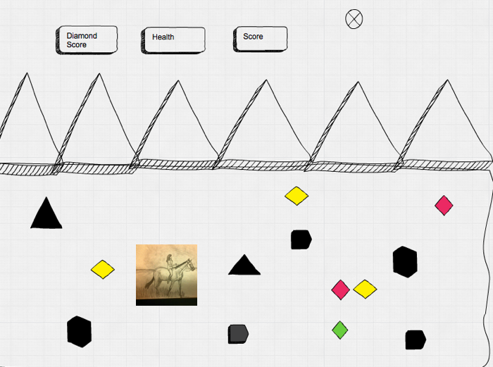

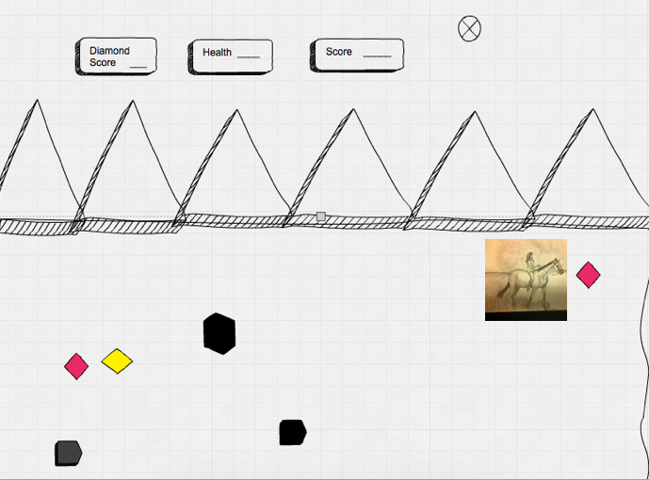

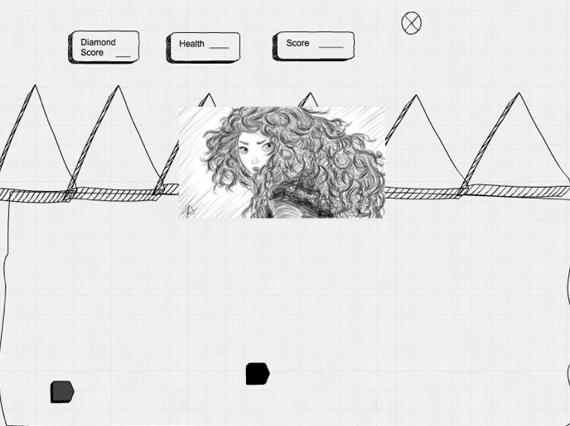

## FINAL TASK BOARD:

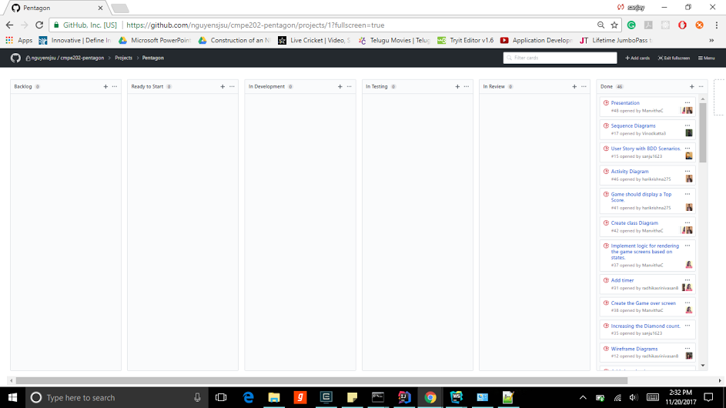

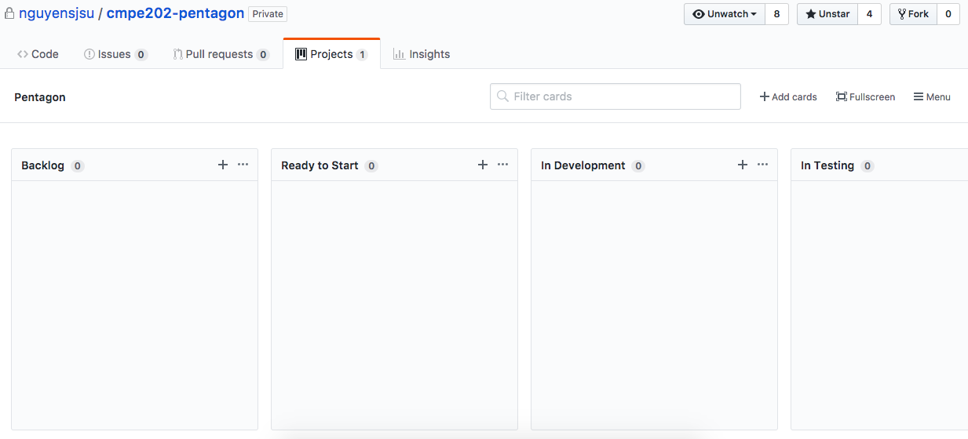

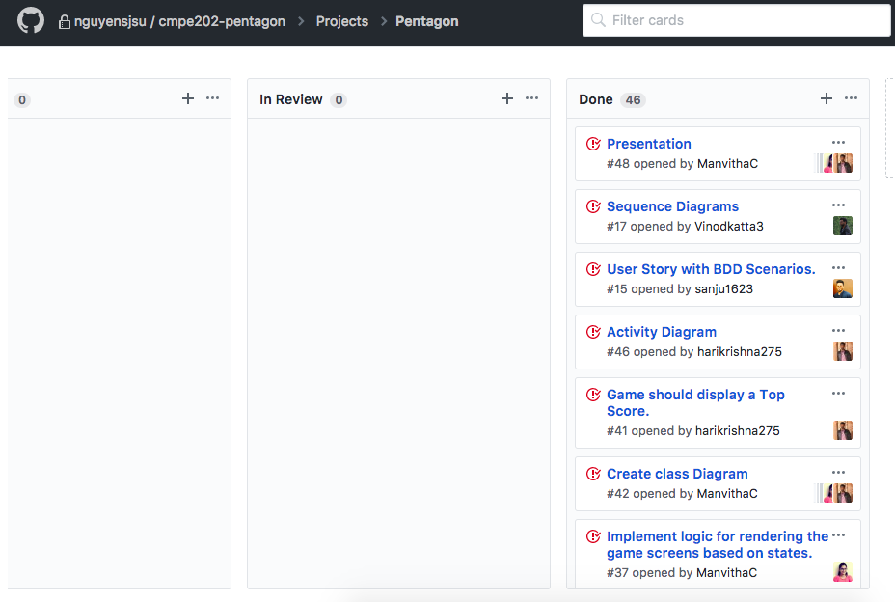

## FINAL CUMULATIVE FLOW DIAGRAM:

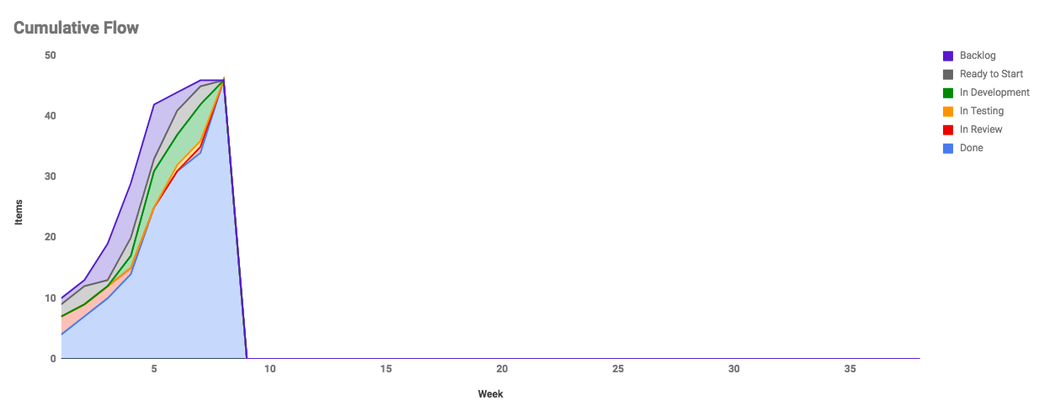



## FINAL SCRUM BURNDOWN CHART:

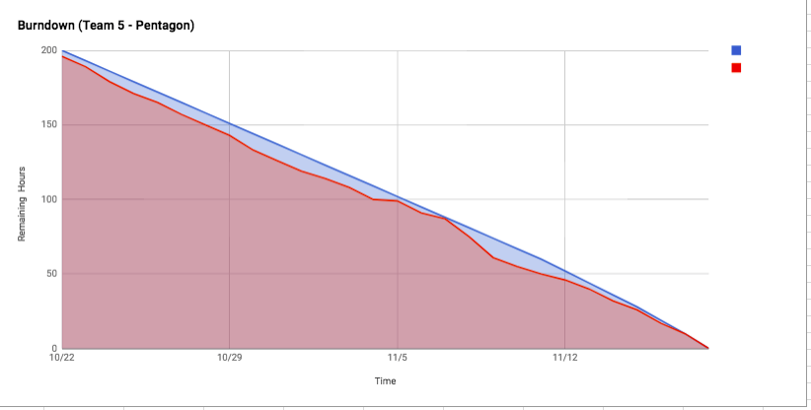

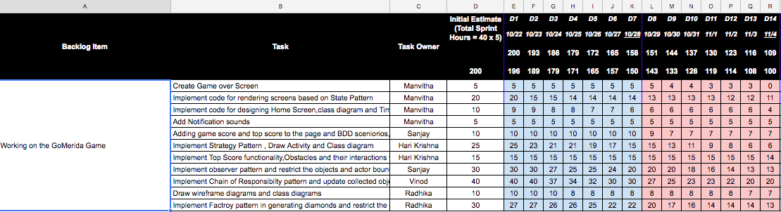

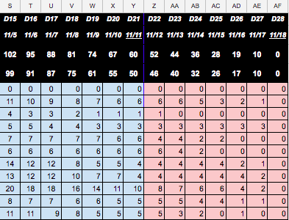

## PROJECT RETROSPECTIVE:

C:\Users\manvi\AppData\Local\Microsoft\Windows\INetCache\Content.Word\bar.png

