Codebuild_lambda:

Go to the codebuild service role and edit the role settings
Iam policy: this part of the lambda permissions are added in the codebuild service role and change the resource arn with the lambda function arn.
{
"Effect": "Allow",
"Action": [
"lambda:AddPermission",
"lambda:RemovePermission",
"lambda:CreateAlias",
"lambda:UpdateAlias",
"lambda:DeleteAlias",
"lambda:UpdateFunctionCode",
"lambda:UpdateFunctionConfiguration",
"lambda:PutFunctionConcurrency",
"lambda:DeleteFunctionConcurrency",
"lambda:PublishVersion"
],
"Resource": [
"arn:aws:lambda:us-east-1:817826001130:function:lambda_updating"
]
},
After the codebuild completes all the stages than refresh the lambda page and test the lambda code.
Lambda function output before code changes:
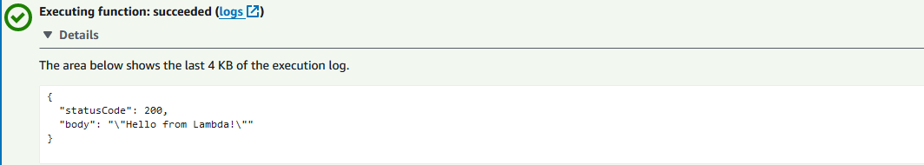

After code changes:
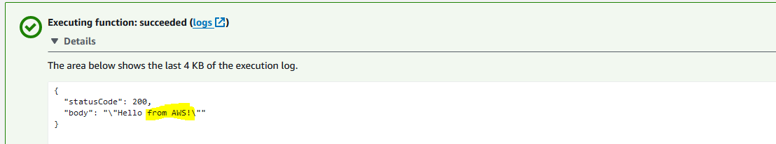
Changes are reflecting in lambda

