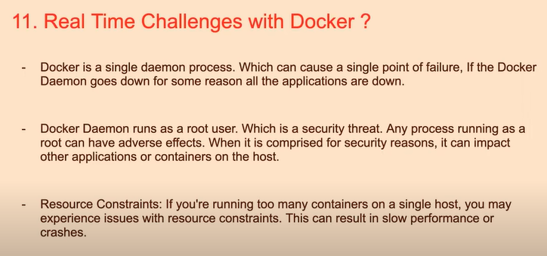
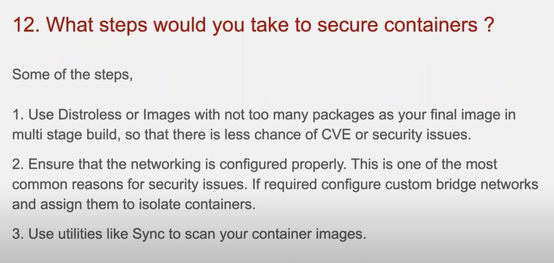
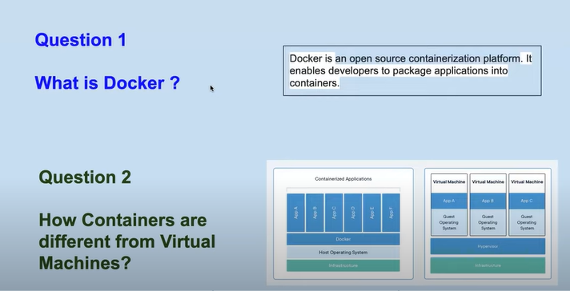
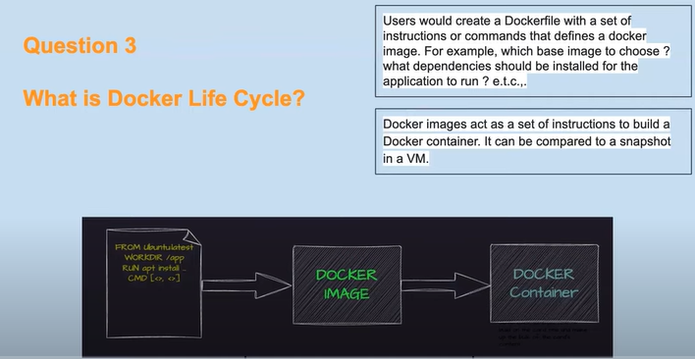
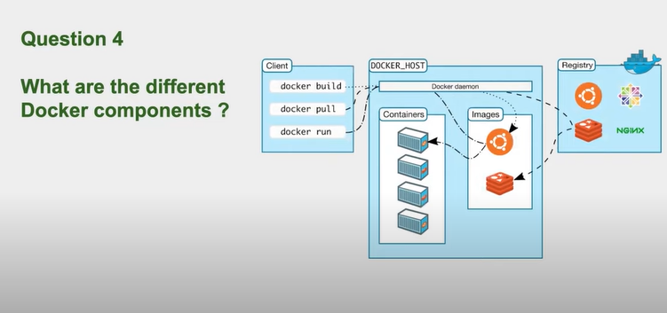
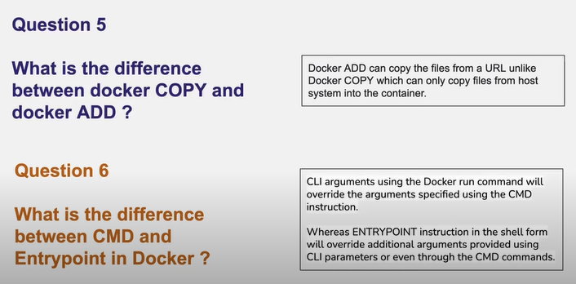

CMD
- Purpose: Provides default arguments for the ENTRYPOINT command or specifies a command to run if no ENTRYPOINT is set.
- Behavior: If arguments are provided in the docker run command, they will override the CMD.
ENTRYPOINT
Purpose: Defines the main command that should be run when the container starts.
Behavior: It is not overridden by command line arguments passed to docker run.
