LDP requirement - Transient cluster

LDP Transient cluster and Deployed in Prod and Non prod.

Analytics Moved from Regular alm and LDP cluster to Transient Cluster.
- gptf_phase2_executor_cf6
- gptf_phase2_executor_leap
- drm-ogv-piston-ring-genx
- det_oil_lube_system_fwd_sump_ptfe_seal_cfm56_5b_7b

Eliminate idle cluster ideal time.
cost saving.

MVP-1 Deploy/Move analytics to Transient Cluster:

- Each analytics trigger/build individual clusters
- Based on the schedule the cron triggers the build
- Developed state machine with predefined cluster components which was integrated with the analytics

We have added 3 states ( GetAmiId , Create_cluster and wait ) to there existing workflow.
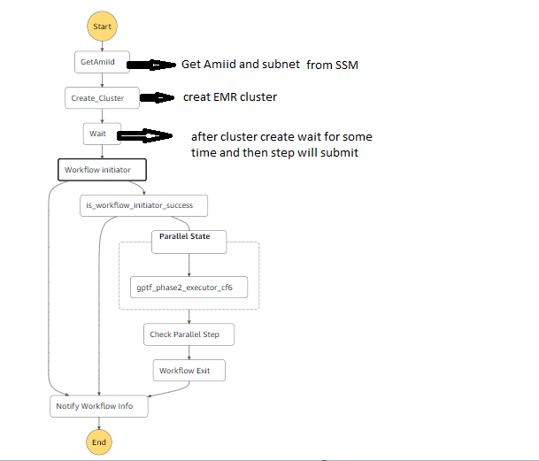

- MVP-2 Developed reusable component.
Cron triggers analytics which invokes the reusable component(creates cluster and submits the jobs)

Reusable component Names:
- ldp-alm-transient-cluster-rs-dev
- ldp-alm-transient-cluster-rs-prod

Workflow of reusable code:
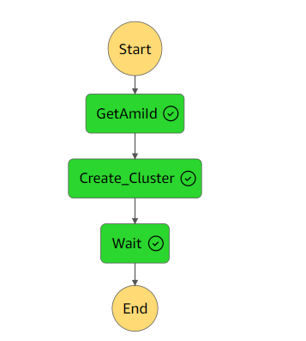

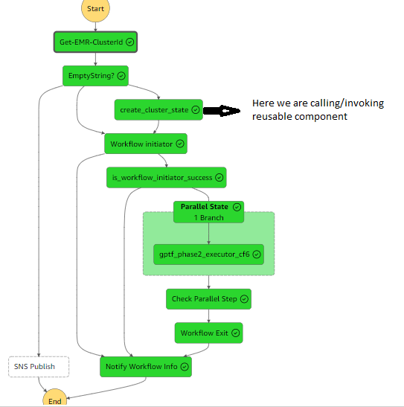

States added to the existing LDP workflows:

• Get-EMR-ClusterId lambda function: Verifies cluster existence and running steps.
Output of the lambda function will be like below:

"states_output": {
"result": "found",
"cf6_running": "",
"ClusterId": "",
"leap_running": ""
}

Use-cases:

Use Case 1: Single Transient Cluster for All 4 Analytics
• Avoids parallel cluster creation if existing transient cluster exists.

- In Emptystring state we are checking the condtions
  - if cluster Id = null it will go to create_cluster (invoking reusable component)
  - If clusterId != null and cf6/leap = null it will go to workflow initator

Flow Chart:
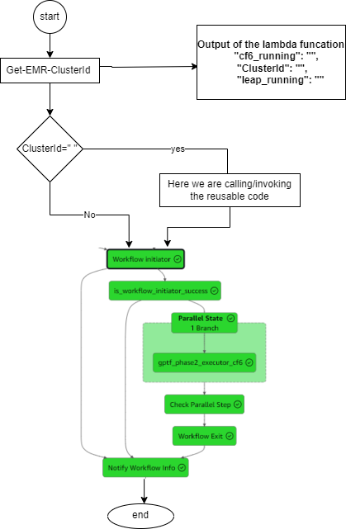

Example:

if cluster is not running

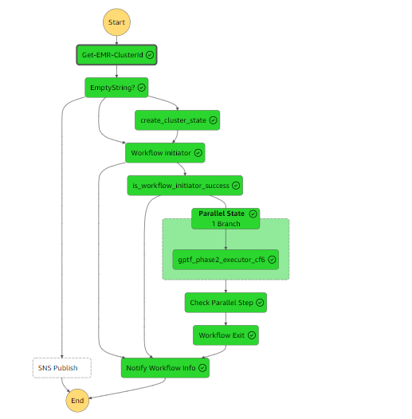

If cluster is already running
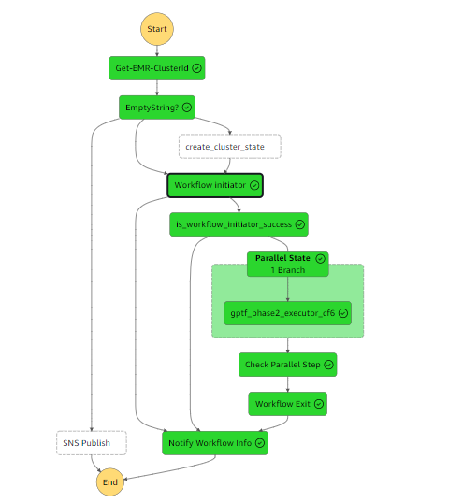

Use Case 2: Skipping analytic schedule if same analytic is running and exceeding schedule time.( send email notification to ldp team ).

- If ClusterId != null and cf6/leap != null it will go to sns (skip the analytic execution and send notification to ldp team ).

Flowchart:

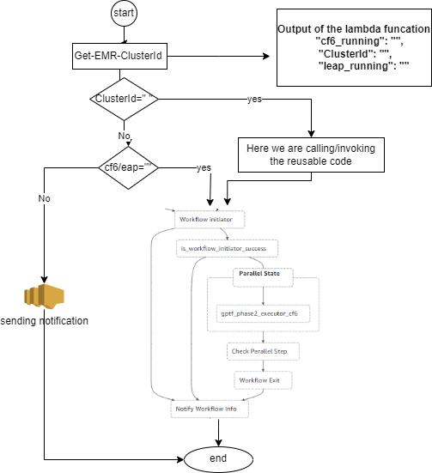

Example:

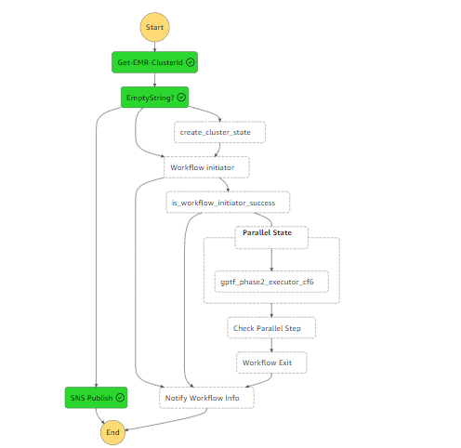

High-level architecture:

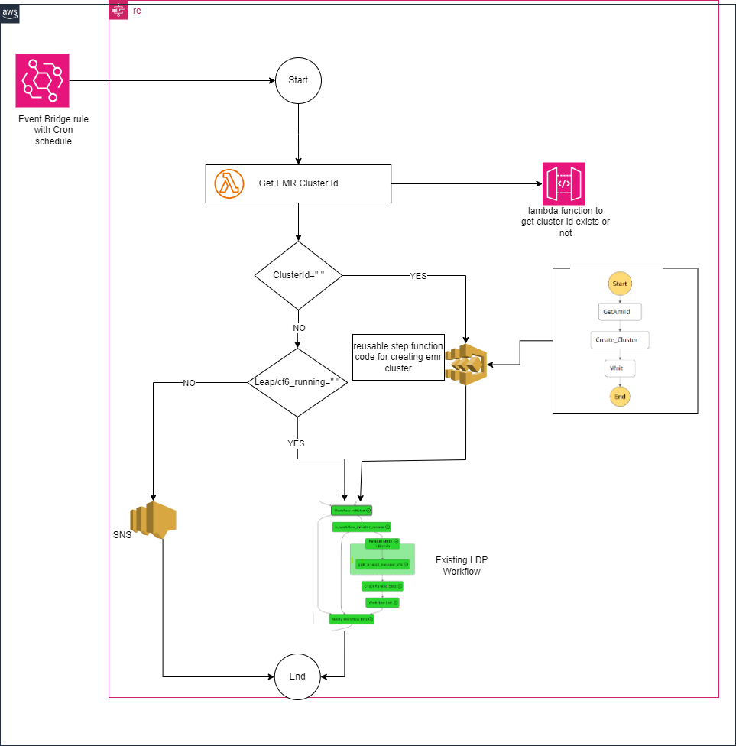

GitHub repo details :

https://github.build.ge.com/AviationDAAS/emr-platform/tree/ldp-alm-transient
Deployed in NonProd
Deployed in Prod

Reusable transient statemachine names in non prod and prod:

ldp-alm-transient-cluster-rs-dev
ldp-alm-transient-cluster-rs-prod

Lambda Function names:

Ldp- alm-transient-get-emr-cluster-id-dev
ldp- alm-transient-get-emr-cluster-id-prod

How to use reusable component and lambda function in their existing workflow.

: These are the changes LDP team have made from there end.

Github location of the analytics.

https://github.build.ge.com/AvCDOOAnalyticsFoundation/analytics-core-rs/blob/dev/pipeline/alm-sam/step.yaml

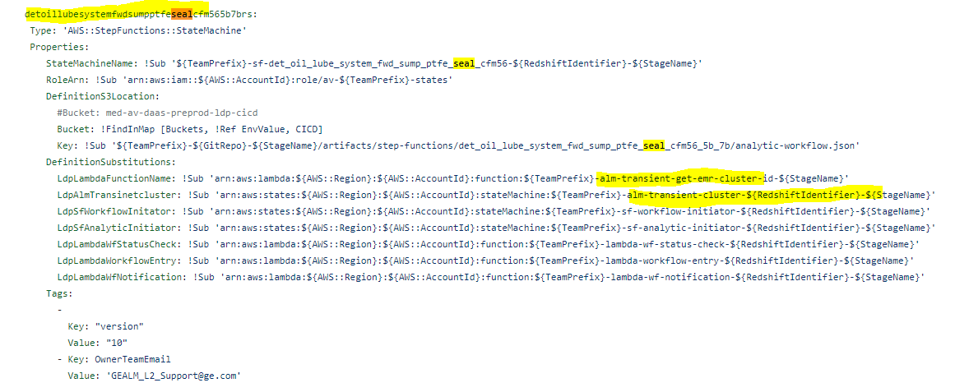

Github location of analytic workflow.json

https://github.build.ge.com/AvCDOOAnalyticsFoundation/analytics-core-rs/blob/dev/analytic_support/workflow/det_oil_lube_system_fwd_sump_ptfe_seal_cfm56_5b_7b/analytic-workflow.json

The LDP team is required to make changes to the existing code to run the analytic using a reusable component.

