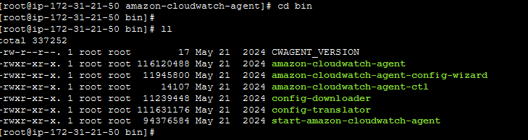
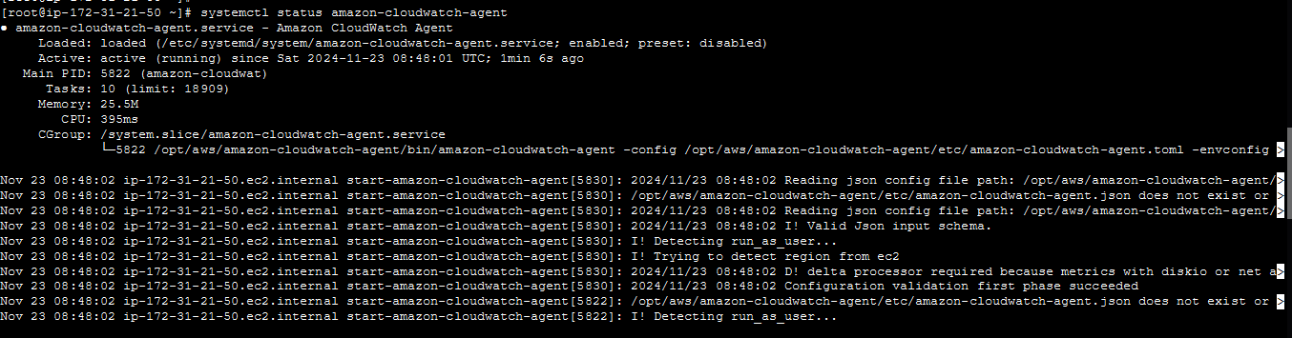
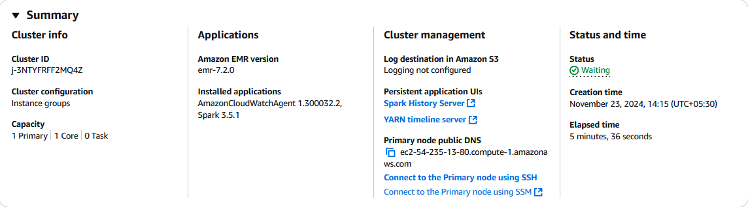
sudo /opt/aws/amazon-cloudwatch-agent/etc/amazon-cloudwatch-agent.d/ file_emr-amazon-cloudwatch-agent.json
sudo /opt/aws/amazon-cloudwatch-agent/bin/start-amazon-cloudwatch-agent
sudo /opt/aws/amazon-cloudwatch-agent/bin/amazon-cloudwatch-agent-ctl -a fetch-config -s -c file:/opt/aws/amazon-cloudwatch-agent/etc/amazon-cloudwatch-agent.d/file_file_emr-amazon-cloudwatch-agent.json

sudo /opt/aws/amazon-cloudwatch-agent/bin/start-amazon-cloudwatch-agent

