GE Aviation – EMR DS Prod DNS MAPPING
SOP (Standard Operating Procedure)

EMR DS DNS MAPPING Documentation

Document Details
Document Title | EMR DS DNS MAPPING
Document Location | Box/Confluence Link :
Version No | 1.0
Domain | GE Aviation EMR
Category | Standard Operating Procedure
Process Owner | DASIREDDY, PHANI PRASAD (502774302)
Prepared by | Yaswanth Pala (503335902)
Reviewed by | Maroli Ashwin (320002288)
Approved by | Dathrika, Sathyanarayana (503032155)
Next Review | Nov-2023
Review Frequency | Quarterly

Document Amendment Record:
A – Added, M – Modified, D – Deleted

SN | Date | Version | Page No# | Change Mode  (A/M/D) | Brief description of change
1. | 18-Aug-2023 | 1.0 |  | A | Initial Version - Draft Copy

Copyright and all rights reserved. No part of this document may be reproduced, stored, or transmitted in any form or by any means, without the prior permission of the company.

Before Mapping the ALB DNS follow the steps for coping the notebook authorization.json file from old cluster to new cluster below is the doc
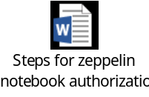

Standard Procedure for EMR DS(Prod, Nonprod) DNS MAPPING Process

Before starting the ALB process
Need to send a notification email to the user community (example template as below)

What is happening?

We are going to map the ALB DNS to the new DS Non-Prod cluster and terminating the OLD DS Non-Prod cluster (ip-10-230-246-21.ec2.internal) No services will be impacted during this time.

- During this mapping of ALB DNS services in old cluster will
Impacted services :
not be available.

When is this planned & ALB DNS down time?

Monday, 09/01/2023 @19:45 PM IST – Monday, 09/01/2023 @20:15 PM IST
Monday, 09/01/2023 @14:15 PM UTC – Monday, 09/01/2023 @14:45 PM UTC
Monday, 09/01/2023 2 @09:15 AM EST – Monday, 09/01/2023 @09:45 AM EST

Total ALB DNS down time – 30 min.

Note: During this time, please pause all your jobs in old DS Non-Prod Cluster and use new DS Non-Prod cluster.

Need additional help?
Please submit a helpdesk ticket

Or Contact us via e-mail for any issue specific to the streams below.

Hadoop/EMR: @AVIATION EMR PLATFORM/@AVIATION DBA X1 Alerts

After sending notification mail, we need to follow below steps for Alb Mapping process.

Step- 1

Go to AWS Systems manager and add the new master instance id in /datasci/emr/alb/master-instance-id
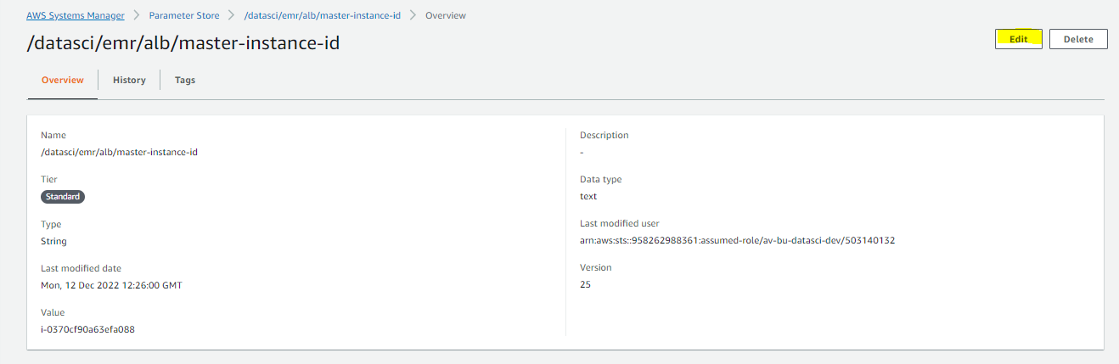

Add the new master instance ID and click on save changes
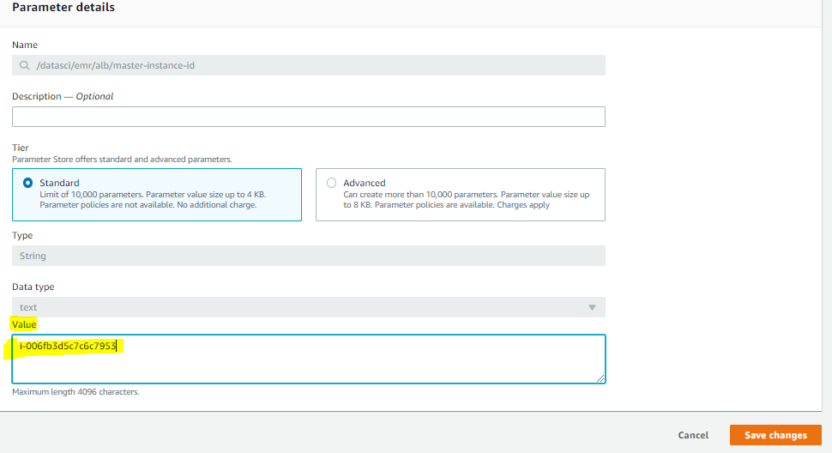

Step- 2

Go to CloudFormation and search for the alb stack for Datasci
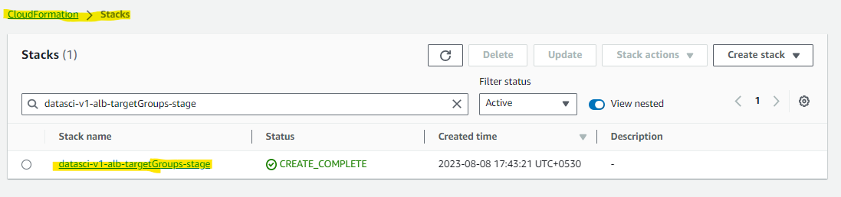

Remove For Non Prod- datasci-v1-alb-targetGroups-stage
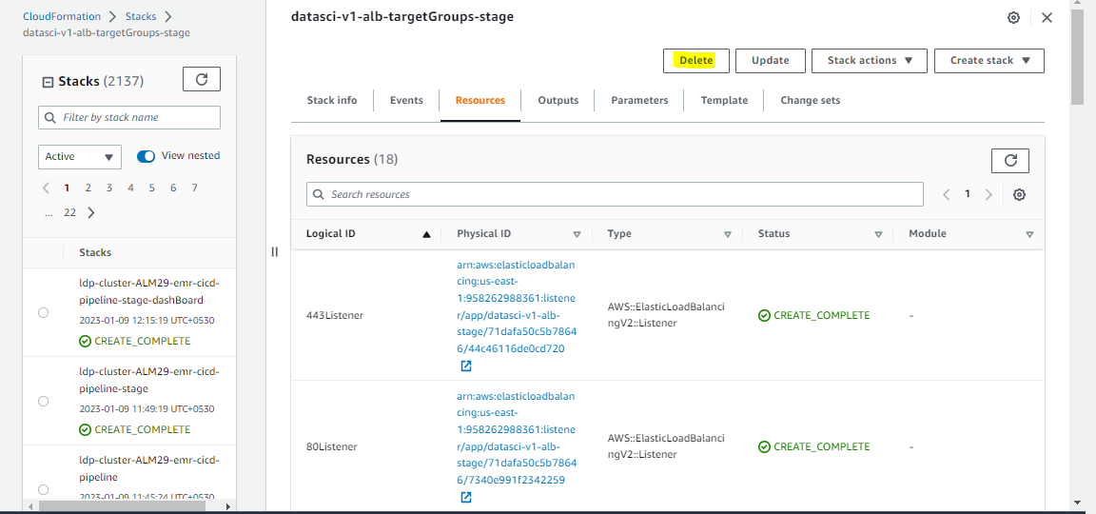

For Prod- datasci-v1-alb-targetGroups-prod
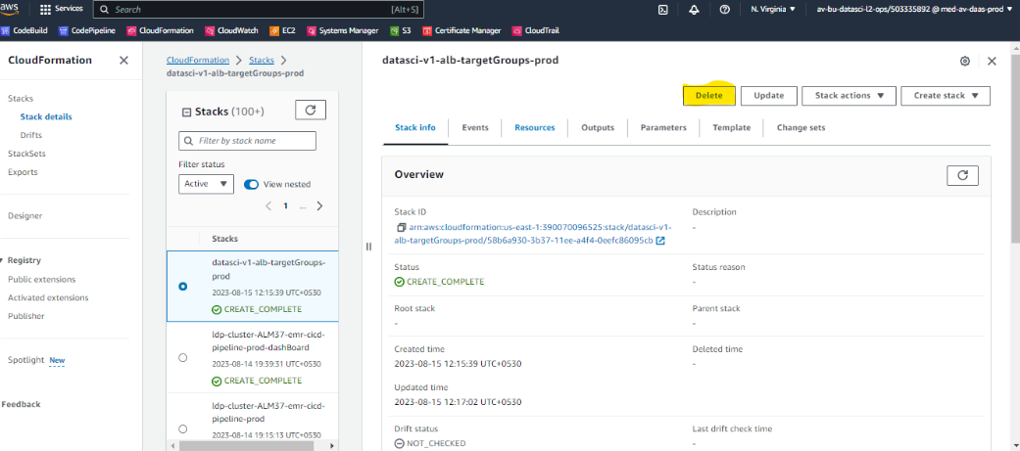

Step- 3

After removing the stack go to code pipeline and release the change
As Below- datasci-v1-alb-targetGroups-cicd-pipeline
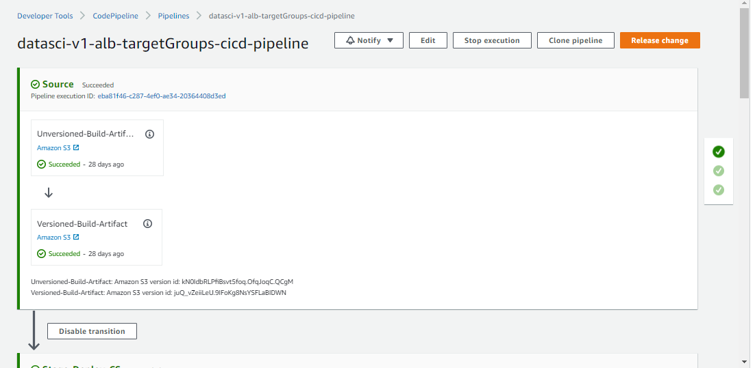

Click on release change and give the required manual approval wherever it’s required

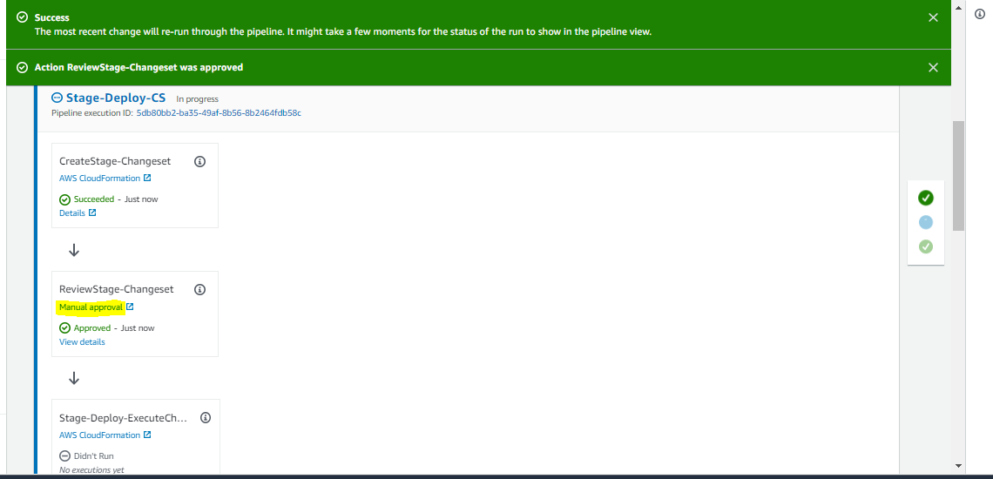

For Non prod -Don’t Proceed after the stage sign off stage, just leave as it is in same step until we deploy same in prod

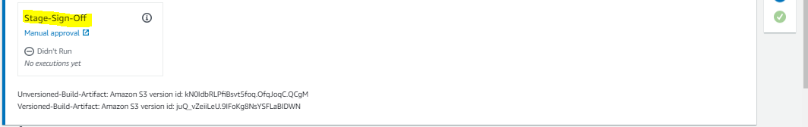

For Prod- We need to approve manually stage-sign-off stage
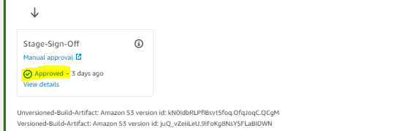
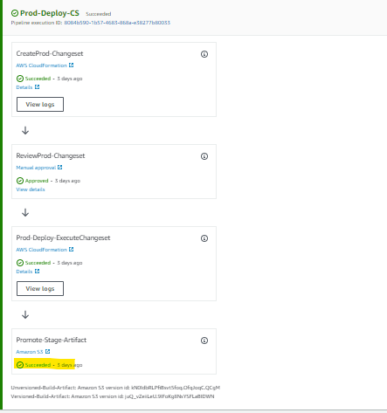

Step- 4

Go to cloud formation and verify weather stack is created or not with latest date and time

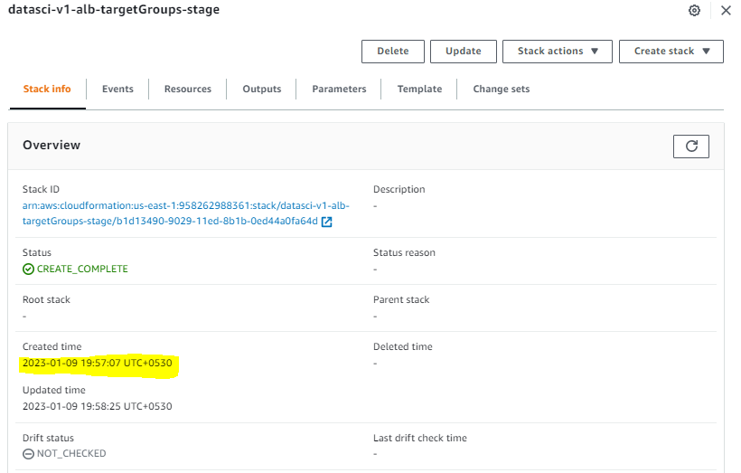

Step- 5

Go to resources and click any of the URL and verify for the latest instance ID is updated or not as below.
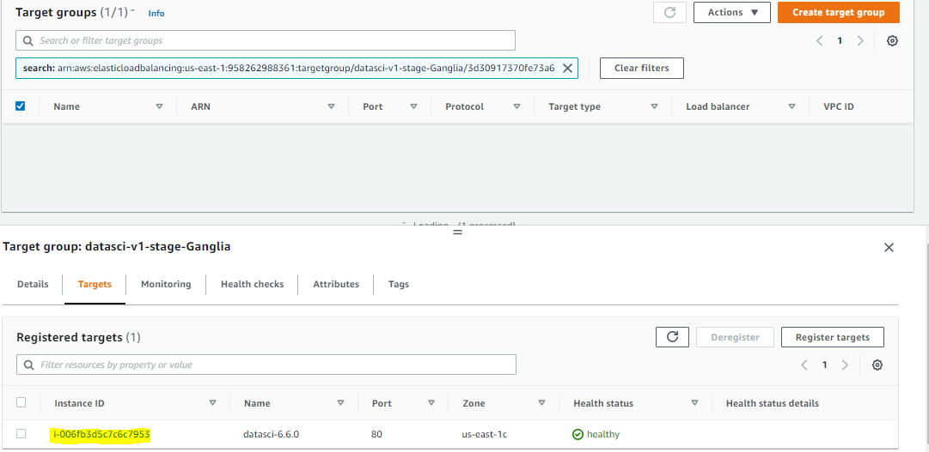

Step- 6

Once after this please open and verify the URL and check for all the services and validate

https://datascistg.av.ge.com/service.html/

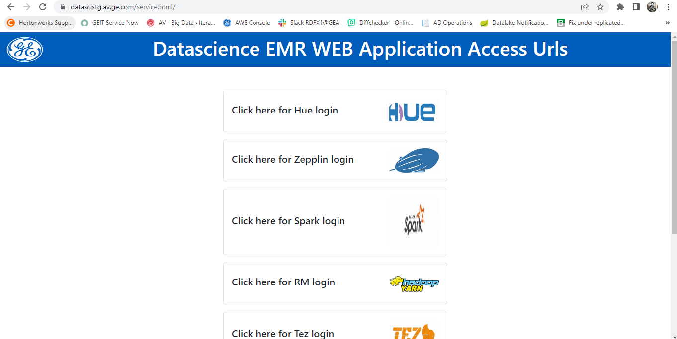

Once after verifying all the services inform and send confirmation mail to user community.

