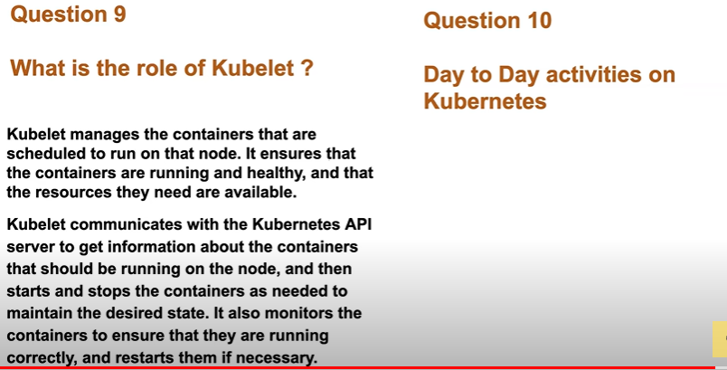
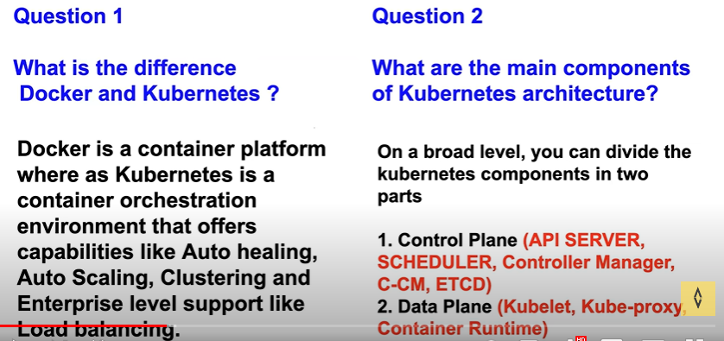
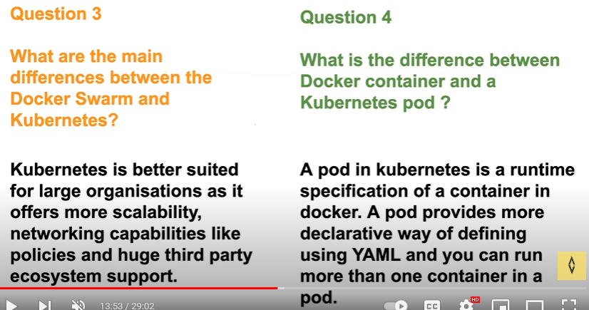
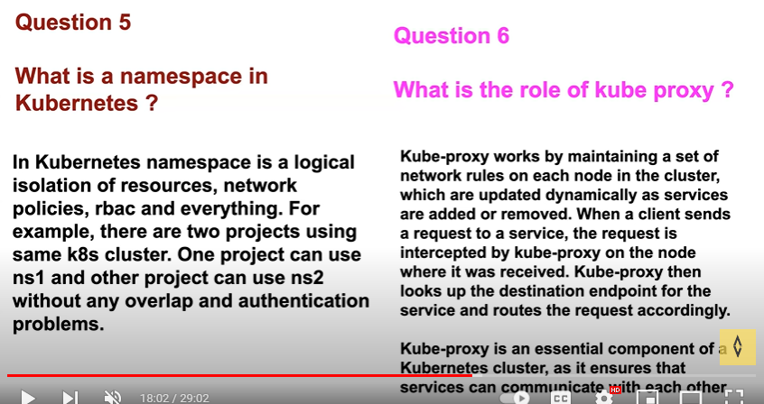
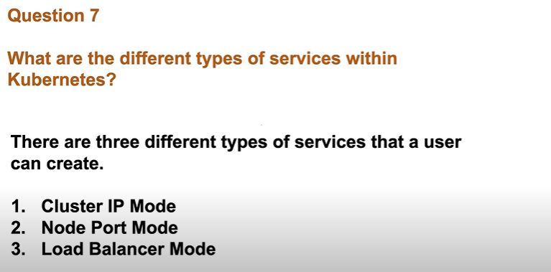
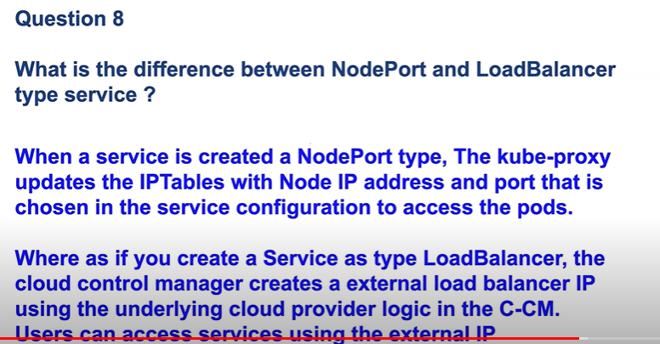
Service :
It is offering discovery, load balancing, exposing to external world.
Ex: Whenever the pod gets terminated or an instance gets terminated it the ip changes in order to but the user need to connect to application through ip in order to track all the ips which belongs to which app the Kubernetes uses labels and selectors (discovery)by using them will k8s track the ip’s.
Deployment: auto healing, auto scaling
It is a wrapper which uses for cluster scalability,replication
Without deploying the pods with the deployment, we can deployment all together by adding in a same code

before ingress problems:
some of the enterprise load balancing supports:
ratio based
sticky session
path based
domain
whitelisting
blacklisting
after migrating to Kubernetes they r providing round robin type load balancing

\missing this in kubernetes
1)enterprise and tls load balance
stciky,TLS,path,host,ratio based
2)load balancer
the cloud provider will charge for every static public ip's
problems that ingress solving:
1)the enterprise level load balancing providing load balancing security but in k8s it is not available in order to solve this k8s introduced ingress
2)for the service load balancing type mode cloud providers where charging for the static public ips
Ingress is of no use without ingress controller, ingress controller is a load balancer u can choose from the requirement(ex: f5,nginx)
**if there are multiple ingress controllers in cluster then we can mention ingress-class that who has to watch the particular resources

RBAC:
RBAC is used incase of anyone deletes etcd
1)service account/users--creating users
2)roles/cluster role- creating roles for users
3)role binding/ crb- binding permisions to users

custom resources:
k8s by default gives the services like deployment, service, pod, config maps, secrets. If u want other than this to extend k8s api or u want to introduce a new resource to k8s like argo cd, git ops applications
CRD: it is a yaml file which is used to introduce a new type of api to k8s and that will have all the fields a user can submit in the custom resource
How the k8s verify the custom resource file is crt or not?
K8s has a resource definition in the controller manager it will validate that the custom resource which is created by user is right or wrong
If ur creating a istio service the istio has created a resource definition which will validate the custom resource which the user has created
Once the custom resource is deployed there is a custom controller which is already in k8s
Whenever a update/delete/create operations r performed k8s has created a watchers inbuilt if u want to create a custom controller u have to create a new watcher some of the popular frame works of watchers are controller runtime
This watchers will use the reflectors this will function whenever a new virtual service is create it will send it in fifo queue and watchers will identify will work on queue
CONFIG MAP:
It is used to store data and later the data can be used by pods.if u have non sensitive data u can store it in config maps.
SECRETS:
IT will deal with sensitive data like username and password because whenever a resource gets created its info will be saved in etcd like an objects with this an hacker can retrieve the data through etcd . In order to deal with this k8s introduced secrets.
Secrets will encrypt the data at rest which means before the object is saved in etcd it will encrypt
K8s says that use RBAC for secrets and use least privileges with this only some of the users can access secrets
EX:
If a config map gets updated how can the pods retrieve the updated data?
Here they introduced the volumes mounts by this config maps data can be stored as a file in volume mounts with this pods get the updated info from the volumes.
Code:
Containers:
-name: python-app
Image: example.coo
Volume mounts:
- Name: db-connection
- Mount: /otp
Ports:
-container port: 8008
Volumes:
- Name: db-connection
- configMap:
without restarting the pod the value of the config map file has been changed after the file got ran try to check into the pod after the config file got ran
secrets can be of diff types like generic and tls(certificates)

k8s troubleshooting:
if the pod is in pending state in order to retrieve the pod details use:
-kubectl describe pod pod-name
Node selector which helps the scheduler to understand which pod should be scheduled on which node even if u don’t have node selector k8s will have its own selector
node selector works only when it will find the match or else it wont implement
Node affinity:
It is opposite to node selector in this we have 2 options one is (preferred and required)
Ex:
Spec:
Affinity:
Nodeaffinity:
Prefferedduringschudlingignoredduringexecution:
-weight: 1
Preference:
Matchexpressions:
- key: foo
- operator: in
values:
- bar

Taint:
There are three types of taints
1)no schedule- which is used for updates,backups
2)noexecute-
3)preferrednoschedule
Tolerations
Storage drivers in k8s:
We have to declare which storage drive we are going to use in k8s cluster like ebs,efs etc..
For the minikube there will be standard storage driver
If we want to use external storage driver we can use CSI(container storage interface driver) which will acts as a provisioner or talks to a provisioner to create persistent volumes
K8s Real time challenges:
By using below concepts, we can find which pod is leaking memory or over utilizing the resources.
1)resource sharing-
Use resource quota to equally share the resources among the namespaces. In this blast radius is restricted to particular namespace.
Use resource limit or resource requests it is set to each pod so that blast radius is restricted to one of the pods.
2)OOM killed issues with pod: use above concepts to resolve
Crashloopbackoff is just a status for oom killed
Ex:
If a java application has run then I went to check the thread dump(kill -3 cmd) and heap dump(jstack)

3)UPGRADES:
AS A DEVOPS ENG created a detailed manual doc where I added the steps:
I)backup
ii)release notes
iii)control plane detailed(etcd,scheduler,api)
iv)worker plane
in this will drain and unscheduled the node and upgrade the kubelet and install other apps and bring the node up will join to k8s
Helm charts:
Statefulset:
Example:
Statefull applications:
Databases like elastic search, mongo db,mysql that stores data of the application state
Deployed using statefulset
Replicating statefull apps is more difficult
Data will survive even when all pods die due to persistent storage
It has fixed ordered names
Next pod is only crated if previous pod is up and running
Deletion is in reverse order
Own dns endpoint from service
Stateless applications:
Don’t keep record of state
Each request is completely new
They deployed using deployment
It has random hash names to the pods

JENKINS:
SHARED LIBRARIES:
In Jenkins, a shared library is a way to store commonly used code(reusable code), such as scripts or functions, that can be used by different Jenkins pipelines.
Instead of writing the same code again and again in multiple pipelines, you can create a shared library and use it in all the pipelines that need it. This can make your code more organized and easier to maintain.
Think of it like a library of books, Instead of buying the same book over and over again, you can borrow it from the library whenever you need it.

Advantages
- Standarization of Pipelines
- Reduce duplication of code
- Easy onboarding of new applications, projects or teams
- One place to fix issues with the shared or common code
- Code Maintainence
- Reduce the risk of errors
Shared library is divided into 3 folders:
i)src
ii)var
iii)resources
were to configure shared libs in Jenkins?
Go to manage Jenkins select configure system search for global pipeline libs there give the lib name and branch name, in the retrieval method i.e, modern SCM give git and repository of var folder at last save the config.
Thn in the pipeline import the library by “@Library(“my-shared-library”) _”
EX CODE:
@Library(“my-shared-library”) _
Pipeline {
Agent any
Stages{
Stage(“hello”){
Steps{
#filename helloworld()
}}}}
Interview QA:
https://github.com/iam-veeramalla/Jenkins-Zero-To-Hero/blob/main/Interview_Questions.md

terraform version upgrade:
terraform init -upgrade
Execute the ls command to see the data stored in the instance:
etcdctl -u root:PASSWORD ls.

