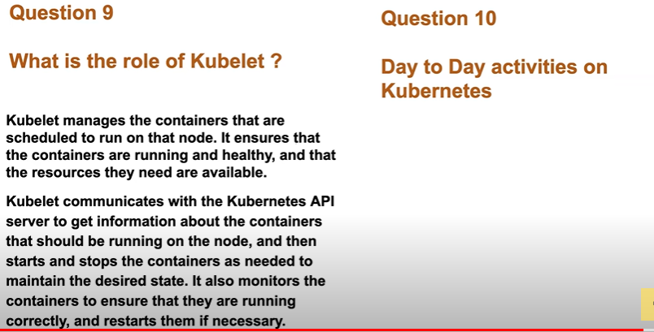
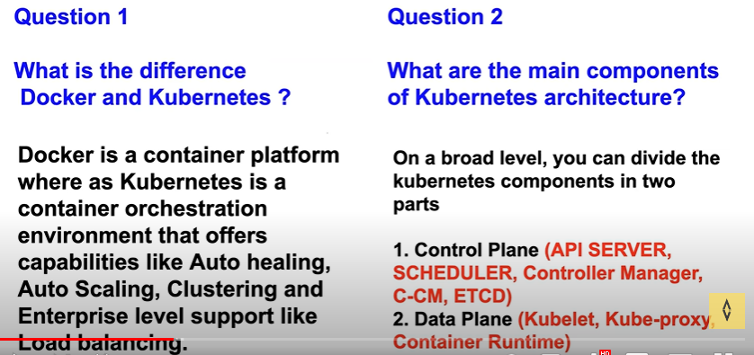
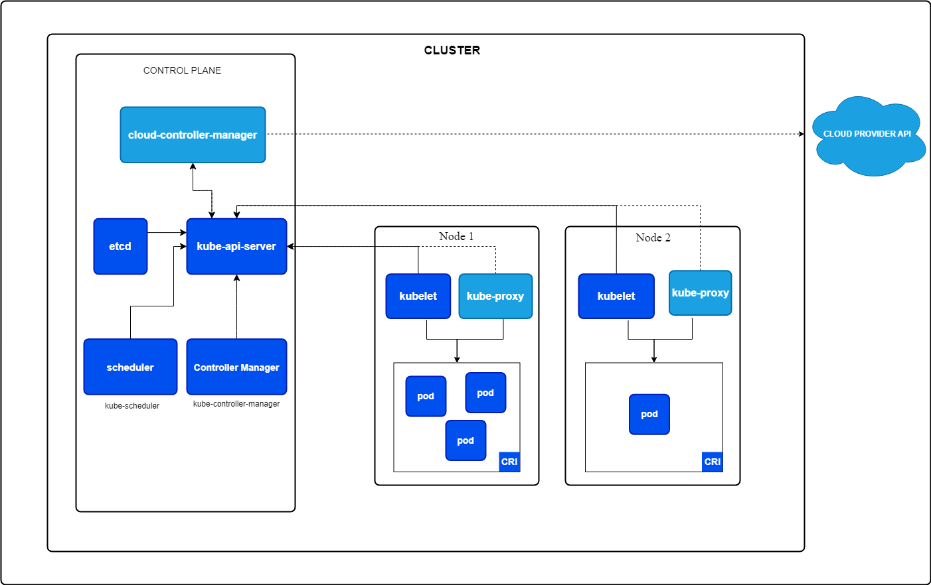
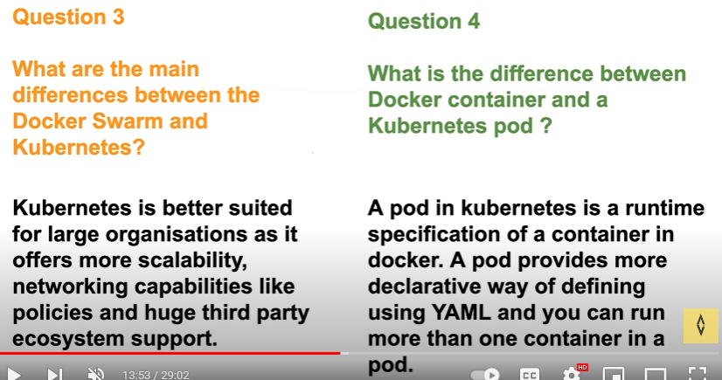
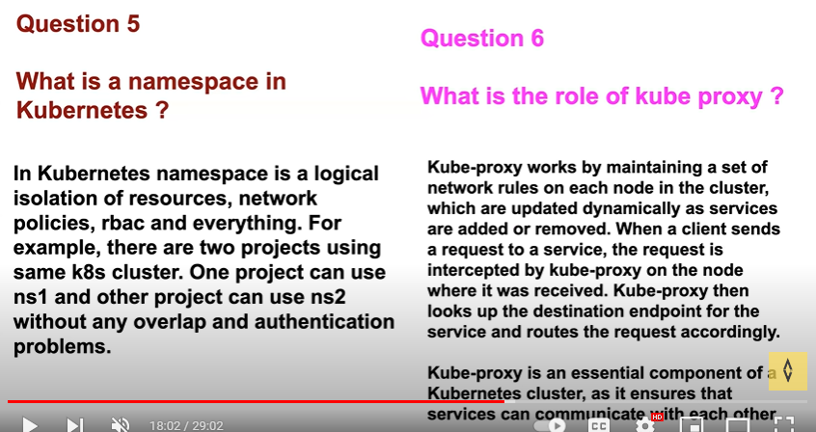
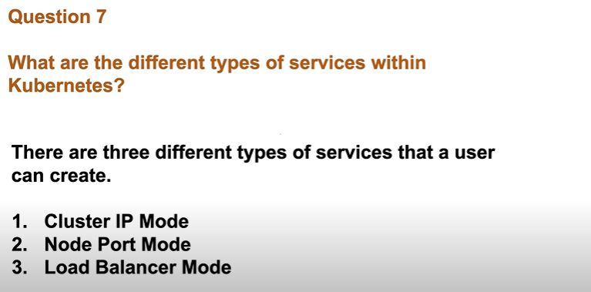
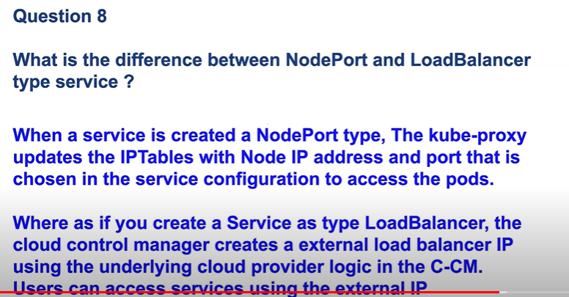
Service :
It is offering discovery, load balancing, exposing to external world.
Ex: Whenever the pod gets terminated or an instance gets terminated it the ip changes in order to but the user need to connect to application through ip in order to track all the ips which belongs to which app the Kubernetes uses labels and selectors (discovery)by using them will k8s track the ip’s.
Deployment: auto healing, auto scaling
It is a wrapper which uses for cluster scalability,replication
Without deploying the pods with the deployment, we can deployment all together by adding in a same code

before ingress problems:
some of the enterprise load balancing supports:
ratio based
sticky session
path based
domain
whitelisting
blacklisting
after migrating to Kubernetes they r providing round robin type load balancing

\missing this in kubernetes
1)enterprise and tls load balance
stciky,TLS,path,host,ratio based
2)load balancer
the cloud provider will charge for every static public ip's
problems that ingress solving:
1)the enterprise level load balancing providing load balancing security but in k8s it is not available in order to solve this k8s introduced ingress
2)for the service load balancing type mode cloud providers where charging for the static public ips
Ingress is of no use without ingress controller, ingress controller is a load balancer u can choose from the requirement(ex: f5,nginx)
**if there are multiple ingress controllers in cluster then we can mention ingress-class that who has to watch the particular resources

RBAC:
RBAC is used incase of anyone deletes etcd
1)service account/users--creating users
2)roles/cluster role- creating roles for users
3)role binding/ crb- binding permisions to users

custom resources:
k8s by default gives the services like deployment, service, pod, config maps, secrets. If u want other than this to extend k8s api or u want to introduce a new resource to k8s like argo cd, git ops applications
CRD: it is a yaml file which is used to introduce a new type of api to k8s and that will have all the fields a user can submit in the custom resource
How the k8s verify the custom resource file is crt or not?
K8s has a resource definition in the controller manager it will validate that the custom resource which is created by user is right or wrong
If ur creating a istio service the istio has created a resource definition which will validate the custom resource which the user has created
Once the custom resource is deployed there is a custom controller which is already in k8s
Whenever a update/delete/create operations r performed k8s has created a watchers inbuilt if u want to create a custom controller u have to create a new watcher some of the popular frame works of watchers are controller runtime
This watchers will use the reflectors this will function whenever a new virtual service is create it will send it in fifo queue and watchers will identify will work on queue
CONFIG MAP:
It is used to store data and later the data can be used by pods. if u have non sensitive data u can store it in config maps.
SECRETS:
IT will deal with sensitive data like username and password because whenever a resource gets created its info will be saved in etcd like an objects with this an hacker can retrieve the data through etcd . In order to deal with this k8s introduced secrets.
Secrets will encrypt the data at rest which means before the object is saved in etcd it will encrypt
K8s says that use RBAC for secrets and use least privileges with this only some of the users can access secrets
EX:
If a config map gets updated how can the pods retrieve the updated data?
Here they introduced the volumes mounts by this config maps data can be stored as a file in volume mounts with this pods get the updated info from the volumes.
Code:
Containers:
-name: python-app
Image: example.coo
Volume mounts:
- Name: db-connection
- Mount: /otp
Ports:
-container port: 8008
Volumes:
- Name: db-connection
- configMap:
without restarting the pod the value of the config map file has been changed after the file got ran try to check into the pod after the config file got ran
secrets can be of diff types like generic and tls(certificates)

k8s troubleshooting:
if the pod is in pending state in order to retrieve the pod details use:
-kubectl describe pod pod-name
Node selector which helps the scheduler to understand which pod should be scheduled on which node even if u don’t have node selector k8s will have its own selector.
node selector works only when it will find the match or else it won’t implement.
Node affinity:
It is opposite to node selector in this we have 2 options one is (preferred and required)
Ex:
Spec:
Affinity:
Nodeaffinity:
Prefferedduringschudlingignoredduringexecution:
-weight: 1
Preference:
Matchexpressions:
- key: foo
- operator: in
values:
- bar

Taint:
There are three types of taints
1)no schedule- which is used for updates,backups
2)noexecute-
3)preferrednoschedule
Tolerations
Storage drivers in k8s:
We have to declare which storage drive we are going to use in k8s cluster like ebs,efs etc..
For the minikube there will be standard storage driver
If we want to use external storage driver we can use CSI(container storage interface driver) which will acts as a provisioner or talks to a provisioner to create persistent volumes
K8s Real time challenges:
By using below concepts, we can find which pod is leaking memory or over utilizing the resources.
1)resource sharing-
Use resource quota to equally share the resources among the namespaces. In this blast radius is restricted to particular namespace.
Use resource limit or resource requests it is set to each pod so that blast radius is restricted to one of the pods.
2)OOM killed issues with pod: use above concepts to resolve
Crashloopbackoff is just a status for oom killed
Ex:
If a java application has run then I went to check the thread dump(kill -3 cmd) and heap dump(jstack)

3)UPGRADES:
AS A DEVOPS ENG created a detailed manual doc where I added the steps:
I)backup
ii)release notes
iii)control plane detailed(etcd,scheduler,api)
iv)worker plane
in this will drain and unscheduled the node and upgrade the kubelet and install other apps and bring the node up will join to k8s
Helm charts:
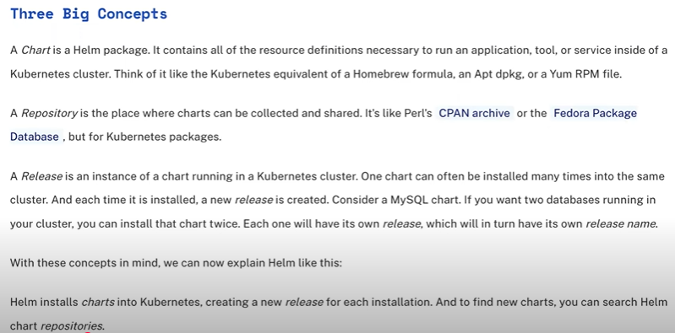
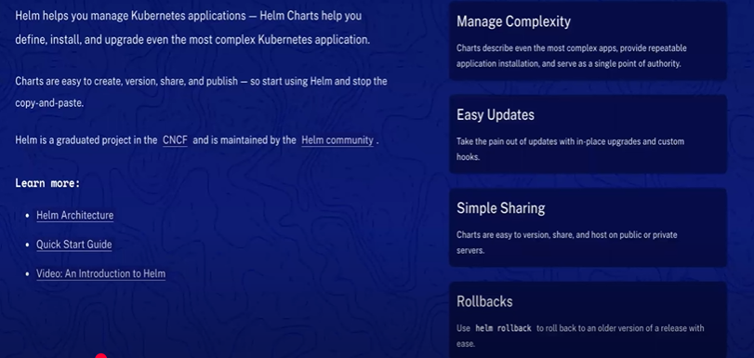
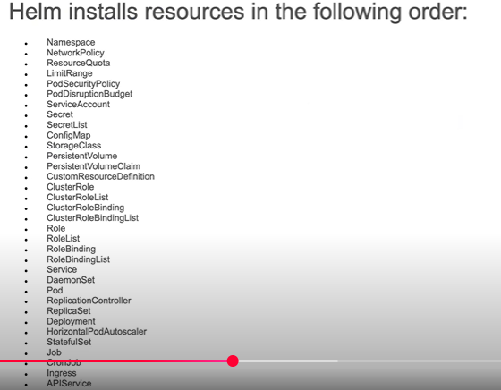
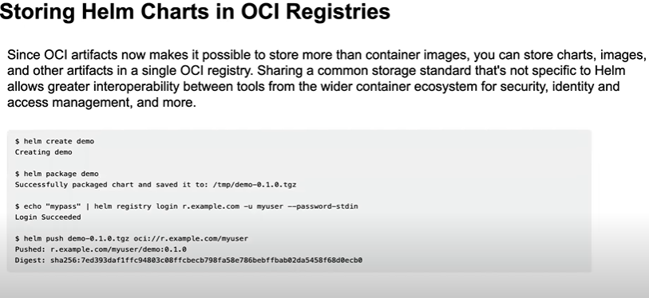
https://helm.sh/docs/
https://github.com/Azure-Samples/helm...
https://github.com/bregman-arie/devop...
when u install helm charts and configure it with ur values means change the values.yaml file there is another option called set

Kubernetes upgrading:
Managed eks service means upgrades will not take place automatically u need to upgrade it from user end.using (eksctl,awscli)
While creating aws ek saws will take care of high availability of control plane ,disaster recovery,security,api server scaling.
For every 3 months Kubernetes upgrades the version recent releases (1.32,1.31,1.30)
There is a process while upgrading need to follow:
Prerequisites:
1)cordon nodes: means make ur nodes unschedulable during the process of cluster upgrading the cluster upgrade generally takes for 1 to 2 hrs
2)go through release notes that observe what changes are made
3) Kubernetes cluster upgrades are irreversible means u cannot downgrade the cluster if the upgrade fails u need to install freshly, in order to overcome this it Is better to test in lower env grace period 2 weeks
4)control plane and worker nodes should be on same version means control plane is on version 1.30 and nodes are on 1.29 u want to upgrade the control plane to 1.31 then u need to first upgrade the nodes to 1.30 then control plane
5)clusterautoscaler make sure this version matches the control plane version
6)atleast 5 available ip address should be available within the subnet during the eks cluster creation
7)kubelet should also match the version of the control plane
Process:
First control plane upgrade(30min)
1) While creating aws ek saws will take care of high availability of control plane, disaster recovery,security,api server scaling.
2)upgrading the node group/nodes/fargate(1hr) u have to be careful at this step
Some might use managed nodegroups with launch templates of aws and aws will manage this,
Manage by users custom launch template,nodes
Some might go on hybrid approach
By using rollout approach individual nodes get upgraded
3)upgrading addons(kube proxy,vpc cni)
Command to upgrade to Kubernetes cluster
Eksctl upgrade cluster –name test – region us-east-1 –version 1.31 –approve
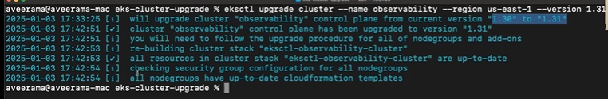
If ur using pod disruption budgets that were u can use forceful update
To test the upgrade write a simple script or u can call it an functional test
Eks recently released eks auto which will upgrade the aws eks nodegroup
Persistent volume:
Apiverison: v1
Kind: persistentvolumeclaim
Metadata:
Name: rest-api-data
Spec:
Accessmode:
- readwritemany
Resources:
Requests:
Storage: 20Gi
Statefulset:
Example:
Statefull applications:
Databases like elastic search, mongo db,mysql that stores data of the application state
Deployed using statefulset
Replicating statefull apps is more difficult
Data will survive even when all pods die due to persistent storage
It has fixed ordered names
Next pod is only crated if previous pod is up and running
Deletion is in reverse order
Own dns endpoint from service
Stateless applications:
Don’t keep record of state
Each request is completely new
They deployed using deployment
It has random hash names to the pods
Deployment strategies: it is used to reduce the down time
K8s by default uses rolling update
This rolling update will add 25%(which is a default value) at once if the first update installed successfully it will deploy completely which is incremental process.
How to select this rolling update:
With in k8s there is an option called strategy in that there are two options i.e, maxunavailable and maxsurge.
Maxsurge will tell the replication controller only create the one copy of deployment at initial.
To check if the new version or deployment is up or not Always configuring readiness probe if it’s not configured by default k8s will consider the container is up and running.
Kubectl scale replicas, kubectl get pods -w
Canary deployment: used in case for critical application.
In order to test the application in qa and production also with canary distribution load balancer will send the traffic 90% to qa and 10% to production with this we can test the application completely if its success in production total deployment takes place

Blue/Green deployment:
It is a safe and costly deployment in this we will point the load balancer to blue and green and side
Kubectl get ing, kubectl edit ing
RBAC:
These are of diff types cluster role, role binding, cluster role binding
!)role is an namespaced object can define user actions ,user can can access default namespaces
Apiversion: rbac.authorization.k8s.io/v1
Kind: Role
Metadata:
Name: pod-reader
Namespace: default
Rules:
- apiGroups: [“”]
resources: [“pods”]
verbs: [“get”,”watch”,”list”]
2)cluster role: it gives access to cluster wide objects like namespace,nodes,pv,clusterrole
Apiversion: rbac.authorization.k8s.io/v1
Kind: ClusterRole
Metadata:
Name: secret-reader
Rules:
- apiGroups: [“”]
resources: [“secrets”]
verbs: [“get”,”watch”,”list”]

3)Role binding: it is used to bind the single user or set of users to bind to a role
Apiversion: rbac.authorization.k8s.io/v1
Kind: RoleBinding
Metadata:
Name: pod-reader
Namespace: default
Subjects:
- kind: user
name: hari
apiGroup: rbac.authorization.k8s.io/v1
roleRef:
- kind: role
name: pod_reader
apiGroup: rbac.authorization.k8s.io/v1
4)clusterrolebinding:
Apiversion: rbac.authorization.k8s.io/v1
Kind: clusterRoleBinding
Metadata:
Name: pod-reader
Subjects:
- kind: group
name: manager
apiGroup: rbac.authorization.k8s.io/v1
roleRef:
- kind: clusterrole
name: secret_reader
apiGroup: rbac.authorization.k8s.io/v1

5)Command to check if the user has required permissions
Kubectl auth can-I get pod –as jack(username)
Kubectl auth can-I watch pod –as jack(username)
Kubectl auth can-I list pod –as jack(username)

JENKINS:
SHARED LIBRARIES:
In Jenkins, a shared library is a way to store commonly used code(reusable code), such as scripts or functions, that can be used by different Jenkins pipelines.
Instead of writing the same code again and again in multiple pipelines, you can create a shared library and use it in all the pipelines that need it. This can make your code more organized and easier to maintain.
Think of it like a library of books, Instead of buying the same book over and over again, you can borrow it from the library whenever you need it.

Advantages
- Standarization of Pipelines
- Reduce duplication of code
- Easy onboarding of new applications, projects or teams
- One place to fix issues with the shared or common code
- Code Maintainence
- Reduce the risk of errors
Shared library is divided into 3 folders:
i)src
ii)var
iii)resources
were to configure shared libs in Jenkins?
Go to manage Jenkins select configure system search for global pipeline libs there give the lib name and branch name, in the retrieval method i.e, modern SCM give git and repository of var folder at last save the config.
Thn in the pipeline import the library by “@Library(“my-shared-library”) _”
EX CODE:
@Library(“my-shared-library”) _
Pipeline {
Agent any
Stages{
Stage(“hello”){
Steps{
#filename helloworld()
}}}}
Interview QA:
https://github.com/iam-veeramalla/Jenkins-Zero-To-Hero/blob/main/Interview_Questions.md

terraform version upgrade:
terraform init -upgrade
Day to Day to activities:
Work as a devops engineer for xyz project teams in Wissen
Or I work in Wissen were I support multipole development teams some of them are payments transactions there apps are written in java so I support them as a devops engineer helping them creating cicd pipelines depoying there apps on eks cluster through cicd creating resources for them on aws using terraform managing the configs of there virtual machines using ansible
Helm charts are a way to package and manage Kubernetes applications. Here’s a simple breakdown:

### What is Helm?

- **Package Manager for Kubernetes**: Just like a package manager (like `apt` for Debian or `npm` for Node.js) helps you install software, Helm helps you manage applications on Kubernetes.

### What is a Helm Chart?

- **Blueprints for Applications**: A Helm chart is a collection of files that describe a Kubernetes application. It includes all the necessary information to deploy the application and manage its configuration.

### Key Components of a Helm Chart

1. **Chart.yaml**: This file contains metadata about the chart, such as its name, version, and description.

2. **Templates**: This directory contains Kubernetes resource definitions (like deployments, services, etc.) written in a templated format. These templates can be customized using variables.

3. **Values.yaml**: This file defines the default configuration values for the chart. Users can override these values when deploying the chart to customize the application.

4. **Charts**: This directory can contain other charts that your chart depends on (subcharts).

5. **README.md**: A documentation file that explains how to use the chart.

### How Helm Charts Work

1. **Installation**: You can install an application using a Helm chart with a simple command, which handles all the underlying Kubernetes resources.

```bash
helm install my-app ./my-chart
```

2. **Configuration**: You can customize the settings of the application by providing your own `values.yaml` file or using command-line options.

3. **Upgrade and Rollback**: Helm makes it easy to upgrade applications to new versions or roll back to previous versions if something goes wrong.

4. **Dependency Management**: Helm charts can specify dependencies on other charts, making it easier to manage complex applications.

### Why Use Helm Charts?

- **Simplifies Deployment**: Helm charts automate the deployment of applications, making it easier and faster.
- **Reusability**: You can share and reuse charts across different projects or teams.
- **Consistency**: Helm ensures that applications are deployed consistently across different environments.

### Summary

Helm charts are a powerful tool for managing Kubernetes applications, providing a way to package, configure, and deploy software easily and consistently. They simplify the complexity of Kubernetes and help teams work more efficiently.
Helm charts and manifest files are related but serve different purposes in the Kubernetes ecosystem. Here's a comparison to clarify their differences and similarities:
3. **Functionality**:
- **Templating**: Helm charts use templates to allow dynamic configuration. You can customize applications easily by changing values in `values.yaml` or providing command-line options.
- **Package Management**: Helm acts as a package manager, allowing you to install, upgrade, and roll back applications easily.
- **Dependencies**: Helm charts can specify dependencies on other charts.

4. **Deployment**:
- Deployments are done using the Helm CLI, which processes the templates and values to generate the final Kubernetes manifests.

### Manifest Files

1. **Definition**:
- A manifest file is a YAML file that explicitly defines a Kubernetes resource (like a Pod, Deployment, Service, etc.).

2. **Structure**:
- A single file (or multiple files) that defines a specific resource, containing fields like `apiVersion`, `kind`, `metadata`, and `spec`.

3. **Functionality**:
- **Static Definition**: Manifest files are static and do not support templating or dynamic configuration out of the box.
- **Direct Application**: You apply manifest files directly to a Kubernetes cluster using `kubectl apply -f`.

4. **Deployment**:
- Each manifest file corresponds to a specific resource and is applied individually.

### Key Differences

| Feature | Helm Charts | Manifest Files |
|---------------------|--------------------------------------------------|--------------------------------------------|
| Structure | Collection of files (templates, values, etc.) | Typically single YAML files for resources |
| Templating | Supports dynamic templating | Static definitions |
| Package Management | Manages applications as packages | No package management; individual resources |
| Dependencies | Can specify dependencies on other charts | No dependency management |
| Deployment Command | Uses `helm install`, `helm upgrade`, etc. | Uses `kubectl apply -f` |

### Summary

- **Helm charts** are more powerful and flexible, allowing for templated, reusable, and manageable applications in Kubernetes.
- **Manifest files** are straightforward definitions of individual resources, best for simpler deployments without the need for templating or packaging.

In many cases, you might use both: Helm charts for complex applications and manifest files for simpler, standalone resources.
Devsecops:
Using synk we can scan code it has a vulnerability database which can identify errors in code
Docker image scan:
Trivy,synk,docker scout these are the tools that are used to scan the docker images
Pod disruption budget:
apiVersion: policy/v1
kind: PodDisruptionBudget
metadata:
name: zk-pdb
spec:
minAvailable: 2
selector:
matchLabels:
app: zookeeper
# container restart delays will start at 10s, increasing

kind: KubeletConfiguration
crashLoopBackOff:
maxContainerRestartPeriod: "100s"
Auto scaling:
the Vertical Pod Autoscaler (VPA) is not part of the default Kubernetes distribution and needs to be installed separately.
kubectl autoscale rs foo --min=2 --max=5 --cpu-percent=80
Endpointslice API:
EndpointSlices include references to all the Pods that match the Service selector. EndpointSlices group network endpoints together by unique combinations of protocol, port number, and Service name. The name of a EndpointSlice object must be a valid DNS subdomain name.
apiVersion: discovery.k8s.io/v1
kind: EndpointSlice
metadata:
name: example-abc
labels:
kubernetes.io/service-name: example
addressType: IPv4
ports:
- name: http
protocol: TCP
port: 80
endpoints:
- addresses:
- "10.1.2.3"
conditions:
ready: true
hostname: pod-1
nodeName: node-1
zone: us-west2-a
EndpointSlices can act as the source of truth for kube-proxy when it comes to how to route internal traffic.
The EndpointSlice API stores conditions about endpoints(pods) that may be useful for consumers. The three conditions are ready, serving, and terminating

