@Aspect :

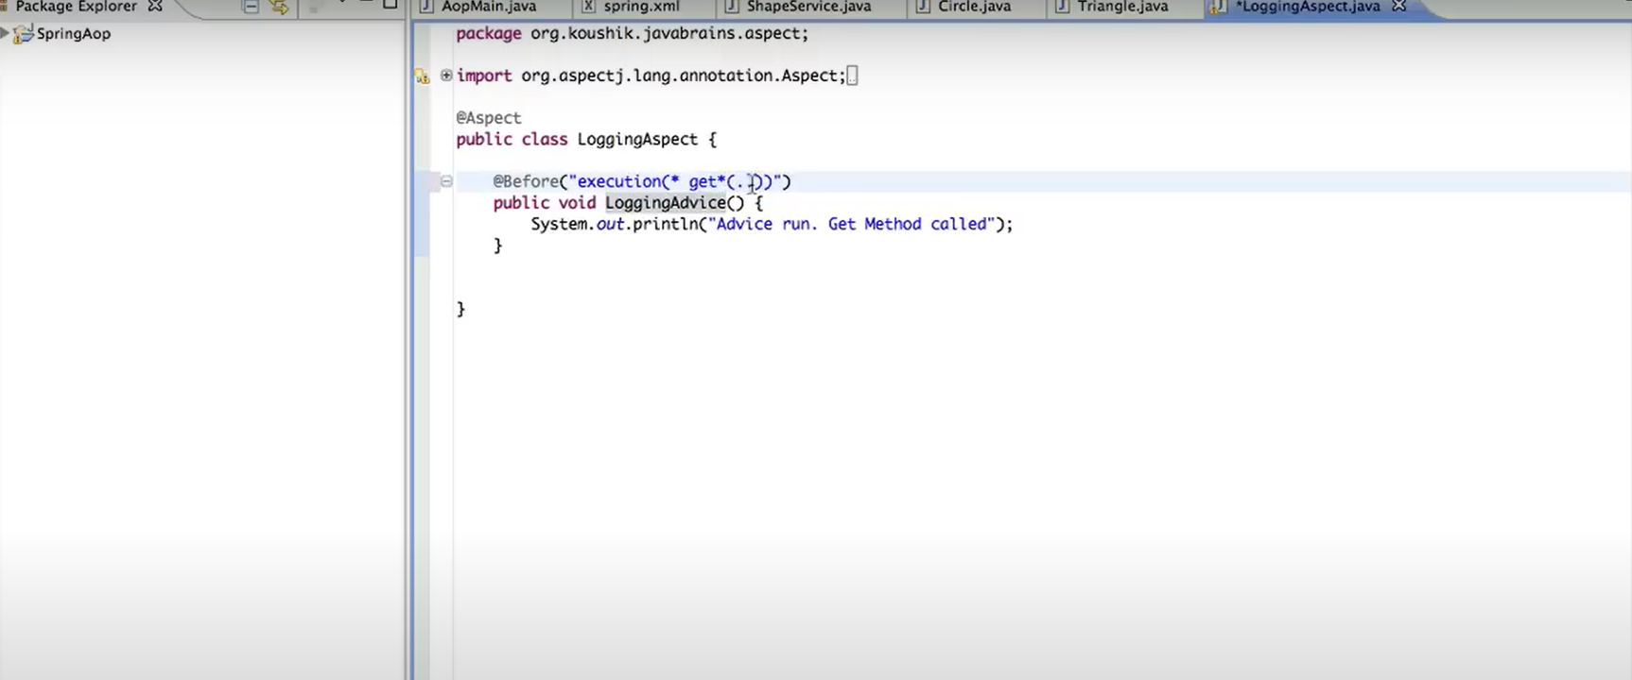

If we want to apply all aero arguments and any arguments methods – use inside method (..)

*-is a wild card entry , it will replace with any name can come.

@PointCut:

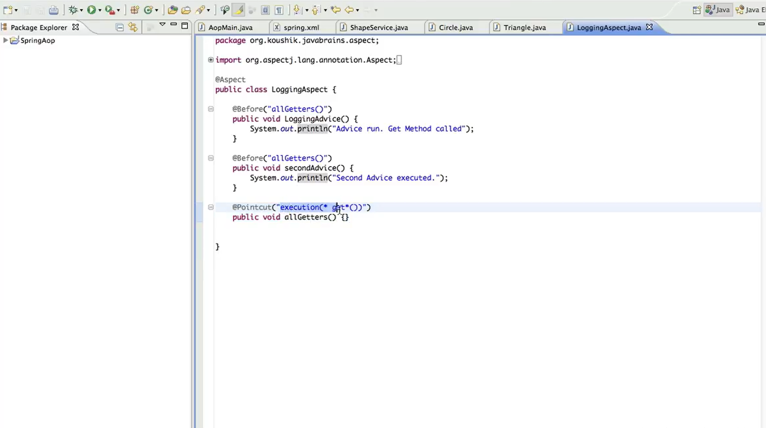

@Pointcut will help us to not to repeat similar type of execution method name sin many places

How @Before(execution(* * * * *)) works :

Public String getName(int id); ----------🡪 we must provide these details for execution method - * * * (..)

**Point cut Expressions:**

1.exceution

@Before(execution(public * org.javabrains.harikrishna.Circle.*get(..))

2.within – with specific class or package if you want to run the advice for all the methods before executing.

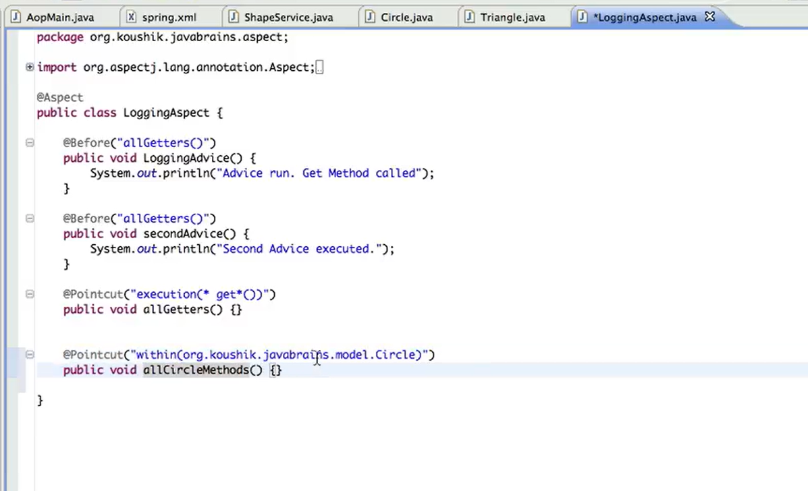

Here also we can apply wild card entries *, within this package and classes all methods also

And if you want to apply same package and inside sub packages also, then we have to give two (..) end o the wilds card

3. args – spring will look at all the methods which matches given arguments, then it will execute for all those

@Pointcut(args())

**Combine the Pointtcut Expressions:**

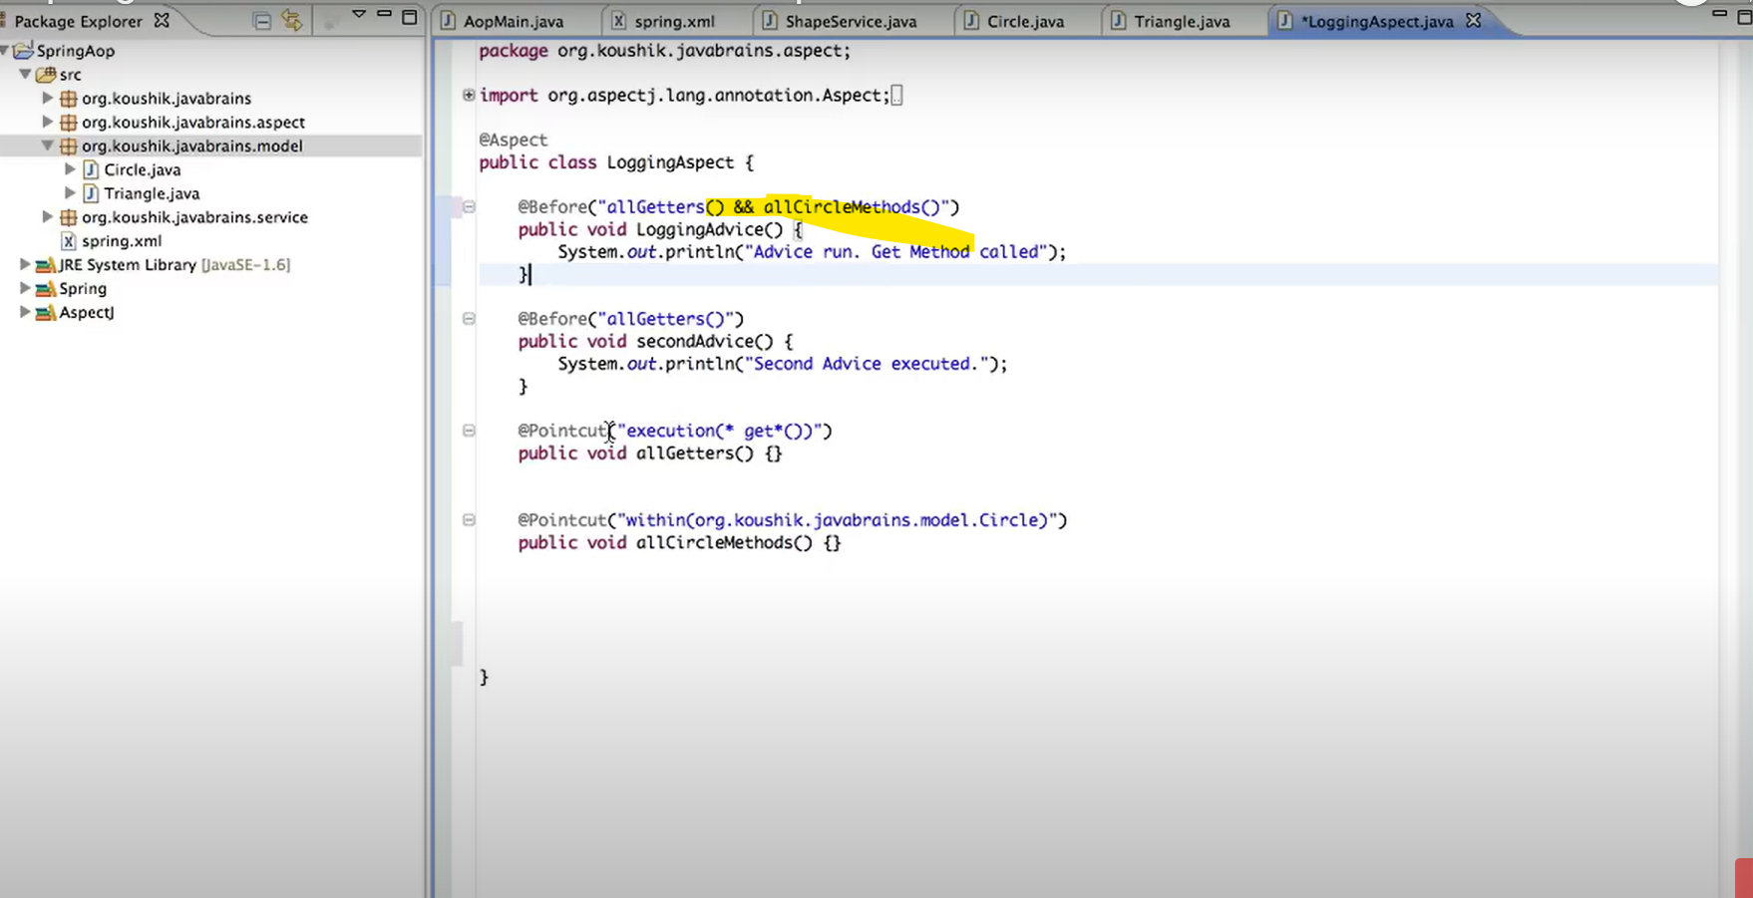

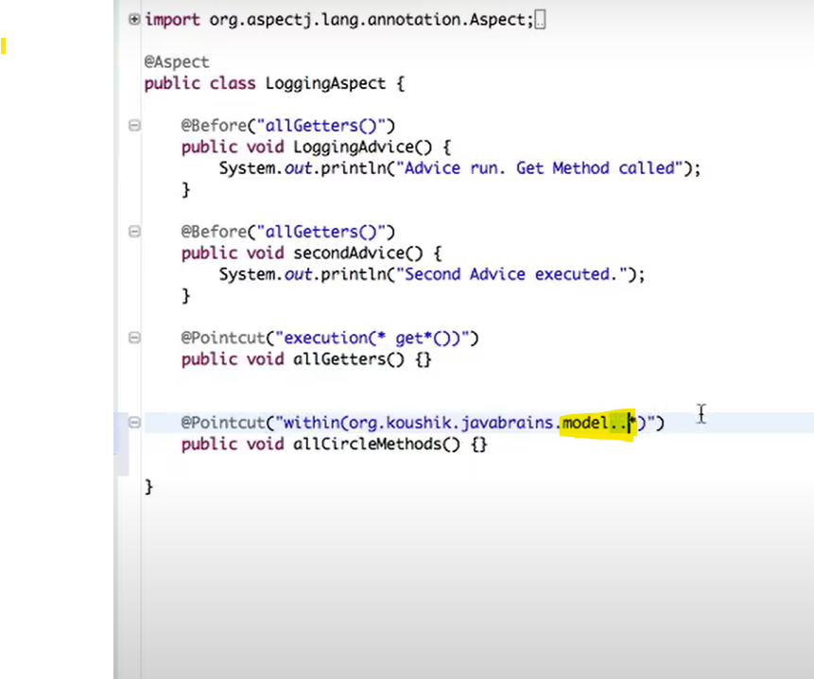

**JointPoint –** This annotation will used to capture/pass the input of the method to the advised method inside Aspect class

