IBM NAANMUTHALVAN
PHASE 5 PROJECT

TEAM MEMBERS:
A.AHAMED IBRAHIM(820421205002)(samadhasanalthauf@gmail.com)
J.JAYACHANDAR(820421205033)(bugal890@gmail.com)
K.HARI KRISHNA(820421205027)(harikrishna22032004@gmail.com)
S.BALAMURUGAN(820421205013)(balamurugan610001@gmail.com)
DOMAIN NAME :
DATA ANALYTICS WITH IBM COGNOS
PROJECT NAME:
ASSESSMENT OF TN MARGINAL WORKERS –A SOCIO-ECONOMIC ANALYSIS.

Objectives:
To analyze the demographic characteristics of marginal workers in Tamil Nadu.
To identify key trends and insights related to their employment status.
To create informative visualizations to present the findings.
Analysis Approach:
- Data Collection: Gather data on demographic characteristics and employment status of
individuals in Tamil Nadu.
- Data Preprocessing: Clean and format the dataset for analysis.
- Data Analysis: Calculate summary statistics and explore the dataset to gain insights.
- Data Visualization: Create visualizations to present the findings.
Data Visualization
Visualizations
Data visualization is a critical component of data analytics. It involves representing data graphically to help analysts and decision-makers understand the data's patterns, relationships, and insights more easily.
With the help of IBM Cognos, we use map for distribution of worker in different regions, use line charts, Box plot, Point graph, Point graph and Driver analysis and Include code and visualizations for age, industrial category, and sex using python.
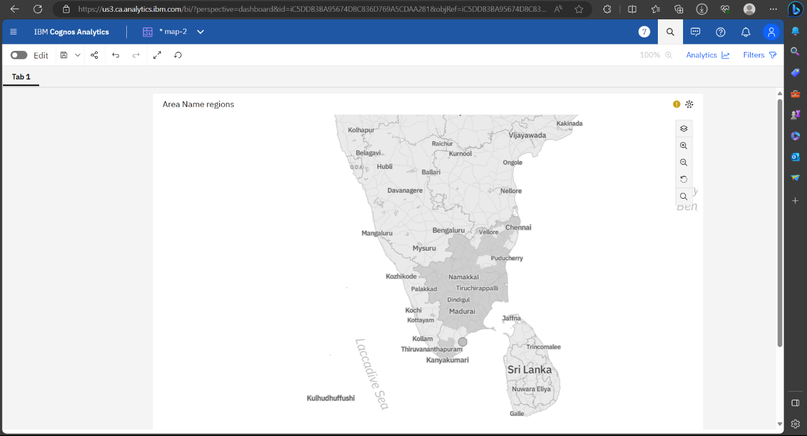
Distribution of workers by region:
Line graph:
The demographic analysis visualization.
Industrial Category - H - Females and Industrial Category - H - Males by Area Name.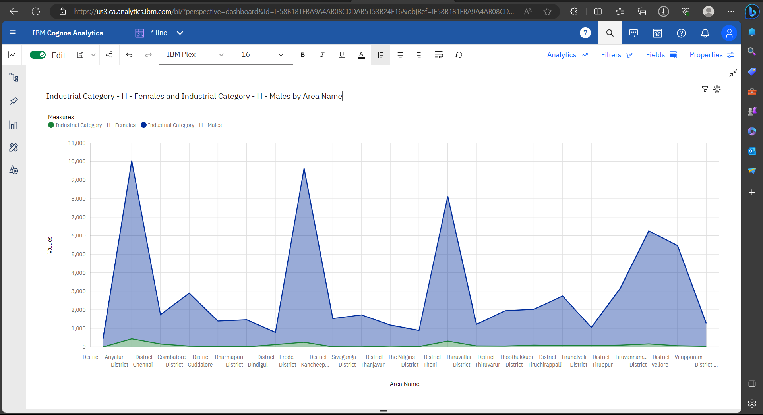
Box plot
Area Name, Worked for less than 3 months - Males, Worked for 3 months or more but less than 6months-Females 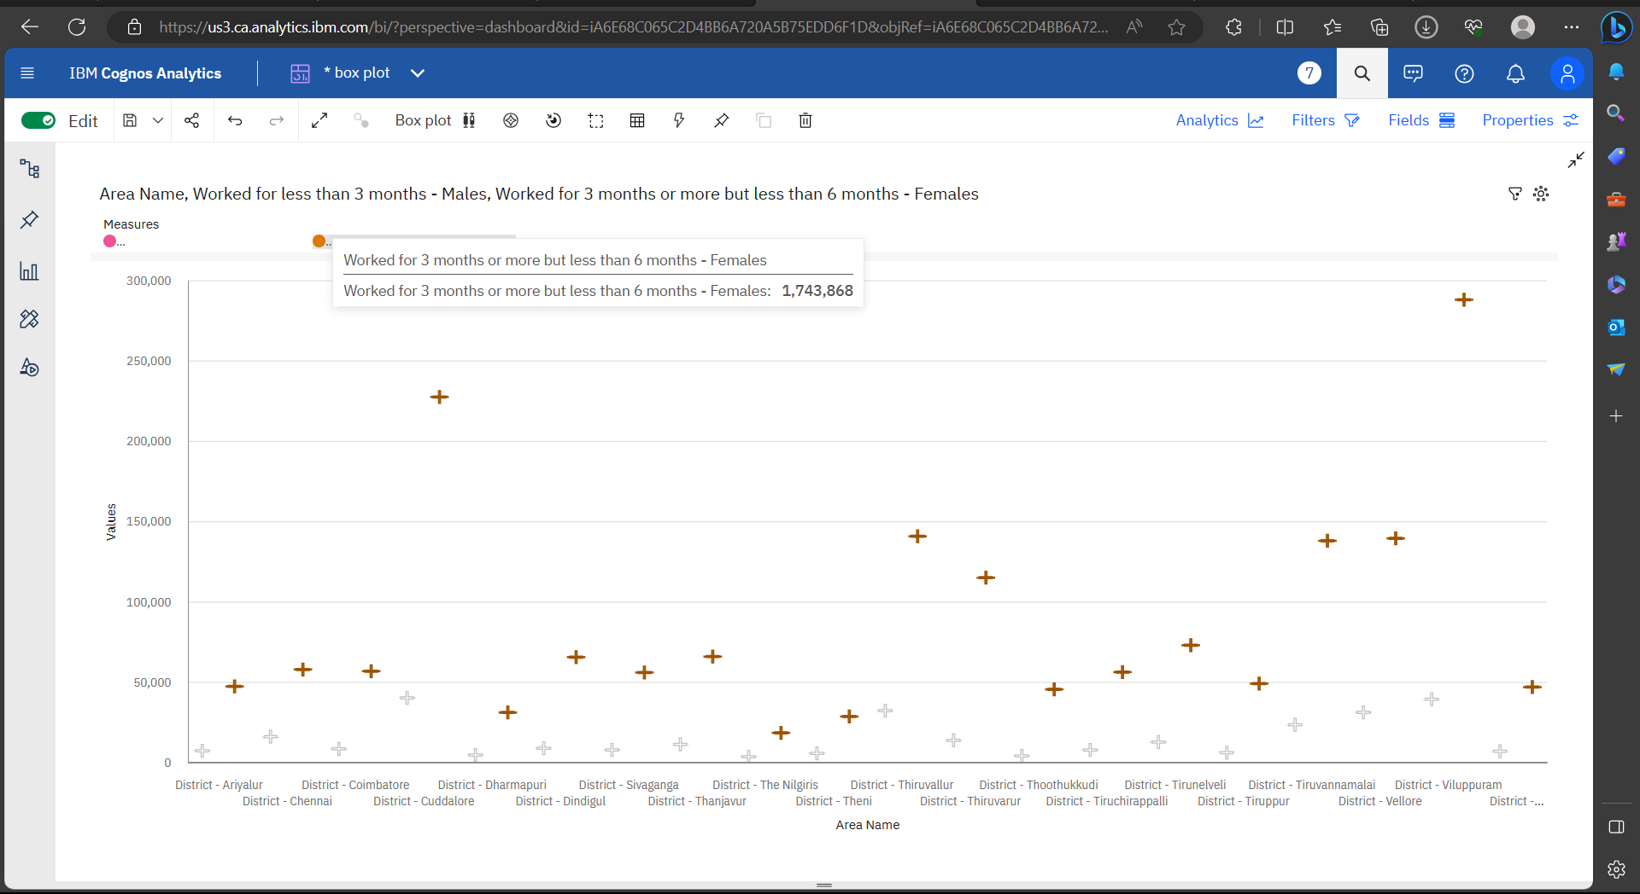
Point graph:Point graph for Industrial Category - F - Males and Industrial Category - F - Females by Area Nam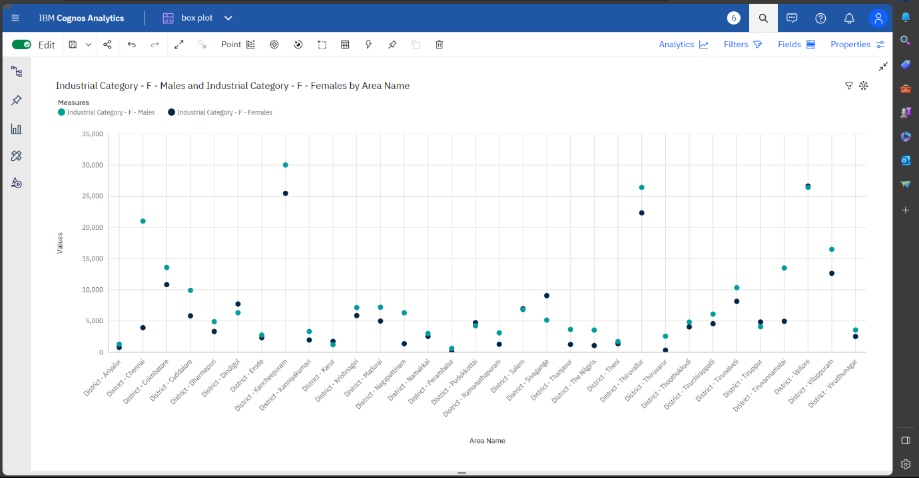

DATA VISUALIZATION USING PYTHON
import numpy as np
import pandas as pd
import matplotlib.pyplot as plt
import seaborn as sns
data=pd.read_csv('DDW_B06SC_3300_State_TAMIL_NADU-2011.csv')
data.head()
Table Code State Code District Code Area Name Total/ Rural/ Urban \
0 B0806SC `33 `000 State - TAMIL NADU Total
1 B0806SC `33 `000 State - TAMIL NADU Total
2 B0806SC `33 `000 State - TAMIL NADU Total
3 B0806SC `33 `000 State - TAMIL NADU Total
4 B0806SC `33 `000 State - TAMIL NADU Total
Age group Worked for 3 months or more but less than 6 months - Persons \
0 Total 1200828
1 `5-14 27791
2 15-34 514340
3 35-59 542581
4 60+ 115103
Worked for 3 months or more but less than 6 months - Males \
0 589003
1 14125
2 259560
3 251957
4 62833
Worked for 3 months or more but less than 6 months - Females \
0 611825
1 13666
2 254780
3 290624
4 52270
Worked for less than 3 months - Persons ... \
0 221386 ...
1 2447 ...
2 92423 ...
3 99202 ...
4 27165 ...
Industrial Category - N to O - Females \
0 3565
1 11
2 1754
3 1619
4 175
Industrial Category - P to Q - Persons \
0 11080
1 122
2 7536
3 3205
4 211
Industrial Category - P to Q - Males \
0 4019
1 71
2 2718
3 1131
4 93
Industrial Category - P to Q - Females \
0 7061
1 51
2 4818
3 2074
4 118
Industrial Category - R to U - HHI - Persons \
0 16833
1 427
2 8346
3 6591
4 1457
Industrial Category - R to U - HHI - Males \
0 4266
1 169
2 2127
3 1487
4 483
Industrial Category - R to U - HHI - Females \
0 12567
1 258
2 6219
3 5104
4 974
Industrial Category - R to U - Non HHI - Persons \
0 122088
1 19305
2 68929
3 26498
4 7065
Industrial Category - R to U - Non HHI - Males \
0 55801
1 9774
2 32803
3 9675
4 3394
Industrial Category - R to U - Non HHI - Females
0 66287
1 9531
2 36126
3 16823
4 3671
[5 rows x 69 columns]
data.shape
(594, 69)
data.info()
<class 'pandas.core.frame.DataFrame'>
RangeIndex: 594 entries, 0 to 593
Data columns (total 69 columns):
# Column Non-Null Count Dtype
--- ------ -------------- -----
0 Table Code 594 non-null object
1 State Code 594 non-null object
2 District Code 594 non-null object
3 Area Name 594 non-null object
4 Total/ Rural/ Urban 594 non-null object
5 Age group 594 non-null object
6 Worked for 3 months or more but less than 6 months - Persons 594 non-null int64
7 Worked for 3 months or more but less than 6 months - Males 594 non-null int64
8 Worked for 3 months or more but less than 6 months - Females 594 non-null int64
9 Worked for less than 3 months - Persons 594 non-null int64
10 Worked for less than 3 months - Males 594 non-null int64
11 Worked for less than 3 months - Females 594 non-null int64
12 Industrial Category - A - Cultivators - Persons 594 non-null int64
13 Industrial Category - A - Cultivators - Males 594 non-null int64
14 Industrial Category - A - Cultivators - Females 594 non-null int64
15 Industrial Category - A - Agricultural labourers - Persons 594 non-null int64
16 Industrial Category - A - Agricultural labourers - Males 594 non-null int64
17 Industrial Category - A - Agricultural labourers - Females 594 non-null int64
18 Industrial Category - A - Plantation, Livestock, Forestry, Fishing, Hunting and allied activities - Persons 594 non-null int64
19 Industrial Category - A - Plantation, Livestock, Forestry, Fishing, Hunting and allied activities - Males 594 non-null int64
20 Industrial Category - A - Plantation, Livestock, Forestry, Fishing, Hunting and allied activities - Females 594 non-null int64
21 Industrial Category - B - Persons 594 non-null int64
22 Industrial Category - B - Males 594 non-null int64
23 Industrial Category - B - Females 594 non-null int64
24 Industrial Category - C - HHI - Persons 594 non-null int64
25 Industrial Category - C - HHI - Males 594 non-null int64
26 Industrial Category - C - HHI - Females 594 non-null int64
27 Industrial Category - C - Non HHI - Persons 594 non-null int64
28 Industrial Category - C - Non HHI - Males 594 non-null int64
29 Industrial Category - C - Non HHI - Females 594 non-null int64
30 Industrial Category - D & E - Persons 594 non-null int64
31 Industrial Category - D & E - Males 594 non-null int64
32 Industrial Category - D & E - Females 594 non-null int64
33 Industrial Category - F - Persons 594 non-null int64
34 Industrial Category - F - Males 594 non-null int64
35 Industrial Category - F - Females 594 non-null int64
36 Industrial Category - G - HHI - Persons 594 non-null int64
37 Industrial Category - G - HHI - Males 594 non-null int64
38 Industrial Category - G - HHI - Females 594 non-null int64
39 Industrial Category - G - Non HHI - Persons 594 non-null int64
40 Industrial Category - G - Non HHI - Males 594 non-null int64
41 Industrial Category - G - Non HHI - Females 594 non-null int64
42 Industrial Category - H - Persons 594 non-null int64
43 Industrial Category - H - Males 594 non-null int64
44 Industrial Category - H - Females 594 non-null int64
45 Industrial Category - I - Persons 594 non-null int64
46 Industrial Category - I - Males 594 non-null int64
47 Industrial Category - I - Females 594 non-null int64
48 Industrial Category - J - HHI - Persons 594 non-null int64
49 Industrial Category - J - HHI - Males 594 non-null int64
50 Industrial Category - J - HHI - Females 594 non-null int64
51 Industrial Category - J - Non HHI - Persons 594 non-null int64
52 Industrial Category - J - Non HHI - Males 594 non-null int64
53 Industrial Category - J - Non HHI - Females 594 non-null int64
54 Industrial Category - K to M - Persons 594 non-null int64
55 Industrial Category - K to M - Males 594 non-null int64
56 Industrial Category - K to M - Females 594 non-null int64
57 Industrial Category - N to O - Persons 594 non-null int64
58 Industrial Category - N to O - Males 594 non-null int64
59 Industrial Category - N to O - Females 594 non-null int64
60 Industrial Category - P to Q - Persons 594 non-null int64
61 Industrial Category - P to Q - Males 594 non-null int64
62 Industrial Category - P to Q - Females 594 non-null int64
63 Industrial Category - R to U - HHI - Persons 594 non-null int64
64 Industrial Category - R to U - HHI - Males 594 non-null int64
65 Industrial Category - R to U - HHI - Females 594 non-null int64
66 Industrial Category - R to U - Non HHI - Persons 594 non-null int64
67 Industrial Category - R to U - Non HHI - Males 594 non-null int64
68 Industrial Category - R to U - Non HHI - Females 594 non-null int64
dtypes: int64(63), object(6)
memory usage: 320.3+ KB
data.describe()
Worked for 3 months or more but less than 6 months - Persons \
count 5.940000e+02
mean 1.617277e+04
std 7.607172e+04
min 0.000000e+00
25% 2.872500e+02
50% 2.225500e+03
75% 9.628500e+03
max 1.200828e+06
Worked for 3 months or more but less than 6 months - Males \
count 594.000000
mean 7932.700337
std 36864.822704
min 0.000000
25% 147.250000
50% 1147.000000
75% 4770.500000
max 589003.000000
Worked for 3 months or more but less than 6 months - Females \
count 594.000000
mean 8240.067340
std 39259.545337
min 0.000000
25% 144.000000
50% 1076.000000
75% 4887.500000
max 611825.000000
Worked for less than 3 months - Persons \
count 594.000000
mean 2981.629630
std 13909.621137
min 0.000000
25% 27.000000
50% 430.000000
75% 1775.250000
max 221386.000000
Worked for less than 3 months - Males \
count 594.000000
mean 1338.289562
std 6127.047670
min 0.000000
25% 14.250000
50% 198.500000
75% 774.250000
max 99368.000000
Worked for less than 3 months - Females \
count 594.000000
mean 1643.340067
std 7808.832522
min 0.000000
25% 13.000000
50% 213.000000
75% 946.500000
max 122018.000000
Industrial Category - A - Cultivators - Persons \
count 594.000000
mean 865.117845
std 4274.458077
min 0.000000
25% 9.000000
50% 69.500000
75% 466.000000
max 64235.000000
Industrial Category - A - Cultivators - Males \
count 594.000000
mean 466.424242
std 2298.072295
min 0.000000
25% 5.000000
50% 35.500000
75% 244.250000
max 34632.000000
Industrial Category - A - Cultivators - Females \
count 594.000000
mean 398.693603
std 1978.682322
min 0.000000
25% 4.000000
50% 32.000000
75% 204.750000
max 29603.000000
Industrial Category - A - Agricultural labourers - Persons ... \
count 594.000000 ...
mean 12225.616162 ...
std 60458.382586 ...
min 0.000000 ...
25% 79.250000 ...
50% 1094.000000 ...
75% 6279.750000 ...
max 907752.000000 ...
Industrial Category - N to O - Females \
count 594.000000
mean 48.013468
std 222.553500
min 0.000000
25% 0.000000
50% 2.000000
75% 18.000000
max 3565.000000
Industrial Category - P to Q - Persons \
count 594.000000
mean 149.225589
std 696.553730
min 0.000000
25% 0.000000
50% 14.500000
75% 99.750000
max 11080.000000
Industrial Category - P to Q - Males \
count 594.000000
mean 54.127946
std 253.067862
min 0.000000
25% 0.000000
50% 6.000000
75% 35.750000
max 4019.000000
Industrial Category - P to Q - Females \
count 594.000000
mean 95.097643
std 444.011425
min 0.000000
25% 0.000000
50% 6.500000
75% 64.000000
max 7061.000000
Industrial Category - R to U - HHI - Persons \
count 594.000000
mean 226.707071
std 1039.953069
min 0.000000
25% 0.000000
50% 27.000000
75% 126.750000
max 16833.000000
Industrial Category - R to U - HHI - Males \
count 594.000000
mean 57.454545
std 265.230865
min 0.000000
25% 0.000000
50% 7.500000
75% 32.000000
max 4266.000000
Industrial Category - R to U - HHI - Females \
count 594.000000
mean 169.252525
std 776.206806
min 0.000000
25% 0.000000
50% 20.000000
75% 97.500000
max 12567.000000
Industrial Category - R to U - Non HHI - Persons \
count 594.000000
mean 1644.282828
std 7325.241597
min 0.000000
25% 64.500000
50% 263.500000
75% 994.000000
max 122088.000000
Industrial Category - R to U - Non HHI - Males \
count 594.000000
mean 751.528620
std 3352.811737
min 0.000000
25% 34.000000
50% 123.000000
75% 447.750000
max 55801.000000
Industrial Category - R to U - Non HHI - Females
count 594.000000
mean 892.754209
std 3988.125301
min 0.000000
25% 30.500000
50% 135.000000
75% 500.000000
max 66287.000000
[8 rows x 63 columns]
data.drop(['Table Code'],axis=1,inplace=True)
data.drop(['State Code'],axis=1,inplace=True)
data.drop(['District Code'],axis=1,inplace=True)
data
Area Name Total/ Rural/ Urban Age group \
0 State - TAMIL NADU Total Total
1 State - TAMIL NADU Total `5-14
2 State - TAMIL NADU Total 15-34
3 State - TAMIL NADU Total 35-59
4 State - TAMIL NADU Total 60+
.. ... ... ...
589 District - Tiruppur Urban `5-14
590 District - Tiruppur Urban 15-34
591 District - Tiruppur Urban 35-59
592 District - Tiruppur Urban 60+
593 District - Tiruppur Urban Age not stated
Worked for 3 months or more but less than 6 months - Persons \
0 1200828
1 27791
2 514340
3 542581
4 115103
.. ...
589 272
590 3285
591 3672
592 696
593 2
Worked for 3 months or more but less than 6 months - Males \
0 589003
1 14125
2 259560
3 251957
4 62833
.. ...
589 129
590 1654
591 1769
592 399
593 1
Worked for 3 months or more but less than 6 months - Females \
0 611825
1 13666
2 254780
3 290624
4 52270
.. ...
589 143
590 1631
591 1903
592 297
593 1
Worked for less than 3 months - Persons \
0 221386
1 2447
2 92423
3 99202
4 27165
.. ...
589 18
590 473
591 522
592 111
593 0
Worked for less than 3 months - Males \
0 99368
1 1247
2 43892
3 40691
4 13465
.. ...
589 6
590 238
591 247
592 50
593 0
Worked for less than 3 months - Females \
0 122018
1 1200
2 48531
3 58511
4 13700
.. ...
589 12
590 235
591 275
592 61
593 0
Industrial Category - A - Cultivators - Persons ... \
0 64235 ...
1 1710 ...
2 24863 ...
3 29692 ...
4 7930 ...
.. ... ...
589 6 ...
590 22 ...
591 25 ...
592 5 ...
593 0 ...
Industrial Category - N to O - Females \
0 3565
1 11
2 1754
3 1619
4 175
.. ...
589 0
590 20
591 33
592 0
593 0
Industrial Category - P to Q - Persons \
0 11080
1 122
2 7536
3 3205
4 211
.. ...
589 0
590 44
591 35
592 3
593 0
Industrial Category - P to Q - Males \
0 4019
1 71
2 2718
3 1131
4 93
.. ...
589 0
590 15
591 12
592 0
593 0
Industrial Category - P to Q - Females \
0 7061
1 51
2 4818
3 2074
4 118
.. ...
589 0
590 29
591 23
592 3
593 0
Industrial Category - R to U - HHI - Persons \
0 16833
1 427
2 8346
3 6591
4 1457
.. ...
589 0
590 62
591 36
592 10
593 0
Industrial Category - R to U - HHI - Males \
0 4266
1 169
2 2127
3 1487
4 483
.. ...
589 0
590 6
591 9
592 3
593 0
Industrial Category - R to U - HHI - Females \
0 12567
1 258
2 6219
3 5104
4 974
.. ...
589 0
590 56
591 27
592 7
593 0
Industrial Category - R to U - Non HHI - Persons \
0 122088
1 19305
2 68929
3 26498
4 7065
.. ...
589 228
590 675
591 279
592 81
593 0
Industrial Category - R to U - Non HHI - Males \
0 55801
1 9774
2 32803
3 9675
4 3394
.. ...
589 104
590 247
591 103
592 35
593 0
Industrial Category - R to U - Non HHI - Females
0 66287
1 9531
2 36126
3 16823
4 3671
.. ...
589 124
590 428
591 176
592 46
593 0
[594 rows x 66 columns]
from sklearn.preprocessing import LabelEncoder
le=LabelEncoder()
data['Area Name'] = le.fit_transform(data['Area Name'])
data['Total/ Rural/ Urban']=le.fit_transform(data['Total/ Rural/ Urban'])
data['Age group']=le.fit_transform(data['Age group'])
correlation=data.corr()
print(correlation)
Area Name \
Area Name 1.000000e+00
Total/ Rural/ Urban 5.231238e-17
Age group -4.027362e-17
Worked for 3 months or more but less than 6 mon... 1.897142e-01
Worked for 3 months or more but less than 6 mon... 1.910842e-01
... ...
Industrial Category - R to U - HHI - Males 1.922415e-01
Industrial Category - R to U - HHI - Females 1.823023e-01
Industrial Category - R to U - Non HHI - Persons 1.682336e-01
Industrial Category - R to U - Non HHI - Males 1.740466e-01
Industrial Category - R to U - Non HHI - Females 1.626845e-01
Total/ Rural/ Urban \
Area Name 5.231238e-17
Total/ Rural/ Urban 1.000000e+00
Age group 1.554834e-17
Worked for 3 months or more but less than 6 mon... -7.947800e-02
Worked for 3 months or more but less than 6 mon... -7.399611e-02
... ...
Industrial Category - R to U - HHI - Males -6.429709e-02
Industrial Category - R to U - HHI - Females -4.692903e-02
Industrial Category - R to U - Non HHI - Persons 8.383706e-03
Industrial Category - R to U - Non HHI - Males -1.558402e-03
Industrial Category - R to U - Non HHI - Females 1.670903e-02
Age group \
Area Name -4.027362e-17
Total/ Rural/ Urban 1.554834e-17
Age group 1.000000e+00
Worked for 3 months or more but less than 6 mon... -1.483919e-02
Worked for 3 months or more but less than 6 mon... -1.489816e-02
... ...
Industrial Category - R to U - HHI - Males -1.440281e-02
Industrial Category - R to U - HHI - Females -2.129752e-02
Industrial Category - R to U - Non HHI - Persons 8.586336e-03
Industrial Category - R to U - Non HHI - Males 1.176675e-02
Industrial Category - R to U - Non HHI - Females 5.878774e-03
Worked for 3 months or more but less than 6 months - Persons \
Area Name 0.189714
Total/ Rural/ Urban -0.079478
Age group -0.014839
Worked for 3 months or more but less than 6 mon... 1.000000
Worked for 3 months or more but less than 6 mon... 0.999263
... ...
Industrial Category - R to U - HHI - Males 0.987514
Industrial Category - R to U - HHI - Females 0.983226
Industrial Category - R to U - Non HHI - Persons 0.883359
Industrial Category - R to U - Non HHI - Males 0.890343
Industrial Category - R to U - Non HHI - Females 0.874011
Worked for 3 months or more but less than 6 months - Males \
Area Name 0.191084
Total/ Rural/ Urban -0.073996
Age group -0.014898
Worked for 3 months or more but less than 6 mon... 0.999263
Worked for 3 months or more but less than 6 mon... 1.000000
... ...
Industrial Category - R to U - HHI - Males 0.991627
Industrial Category - R to U - HHI - Females 0.987635
Industrial Category - R to U - Non HHI - Persons 0.898087
Industrial Category - R to U - Non HHI - Males 0.904637
Industrial Category - R to U - Non HHI - Females 0.889046
Worked for 3 months or more but less than 6 months - Females \
Area Name 0.188173
Total/ Rural/ Urban -0.084519
Age group -0.014764
Worked for 3 months or more but less than 6 mon... 0.999351
Worked for 3 months or more but less than 6 mon... 0.997232
... ...
Industrial Category - R to U - HHI - Males 0.982327
Industrial Category - R to U - HHI - Females 0.977768
Industrial Category - R to U - Non HHI - Persons 0.868345
Industrial Category - R to U - Non HHI - Males 0.875727
Industrial Category - R to U - Non HHI - Females 0.858721
Worked for less than 3 months - Persons \
Area Name 0.190177
Total/ Rural/ Urban -0.075662
Age group -0.015653
Worked for 3 months or more but less than 6 mon... 0.998865
Worked for 3 months or more but less than 6 mon... 0.999020
... ...
Industrial Category - R to U - HHI - Males 0.988538
Industrial Category - R to U - HHI - Females 0.985253
Industrial Category - R to U - Non HHI - Persons 0.887969
Industrial Category - R to U - Non HHI - Males 0.893847
Industrial Category - R to U - Non HHI - Females 0.879533
Worked for less than 3 months - Males \
Area Name 0.191344
Total/ Rural/ Urban -0.064609
Age group -0.016291
Worked for 3 months or more but less than 6 mon... 0.994883
Worked for 3 months or more but less than 6 mon... 0.997622
... ...
Industrial Category - R to U - HHI - Males 0.993430
Industrial Category - R to U - HHI - Females 0.991781
Industrial Category - R to U - Non HHI - Persons 0.913979
Industrial Category - R to U - Non HHI - Males 0.918710
Industrial Category - R to U - Non HHI - Females 0.906405
Worked for less than 3 months - Females \
Area Name 0.188622
Total/ Rural/ Urban -0.084081
Age group -0.015100
Worked for 3 months or more but less than 6 mon... 0.998631
Worked for 3 months or more but less than 6 mon... 0.996757
... ...
Industrial Category - R to U - HHI - Males 0.981375
Industrial Category - R to U - HHI - Females 0.976818
Industrial Category - R to U - Non HHI - Persons 0.864574
Industrial Category - R to U - Non HHI - Males 0.871332
Industrial Category - R to U - Non HHI - Females 0.855491
Industrial Category - A - Cultivators - Persons \
Area Name 0.181291
Total/ Rural/ Urban -0.106286
Age group -0.009244
Worked for 3 months or more but less than 6 mon... 0.987308
Worked for 3 months or more but less than 6 mon... 0.982657
... ...
Industrial Category - R to U - HHI - Males 0.963460
Industrial Category - R to U - HHI - Females 0.952677
Industrial Category - R to U - Non HHI - Persons 0.820028
Industrial Category - R to U - Non HHI - Males 0.832068
Industrial Category - R to U - Non HHI - Females 0.806678
... \
Area Name ...
Total/ Rural/ Urban ...
Age group ...
Worked for 3 months or more but less than 6 mon... ...
Worked for 3 months or more but less than 6 mon... ...
... ...
Industrial Category - R to U - HHI - Males ...
Industrial Category - R to U - HHI - Females ...
Industrial Category - R to U - Non HHI - Persons ...
Industrial Category - R to U - Non HHI - Males ...
Industrial Category - R to U - Non HHI - Females ...
Industrial Category - N to O - Females \
Area Name 0.158047
Total/ Rural/ Urban 0.017692
Age group -0.027006
Worked for 3 months or more but less than 6 mon... 0.886220
Worked for 3 months or more but less than 6 mon... 0.897920
... ...
Industrial Category - R to U - HHI - Males 0.910143
Industrial Category - R to U - HHI - Females 0.940298
Industrial Category - R to U - Non HHI - Persons 0.962054
Industrial Category - R to U - Non HHI - Males 0.945421
Industrial Category - R to U - Non HHI - Females 0.972250
Industrial Category - P to Q - Persons \
Area Name 0.188427
Total/ Rural/ Urban -0.014386
Age group -0.038667
Worked for 3 months or more but less than 6 mon... 0.923176
Worked for 3 months or more but less than 6 mon... 0.934548
... ...
Industrial Category - R to U - HHI - Males 0.956272
Industrial Category - R to U - HHI - Females 0.965278
Industrial Category - R to U - Non HHI - Persons 0.973702
Industrial Category - R to U - Non HHI - Males 0.976197
Industrial Category - R to U - Non HHI - Females 0.967772
Industrial Category - P to Q - Males \
Area Name 0.185130
Total/ Rural/ Urban -0.021299
Age group -0.036319
Worked for 3 months or more but less than 6 mon... 0.930708
Worked for 3 months or more but less than 6 mon... 0.941462
... ...
Industrial Category - R to U - HHI - Males 0.963555
Industrial Category - R to U - HHI - Females 0.969691
Industrial Category - R to U - Non HHI - Persons 0.970974
Industrial Category - R to U - Non HHI - Males 0.975075
Industrial Category - R to U - Non HHI - Females 0.963706
Industrial Category - P to Q - Females \
Area Name 0.190083
Total/ Rural/ Urban -0.010429
Age group -0.039960
Worked for 3 months or more but less than 6 mon... 0.917791
Worked for 3 months or more but less than 6 mon... 0.929501
... ...
Industrial Category - R to U - HHI - Males 0.950989
Industrial Category - R to U - HHI - Females 0.961621
Industrial Category - R to U - Non HHI - Persons 0.974104
Industrial Category - R to U - Non HHI - Males 0.975681
Industrial Category - R to U - Non HHI - Females 0.968945
Industrial Category - R to U - HHI - Persons \
Area Name 0.185097
Total/ Rural/ Urban -0.051426
Age group -0.019569
Worked for 3 months or more but less than 6 mon... 0.985723
Worked for 3 months or more but less than 6 mon... 0.990063
... ...
Industrial Category - R to U - HHI - Males 0.995826
Industrial Category - R to U - HHI - Females 0.999514
Industrial Category - R to U - Non HHI - Persons 0.938478
Industrial Category - R to U - Non HHI - Males 0.942038
Industrial Category - R to U - Non HHI - Females 0.931792
Industrial Category - R to U - HHI - Males \
Area Name 0.192242
Total/ Rural/ Urban -0.064297
Age group -0.014403
Worked for 3 months or more but less than 6 mon... 0.987514
Worked for 3 months or more but less than 6 mon... 0.991627
... ...
Industrial Category - R to U - HHI - Males 1.000000
Industrial Category - R to U - HHI - Females 0.992495
Industrial Category - R to U - Non HHI - Persons 0.926353
Industrial Category - R to U - Non HHI - Males 0.934201
Industrial Category - R to U - Non HHI - Females 0.916109
Industrial Category - R to U - HHI - Females \
Area Name 0.182302
Total/ Rural/ Urban -0.046929
Age group -0.021298
Worked for 3 months or more but less than 6 mon... 0.983226
Worked for 3 months or more but less than 6 mon... 0.987635
... ...
Industrial Category - R to U - HHI - Males 0.992495
Industrial Category - R to U - HHI - Females 1.000000
Industrial Category - R to U - Non HHI - Persons 0.940827
Industrial Category - R to U - Non HHI - Males 0.942914
Industrial Category - R to U - Non HHI - Females 0.935369
Industrial Category - R to U - Non HHI - Persons \
Area Name 0.168234
Total/ Rural/ Urban 0.008384
Age group 0.008586
Worked for 3 months or more but less than 6 mon... 0.883359
Worked for 3 months or more but less than 6 mon... 0.898087
... ...
Industrial Category - R to U - HHI - Males 0.926353
Industrial Category - R to U - HHI - Females 0.940827
Industrial Category - R to U - Non HHI - Persons 1.000000
Industrial Category - R to U - Non HHI - Males 0.997456
Industrial Category - R to U - Non HHI - Females 0.998203
Industrial Category - R to U - Non HHI - Males \
Area Name 0.174047
Total/ Rural/ Urban -0.001558
Age group 0.011767
Worked for 3 months or more but less than 6 mon... 0.890343
Worked for 3 months or more but less than 6 mon... 0.904637
... ...
Industrial Category - R to U - HHI - Males 0.934201
Industrial Category - R to U - HHI - Females 0.942914
Industrial Category - R to U - Non HHI - Persons 0.997456
Industrial Category - R to U - Non HHI - Males 1.000000
Industrial Category - R to U - Non HHI - Females 0.991392
Industrial Category – R to U – Non HHI – Females
Area Name 0.162684
Total/ Rural/ Urban 0.016709
Age group 0.005879
Worked for 3 months or more but less than 6 mon… 0.874011
Worked for 3 months or more but less than 6 mon… 0.889046
... ...
Industrial Category – R to U – HHI – Males 0.916109
Industrial Category – R to U – HHI – Females 0.935369
Industrial Category – R to U – Non HHI – Persons 0.998203
Industrial Category – R to U – Non HHI – Males 0.991392
Industrial Category – R to U – Non HHI – Females 1.000000
[66 rows x 66 columns]
plt.figure(figsize=(8, 8))
sns.heatmap(correlation, cbar=True, square=True, fmt=’.1f’, annot=True, annot_kws={‘size’: 8}, cmap=’Reds’)
print(plt.show())
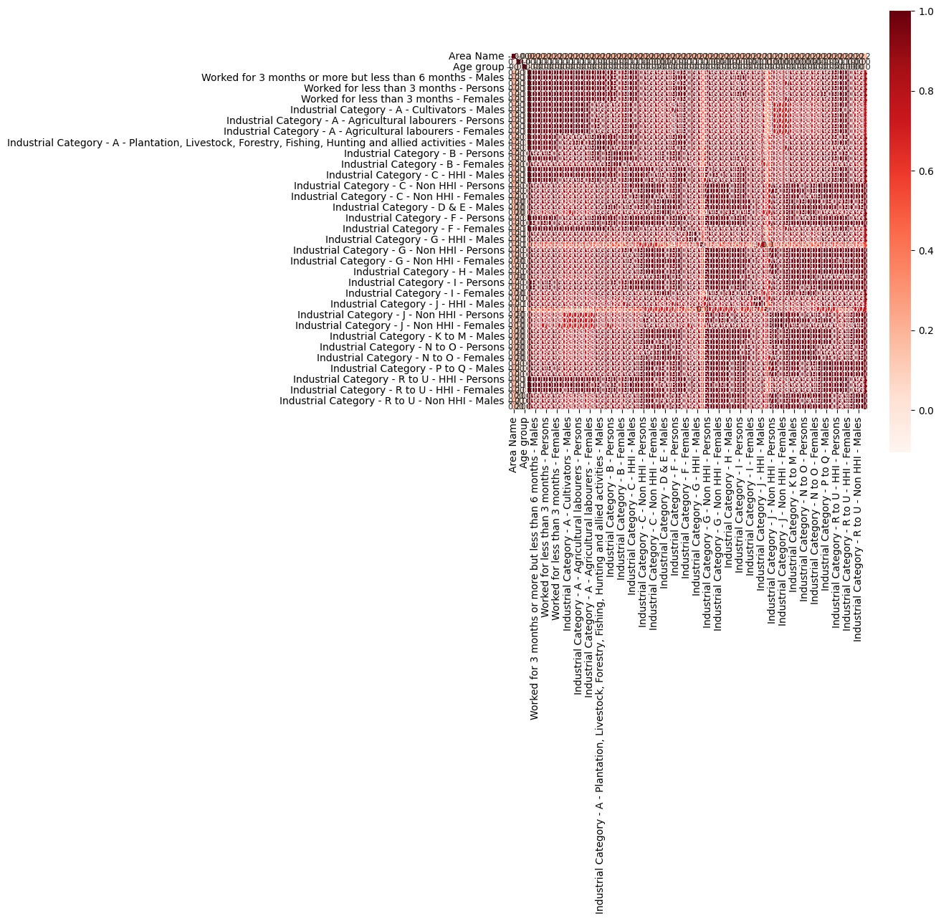

data=df.dropna()
data = data[(data['Age group'] != 'Total') & (data['Age group'] != 'Age not stated')]
data['Age group'] = data['Age group'].apply(lambda x: (int(x.split('-')[0]) + int(x.split('-')[1])) // 2 if '-' in x else int(x))
X = data[['Age group']].values
Y=data[['Industrial Category - A - Cultivators - Females']].values
Z=data[['Industrial Category - A - Cultivators - Males']].values
birch = Birch(threshold=5.5, n_clusters=2)
birch.fit(X)
cluster_labels = birch.predict(X)
data['cluster'] = cluster_labels
fig = plt.figure()
ax = fig.add_subplot(111, projection='3d')
ax.scatter(X, Y, Z, c= data['cluster'], cmap='RdBu')
ax.set_xlabel('Age group')
ax.set_ylabel('Industrial Category - A - Cultivators - Females')
ax.set_zlabel('Industrial Category - A - Cultivators - Males')
plt.title('Birch Clustering Results')
plt.show()

Output:
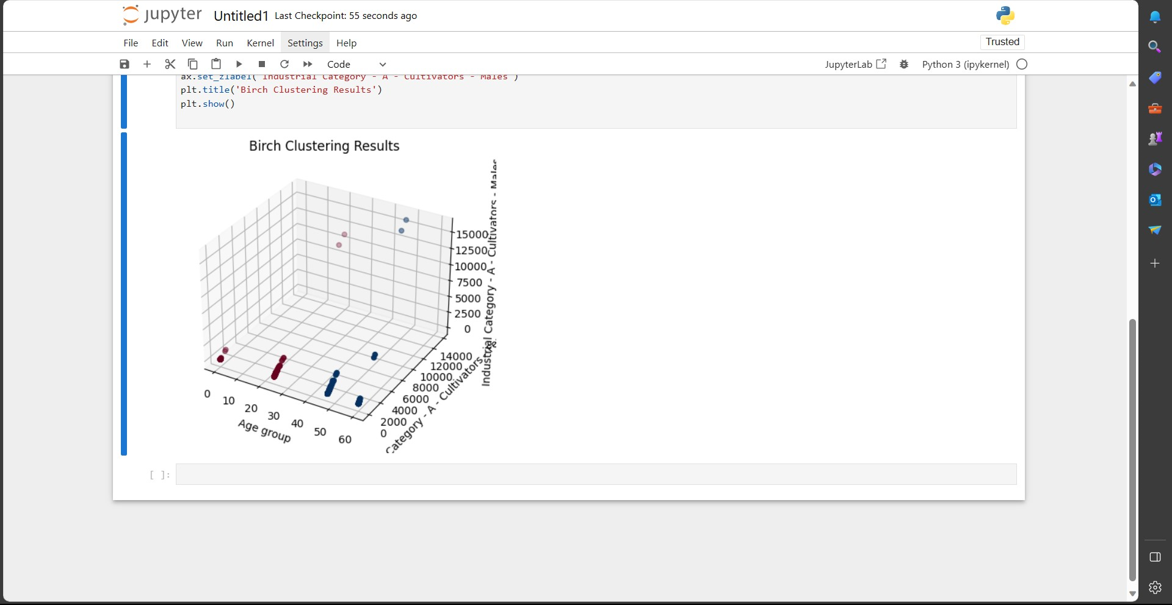

CONCLUSION:
This project has provided valuable insights into the demographic characteristics of marginal workers in Tamil Nadu. The analysis and visualizations have revealed key trends related to gender distribution, employment categories, education levels, and more. This information can be used for policymaking and improving the socio-economic conditions of marginal workers in the region.

