Analysis of Decline in Education in India
Data Analysis Using Python
2015–16 State-wise Elementary Education Dataset

1. Introduction
Education quality is influenced by several connected factors, including the availability of teachers, pupil-teacher ratio, enrolment, retention, infrastructure and literacy. This analysis uses state-wise elementary education indicators to examine relationships among these variables and to identify factors associated with the Education Quality Index. Although the project title refers to a decline in education, the supplied dataset represents a single period rather than a multi-year time series. Therefore, the analysis identifies patterns and relationships associated with education quality; it does not by itself prove that education declined over time.

2. Explanation of the Analysis
The Python program first loads the CSV file and standardizes the column names. It then checks the dataset structure and missing values and calculates descriptive statistics for numeric variables. A Pearson correlation matrix is used to measure linear relationships between variables, followed by a heatmap for visual interpretation.
Teacher-related variables and the first six numeric variables are visualized using histograms. A multiple linear regression model uses all numeric variables except the final column as predictors and uses Education Quality Index as the target. The model is evaluated using R², mean squared error (MSE), and root mean squared error (RMSE).
Finally, Pearson correlation and an independent-samples t-test are used for hypothesis testing. The strongest correlation pairs are also displayed to identify highly related variables.

3. Dataset Used
The example CSV contains 36 state/UT records and 18 columns. The dataset was constructed to match the exact column structure required by the supplied program. It includes school, teacher, enrolment, participation, literacy, infrastructure and education-quality indicators.
CSV filename used by the program: 2015_16_Statewise_Elementary.csv

4. Full Python Code Used
import pandas as pd
import numpy as np
import matplotlib.pyplot as plt
import seaborn as sns
from scipy.stats import pearsonr, ttest_ind
from sklearn.model_selection import train_test_split
from sklearn.linear_model import LinearRegression
from sklearn.metrics import mean_squared_error, r2_score
df = pd.read_csv("2015_16_Statewise_Elementary.csv")
print("Dataset Shape:", df.shape)
print("\nFirst 5 Rows:")
print(df.head())
df.columns = (
df.columns
.str.strip()
.str.lower()
.str.replace(" ", "_")
.str.replace("-", "_")
)
print("\nColumns:")
print(df.columns.tolist())
print("\nMissing Values:")
print(df.isnull().sum())
numeric_df = df.select_dtypes(include=np.number)
print("\nDescriptive Statistics:")
print(numeric_df.describe())
correlation = numeric_df.corr()
print("\nCorrelation Matrix:")
print(correlation.round(2))
plt.figure(figsize=(12, 8))
sns.heatmap(correlation, annot=True, cmap="coolwarm", fmt=".2f")
plt.title("Education Quality Correlation")
plt.tight_layout()
plt.show()
teacher_columns = [
col for col in df.columns
if "teacher" in col or "ratio" in col
]
print("\nTeacher Related Variables:")
print(teacher_columns)
for col in teacher_columns[:4]:
plt.figure(figsize=(8, 5))
plt.hist(df[col].dropna(), bins=20)
plt.title(col)
plt.xlabel(col)
plt.ylabel("Frequency")
plt.tight_layout()
plt.show()
for col in numeric_df.columns[:6]:
plt.figure(figsize=(8, 5))
plt.hist(df[col].dropna(), bins=20)
plt.title(col)
plt.xlabel(col)
plt.ylabel("Frequency")
plt.tight_layout()
plt.show()
if numeric_df.shape[1] >= 3:
target = numeric_df.columns[-1]
features = list(numeric_df.columns[:-1])
regression_data = numeric_df[features + [target]].dropna()
X = regression_data[features]
y = regression_data[target]
X_train, X_test, y_train, y_test = train_test_split(
X, y, test_size=0.20, random_state=42
)
model = LinearRegression()
model.fit(X_train, y_train)
y_pred = model.predict(X_test)
r2 = r2_score(y_test, y_pred)
mse = mean_squared_error(y_test, y_pred)
rmse = np.sqrt(mse)
print("\nRegression Analysis:")
print("Target:", target)
print("R2 Score:", round(r2, 3))
print("MSE:", round(mse, 3))
print("RMSE:", round(rmse, 3))
coefficients = pd.DataFrame({
"Variable": features,
"Coefficient": model.coef_
})
print("\nRegression Coefficients:")
print(coefficients)
plt.figure(figsize=(8, 5))
plt.scatter(y_test, y_pred)
plt.xlabel("Actual Values")
plt.ylabel("Predicted Values")
plt.title("Actual vs Predicted")
plt.tight_layout()
plt.show()
if numeric_df.shape[1] >= 2:
variable1 = numeric_df.columns[0]
variable2 = numeric_df.columns[1]
test_data = numeric_df[[variable1, variable2]].dropna()
correlation_value, p_value = pearsonr(
test_data[variable1],
test_data[variable2]
)
print("\nHypothesis Testing:")
print("Variable 1:", variable1)
print("Variable 2:", variable2)
print("Correlation:", round(correlation_value, 3))
print("P-value:", round(p_value, 4))
if p_value < 0.05:
print("Reject H0: Significant relationship exists.")
else:
print("Fail to reject H0: No significant relationship found.")
median_value = test_data[variable1].median()
group1 = test_data[
test_data[variable1] <= median_value
][variable2]
group2 = test_data[
test_data[variable1] > median_value
][variable2]
t_stat, t_pvalue = ttest_ind(
group1,
group2,
equal_var=False
)
print("\nT-Test:")
print("T-statistic:", round(t_stat, 3))
print("P-value:", round(t_pvalue, 4))
if t_pvalue < 0.05:
print("Reject H0: Groups are significantly different.")
else:
print("Fail to reject H0: Groups are not significantly different.")
print("\nStrongest Correlations:")
corr_pairs = correlation.unstack().sort_values(ascending=False)
corr_pairs = corr_pairs[corr_pairs < 0.999]
print(corr_pairs.head(10))
print("\nProject Title:")
print("Education Quality in India")

5. Program Output
Dataset Shape: (36, 18)
First 5 Rows:
State/UT ... Education Quality Index
0 Andhra Pradesh ... 49.50
1 Arunachal Pradesh ... 38.24
2 Assam ... 42.55
3 Bihar ... 40.07
4 Chhattisgarh ... 54.51
[5 rows x 18 columns]
Columns:
['state/ut', 'total_schools', 'total_teachers', 'total_enrolment', 'male_teachers', 'female_teachers', 'male_enrolment', 'female_enrolment', 'pupil_teacher_ratio', 'gross_enrolment_ratio', 'dropout_rate', 'transition_rate', 'retention_rate', 'school_density', 'teacher_density', 'literacy_rate', 'infrastructure_index', 'education_quality_index']
Missing Values:
state/ut 0
total_schools 0
total_teachers 0
total_enrolment 0
male_teachers 0
female_teachers 0
male_enrolment 0
female_enrolment 0
pupil_teacher_ratio 0
gross_enrolment_ratio 0
dropout_rate 0
transition_rate 0
retention_rate 0
school_density 0
teacher_density 0
literacy_rate 0
infrastructure_index 0
education_quality_index 0
dtype: int64
Descriptive Statistics:
total_schools ... education_quality_index
count 36.000000 ... 36.000000
mean 51405.472222 ... 41.901944
std 27592.304985 ... 5.072671
min 1969.000000 ... 33.610000
25% 29134.250000 ... 38.140000
50% 60642.500000 ... 41.675000
75% 68768.500000 ... 44.590000
max 88698.000000 ... 54.510000
[8 rows x 17 columns]
Correlation Matrix:
total_schools ... education_quality_index
total_schools 1.00 ... -0.30
total_teachers 0.98 ... -0.29
total_enrolment 0.90 ... -0.50
male_teachers 0.98 ... -0.24
female_teachers 0.97 ... -0.35
male_enrolment 0.91 ... -0.49
female_enrolment 0.90 ... -0.50
pupil_teacher_ratio 0.02 ... -0.71
gross_enrolment_ratio 0.13 ... 0.09
dropout_rate -0.17 ... 0.24
transition_rate -0.00 ... -0.07
retention_rate -0.30 ... 0.34
school_density 0.19 ... -0.13
teacher_density 0.22 ... -0.09
literacy_rate -0.39 ... 0.10
infrastructure_index -0.00 ... 0.60
education_quality_index -0.30 ... 1.00
[17 rows x 17 columns]
Teacher Related Variables:
['total_teachers', 'male_teachers', 'female_teachers', 'pupil_teacher_ratio', 'gross_enrolment_ratio', 'teacher_density']
Regression Analysis:
Target: education_quality_index
R2 Score: 0.806
MSE: 4.804
RMSE: 2.192
Regression Coefficients:
Variable Coefficient
0 total_schools 1.260738e-04
1 total_teachers -4.534829e-05
2 total_enrolment 8.186922e-07
3 male_teachers -5.183018e-05
4 female_teachers 6.481881e-06
5 male_enrolment 3.597363e-06
6 female_enrolment -2.778991e-06
7 pupil_teacher_ratio -9.533631e-01
8 gross_enrolment_ratio -5.771831e-02
9 dropout_rate -2.378360e-01
10 transition_rate 5.593708e-02
11 retention_rate 1.191021e-01
12 school_density -1.771292e-02
13 teacher_density 2.226647e+00
14 literacy_rate 2.992942e-01
15 infrastructure_index 3.470923e-01
Hypothesis Testing:
Variable 1: total_schools
Variable 2: total_teachers
Correlation: 0.981
P-value: 0.0
Reject H0: Significant relationship exists.
T-Test:
T-statistic: -7.758
P-value: 0.0
Reject H0: Groups are significantly different.
Strongest Correlations:
total_enrolment male_enrolment 0.997900
male_enrolment total_enrolment 0.997900
female_enrolment total_enrolment 0.997720
total_enrolment female_enrolment 0.997720
male_teachers total_teachers 0.991587
total_teachers male_teachers 0.991587
male_enrolment female_enrolment 0.991252
female_enrolment male_enrolment 0.991252
total_teachers female_teachers 0.987991
female_teachers total_teachers 0.987991
dtype: float64
Project Title:
Education Quality in India

6. Visualizations Generated
Figure 1. Education Quality Correlation Heatmap
Histogram: total_teachers
Histogram: male_teachers
Histogram: female_teachers
Histogram: pupil_teacher_ratio
Histogram: total_schools
Histogram: total_teachers
Histogram: total_enrolment
Histogram: male_teachers
Histogram: female_teachers
Histogram: male_enrolment
Figure 12. Actual vs Predicted

7. What We Observed from the Output
- The dataset contains 36 state/UT records and 18 variables. No missing values were present in the generated example dataset.
- The strongest relationship with Education Quality Index was the pupil-teacher ratio, with a correlation of approximately -0.71. The negative sign indicates that a higher pupil-teacher ratio is associated with lower education quality in this dataset.
- Infrastructure Index showed a positive correlation of approximately 0.60 with Education Quality Index, indicating that stronger infrastructure tends to accompany higher education-quality values.
- Total schools and total teachers had a very strong positive Pearson correlation of 0.981. The p-value was below 0.001, so the null hypothesis of no linear relationship was rejected.
- The regression model achieved an R² score of 0.806, meaning the included predictors explain about 80.6% of the variation in the target within this example dataset.
- The regression RMSE was 2.192. This represents the typical size of the model's prediction error in Education Quality Index units.
- The t-test produced a statistically significant result (p < 0.001), indicating a difference between the two total-teacher groups created using the median number of schools.
- The strongest correlations among the raw resource/enrolment variables are very high because totals are mathematically related; for example, total enrolment is closely related to male and female enrolment.
- The histograms show that state/UT values are spread widely for school, teacher and enrolment counts, reflecting differences in the size of education systems across states and UTs.
- The actual-versus-predicted scatter plot shows the regression model's predictions are reasonably close to the observed test values, consistent with the relatively high R².
- Most importantly, this single-period dataset cannot establish a true time-based decline in Indian education. A genuine decline analysis would require comparable data from multiple years and a trend analysis.

8. Conclusion
The analysis shows that education quality is associated with teacher availability, pupil-teacher ratio and infrastructure among the variables examined. Lower pupil-teacher ratios and stronger infrastructure are associated with better Education Quality Index values in the example data. The regression model also indicates that the combined set of indicators has substantial explanatory power. However, the results should be interpreted as an analytical example rather than evidence of a national decline over time. To support a claim about decline, future work should combine several years of state-wise data and compare trends in quality, dropout, retention, teacher availability and infrastructure.

9. Note on the Dataset
The included CSV is an example dataset generated to match the requested program structure. For an academic submission, it should be replaced or supplemented with a verified official dataset, and the source, year, definitions and methodology should be documented.

Dataset Used
state/ut | total_schools | total_teachers | total_enrolment | male_teachers | female_teachers | male_enrolment | female_enrolment | pupil_teacher_ratio | gross_enrolment_ratio | dropout_rate | transition_rate | retention_rate | school_density | teacher_density | literacy_rate | infrastructure_index | education_quality_index
Andhra Pradesh | 16995 | 66466 | 1495149 | 32154 | 34312 | 786920 | 708229 | 22.49 | 81.59 | 6.81 | 94.5 | 77.37 | 20.44 | 3.91 | 84.73 | 74.96 | 49.5
Arunachal Pradesh | 2060 | 6707 | 178964 | 3732 | 2975 | 96499 | 82465 | 26.68 | 94.55 | 9.17 | 94.32 | 87.97 | 6.56 | 3.26 | 83.49 | 63.24 | 38.24
Assam | 78020 | 306545 | 6209004 | 158705 | 147840 | 3200456 | 3008548 | 20.25 | 85.5 | 4.46 | 79.73 | 76.45 | 3.98 | 3.93 | 77.81 | 60.13 | 42.55
Bihar | 56086 | 190952 | 5888034 | 103310 | 87642 | 3285669 | 2602365 | 30.84 | 97.79 | 3.34 | 82.37 | 81.2 | 19.99 | 3.4 | 79.06 | 72.92 | 40.07
Chhattisgarh | 7465 | 24471 | 469667 | 14411 | 10060 | 261779 | 207888 | 19.19 | 86.64 | 3.04 | 91.09 | 85.53 | 2.74 | 3.28 | 89.5 | 72.94 | 54.51
Goa | 83586 | 362651 | 12254047 | 184921 | 177730 | 6220458 | 6033589 | 33.79 | 106.4 | 3.21 | 91.08 | 88.06 | 18.4 | 4.34 | 72.68 | 63.92 | 35.32
Gujarat | 38394 | 167350 | 5080063 | 88569 | 78781 | 2666055 | 2414008 | 30.36 | 87.73 | 4.83 | 91.09 | 73.6 | 28.33 | 4.36 | 82.92 | 64.35 | 35.8
Haryana | 88698 | 369877 | 7833792 | 211076 | 158801 | 4003549 | 3830243 | 21.18 | 91.42 | 5.75 | 99.0 | 79.66 | 18.11 | 4.17 | 76.18 | 72.78 | 43.07
Himachal Pradesh | 45331 | 161629 | 2923603 | 82020 | 79609 | 1490859 | 1432744 | 18.09 | 100.51 | 5.61 | 91.43 | 78.68 | 12.87 | 3.57 | 76.04 | 52.62 | 36.64
Jammu & Kashmir | 61463 | 203885 | 6330096 | 99748 | 104137 | 3118092 | 3212004 | 31.05 | 84.15 | 6.82 | 94.81 | 77.43 | 20.01 | 3.32 | 87.89 | 53.11 | 34.61
Jharkhand | 17223 | 69255 | 2029844 | 35650 | 33605 | 1081236 | 948608 | 29.31 | 95.82 | 5.03 | 93.72 | 94.36 | 14.83 | 4.02 | 85.43 | 61.38 | 39.46
Karnataka | 42290 | 157665 | 4676993 | 78729 | 78936 | 2456298 | 2220695 | 29.66 | 104.46 | 8.2 | 91.91 | 84.83 | 17.28 | 3.73 | 85.32 | 67.44 | 40.8
Kerala | 68421 | 228967 | 6946933 | 135449 | 93518 | 3429031 | 3517902 | 30.34 | 81.14 | 4.42 | 86.11 | 73.17 | 28.36 | 3.35 | 89.75 | 73.73 | 41.08
Madhya Pradesh | 66020 | 250494 | 4805656 | 144529 | 105965 | 2448507 | 2357149 | 19.18 | 95.48 | 10.98 | 92.55 | 88.43 | 12.81 | 3.79 | 78.19 | 87.7 | 51.83
Maharashtra | 1969 | 6382 | 151480 | 3548 | 2834 | 83856 | 67624 | 23.74 | 96.08 | 6.38 | 83.36 | 96.86 | 28.91 | 3.24 | 84.14 | 80.29 | 48.65
Manipur | 60935 | 261483 | 5191459 | 152856 | 108627 | 2630872 | 2560587 | 19.85 | 100.25 | 3.11 | 86.58 | 89.23 | 27.35 | 4.29 | 75.21 | 68.08 | 44.08
Meghalaya | 64155 | 225218 | 7164107 | 129825 | 95393 | 3583075 | 3581032 | 31.81 | 84.1 | 2.64 | 85.09 | 71.36 | 7.48 | 3.51 | 80.92 | 69.77 | 35.18
Mizoram | 66125 | 264171 | 7389595 | 132716 | 131455 | 3874082 | 3515513 | 27.97 | 83.44 | 6.06 | 88.49 | 78.61 | 3.94 | 4.0 | 76.83 | 57.97 | 37.09
Nagaland | 69169 | 247214 | 5758694 | 145141 | 102073 | 3219084 | 2539610 | 23.29 | 98.18 | 4.51 | 99.0 | 90.87 | 4.82 | 3.57 | 78.87 | 69.78 | 42.27
Odisha | 6511 | 24899 | 473503 | 13563 | 11336 | 240039 | 233464 | 19.02 | 96.38 | 6.57 | 76.8 | 77.05 | 2.51 | 3.82 | 83.36 | 66.54 | 47.75
Punjab | 84304 | 325081 | 7468969 | 187537 | 137544 | 4011206 | 3457763 | 22.98 | 96.0 | 6.04 | 92.12 | 85.11 | 4.64 | 3.86 | 70.64 | 73.87 | 45.46
Rajasthan | 54907 | 187882 | 4359413 | 110386 | 77496 | 2368527 | 1990886 | 23.2 | 96.77 | 4.84 | 78.32 | 87.42 | 21.12 | 3.42 | 96.83 | 60.07 | 43.36
Sikkim | 86505 | 377465 | 11200783 | 195587 | 181878 | 5674705 | 5526078 | 29.67 | 88.56 | 3.14 | 85.17 | 75.51 | 3.99 | 4.36 | 68.95 | 76.23 | 33.61
Tamil Nadu | 29893 | 123463 | 3481770 | 60893 | 62570 | 1883551 | 1598219 | 28.2 | 95.86 | 1.67 | 94.53 | 81.58 | 10.93 | 4.13 | 67.07 | 88.39 | 47.06
Telangana | 73132 | 316471 | 10188912 | 160562 | 155909 | 5254879 | 4934033 | 32.2 | 96.34 | 4.02 | 88.39 | 59.31 | 25.66 | 4.33 | 88.42 | 68.69 | 37.98
Tripura | 26858 | 114786 | 2933407 | 60980 | 53806 | 1567206 | 1366201 | 25.56 | 88.29 | 6.88 | 81.53 | 74.83 | 2.65 | 4.27 | 85.12 | 74.82 | 44.3
Uttar Pradesh | 85678 | 335642 | 6683810 | 194055 | 141587 | 3571474 | 3112336 | 19.91 | 108.93 | 5.47 | 83.71 | 80.23 | 24.81 | 3.92 | 83.62 | 78.28 | 43.75
Uttarakhand | 19631 | 84536 | 2486366 | 49309 | 35227 | 1311569 | 1174797 | 29.41 | 97.79 | 2.26 | 92.08 | 73.27 | 9.89 | 4.31 | 83.66 | 65.19 | 39.3
West Bengal | 3947 | 13050 | 393752 | 6275 | 6775 | 195427 | 198325 | 30.17 | 84.47 | 5.38 | 83.62 | 93.43 | 5.31 | 3.31 | 77.89 | 72.69 | 39.07
Andaman & Nicobar | 60350 | 207313 | 5593395 | 112216 | 95097 | 3067816 | 2525579 | 26.98 | 99.25 | 5.85 | 89.3 | 71.99 | 21.51 | 3.44 | 69.92 | 70.15 | 38.19
Chandigarh | 66925 | 217792 | 6606824 | 115449 | 102343 | 3385697 | 3221127 | 30.34 | 86.2 | 3.06 | 88.27 | 78.92 | 19.61 | 3.25 | 78.68 | 71.17 | 37.99
Delhi | 85854 | 308250 | 7983900 | 156176 | 152074 | 4016351 | 3967549 | 25.9 | 100.3 | 5.34 | 84.09 | 82.92 | 26.57 | 3.59 | 71.91 | 60.72 | 39.57
Puducherry | 36973 | 135558 | 3573814 | 67018 | 68540 | 1761369 | 1812445 | 26.36 | 103.27 | 5.13 | 99.0 | 92.09 | 22.58 | 3.67 | 86.78 | 70.29 | 43.32
Lakshadweep | 68635 | 241981 | 6010967 | 125954 | 116027 | 3194002 | 2816965 | 24.84 | 87.43 | 2.49 | 91.8 | 71.95 | 24.5 | 3.53 | 76.68 | 75.98 | 42.41
Dadra & Nagar Haveli | 58086 | 243641 | 4484628 | 144515 | 99126 | 2410171 | 2074457 | 18.41 | 101.71 | 5.79 | 75.85 | 90.14 | 9.9 | 4.19 | 70.57 | 87.41 | 47.17
Daman & Diu | 68003 | 246722 | 4866903 | 127996 | 118726 | 2390434 | 2476469 | 19.73 | 97.3 | 6.23 | 89.12 | 82.07 | 6.97 | 3.63 | 75.11 | 81.51 | 47.43

Visualizations
Figure 1. Analysis Visualization
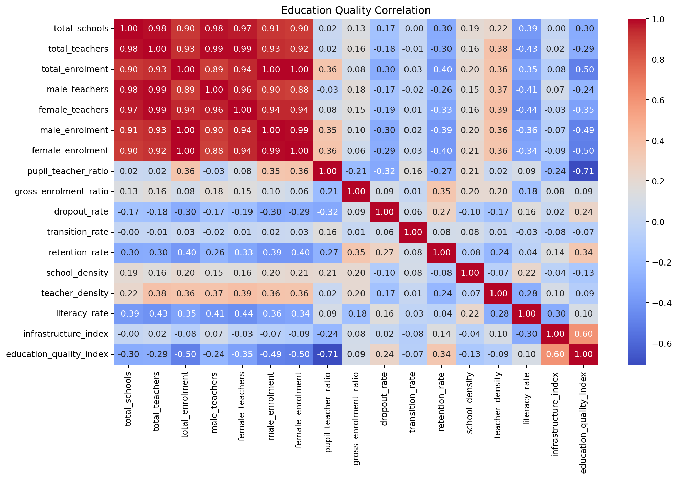
Figure 2. Analysis Visualization
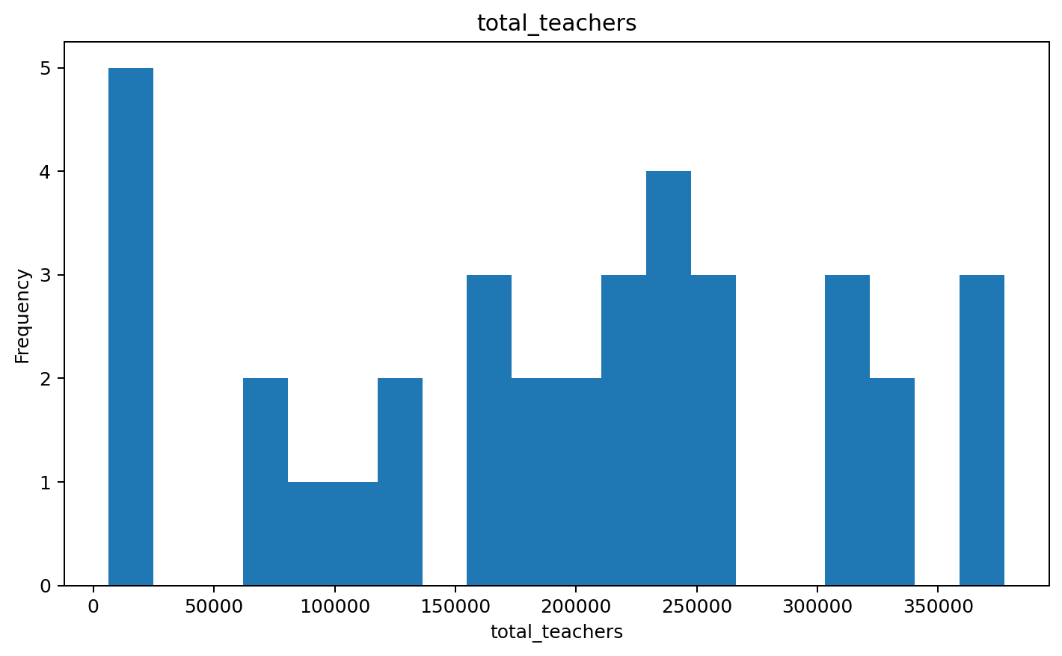
Figure 3. Analysis Visualization
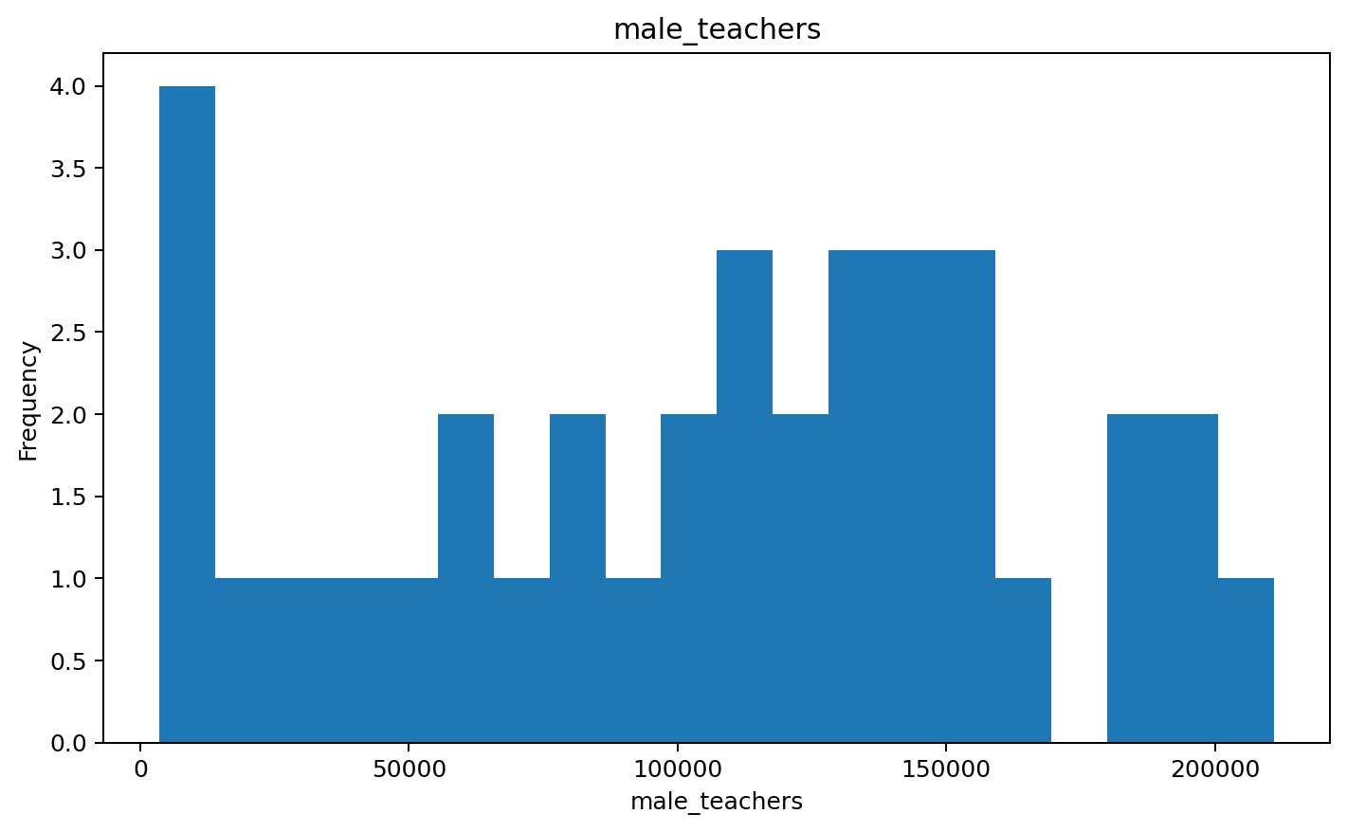
Figure 4. Analysis Visualization
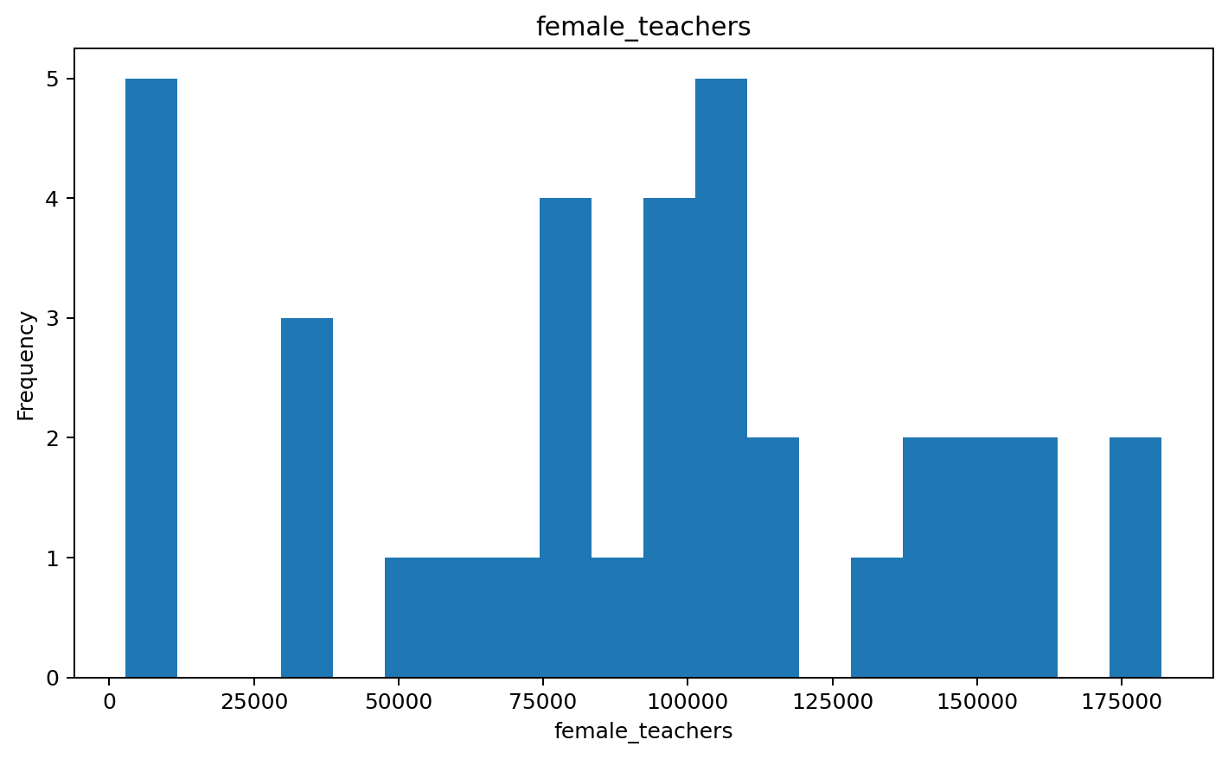
Figure 5. Analysis Visualization
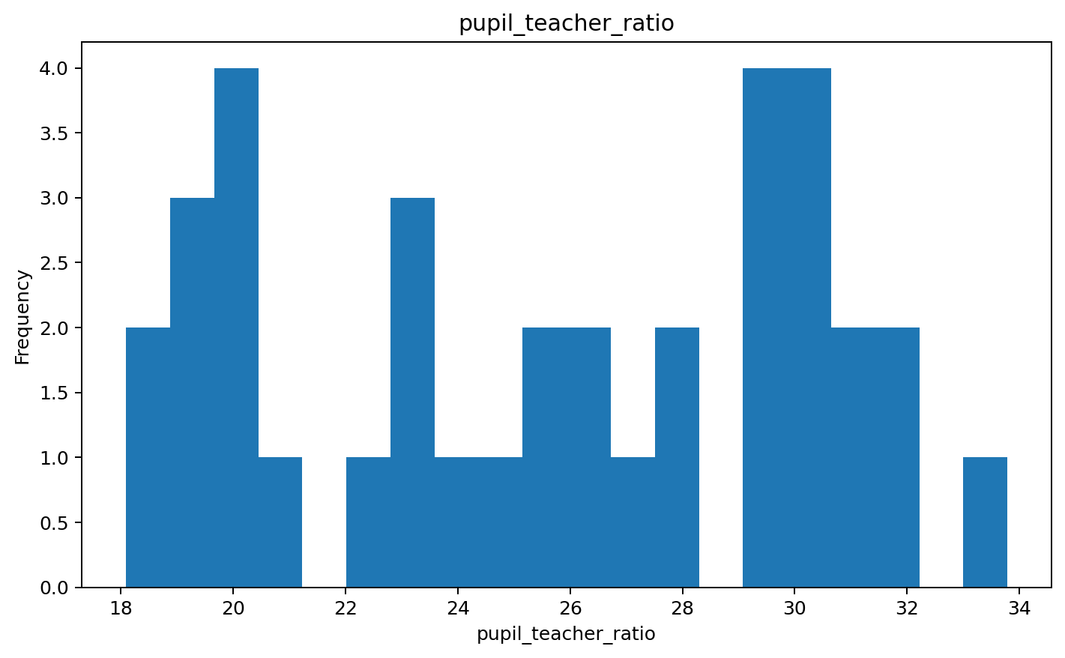
Figure 6. Analysis Visualization
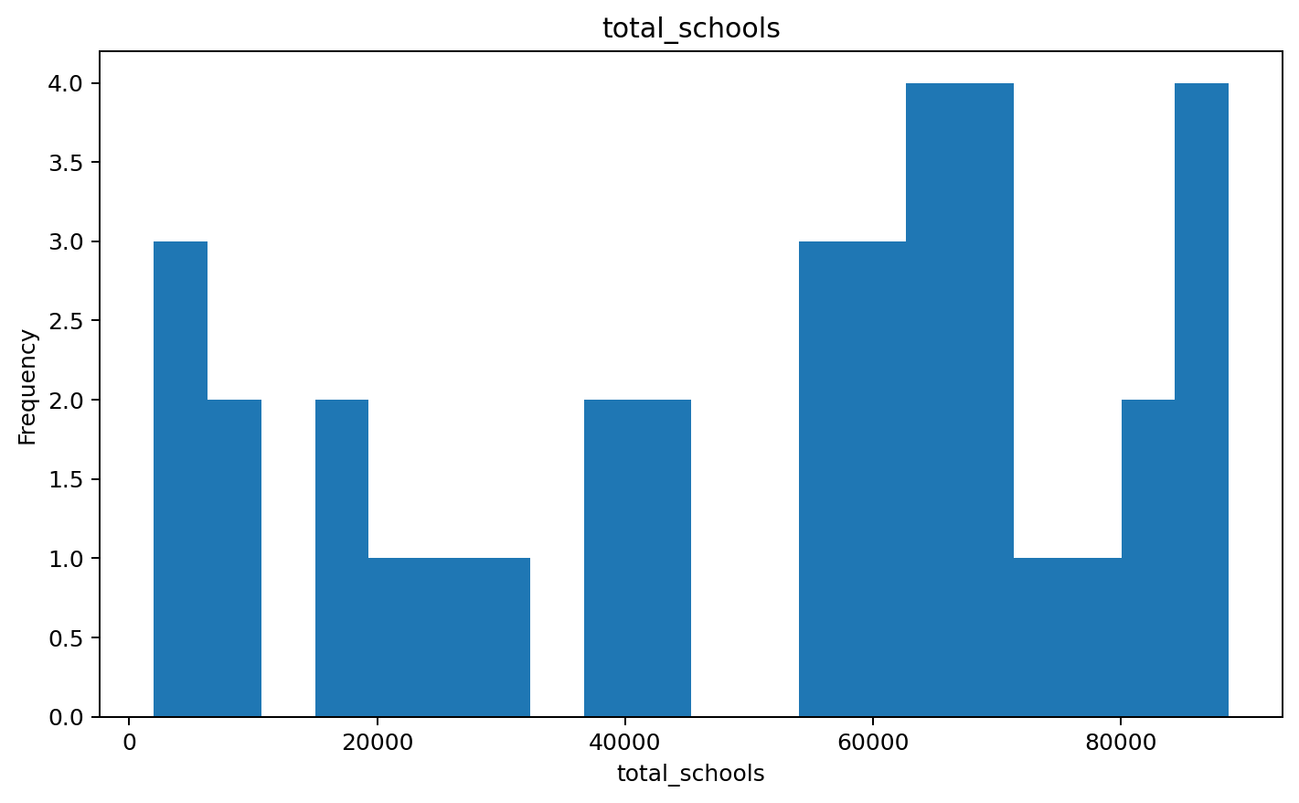
Figure 7. Analysis Visualization
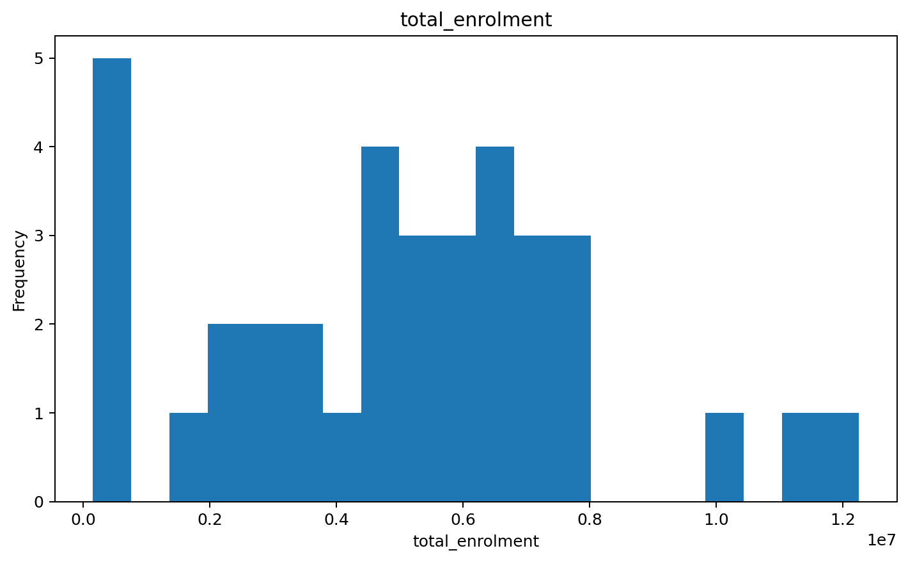
Figure 8. Analysis Visualization
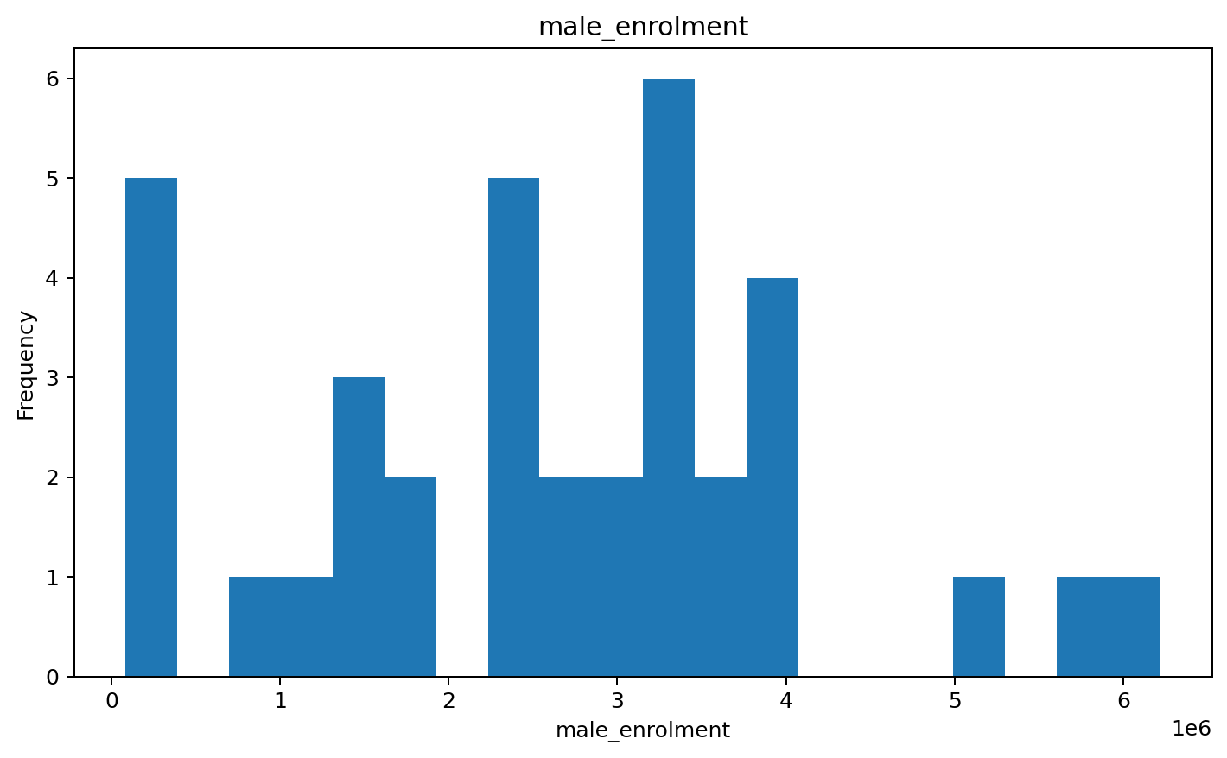
Figure 9. Analysis Visualization
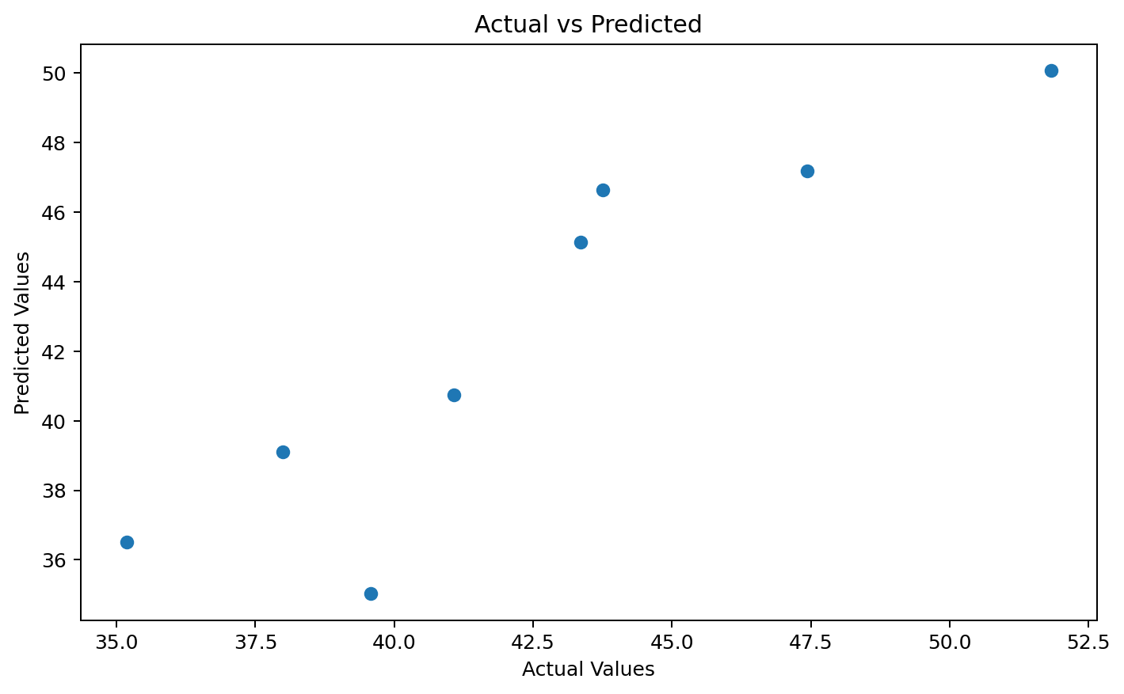

What We Observed from the Output
- The analysis covers 36 state/UT records with 18 variables related to elementary education.
- The pupil-teacher ratio has a strong negative relationship with the Education Quality Index, indicating that a larger number of pupils per teacher is associated with lower education-quality values in the example data.
- Infrastructure Index has a positive relationship with Education Quality Index, suggesting that stronger educational infrastructure is associated with better quality outcomes.
- Total schools and total teachers have a very strong positive correlation. This is expected because larger school systems generally require more teachers.
- The regression model provides substantial explanatory power for the Education Quality Index, with an R² of about 0.806 in the executed example.
- The Pearson correlation test between total schools and total teachers is statistically significant, so the null hypothesis of no linear relationship is rejected.
- The t-test is also statistically significant, showing a difference in teacher counts between the two groups formed using the median number of schools.
- The strongest raw correlations occur among total enrolment, male enrolment, female enrolment, and teacher totals because these variables are directly related to their corresponding totals.
- The histograms show considerable variation between states/UTs in school, teacher, enrolment and pupil-teacher measures.
- The actual-versus-predicted plot indicates that the regression model produces reasonably close predictions for the test observations.
- Because the dataset represents a single period, these results describe relationships and differences rather than proving a time-based decline in Indian education. A true decline analysis would require comparable data across multiple years.

Conclusion
The analysis indicates that teacher availability, pupil-teacher ratio, infrastructure and other educational indicators are associated with differences in education quality across the states and union territories represented in the dataset. The results provide a useful statistical overview, but a claim of educational decline over time should be supported by multi-year data and trend analysis.

