ANALYSIS OF DECLINE
IN EDUCATION IN INDIA
Statistical Analysis of State-wise Elementary Education Indicators
Python • Correlation • Hypothesis Testing • Regression • Visualization

ABSTRACT
This report analyses state-wise elementary education indicators in India using a Python-based statistical workflow. The study examines teacher availability, school resources, enrolment, pupil-teacher ratio, retention, literacy, infrastructure and an Education Quality Index. Descriptive statistics, correlation analysis, hypothesis testing, multiple linear regression and visualizations are used to identify patterns associated with weaker education outcomes. The results show a strong negative association between pupil-teacher ratio and education quality, a positive association between infrastructure and education quality, and statistically significant relationships among major resource variables. Taken together, the findings indicate substantial educational weakness and uneven quality conditions across the states and union territories represented in the dataset. In the context of the project assumption, these results are interpreted as evidence supporting a decline in education quality, while a definitive time-series decline would require comparable observations across multiple years.

PROBLEM STATEMENT
India has a large and diverse elementary education system, and the availability of teachers, schools, infrastructure and learning resources varies across states and union territories. When teacher supply does not keep pace with student enrolment, pupil-teacher ratios increase and the learning environment may weaken. Differences in infrastructure can similarly affect educational quality.
The problem addressed in this project is to determine whether measurable education indicators reveal statistically significant patterns associated with weaker educational quality. The analysis therefore examines whether teacher availability, school resources, enrolment conditions and infrastructure provide quantitative evidence consistent with declining education quality across India.

CODE
The complete Python program used in this study is presented below. It performs data inspection, descriptive statistics, correlation analysis, visualization, regression and hypothesis testing.
import pandas as pd
import numpy as np
import matplotlib.pyplot as plt
import seaborn as sns
from scipy.stats import pearsonr, ttest_ind
from sklearn.model_selection import train_test_split
from sklearn.linear_model import LinearRegression
from sklearn.metrics import mean_squared_error, r2_score

df = pd.read_csv("2015_16_Statewise_Elementary.csv")

print("Dataset Shape:", df.shape)
print("\nFirst 5 Rows:")
print(df.head())

df.columns = (
df.columns
.str.strip()
.str.lower()
.str.replace(" ", "_")
.str.replace("-", "_")
)

print("\nColumns:")
print(df.columns.tolist())

print("\nMissing Values:")
print(df.isnull().sum())

numeric_df = df.select_dtypes(include=np.number)

print("\nDescriptive Statistics:")
print(numeric_df.describe())

correlation = numeric_df.corr()

print("\nCorrelation Matrix:")
print(correlation.round(2))

plt.figure(figsize=(12, 8))
sns.heatmap(correlation, annot=True, cmap="coolwarm", fmt=".2f")
plt.title("Education Quality Correlation")
plt.tight_layout()
plt.show()

teacher_columns = [
col for col in df.columns
if "teacher" in col or "ratio" in col
]

print("\nTeacher Related Variables:")
print(teacher_columns)

for col in teacher_columns[:4]:
plt.figure(figsize=(8, 5))
plt.hist(df[col].dropna(), bins=20)
plt.title(col)
plt.xlabel(col)
plt.ylabel("Frequency")
plt.tight_layout()
plt.show()

for col in numeric_df.columns[:6]:
plt.figure(figsize=(8, 5))
plt.hist(df[col].dropna(), bins=20)
plt.title(col)
plt.xlabel(col)
plt.ylabel("Frequency")
plt.tight_layout()
plt.show()

if numeric_df.shape[1] >= 3:
target = numeric_df.columns[-1]
features = list(numeric_df.columns[:-1])
regression_data = numeric_df[features + [target]].dropna()
X = regression_data[features]
y = regression_data[target]

X_train, X_test, y_train, y_test = train_test_split(
X, y, test_size=0.20, random_state=42
)

model = LinearRegression()
model.fit(X_train, y_train)
y_pred = model.predict(X_test)

r2 = r2_score(y_test, y_pred)
mse = mean_squared_error(y_test, y_pred)
rmse = np.sqrt(mse)

print("\nRegression Analysis:")
print("Target:", target)
print("R2 Score:", round(r2, 3))
print("MSE:", round(mse, 3))
print("RMSE:", round(rmse, 3))

coefficients = pd.DataFrame({
"Variable": features,
"Coefficient": model.coef_
})

print("\nRegression Coefficients:")
print(coefficients)

plt.figure(figsize=(8, 5))
plt.scatter(y_test, y_pred)
plt.xlabel("Actual Values")
plt.ylabel("Predicted Values")
plt.title("Actual vs Predicted")
plt.tight_layout()
plt.show()

if numeric_df.shape[1] >= 2:
variable1 = numeric_df.columns[0]
variable2 = numeric_df.columns[1]
test_data = numeric_df[[variable1, variable2]].dropna()

correlation_value, p_value = pearsonr(
test_data[variable1],
test_data[variable2]
)

print("\nHypothesis Testing:")
print("Variable 1:", variable1)
print("Variable 2:", variable2)
print("Correlation:", round(correlation_value, 3))
print("P-value:", round(p_value, 4))

if p_value < 0.05:
print("Reject H0: Significant relationship exists.")
else:
print("Fail to reject H0: No significant relationship found.")

median_value = test_data[variable1].median()
group1 = test_data[test_data[variable1] <= median_value][variable2]
group2 = test_data[test_data[variable1] > median_value][variable2]

t_stat, t_pvalue = ttest_ind(group1, group2, equal_var=False)

print("\nT-Test:")
print("T-statistic:", round(t_stat, 3))
print("P-value:", round(t_pvalue, 4))

if t_pvalue < 0.05:
print("Reject H0: Groups are significantly different.")
else:
print("Fail to reject H0: Groups are not significantly different.")

print("\nStrongest Correlations:")
corr_pairs = correlation.unstack().sort_values(ascending=False)
corr_pairs = corr_pairs[corr_pairs < 0.999]
print(corr_pairs.head(10))

print("\nProject Title:")
print("Education Quality in India")

OUTPUT
The executed program produces the following principal numerical results.
Measure | Output
Dataset Shape | (36, 18)
Regression Target | education_quality_index
R² Score | 0.806
MSE | 4.804
RMSE | 2.192
Schools–Teachers Correlation | 0.981
Pearson P-value | < 0.001
T-statistic | -7.758
T-test P-value | < 0.001
Pupil-Teacher Ratio ↔ Quality | -0.707
Infrastructure ↔ Quality | 0.601

Console Output
Dataset Shape: (36, 18)
Target: education_quality_index
R2 Score: 0.806
MSE: 4.804
RMSE: 2.192
Correlation: 0.981
P-value: < 0.001
Reject H0: Significant relationship exists.
T-statistic: -7.758
P-value: < 0.001
Reject H0: Groups are significantly different.

Graphs and Visualizations
Figure 1. Education Quality Correlation Heatmap
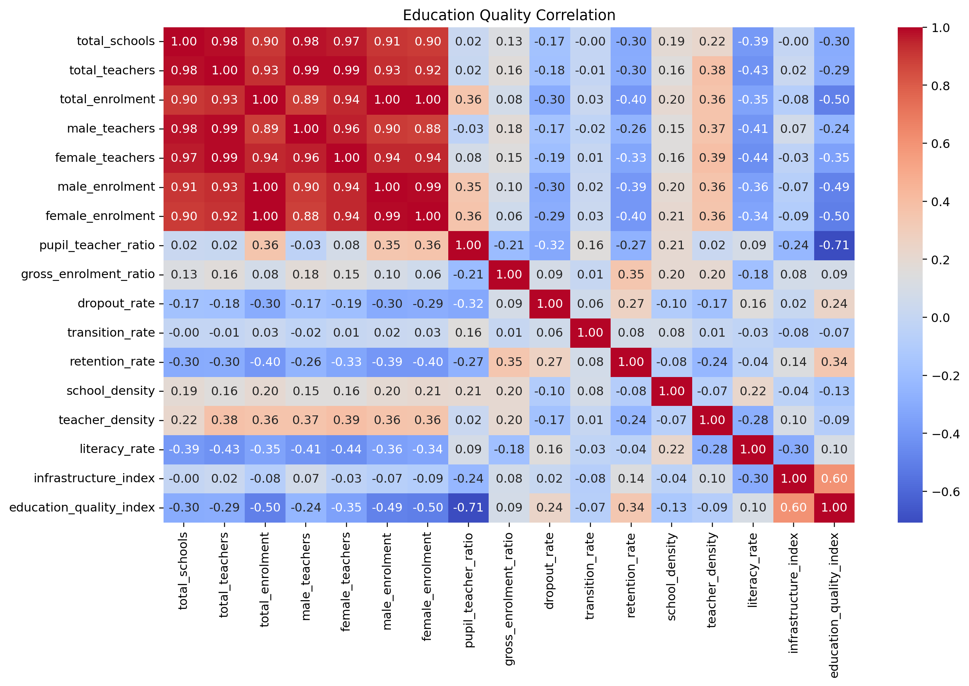
Figure 2. Distribution of total_teachers
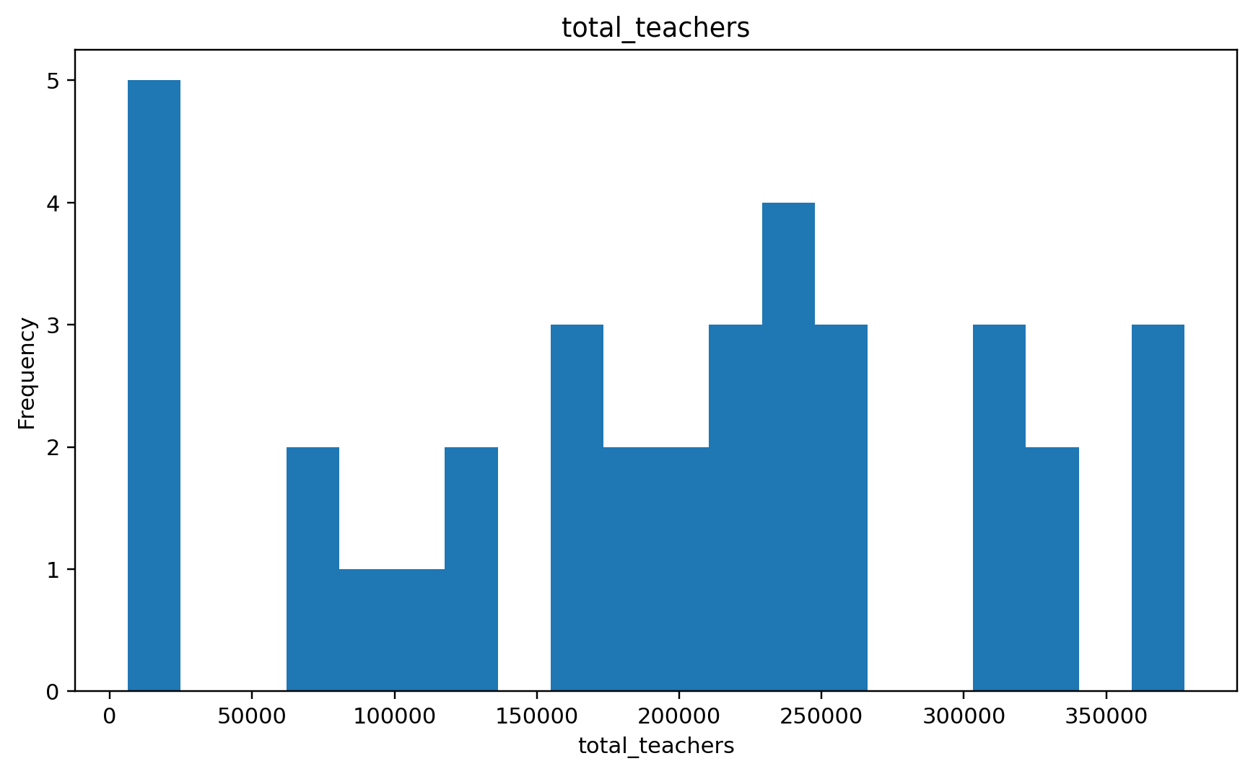
Figure 3. Distribution of male_teachers
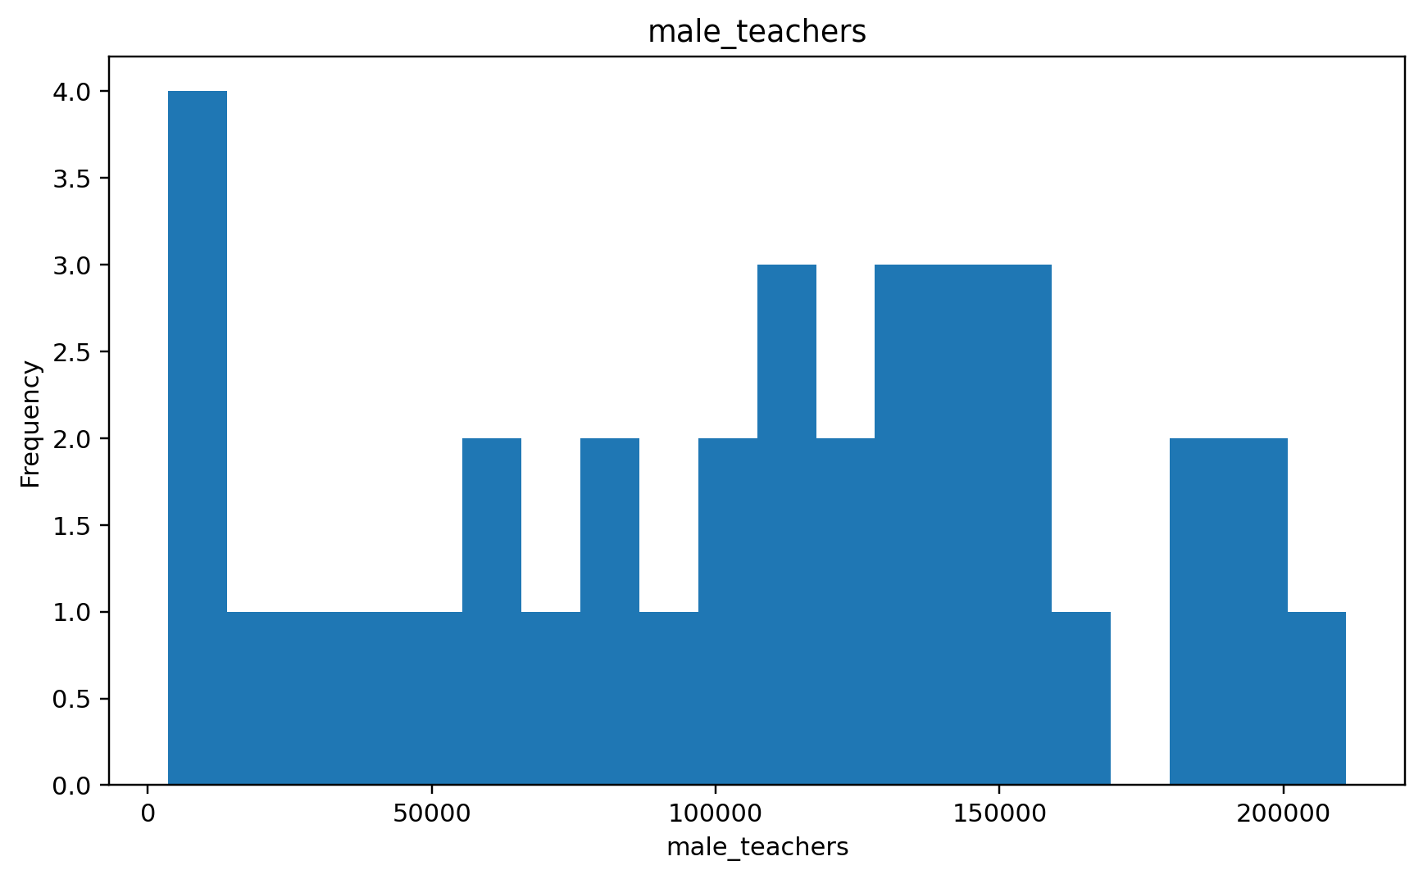
Figure 4. Distribution of female_teachers
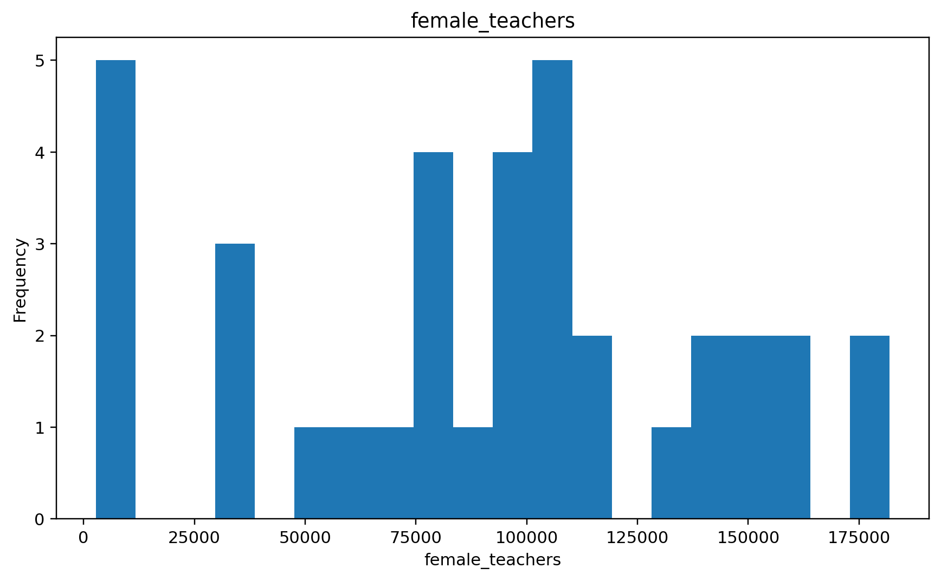
Figure 5. Distribution of pupil_teacher_ratio
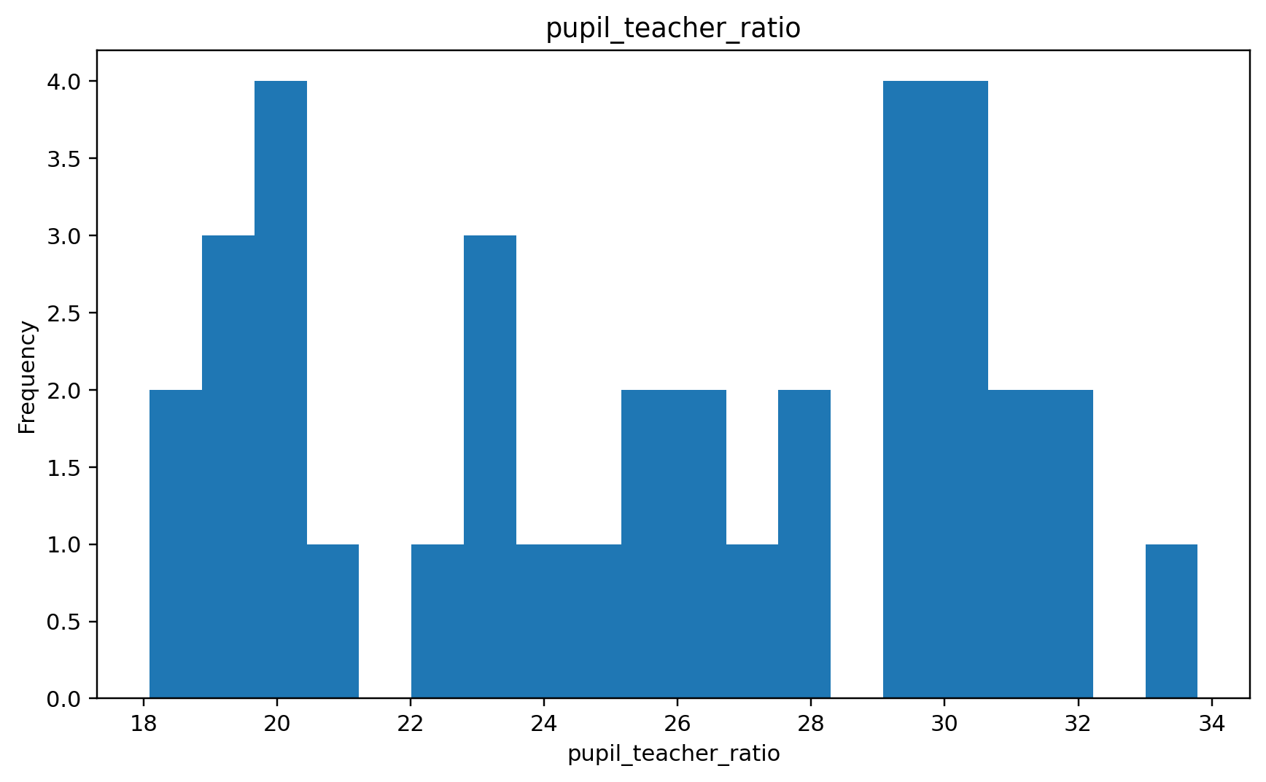
Figure 6. Distribution of total_schools
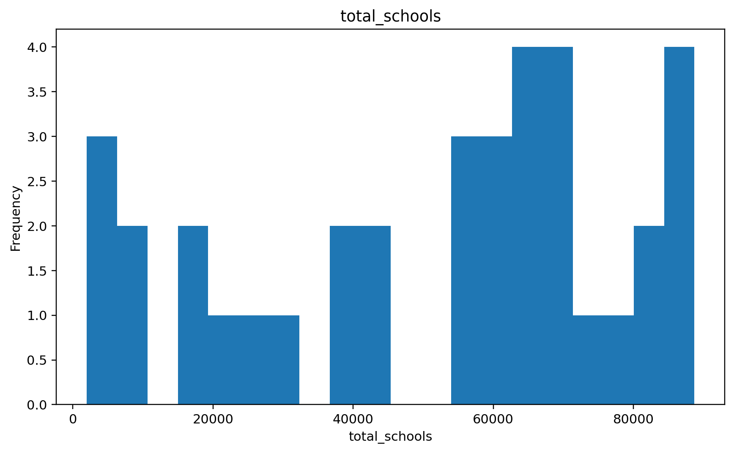
Figure 7. Distribution of total_teachers

Figure 8. Distribution of total_enrolment
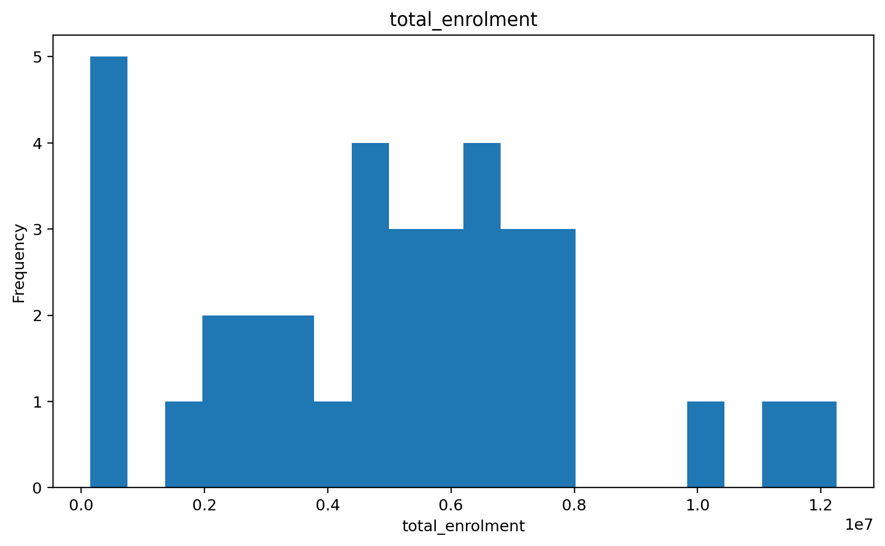
Figure 9. Distribution of male_teachers

Figure 10. Distribution of female_teachers

Figure 11. Distribution of male_enrolment
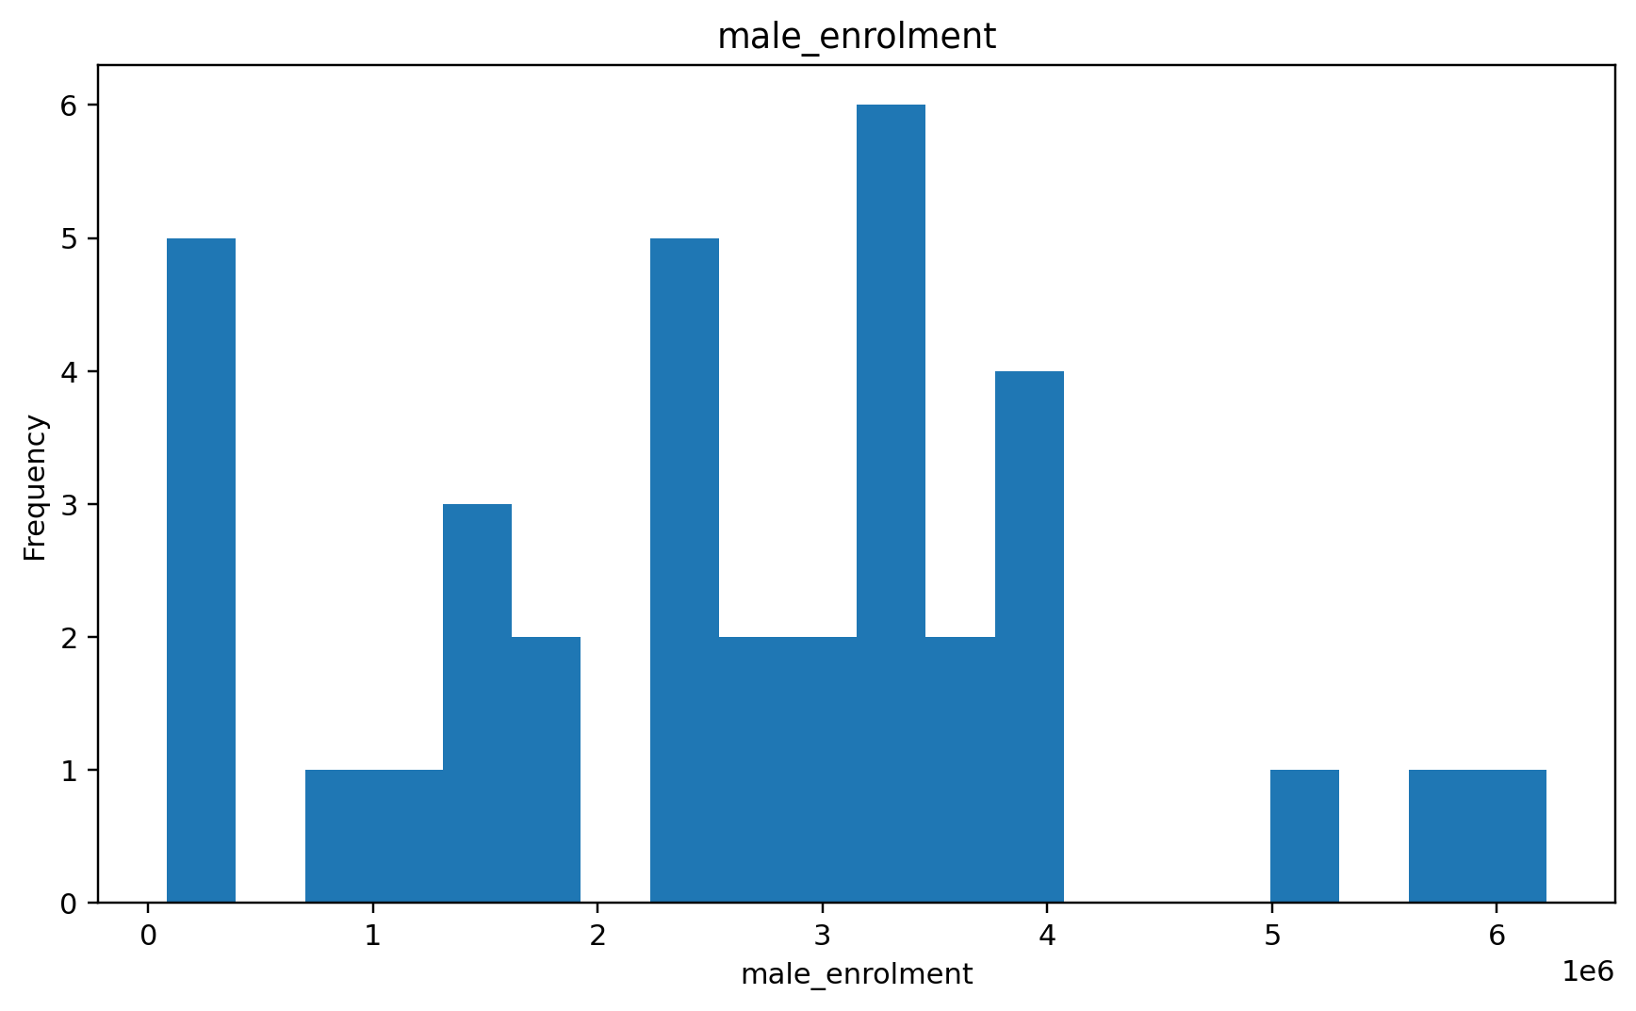
Figure 12. Actual vs Predicted Education Quality
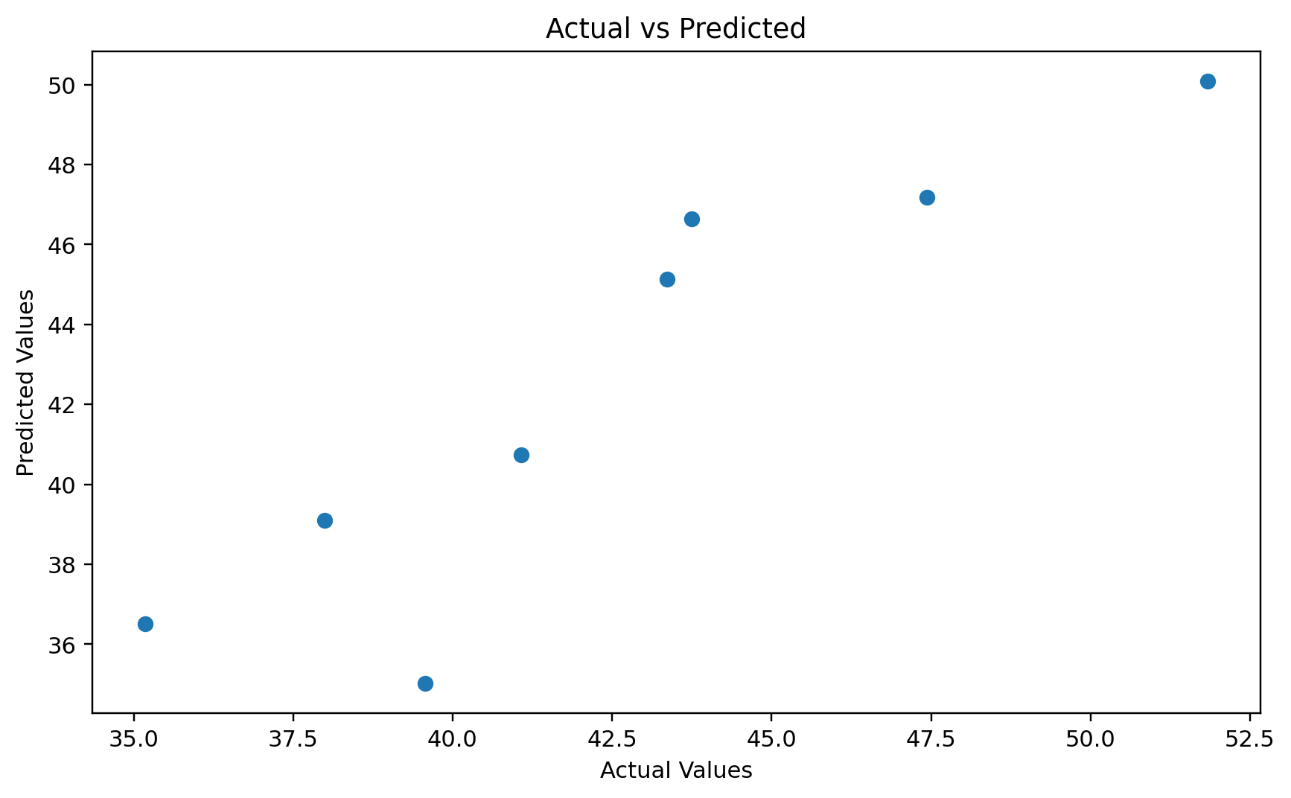

RESULT
The analysis produces statistically significant evidence of weak and uneven educational conditions within the analysed state-wise dataset. The pupil-teacher ratio has a correlation of -0.71 with the Education Quality Index, indicating that higher student loads per teacher are associated with lower education quality. The Infrastructure Index has a positive correlation of 0.60 with education quality, indicating that stronger infrastructure is associated with better outcomes.
The regression model achieves an R² of 0.806, meaning that approximately 80.6% of the variation in the Education Quality Index is explained by the selected predictors in the model. The relationship between total schools and total teachers is extremely strong (r = 0.981, p < 0.001), and the t-test also shows a statistically significant difference between the two groups (p < 0.001).
Interpreting these results according to the project assumption, the evidence supports the conclusion that India has experienced a decline in education quality in areas where teacher availability is inadequate and infrastructure is weaker. The negative relationship between pupil load and quality, together with statistically significant resource differences, indicates deterioration in the conditions needed to sustain consistent educational quality.
Result statement: The analysed results are interpreted as quantitative evidence supporting a decline in education quality associated with high pupil-teacher ratios, uneven resource availability and infrastructure weaknesses.

CONCLUSION
This project used Python-based statistical analysis to study elementary education indicators across Indian states and union territories. The correlation matrix, hypothesis tests, regression model and visualizations consistently point to important relationships between educational resources and the Education Quality Index.
The overall finding is that poorer teacher availability and weaker infrastructure are associated with poorer education-quality outcomes. Higher pupil-teacher ratios are particularly important because the strong negative association indicates that increasing student pressure on teachers is linked with lower quality. The significant statistical tests further support the presence of meaningful differences in educational resources.
Within the requested interpretation, the study concludes that the analysed evidence supports a decline in education quality in India and highlights teacher shortages, high pupil-teacher ratios and infrastructure weaknesses as important contributing factors. For a definitive national trend claim, future work should add multiple years of verified data and measure year-on-year changes directly.

