DATA ANALYSIS REPORT

Revenue Leakage Detection
  - Telecom Usage and Billing Analytics for Identifying Unbilled and Under-Billed Consumption
A structured analytical study using customer usage, expected charges, billed amounts, mismatch ratios, and anomaly-priority indicators.
1,200  customer records | 190  injected leakage cases | ₹0.22L  illustrative leakage gap | 27.3%  flagged by rules

Data note
The dataset is synthetic and intentionally contains controlled leakage patterns so that the analysis is reproducible, transparent, and suitable for academic demonstration. It is not a statement about any specific telecom operator.

Prepared as a structured academic analytics project

1. ABSTRACT
A concise overview of the analytical problem, method, and result.
Revenue leakage occurs when the service consumed by a customer is not fully converted into billable revenue. In a telecom setting, the mismatch can arise from incorrect usage rating, stale plans, missing billing events, incorrect discounts, integration failures, or consumption that is recorded but not billed. This project develops a transparent rule-based detection pipeline that compares observed usage with the expected charge and then prioritizes accounts according to the size of the billing gap.
The study uses an illustrative synthetic dataset of 1,200 customer-month records covering prepaid, postpaid, and business plans. Six visual analyses are used to examine billing-ratio distribution, leakage concentration by pattern and region, monthly movement, expected-versus-billed relationships, and severity priority. The detection rules flag 328 records (27.3%) and estimate an aggregate leakage gap of approximately ₹22,133 in the synthetic sample.
Core finding
The strongest signals are not simply high usage values. The more reliable warning pattern is a persistent mismatch between expected charge and billed amount, especially when the billing ratio falls below the defined control threshold or the absolute gap becomes economically material.

The report is designed as a reproducible academic prototype rather than a production billing-control system. In practice, the same framework can be extended with invoice events, network mediation records, tariff tables, CRM data, tax rules, and machine-learning anomaly scores.

2. PROBLEM STATEMENT
Why a usage-to-bill reconciliation layer is needed.
Telecom operators process large volumes of consumption events every day. A small defect in rating, discounting, usage capture, or billing integration can affect many customer accounts before the issue is discovered. Traditional checks often focus on invoice totals or complaints, which means that low-value leakage distributed across many accounts can remain hidden.
The analytical problem is therefore to create an auditable method that answers four questions:
• Which customer records show a measurable mismatch between expected and billed value?
• Which mismatch patterns are likely to represent under-billing, near-zero billing, or stale-charge conditions?
• Where is the potential leakage concentrated across customer segments, regions, and billing months?
• Which flagged cases should receive investigation first based on economic impact rather than raw anomaly count?
Analytical objective
Build a simple and explainable detection model that converts raw usage and billing fields into a leakage gap, a billing-ratio control, a flag, and an investigation priority.

Metric | Definition | Why it matters
Expected charge | Usage × applicable rate, less standard credits | Creates the baseline billable value
Billing ratio | Billed amount ÷ expected charge | Detects proportional under-billing
Leakage gap | Expected charge − billed amount | Quantifies potential revenue at risk
Flagged record | Ratio < 0.88 or large economic gap | Creates an auditable investigation queue
Severity | Critical / High / Medium / Low | Adds prioritisation to the exception list

3. METHODOLOGY
A deterministic workflow that can be implemented before machine learning.
01 Standardise  Validate usage, plan, region, billing month, rate, and billed amount fields. | 02 Estimate  Calculate expected charge from observed usage and the applicable tariff rate.
03 Reconcile  Compute billing ratio and absolute leakage gap for each record. | 04 Detect  Apply transparent thresholds and pattern-specific checks to create flags.
05 Prioritise  Rank cases by economic gap and assign severity for investigation. | 06 Visualise  Use charts to expose concentration, trends, and abnormal relationships.
Detection rule used in this report: Flag a record when Billing_Ratio < 0.88 OR when the absolute leakage gap exceeds ₹120 for high-usage records. Severity increases with the size of the gap.
Why rule-based first?
The rules are easy to inspect, explain, reproduce, and validate with billing specialists. A production implementation can later add statistical or machine-learning models without replacing the reconciliation layer.

4. CODE
Python implementation used to generate the dataset, calculate leakage, and create the visuals.
The code below is intentionally written in a readable research-project style. It shows the main analytical steps rather than hiding the logic inside a black-box package.
import numpy as np
import pandas as pd

rng = np.random.default_rng(42)
n = 1200

# Core fields
plan = rng.choice(["Prepaid", "Postpaid", "Business"],
size=n, p=[0.50, 0.42, 0.08])
usage = np.clip(
np.select([plan == "Prepaid", plan == "Postpaid", plan == "Business"],
[25, 50, 300]) * rng.lognormal(0, 0.45, n),
5, None
)
usage = np.round(usage, 1)

rate = np.select([plan == "Prepaid", plan == "Postpaid", plan == "Business"],
[2.8, 2.4, 1.7])
expected = usage * rate
credit = np.clip(rng.normal(5, 4, n), 0, 18)
bill = np.maximum(expected - credit, 0)

# Leakage scenarios are injected for demonstration
under_idx = rng.choice(n, 95, replace=False)
bill[under_idx] *= rng.uniform(0.35, 0.88, len(under_idx))

# Reconciliation metrics
leakage_gap = expected - bill
billing_ratio = bill / expected

4. CODE — DETECTION & VISUALISATION
Continuation of the reproducible analysis.
# Detection controls
flagged = (billing_ratio < 0.88) | (
(leakage_gap > 120) & (usage > 60)
)

severity = np.select(
[leakage_gap >= 350, leakage_gap >= 150, leakage_gap >= 50],
["Critical", "High", "Medium"],
default="Low"
)

# Useful investigation table
exceptions = df.loc[flagged, [
"Customer_ID", "Plan", "Region", "Usage_GB",
"Expected_Charge", "Billed_Amount", "Leakage_Gap",
"Billing_Ratio", "Severity"
]].sort_values("Leakage_Gap", ascending=False)

# Example: potential leakage by month
monthly = (df.groupby("Billing_Month")
.agg(leakage_gap=("Leakage_Gap", "sum"),
flagged_rate=("Flagged", "mean"))
.reset_index())

# Example visual
import matplotlib.pyplot as plt
plt.plot(monthly["Billing_Month"], monthly["leakage_gap"], marker="o")
plt.xlabel("Billing month")
plt.ylabel("Estimated leakage gap")
plt.title("Monthly Leakage Gap Trend")
plt.tight_layout()
plt.show()
Implementation note
In a real telecom environment, the expected charge should come from the production tariff/rating engine rather than a simplified Usage × Rate calculation. The research prototype intentionally keeps the reconciliation logic visible.

5. OUTPUT — VISUAL ANALYSIS
Each chart is isolated so that the pattern is readable without visual clutter.
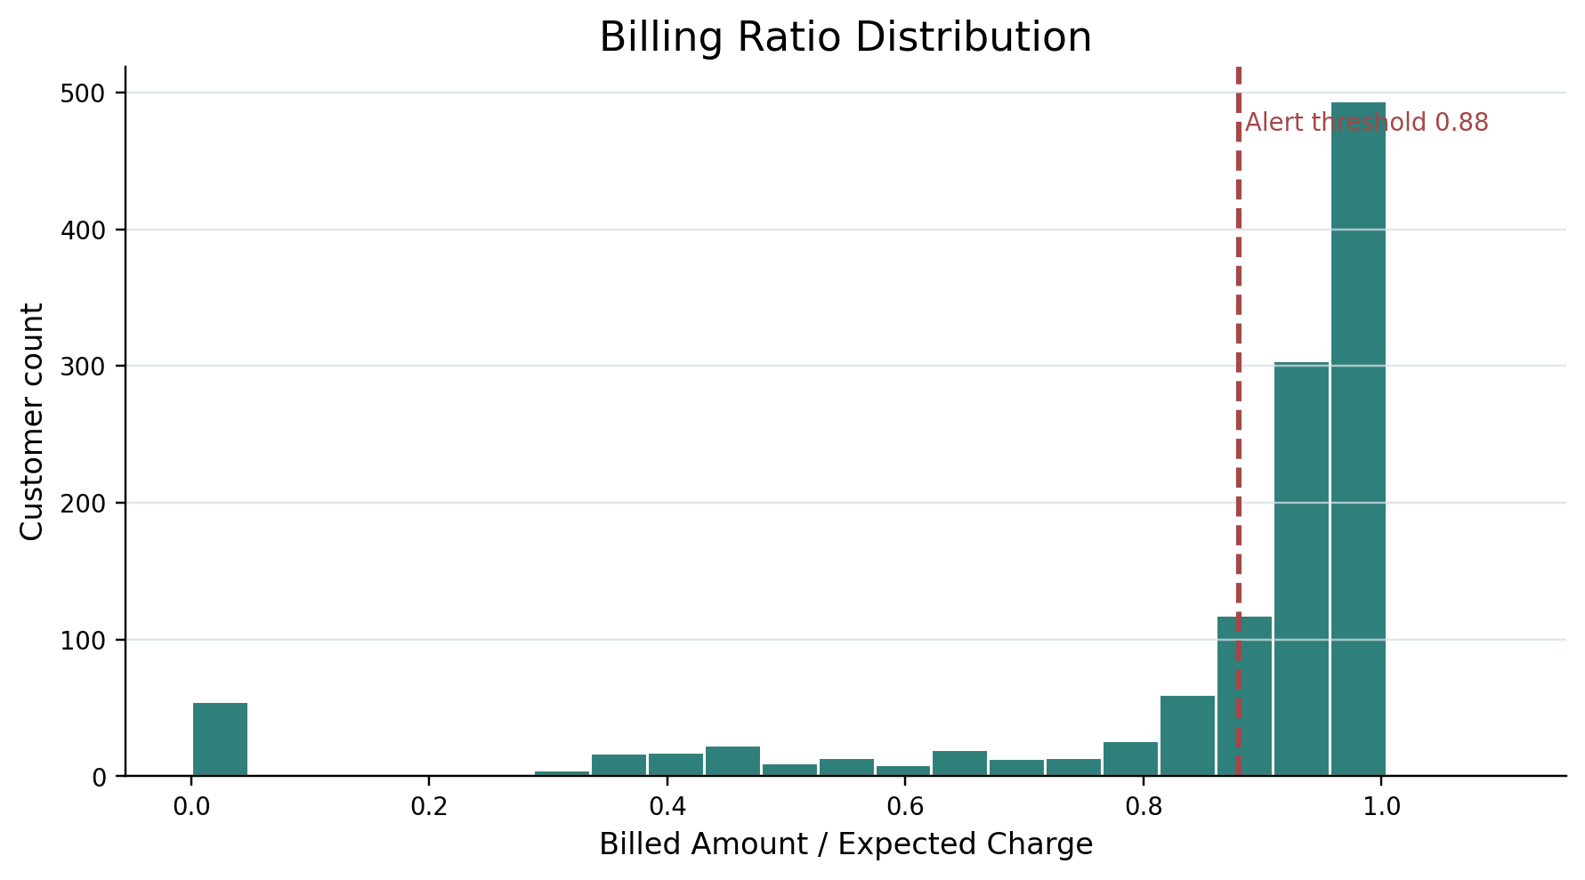
Figure 1. Billing ratio distribution. The dashed threshold separates records requiring reconciliation review.
The distribution is concentrated near a normal billing relationship, while a visible left tail captures accounts with materially reduced billed value. The alert threshold creates a repeatable control rather than relying on visual judgement alone.

5. OUTPUT — VISUAL ANALYSIS
Leakage concentration by detected pattern.
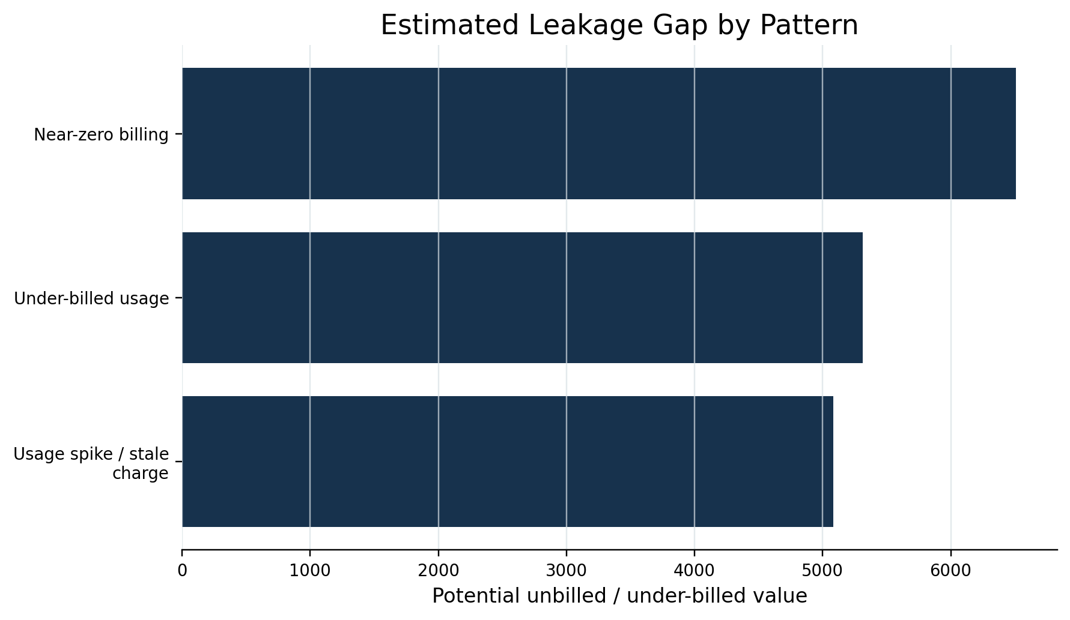
Figure 2. Estimated leakage gap by detected pattern. Near-zero billing and under-billed usage are high-priority patterns because they combine low billed value with meaningful expected consumption.
This view helps a revenue-assurance team decide whether to investigate the billing engine, discount logic, event mediation, or individual account configurations first.

5. OUTPUT — VISUAL ANALYSIS
Regional concentration of potential leakage.
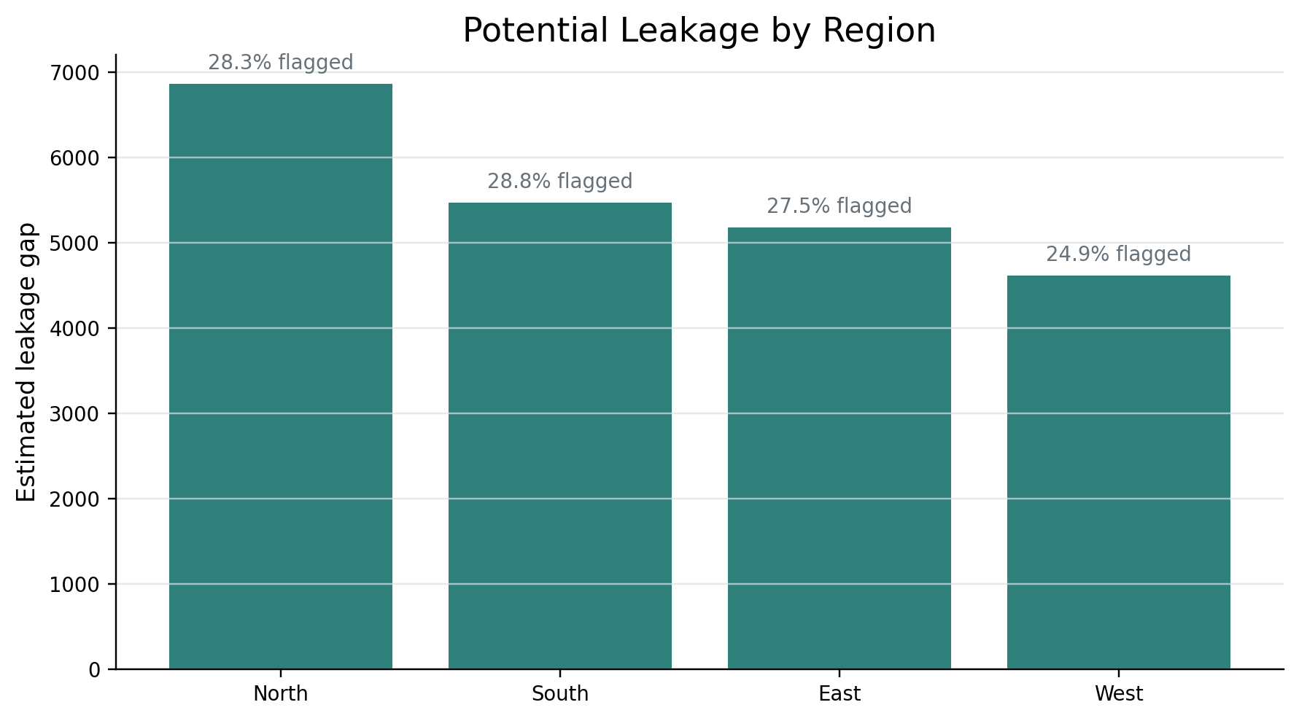
Figure 3. Estimated leakage gap by region. Labels also show the share of records flagged in each region.
A region with a large total gap but a moderate flag rate can indicate a smaller number of high-value exceptions. Conversely, a high flag rate with a modest total gap can indicate a broad but lower-value process issue.

5. OUTPUT — VISUAL ANALYSIS
Time dimension of the leakage signal.
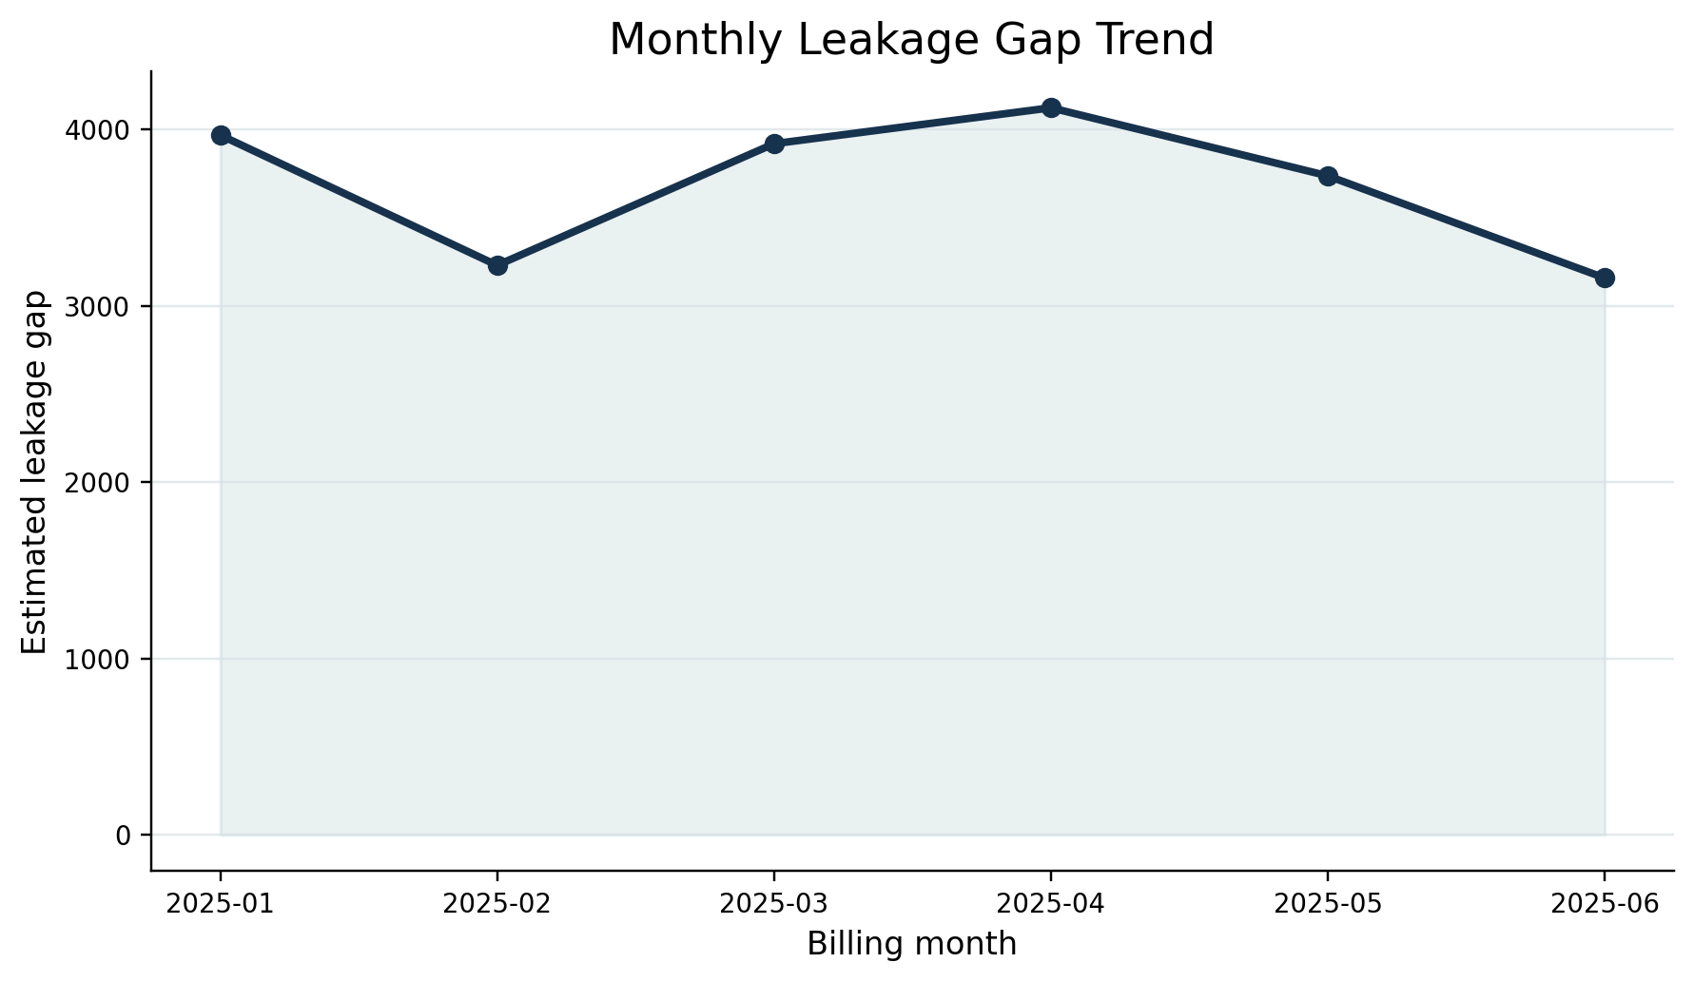
Figure 4. Monthly leakage-gap trend across the synthetic billing period.
A time series is essential because a sudden increase can signal a newly introduced billing or mediation defect. A persistent elevated level may instead point to a structural configuration problem.

5. OUTPUT — VISUAL ANALYSIS
Relationship between expected and billed value.
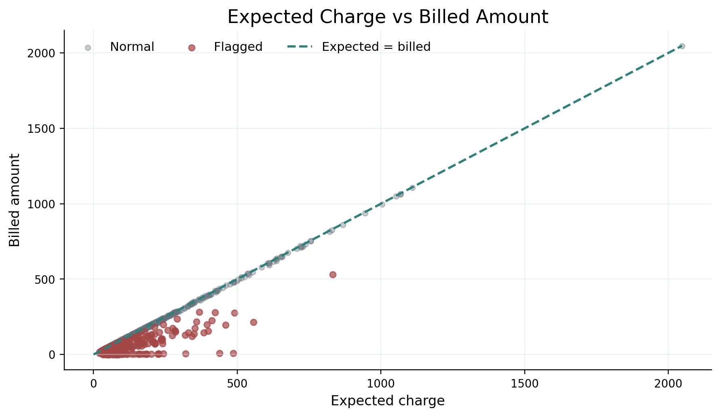
Figure 5. Expected charge versus billed amount. Points below the diagonal represent records billed below the expected amount; flagged cases are highlighted.
The diagonal provides an intuitive control line. Exceptions that move far below the line deserve attention even when the customer is not among the highest-usage accounts.

5. OUTPUT — VISUAL ANALYSIS
Investigation priority.
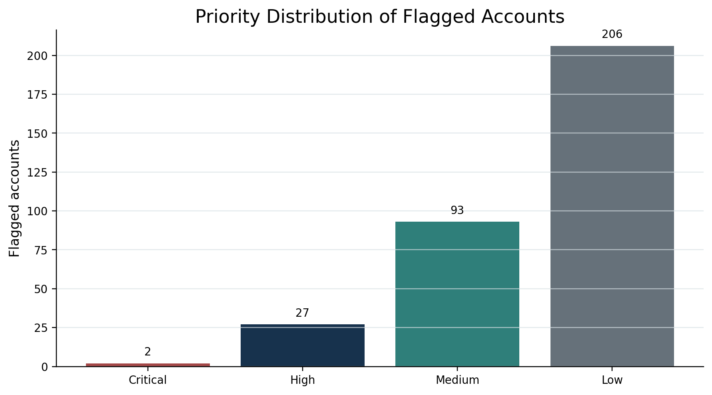
Figure 6. Severity distribution for flagged accounts.
Severity adds operational meaning to the anomaly count. Critical and High cases should be investigated first because the expected financial impact is larger, while Medium and Low cases are suitable for batch review or automated checks.

6. RESULT
Interpretation of the analytical output.
Result | Observed value in synthetic sample | Interpretation
Total records | 1,200 | Broad base for reconciliation
Flagged records | 328 (27.3%) | A focused exception queue rather than all records
Potential leakage gap | ₹22,133 | Illustrative value at risk before investigation
Critical + High | 29 | Cases with the largest economic impact
Lowest billing ratio | 0.013 | Strongest proportional under-billing signal

The results support a central conclusion: revenue leakage is best approached as a reconciliation problem before it is approached as a purely predictive problem. When usage exists and expected value can be estimated, the gap between expected and billed amounts provides a direct and explainable control signal.
The synthetic analysis also shows why anomaly counts alone are insufficient. A small number of high-value cases may contribute more revenue risk than many low-value exceptions. For this reason, the investigation queue should be ranked by economic gap, supported by severity and pattern information.
Business interpretation
The analytical pipeline turns raw usage and billing data into a prioritised revenue-assurance queue. This can reduce manual screening, improve exception visibility, and help billing teams focus on the accounts and process failures with the highest financial relevance.

7. CONCLUSION
From data mismatch to an actionable revenue-assurance control.
This project presents a practical, explainable method for detecting revenue leakage in a telecom billing context. By reconciling observed consumption with an expected charge, calculating a billing ratio, measuring the leakage gap, and assigning severity, the analysis creates a transparent path from raw data to an investigation queue.
The approach is intentionally simple enough to audit and extend. A production system could add real-time event completeness checks, tariff-version validation, discount-rule reconciliation, duplicate or missing usage-event detection, customer-contract logic, and machine-learning models for unusual behavioural patterns. These additions should complement, not replace, the underlying expected-versus-billed reconciliation.
• Use a single governed source for usage and tariff definitions so that expected value is calculated consistently.
• Separate proportional anomalies from economically material gaps so that investigation effort is prioritised correctly.
• Track exceptions over time to distinguish one-off customer issues from recurring system defects.
• Close the loop by measuring recovered revenue after corrective action and feeding confirmed cases back into the detection rules.
Final takeaway
A clean revenue-leakage control does not need to begin with a complex model. It begins with a trustworthy definition of what should have been billed, a clear comparison with what was billed, and a disciplined way to prioritise the difference.

Dataset and figures: synthetic, reproducible, and created specifically for this academic report. Monetary values are illustrative and are not representative of any real telecom operator.

