E-WALLET

Problem Statement

Objective
To create the e-wallet payment system for the xyz bank.

Abstract of the project
This project is aimed to be development of the-wallet system for a xyz bank. Here the customers will be able to park their money in e-wallet. This e-wallet application allows the customers to check the balance and also makes us to deposit, withdraw money from bank.

Software requirements:
- Operating system: Windows 7
- Programming language: Java

Functional components of the project
Following is a list of functionalities of the system.

Customer should be able to

  - Create an account
  - Show the balance
  - Deposit the amount
  - Withdraw the amount
  - Fund transfer
  - Print transactions

Layered architecture of the project
Following it list the layered architecture of the system
- com.ewallet.ui(USER INTEFACE LAYER)
- com.ewallet.bean(DTO LAYER)
- com.ewallet.dao(DAO LAYER)
- com.ewallet.service(SERVICE LAYER)
- com.ewallet.exception(EXCEPTION HANDLING LAYER)

CLASSES AND INTERFACE USED:

- DTO LAYER:

- PACKAGE : com.ewallet.bean
- CLASS NAME :CustomerDetails

CLASS DIAGRAM:

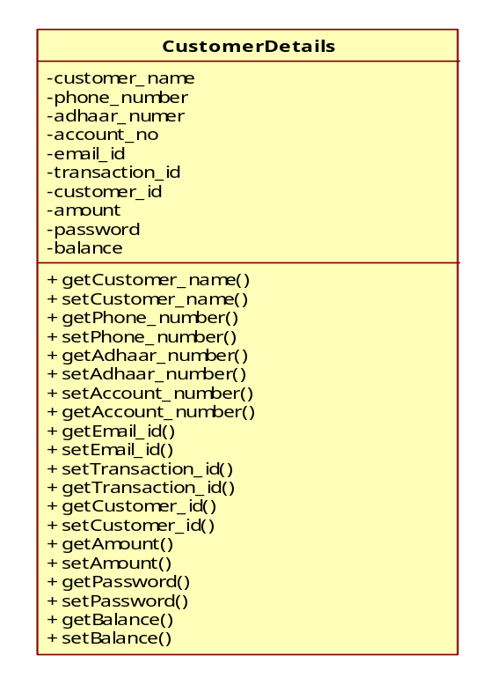
- USER INTERFACE LAYER

- This layer is a user interface layer, used for user interation.

- PACKAGE : com.ewallet.ui

- CLASSNAME : CustomerUI
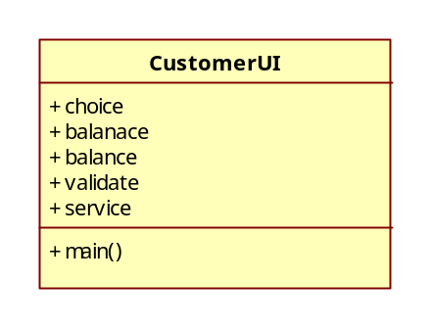
- DAO LAYER

- In DAO layer the e-wallet service logic is implemented.

- PACAKGE : com.ewallet.dao

- CLASSNAME : CustomerDao

- INTERFACENAME : ICustomerDao

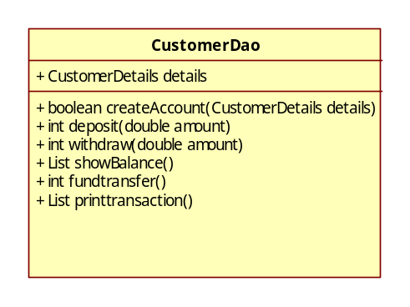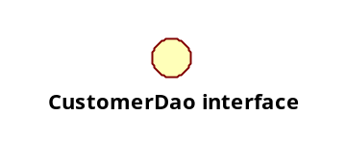
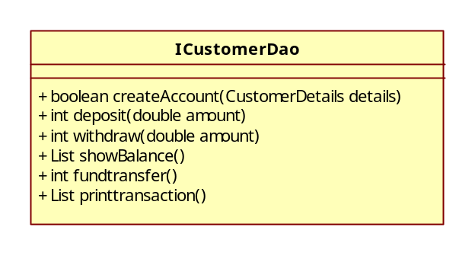

SERVICE LAYER

PACAKGE : com.ewallet.service

CLASSNAME : CustomerService

INTERFACENAME : ICustomerService

