Where Should This Kernel Run? A Leakage-Aware Re-evaluation of Transformer Models for CPU–GPU Device Mapping and a GraphCodeBERT–Random Forest Hybrid
Harikrishnan J
M.Tech. Artificial Intelligence and Machine Learning (Reg. No. 26MAI0060)
Vellore Institute of Technology, Vellore, Tamil Nadu, India
harikrishnan2004j@gmail.com
Guide: [Faculty name], [Department / School], Vellore Institute of Technology, Vellore, India

Abstract—Deciding whether an OpenCL kernel should run on the CPU or the GPU is a small decision with a large price: on the DevMap benchmark the better device is typically 2–3 times faster. A recent study reported 92.8% (AMD) and 89.1% (NVIDIA) accuracy for a fine-tuned CodeBERTa model on this task. We re-implemented that study and reproduced its numbers (92.1% and 88.8%), then asked how well the model does on programs it has never seen. Under the original random split, identical kernels and application-specific job sizes appear on both sides of the split; when whole applications are held out, CodeBERTa falls to 62.5% and 64.3%, close to always guessing the majority device. We evaluate GraphCodeBERT, which had not been used for device mapping before, and a hybrid that feeds frozen GraphCodeBERT embeddings, code counts and scale-free job ratios to a Random Forest. On unseen applications GraphCodeBERT beats CodeBERTa by 10 points on AMD, and the hybrid reaches 75.8% and 72.1%, with a statistically reliable gain over a feature-only Random Forest on NVIDIA. We also test seven alternative decision models, an end-to-end Transformer, a merged two-machine dataset, an open-source alternative to the closed Jev classifier, and a Gemini-based agent, and we show that one benchmark suite (77.5% of the rows) drives much of every reported score. The results argue for application-level evaluation and speed-based reporting in future device-mapping work.
Index Terms—heterogeneous computing, device mapping, OpenCL, GraphCodeBERT, code language models, random forest, data leakage, evaluation methodology.

I. Introduction
Almost every computer sold today is heterogeneous. Laptops pair a CPU with an integrated or discrete GPU, phones add neural engines, and 276 of the 500 fastest supercomputers in June 2026 used accelerators [23]. Having several kinds of processor only pays off when each piece of work goes to the one that runs it best. For a data-parallel OpenCL kernel the choice is usually between the host CPU and a GPU, and it is not obvious: the GPU has far more arithmetic throughput, but every launch pays for copying data across the bus, and small or irregular jobs are often faster on the CPU.
Programmers rarely have the time to benchmark each kernel on each device, so the decision is a natural target for machine learning. Grewe et al. [3] trained a decision tree on hand-picked code and runtime features. Cummins et al. [2] replaced the features with an LSTM over source tokens (DeepTune) and released the DevMap dataset that most later work uses. Graph neural networks over compiler IR [4]–[8] and, most recently, pretrained Transformer models of source code [1], [11] followed. Our base paper, by Siino et al. [1], fine-tuned CodeBERTa and several other Transformers on DevMap and reported 92.8% accuracy on the AMD platform and 89.1% on the NVIDIA one.
We started this project by re-implementing that study, and we could reproduce it. While doing so we noticed that the random five-fold split puts copies of the same kernel, run at different input sizes, into both the training and the test folds, and that the two job numbers given to the model (bytes transferred and work-group size) are almost unique to each application. A model can therefore score well by recognising the application rather than by understanding the code. This paper reports what happens when that shortcut is removed, and what actually helps once it is.
Our contributions are:
- A leakage audit of the base paper. We reproduce its results (92.1%/88.8% against the published 92.8%/89.1%) and show that accuracy drops to 61–78% for every model once whole applications are held out.
- The first use of GraphCodeBERT for device mapping, fine-tuned and as a frozen encoder. It improves on CodeBERTa by 10 points on AMD for unseen applications.
- A hybrid model (frozen GraphCodeBERT, code counts and scale-free ratios, decided by a Random Forest) that is the most accurate model on NVIDIA, with a reliable +4.1-point gain over a feature-only forest.
- A broad set of controlled comparisons answering questions raised during our project reviews: seven other decision models, an end-to-end Transformer with a numeric branch, a merged AMD+NVIDIA dataset, an open-source alternative to the Jev decision model, and a large language model (LLM) agent.
- A dataset analysis showing that the NPB suite contributes 77.5% of the rows and is one of only two suites that run kernels at several input sizes, and that accuracy gains on NVIDIA do not turn into faster execution.

II. Problem Substantiation
Three trends make the device decision more important than it was when DevMap was collected.
Accelerators are now the norm. In the June 2026 TOP500 list, 276 systems use accelerators or co-processors, up from 255 six months earlier [23]. NVIDIA reported US$193.7 billion of data-centre revenue in fiscal 2026, 68% more than the year before [25], and Gartner forecasts that AI PCs will make up 54.7% of PC shipments in 2026 [26]. Code that once ran on a single CPU now has a choice of devices almost everywhere.
Energy is a constraint. Data centres used about 415 TWh in 2024, roughly 1.5% of the world's electricity, and the International Energy Agency projects about 945 TWh by 2030 [24]. Running a kernel on the slower device wastes both time and energy.
The gap between devices is large but not one-sided. After careful tuning of both sides, Lee et al. measured an average GPU advantage of only 2.5× over 14 throughput kernels [22], far below the 100× claims common at the time. DevMap shows the same pattern. Always choosing the more common device is right only 58.8% of the time on the AMD platform and 56.9% on the NVIDIA platform [2]. In our own analysis of the dataset, the faster device beats the slower one by a median factor of 3.3 on AMD and 2.1 on NVIDIA, and only 4.1% and 7.5% of runs are within 10% of each other. A wrong choice is therefore expensive, and it is wrong often enough that a fixed rule is not acceptable.

III. Survey of Existing Solutions

A. Published research
Table I summarises the main published approaches on DevMap. Accuracies come from the cited papers, which mostly use a stratified ten-fold split in which kernels of the same program can appear in both training and test folds. The numbers are therefore comparable with each other but optimistic, a point we return to in Section VIII.
Early work relied on expert features. Grewe et al. [3] described each kernel by a handful of ratios, such as communication per computation and the share of coalesced memory accesses, and trained a decision tree. DeepTune [2] learned directly from source tokens and became the reference deep-learning baseline. Later work moved to LLVM IR: inst2vec/NCC [4] learned statement embeddings over a contextual flow graph, ProGraML [5] used a gated graph network over control, data and call flow, IR2Vec [6] built flow-aware embeddings fed to gradient boosting, and PerfoGraph [7] added numeric awareness to the program graph, reaching 94.0% and 90.0%. MIREncoder [8] pretrained a multi-modal IR encoder and reported 93.6% and 93.7%. ConTraPh [9] combined a CodeBERT text view with a graph view through contrastive learning.
Transformers over raw source arrived more recently. The base paper [1] fine-tuned DistilBERT, CodeBERT, CodeBERTa, CodeT5 and jTrans, and prompted LLaMA 3, Gemma 2 and Mistral with a few examples; CodeBERTa was best. The study noted that duplicated code can fall into both splits, but its headline numbers still use the random split. Closest to our hybrid is the August 2026 preprint of Higgins and Alvarez [11], who fed frozen embeddings from seven LLMs, including CodeBERT, together with transfer and work-group size to a small neural network. Under a leave-one-group-out split (seven groups, most likely the benchmark suites) their CodeBERT variant fell from 87.5%/82.2% to 73.2%/43.8%. None of these papers uses GraphCodeBERT, and none evaluates at the level of held-out applications with repeated runs and paired significance tests.

TABLE I
Published approaches on DevMap (accuracy as reported by each paper)
Work | Year, venue | Representation and model | Split | AMD % | NVIDIA %
Grewe et al. [3] | 2013, CGO | Hand-crafted features, decision tree | 10-fold | 73.4 | 72.9
DeepTune [2] | 2017, PACT | Source tokens, LSTM | 10-fold | 83.7 | 80.3
inst2vec / NCC [4] | 2018, NeurIPS | LLVM-IR embeddings, LSTM | 10-fold | 82.8 | 82.1
ProGraML [5] | 2021, ICML | IR program graph, GGNN | 10-fold | 86.6 | 80.0
IR2Vec [6] | 2020, TACO | Flow-aware IR embeddings, boosting | 10-fold | 92.8 | 89.7
PerfoGraph [7] | 2023, NeurIPS | Numeric-aware IR graph, GNN | 10-fold | 94.0 | 90.0
MIREncoder [8] | 2024, PACT | Pretrained multi-modal IR encoder | 10-fold | 93.6 | 93.7
Vavaroutsos et al. [10] | 2022, arXiv | CNN-BiLSTM-attention on tokens | 10-fold | 87.4 | 81.5
Siino et al. [1] (base) | 2026, EAAI | Fine-tuned CodeBERTa on source | Random 5-fold | 92.8 | 89.1
Higgins & Alvarez [11] | 2026, arXiv | Frozen CodeBERT + job features, MLP | 10-fold / leave-group-out | 87.5 / 73.2 | 82.2 / 43.8
This work | 2026 | Frozen GraphCodeBERT + counts + ratios, Random Forest | Unseen applications | 75.8 | 72.1
Values for Grewe et al. and DeepTune are as re-reported in [4]; IR2Vec as reported in [8]. Our number is not comparable with the 10-fold column: it comes from a stricter split in which test applications are never seen in training.

B. Patents
We searched Google Patents for inventions that choose a processor for a piece of work, or that use learned models inside a compiler. Table II lists the eight closest. The IBM patent [27] is the nearest in spirit: it times the CPU and GPU versions of a loop for several sizes and then predicts the better device for new sizes, but it needs previous runs of the same loop and never looks at the code. AMD [28] and Lenovo [29] match kernel or function profiles against processor profiles and size-indexed tables. Google's patents [30], [31] use reinforcement learning to place operations of a neural-network graph, which requires many timed runs of each graph. Intel [32] uses machine learning to prune compiler transformations for a single target, Cornell [33] predicts task time from hand-picked features to drive frequency scaling, and Samsung [34] dispatches work by rules over device state.

C. Company products
Table III shows how widely used tools make the same decision. Intel's OpenVINO AUTO plugin [35] picks the first capable device from a fixed priority list; ONNX Runtime [36] assigns sub-graphs to execution providers in the order the user lists them; SYCL device selectors [37] score devices with an implementation-defined heuristic; TensorFlow [39] places an operation on the GPU whenever a GPU kernel exists. Apple Core ML [38] lets the operating system choose, without documenting how. StarPU [41], a research runtime, schedules tasks with performance models built from earlier runs. Google's MLGO [20] and Meta's LLM Compiler [21] do learn from code, but they optimise inlining, register allocation or code size for one target and never choose between devices.

TABLE II
Patents related to automatic device selection and learned compiler heuristics
Patent | Assignee, year | Method | Difference from this work
US10540194B2 [27] | IBM, 2019 | Times CPU and GPU versions of a loop per size; picks a device by confidence intervals or a small regression model | Needs earlier runs of the same loop; uses loop size only, not code
WO2013090788A1 [28] | AMD, 2013 | Matches kernel profiles to processor profiles; refines with performance counters | Hand-built matching, no learned model
US10884761B2 [29] | Lenovo, 2021 | Chooses CPU/GPU/FPGA/DSP from performance curves indexed by problem size | Lookup tables, no code-level learning
US10692003B2 [30] | Google, 2020 | RNN over operation embeddings places graph ops on devices; trained by reinforcement learning | Neural-network graphs; many timed runs per graph
WO2021248138A1 [31] | Google, 2021 | Graph embedding and attention policy for placement, scheduling and fusion | Computation graphs, not kernel source
US11954466B2 [32] | Intel, 2024 | ML model prunes the search over code transformations | One target; no CPU-vs-GPU choice
WO2017096338A1 [33] | Cornell Univ., 2017 | Linear model on program features predicts task time for frequency scaling | Instrumented runs; big/little cores, not GPU
WO2018155963A1 [34] | Samsung, 2018 | Dispatcher picks DSP, CPU or GPU from load, temperature and user mode | Rules over device state; no prediction from code
Dates are publication or grant years from Google Patents; legal status was not checked.
TABLE III
Industry products that decide where code runs
Product | Company | Decision | How it decides | Predicts from code before running?
OpenVINO AUTO [35] | Intel | Device for DNN inference | Fixed priority list (discrete GPU, integrated GPU, CPU) with fallback | No
ONNX Runtime EPs [36] | Microsoft | Provider for each sub-graph | User-ordered provider list and capability check | No
SYCL device selector [37] | Khronos / Intel oneAPI | Device for a queue | Implementation-defined heuristic or user score | No
Core ML compute units [38] | Apple | CPU, GPU or Neural Engine | Operating system policy, not documented | Not documented
TensorFlow placement [39] | Google | Device for each operation | GPU preferred when a GPU kernel exists | No
StarPU [41] | Inria | CPU or GPU worker per task | Performance models from calibration runs | No (needs runs)
MLGO in LLVM [20] | Google | Inlining and register eviction | Trained models compiled into LLVM | Yes, but no device choice
LLM Compiler [21] | Meta | Code-size flags, disassembly | Code LLM trained on LLVM-IR and assembly | Yes, but no device choice

Across the patents and products the picture is consistent. The decision is made by fixed rules, by profiling the same code at run time, or by an undocumented policy. The systems that do learn from code optimise something other than device choice. None predicts the faster device from source code before execution and validates that prediction on programs held out from training.

D. Technology trends
Four trends shape what a device-mapping model can be built from today. Machine learning inside compilers has moved from research into production toolchains: MLGO ships with LLVM and cut code size by up to 7% over -Oz [20], and Meta's LLM Compiler was trained on 546 billion tokens of IR and assembly [21]. Pretrained code models such as CodeBERT [12], GraphCodeBERT [13], UniXcoder [14] and CodeT5+ [15] give strong general representations of source code; GraphCodeBERT adds data-flow information during pretraining, which is relevant for kernels whose behaviour depends on how values move through memory. Tabular foundation models such as TabPFN v2 [16] now compete with tuned tree ensembles on small tables. Finally, decision models and agents have appeared: LLM agents that call tools [45], and “System One” classifiers such as TypeSafe AI's closed Jev model (September 2026) and its open-source alternatives Laya and Kev [42]–[44], which return calibrated probabilities over fixed options instead of generating text.

E. Research gaps
- Evaluation leakage. Published DevMap results use random or stratified splits that let the same kernel, and the same application's job sizes, appear in training and test.
- Untested encoders. GraphCodeBERT, whose data-flow pretraining suits memory-bound kernels, has not been evaluated for device mapping.
- Weak use of numbers. Transformer studies feed transfer size and work-group size as text, although these numbers drive much of the decision.
- Single-number reporting. Results are rarely broken down by suite or reported as achieved speed, so dataset imbalance and the cost of mistakes stay hidden.
- Untested newer options. Tabular foundation models, closed and open decision models, and LLM agents have not been compared on this task under a fair protocol.

IV. Dataset
We use DevMap [2] as distributed with the base paper's code. Each row is one OpenCL kernel run with one input size on one machine: an Intel Core i7-3820 CPU paired with either an AMD Radeon HD 7970 or an NVIDIA GeForce GTX 970 GPU. The two files contain the same 680 rows, built from 256 kernel names (249 distinct source codes) in 71 applications from seven suites; only the measured GPU times and the labels differ. Table IV lists the columns.
TABLE IV
DevMap columns (AMD file; NVIDIA identical except GPU time and label)
Column | Meaning | Range (min / median / max)
benchmark | suite-version-application-kernel | identifier
dataset | input size name (NPB: S, W, A, B, C) | 15 names
comp / rational | arithmetic / comparison operations | 0 / 52 / 2,650; 0 / 4 / 135
mem / localmem | global / local memory accesses | 1 / 5 / 702; 0 / 0 / 260
coalesced | coalesced accesses (may exceed mem) | 0 / 5 / 233
atomic | atomic operations | always 0
transfer | bytes copied between host and device | 280 / 57.6 M / 3.74 G
wgsize | work-group size | 0 / 62 / 640
runtime_cpu / _gpu | measured times (define the label) | not used as input
oracle | faster device (label) | CPU or GPU
src | kernel source, identifiers anonymised | median 338 tokens
seq | token ids for DeepTune | truncated, unusable

We checked the base paper's copy against the original 2017 release [2] column by column. All numbers and all labels are identical in every row; the kernel source differs in 184 rows (27%), where the base paper's copy adds missing helper-function declarations or restores field accesses such as r.x that the original had lost. So the base paper, and we, train on exactly the labels used by every DevMap study since 2017.
Four properties of the data matter for evaluation. First, kernels repeat: 71 kernels appear five times, once per NPB input size, with identical code and code counts. Second, the job numbers act as a name tag: 104 of the 108 distinct transfer sizes belong to a single application, covering 98% of rows. Third, one suite dominates: NPB supplies 527 of the 680 rows (77.5%) from only seven applications, and it is one of only two suites (with Parboil) in which a kernel is run at several input sizes; the other five suites contribute exactly one row per kernel. Fourth, the platforms disagree on 37.5% of rows, and they respond differently to job size (Fig. 1). On AMD the GPU wins 13% of runs with the least data and 72% with the most; on NVIDIA the share moves between 43% and 69% without a trend.
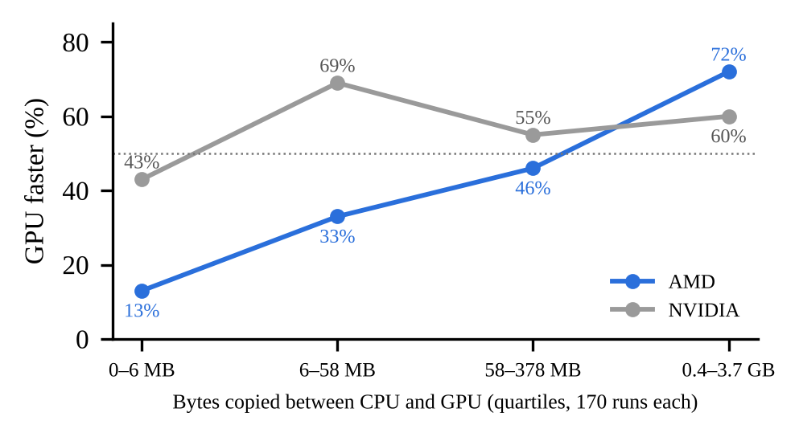
Fig. 1. Share of runs in which the GPU is faster, by data transferred (quartiles of 170 runs). Job size decides much of the AMD label but little of the NVIDIA label.

V. Re-implementation of the Base Paper
We rebuilt the base paper's pipeline from its public notebooks: the input text is the transfer size, the work-group size and the kernel source joined by dashes; it is truncated to 512 tokens and passed to the pretrained encoder; the first token's output goes through a 768-unit layer with ReLU and dropout of 0.3 to a two-way classifier. Training uses Adam with a learning rate of 10⁻⁵, a batch size of four and ten epochs, exactly as published. We fixed random seeds, which the original did not.
With the paper's own split (rows shuffled with seed 1, then five consecutive folds), our CodeBERTa reached 92.1% on AMD and 88.8% on NVIDIA, against 92.8% and 89.1% in [1]. The gap is within the run-to-run variation we observed. For the later experiments we used two speed-ups that do not change the model or the data (padding each batch only to its longest input, and 16-bit arithmetic on the GPU). With them the same protocol gives 92.9% and 88.7%, so the faster training is a fair substitute.
We then built three stricter splits with our own deterministic grouping procedure: unseen program (all rows of a source code stay together), unseen application (all programs of an application stay together, and any identical code elsewhere is removed from training) and unseen suite (each of the seven suites held out in turn). Unseen application is our main test, because it matches the realistic case of a new program arriving at a compiler.

VI. Proposed Work
Fig. 2 shows the proposed hybrid. Instead of fine-tuning the Transformer, we use GraphCodeBERT [13] as a frozen reader. Each distinct kernel is encoded once, the token outputs are mean-pooled into a 768-dimensional vector, and the vectors are standardised and reduced to 16 numbers with PCA. The scaler and PCA are fitted on the training kernels of each fold only, so no information from test applications leaks into the representation.
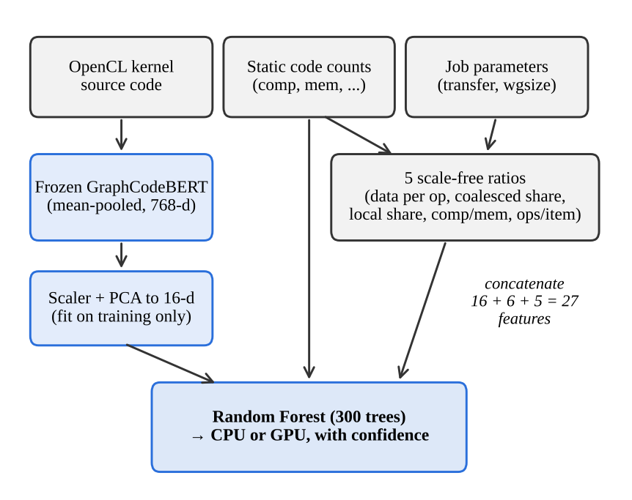
Fig. 2. Proposed hybrid. A frozen GraphCodeBERT reads the code; numbers stay numbers; a Random Forest makes the decision.
The numeric side has two parts. The six code counts that ship with DevMap are used as they are. The raw job numbers are not, because they identify the application; we replace them with five scale-free ratios: bytes transferred per operation, the share of coalesced accesses, the share of local-memory accesses, arithmetic operations per memory access, and operations per work item. The 27 resulting features are given to a Random Forest [17] with 300 trees. The forest needs no feature scaling, handles the heavy skew of the counts, and works well with the 540 or so training rows available in each fold.
We also built an extension for the uncertain cases. The Random Forest acts as a junior that answers every row; rows on which its confidence is below 0.7 (182 on AMD, 290 on NVIDIA) go to a senior, a Gemini 3.5 Flash-Lite model. The senior is tested in four forms: reading only the code, reading the code plus a fact sheet of derived numbers, receiving all tools at once, and acting as an agent that chooses among three tools (the fact sheet, the junior's opinion and the three most similar training kernels with their measured speed-ups).

VII. Experimental Setup
All fine-tuning and embedding extraction ran on Google Colab with an NVIDIA T4 GPU; tree models ran on a CPU. Fine-tuned Transformers were trained three times with different seeds on the same unseen-application folds; tree models were run on five different fold assignments. We report the mean accuracy over runs, pooled over all 680 rows unless stated otherwise.
To decide whether a difference is real we use two tests on the same rows. McNemar's exact test [46] compares two models' correct and incorrect answers row by row within each run. An application-level bootstrap [47] with 2,000 resamples gives a 95% range for the difference in accuracy, resampling whole applications so that rows of one application are not treated as independent. We call a difference reliable when the bootstrap range excludes zero. Following earlier DevMap work, we also measure achieved speed: the geometric mean, over all rows, of the best possible runtime divided by the runtime of the chosen device, and the speed-up over always choosing the majority device.

VIII. Results and Analysis

A. The cost of leakage
Fig. 3 compares the paper's random split with the unseen-application split. Every model loses between 11 and 30 points. CodeBERTa, the base paper's best model, drops from 92.9% to 62.5% on AMD and from 88.7% to 64.3% on NVIDIA, only 3.7 and 7.4 points above always guessing the majority device. Table V gives the full cross-validation picture. Fold-to-fold spread is small under the random split (2–4 points) and large for unseen applications (11–17 points), which is why we repeat runs and test significance.
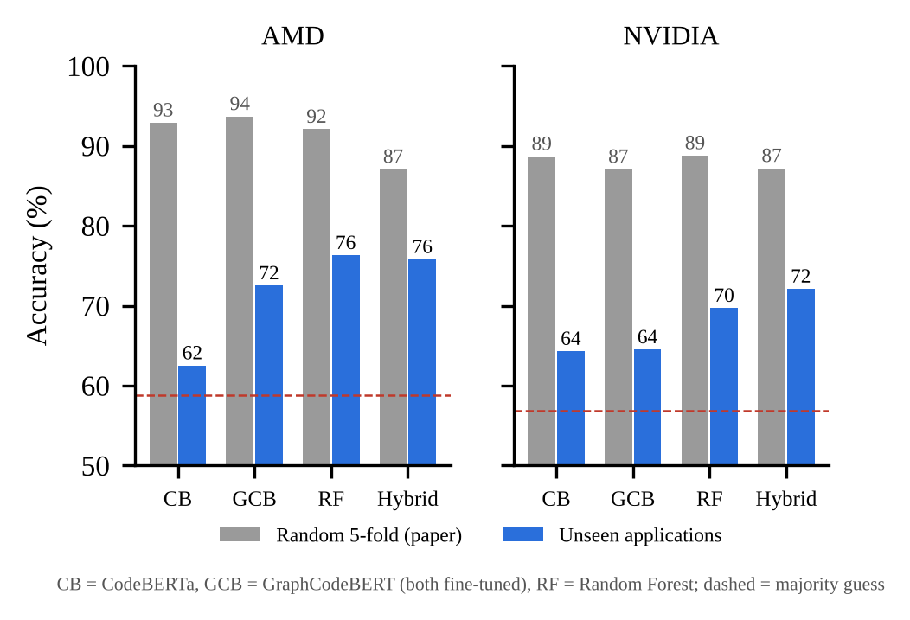
Fig. 3. Accuracy under the paper's random split and with unseen applications. All models lose 11–30 points once applications are held out.
TABLE V
Cross-validation: mean of folds ± SD (AMD / NVIDIA)
Model | Random 5-fold | Unseen program | Unseen app. | Unseen suite (7)
CodeBERTa | 92.9 / 88.7 | 90.7 / 83.7 | 60.8 / 64.6 | 59.6 / 51.9
GraphCodeBERT | 93.7 / 87.1 | 89.9 / 84.3 | 73.2 / 63.2 | 69.3 / 44.7
Random Forest | 92.1 / 88.8 | 86.8 / 83.7 | 75.1 / 70.2 | 72.8 / 51.7
Hybrid (ours) | 87.1 / 87.2 | 86.2 / 81.8 | 74.3 / 73.9 | 66.7 / 48.7
SD across folds | 2.4–3.8 | 1.1–5.5 | 10.9–16.6 | 11.4–18.0
Shuffle seed 1, training seed 1. Elsewhere we report pooled accuracy over all rows and runs, which differs slightly because folds differ in size.

B. CodeBERTa versus GraphCodeBERT
Fine-tuned under identical settings, GraphCodeBERT reaches 72.5% on AMD against 62.5% for CodeBERTa (+10.0 points, bootstrap range +1.4 to +21.2, significant in all three runs). On NVIDIA the two are level (64.5% against 64.3%). The AMD gain is concentrated where job size matters: on kernels whose label changes with input size, GraphCodeBERT is right 79.6% of the time against 63.8%, and it changes its answer across input sizes of the same kernel in 83% of cases against 63%. On NVIDIA it is better than CodeBERTa on six of the seven suites, for example 64.9% against 36.8% on Parboil and 79.2% against 65.3% on SHOC, but worse on NPB (62.7% against 66.5%), and NPB's weight cancels the rest.

C. The hybrid against its baselines
Table VI collects the main unseen-application results. The hybrid is the most accurate model on NVIDIA (72.1%) and level with the feature-only Random Forests on AMD (75.8% against 76.1% with raw job numbers and 77.7% with our ratios). The NVIDIA gain over the forest is reliable (+4.1 points, range +0.8 to +6.8, significant in three of five runs), while the AMD difference is not (−0.3, range −4.6 to +5.2). Against the same forest on counts and ratios, which is the hybrid without its embeddings, the embeddings add a reliable +3.8 points on NVIDIA (range +0.1 to +6.4) and nothing on AMD (−1.9, not reliable). Frozen GraphCodeBERT embeddings were also more useful than frozen CodeBERTa embeddings on NVIDIA (+2.8, range +0.7 to +5.3). Embeddings alone, without the numeric features, are far weaker on AMD (60.6%), confirming that the job-size information has to be present.
TABLE VI
Main results on unseen applications (accuracy %, mean over runs)
Model | AMD | NVIDIA | Runs
Majority device | 58.8 | 56.9 | –
Job numbers only (RF) | 69.3 | 57.1 | 5
CodeBERTa, fine-tuned [1] | 62.5 | 64.3 | 3
GraphCodeBERT, fine-tuned | 72.5 | 64.5 | 3
GraphCodeBERT, end-to-end | 70.9 | 66.2 | 3
Laya (Jev alternative), fine-tuned | 64.6 | 57.2 | 1
RF, counts + raw job numbers | 76.1 | 68.0 | 5
RF, counts + ratios (no embeddings) | 77.7 | 68.3 | 5
Hybrid (ours) | 75.8 | 72.1 | 5

D. Newer code readers and decision makers
We replaced GraphCodeBERT inside the hybrid with newer encoders. CodeSage reached 77.3%/70.6%, CodeT5+ 76.9%/70.4%, UniXcoder 76.6%/66.0% and a version of GraphCodeBERT that reads long kernels in overlapping pieces 73.8%/72.1%. The mean of the two platforms stays near 74% for the best four, so a newer reader does not lift the ceiling, and UniXcoder is reliably worse on NVIDIA.
Table VII keeps the hybrid's inputs fixed and swaps the decision model. No alternative beats the Random Forest reliably, and on NVIDIA all seven are worse; for SVM (−4.7), the neural network (−7.9) and logistic regression (−14.2) the drop is reliable. TabPFN v2, a pretrained Transformer for small tables, gains 2.1 points on AMD with hand features alone, but the gain is not reliable (range −0.6 to +5.3). All settings were fixed before results were seen.
TABLE VII
Decision models on the hybrid's inputs (unseen applications)
Decision model | AMD | NVIDIA | Mean
Random Forest (ours) | 75.8 | 72.1 | 73.9
XGBoost [18] | 77.5 | 69.1 | 73.3
LightGBM [19] | 76.9 | 68.5 | 72.7
TabPFN v2 [16] | 75.3 | 69.6 | 72.4
SVM (RBF) | 74.9 | 67.4 | 71.2
k-nearest neighbours | 70.2 | 69.5 | 69.8
Neural network (64, 32) | 74.9 | 64.2 | 69.6
Logistic regression | 73.0 | 57.9 | 65.4

E. Can the Transformer decide by itself?
A reviewer asked why we do not simply let GraphCodeBERT's own last layer decide. We tested this directly: the same counts and ratios enter through a small numeric branch that is joined to the Transformer's output before the final layer, and the whole network is trained end to end. On the same folds it scores 70.9% on AMD and 66.2% on NVIDIA, against 74.4% and 73.7% for the hybrid. The AMD gap is reliable (−3.5, range −9.1 to −0.5, significant in all runs); the NVIDIA gap is larger (−7.5) and significant in every run by McNemar, although its bootstrap range touches zero. Fed the numbers, the network behaves more like the forest: it improves on NPB but drops to 49.9% on AMD outside NPB. With a few hundred training rows, a tree ensemble makes the decision better than a fine-tuned output layer.

F. Merging the two platforms
Merging the AMD and NVIDIA tables into one dataset of 1,360 rows, with a column that says which GPU each row is for and folds that keep both copies of a kernel together, does not help. A merged Random Forest scores 80.2%/66.7% against 80.9%/67.4% for two separate forests on the same folds; without the GPU column it falls to 74.9%/64.0%. Fine-tuned GraphCodeBERT suffers more: 65.3%/57.9% merged against 69.0%/64.0% separately. Identical code with opposite labels is told apart only by the GPU name at the start of the text, and the Transformer does not learn to rely on it from so little data.

G. Open-source alternative to a closed decision model
We fine-tuned Laya [43], an Apache-licensed alternative to TypeSafe's closed Jev classifier built on ModernBERT-large (421M parameters), with its own training code. Each row became the question “Which device runs this OpenCL kernel faster for this job?” with the GPU name, job numbers and code as context. Laya reached 64.6% on AMD and 57.2% on NVIDIA, reliably below the hybrid on both platforms (−9.9 and −16.5 points) and no better than guessing on NVIDIA. General-purpose decision models are built for ordinary text and do not bridge the gap to code and numbers with a few hundred examples. Kev, the larger Qwen3.5-based alternative [44], is prepared and tested but not yet run at full scale.

H. An LLM senior for uncertain rows
On the 182 AMD rows where the junior forest was unsure, it was right 53.3% of the time. Gemini answered these rows with 51.1% accuracy as an agent, 48.4% with all tools or the fact sheet, and 47.8% from code alone. The agent's overall accuracy (74.6%) was not different from the junior alone (75.1%; difference −0.6, range −2.5 to +1.8). The agent consulted the fact sheet on 84% of rows and the junior's opinion on 66%, but asked for similar kernels, the only tool that shows measured outcomes, on just 7%. The NVIDIA run is still in progress because of the free API quota.

I. What drives the decision
Fig. 4 shows permutation importance on unseen applications. On AMD the transfer size dominates: shuffling it costs 13.6 points. On NVIDIA no feature dominates; work-group size leads with 3.4 points and shuffling the transfer size does not hurt at all, although mutual information ranks it second. The reason is the name-tag effect. A forest given only the two job numbers scores 89.4% (AMD) and 82.0% (NVIDIA) on unseen programs from known applications, but 69.3% and 57.1% on unseen applications, the latter equal to guessing.
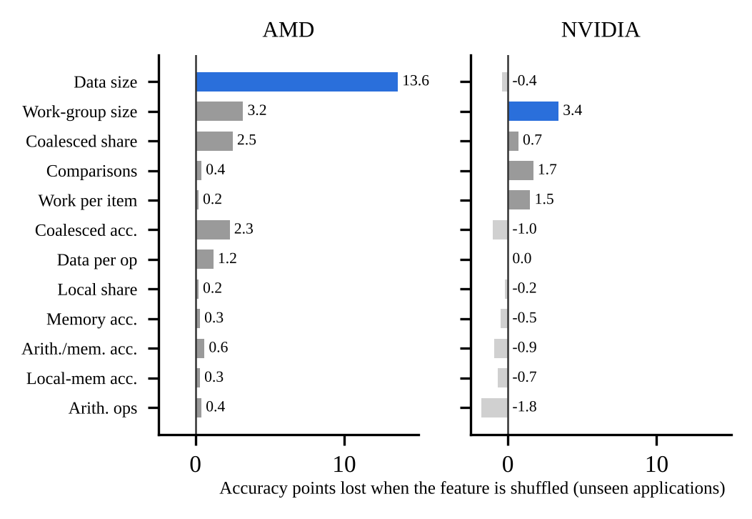
Fig. 4. Permutation importance on unseen applications (Random Forest). Data size dominates on AMD; on NVIDIA no single feature carries the decision.

J. The NPB effect and achieved speed
Fig. 5 splits the unseen-application results into NPB and the other six suites. The forest and the hybrid win on NPB, where every kernel comes in five input sizes and job size decides. Outside NPB, where 29 applications have a single row and 16 have two, fine-tuned GraphCodeBERT is 6–9 points ahead on both platforms. These gaps are not yet reliable (for example +8.7 on AMD, range −6.8 to +23.0, with only 153 rows), but their direction agrees across platforms. Counting each application equally, GraphCodeBERT is ahead on NVIDIA (65.9% against 58.6% for the hybrid).
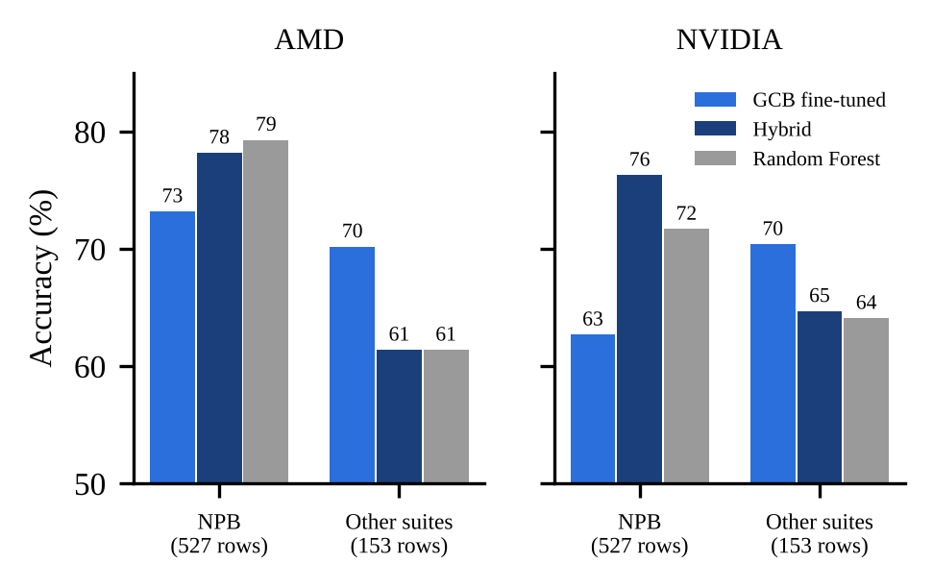
Fig. 5. Accuracy on NPB and on the other suites (unseen applications, same folds). The ranking flips between the two groups.
Accuracy also hides the cost of mistakes. On AMD the hybrid's choices deliver 1.31× the speed of always using the CPU (the perfect choice gives 1.67×). On NVIDIA, no model is meaningfully faster than always using the GPU on unseen applications: the hybrid reaches 1.01×, the forest 0.97× and fine-tuned GraphCodeBERT 0.98×, against 1.34× for a perfect choice. The models beat the majority rule on accuracy but make their mistakes on runs where the gap is large.

IX. Discussion and Limitations
The main lesson is methodological. With random splits, DevMap rewards recognising applications, and almost any model reaches 87–94%. With held-out applications, all models land between 61% and 78%, differences of a few points need repeated runs and paired tests to be trusted, and one suite decides much of the ranking. Within that honest range, the encoder matters (GraphCodeBERT over CodeBERTa), the way numbers are supplied matters (as numbers, through ratios, to a tree ensemble), and newer components such as larger code readers, tabular foundation models, closed or open decision models and LLM agents did not help.
Several limits apply. DevMap covers two GPUs from 2012 and 2014 and one CPU, so absolute numbers may not carry over to modern hardware. Most results use one shuffle of folds for fine-tuned models, the GraphCodeBERT merged and Laya experiments use a single training run, and the LLM agent was tested on AMD only so far. Our significance tests resample applications, but with 71 applications the ranges remain wide. Finally, 34% of kernels exceed GraphCodeBERT's 512-token limit and are read only in part, although reading them in pieces did not help.

X. Conclusion and Future Work
We reproduced a recent Transformer study of CPU–GPU device mapping, showed that its accuracy depends on leakage between training and test data, and re-evaluated the task on held-out applications. GraphCodeBERT improves on CodeBERTa by 10 points on AMD, and a hybrid of frozen GraphCodeBERT embeddings, code counts and scale-free ratios decided by a Random Forest gives the best NVIDIA accuracy, with a reliable gain over a feature-only forest. A broad set of alternatives, from end-to-end Transformers to an LLM agent, did not do better. We recommend that future device-mapping work report application-level and per-suite results together with achieved speed.
Next, we plan to finish the LLM-agent and Kev experiments on NVIDIA, train with each application weighted equally to reduce the NPB bias, adapt GraphCodeBERT to GPU code by continued pretraining on a large corpus of OpenCL and CUDA kernels with DevMap programs removed, and collect a new dataset on current CPUs and GPUs with several input sizes for every application.

Data and Code Availability
The datasets, source code, Colab notebooks, per-row predictions and analysis scripts are available at [GitHub repository link]. A demonstration video is available at [video link].

Acknowledgment
The author thanks [guide name] and the review panel for their questions, which shaped Section VIII. Claude (Anthropic) was used as a coding and writing assistant; all experiments were run and checked by the author.

References
[1] M. Siino et al., “A transformer-based approach for source code classification for heterogeneous device mapping,” Eng. Appl. Artif. Intell., vol. 163, Art. no. 112987, 2026.
[2] C. Cummins, P. Petoumenos, Z. Wang, and H. Leather, “End-to-end deep learning of optimization heuristics,” in Proc. PACT, 2017, pp. 219–232.
[3] D. Grewe, Z. Wang, and M. F. P. O'Boyle, “Portable mapping of data parallel programs to OpenCL for heterogeneous systems,” in Proc. CGO, 2013, pp. 1–10.
[4] T. Ben-Nun, A. S. Jakobovits, and T. Hoefler, “Neural code comprehension: A learnable representation of code semantics,” in Proc. NeurIPS, 2018.
[5] C. Cummins, Z. V. Fisches, T. Ben-Nun, T. Hoefler, M. F. P. O'Boyle, and H. Leather, “ProGraML: A graph-based program representation for data flow analysis and compiler optimizations,” in Proc. ICML, 2021.
[6] S. VenkataKeerthy, R. Aggarwal, S. Jain, M. S. Desarkar, R. Upadrasta, and Y. N. Srikant, “IR2Vec: LLVM IR based scalable program embeddings,” ACM Trans. Archit. Code Optim., vol. 17, no. 4, 2020.
[7] A. TehraniJamsaz, Q. I. Mahmud, L. Chen, N. K. Ahmed, and A. Jannesari, “PERFOGRAPH: A numerical aware program graph representation for performance optimization and program analysis,” in Proc. NeurIPS, 2023.
[8] A. Dutta and A. Jannesari, “MIREncoder: Multi-modal IR-based pretrained embeddings for performance optimizations,” in Proc. PACT, 2024.
[9] Q. I. Mahmud, A. TehraniJamsaz, N. K. Ahmed, T. L. Willke, and A. Jannesari, “ConTraPh: Contrastive learning for parallelization and performance optimization,” in Proc. ICS, 2025.
[10] P. Vavaroutsos, I. Oroutzoglou, D. Masouros, and D. Soudris, “Towards making the most of NLP-based device mapping optimization for OpenCL kernels,” arXiv:2208.14124, 2022.
[11] C. Higgins and M. Alvarez, “LLM-based embeddings for program analysis and optimization,” arXiv:2608.07894, 2026.
[12] Z. Feng et al., “CodeBERT: A pre-trained model for programming and natural languages,” in Findings of EMNLP, 2020.
[13] D. Guo et al., “GraphCodeBERT: Pre-training code representations with data flow,” in Proc. ICLR, 2021.
[14] D. Guo et al., “UniXcoder: Unified cross-modal pre-training for code representation,” in Proc. ACL, 2022.
[15] Y. Wang et al., “CodeT5+: Open code large language models for code understanding and generation,” in Proc. EMNLP, 2023.
[16] N. Hollmann et al., “Accurate predictions on small data with a tabular foundation model,” Nature, vol. 637, pp. 319–326, 2025.
[17] L. Breiman, “Random forests,” Mach. Learn., vol. 45, no. 1, pp. 5–32, 2001.
[18] T. Chen and C. Guestrin, “XGBoost: A scalable tree boosting system,” in Proc. KDD, 2016.
[19] G. Ke et al., “LightGBM: A highly efficient gradient boosting decision tree,” in Proc. NeurIPS, 2017.
[20] M. Trofin et al., “MLGO: A machine learning guided compiler optimizations framework,” arXiv:2101.04808, 2021.
[21] C. Cummins et al., “Meta large language model compiler: Foundation models of compiler optimization,” arXiv:2407.02524, 2024.
[22] V. W. Lee et al., “Debunking the 100X GPU vs. CPU myth: An evaluation of throughput computing on CPU and GPU,” in Proc. ISCA, 2010.
[23] TOP500, “Highlights – June 2026,” top500.org, 2026.
[24] International Energy Agency, Energy and AI, Paris, 2025.
[25] NVIDIA Corp., “NVIDIA announces financial results for fourth quarter and fiscal 2026,” press release, Feb. 25, 2026.
[26] Gartner, “Gartner says artificial intelligence PCs will represent 31% of worldwide PC market by the end of 2025,” press release, Aug. 28, 2025.
[27] IBM, “Runtime GPU/CPU selection,” U.S. Patent 10 540 194 B2 (appl. pub. US20190196853A1).
[28] AMD, “Allocating compute kernels to processors in a heterogeneous system,” WO2013090788A1, 2013.
[29] Lenovo, “Best performance delivery in heterogeneous computing unit environment,” U.S. Patent 10 884 761 B2.
[30] Google, “Device placement optimization with reinforcement learning,” U.S. Patent 10 692 003 B2, 2020.
[31] Google, “Learned graph optimizations for compilers,” WO2021248138A1, 2021.
[32] Intel, “Machine learning-guided compiler optimizations for register-based hardware architectures,” U.S. Patent 11 954 466 B2, 2024.
[33] Cornell University, “Execution time prediction for energy-efficient computer systems,” WO2017096338A1, 2017.
[34] Samsung Electronics, “Accelerating execution of machine-learning-based application tasks in a computing device,” WO2018155963A1, 2018.
[35] Intel, “Automatic device selection and configuration (OpenVINO AUTO plugin),” OpenVINO documentation and blog.
[36] Microsoft, “ONNX Runtime high-level design: execution providers,” onnxruntime.ai documentation.
[37] Khronos Group, “SYCL device selector,” SYCL reference documentation.
[38] Apple, “MLComputeUnits,” Core ML developer documentation.
[39] Google, “Use a GPU,” TensorFlow guide, tensorflow.org.
[40] LLVM Project, “Machine learning – guided optimization (MLGO),” llvm.org documentation.
[41] C. Augonnet, S. Thibault, R. Namyst, and P.-A. Wacrenier, “StarPU: A unified platform for task scheduling on heterogeneous multicore architectures,” Concurr. Comput.: Pract. Exper., vol. 23, no. 2, pp. 187–198, 2011.
[42] TypeSafe AI, “Jev” System One decision model, early access Sept. 15, 2026 (described in DigitalOcean, “What is Jev?”, 2026).
[43] Convai Innovations, “Laya: typed decision models,” Hugging Face model card convaiinnovations/laya, 2026.
[44] J. Palmer, “Kev: open-weight Jev-style decision models,” GitHub repository jaredpalmer/kev, 2026.
[45] J. Yang et al., “SWE-agent: Agent-computer interfaces enable automated software engineering,” in Proc. NeurIPS, 2024.
[46] Q. McNemar, “Note on the sampling error of the difference between correlated proportions or percentages,” Psychometrika, vol. 12, no. 2, pp. 153–157, 1947.
[47] B. Efron and R. J. Tibshirani, An Introduction to the Bootstrap. New York, NY, USA: Chapman & Hall, 1993.

Appendix: Publication Plan
The work combines a reproduction, a leakage analysis and a new model with extensive controlled experiments, which suits a journal article; a shorter conference or workshop version can report the hybrid and the evaluation protocol. Table VIII lists the venues we are considering.
TABLE VIII
Candidate publication venues
Venue | Type | Why it fits
Engineering Applications of Artificial Intelligence (Elsevier) | Journal | Published the base paper; a re-evaluation fits its scope
Journal of Systems Architecture (Elsevier) | Journal | Heterogeneous systems and compilers
ACM Trans. Architecture and Code Optimization | Journal | Top venue for learned compiler heuristics
The Journal of Supercomputing (Springer) | Journal | HPC applications of machine learning
IEEE Access | Journal | Broad scope, faster review
HiPC, CGO, CC, PACT, ICS, Euro-Par | Conference | Short version of the method and results
ML for Systems workshop (NeurIPS) | Workshop | Evaluation-methodology contribution
Indexing (Scopus/SCIE), deadlines and fees to be confirmed with the guide before submission.

