Recorded and replayed the script

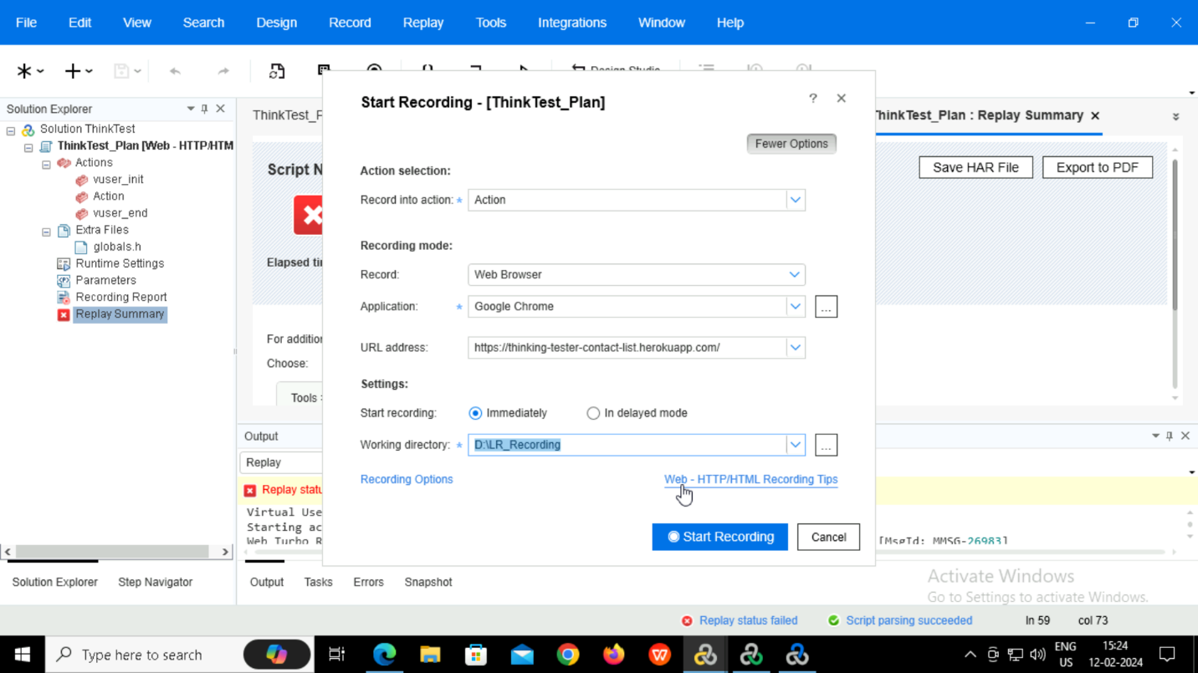

Parameterization completed and obtained the result

In runtime settings the number of iterations is set to 5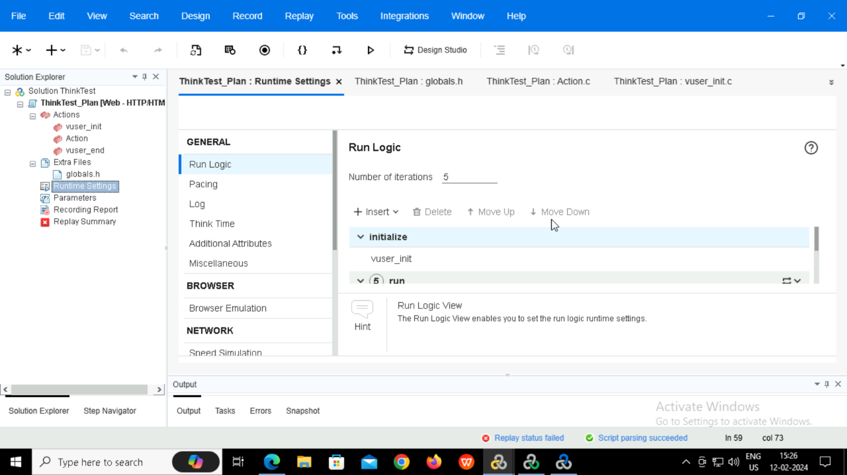

Then now loadrunner controller is opened and the testscript is added

Increased the number of vusers from quantity

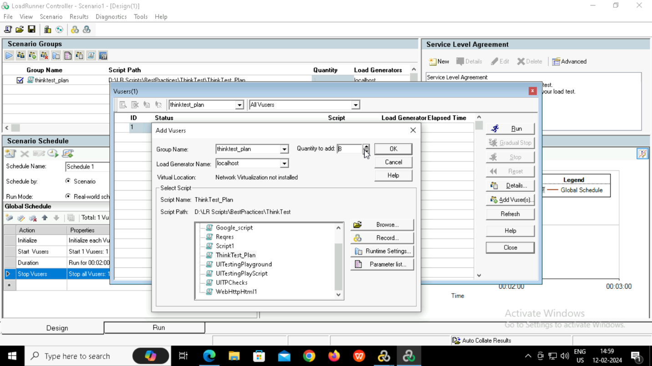

Now started running the scenario

Obtained results in controller

From the results option select the analyze results. Now it will redirect to loadrunner analysis.

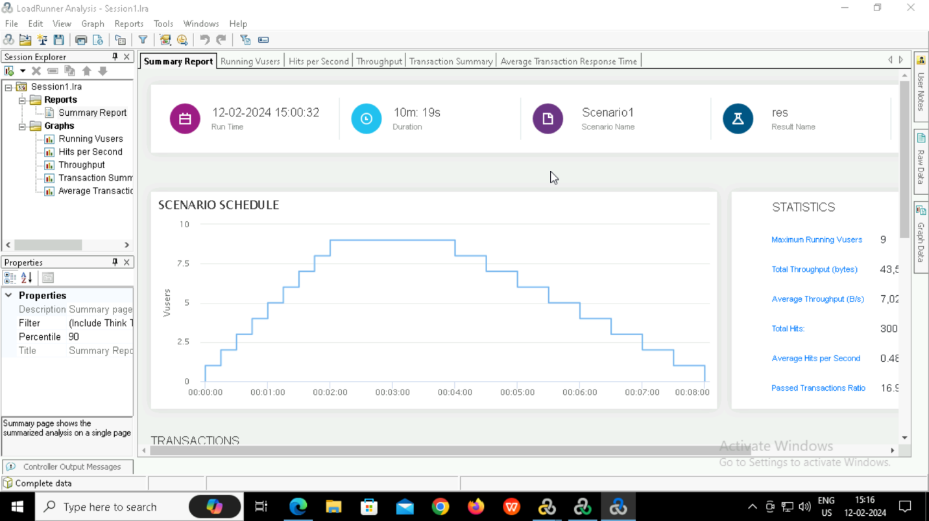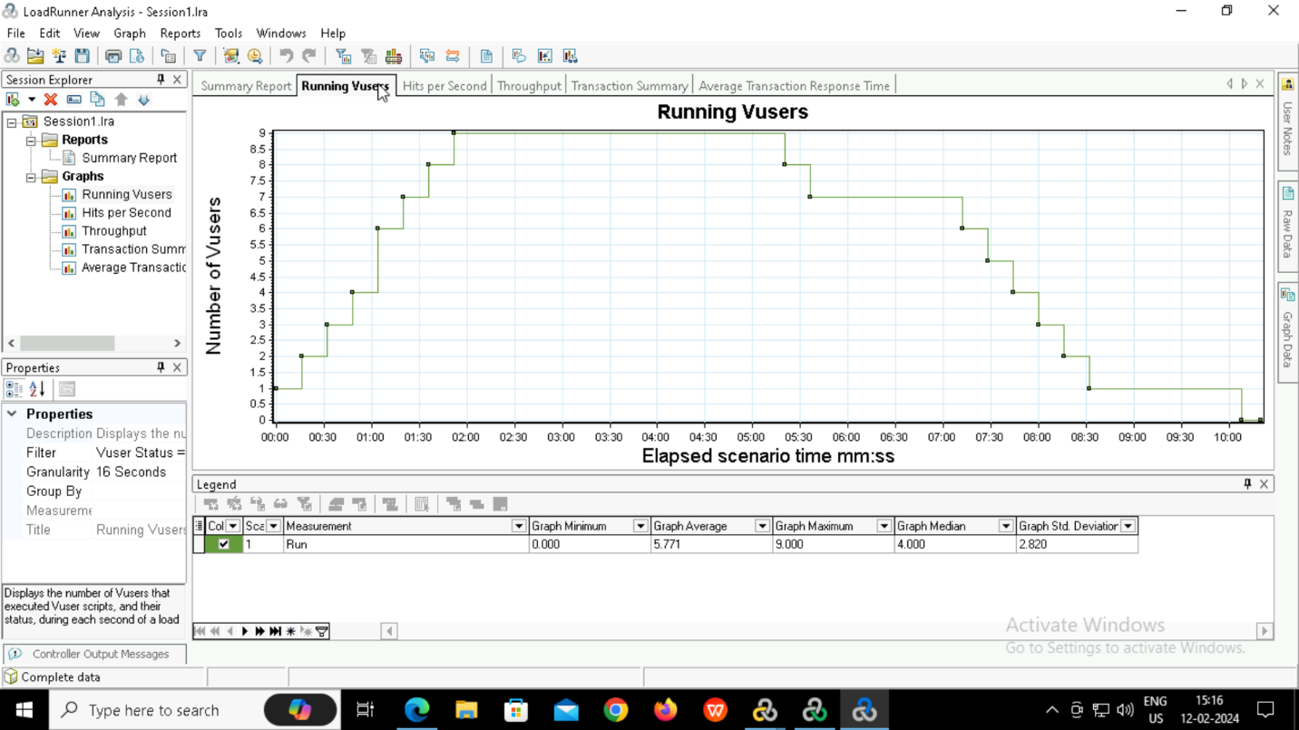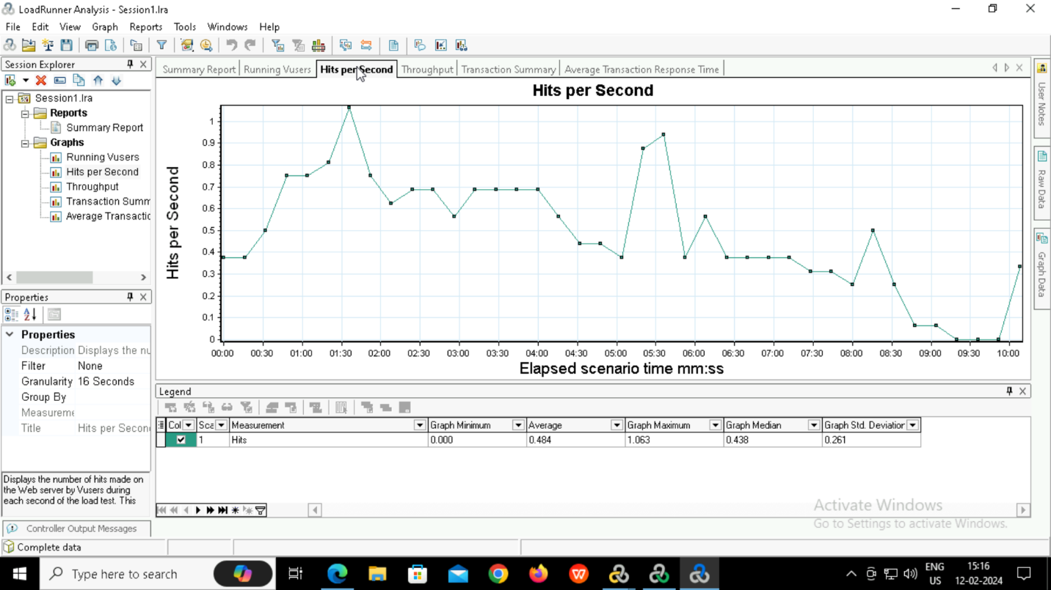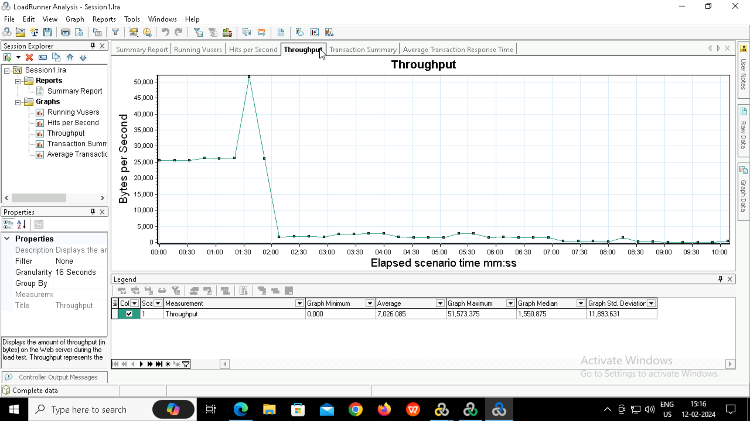

Go to reports and save the html file.

