Lesson – 1 -

[SQL Lesson 1: SELECT queries 101](https://sqlbolt.com/lesson/select_queries_introduction)

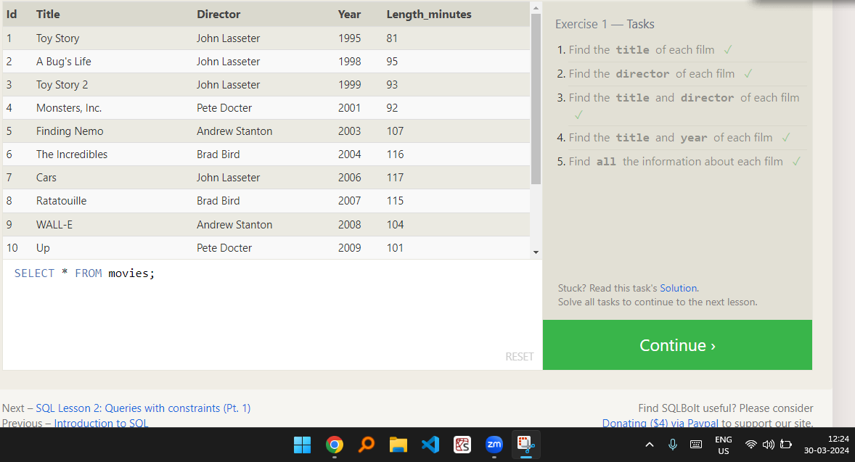

Lesson -2

[SQL Lesson 2: Queries with constraints (Pt. 1)](https://sqlbolt.com/lesson/select_queries_with_constraints)

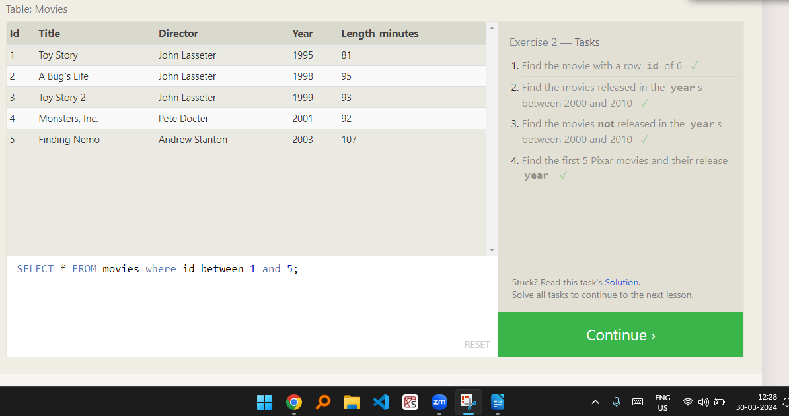

Lesson-3

[SQL Lesson 3: Queries with constraints (Pt. 2)](https://sqlbolt.com/lesson/select_queries_with_constraints_pt_2)

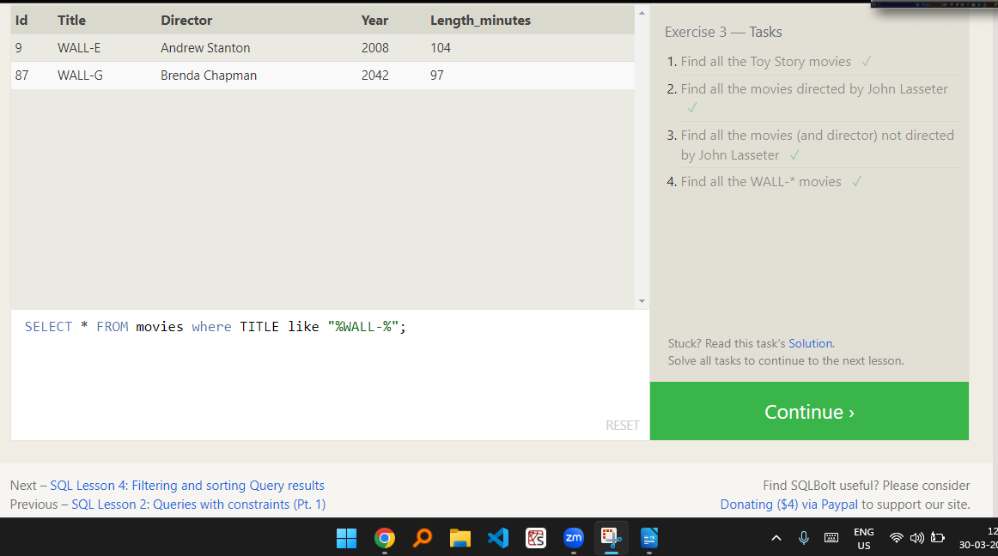

Lesson – 4

[SQL Lesson 4: Filtering and sorting Query results](https://sqlbolt.com/lesson/filtering_sorting_query_results)

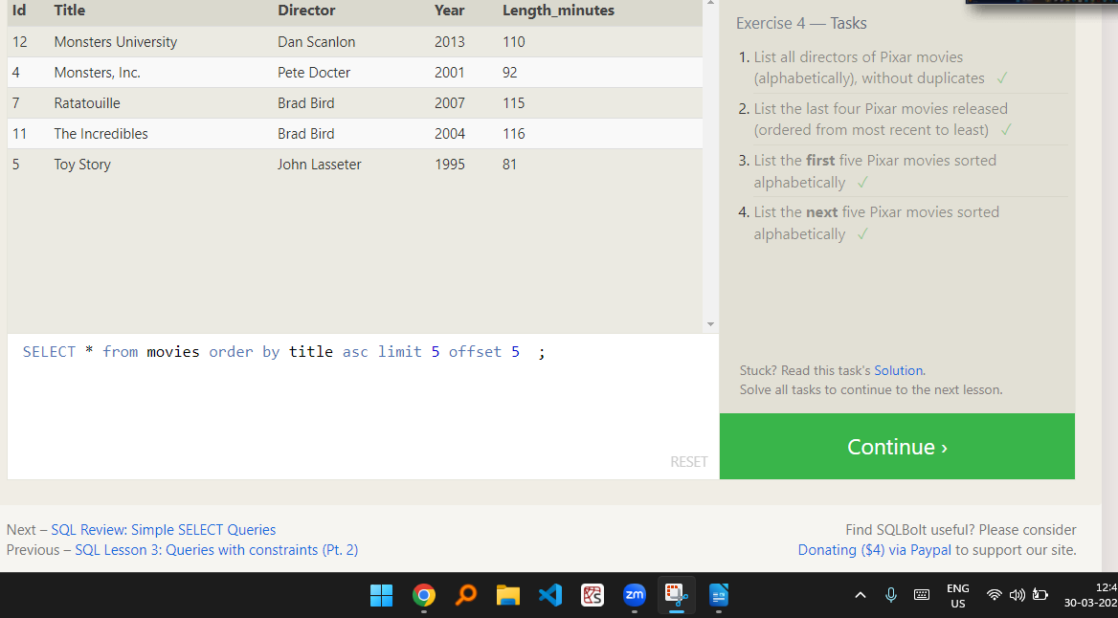

Lesson – 5

[SQL Review: Simple SELECT Queries](https://sqlbolt.com/lesson/select_queries_review)

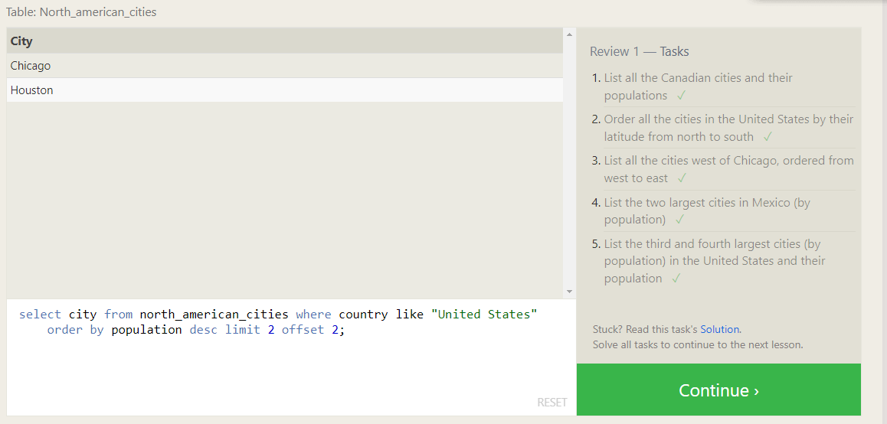

Lesson – 6

[SQL Lesson 6: Multi-table queries with JOINs](https://sqlbolt.com/lesson/select_queries_with_joins)

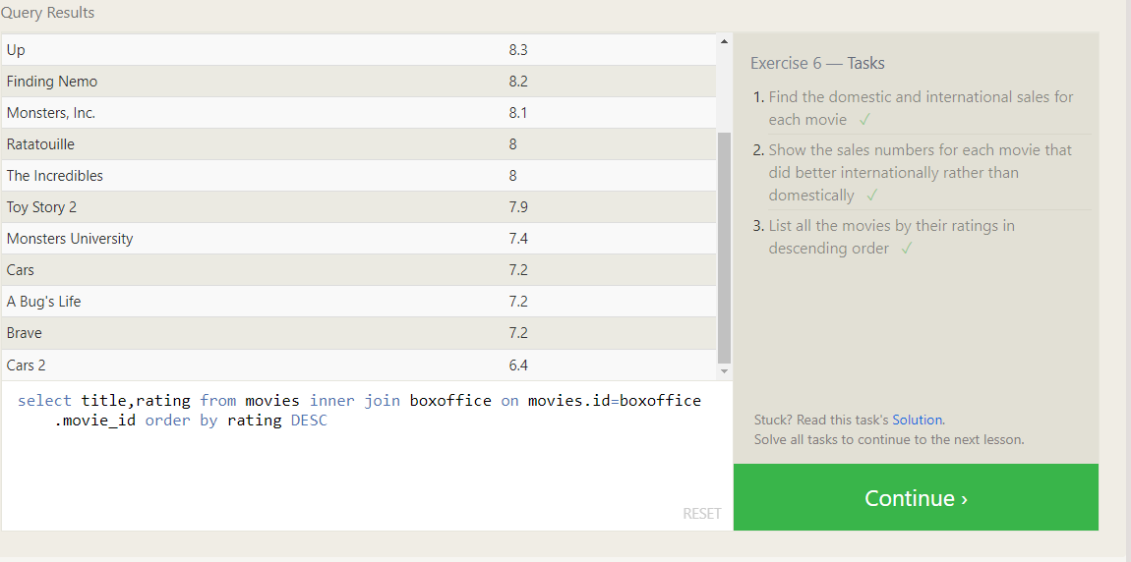

Lesson – 7

[SQL Lesson 7: OUTER JOINs](https://sqlbolt.com/lesson/select_queries_with_outer_joins)

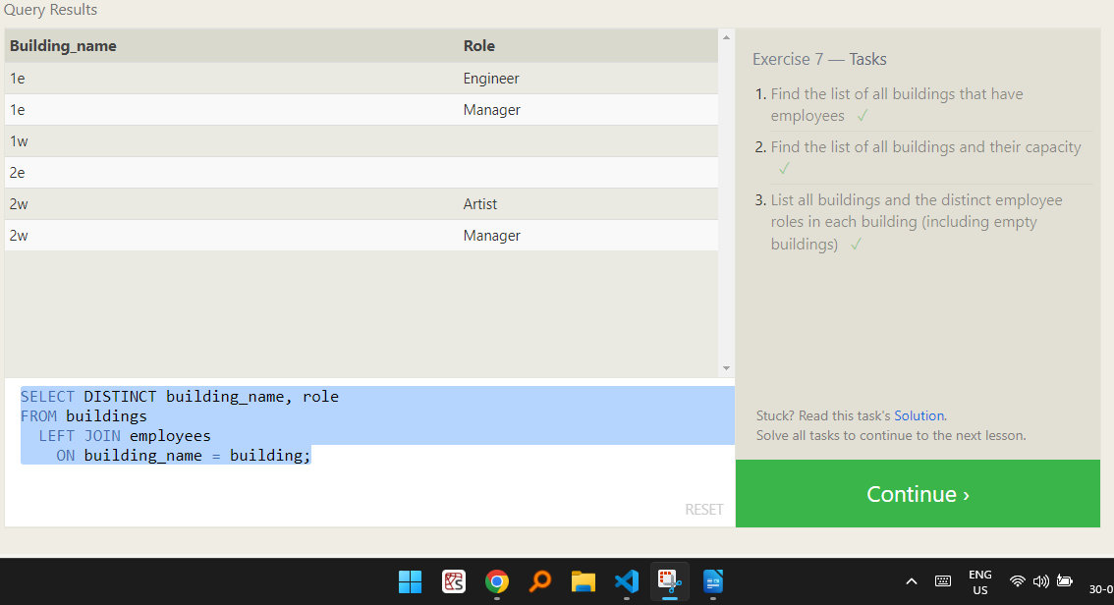

Lesson – 8

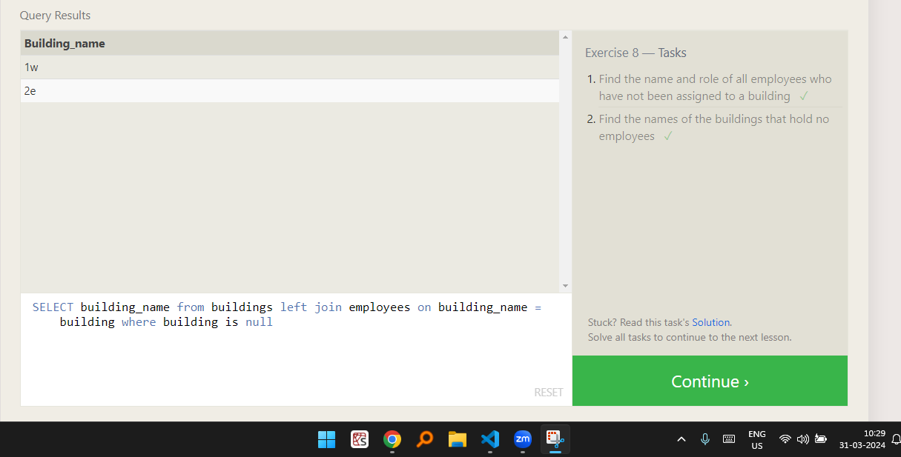

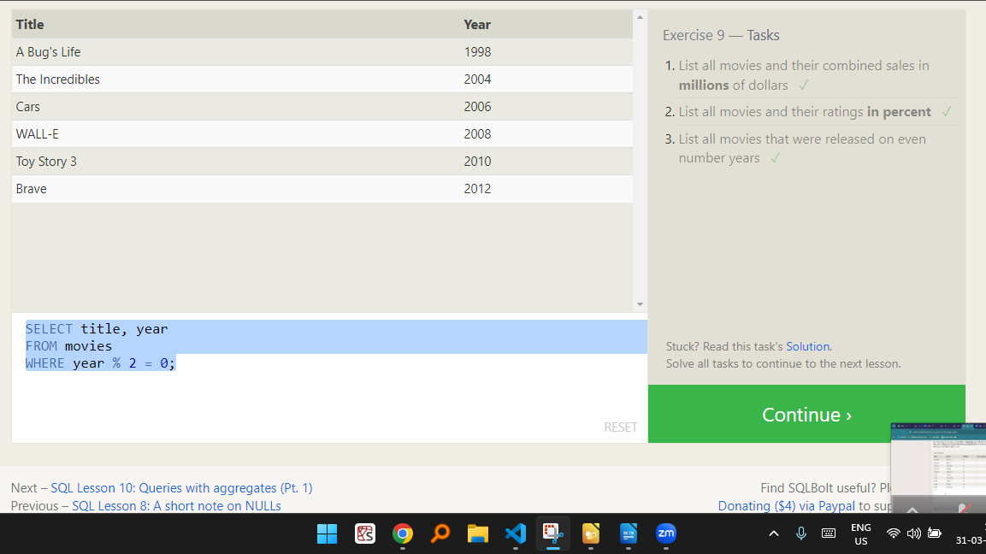Lesson – 9

Lesson – 10

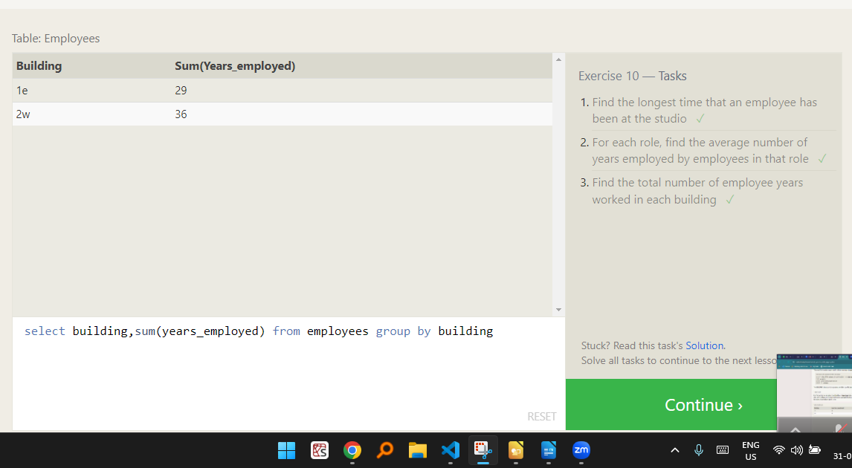

Lesson – 11

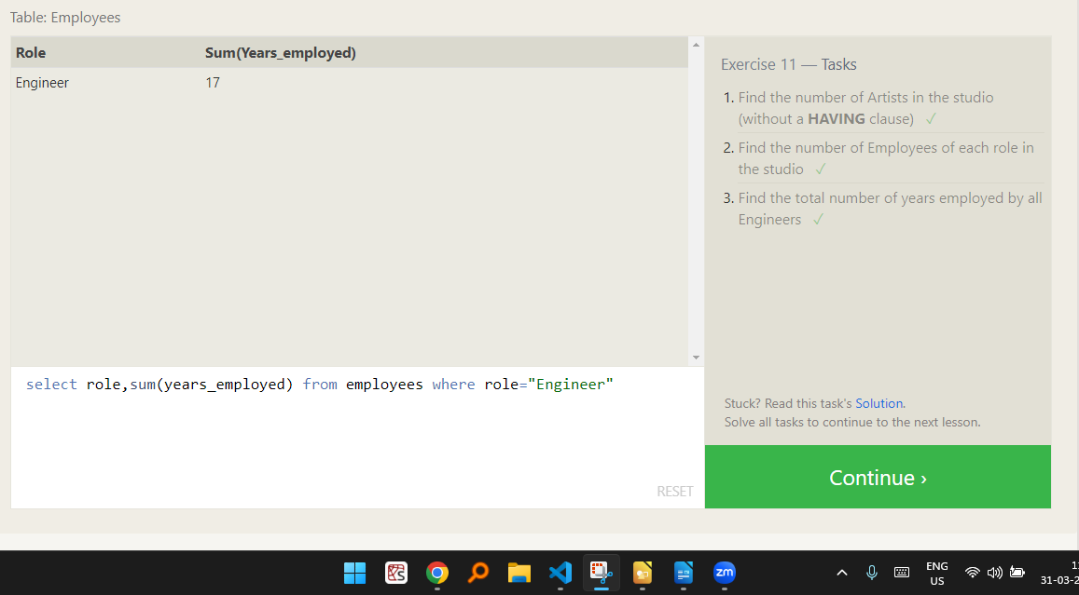

Lesson – 12

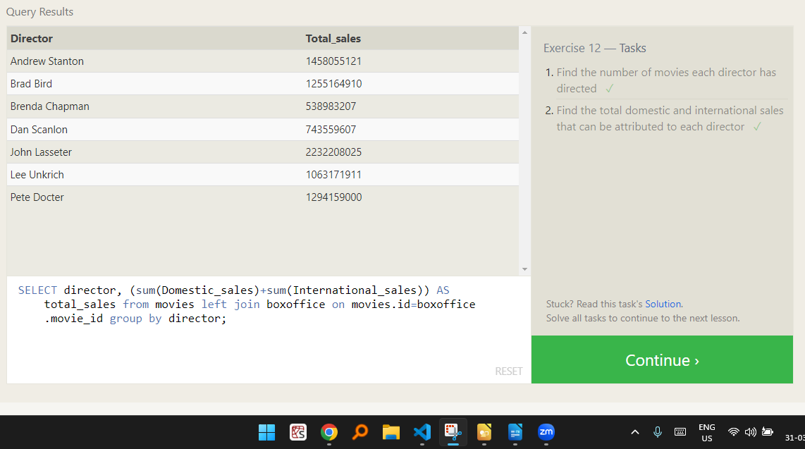

Lesson – 13

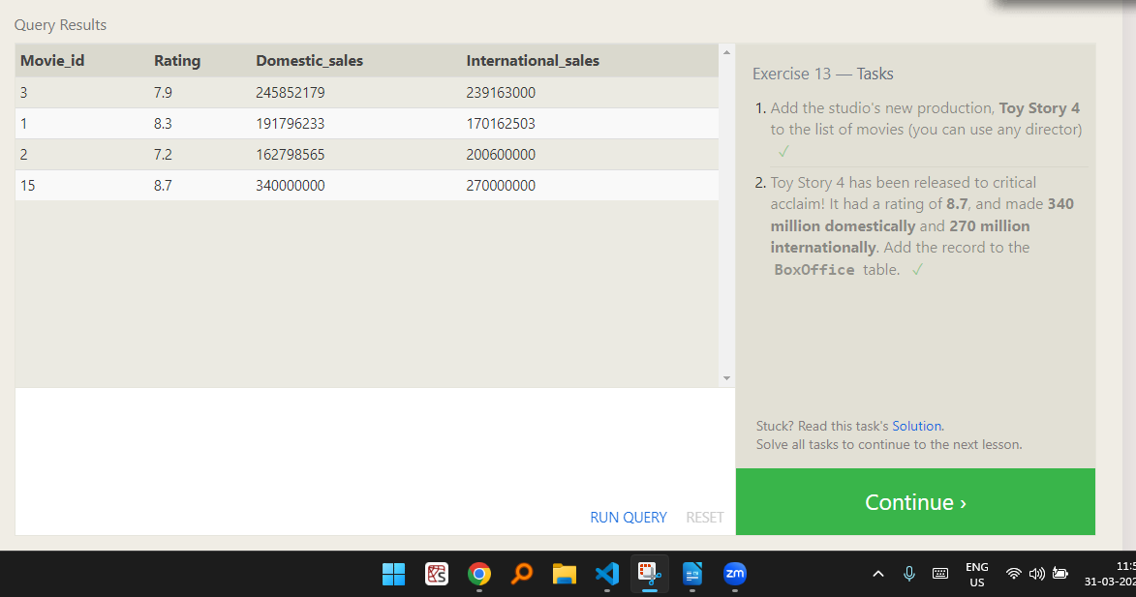

Lesson – 14

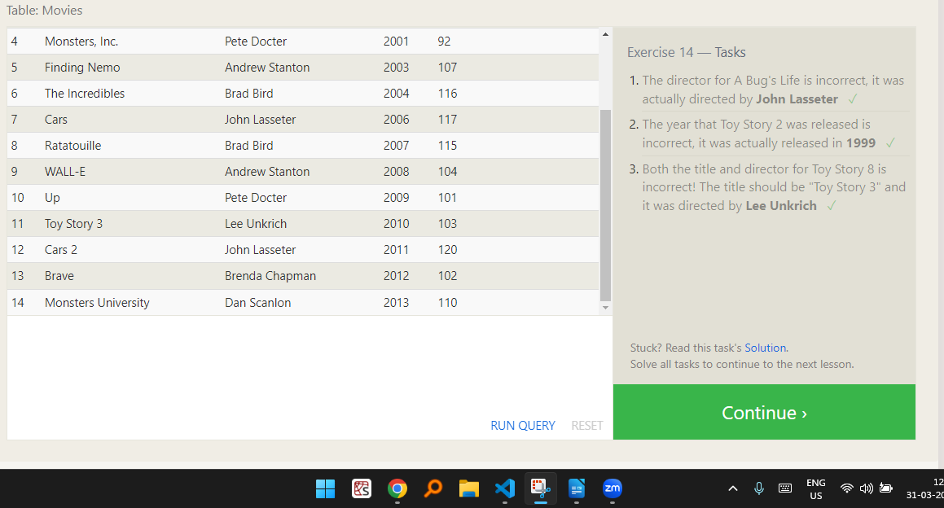

Lesson- 15

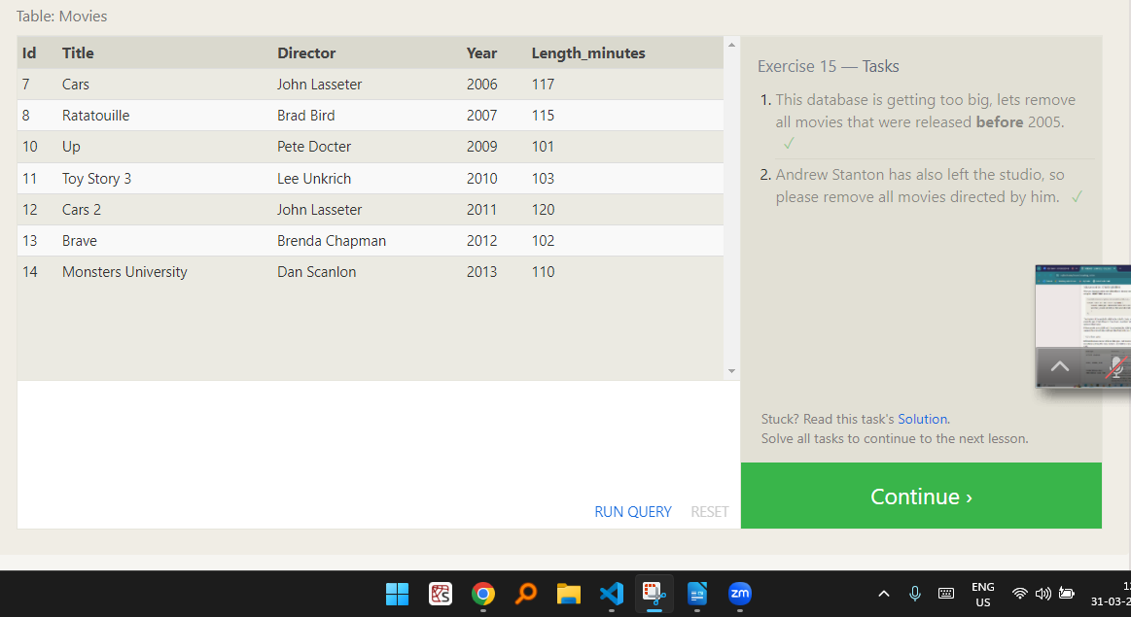

Lesson – 16

[SQL Lesson 16: Creating tables](https://sqlbolt.com/lesson/creating_tables)

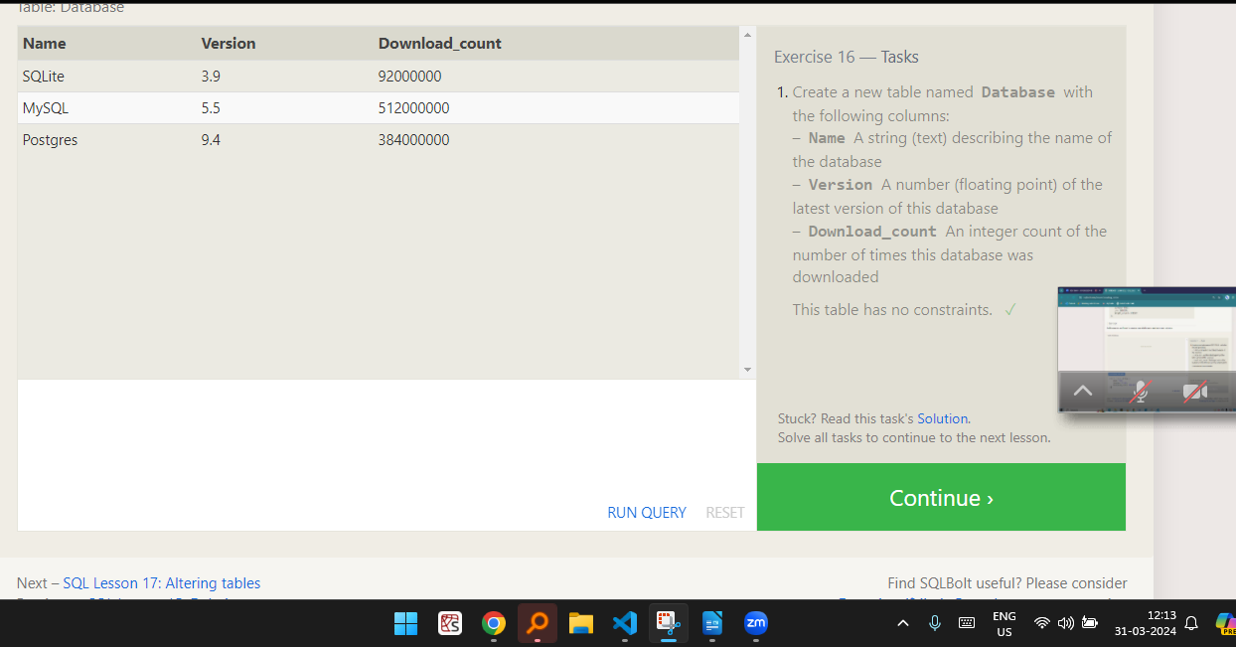

Lesson – 17

SQL Lesson 17: Altering tables

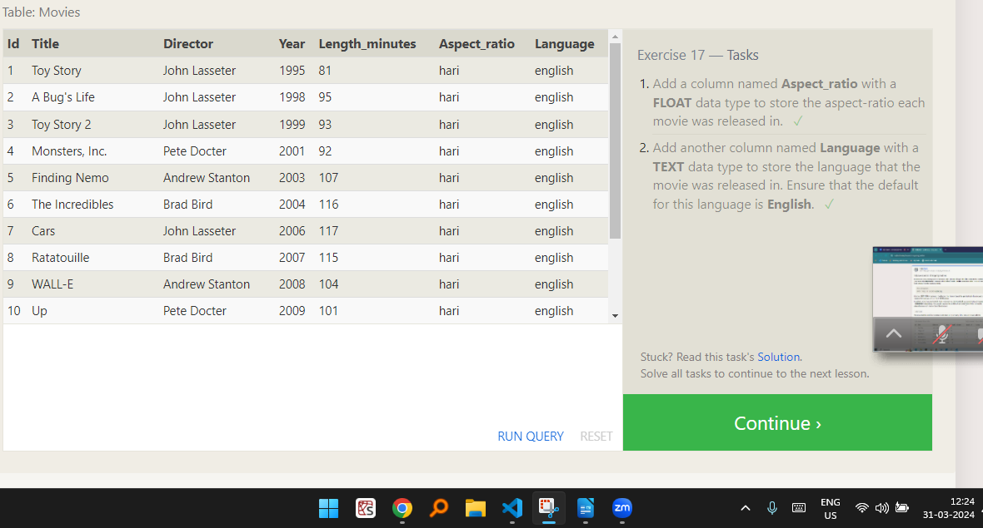

Lesson – 18

SQL Lesson 18: Dropping tables

