PROJECT REPORT
CDACL-002
Customer Segmentation
& Shopping Trend Analysis
Using SQL, Power BI, and Orange Data Mining (K-Means Clustering)
Prepared by
M. Hari Kumar
Data-mites | Date: 18 July 2026
3,900  Customer Records | 3  Customer Segments | K-Means  Clustering Method | United States  Market
TOOLS & TECHNOLOGIES
MySQL | Power BI | Orange Data Mining | K-Means Clustering

Table of Contents
Project Overview 1
Introduction 1
Business Problem 1
Project Objectives 1
Dataset Description 1
Dataset Attributes 1
Tools and Technologies 1
Project Workflow 1
Data Preparation 1
SQL Analysis 1
Exploratory Data Analysis 1
Power BI Dashboard 1
Customer Segmentation Using K-Means 1
Features Used 1
Why K-Means? 1
Working of the K-Means Algorithm 1
Orange Data Mining Workflow 1
Widget Description 1
Cluster Analysis 1
Dominant Factors Affecting Customer Segmentation 1
Business Insights 1
Business Recommendations 1
Expected Outcomes 1
Conclusion 1

1 | Project Overview

Introduction
In today's competitive retail market, understanding customer behavior is essential for increasing sales, improving customer satisfaction, and building long-term customer relationships. Every customer has unique shopping habits based on factors such as age, gender, purchase amount, payment method, shopping frequency, location, and seasonal preferences. Businesses that understand these patterns can make better decisions regarding pricing, promotions, inventory management, and marketing strategies.
Customer Segmentation is a data analytics technique used to divide customers into groups with similar characteristics and purchasing behaviors. Instead of treating every customer the same, businesses can create personalized marketing campaigns for each customer segment. This improves customer engagement, increases revenue, reduces marketing costs, and enhances customer loyalty.
This project analyzes a shopping trends dataset containing 3,900 customer records collected from customers in the United States retail market. The analysis is performed using MySQL for data querying and business analysis, Power BI for interactive dashboard visualization, and Orange Data Mining using the K-Means Clustering algorithm to identify customer groups based on shopping behavior.
The project provides valuable business insights into purchasing trends, customer demographics, seasonal demand, payment preferences, and discount strategies. Based on the analysis, targeted marketing campaigns are recommended for each customer segment to improve business performance and customer satisfaction.
2 | Business Problem

Retail companies generate large amounts of customer transaction data every day, but most organizations do not fully utilize this data for strategic decision-making. The company wants to answer several important business questions:
- Which product categories should receive discounts?
- Which customers spend the highest amount?
- Which payment methods are preferred by different age groups?
- Which season generates the highest revenue?
- Which locations contribute the most sales?
- Which customers are loyal?
- How can customers be grouped based on shopping behavior?
- What personalized marketing campaigns should be implemented?
Without customer segmentation, businesses often apply the same promotional strategy to every customer, resulting in lower conversion rates, reduced profitability, and inefficient marketing spending.
3 | Project Objectives

The primary objectives of this project are:
- Analyze customer shopping behavior using SQL.
- Identify product categories where discounts should be applied.
- Analyze spending patterns across different age groups.
- Study payment method preferences.
- Analyze seasonal purchasing behavior.
- Study location-wise sales performance.
- Understand customer loyalty using previous purchase history.
- Segment customers into meaningful groups using K-Means Clustering.
- Build interactive Power BI dashboards for business decision-making.
- Recommend personalized marketing campaigns for each customer segment.
4 | Dataset Description

The dataset consists of 3,900 customer shopping transactions collected from the U.S. retail market. Each row represents one completed customer purchase. The dataset contains demographic information, purchase details, payment preferences, customer reviews, promotional activities, shopping frequency, and previous purchase history.

Dataset Attributes
# | Attribute | # | Attribute
1 | Customer ID | 10 | Review Rating
2 | Age | 11 | Subscription Status
3 | Gender | 12 | Shipping Type
4 | Item Purchased | 13 | Discount Applied
5 | Category | 14 | Promo Code Used
6 | Purchase Amount (USD) | 15 | Previous Purchases
7 | Location | 16 | Payment Method
8 | Size | 17 | Frequency of Purchases
9 | Color

5 | Tools and Technologies

Tool | Purpose
MySQL | Data analysis using SQL
Power BI | Dashboard development
Orange Data Mining | Customer segmentation
CSV Dataset | Data source

6 | Project Workflow

Customer Shopping Dataset
↓
Import CSV into MySQL
↓
Data Cleaning
↓
SQL Analysis
↓
Business Insights
↓
Power BI Dashboard
↓
Orange Data Mining
↓
K-Means Clustering
↓
Customer Segmentation
↓
Marketing Recommendations
↓
Business Decision Making
7 | Data Preparation

The following preprocessing steps are performed before analysis:
- Import dataset into MySQL
- Verify data types
- Remove duplicate records
- Check missing values
- Validate numerical columns
- Standardize categorical values
- Prepare data for dashboard visualization
- Prepare data for clustering
8 | SQL Analysis

SQL is used to answer important business questions. The analysis includes: Total Customers, Total Sales, Average Purchase Amount, Category-wise Revenue, Discount Analysis, Age-wise Spending, Payment Method Analysis, Gender Distribution, Season-wise Sales, Location-wise Revenue, Subscription Analysis, and Purchase Frequency Analysis.
Approximately 15–20 simple SQL queries are used to generate business insights.
▸ Query 1 — Total Customers
SELECT COUNT(*) AS Total_Customers
FROM shopping_trends;

▸ Query 2 — Total Sales
SELECT SUM(`Purchase Amount (USD)`) AS Total_Sales
FROM shopping_trends;

▸ Query 3 — Average Purchase
SELECT AVG(`Purchase Amount (USD)`) AS Average_Purchase
FROM shopping_trends;

▸ Query 4 — Sales by Category
SELECT Category, SUM(`Purchase Amount (USD)`) AS Sales
FROM shopping_trends
GROUP BY Category;

▸ Query 5 — Categories for Discount
SELECT Category, AVG(`Purchase Amount (USD)`) AS Average_Sales
FROM shopping_trends
GROUP BY Category
ORDER BY Average_Sales;

▸ Query 6 — Age-wise Spending
SELECT Age, SUM(`Purchase Amount (USD)`) AS Spending
FROM shopping_trends
GROUP BY Age;

▸ Query 7 — Payment Method
SELECT `Payment Method`, COUNT(*) AS Customers
FROM shopping_trends
GROUP BY `Payment Method`;

▸ Query 8 — Season-wise Sales
SELECT Season, SUM(`Purchase Amount (USD)`) AS Sales
FROM shopping_trends
GROUP BY Season;

▸ Query 9 — Location-wise Sales
SELECT Location, SUM(`Purchase Amount (USD)`) AS Sales
FROM shopping_trends
GROUP BY Location
ORDER BY Sales DESC;

▸ Query 10 — Subscription Status
SELECT `Subscription Status`, COUNT(*) AS Customers
FROM shopping_trends
GROUP BY `Subscription Status`;

▸ Query 11 — Discount Applied
SELECT `Discount Applied`, COUNT(*) AS Total
FROM shopping_trends
GROUP BY `Discount Applied`;

▸ Query 12 — Purchase Frequency
SELECT `Frequency of Purchases`, COUNT(*) AS Customers
FROM shopping_trends
GROUP BY `Frequency of Purchases`;

9 | Exploratory Data Analysis

EDA is performed to understand customer behavior. The analysis includes:
- Customer age distribution
- Gender distribution
- Product category popularity
- Spending patterns
- Seasonal shopping trends
- Location-wise purchases
- Review ratings
- Payment preferences
- Subscription analysis
- Shopping frequency
The results help identify purchasing trends before performing customer segmentation.
10 | Power BI Dashboard

Power BI is used to build an interactive dashboard that summarizes business performance.
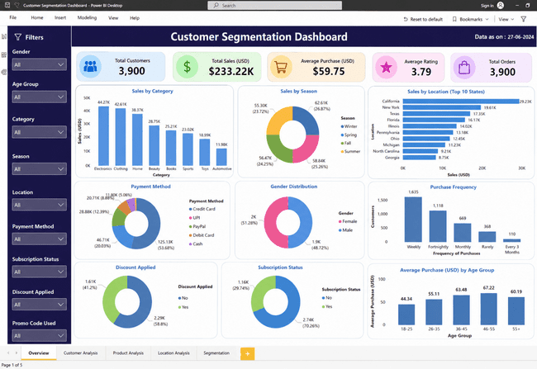
Figure 1 — Power BI interactive business performance dashboard
11 | Customer Segmentation Using K-Means

Customer segmentation is performed using the K-Means clustering algorithm in Orange Data Mining. The objective is to divide customers into groups having similar purchasing behavior.

Features Used
- Age
- Purchase Amount
- Previous Purchases
- Review Rating

Why K-Means?
- Simple and efficient algorithm
- Fast execution
- Suitable for customer segmentation
- Easy interpretation
- Works well with retail datasets
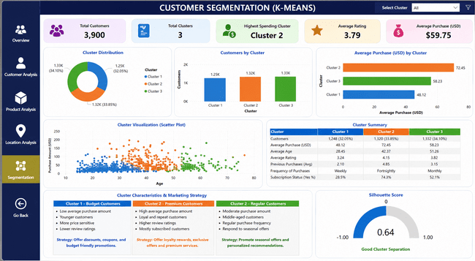
Figure 2 — Orange Data Mining K-Means clustering output
12 | Working of the K-Means Algorithm

Step 1 — Choose the number of clusters (K = 3)
↓
Step 2 — Randomly initialize three centroids
↓
Step 3 — Calculate the Euclidean distance between each customer and each centroid
↓
Step 4 — Assign every customer to the nearest centroid
↓
Step 5 — Recalculate the centroid of each cluster
↓
Step 6 — Repeat Steps 3–5 until centroid positions no longer change
↓
Final Customer Clusters Generated
13 | Orange Data Mining Workflow

File — Imports the shopping dataset
↓
Select Columns — Selects attributes used for clustering
↓
Edit Domain — Defines variable types
↓
Normalize — Scales numerical values
↓
K-Means — Performs customer segmentation
↓
Data Table / Scatter Plot / Silhouette Plot / Save Data — Outputs
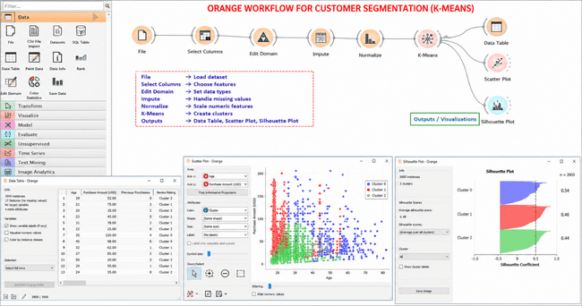

Widget Description
Widget |  | Description
File |  | Imports the shopping dataset.
Select Columns |  | Selects the attributes used for clustering.
Edit Domain |  | Defines variable types.
Normalize |  | Scales numerical values.
K-Means |  | Performs customer segmentation.
Data Table |  | Displays clustered customers.
Scatter Plot |  | Visualizes customer clusters.
Silhouette Plot |  | Measures cluster quality.
Save Data |  | Exports clustered results.
14 | Cluster Analysis

The K-Means algorithm divides customers into three major groups:

Cluster 1 — Budget Customers
Characteristics
- Low purchase amount
- Frequent discount usage
- Price-sensitive
- Moderate shopping frequency
Marketing Strategy
- Coupons
- Flash sales
- Bundle offers

Cluster 2 — Premium Customers
Characteristics
- High spending
- Loyal customers
- Subscription members
- Higher review ratings
Marketing Strategy
- VIP membership
- Loyalty rewards
- Personalized recommendations

Cluster 3 — Seasonal Customers
Characteristics
- Moderate spending
- Purchases concentrated during specific seasons
- Respond well to promotional campaigns
Marketing Strategy
- Festival discounts
- Seasonal promotions
- Holiday campaigns

Dominant Factors Affecting Customer Segmentation
Factor | Importance
Purchase Amount | Very High
Previous Purchases | Very High
Age | High
Review Rating | High
Shopping Frequency | High
Subscription Status | Medium
Season | Medium
Payment Method | Medium
Discount Applied | Medium
Promo Code Used | Medium

Business Insights
- Premium customers contribute the highest revenue and should be retained with loyalty programs.
- Budget customers are highly responsive to discounts and promotional offers.
- Seasonal customers increase purchases during festivals and holiday periods.
- Personalized marketing campaigns are more effective than offering the same promotion to every customer.
- Understanding customer segments helps improve customer satisfaction, optimize marketing costs, and increase overall profitability.
15 | Business Recommendations

- Apply discounts to low-performing product categories.
- Offer exclusive rewards to premium customers.
- Increase marketing campaigns during high-sales seasons.
- Expand promotional activities in high-performing locations.
- Improve customer loyalty programs.
- Personalize recommendations using customer segments.
- Monitor payment trends for future marketing strategies.
16 | Expected Outcomes

- Improve customer satisfaction.
- Increase customer retention.
- Optimize promotional campaigns.
- Increase sales revenue.
- Improve inventory planning.
- Understand customer purchasing behavior.
- Support data-driven business decisions.
- Enhance overall profitability.
17 | Conclusion

This project demonstrates how customer shopping data can be transformed into meaningful business intelligence using MySQL, Power BI, and Orange Data Mining. SQL is used to analyze customer purchasing behavior and answer business questions, Power BI provides interactive dashboards for visualizing key performance indicators, and Orange Data Mining applies the K-Means clustering algorithm to identify customer segments based on shopping behavior.
The K-Means clustering analysis successfully grouped customers into three distinct segments based on their shopping behavior. The most influential factors were Purchase Amount, Previous Purchases, Age, and Review Rating. These segments enable businesses to design targeted marketing campaigns, improve customer retention, optimize promotional strategies, and make better data-driven business decisions. Customer segmentation ultimately helps increase sales while delivering a more personalized shopping experience.
The results enable businesses to identify profitable customer groups, optimize discount strategies, improve promotional campaigns, and develop personalized marketing plans. Overall, the project provides a complete customer analytics solution that supports strategic decision-making, increases customer satisfaction, and improves long-term business growth.

