JARIAN PERMANA
Ecological Conservation
📱 +62 812 9221 3472  📧 jarian.work.1@gmail.com | 🎓 Bachelor of Forestry,  University of Sumatera Utara | linkedin.com/in/jarianpermana  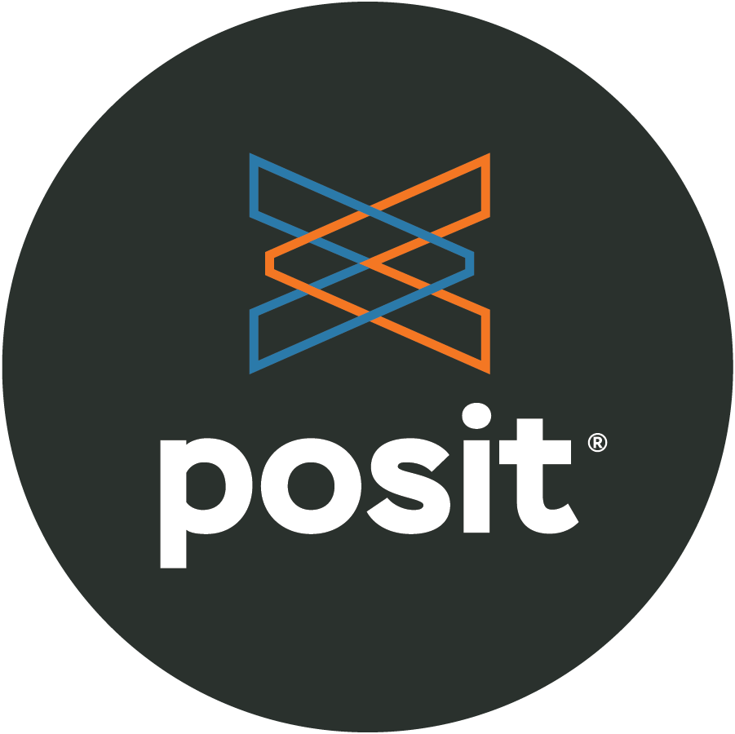 Data Science Portfolio | Jarian Permana
Dedicated conservation professional with 10+ years of working experience with leading NGOs and cross-disciplinary teams in science and conservation action. Expertise includes orangutan habitat management, marine conservation, spatial planning, and community-based initiatives throughout Indonesia. Proven ability to deliver scientific research, engage diverse stakeholders, and implement innovative conservation technologies.

KEY EXPERTISE

TECHNICAL ANALYTICAL  - Biodiversity and Ecology Assessments  - GIS & Spatial Analysis  - Population Viability Assessment  - MEL Analysis  - Strategy Analysis | ANALYTICAL TOOLS  - SMART Conservation Tools  - Maxent Habitat Modeling  - R Studio for Conservation  - Google Earth Engine for Conservation  - VORTEX for Conservation | PROFESSIONAL  - Project Management  - Biodiversity and Ecology Management  - Stakeholder Management

PROFESSIONAL EXPERIENCE
Biodiversity Officer Staff  Fauna & Flora Indonesia Programme | Jul 2022 – Jun 2026
Key Achievements:
- Spearheaded ecological management efforts across priority landscapes in West Kalimantan, delivering integrated terrestrial habitat conservation and seascape habitat assessments within key achievements:
- Pioneered Citizen Science monitoring program in Karimata Islands Nature Reserve, increasing METT scores by 12.5%
- Strengthened wildlife protection and community wellbeing through multi-stakeholder collaboration adjacent to Muara Kendawangan Nature Reserve, increasing METT scores by 6%
- Improved protection and sustainable use of Gunung Palung National Park and adjacent village forests by implementing collaborative patrolling, effective fire prevention, and biodiversity-friendly livelihoods. This resulted in a 55% reduction in forest crimes compared to the 2020 baseline, a 12.6% increase in the Bornean orangutan population, and an METT score of 80.49%
- Successfully facilitated the establishment of fourteen Village Forests, with twelve in the Schwaner landscape and two in the Karimata landscape, all granted official management permits by the Ministry of Environment and Forestry
- A High Value Conservation Assessment (HVC) was conducted for the Arabella-Schwaner Landscape in West Kalimantan. This assessment utilized a variety of approaches, including the HCV-HCS approach, the STAR Metric, and modeling techniques by COLA Landscape. Additionally, a Population Viability Assessment (PVA) was conducted to assess the impact of the project on the local population.
- Led the design and implementation of village forest restoration programs in West Kalimantan, systematically testing various methods before standardizing procedures grounded in the Ten Golden Rules for Reforestation. This approach ensured a balanced outcome of carbon sequestration, biodiversity restoration, and livelihood improvement. Two village forests have been successfully implemented, while 20 additional village forests have been designed to sustain and scale these efforts
- Contributes a guide for standardizing data management and processing, as well as a biodiversity and ecology assessment methodology for the national level
- Leading MEL (Monitoring, Evaluation & Learning) for the FFI West Kalimantan project including analysis and strategy recommendation
- Ensured the successful completion of all fund reports for FFI West Kalimantan, contributing to effective donor engagement and sustained support from Darwin Initiative, Arcadia, Halcyon, and Rainforest Trust
- Co-authored the Project Design Document (PDD) for a climate project in West Kalimantan, contributing technical biodiversity and carbon data
- Co-developed and implemented the SMART conservation data management system for multiple stakeholders in West Kalimantan, including BKSDA West Kalimantan, DLHK West Kalimantan, and Village Forest management units
- Built and managed a large-scale biodiversity and ecology database consolidating survey data, camera trap records, SMART-based wildlife and threat monitoring, and orangutan/gibbon survey data. Automated end-to-end data processing and management using R Studio, enabling scalable, reproducible, and error-resistant conservation data workflows
- Engaged strategic partners including BKSDA, DKP West Kalimantan, regional government, and DLHK West Kalimantan to foster long-term collaboration in both marine and terrestrial conservation initiatives

Camera Trap Leader  Fauna & Flora Indonesia Programme | 2020 – 2022
Key Achievements:
- Deployed 100 camera traps across 91 survey plots (2×2 km grid) in Riau Ecosystem Restoration Area
- Identified 23 species including critically endangered Sumatran tiger, pangolin, and clouded leopard
- Developed Maxent habitat suitability model indicating 44.16% tiger occupancy in study area

Spatial and Data Analyst Officer  Amfibi Reptil Sumatra  Key Achievements: | 2019 – 2020
- Collected herpetofauna data across Java Island (Ujung Kulon, Gunung Gede Pangrango, Leuweung Sancang, Gunung Slamet), including the first field expedition to record the Gunung Slamet tree frog later described by other researchers as a species new to science, Zhangixalus faritsalhadii
- Built a comprehensive herpetofauna database compiling data from both field surveys across Java and systematic literature review, serving as the foundation for two published books
- Authored and published two scientific books documenting amphibian species: 'Amfibi di Taman Nasional Batang Gadis' (Amphibians of Batang Gadis National Park) and 'Amfibi di Pulau Jawa' (Amphibians of Java Island), contributing to baseline biodiversity knowledge and conservation reference materials

Facilitator and Mapping of Cocoa Farmers  USAID – Lestari  Key Achievements: | 2019
- Created spatial-based fieldwork SOP for Aceh and North Sumatra land rehabilitation projects
- Evaluated cocoa production systems by analyzing relationships between tree population, land area, and annual yield, providing critical inputs for sustainable financing models and market access strategies for smallholder farmers

Community Development Facilitator  Pesona Tropis Alam Indonesia (PETAI)  Key Achievements: | 2015 – 2017
- Facilitated social forestry permit acquisition in Pakpak Bharat District, North Sumatra
- Developed organic farming and market analysis as alternative livelihoods for forest communities
- Contributed to the facilitation of Social Forestry (Perhutanan Sosial – HKm) permit application for three villages in Pakpak Bharat (Desa Aornakan I, Desa Kuta Tinggi, and Desa Sibongkaras), providing direct assistance to farmer groups throughout the permit submission process to the Ministry of Environment and Forestry (KLHK)

PART-TIME CONSULTING
Biodiversity & MEL Specialist  PT Terra Equity Impact (Independent / Part-time) | Oct 2025 – Present
Key Achievements:
- Engaged as an independent paid specialist (tenaga ahli), providing biodiversity assessment and Monitoring, Evaluation & Learning (MEL) support for forest-carbon and biodiversity investment projects
- Assessed forest eligibility against internationally accepted definitions (UNFCCC, FAO, and IPCC), covering thresholds such as minimum forest area, tree height, and crown cover across mature, secondary, degraded, and wetland forests
- Contributed to the verification and monitoring of forest-carbon projects spanning REDD (reduced emissions from deforestation and forest degradation), ARR (afforestation, reforestation and revegetation), and IFM (improved forest management) activities under the VCS Program
- Delivered biodiversity monitoring and verification reports for the BKT Bahenap VF, AHI Mentari Huluan Jambi, and KBCF Himba Lestari projects, turning field data into standard and investor-ready documentation

PUBLICATIONS & PRESENTATIONS

Published Books
- Amfibi di Taman Nasional Batang Gadis – ISBN: 978-3-9822269-0-3
- Amfibi Pulau Jawa - Panduan Bergambar dan Identifikasi – ISBN: 978-3-9822269-9-6
- Seraut Suaka di Hutan Gambut – ISBN: 978-623-440-017-5
- Prosedur Tetap Patroli Kawasan Berbasis SMART – Fauna & Flora Indonesia Programme
- Panduan Kehati - Fauna & Flora Indonesia Programme (Panduan Survei Kehati)

International Conference Presentations
- Oral: "The Success Strategy of Forest Community Program in Pakpak Bharat" – AEFS 2019
- Oral: "Study and Challenges of Orangutan Habitat in Muara Kendawangan" – ATBC 2023
- Poster: "Preliminary Study on Sea Turtle in Karimata Islands" & "Citizen Science in Karimata" – APCRS 2023
TRAINING DELIVERED

TRAINING TOPIC | AUDIENCE
Maxent Tools Application for Conservation | BBKSDA Riau
Camera Trap Techniques & Data Analysis | BBKSDA Riau
SMART Tools for Conservation | BKSDA West Kalimantan, IOI Group
Biodiversity Identification & Survey Methods | IOI Group
Public Lecture: Analysis Tools for Conservation | University of Tanjung Pura
Identification of Herpetofauna | University of Nastional (UNAS)
"Conservation is not just about saving species – it's about building sustainable relationships between people and nature."

