**Introduction**

This dataset mainly deals with how customers are feeling about their airline services. In this airline services utilized twitter. In twitter, customer of airline services can tweet their opinions about their experience in flight travelled .in this social media has a lot of information about airline services. This tweet are collected and explored the sentimental analysis about the airline services to track customer satisfaction report and discover location of the customer. Using this dataset mainly analyzed best and worst airlines and also to predicted the most common issues occurred in airline services. Analyzed dataset and predict and predicted positive and negative feedbacks and visualized using graphical analysis. Divided data set into train and test datasets trained the train dataset using different models like logistic regression classifier, KNeighbors classifier, SVC, Decision Tree Classifier, Random Forest classifier, AdaBoost classifier and GaussianNB. The results of our experiments demonstrate that the Random forest approach good score of accuracy.

**Dataset basic explanation**

Twitter airline dataset are analyzed and most common problems occurs during services are predicted and location of the predicted tweets are visualized. Then several sentiment classification algorithms including LogisticRegression, KNeighbors, SVC, DecisionTree, RandomForest, AdaBoost and GaussianNB are tested and compared. In the test results, the best sentiment classification algorithms for airline services companies are selected based on good accuracy. In the next section, some related works on sentiment analysis and machine learning classifier are discussed. Then the proposed system is described and classification approaches are explained. The experiment section describes the experimental results from different sentiment classification algorithms tested on airline services datasets. Finally, the best sentiment analysis algorithm for airline services is presented and several directions of future work are also suggested. Adeborna et al adopted Naive Bayesian method in sentiment detection process by comparing with SVM and Entropy. The result of this case study reached 86.4% accuracy in subjectivity classification and displayed specific topics describing the nature of the sentiment. In this research, the author only used unigrams as sentiment classification features in Naive Bayes algorithm, which can cause problems because phrases and negation terms can change sentiment orientation of those terms in sentences . In my work, seven classifier are compared and random forest classifier yields higher accuracy. A discussion of the relationship between sentiment classification and airline service domain studied. This airline data set is mainly focus to find positive feedback, and negative feed backs.

**Classification models details.**

for this data set used classification models are used to predict accuracy of getting feedbacks. The classification exploration that can be used to extract model describing important data classes or to predict future data trends. Classification is a machine learning technique used to predict group memebership for data instances. Machine learning refers to a system that has the capability to automatically learn knowledge from the post experience. This classification approaches predicts categorical labels where as prediction model continuous valued functions and also it is one of the task of generalizing known structure to apply to new data. The different classification approaches are implemented for the twitter airline dataset to find the sentiment of the tweets. They are described as below

**Logistic Regression**

Logistic regression is a supervised learning classification algorithm used to predict the probability of a target variable. It is one of the simplest ML algorithms that can be used for various classification problems such as spam detection, Diabetes prediction, cancer detection etc.The goal of logistic regression is to find the best fitting model to describe the relationship between the dichotomous characteristic of interest and a set of independent variables hat determine an outcome. The outcome is measured with a dichotomous variable.

**Decision Tree**

Decision Tree Classification. Decision tree builds classification or regression models in the form of a tree structure. It breaks down a dataset into smaller and smaller subsets while at the same time an associated decision tree is incrementally developed. Decision trees can handle both categorical and numerical data.It is a flowchart-like tree structure, in which each internal node represents a test on an attribute and each branch represents an outcome of the test, and each leaf node represents a class. Decision tree builds classification or regression models in the form of a tree structure. It breaks down a data set into smaller and smaller subsets while at the same time an associated decision tree is incrementally developed. The final result is a tree with decision nodes and leaf nodes. The topmost decision node in a tree which corresponds to the best predictor called root node

**AdaBoost classifier**

AdaBoost is the short for adapting boosting. AdaBoost classifier is a meta estimator that begins by fitting a classifier on the original dataset and then fits additional copies of the classifier on the same dataset but where the weights of incorrectly classified instances are adjusted such that subsequent classifiers focus more on difficult cases.

**Gaussian NB**

Gaussian Naive Bayes is a variant of Naive Bayes that follows Gaussian normal distribution and supports continuous data. Naive Bayes are a group of supervised machine learning classification algorithms based on the Bayes theorem. It is a simple classification technique, but has high functionality Gaussian NB classifier is a classification technique based on Bayes Theorem with an assumption of independence among predictors. Naive Bayes model is easy to build and particularly useful for very large data sets. Along with simplicity, Naive Bayes is known to outperform even highly sophisticated classification methods. When dealing with Gaussian Naïve Bayes classifier, the outcome model will have a high-performance with high training speed with the capabilities to predict the probability of the feature that belongs to Zk class

**Multinomial Naive Bayes Classifier.**

This model is suitable for classification with discrete features. This multinomial discrete normally requires integer feature counts. However, in practice, fractional counts.

**Proposed System**

In this paper, tweets about people’s flight experiences are gathered from Twitter and airline companies can make suggestion about the people comments based their trip. Fig 1 shows the block diagram of the proposed system. The dataset contains about 14,640 tweets which are collected on airline reviews. Normalized sentiment by airline I next plotted how the relative number of the individual sentiments varies across different airlines. United had the most negative tweets, however, it also has the most tweets. The number of tweets about an airline may be correlated to the number of planes the airline operates. I therefore divided the tweets with individual sentiments by total number of tweets. It appears that US Airways has relatively higher tweets with negative sentiments. I investigated the reason for negative sentiments. Every build to perform sentiment analysis on the data set. In our data set, about 80% of the negative reviews have a negative reason label, yet the rests are labeled as “can’t tell”. By knowing every review’s negative reason, we can give specific suggestions to different airline companies on how to improve their service. Review is labeled as positive, negative or neutral. First, a reason to each negative response were analyzed as late flight, lost luggage, etc and also seven different classifier model are In existing work, the dataset was analyzed and predict only the negative tweets and visualized the negative tweets using word cloud. So it displays the frequently tweeted words from the user about the airline service. But in this paper, the proposed work is to collect the negative reviews separately and form a word cloud and also the locations of the negatively tweeted user are visualized using Google map. This visualization displays the location of the user easily who is negatively tweeted. Then seven different classification methods are implemented for training and testing. They are Logistic Regression classifier, Random Forest classifier, AdaBoost classifier and GaussianNB. These classifiers were called as Supervised Learning algorithm. The training process continues until the model achieves a desired level of accuracy on the training data. For most of the sentiment classification research, the accuracy of the classification result is evaluated by calculating the ratio between correctly classified tweet and incorrectly classified tweets. The calculation of precision, recall and f measure are known to be common accuracy evaluation method for sentiment classification result.

**RESULTS AND DISCUSSIONS**

In this proposed work, the dataset contains various tweets based on different airline company services. The “Twitter Airline Sentiment” dataset was downloaded from Kaggle which contains tweets covering six U.S. airline companies with a total number of (14,640) tweets, each of which is labeled according to sentiment polarity as: positive, negative, and neutral. The six U.S airline companies and the total number tweets collected on each airlines are United (3822), US airways (2913), American (2759), Southwest (2420), Delta (2222) and Virgin America (504) respectively. Then these tweets are analyzed and predict the top most negative reasons (such as late flight or rude service). Before training machine-learning models on the data, some exploratory data analysis was conducted on the dataset to get a better analysis. Fig 2 represents the total number of tweets collected for each airline. Below figure shows the total number of tweets for each sentiment. The numbers of negative, neutral and positive tweets are 9178, 3099 and 2363 respectively. Below figure represents the pie-chart representation of airline sentiment. It shows 62.69% of the tweets contain negative comments, 21.17% of the tweets contain neutral comments and 16.14% of the tweets contain positive comments from the customer services. It shows that customers had tweeted more negative comments and it is further analyzed to predict the issues on the airline services. It is also investigated how the sentiments vary across airlines.

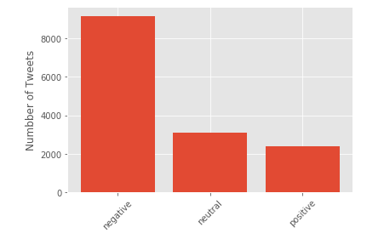

Total number of tweets for each sentiment

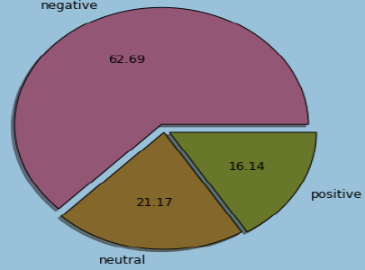

Pie-chart representation of airline sentiment

Represents how sentiments vary across different airlines services. United had the most tweets with negative sentiment and it has the maximum number of tweets. The number of tweets about an airline may be correlated to the number of planes the airline operates. Then normalize the number of individual sentiments by the total number of tweets to make relative comparisons. figure shows the reason for negative comment reported in the tweets. The excluded data where the reason was not specified or reason was given as 'can't tell' are reported more in the dataset. This reduced the number of negative comments of the airline services. This plot shows that the most common reason for negative sentiment was customer service issue, followed by late fight and cancelled flights.

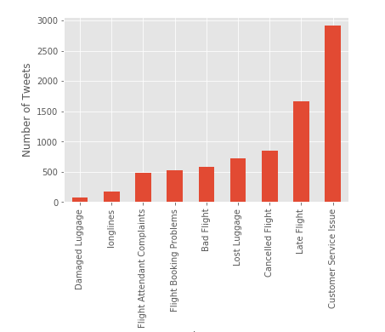

Negative Reason

I plotted the reason for negative comment reported in the tweets. I excluded data where the reason was given as 'can't tell'. The plot shows that the most common reason for negative sentiment was customer service issue, followed by late fight and canceled flights.

Represents the pie chart of top 5 negative reasons. It shows that customer service issue has occurred 39.67% compared to other issues. Below figure grouped the reason for negative comments by airline, and plots them in stacked bar graphs. United had most number of negative tweets, however, the relative distribution of negative comments was different for different airlines. Southwest had the most number of negative comments due to customer service issues. Then normalize the reason for negative comment by total number of negative tweets for each airline.

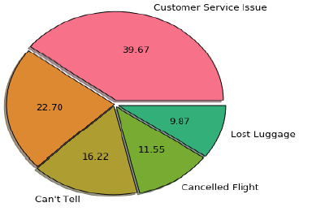

Reason for top 5 negative comments

After normalizing, the contribution of negative tweets due to poorer customer service is higher (more than 50%) for Virgin America, Delta and Southwest. US Airways had the least fractions of negative tweets due to customer service issues. US airways and American Airlines have as much complaints due to customer service as due to lost luggage.

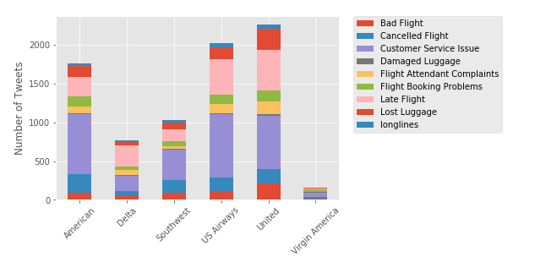

Airline

I next grouped the reason for negative comments by airline, and plot them in stacked bar graphs. United had most number of negative tweets, however, the relative distribution of negative comments was different for different airlines. Southwest had the most number of negative comments due to customer service issues. I next normalize the reason for negative comment by total number of negative tweets for each airline. After normalizing, the contribution of negative tweets due to poorer customer service is higher (more than 50%) for Virgin America, Delta and Southwest. US Airways had the least fractions of negative tweets due to customer service issues. US airways and American Airlines have as much complaints due to customer service as due to lost luggage. Represents the word cloud for the negative tweets. These are the frequently repeated words for the negative comments of the airline services. Some of the negative words are flight cancelled, delayed, call hold, weather problem service issue etc. The tweets by location are plotted as shown in Figure of the 14640 tweets; only 841 had data on location. The locations of tweets across USA are plotted. Tweets appear to be clustered around big airports, like New York, Chicago, Los Angeles, etc. Therefore got data for the 30 busiest airports locations from Wikipedia, and assigned each tweet to the airport nearest to it. Each tweet was made closest to the corresponding airport was assumed. This works well in most cases except when airports are very close to each other. This visualization makes the airline services companies to know at which location, at which airline and at which customer had tweeted negative comments can be analyzed and that faults can be resolved by the airline services.

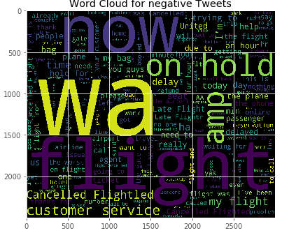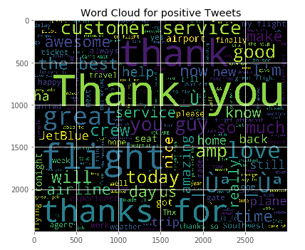

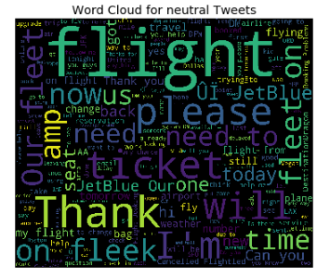

The cloud of words provides a nice visual representation of the word frequency for each type of sentiment (negative: left or positive: right). The size of the word correlates with its frequency accross all tweets. We can get an idea of what people are talking about. For example, for negative sentiment, people seem to complain about cancelled or delayed flights, and hours waiting. However, for positive sentiment, people are mostly thankful and they talk about great service/flight. The experiments with the seven classification models are conducted to evaluate the machine learning classification approaches includes Logistic Regression, RandomForest, AdaBoost and GaussianNB classifier. Accuracy is a ratio of correctly predicted observation to the total observations. Accuracy is the most intuitive performance measure. This performance measure is used to find the accuracy is given in the equation

Accuracy = ( True Positive + True Negative ) / Total Population

where True Positive is the number of correct predictions that the occurrence is positive and True Negative is the number of correct predictions that the occurrence is negative respectively.

Fig 10 represents the comparison of the classifier model. The GaussianNB classifier gets the lowest accuracy, which is 57.24%. The KNeighborsClassifier obtain the accuracy of 58.91%. The Logistic Regression and SVC classifier gets the same accuracy of 64.51%. The MultinomialNB and AdaBoostClassifier contains the accuracy of 76.24% and 72.41% respectively. The accuracy of the Random Forest Classifier model classification reached 75.02% which is the highest accuracy. In our experiment, the accuracy of the Random Forest Classifier is high compared to other classifier and also it will be the most suitable sentiment classification methods for tweets about airline services.

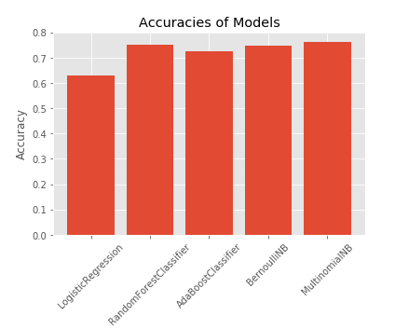

Observe the above graphical visualization.

Logistic Regression classification = 63.10

Random forest classification = 75.02

Ada Boost classification = 72.41

BernouliNB = 74.71

MultinomialNB = 76.24

See the above accuracy among this models MultinomiaNB classification got high accuracy is 76.24.

**CONCLUSION**

In recent years, Twitter has become the online customer service platform in the world. In this paper, Twitter Airline Sentiment dataset is extracted and more than 60% as negative comments are only predicted. So the negative tweets are analyzed and the wordcloud of the negative words are created. On analyzing the dataset, United airlines services contains the most number of tweets, followed by US airway and American airlines services. United, US airways and American airlines have more proportions of negative comments whereas, Southwest, Delta and Virgin America had less proportion of negative comments. The customer service issues and late flights are the two main reasons for negative comments of the customer in the airline services are analyzed. US Airways contains the highest proportion of negative tweets due to customer service issues. Here, the customer’s problems can be known to the airline services to resolve and the location of the customers are mapped using graphical visualization. Then the seven classification methods are compared for Twitter sentiments of airline services and the best sentiment classifier was selected, which is the Random forest classifier. This classifier can be used for airline services business analysis applications, which will be able to automatically classify customer's satisfaction about airline services.

**ACKNOWLEDGMENT**

This work was supported by Department of Computer Science and Engineering, Annamalai University and funded by University Grants Commission (UGC) of Indian Union government.