Execution Time, Memory & Complexity
  - Lab 3 — Performance Measurement and Complexity Comparison
Name | Harinand S
Roll No. | 2401201056
Specialisation | BCA (AI & Data Science)
Section | ________________
Lab Name: Lab 3 — Smart Resource Allocation and Scheduling System using Greedy Algorithms

Measurement method
Execution time was measured with time.perf_counter(); peak traced Python allocation was measured with tracemalloc. Each case was run five times and the median was reported. Values are machine- and runtime-dependent; they are measured results from this execution, not universal constants.

Measured results
Algorithm | Input n | Median time (ms) | Peak memory (KiB)
Fractional Knapsack | 100 | 0.0596 | 1.41
Activity Selection | 100 | 0.0128 | 1.79
Huffman Coding | 100 | 0.0983 | 8.92
Fractional Knapsack | 500 | 0.5260 | 21.32
Activity Selection | 500 | 0.0703 | 11.91
Huffman Coding | 500 | 0.1269 | 14.07
Fractional Knapsack | 1000 | 1.3580 | 44.77
Activity Selection | 1000 | 0.1309 | 23.60
Huffman Coding | 1000 | 0.1788 | 21.03
Fractional Knapsack | 2500 | 2.8864 | 114.98
Activity Selection | 2500 | 0.4153 | 58.66
Huffman Coding | 2500 | 0.2755 | 39.72
Fractional Knapsack | 5000 | 5.9446 | 232.02
Activity Selection | 5000 | 1.0939 | 117.10
Huffman Coding | 5000 | 0.4448 | 72.68

Asymptotic complexity
Algorithm | Time complexity | Auxiliary space | Reason
Fractional Knapsack | O(n log n) | O(n) | Sorting by value/weight ratio dominates.
Activity Selection | O(n log n) | O(n) | Sorting by finish time dominates; scan is O(n).
Huffman Coding | O(k log k) | O(k) | k distinct symbols; heap operations and tree construction dominate.

Performance graph
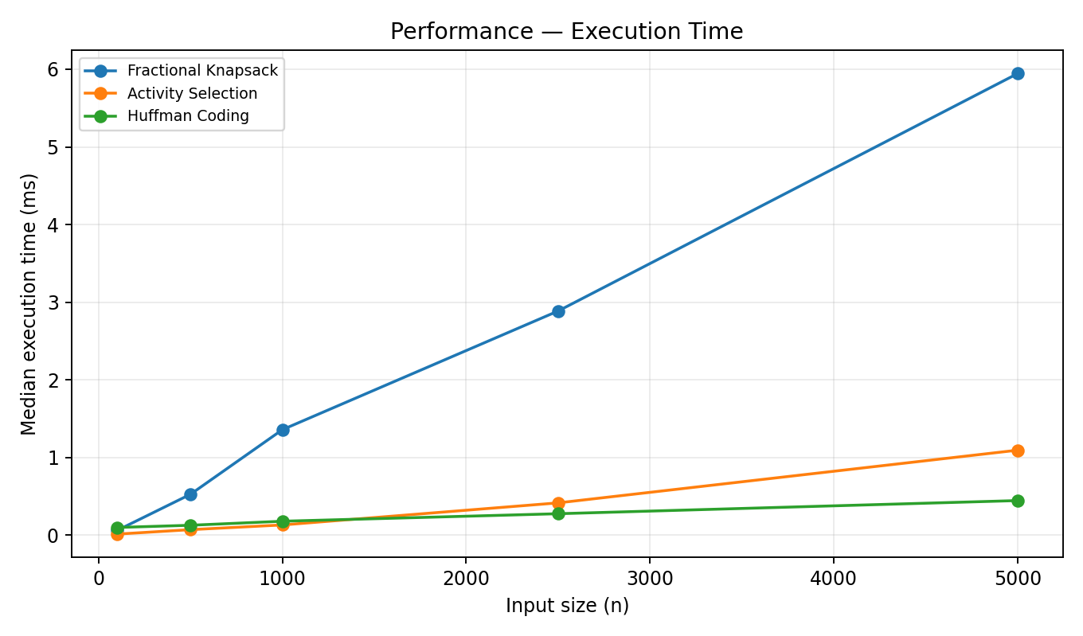
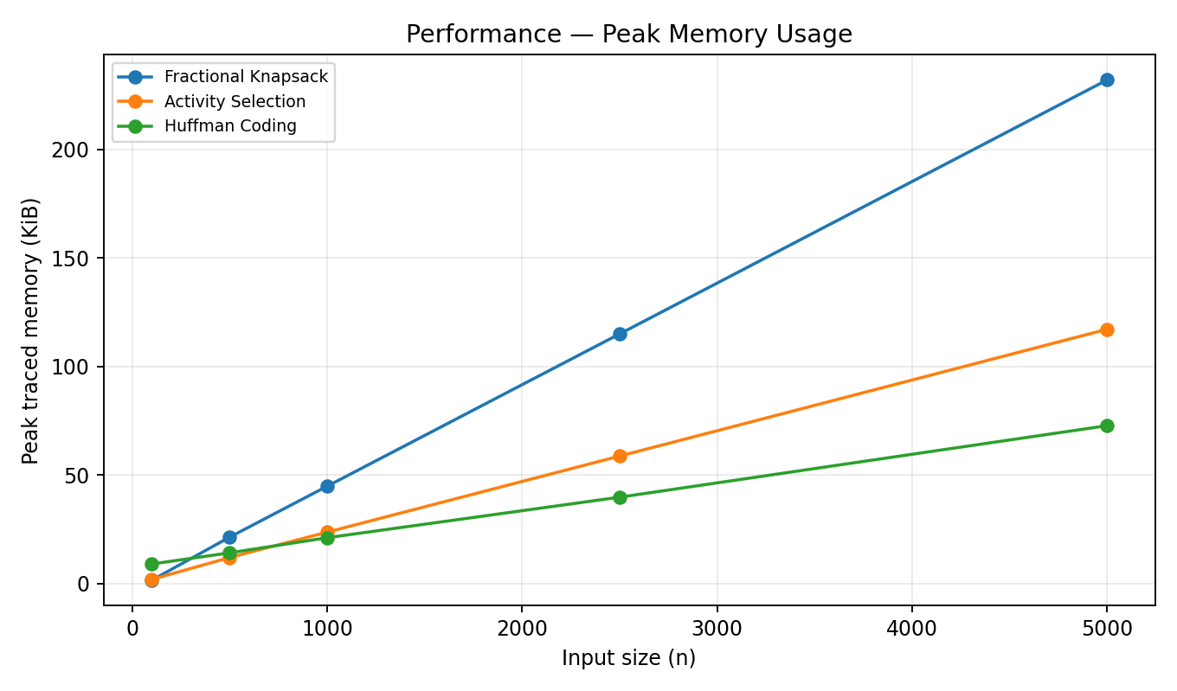

Observation
Fractional Knapsack and Activity Selection show the expected sorting-related growth. Huffman timings depend strongly on the number of distinct symbols (k), not only the raw text length. The memory values are Python-traced peak allocations and do not include every native/runtime allocation.

