Greedy Algorithm Visualizations
  - Lab 3 — Resource Allocation, Scheduling, Huffman Tree and Performance
Name | Harinand S
Roll No. | 2401201056
Specialisation | BCA (AI & Data Science)
Section | ________________
Lab Name: Lab 3 — Smart Resource Allocation and Scheduling System using Greedy Algorithms

1. Fractional Knapsack — Resource Allocation
The chart shows the fraction of each selected item placed into a capacity-50 knapsack. Gold and Silver are fully selected; two-thirds of Bronze is selected. Total value = 240.
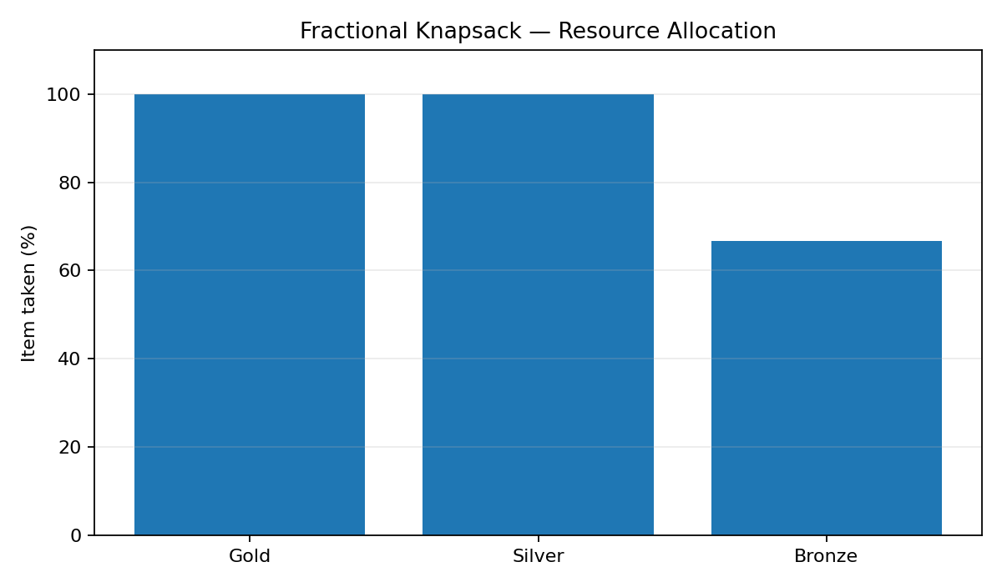

2. Activity Selection — Timeline
The earliest-finish-time greedy strategy selects A1 [1,4], A4 [5,7], and A8 [8,11], producing three non-overlapping activities.
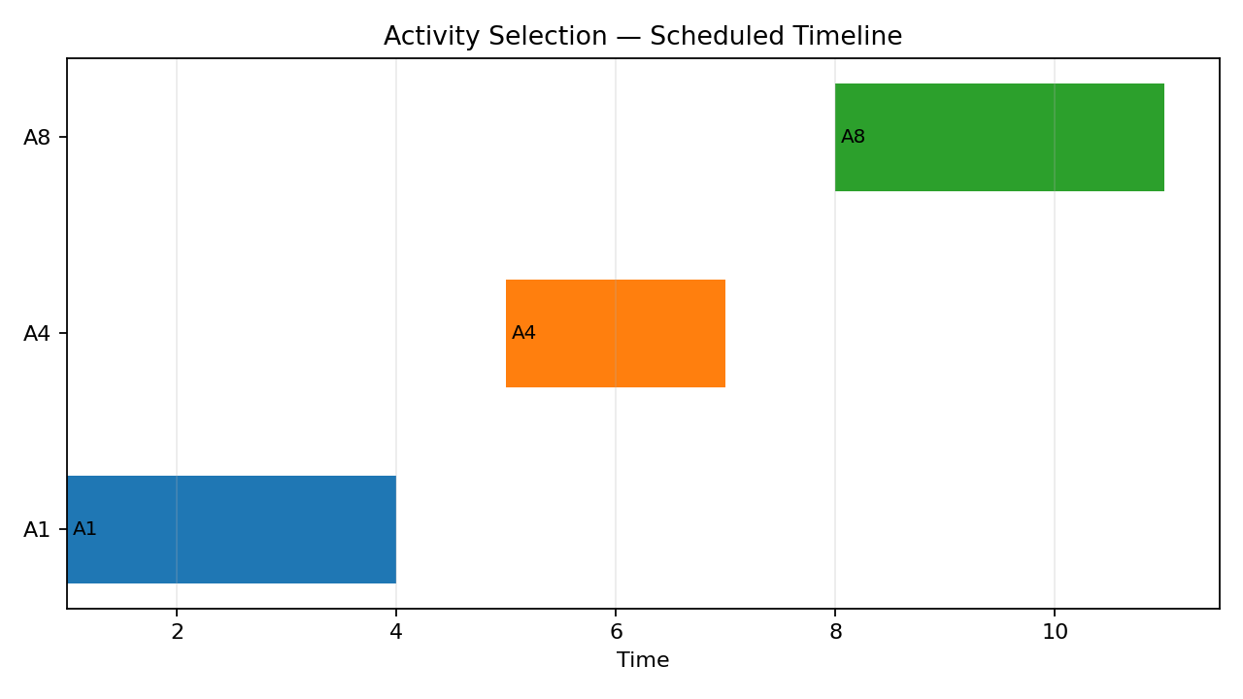

3. Huffman Tree
Huffman Coding repeatedly merges the two least-frequent nodes. Left edges represent 0 and right edges represent 1. The displayed tree is generated from the sample string 'abracadabra'.
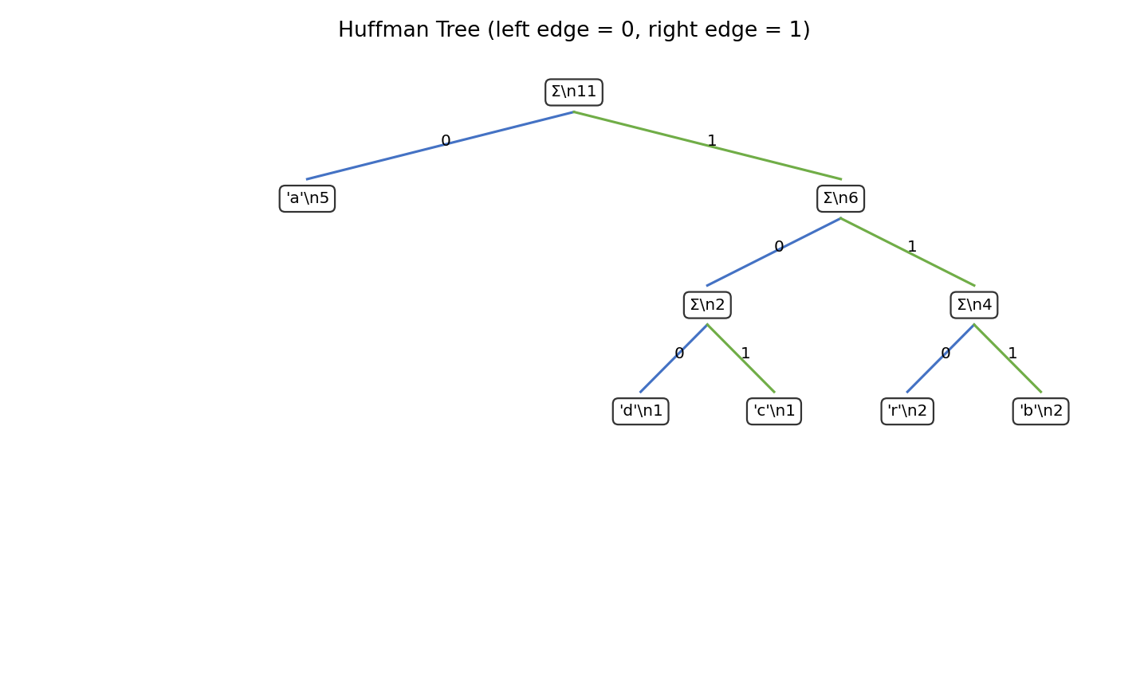

4. Performance Graphs
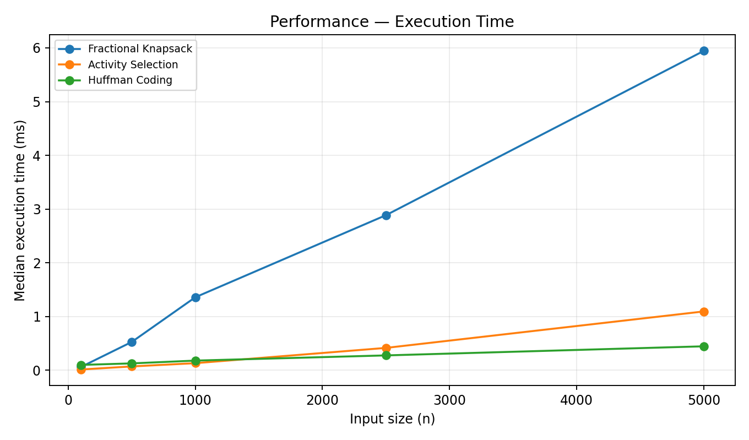
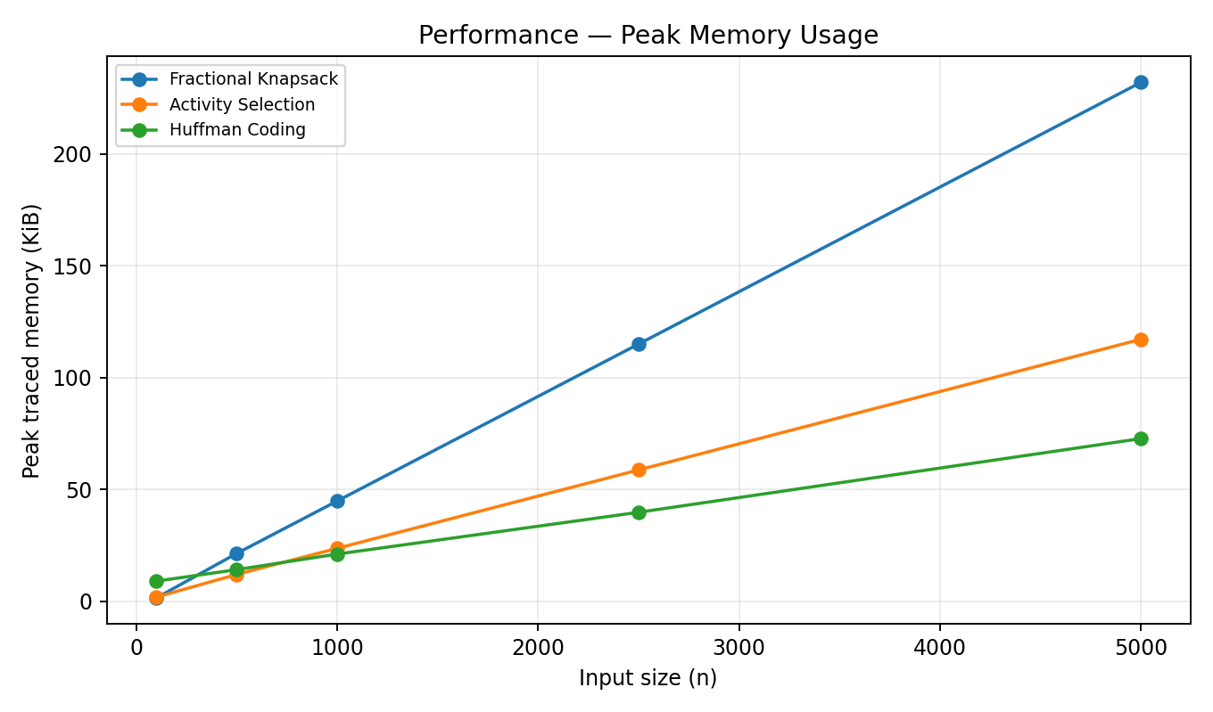

5. Program Output Screenshot
Generated from the actual execution of greedy_lab3.py.
