Lab 3 Complete Report
  - Smart Resource Allocation and Scheduling System using Greedy Algorithms
Name | Harinand S
Roll No. | 2401201056
Specialisation | BCA (AI & Data Science)
Section | ________________
Lab Name: Lab 3 — Smart Resource Allocation and Scheduling System using Greedy Algorithms

Question / Aim
Develop a Smart Resource Allocation and Scheduling System using greedy algorithms to solve resource allocation, activity scheduling, and data compression problems. Implement Fractional Knapsack, Activity Selection, and Huffman Coding; analyze execution time and memory use; and generate visualizations.

1. Introduction
A greedy algorithm constructs a solution by repeatedly selecting the locally best available choice. This lab demonstrates three classic applications: allocating divisible resources, scheduling compatible activities, and constructing variable-length prefix codes for compression.

2. Tools and Environment
Language: Python 3. Libraries: heapq and collections for Huffman Coding; time and tracemalloc for performance measurement; matplotlib for visualizations. Timing and memory numbers are measured on the execution environment used to generate this report and may differ on another computer.

3. Solution 1 — Fractional Knapsack
Problem: Given items with weights and values and a capacity, maximize value when fractions of items are allowed.
Greedy rule: Sort by value/weight ratio in descending order, take the highest-ratio items first, and take a fraction of the next item if capacity is insufficient.
Sample input: Gold (weight 10, value 60), Silver (20, 100), Bronze (30, 120), capacity 50. Ratios are 6, 5, and 4. The algorithm takes Gold and Silver fully and 2/3 of Bronze. Maximum value = 60 + 100 + 80 = 240.
Why greedy works: The value per unit weight is constant within each divisible item. If a solution uses weight from a lower-ratio item while a higher-ratio item remains available, exchanging that weight improves or preserves value. Repeating the exchange yields the ratio-sorted solution.
Complexity: O(n log n) time for sorting and O(n) auxiliary space for the sorted list and selection.
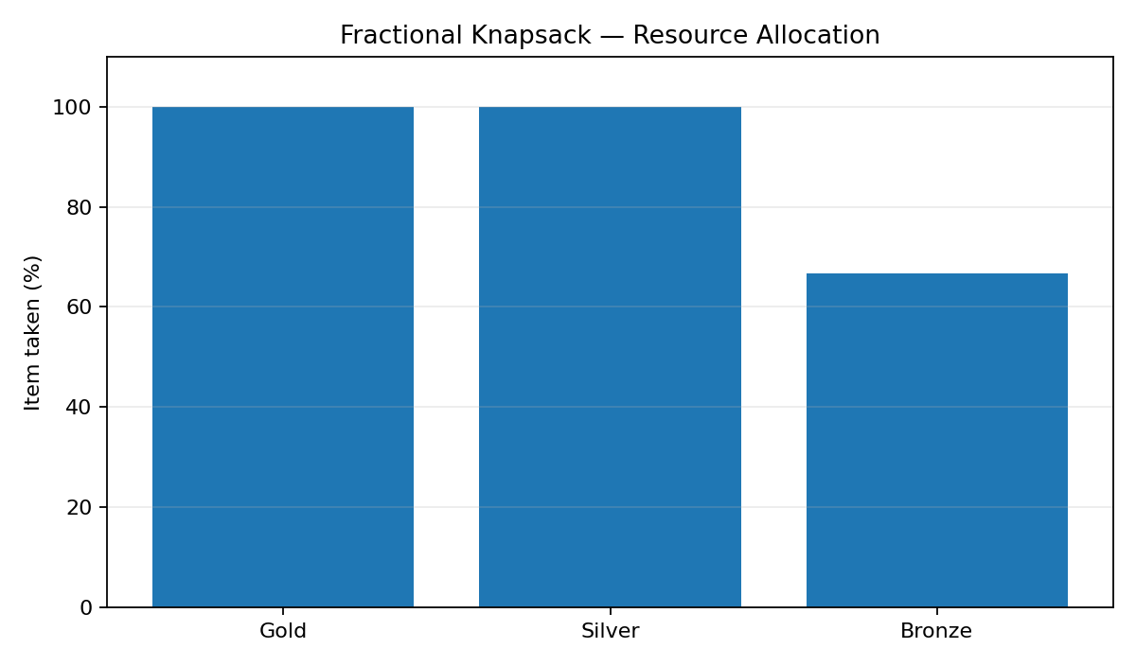

4. Solution 2 — Activity Selection
Problem: Select the maximum number of mutually compatible activities, each with a start and finish time, for one resource.
Greedy rule: Sort activities by finish time. Select the first activity, then select each activity whose start time is greater than or equal to the finish time of the last selected activity.
For the supplied sample, the selected schedule is A1 [1,4], A4 [5,7], A8 [8,11]. This gives three compatible activities.
Why greedy works: An activity that finishes earliest leaves at least as much time for all remaining activities as any activity that finishes later. Replacing the first activity of an optimal schedule with the earliest-finishing compatible activity cannot reduce the number of activities; the same argument applies to the remaining suffix.
Complexity: O(n log n) time for sorting, followed by an O(n) scan; O(n) auxiliary space for sorting and the selected list.
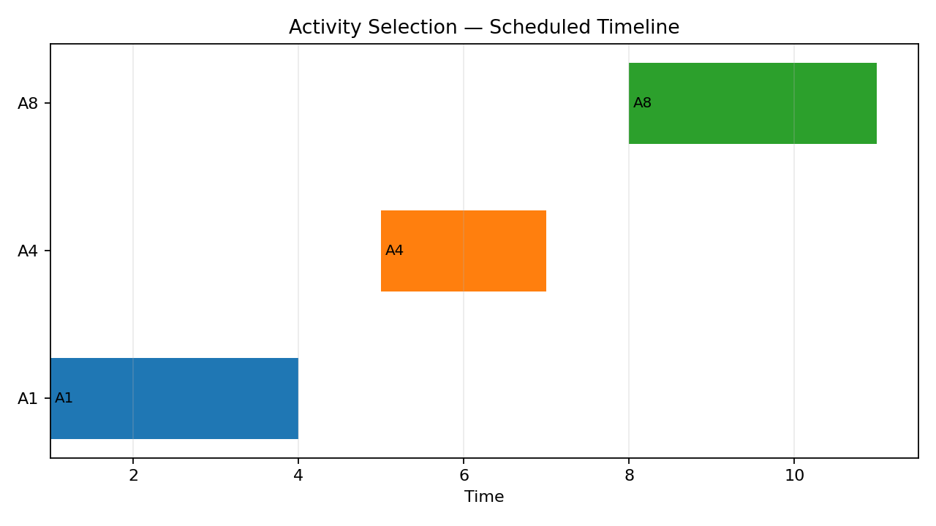

5. Solution 3 — Huffman Coding
Problem: Create a prefix-free binary code from symbol frequencies so that frequent symbols generally use shorter codes and the total weighted encoded length is minimized.
Greedy rule: Put each symbol in a min-heap by frequency. Repeatedly remove the two least-frequent nodes, combine them as children of a new node with summed frequency, and reinsert the parent. Traverse left as 0 and right as 1 to generate codes.
Sample text: abracadabra. The generated code map is {'a': '0', 'b': '111', 'c': '101', 'd': '100', 'r': '110'} for this run. Encoded length = 23 bits versus 88 bits when each of the 11 characters is represented as 8 bits. The encoded/original ratio is 26.14%, excluding codebook/header storage.
Why greedy works: The two least-frequent symbols can be placed as deepest siblings in an optimal prefix tree without increasing the weighted path length. Merging them into one combined symbol reduces the problem to a smaller instance; recursively solving that instance gives an optimal Huffman tree.
Complexity: O(k log k) time and O(k) space, where k is the number of distinct symbols. Building codes traverses the tree.
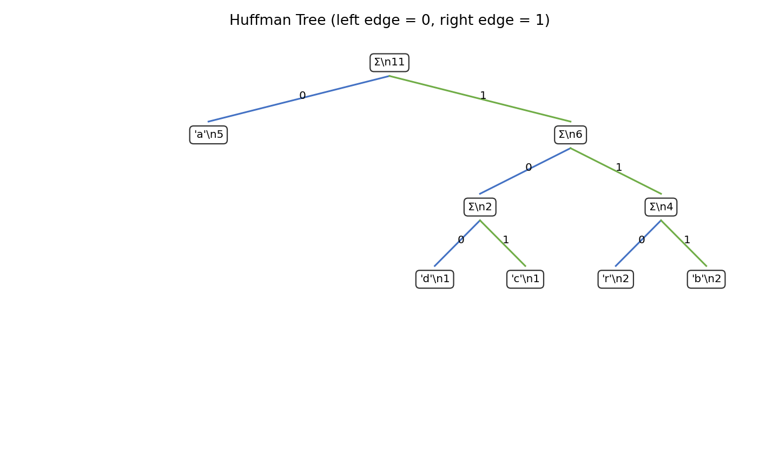

6. Measured Execution Time and Memory
For each input size, each algorithm was measured five times. The reported execution time and peak traced allocation are medians. The memory figure is tracemalloc's Python allocation peak, not total operating-system process memory.
Algorithm | n | Time (ms) | Peak memory (KiB)
Fractional Knapsack | 100 | 0.0596 | 1.41
Activity Selection | 100 | 0.0128 | 1.79
Huffman Coding | 100 | 0.0983 | 8.92
Fractional Knapsack | 500 | 0.5260 | 21.32
Activity Selection | 500 | 0.0703 | 11.91
Huffman Coding | 500 | 0.1269 | 14.07
Fractional Knapsack | 1000 | 1.3580 | 44.77
Activity Selection | 1000 | 0.1309 | 23.60
Huffman Coding | 1000 | 0.1788 | 21.03
Fractional Knapsack | 2500 | 2.8864 | 114.98
Activity Selection | 2500 | 0.4153 | 58.66
Huffman Coding | 2500 | 0.2755 | 39.72
Fractional Knapsack | 5000 | 5.9446 | 232.02
Activity Selection | 5000 | 1.0939 | 117.10
Huffman Coding | 5000 | 0.4448 | 72.68
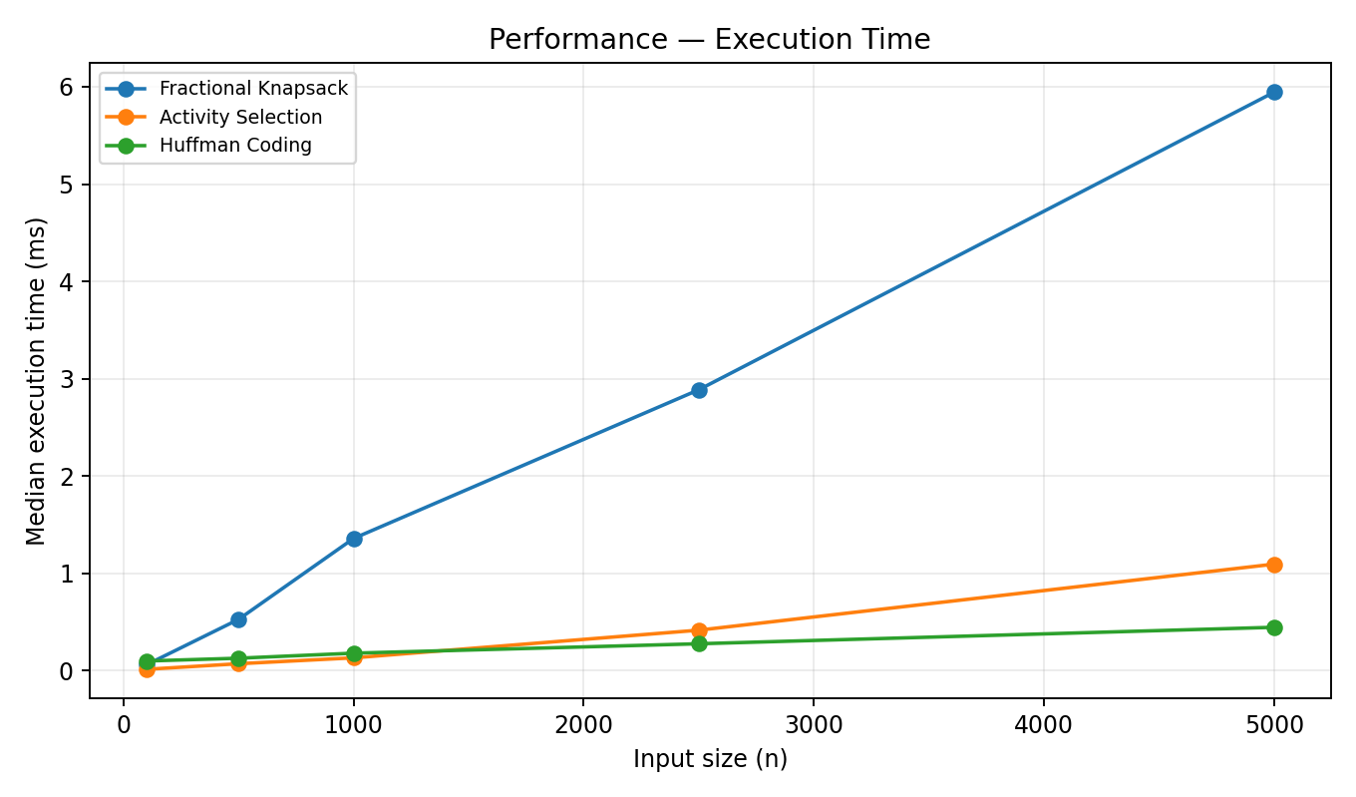
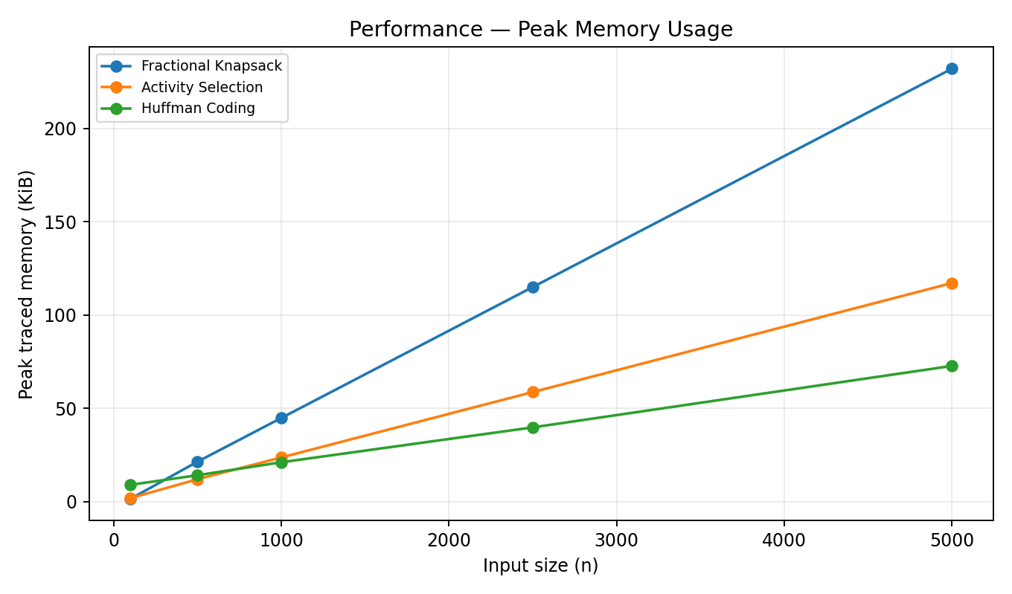

7. Complexity Comparison
Algorithm | Time complexity | Space complexity
Fractional Knapsack | O(n log n) | O(n)
Activity Selection | O(n log n) | O(n)
Huffman Coding | O(k log k) | O(k)

8. Practical Applications
- Fractional Knapsack: allocating divisible budget, bandwidth, or material quantities when value per unit is known.
- Activity Selection: meeting-room booking, classroom/lab scheduling, and selecting non-overlapping tasks.
- Huffman Coding: lossless data compression and entropy coding used in formats and compression pipelines.

9. Observations and Limitations
- Greedy solutions are efficient when the problem has the appropriate greedy-choice property and optimal substructure.
- Fractional Knapsack permits fractions; the same ratio-based greedy strategy is not guaranteed optimal for 0/1 Knapsack, where items cannot be split.
- Activity Selection assumes one shared resource and that activities are compatible when the next start is at least the previous finish.
- Huffman coding's measured cost depends on the number of distinct symbols as well as input length. The sample compression ratio excludes the codebook and file-format overhead.
- Benchmark timings are affected by processor load, Python version, and interpreter overhead; use repeated runs and medians for fairer comparison.

10. Program Output Screenshot
The screenshot below was generated from the actual execution of the submitted Python program.
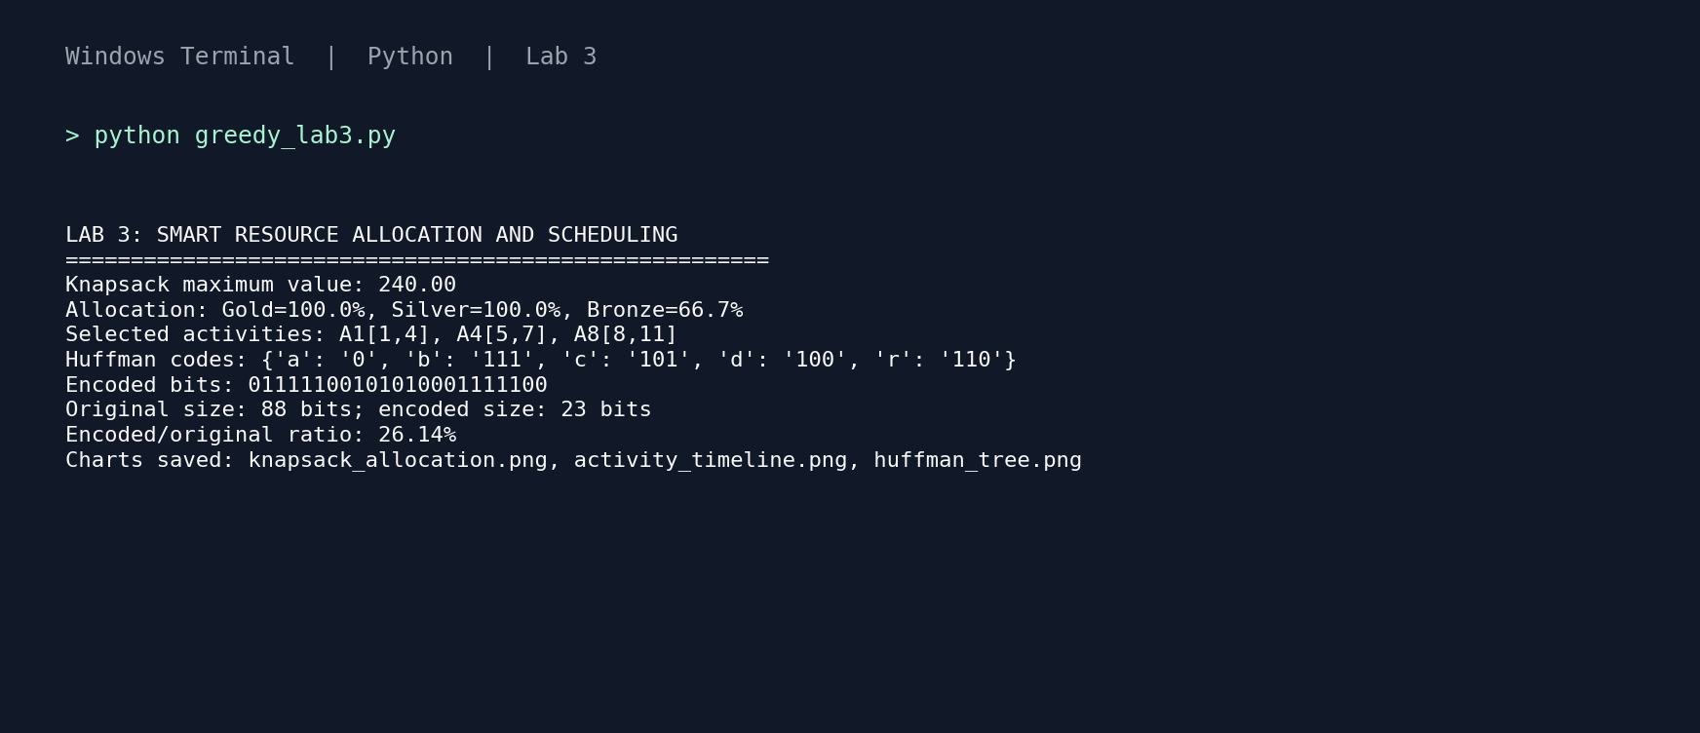

11. Conclusion
The lab implements three greedy algorithms and demonstrates their solutions, visualizations, empirical performance, and asymptotic complexities. Greedy methods can be fast and optimal for the specific structures studied, but their assumptions must be checked before applying them to a new optimization problem.

12. Source Code / Solution
Complete runnable source is provided in the attached project bundle at src/greedy_lab3.py; benchmark runner: src/benchmark_lab3.py. The source listing begins below.
"""
Lab 3: Smart Resource Allocation and Scheduling System using Greedy Algorithms
Student: Kushagra Verma | Roll No.: 2401201044
Specialisation: BCA (AI & Data Science) | Section: __________
Run: python greedy_lab3.py
"""
from collections import Counter
from dataclasses import dataclass
import heapq
import time
import tracemalloc
import random
import statistics
import matplotlib.pyplot as plt

def fractional_knapsack(items, capacity):
"""Return (maximum value, [(name, fraction_taken), ...])."""
if capacity < 0:
raise ValueError("Capacity must be non-negative.")
if any(x["weight"] <= 0 for x in items):
raise ValueError("Every item weight must be positive.")
ordered = sorted(items, key=lambda x: x["value"] / x["weight"], reverse=True)
total, chosen, remaining = 0.0, [], capacity
for item in ordered:
if remaining <= 0:
break
take = min(1.0, remaining / item["weight"])
total += item["value"] * take
remaining -= item["weight"] * take
if take > 0:
chosen.append((item["name"], take))
return total, chosen

def activity_selection(activities):
"""Return maximum-size compatible activity set, sorted by finish time."""
if not activities:
return []
ordered = sorted(activities, key=lambda a: a["finish"])
chosen = [ordered[0]]
last_finish = ordered[0]["finish"]
for act in ordered[1:]:
if act["start"] >= last_finish:
chosen.append(act)
last_finish = act["finish"]
return chosen

@dataclass
class HuffmanNode:
char: str | None
freq: int
left: object = None
right: object = None
def __lt__(self, other):
return self.freq < other.freq

def build_huffman_tree(text):
if not text:
return None
freq = Counter(text)
heap = [HuffmanNode(ch, count) for ch, count in freq.items()]
heapq.heapify(heap)
while len(heap) > 1:
left = heapq.heappop(heap)
right = heapq.heappop(heap)
heapq.heappush(heap, HuffmanNode(None, left.freq + right.freq, left, right))
return heap[0]

def generate_codes(node, prefix="", codes=None):
if codes is None:
codes = {}
if node is None:
return codes
if node.char is not None:
codes[node.char] = prefix or "0"
else:
generate_codes(node.left, prefix + "0", codes)
generate_codes(node.right, prefix + "1", codes)
return codes

def huffman_encode(text):
root = build_huffman_tree(text)
codes = generate_codes(root)
encoded = "".join(codes[ch] for ch in text)
return encoded, codes, root

def plot_knapsack(selection, output="knapsack_allocation.png"):
names = [name for name, _ in selection]
vals = [fraction * 100 for _, fraction in selection]
plt.figure(figsize=(7.5, 4.4))
plt.bar(names, vals)
plt.ylabel("Item taken (%)")
plt.ylim(0, 110)
plt.title("Fractional Knapsack — Resource Allocation")
plt.grid(axis="y", alpha=.25)
plt.tight_layout(); plt.savefig(output, dpi=160); plt.close()

def plot_activity_timeline(selected, output="activity_timeline.png"):
plt.figure(figsize=(8, 4.5))
for i, a in enumerate(selected):
plt.barh(i, a["finish"]-a["start"], left=a["start"], height=.55)
plt.text(a["start"]+.05, i, a["name"], va="center", ha="left", fontsize=9)
plt.yticks(range(len(selected)), [a["name"] for a in selected])
plt.xlabel("Time")
plt.title("Activity Selection — Scheduled Timeline")
plt.grid(axis="x", alpha=.25)
plt.tight_layout(); plt.savefig(output, dpi=160); plt.close()

def plot_huffman_tree(node, output="huffman_tree.png"):
fig, ax = plt.subplots(figsize=(9, 5.4))
ax.axis("off")
def layout(n, depth=0, x0=0, x1=1):
if n is None: return
x=(x0+x1)/2; y=1-depth*.19
label = f"{n.char!r}\\n{n.freq}" if n.char is not None else f"Σ\\n{n.freq}"
ax.text(x,y,label,ha="center",va="center",fontsize=9,
bbox=dict(boxstyle="round,pad=.35",fc="white",ec="#333333"))
if n.left:
lx,ly=layout(n.left,depth+1,x0,x)
ax.plot([x,lx],[y-.035,ly+.035],color="#4472C4",lw=1.4)
ax.text((x+lx)/2,(y+ly)/2,"0",fontsize=9)
if n.right:
rx,ry=layout(n.right,depth+1,x,x1)
ax.plot([x,rx],[y-.035,ry+.035],color="#70AD47",lw=1.4)
ax.text((x+rx)/2,(y+ry)/2,"1",fontsize=9)
return x,y
layout(node)
ax.set_xlim(-.02,1.02); ax.set_ylim(-.03,1.08)
ax.set_title("Huffman Tree (left edge = 0, right edge = 1)")
plt.tight_layout(); plt.savefig(output,dpi=160); plt.close()

def benchmark_once(fn):
tracemalloc.start()
start = time.perf_counter()
fn()
elapsed = time.perf_counter() - start
_, peak = tracemalloc.get_traced_memory()
tracemalloc.stop()
return elapsed * 1000, peak / 1024

def benchmark():
"""Median of 5 measured runs; timings vary by machine and Python version."""
rows=[]
for n in [100, 500, 1000, 2500, 5000]:
items=[{"name":f"I{i}","weight":random.randint(1,100)+.1,
"value":random.randint(1,300)} for i in range(n)]
acts=[]
t=0
for i in range(n):
start=random.randint(0, n*2)
acts.append({"name":f"A{i}","start":start,"finish":start+random.randint(1,20)})
text="".join(random.choice("abcdefghijklmnopqrstuvwxyz ") for _ in range(n))
cases=[
("Fractional Knapsack", lambda items=items: fractional_knapsack(items, n*20)),
("Activity Selection", lambda acts=acts: activity_selection(acts)),
("Huffman Coding", lambda text=text: huffman_encode(text)),
]
for name, fn in cases:
results=[benchmark_once(fn) for _ in range(5)]
rows.append({"Algorithm":name,"Input size":n,
"Time (ms)":statistics.median(x[0] for x in results),
"Peak memory (KiB)":statistics.median(x[1] for x in results)})
return rows

def main():
items=[{"name":"Gold","weight":10,"value":60},
{"name":"Silver","weight":20,"value":100},
{"name":"Bronze","weight":30,"value":120}]
value, selection=fractional_knapsack(items,50)
activities=[{"name":"A1","start":1,"finish":4},{"name":"A2","start":3,"finish":5},
{"name":"A3","start":0,"finish":6},{"name":"A4","start":5,"finish":7},
{"name":"A5","start":3,"finish":9},{"name":"A6","start":5,"finish":9},
{"name":"A7","start":6,"finish":10},{"name":"A8","start":8,"finish":11}]
selected=activity_selection(activities)
encoded,codes,root=huffman_encode("abracadabra")
print("LAB 3: SMART RESOURCE ALLOCATION AND SCHEDULING")
print("="*54)
print(f"Knapsack maximum value: {value:.2f}")
print("Allocation:", ", ".join(f"{n}={f*100:.1f}%" for n,f in selection))
print("Selected activities:", ", ".join(f"{a['name']}[{a['start']},{a['finish']}]" for a in selected))
print("Huffman codes:", dict(sorted(codes.items())))
print("Encoded bits:", encoded)
print(f"Original size: {len('abracadabra')*8} bits; encoded size: {len(encoded)} bits")
print(f"Encoded/original ratio: {len(encoded)/(len('abracadabra')*8):.2%}")
plot_knapsack(selection, "knapsack_allocation.png")
plot_activity_timeline(selected, "activity_timeline.png")
plot_huffman_tree(root, "huffman_tree.png")
print("Charts saved: knapsack_allocation.png, activity_timeline.png, huffman_tree.png")

if __name__ == "__main__":
main()

13. GitHub Repository
GitHub link: [Paste your actual GitHub repository URL here after uploading the project folder].
Repository should contain src/greedy_lab3.py, src/benchmark_lab3.py, benchmark_results.csv, screenshots/, README.md, and the submitted reports.

